Predicting Hourly Boarding Demand of Bus Passengers using Imbalanced Records from Smart-Cards: A Deep Learning Approach
In advance countries bus boarding and payment will be done with the help of smart cards. Using smart card data bus management services can predict passenger boarding demand but this algorithms may suffer from imbalance data as the passenger boarding at particular bus stop may have different timing and this will lead to different instances where one time will have more records and other time will have less records.
Such high and few instances in dataset leads to imbalance issue which may affect algorithm accuracy and to tackle this issue author of this paper employing novel imputation technique called DC-GAN which can be used to generate synthetic new data for fewer exists records. New data generation will avoid data imbalance issue and algorithm performance will be enhance.
In the past many data imputation algorithms such as SMOTE, ADASYN and many more but those algorithms are not much accurate as GAN algorithms. DC-GAN is based on deep learning algorithm which will generate close instances related to source data.
In propose paper author is training DCGAN generated data with DNN (deep neural network) algorithm and then comparing DNN performance by using SMOTE and DCGAN generated data. In both SMOTE and DCGAN we found DNN working best with DCGAN synthetic generated data.
Each algorithm performance is evaluated using accuracy, precision, recall confusion matrix and FSCORE.
Extension Concept
In propose paper author has used traditional DNN algorithm so as extension we have utilized CNN2D (convolution neural network 2 Dimension) algorithm. CNN2D known for data optimization using multiple neurons so its prediction accuracy will be high with more optimized features.
To train above algorithm we have used BUS boarding dataset available on KAGGLE website and in below screen showing dataset details
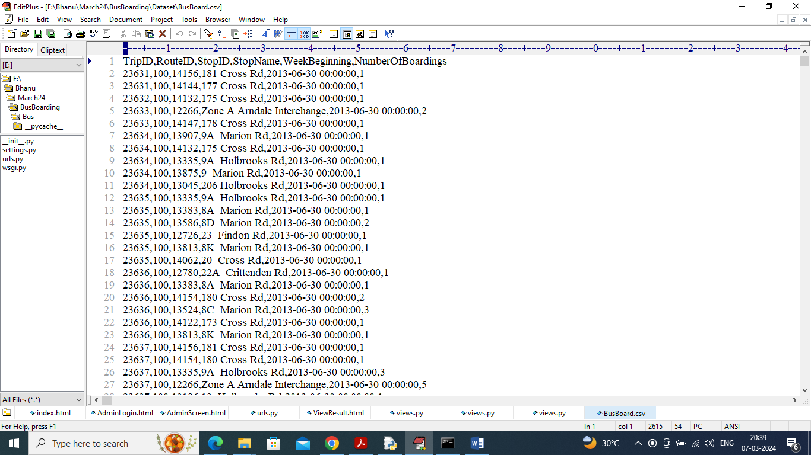
In above dataset screen first row contains dataset column names along with Route and Trip id and then in last column we have class labels as Number of Boardings from 1 to 5 (number of board person from each stop is between 1 to 5). Remaining rows contains dataset values. So by using above dataset will train and test all algorithms performance.
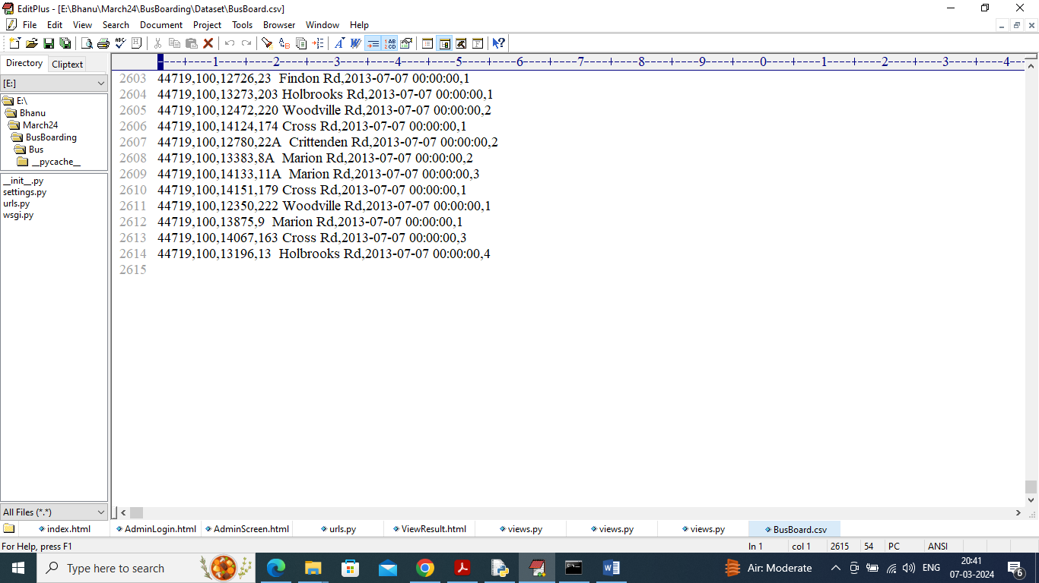
In above screen can see dataset contains 2614 records and after applying DCGAN it will increased to 4000.
To implement this project we have designed following modules as web application
- User Login: user can login to system using username and password as admin and admin
- Process Dataset: this module will load dataset and then normalize, clean and apply DCGAN to handle imbalance issue
- Existing Smote: process dataset will be run with SMOTE algorithm and then test accuracy with test data
- Propose Deep-GAN DNN: DNN algorithm get trained on DEEP GAN generated data and then calculate accuracy on test data
- Extension Deep-GAN CNN2D: CNN2D algorithm get trained on DEEP GAN gene rated data and then calculate prediction accuracy
- Comparison Graph: will plot comparison graph between all algorithms and then display number of test data boarding and predicted boarding
SCREEN SHOTS
To run project double click on run.bat file to start python web server and get below page
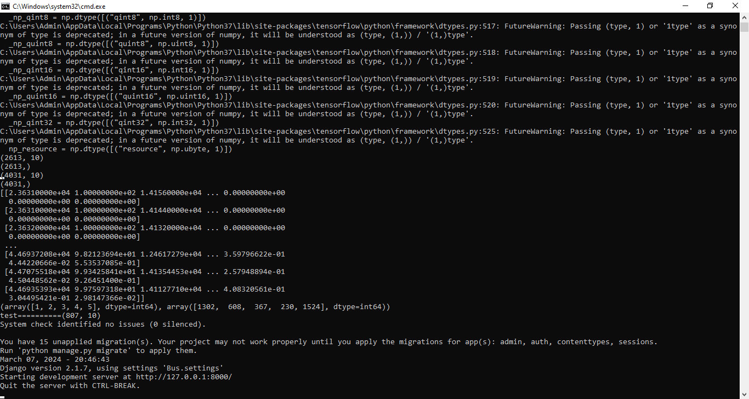
In above screen web server started and now open browser and enter URL as http://127.0.0.1:8000/index.html and press enter key to get below page

In above screen click on ‘User Login’ link to get below page

In above screen user is login and after login will get below page

In above screen click on ‘Process Dataset’ link to load and process data using DC GAN and get below page

In above screen can see Dataset contains 2613 records and after applying DC-GAN records increased to 4031 and now click on ‘Existing Smote’ link to train DNN using smote generated data and get below page
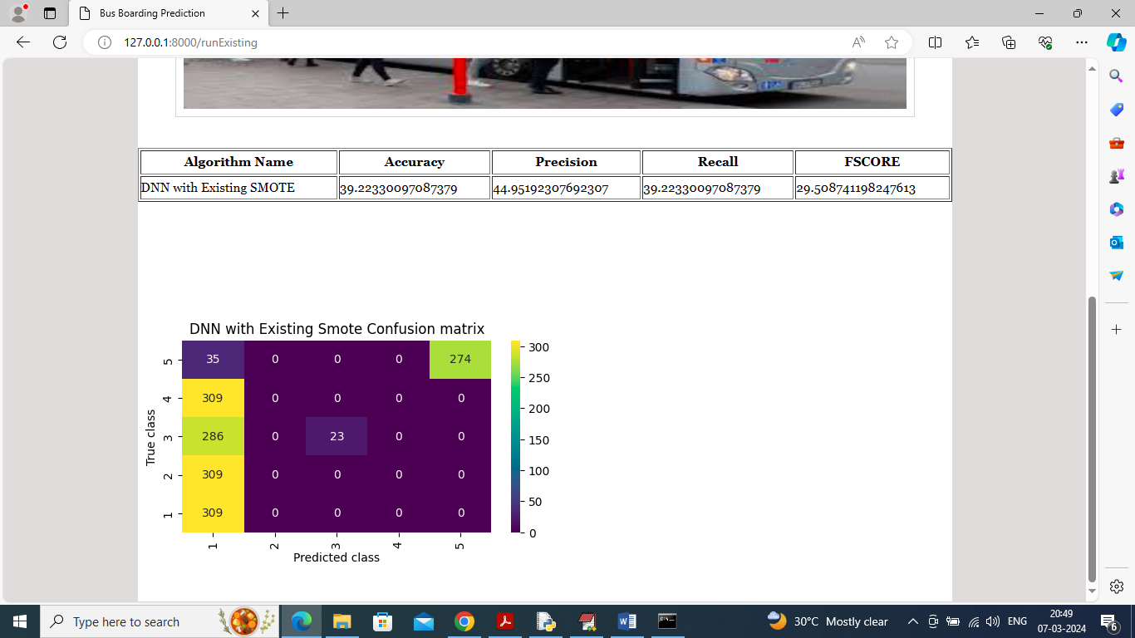
In above screen DNN got 39% accuracy on SMOTE generate data and in confusion matrix graph x-axis represents Predicted Labels and y-axis represents True labels and in above graph all boxes values in diagnol represents correct prediction count and remaining boxes contains incorrect prediction count. In above graph can see maximum predictions are wrong and now click on ‘Propose Deep-GAN DNN’ link to train propose algorithm and get below output
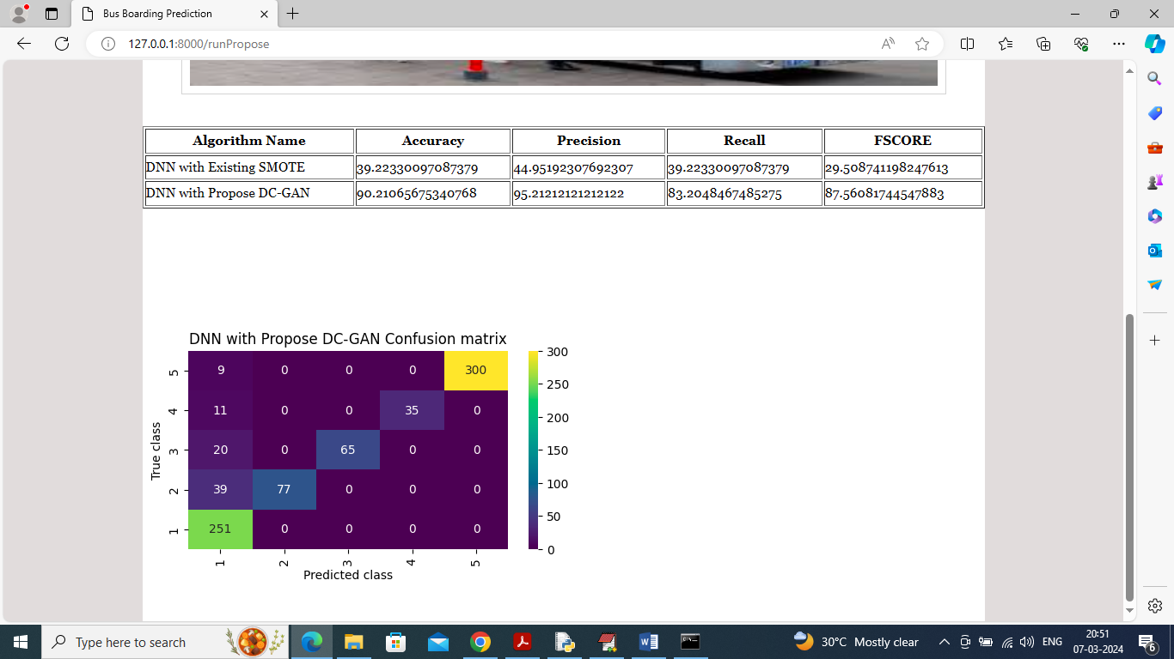
In above screen propose DNN with DC-GAN generated data got 90% accuracy and in confusion matrix graph can see all diagnol values are correct prediction count and remaining blue boxes has very few incorrect prediction count. Now click on ‘Extension DC-GAN CNN2D’ link to train extension algorithm and get below page
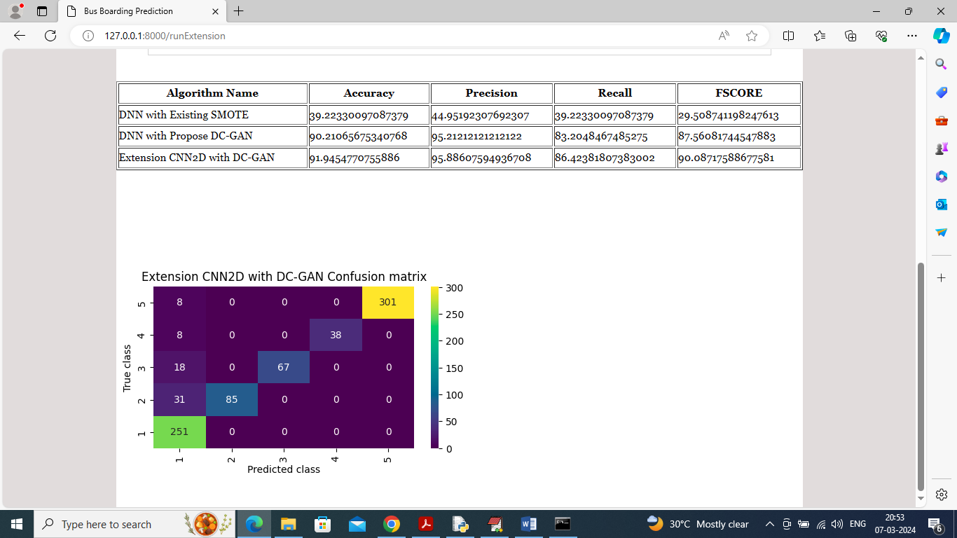
In above screen extension got 91% accuracy and can see other metrics also. Now click on ‘Comparison Graph’ link to get below graph
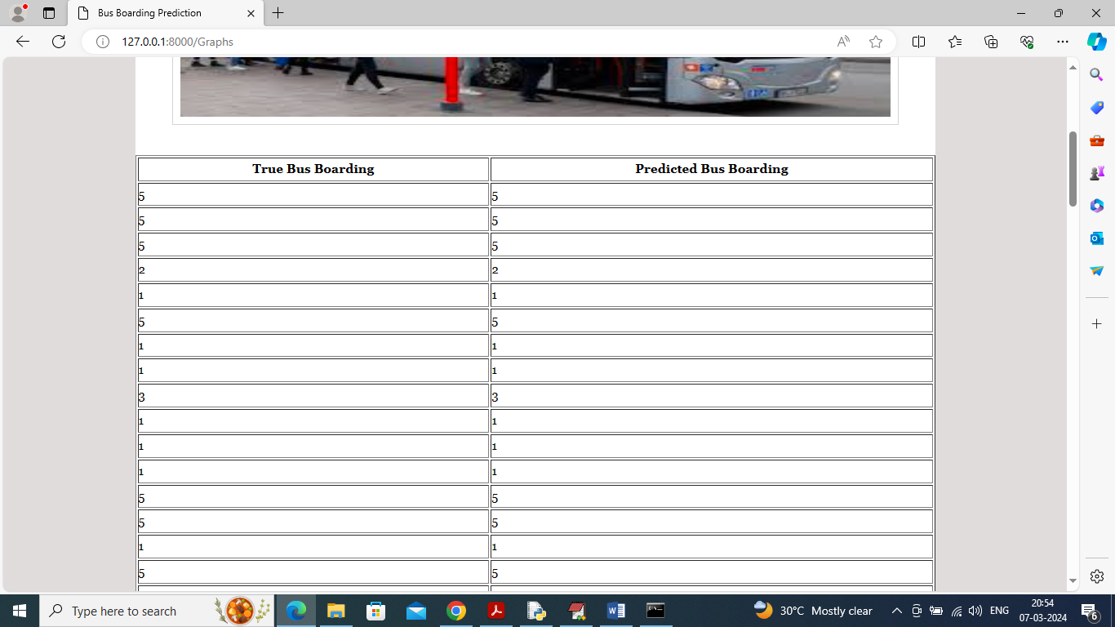
In above screen first column contains Test data boarding person count and second column contains Extension prediction boarding persons and scroll down above page to view below graph
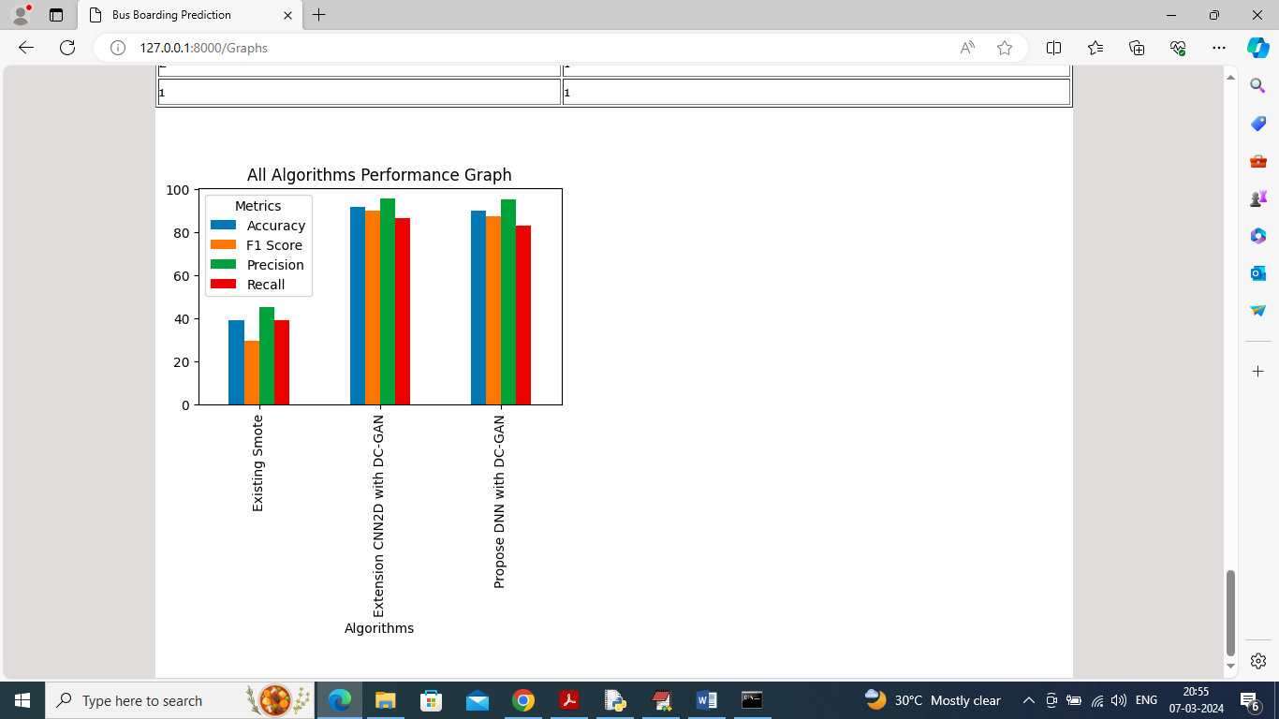
In above graph x-axis represents algorithm names and y-axis represents accuracy and other metrics in different bars and in all algorithms extension got high accuracy

