CO1
ASSIGNMENT 1

Design, Implement and Validate the Fare Logic of a City Metro Smart-Card System

Student Name: G Hasini
Register Number: 192425262
Department / Section: AIML
Course Code&Name: DSA0116_C++ Object Oriented Programming
GitHub Repository Link:
Submission Date: 10-11-2026

Contents
1. Introduction and problem statement
2. Task 1 – Understand the problem and identify objects
3. Task 2 – Tokens, keywords, identifiers and constants
4. Task 3 – Data types and type compatibility
5. Task 4 – Implicit conversions
6. Task 5 – Expressions and operator precedence
7. Task 6 – Control structures
8. Task 7 – Procedural and object-oriented design
9. Task 8 – Safe input and output
10. Task 9 – Implementation and testing
11. Task 10 – Expected results and execution
12. Task 11 – Final design recommendation
13. Task 12 – Design challenge
14. Conclusion
15. References

Introduction
This assignment develops the fare calculation logic for a city metro smart-card system. The metro has Inner, Middle and Outer zones with base fares of Rs 10, Rs 20 and Rs 30. A 20 percent surcharge applies during peak hours: 8:00–10:00 AM and 5:00–8:00 PM. A journey is accepted only when at least Rs 50 remains on the card after the fare is deducted. The main aim is to use suitable C++ data types, constants, operators, control structures and classes so that the fare and balance calculations remain correct.

Problem statement
The first version of the gate program may calculate money inaccurately, treat the peak-hour boundaries inconsistently or allow the balance to fall below the required minimum. The program should centralise fare values, use exact integer arithmetic for money, validate journeys and be easy to update when the metro introduces additional fare rules.

Objectives
- Identify the main objects and their responsibilities.
- Select suitable constants, enumerations and data types.
- Apply C++ operators and control structures correctly.
- Implement and test the fare and balance rules.
- Compare procedural and object-oriented solutions.
- Adapt the design for the additional requirements in Task 12.

Task 1 – Understand the Problem and Identify the Objects (4 marks)
The system can be represented using objects because each part has its own information and work to perform.
SmartCard: Stores the card number and balance. Its operations include checking whether a journey is allowed and deducting the fare.
Passenger: Stores passenger details and passenger category, such as regular passenger, student or senior citizen.
Journey: Stores the selected zone, journey time and calculated fare.
Zone: Represents Inner, Middle and Outer travel zones. Each zone is associated with a base fare.
FareTable: Stores the base fare values and surcharge percentage so that fare changes can be made in one place.
In a procedural solution, the balance, fare and passenger details may be separate variables and free functions calculate and deduct fares. In an object-oriented solution, these values and operations are grouped into classes. This makes it easier to protect the balance and update one part without changing unrelated code.

OOP principles in this system
- Encapsulation: SmartCard keeps its balance private and provides controlled methods such as canTravel() and deduct().
- Abstraction: the gate calls a fare-calculation method without needing to know every internal calculation step.
- Inheritance: StudentPassenger or SeniorPassenger could inherit common passenger details from a Passenger base class if passenger-specific rules are implemented.
- Polymorphism: different passenger types could override a virtual concession method to calculate their own discount.

Journey rules
- The base fare is Rs 10, Rs 20 or Rs 30 according to the farthest zone travelled.
- Peak surcharge is 20 percent from 08:00 inclusive to 10:00 exclusive and from 17:00 inclusive to 20:00 exclusive.
- Money is stored in paise to avoid binary floating-point rounding.
- A journey is accepted only if balance minus fare is at least 5000 paise.
- Invalid zone, time or negative recharge values must be rejected.

UML class diagram (text representation)
Passenger
- name: string
- category: PassengerType
+ concessionPercent(): int
SmartCard
- balancePaise: long long
+ canTravel(farePaise): bool
+ deduct(farePaise): bool
+ getBalance(): long long
Journey
- zone: Zone
- hour: int
- farePaise: long long
+ calculateFare(): long long
FareTable
+ baseFare(zone): long long
+ isPeakHour(hour): bool
Complexity: For a fixed number of zones, fare calculation and balance checking take O(1) time per journey. A card stores a fixed number of fields, so its storage is O(1). A procedural version has the same time and space complexity; the main difference is maintainability and control over data.
Source file: Task01/Task01.cpp. The complete source is included in the accompanying GitHub-ready folder.
Execution status in preparation environment: COMPILED AND EXECUTED.

output:
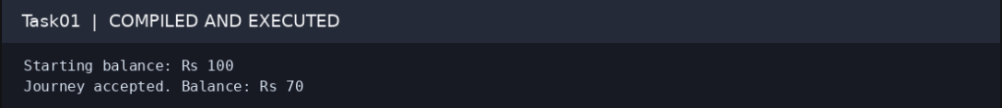

Task 2 – Tokens, Keywords, Identifiers and Constants (3 marks)
C++ source code is made up of tokens. The five token groups used in this program are keywords (int, class, return), identifiers (balancePaise, fare, Zone), literals/constants (1000, 20), operators (+, -, *, /) and punctuators ({ }, ( ), ;).
The fare values and surcharge should be declared once. #define is a preprocessor substitution and does not provide normal type checking or scope. const creates a read-only object. constexpr indicates that a value can be evaluated at compile time. constexpr is suitable for fixed fare values because it is typed and can be checked by the compiler.
enum class Zone { Inner, Middle, Outer } is safer than an unscoped enum because its enumerators are scoped and do not implicitly convert to int. Identifiers should use meaningful names, begin with a letter or underscore, contain no spaces and avoid reserved keywords.
Alternative comparison: replacing constexpr and enum class with macros may remove type checking and scope protection. Macros normally use no storage; constexpr values may also be optimised away. Neither approach changes the O(1) fare lookup time, but enum class and constexpr are easier to maintain safely.
Source file: Task02/Task02.cpp. The complete source is included in the accompanying GitHub-ready folder.
Execution status in preparation environment: COMPILED AND EXECUTED.

output:
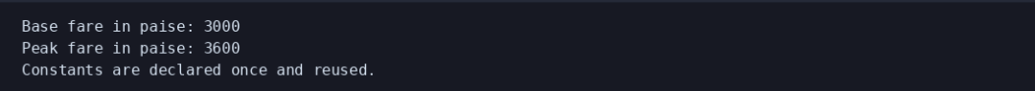

Task 3 – Choose Data Types and Check Type Compatibility (4 marks)
The program uses long long for balances and accumulated collections because totals can grow over millions of journeys. Money is stored in paise as an integer. For example, Rs 36.00 is stored as 3600 paise. This avoids rounding issues that can occur when decimal rupee values are represented in binary floating point.
Value | Suggested type | Reason
Peak flag | bool | Stores true or false.
Initial / zone character | char | Stores one character.
Hour / percentage | int | Small whole-number values.
Card balance / money | long long | Stores paise and large totals.
Zone | enum class Zone | Restricts values to named zones.
Collection estimate | double | Useful for comparison, not exact money storage.
Journey count | long long | Supports large daily counts.
The exact result of sizeof depends on the compiler and platform. The Task03 program prints the sizes and the limits from <climits> on the machine where it is executed. An int is commonly a 32-bit signed value, whose maximum is 2,147,483,647. A total of 3,000,000 journeys at 3600 paise each is 10,800,000,000 paise, which exceeds that limit. long long is therefore required.
Both integer and floating-point additions are O(1) time and use a fixed amount of storage per variable. The difference is numeric range and precision, not asymptotic complexity.
Source file: Task03/Task03.cpp. The complete source is included in the accompanying GitHub-ready folder.
Execution status in preparation environment: COMPILED AND EXECUTED.

output:
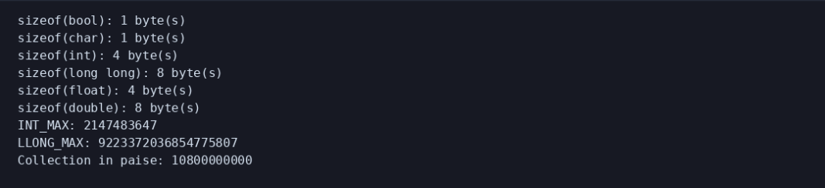

Task 4 – Control Implicit Conversions (4 marks)
The supplied program is copied into Task04.cpp. Before running it, the predicted output is:
3 3.5\nC 68\n1 true\ns >= u
Explanation: a / b performs integer division first, so 7 / 2 becomes 3 before assignment to double. static_cast<double>(a) makes the division floating point and gives 3.5. The character expression produces 'C'; when ch is printed in arithmetic, it is promoted to an integer (67 + 1 = 68). The integer 5 converts to bool true, printed first as 1 and then as true after boolalpha. In the signed/unsigned comparison, -1 is converted to unsigned, so it becomes a large unsigned value and the condition s < u is false.
Brace initialisation, such as int count{3};, prevents many narrowing conversions. Explicit static_cast makes intentional conversions visible. These changes generally do not alter O(1) runtime or fixed storage, but they help catch mistakes at compile time.
Source file: Task04/Task04.cpp. The complete source is included in the accompanying GitHub-ready folder.
Execution status in preparation environment: COMPILED AND EXECUTED.

output: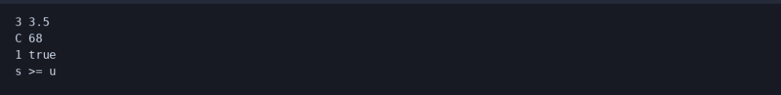

Task 5 – Write Correct Expressions with the Right Precedence (4 marks)
The peak condition is (hour >= 8 && hour < 10) || (hour >= 17 && hour < 20). Parentheses make the two time windows clear. The surcharge can be calculated with fare += fare * 20 / 100 using integer paise. A concession can be selected with a conditional expression, for example fare = eligible ? discountedFare : fare.
Predicted output of the supplied program:
11 16\n9 6 4\n6 4\n3 1 -3 -1\n18
Multiplication has higher precedence than addition, so 5 + 3 * 2 is 11. Parentheses make (5 + 3) * 2 equal 16. x++ uses the old x value and then increments x; ++y increments y before it is used. Thus z is 10, x becomes 6 and y becomes 4. The conditional operator returns the larger value, 6. Modulus and multiplication are evaluated left to right at the same precedence, giving 4. Integer division truncates toward zero, and the remainder has the sign of the dividend.
A lookup table bool peak[24] also checks a peak hour in O(1) time, but uses 24 boolean entries. The expression approach uses constant space and is clear for only two windows; a table can be easier to maintain for complex schedules.
Source file: Task05/Task05.cpp. The complete source is included in the accompanying GitHub-ready folder.
Execution status in preparation environment: COMPILED AND EXECUTED.
output: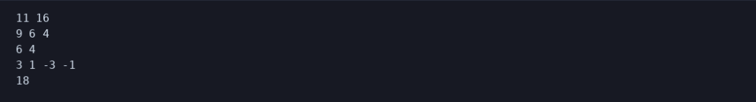

Task 6 – Design the Control Structures (4 marks)
Pseudocode:
START
Set balance to 10000 paise
For each trip
Select base fare using the zone
If the hour is in either peak window
Add 20 percent to the base fare using integer arithmetic
End if
If balance - fare >= 5000
Deduct fare from balance
Display fare and remaining balance
Else
Display journey denied
End if
End for
STOP
The switch statement is suitable for selecting one of the named zones. if-else is suitable for the peak rule and minimum-balance decision. A for loop is suitable when the trips are stored in an array. break ends a switch case, while continue can skip an invalid trip in a larger input loop.
The completed TODO program uses integer paise and a switch. The expected output is Rs 10.00 with balance Rs 90, then Rs 36.00 with balance Rs 54, followed by a denied middle-zone journey because paying Rs 20 would leave less than Rs 50.
The peak interval must be start-inclusive and end-exclusive: 08:00 and 17:00 are peak, while 10:00 and 20:00 are off-peak. A switch and a constant array both provide O(1) lookup for a fixed number of zones. A fourth zone requires adding another case or extending the array.
Source file: Task06/Task06.cpp. The complete source is included in the accompanying GitHub-ready folder.
Execution status in preparation environment: COMPILED AND EXECUTED.
output:

Task 7 – From Procedural to Object-Oriented (4 marks)
The procedural version uses separate functions and a balance variable. It is simple for a small program, but any function that can access the balance may accidentally change it incorrectly. The object-oriented version puts the balance inside SmartCard as a private data member. The deduct() method checks the minimum-balance condition before changing the value.
Both designs use O(1) time for one fare deduction and O(1) storage for one card. The class version does not make the operation faster; it makes the rule easier to protect. If the minimum balance changes, a named constant or class method can be updated in one place.
Source file: Task07/Task07.cpp. The complete source is included in the accompanying GitHub-ready folder.
Execution status in preparation environment: COMPILED AND EXECUTED.
output:

Task 8 – Read and Print Data Safely (4 marks)
Task08 reads a passenger name, hour and balance. It checks the input stream before using the values and rejects an hour outside 0–23 or a negative balance. cin.fail() indicates that formatted input could not be read. cin.clear() resets the stream state and cin.ignore() discards the remaining invalid characters.
setw() controls field width and setfill() selects the padding character. fixed and setprecision(2) display two digits after the decimal point. An alternative is to read a full line with getline() and convert it using stoi() inside a try/catch block. Both approaches take O(L) time for a line of length L; getline uses a buffer proportional to the line length.
Source file: Task08/Task08.cpp. The complete source is included in the accompanying GitHub-ready folder.
Execution status in preparation environment: COMPILED AND EXECUTED.
output: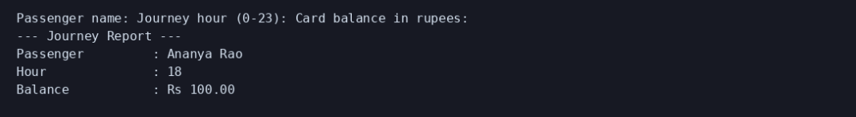

Task 9 – Implement and Test the Fare Logic (4 marks)
The fare rule was tested at ordinary times and at the four peak-hour boundaries. The end times are exclusive, so 10:00 AM and 8:00 PM are off-peak.
Test | Expected fare | Actual fare | Status
Inner off-peak | 1000 paise | 1000 paise | PASS
Middle off-peak | 2000 paise | 2000 paise | PASS
Outer off-peak | 3000 paise | 3000 paise | PASS
Outer peak | 3600 paise | 3600 paise | PASS
08:00 boundary | 1200 paise | 1200 paise | PASS
10:00 boundary | 1000 paise | 1000 paise | PASS
17:00 boundary | 2400 paise | 2400 paise | PASS
20:00 boundary | 2000 paise | 2000 paise | PASS
A card starting with Rs 100 and taking an Inner off-peak, Outer peak and Middle off-peak trip would be charged Rs 10 + Rs 36 + Rs 20 = Rs 66. The first two trips leave Rs 54, but the third is rejected because it would leave Rs 34, below the required Rs 50.
A table-driven test loop takes O(t) time for t test cases and uses O(t) storage for the test table. Adding a boundary test is straightforward because a new row can be inserted.
Source file: Task09/Task09.cpp. The complete source is included in the accompanying GitHub-ready folder.
Execution status in preparation environment: COMPILED AND EXECUTED.
output: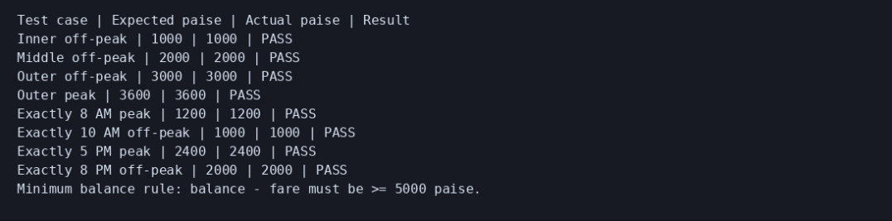

Task 10 – Compare Expectations with Execution (4 marks)
The Task10 program compares an exact integer-paise total with a double-rupee total for 20,000, 500,000 and 3,000,000 journeys. At Rs 36 per journey, the expected totals are Rs 720,000, Rs 18,000,000 and Rs 108,000,000 respectively. The last total is 10,800,000,000 paise and is too large for a typical 32-bit int.
long long can store this total safely. double can represent the values at this scale with useful precision, but floating-point values are not a suitable representation for exact currency arithmetic. Each addition is O(1), and each accumulator uses O(1) space. Compiler warnings should be reviewed rather than ignored; the README records the warning flags used.
Source file: Task10/Task10.cpp. The complete source is included in the accompanying GitHub-ready folder.
Execution status in preparation environment: COMPILED AND EXECUTED.
output: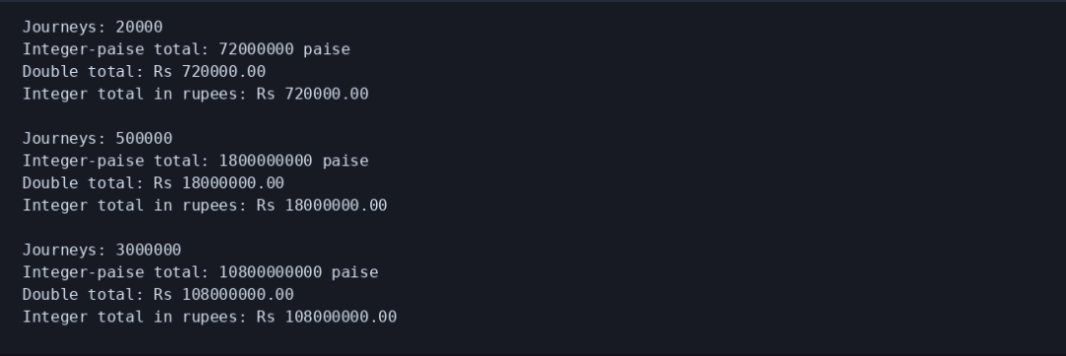

Task 11 – Recommend and Defend the Final Design (4 marks)
The recommended design stores money as long long paise, uses constexpr for fixed values, enum class for zones and a SmartCard class with a private balance. Fare calculation should be kept in one function or FareTable so a fare revision is not repeated throughout the program. The design has O(1) fare calculation and balance checking for each journey.
The main limitation of compile-time fare constants is that a fare revision requires a code change and a new build. A configuration file would allow authorised fare changes without recompilation, but it adds file-reading, validation and error-handling work at start-up. Reading z zone values takes O(z) time and O(z) storage.
Source file: Task11/Task11.cpp. The complete source is included in the accompanying GitHub-ready folder.
Execution status in preparation environment: COMPILED AND EXECUTED.
output:

Task 12 – Re-evaluate and Adapt the Design Challenge (8 marks)
The new requirements add an Airport zone with a Rs 60 base fare, a 10 percent weekend discount that does not combine with the peak surcharge, and a monthly pass covering two selected zones.

A. Impact analysis
- Add Airport to the Zone enumeration and add 6000 paise to the fare table.
- Add a DayType value and a weekend-discount rule.
- Ensure the weekend branch is selected instead of the peak-surcharge branch.
- Introduce a MonthlyPass class that stores the two covered zones and checks whether a journey is included.

B. Evaluation of the original design
The original switch can be extended with an Airport case, but repeated switch statements in different places would become difficult to maintain. The SmartCard class can remain responsible for stored balance, while the new pass should be represented separately. A pass should not be implemented as a special balance value because its rules are different.

C. Adapted design and worked examples
- Airport weekday peak: Rs 60 + 20% = Rs 72 (7200 paise).
- Outer weekend: Rs 30 less 10% = Rs 27 (2700 paise). No peak surcharge is added on the weekend.
- Inner or Middle covered by the monthly pass: Rs 0 for the journey.
- Airport is not covered by a pass that covers only Inner and Middle, so its normal fare is charged.
The Task12.cpp program uses a fare table, a separate DayType rule and a MonthlyPass class. The pass checks whether the selected zone is one of its two covered zones. The weekend branch takes priority over the peak branch, so the two discounts do not combine.

D. Evidence-based defence
The design is modified rather than completely replaced. The SmartCard responsibility remains useful, while the fare rules are separated into functions and the monthly pass is represented by its own class. This reduces the amount of unrelated code that must change when another fare rule is introduced. Each fare lookup remains O(1); checking the two pass zones is also O(1).
Source file: Task12/Task12.cpp. The complete source is included in the accompanying GitHub-ready folder.
Execution status in preparation environment: COMPILED AND EXECUTED.
output: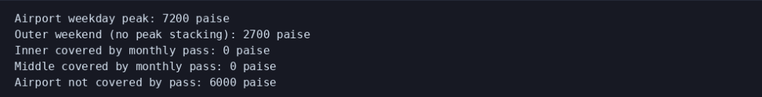

Conclusion
The assignment shows that a reliable fare system needs clear rules, suitable data types and controlled access to the card balance. Integer paise avoids floating-point currency errors, while long long supports large network totals. The object-oriented design keeps the card balance protected and separates fare calculation from payment. The revised design also supports the Airport zone, weekend discount and monthly pass without changing the basic purpose of the SmartCard class.

References
- Assignment 1 – CO1: Design, Implement and Validate the Fare Logic of a City Metro Smart-Card System (course-provided assignment brief).
- C++ standard library documentation: <iostream>, <iomanip>, <climits>, <limits> and <string>.
- C++ language reference for expressions, conversions, enumerations and classes.
Student verification note: Replace the cover-page details, compile and run the source files on your own system, and insert direct screenshots from your own execution before final submission.

