DEPARTMENT OF COMPUTER SCIENCE AND ENGINEERING
CSA06 – DESIGN AND ANALYSIS OF ALGORITHMS
CO3 – ASSESSMENT TOOL 3
MODULE 1 REPORT
MERGE SORT FOR NIGHTLY ORDER CONSOLIDATION

Case Study: KartIQ Retail Data Analytics Platform

Student Name: Konduru Hasini
Register Number: 192424181

1. Abstract
This report analyzes Module 1 of the CO3 case study: nightly order consolidation for KartIQ, a retail data analytics platform. Orders must be sorted by timestamp while preserving original arrival order when timestamps are equal. A stable Merge Sort is designed, implemented in Python, traced using the supplied sample data, and evaluated through recurrence analysis, comparison estimates, memory analysis, test cases, complexity analysis, and practical recommendations.

2. Case Study Analysis
KartIQ processes approximately 10,000,000 orders per day. The nightly audit report requires orders sorted by timestamp. Orders from different payment gateways may share the same timestamp, and their original relative arrival order must be retained for audit reconciliation. The design must therefore be efficient, stable, and capable of handling data that may not fit into RAM.
Requirement / issue | Analysis | Consequence if ignored
Sort by timestamp | Output must be in nondecreasing timestamp order. | Audit report may be incorrect.
Equal timestamps | Preserve relative input order of tied orders. | Gateway reconciliation order may change.
Large workload | About 10 million orders per day. | Slow sorting may miss the nightly deadline.
Memory | Merge Sort needs temporary storage. | In-memory sorting may exceed available RAM.
Verification | Trace, tests, and output evidence are required. | Correctness becomes harder to demonstrate.

3. Problem Definition and Input Dataset
Input records have the form (timestamp, order ID). Timestamp is the sorting key and order ID identifies each order. The required output is ascending by timestamp, with equal-timestamp records retaining their input order.
Input position | Timestamp | Order ID
1 | 105 | O1
2 | 102 | O2
3 | 105 | O3
4 | 101 | O4
5 | 102 | O5
6 | 103 | O6
Expected output: [(101,O4), (102,O2), (102,O5), (103,O6), (105,O1), (105,O3)].

4. Algorithm Design

4.1 Divide-and-Conquer Strategy
- Divide: split the input into two approximately equal halves.
- Conquer: recursively sort each half until each sublist contains zero or one order.
- Combine: merge the sorted halves by selecting the smaller timestamp first.
- Stability: when timestamps are equal, select the record from the left half first. This preserves relative input order.

4.2 Pseudocode
MERGE_SORT(A)
if length(A) <= 1: return A
mid = floor(length(A) / 2)
Left = MERGE_SORT(A[0:mid])
Right = MERGE_SORT(A[mid:end])
return MERGE(Left, Right)
MERGE(Left, Right)
Result = empty list; i = 0; j = 0
while i < length(Left) and j < length(Right):
if Left[i].timestamp <= Right[j].timestamp:
append Left[i]; i = i + 1
else:
append Right[j]; j = j + 1
append all remaining records from Left and Right
return Result

5. Execution Trace: Every Merge

5.1 Division
Left = [(105,O1), (102,O2), (105,O3)]
Right = [(101,O4), (102,O5), (103,O6)]

5.2 Left-half merges
Operation | Action | Result
L1 | Merge [(105,O1)] and [(102,O2)]; 102 is smaller. | [(102,O2), (105,O1)]
L2 | Merge [(102,O2),(105,O1)] and [(105,O3)]; O1 precedes O3 on equal timestamp. | [(102,O2),(105,O1),(105,O3)]

5.3 Right-half merges
Operation | Action | Result
R1 | Merge [(101,O4)] and [(102,O5)]; 101 is smaller. | [(101,O4),(102,O5)]
R2 | Merge [(101,O4),(102,O5)] and [(103,O6)]. | [(101,O4),(102,O5),(103,O6)]

5.4 Final merge
Step | Selected record | Reason
1 | (101,O4) | Smallest timestamp.
2 | (102,O2) | Tie at 102; left-half record is selected first.
3 | (102,O5) | Next remaining timestamp is 102.
4 | (103,O6) | Smaller than remaining timestamp 105.
5 | (105,O1) | O1 precedes O3 in the original order.
6 | (105,O3) | Last remaining record.
Final sorted list: [(101,O4), (102,O2), (102,O5), (103,O6), (105,O1), (105,O3)].

6. Source Code and Output Evidence
The executable Python file merge_sort.py is provided alongside this report. The stability-critical condition is left[i][0] <= right[j][0], which chooses the left record when timestamps are equal.
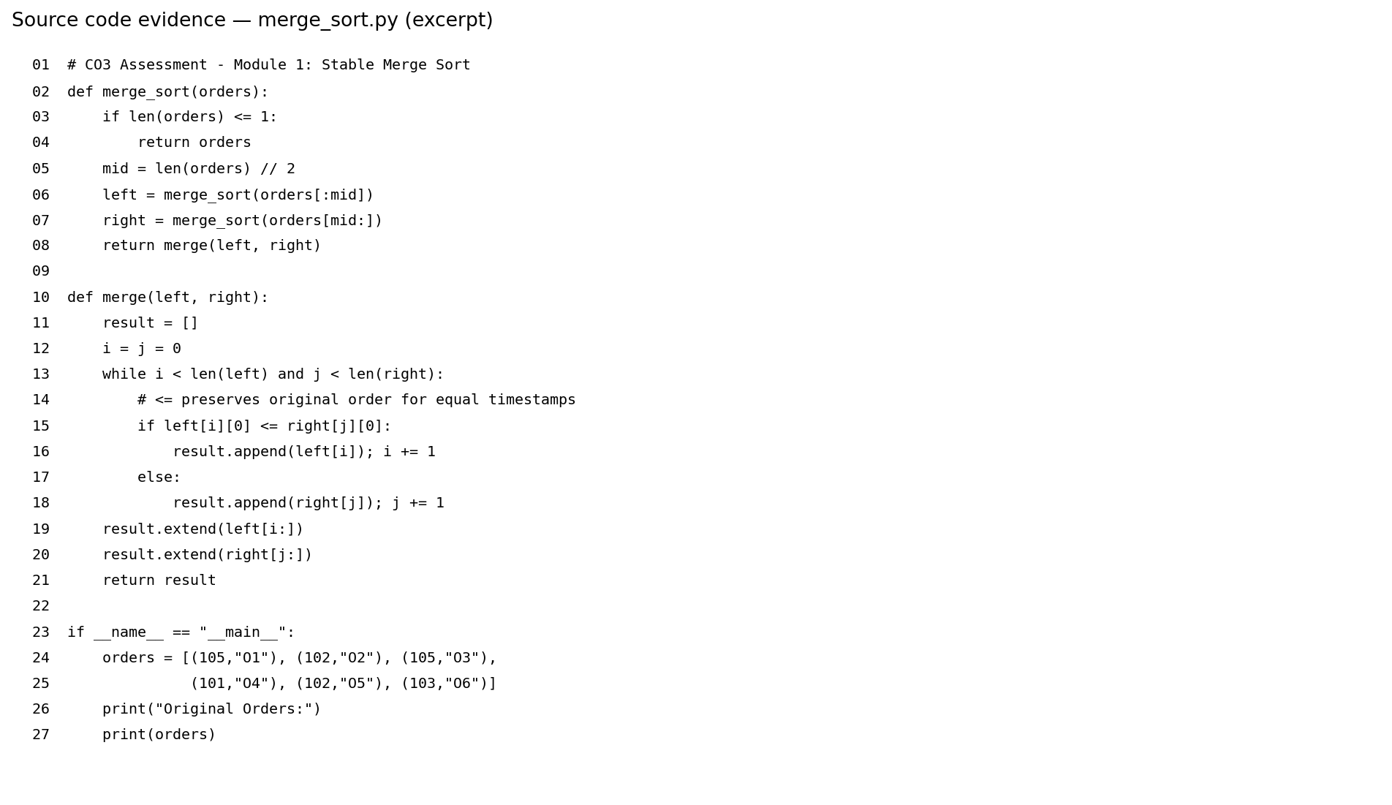
Figure 1. Source-code screenshot-style excerpt generated from merge_sort.py.
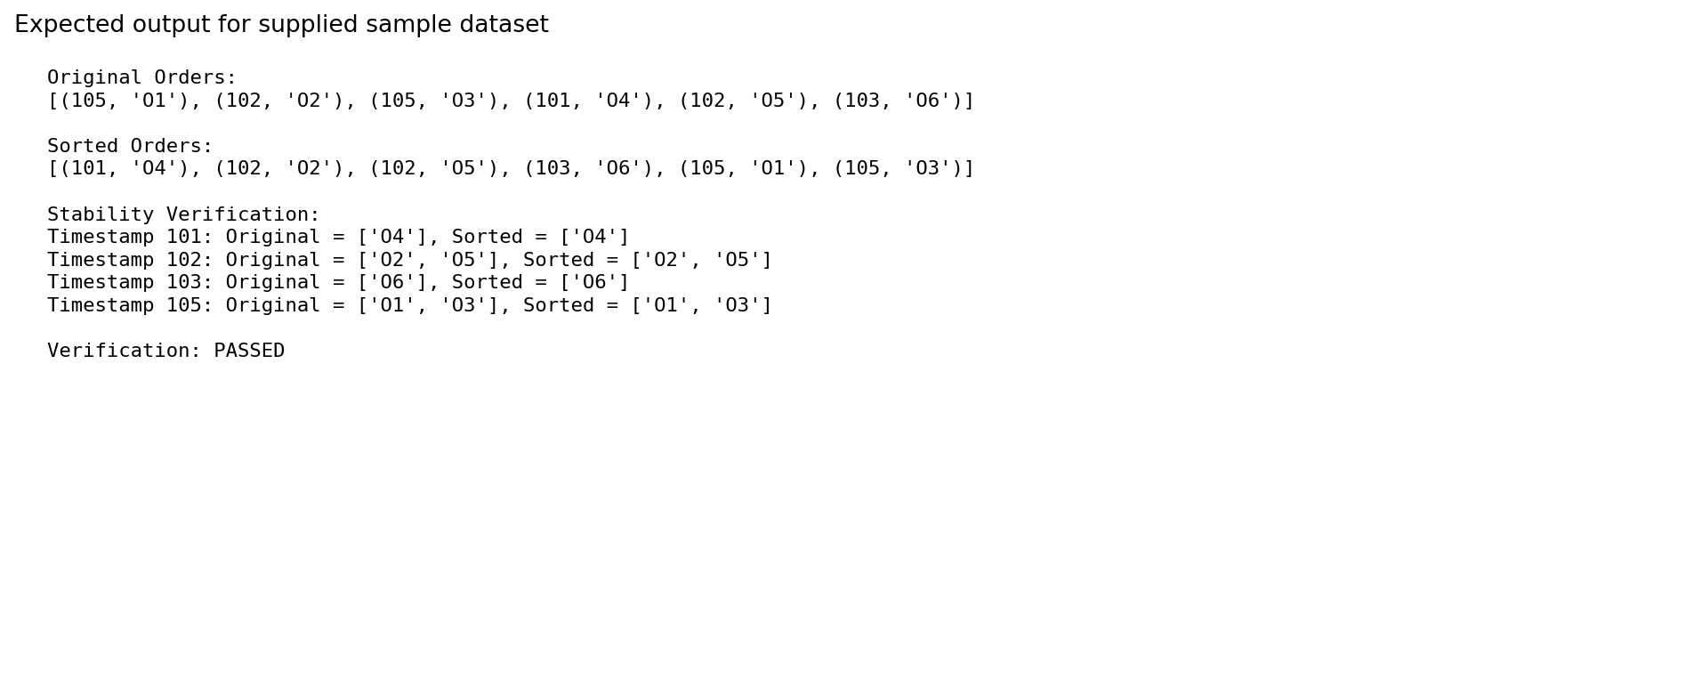
Figure 2. Expected output for the sample dataset. These are generated evidence images, not screenshots from the student's own Colab session. Run the code and capture genuine screenshots if required.

7. Test Cases and Experimental Results
Test case | Input | Expected behaviour | Validation
TC1 sample | Six supplied orders | Sorted ascending; ties stable | Sample output verified
TC2 sorted | [(1,A),(2,B),(3,C)] | Output unchanged | Algorithm supports
TC3 reverse | [(3,C),(2,B),(1,A)] | [(1,A),(2,B),(3,C)] | Algorithm supports
TC4 duplicates | [(5,A),(2,B),(5,C),(5,D)] | A,C,D retain relative order | Stable rule supports
TC5 one record | [(7,X)] | Returned unchanged | Base case
TC6 empty list | [] | Empty list returned | Base case
The supplied sample was evaluated with the same merge logic as the program. It produces ascending timestamps and preserves the relative order of O2 before O5 and O1 before O3. Since the sample has only six records, it is not suitable for making claims about production runtime.

8. Recurrence Relation and Solution
For n orders, Merge Sort performs two recursive calls on subproblems of size approximately n/2 and Θ(n) work to merge them.
T(n) = 2T(n/2) + cn, for n > 1; T(1) = d.
By the Master Theorem, a = 2, b = 2, and f(n) = Θ(n). Since n^(log₂ 2) = n, this is the balanced case T(n) = Θ(n log₂ n).

9. Mathematical Calculation for 10,000,000 Orders
n = 10,000,000 and log₂(n) ≈ 23.2535. Therefore n log₂(n) ≈ 232,534,967, or approximately 232.5 million as an asymptotic comparison scale. This is not an exact comparison count.
A standard upper bound is n⌈log₂ n⌉ − 2^⌈log₂ n⌉ + 1. Since ⌈log₂ n⌉ = 24, the bound is 10,000,000 × 24 − 16,777,216 + 1 = 223,222,785 comparisons.
Measure | Value | Meaning
Input size n | 10,000,000 | Number of orders
log₂ n | ≈ 23.2535 | Logarithmic factor
n log₂ n | ≈ 232,534,967 | Asymptotic scale, not exact
Upper bound | n⌈log₂n⌉ − 2^⌈log₂n⌉ + 1 | Balanced Merge Sort comparison bound
Calculated bound | 223,222,785 | Upper-bound value for n = 10 million

10. Complexity Analysis
Measure | Complexity | Explanation
Best-case time | Θ(n log n) | Recursive splitting and merging still occur.
Average-case time | Θ(n log n) | Each level processes all records.
Worst-case time | Θ(n log n) | Total merge work is bounded at every level.
Auxiliary space | O(n) | Temporary storage for merging.
Recursion stack | O(log n) | Depth of recursive calls.

11. Graph and Comparison
The graph compares the growth scale n log₂ n for Merge Sort with a quadratic n² scale. Logarithmic axes are used to show the trends across different input sizes.
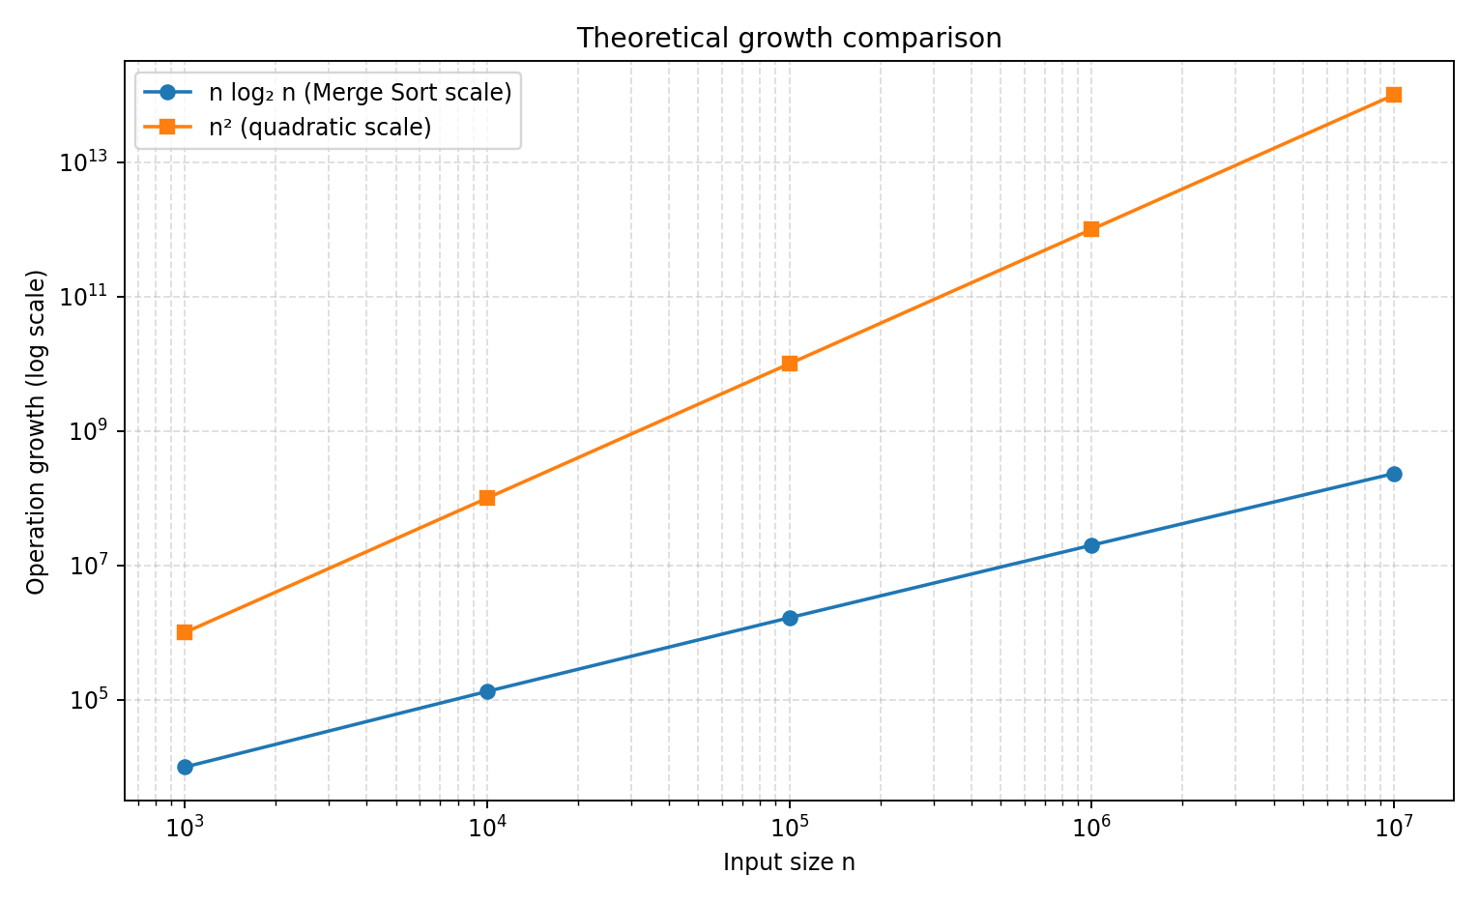
Figure 3. Theoretical operation-growth comparison; this graph is not measured runtime.
n | n log₂ n (approx.) | n²
1000 | 9,966 | 1,000,000
10000 | 132,877 | 100,000,000
100000 | 1,660,964 | 10,000,000,000
1000000 | 19,931,569 | 1,000,000,000,000
10000000 | 232,534,967 | 100,000,000,000,000

12. Memory Analysis and External Merge Sort
Standard array-based Merge Sort uses O(n) auxiliary space. Actual memory depends on record representation, buffers, and runtime overhead. As an illustration only, if one record occupies 32 bytes, ten million records require about 320,000,000 bytes (320 MB decimal) before temporary copies and overhead.
If the complete dataset does not fit in RAM, use external Merge Sort: read manageable chunks, sort each chunk, write sorted runs to disk, then merge the runs using buffered file I/O. This controls RAM use at the cost of additional disk I/O.

13. Optimization Recommendations
- Use the stable <= comparison so equal timestamps preserve their arrival order.
- Use buffered sequential file I/O for large datasets.
- Use external Merge Sort when data exceeds available RAM.
- Where practical, sort compact keys or references instead of copying large records repeatedly.
- Benchmark on representative data and hardware before selecting chunk size and merge fan-in.
- Automate validation of sorted order and stability after each code change.

14. Limitations and Trade-offs
Merge Sort offers predictable Θ(n log n) time and stability, which suit audit-oriented sorting. Its main trade-off is O(n) auxiliary memory. External sorting reduces RAM pressure but introduces disk I/O and operational complexity. Theoretical comparison estimates should not be presented as measured runtime results.

15. Conclusion
Stable Merge Sort meets KartIQ's nightly consolidation requirement because it sorts by timestamp in Θ(n log n) time and preserves the relative order of equal-timestamp records. The n log₂ n scale for ten million orders is about 232.5 million, while exact comparisons depend on the merge pattern. If the dataset cannot fit in RAM, external Merge Sort is a practical approach.

Appendix A – Files for GitHub
File / path | Purpose
Pseudocode/merge_sort.md | Pseudocode and stability rule
Source_Code/merge_sort.py | Executable Python implementation
Report/CO3_Module_1_Merge_Sort_Report.docx | This report
Supporting_Files/module1_source_code_screenshot.png | Generated code illustration
Supporting_Files/module1_execution_output.png | Generated expected-output illustration
Supporting_Files/module1_comparison_graph.png | Theoretical growth graph

Appendix B – Evidence Note
The code and output figures in this report are generated illustrations based on the included program and supplied dataset. They are not screenshots captured from the student's own Google Colab session. For submission evidence, run the code in Colab or locally and capture actual screenshots, replacing these illustrations if required.

