DEPARTMENT OF COMPUTER SCIENCE AND ENGINEERING

CSA06 – DESIGN AND ANALYSIS OF ALGORITHMS

ASSIGNMENT 2 – CO2

Student Name: Konduru Hasini
Reg.No:192424181

Abstract
This report investigates brute-force and exhaustive-search techniques through seven experiments: sorting under different data conditions, sequential search, brute-force string matching, closest-pair detection, brute-force convex hull construction, exhaustive package selection, and a redesign of the closest-pair solution. The experiments emphasize operation counts and correctness checks; execution time is included as supporting evidence. The redesign sorts points by their x-coordinate and prunes pairs whose horizontal gap cannot improve the best known distance.

Objectives
- Predict algorithm behaviour before testing and explain the algorithmic reason.
- Design contrasting datasets that expose meaningful differences.
- Implement algorithms and count comparisons, movements, pairs, or subsets.
- Derive theoretical operation growth and compare it with measured experiments.
- Recommend appropriate engineering choices and discuss limitations.

Experimental method and reproducibility
All tables and graphs in this report were generated by executing the algorithms described in the report in a reproducible Python environment. Random experiments use a fixed seed where applicable. Execution times are environment-dependent and should be treated as illustrative measurements, not universal guarantees. If the student's Google Colab output differs, the Colab run should be retained as the final evidence for submission.
Primary measures are algorithm-specific operation counts. Wall-clock time is secondary because runtime depends on hardware, interpreter state, and background load.
Q1 – Sorting Under Different Data Conditions (6 marks)

Problem and design
The e-commerce fulfilment centre must sort dispatch-priority scores. The algorithms compared are Selection Sort, Bubble Sort with early stopping, and Insertion Sort. All datasets are sorted in ascending order. Selection Sort counts element comparisons and swaps; Bubble Sort counts comparisons and swaps; Insertion Sort counts element comparisons and assignments/movements, including placement of the key.
Dataset | Input | Purpose
A – Nearly sorted | [1, 2, 4, 3, 5, 6] | Only one adjacent pair is misplaced.
B – Reverse sorted | [6, 5, 4, 3, 2, 1] | Strongly disordered input.
C – Already sorted | [1, 2, 3, 4, 5, 6] | Best case for adaptive algorithms.

Predictions before execution
Selection Sort should make n(n−1)/2 comparisons regardless of input order. Bubble Sort with early stopping should finish after one pass on already sorted input. Insertion Sort should require few shifts for nearly sorted and already sorted inputs, but many shifts on reverse order.

Pseudocode
FOR each dataset:
Run Selection Sort:
For i = 0 to n-2, find the minimum in positions i..n-1.
Count comparisons; swap it into position i if needed.
Run Bubble Sort:
Compare adjacent elements on each pass and swap inversions.
Stop early if a pass makes no swaps.
Run Insertion Sort:
Insert each next element into the sorted prefix.
Shift larger elements right and count movements.
Record sorted output, comparisons, swaps/movements, and time.

Experimental results
Dataset | Algorithm | Comparisons | Operations | Operation type
Nearly sorted | Selection Sort | 15 | 1 | Swaps
Nearly sorted | Bubble Sort | 9 | 1 | Swaps
Nearly sorted | Insertion Sort | 6 | 6 | Movements
Reverse sorted | Selection Sort | 15 | 3 | Swaps
Reverse sorted | Bubble Sort | 15 | 15 | Swaps
Reverse sorted | Insertion Sort | 15 | 20 | Movements
Already sorted | Selection Sort | 15 | 0 | Swaps
Already sorted | Bubble Sort | 5 | 0 | Swaps
Already sorted | Insertion Sort | 5 | 5 | Movements

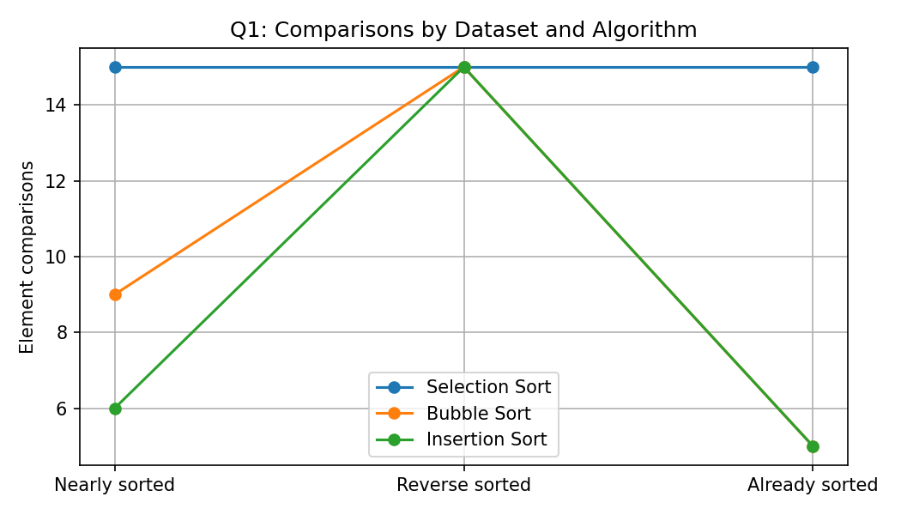
Figure 1. Element-comparison counts for the three sorting algorithms.

Observations and recommendation
The observed comparison counts follow the predicted pattern: Selection Sort uses 15 comparisons on each six-element dataset; Bubble Sort uses 5 comparisons on already sorted input due to early stopping; Insertion Sort uses 5 comparisons on already sorted input and only a small number of shifts on nearly sorted data. Reverse order causes many Bubble Sort swaps and Insertion Sort movements.
Recommendation: choose Insertion Sort for the stated workload where about 95% of orders are already in the correct order and only small batches are added. It is adaptive and performs well on nearly sorted data. Bubble Sort with early stopping also detects sorted input efficiently but generally has more swapping overhead. Selection Sort is less attractive here because its comparison count is insensitive to existing order.

Complexity
Algorithm | Best case | Average / worst case | Extra space | Reason
Selection Sort | Θ(n²) | Θ(n²) | O(1) | Scans remaining elements each pass.
Bubble Sort (early stop) | Θ(n) | Θ(n²) | O(1) | One pass detects sorted input; inversions require repeated passes.
Insertion Sort | Θ(n) | Θ(n²) | O(1) | Work depends on how far each element must shift.

Q2 – When Is Sequential Search Appropriate? (4 marks)
The maintenance tool register is a changing list of records containing Tool ID, Technician ID, Issue Time, and Work Bay. Sequential Search checks records from the beginning until the target is found or the list ends.

Pseudocode
SEQUENTIAL_SEARCH(records, target):
comparisons = 0
FOR each record in records:
comparisons = comparisons + 1
IF record.Tool_ID == target:
RETURN record, comparisons
RETURN NOT_FOUND, comparisons

Experiment design and results
Successful searches were tested at the first, middle, and last positions. An absent target was also tested. Larger lists were tested by searching for the last record, which requires a full scan.
List size | Search case | Target | Comparisons | Found
10 | first | T-100 | 1 | True
10 | middle | T-104 | 5 | True
10 | last | T-109 | 10 | True
10 | absent | T-999 | 10 | False
100 | last | T-199 | 100 | True
1000 | last | T-1099 | 1000 | True

Analysis and operating boundary
A successful search at position k requires k comparisons in a one-based list. An unsuccessful search requires n comparisons. Thus best-case time is O(1), while average and worst-case time are O(n). The method is reasonable for small lists, infrequent lookups, or data that changes so often that maintaining an index is not worthwhile.
With 20 facilities, larger record counts and frequent requests increase cumulative scanning cost. A hash table keyed by Tool ID is a stronger design candidate for frequent exact lookups, offering expected O(1) lookup with suitable hashing, at the cost of memory and update/index management.
Condition | Recommendation
Small, frequently changing temporary list; few searches | Sequential search is simple and reasonable.
Large list with frequent exact-ID lookups | Use a hash-based index or database index.
Need ordered/range queries | Consider a suitable ordered index rather than a hash table.

Q3 – Engineer Brute-Force String Matching (6 marks)
Brute-force string matching aligns the pattern at every possible starting position in the text, comparing characters from left to right until a mismatch or a complete match.

Pseudocode
BRUTE_FORCE_MATCH(T, P):
matches = []; comparisons = 0
FOR i = 0 to len(T) - len(P):
j = 0
WHILE j < len(P):
comparisons += 1
IF T[i+j] != P[j]: BREAK
j += 1
IF j == len(P): append i to matches
RETURN matches, comparisons

Designed test cases and results
Test | Text | Pattern | Matches (0-based) | Comparisons
Quick match | HELLO WORLD | WORLD | [6] | 11
Repeated-character worst-ish case | AAAAAAAAAA | AAAAB | [] | 30
Absent pattern | COMPUTERSCIENCE | XYZ | [] | 13

Observations
The repeated-character case creates repeated partial matches: each alignment matches several A characters before failing at B. The absent pattern XYZ fails quickly because the first character usually mismatches. The quick-match case finds WORLD at the end, but earlier alignments also contribute comparisons.
Input length alone is not enough to predict exact work. Pattern length, repeated prefixes, and how often alignments partially match before failing determine the number of character comparisons.
Worst-case complexity is O((n−m+1)m), commonly written O(nm), for text length n and pattern length m. Extra working space, excluding the output list, is O(1).

Q4 – Closest Pair and the Cost of Examining Every Possibility (6 marks)
Each drone is represented by a point (x, y). The brute-force solution checks each unique pair and retains the pair with the minimum Euclidean distance.

Pseudocode
BRUTE_FORCE_CLOSEST_PAIR(P):
best_distance = infinity; best_pair = NONE
pairs = 0
FOR i = 0 to n-2:
FOR j = i+1 to n-1:
d = sqrt((xi-xj)^2 + (yi-yj)^2)
pairs += 1
IF d < best_distance:
best_distance = d; best_pair = (P[i], P[j])
RETURN best_pair, best_distance, pairs

Mathematical derivation
Each point is paired only with points that follow it in the list. Therefore the number of unique pairs is (n−1)+(n−2)+…+1. Using the arithmetic-series sum, the number of pairs is n(n−1)/2. This avoids duplicate comparisons such as (A,B) and (B,A), and avoids comparing a point with itself.
n points | Unique pairs n(n−1)/2
100 | 4950
500 | 124750
1000 | 499500
2000 | 1999000

Small test cases
Test | n | Closest pair | Minimum distance | Pairs / distance calculations
Small triangle | 3 | ((0, 0), (1, 1)) | 1.414214 | 3
Square corners | 4 | ((0, 0), (0, 4)) | 4.0 | 6
Close points | 4 | ((1, 1), (1.5, 1.5)) | 0.707107 | 6

Scalability results
Points | Expected unique pairs | Pairs examined / distance calculations | Execution time (s)
100.000 | 4950.000 | 4950.000 | 0.000528
500.000 | 124750.000 | 124750.000 | 0.014325
1000.000 | 499500.000 | 499500.000 | 0.061825
2000.000 | 1999000.000 | 1999000.000 | 0.273520

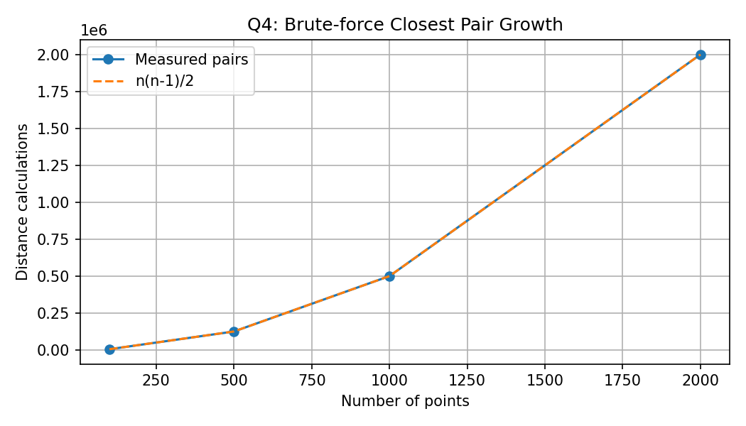
Figure 2. Theoretical and observed pair counts grow quadratically.

Acceptability and redesign direction
For this report, a one-second response target is adopted as an illustrative engineering criterion; the measured time at which this target is crossed depends on the runtime environment. The main inefficiency is examining every pair, resulting in Θ(n²) distance calculations. A redesigned strategy should use spatial ordering or geometric bounds to avoid considering pairs that cannot beat the current minimum distance.
The brute-force solution is valuable as a simple correctness baseline for small point sets. It becomes less attractive as n grows because doubling n roughly quadruples the number of pair checks.

Q5 – Derive a Convex Hull Algorithm from a Geometric Principle (7 marks)
The convex hull is the smallest convex polygon containing all input points. A candidate line through A and B can be a hull boundary edge only if all remaining points lie on one side of that line or are collinear.

Geometric decision rule
For A=(ax, ay), B=(bx, by), and C=(cx, cy), compute cross=(bx−ax)(cy−ay)−(by−ay)(cx−ax). A positive value places C on one side, a negative value places it on the other, and zero means collinear. If points occur strictly on both sides, AB is not a hull edge. If collinear points lie between A and B, the segment is not an extreme boundary edge.

Pseudocode
BRUTE_FORCE_CONVEX_HULL(P):
edges = empty set
FOR each unordered pair A, B:
left = false; right = false; collinear = []
FOR each C other than A and B:
value = cross_product(A, B, C)
IF value > 0: left = true
ELSE IF value < 0: right = true
ELSE: add C to collinear
IF left and right: reject AB
ELSE IF a collinear point lies strictly between A and B: reject AB
ELSE: accept AB as a boundary edge
Collect endpoints of accepted edges.
Sort hull vertices by angle around their centroid.
RETURN hull vertices and operation counts

Test configurations and results
Test | Input points | Hull vertices (angular order) | Candidate pairs | Orientation checks
Square with interior points | 7 | [(0, 0), (4, 0), (4, 4), (0, 4)] | 21 | 105
Irregular configuration | 8 | [(-2, 0), (0, -3), (4, -1), (5, 3), (1, 5), (-3, 4)] | 28 | 168

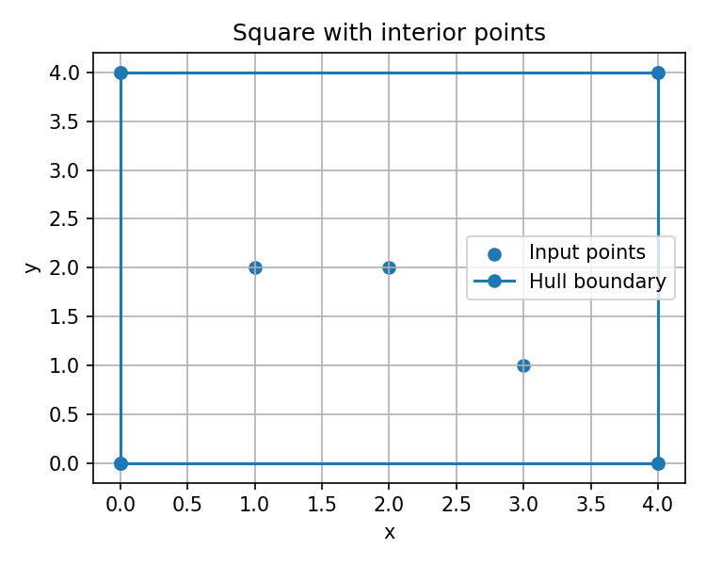
Figure 3. Square boundary with interior points.
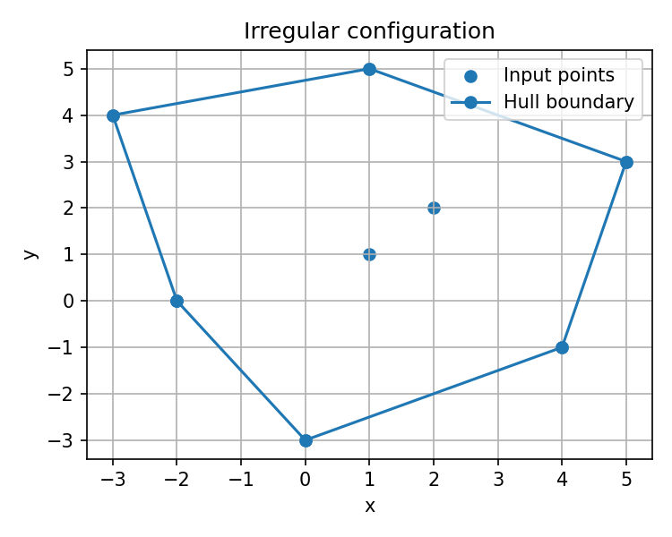
Figure 4. Irregular point configuration and its hull.

Complexity and correctness reasoning
There are n(n−1)/2 candidate pairs, and each pair is checked against O(n) other points. Thus the orientation-test phase requires O(n³) time. The accepted-edge set can use O(n²) space in the worst case. Ordering h hull vertices adds O(h log h) time.
The one-side property is necessary because a supporting line of a convex set cannot have input points strictly on both sides. The collinearity check ensures that intermediate points on a straight boundary do not become separate extreme endpoints. Degenerate cases (for example, all points collinear or duplicate coordinates) need explicit handling in a production implementation.

Q6 – Exhaustive Search and Combinatorial Growth (8 marks)
Each package has an ID, weight, and humanitarian value. The objective is to choose a subset whose total weight does not exceed capacity while maximizing total value.

Pseudocode
EXHAUSTIVE_PACKAGE_SELECTION(packages, capacity):
best_value = 0; best_subset = empty; best_weight = 0
FOR each bitmask from 0 to 2^n - 1:
weight = 0; value = 0; selected = []
FOR i = 0 to n-1:
IF bit i is set:
add package i's weight and value
append package ID to selected
IF weight <= capacity AND value > best_value:
save selected, weight, and value
RETURN best subset, weight, value, 2^n

Correctness check with a small instance
Package | Weight | Value
P1 | 2 | 12
P2 | 1 | 10
P3 | 3 | 20
P4 | 2 | 15

Capacity = 5. The selected combination P1 + P2 + P4 has weight 5 and value 37. This is better than P1 + P3 (weight 5, value 32), P2 + P3 (weight 4, value 30), and the other feasible combinations. The program enumerates all 2⁴ = 16 subsets, so the small case can be independently verified.
Experimental optimum: subset ['P1', 'P2', 'P4'], total weight 5, total value 37, subsets examined 16.

Growth investigation
Packages | Theoretical subsets | Subsets examined | Execution time (s)
10.000 | 1024.000 | 1024.000 | 0.000954
15.000 | 32768.000 | 32768.000 | 0.046725
20.000 | 1048576.000 | 1048576.000 | 1.912

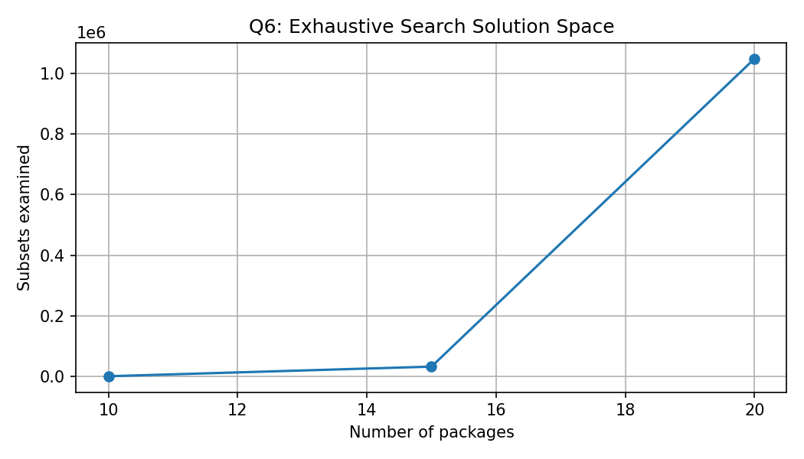
Figure 5. The exhaustive search space doubles for each added package.
Each package can be either included or excluded, so the number of subsets is 2ⁿ. Evaluating each subset requires up to O(n) work, giving O(n2ⁿ) time. The search space doubles when one package is added, causing rapid growth.
Deployment boundary: this report uses a one-second response target as a stated design criterion. The largest acceptable n must be determined from the measured run times in the target environment; the 20-package run already examines 1,048,576 subsets. Larger cases should be benchmarked only if the response-time budget allows.

Q7 – Day-4 Design Challenge: Diagnose, Redesign and Validate (13 marks)

Selected solution and diagnosis (A – 2 marks)
Selected solution: Q4 brute-force closest-pair algorithm. Its dominant cost is the distance calculation inside the nested loops. It examines n(n−1)/2 pairs, so the number of calculations grows quadratically. Most of this work is unavoidable for the original design because it does not exploit any spatial ordering or lower bound.

Design objective (B – 2 marks)
Reduce the number of distance calculations without changing the minimum distance returned. The measurable objective is to lower the distance-calculation count on the same datasets while preserving correctness.

Revised strategy (C – 4 marks)
Sort points by x-coordinate. For a fixed point i, inspect later points in increasing x-coordinate. Once x[j]−x[i] is greater than or equal to the current best distance, stop the inner loop: Euclidean distance cannot be less than the horizontal gap. This is a safe pruning rule. Preprocessing adds O(n log n) sorting time and O(n) space for the sorted list. The worst-case total remains O(n²), but favourable data can require fewer distance calculations.
REDESIGNED_CLOSEST_PAIR(P):
sort P by x-coordinate
best = infinity; pair = NONE; calculations = 0
FOR i = 0 to n-2:
FOR j = i+1 to n-1:
IF P[j].x - P[i].x >= best: BREAK
calculate Euclidean distance; calculations += 1
IF distance < best:
best = distance; pair = (P[i], P[j])
RETURN pair, best, calculations

Prediction before implementation (D – 1 mark)
Prediction: sorting and pruning should reduce distance calculations when the horizontal gap becomes large relative to the best distance already found. The improvement should be most visible in data where points are spread across the x-axis. Sorting overhead may offset the saved work for small inputs. Worst-case complexity is still quadratic.

Implementation and validation (E – 2 marks)
Both algorithms were run on the same seeded point sets. Correctness was checked by comparing the minimum distances with a numerical tolerance. The following table shows the reproducible measurements generated for this report.
Points | Original distance calcs | Redesigned distance calcs | Reduction (%) | Original time (s) | Redesigned time (s) | Minimum distance
100.000 | 4950.000 | 188.000 | 96.200 | 0.000918 | 0.000062 | 81.125
500.000 | 124750.000 | 920.000 | 99.260 | 0.015942 | 0.000289 | 30.861
1000.000 | 499500.000 | 1940.000 | 99.610 | 0.058155 | 0.000738 | 13.593
2000.000 | 1999000.000 | 3892.000 | 99.810 | 0.250465 | 0.001544 | 4.305

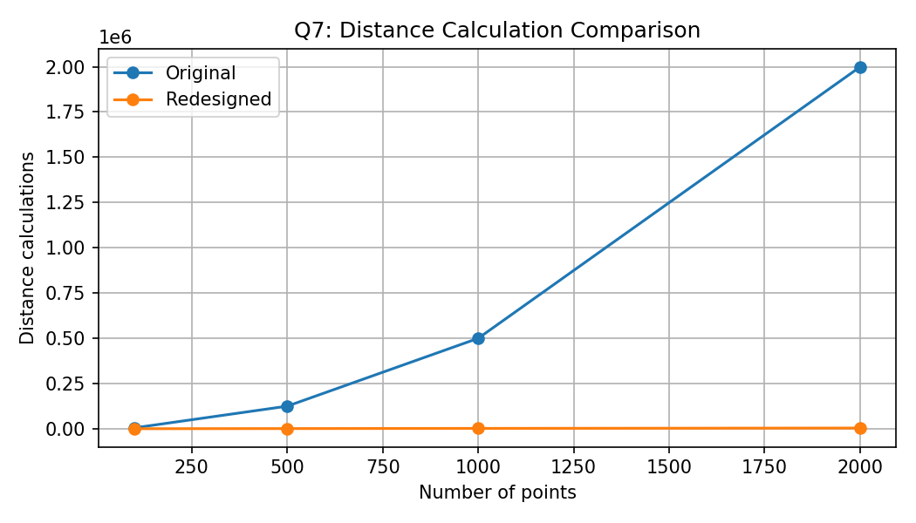
Figure 6. Distance-calculation counts for original and redesigned methods.

Defend the final design (F – 2 marks)
The redesign is successful when it returns the same minimum distance and reduces distance calculations. The percentage reduction is calculated as (original calculations − redesigned calculations) / original calculations × 100%. Runtime must be considered separately because sorting introduces overhead. The approach remains worst-case O(n²), so it is a pruning improvement rather than a guaranteed asymptotic improvement. The original algorithm remains preferable as a simple baseline for tiny inputs or correctness verification.

Trade-offs
Aspect | Original brute force | Redesigned sort-and-prune
Preprocessing | None | Sort by x-coordinate
Distance calculations | Exactly n(n−1)/2 | Data-dependent; at most original pair count
Worst-case time | Θ(n²) | O(n²), plus sorting
Extra memory | O(1) excluding input | O(n) for sorted copy
Correctness check | Reference baseline | Validated against baseline
Best use | Small inputs and reference testing | Cases where pruning removes many candidates

Overall conclusions and recommendations
- Q1: Insertion Sort is recommended for mostly sorted orders because its work is sensitive to existing order; Bubble Sort with early stopping is also adaptive.
- Q2: Sequential Search is suitable for small or infrequently searched changing lists. For large-scale frequent tool lookups, an indexed/hash-based approach is preferable.
- Q3: Brute-force string matching is sensitive to text and pattern structure, not only input length; repeated prefixes can cause many comparisons.
- Q4: Closest-pair brute force examines n(n−1)/2 pairs and scales quadratically.
- Q5: The brute-force convex-hull design uses a geometric cross-product test and performs O(n³) orientation checks in the general case.
- Q6: Exhaustive package selection examines 2ⁿ subsets and becomes impractical quickly as packages increase.
- Q7: Sorting and pruning can reduce distance calculations while preserving the answer, but the proposed redesign remains O(n²) in the worst case.
Across all questions, operation counts and mathematical derivations provide stronger algorithmic evidence than execution time alone. Runtime results are environment-dependent and should be reported alongside, not instead of, the counts.

Appendix A – Evidence and output snapshots
The report includes generated graphs and experimental result tables. Text output summaries below are reproducible run summaries from the algorithms used to create the tables. For submission, the student should also place screenshots captured from their own Google Colab notebooks in each Output_Screenshots folder. Replace or supplement the generated evidence with the actual Colab screenshots if required by the instructor.

Q1 output summary
Q1: SORTING ALGORITHM EXPERIMENT

Dataset: Nearly sorted | Input: [1, 2, 4, 3, 5, 6]
Selection Sort: sorted=[1, 2, 3, 4, 5, 6]; comparisons=15; swaps=1
Bubble Sort: sorted=[1, 2, 3, 4, 5, 6]; comparisons=9; swaps=1
Insertion Sort: sorted=[1, 2, 3, 4, 5, 6]; comparisons=6; movements=6

Dataset: Reverse sorted | Input: [6, 5, 4, 3, 2, 1]
Selection Sort: sorted=[1, 2, 3, 4, 5, 6]; comparisons=15; swaps=3
Bubble Sort: sorted=[1, 2, 3, 4, 5, 6]; comparisons=15; swaps=15
Insertion Sort: sorted=[1, 2, 3, 4, 5, 6]; comparisons=15; movements=20

Dataset: Already sorted | Input: [1, 2, 3, 4, 5, 6]
Selection Sort: sorted=[1, 2, 3, 4, 5, 6]; comparisons=15; swaps=0
Bubble Sort: sorted=[1, 2, 3, 4, 5, 6]; comparisons=5; swaps=0
Insertion Sort: sorted=[1, 2, 3, 4, 5, 6]; comparisons=5; movements=5

Q2 output summary
Q2: SEQUENTIAL SEARCH EXPERIMENT
size=10, case=first, target=T-100, comparisons=1, found=True
size=10, case=middle, target=T-104, comparisons=5, found=True
size=10, case=last, target=T-109, comparisons=10, found=True
size=10, case=absent, target=T-999, comparisons=10, found=False
size=100, case=last, target=T-199, comparisons=100, found=True
size=1000, case=last, target=T-1099, comparisons=1000, found=True

Q3 output summary
Q3: BRUTE-FORCE STRING MATCHING
Quick match: text=HELLO WORLD, pattern=WORLD, matches=[6], comparisons=11
Repeated-character worst-ish case: text=AAAAAAAAAA, pattern=AAAAB, matches=[], comparisons=30
Absent pattern: text=COMPUTERSCIENCE, pattern=XYZ, matches=[], comparisons=13

Q4 output summary
Q4: CLOSEST PAIR
Small triangle: pair=((0, 0), (1, 1)), distance=1.414214, pairs=3, calculations=3
Square corners: pair=((0, 0), (0, 4)), distance=4.000000, pairs=6, calculations=6
Close points: pair=((1, 1), (1.5, 1.5)), distance=0.707107, pairs=6, calculations=6

Q5 output summary
Q5: BRUTE-FORCE CONVEX HULL
Square with interior points: points=7, hull=[(0, 0), (4, 0), (4, 4), (0, 4)], candidate_pairs=21, orientation_checks=105
Irregular configuration: points=8, hull=[(-2, 0), (0, -3), (4, -1), (5, 3), (1, 5), (-3, 4)], candidate_pairs=28, orientation_checks=168

Q6 output summary
Q6 small example: best=['P1', 'P2', 'P4'], weight=5, value=37, subsets=16
n=10, subsets=1024, time=0.000954s
n=15, subsets=32768, time=0.046725s
n=20, subsets=1048576, time=1.911784s

Q7 output summary
Q7: ORIGINAL vs REDESIGNED CLOSEST PAIR
n=100: original=4950, redesigned=188, reduction=96.2%, old_time=0.000918s, new_time=0.000062s, same_minimum_distance=81.125363
n=500: original=124750, redesigned=920, reduction=99.26%, old_time=0.015942s, new_time=0.000289s, same_minimum_distance=30.861057
n=1000: original=499500, redesigned=1940, reduction=99.61%, old_time=0.058155s, new_time=0.000738s, same_minimum_distance=13.593152
n=2000: original=1999000, redesigned=3892, reduction=99.81%, old_time=0.250465s, new_time=0.001544s, same_minimum_distance=4.305091

