Lab Assignment_08(Monday)
Name:G.Hasini
Hallticket:2303A51099 Batch-02

Task Description #1 (Username Validator – Apply AI in
Authentication Context)
- Task: Use AI to generate at least 3 assert test cases for a function is_valid_username(username) and then implement the function using Test-Driven Development principles.
- Requirements:
  - Username length must be between 5 and 15 characters.
  - Must contain only alphabets and digits.
  - Must not start with a digit.
  - No spaces allowed.
Example Assert Test Cases:
assert is_valid_username("User123") == True assert is_valid_username("12User") == False assert is_valid_username("Us er") == False
Expected Output #1:
- Username validation logic successfully passing all AI- generated test cases.

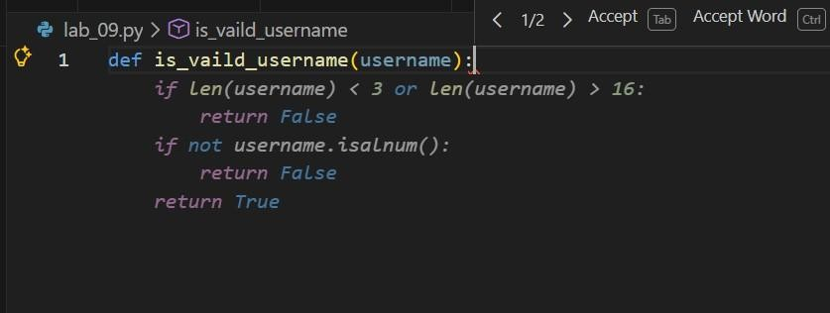

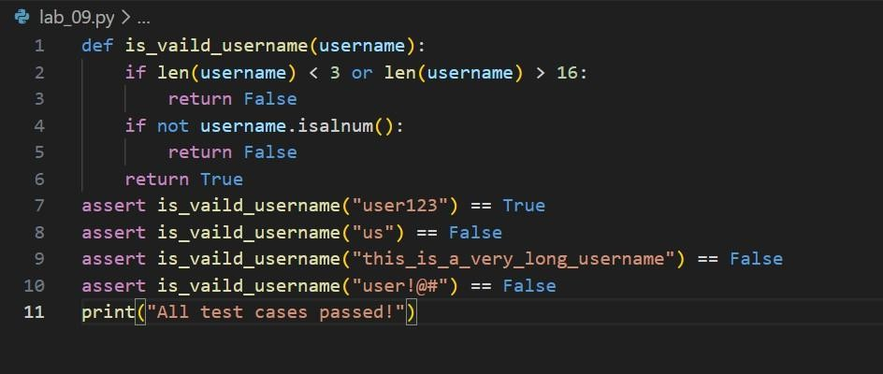

Code:
def is_vaild_username(username):
if len(username) < 3 or len(username) > 16: return False
if not username.isalnum(): return False
return True
assert is_vaild_username("user123") == True assert is_vaild_username("us") == False
assert is_vaild_username("this_is_a_very_long_username") == False assert is_vaild_username("user!@#") == False
print("All test cases passed!")

Output:

Task Description #2 (Even–Odd & Type Classification – Apply
AI for Robust Input Handling)
  - Task: Use AI to generate at least 3 assert test cases for a function classify_value(x) and implement it using conditional logic and loops.
  - Requirements:
    - If input is an integer, classify as "Even" or "Odd".
    - If input is 0, return "Zero".
    - If input is non-numeric, return "Invalid Input".
Example Assert Test Cases:

assert classify_value(8) == "Even" assert classify_value(7) == "Odd"
assert classify_value("abc") == "Invalid Input" Expected Output #2:
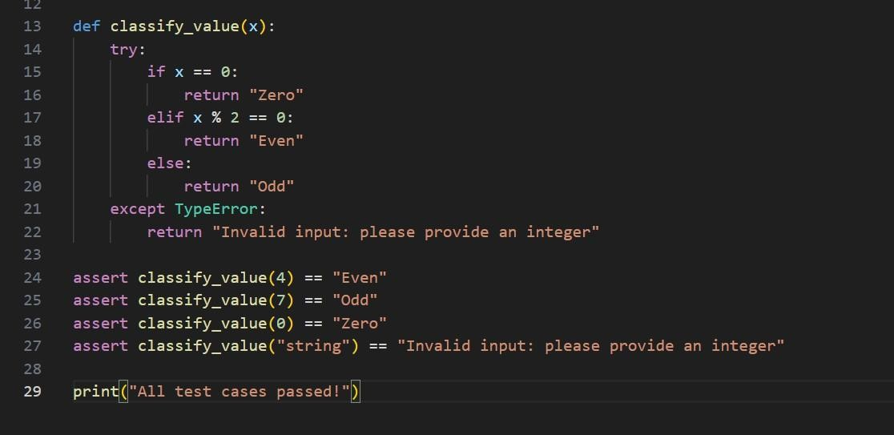
  - Function correctly classifying values and passing all test cases.
Code:
def classify_value(x): try:
if x == 0:
return "Zero" elif x % 2 == 0:
return "Even" else:
return "Odd" except TypeError:
return "Invalid input: please provide an integer"

assert classify_value(4) == "Even" assert classify_value(7) == "Odd" assert classify_value(0) == "Zero"
assert classify_value("string") == "Invalid input: please provide an integer"

print("All test cases passed!")

output:

Task Description #3 (Palindrome Checker – Apply AI for
String Normalization)
  - Task: Use AI to generate at least 3 assert test cases for a function is_palindrome(text) and implement the function.
  - Requirements:
- Ignore case, spaces, and punctuation.
- Handle edge cases such as empty strings and single characters.
Example Assert Test Cases:
assert is_palindrome("Madam") == True
assert is_palindrome("A man a plan a canal Panama") == True assert is_palindrome("Python") == False
Expected Output #3:
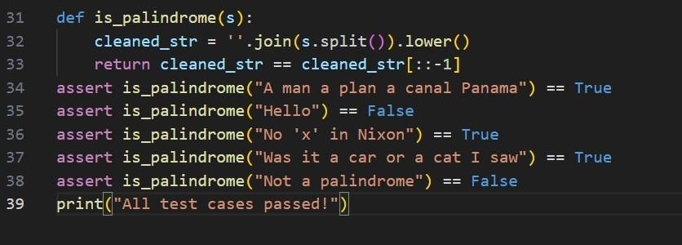
  - Function correctly identifying palindromes and passing all AI-generated tests.
Code:
def is_palindrome(s):
cleaned_str = ''.join(s.split()).lower() return cleaned_str == cleaned_str[::-1]
assert is_palindrome("A man a plan a canal Panama") == True assert is_palindrome("Hello") == False
assert is_palindrome("No 'x' in Nixon") == True

assert is_palindrome("Was it a car or a cat I saw") == True assert is_palindrome("Not a palindrome") == False print("All test cases passed!")

output:

Task Description #4 (Email ID Validation – Apply AI for Data
Validation)
  - Task: Use AI to generate at least 3 assert test cases for a function validate_email(email) and implement the function.
  - Requirements:
    - Must contain @ and .
    - Must not start or end with special characters.
    - Should handle invalid formats gracefully.
Example Assert Test Cases:
assert validate_email("user@example.com") == True assert validate_email("userexample.com") == False assert validate_email("@gmail.com") == False
Expected Output #5:
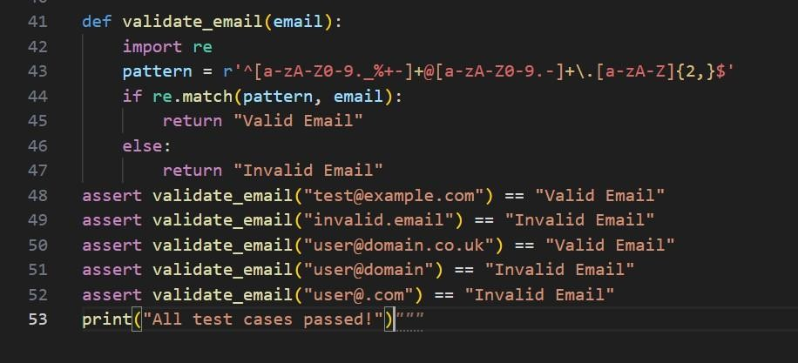
  - Email validation function passing all AI-generated test cases and handling edge cases correctly.

Code:
def validate_email(email): import re
pattern = r'^[a-zA-Z0-9._%+-]+@[a-zA-Z0-9.-]+\.[a-zA-Z]{2,}$' if re.match(pattern, email):
return "Valid Email" else:
return "Invalid Email"
assert validate_email("test@example.com") == "Valid Email" assert validate_email("invalid.email") == "Invalid Email" assert validate_email("user@domain.co.uk") == "Valid Email" assert validate_email("user@domain") == "Invalid Email" assert validate_email("user@.com") == "Invalid Email" print("All test cases passed!")

output:

Task 5 (Perfect Number Checker – Test Case Design)
  - Function: Check if a number is a perfect number (sum of divisors = number).
- Test Cases to Design:
- Normal case: 6 → True, 10 → False.
- Edge case: 1.
- Negative number case.
- Larger case: 28.
- Requirement: Validate correctness with assertions.

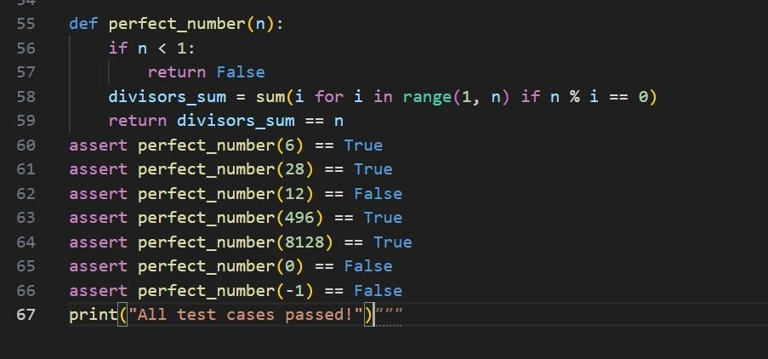
Code:
def perfect_number(n): if n < 1:
return False
divisors_sum = sum(i for i in range(1, n) if n % i == 0) return divisors_sum == n
assert perfect_number(6) == True assert perfect_number(28) == True assert perfect_number(12) == False assert perfect_number(496) == True assert perfect_number(8128) == True assert perfect_number(0) == False assert perfect_number(-1) == False print("All test cases passed!")

output:

Task 6 (Abundant Number Checker – Test Case Design)
- Function: Check if a number is abundant (sum of divisors > number).
- Test Cases to Design:
- Normal case: 12 → True, 15 → False.
- Edge case: 1.
- Negative number case.
- Large case: 945.

Requirement: Validate correctness with unittest
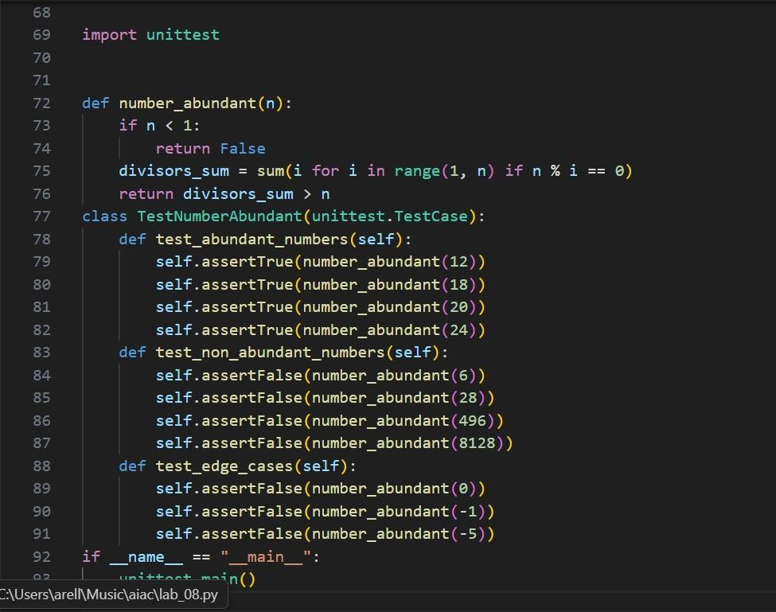
Code:
import unittest

def number_abundant(n): if n < 1:
return False
divisors_sum = sum(i for i in range(1, n) if n % i == 0) return divisors_sum > n
class TestNumberAbundant(unittest.TestCase): def test_abundant_numbers(self):
self.assertTrue(number_abundant(12)) self.assertTrue(number_abundant(18)) self.assertTrue(number_abundant(20)) self.assertTrue(number_abundant(24))
def test_non_abundant_numbers(self): self.assertFalse(number_abundant(6)) self.assertFalse(number_abundant(28)) self.assertFalse(number_abundant(496)) self.assertFalse(number_abundant(8128))
def test_edge_cases(self): self.assertFalse(number_abundant(0))

self.assertFalse(number_abundant(-1)) self.assertFalse(number_abundant(-5))
if name == " main ": unittest.main()

Output:
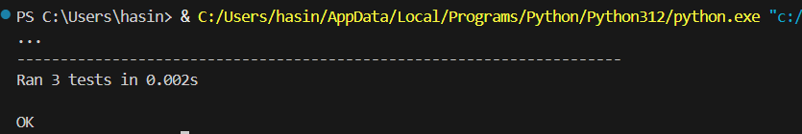
Task 7 (Deficient Number Checker – Test Case Design)
  - Function: Check if a number is deficient (sum of divisors < number).
  - Test Cases to Design:
    - Normal case: 8 → True, 12 → False.
    - Edge case: 1.
    - Negative number case.
    - Large case: 546.
Requirement: Validate correctness with pytest.
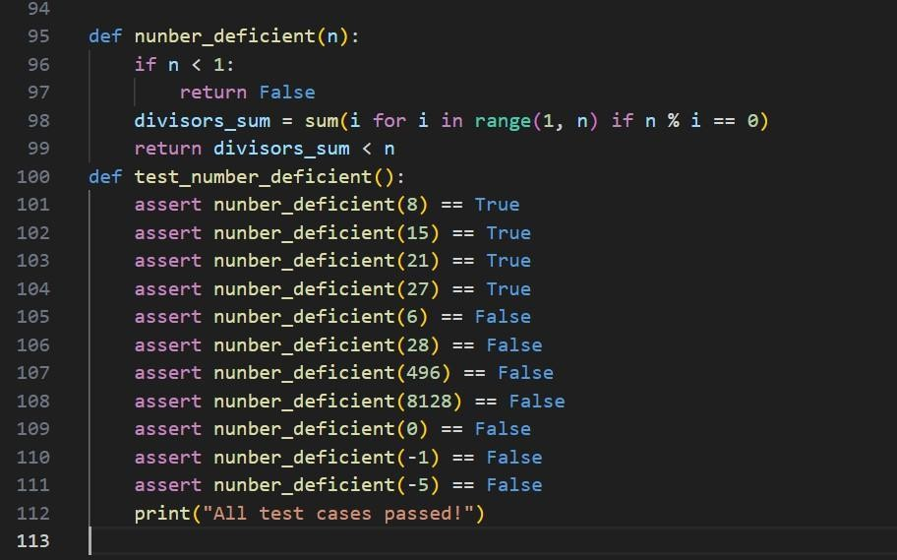

Code:
def nunber_deficient(n): if n < 1:
return False
divisors_sum = sum(i for i in range(1, n) if n % i == 0) return divisors_sum < n
def test_number_deficient():
assert nunber_deficient(8) == True assert nunber_deficient(15) == True assert nunber_deficient(21) == True assert nunber_deficient(27) == True assert nunber_deficient(6) == False assert nunber_deficient(28) == False assert nunber_deficient(496) == False assert nunber_deficient(8128) == False assert nunber_deficient(0) == False assert nunber_deficient(-1) == False assert nunber_deficient(-5) == False print("All test cases passed!")

Output:
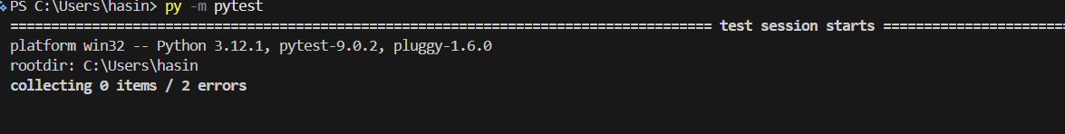

Task 8 :
Write a function LeapYearChecker and validate its implementation using 10 pytest test cases

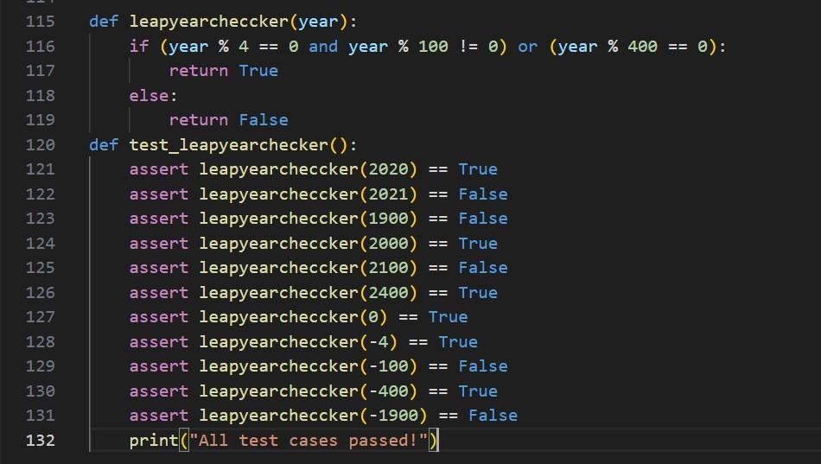

Code:
def leapyearcheccker(year):
if (year % 4 == 0 and year % 100 != 0) or (year % 400 == 0): return True
else:
return False
def test_leapyearchecker():
assert leapyearcheccker(2020) == True assert leapyearcheccker(2021) == False assert leapyearcheccker(1900) == False assert leapyearcheccker(2000) == True assert leapyearcheccker(2100) == False assert leapyearcheccker(2400) == True assert leapyearcheccker(0) == True assert leapyearcheccker(-4) == True assert leapyearcheccker(-100) == False assert leapyearcheccker(-400) == True assert leapyearcheccker(-1900) == False print("All test cases passed!")
output:


Task 9 :

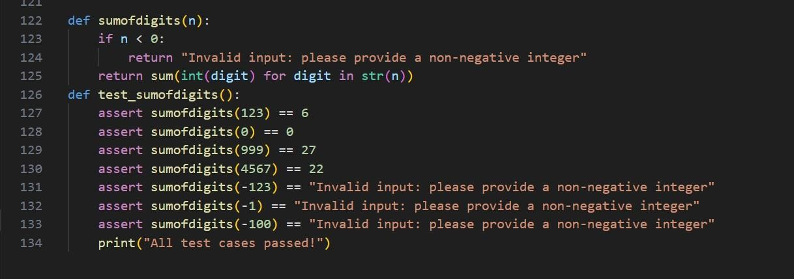
Write a function SumOfDigits and validate its implementation using 7 pytest test cases.

Code:
def sumofdigits(n): if n < 0:
return "Invalid input: please provide a non-negative integer" return sum(int(digit) for digit in str(n))
def test_sumofdigits():
assert sumofdigits(123) == 6 assert sumofdigits(0) == 0 assert sumofdigits(999) == 27 assert sumofdigits(4567) == 22
assert sumofdigits(-123) == "Invalid input: please provide a non-negative integer"
assert sumofdigits(-1) == "Invalid input: please provide a non-negative integer"
assert sumofdigits(-100) == "Invalid input: please provide a non-negative integer"
print("All test cases passed!")

Output:


Task 10 :
Write a function SortNumbers (implement bubble sort) and validate its implementation using 25 pytest test cases.

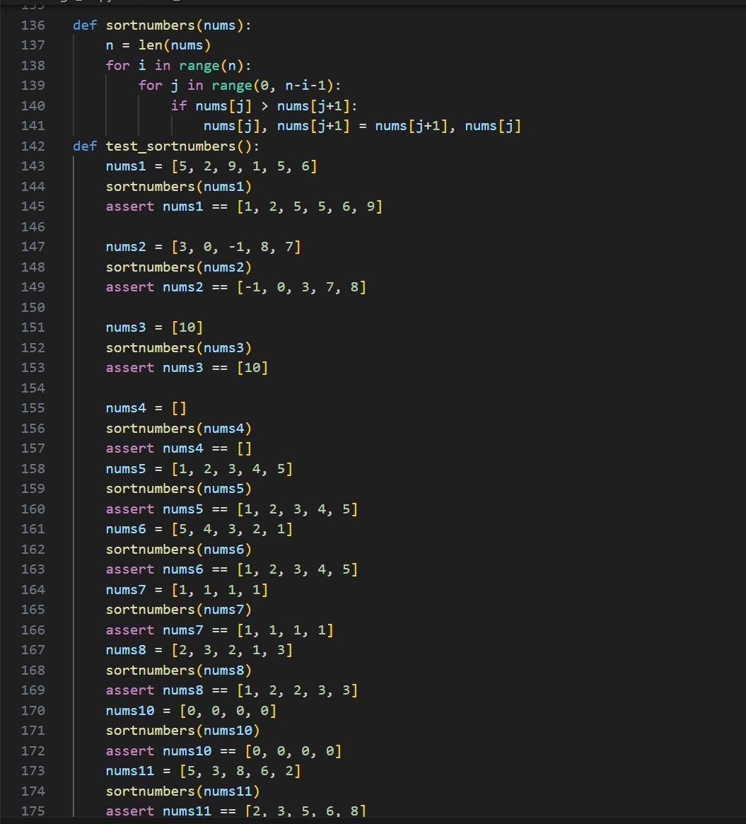

Code:

def sortnumbers(nums): n = len(nums)
for i in range(n):
for j in range(0, n-i-1): if nums[j] > nums[j+1]:
nums[j], nums[j+1] = nums[j+1], nums[j] def test_sortnumbers():
nums1 = [5, 2, 9, 1, 5, 6]
sortnumbers(nums1)
assert nums1 == [1, 2, 5, 5, 6, 9]

nums2 = [3, 0, -1, 8, 7]

sortnumbers(nums2)
assert nums2 == [-1, 0, 3, 7, 8]

nums3 = [10]
sortnumbers(nums3) assert nums3 == [10]
nums4 = []
sortnumbers(nums4)
assert nums4 == []
nums5 = [1, 2, 3, 4, 5]
sortnumbers(nums5)
assert nums5 == [1, 2, 3, | 4, | 5]
nums6 = [5, 4, 3, 2, 1]
sortnumbers(nums6)
assert nums6 == [1, 2, 3, | 4, | 5]
nums7 = [1, 1, 1, 1]
sortnumbers(nums7)
assert nums7 == [1, 1, 1, | 1]
nums8 = [2, 3, 2, 1, 3]
sortnumbers(nums8)
assert nums8 == [1, 2, 2, | 3, | 3]
nums10 = [0, 0, 0, 0]
sortnumbers(nums10)
assert nums10 == [0, 0, 0, 0]
nums11 = [5, 3, 8, 6, 2]
sortnumbers(nums11)
assert nums11 == [2, 3, 5, 6, 8]
nums12 = [9, 7, 5, 3, 1]
sortnumbers(nums12)
assert nums12 == [1, 3, 5, 7, 9]

print("All test cases passed!")
Output:

Task 11 :
Write a function ReverseString and validate its implementation using 5 unittest test cases

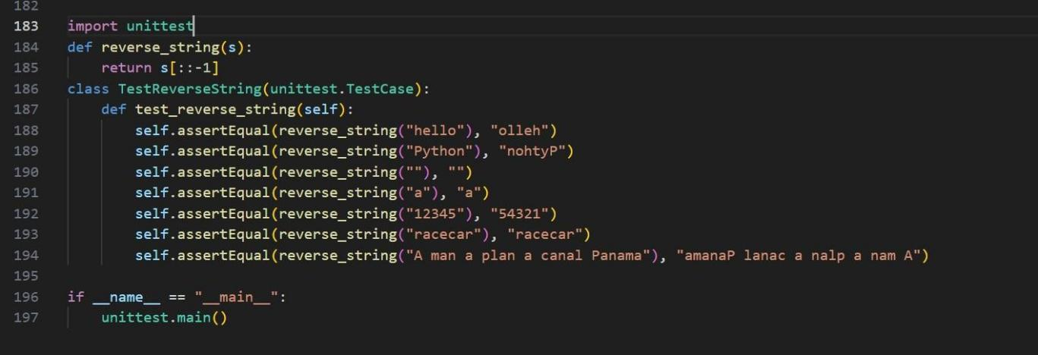

code:
import unittest

def reverse_string(s): return s[::-1]
class TestReverseString(unittest.TestCase): def test_reverse_string(self):
self.assertEqual(reverse_string("hello"), "olleh") self.assertEqual(reverse_string("Python"), "nohtyP") self.assertEqual(reverse_string(""), "") self.assertEqual(reverse_string("a"), "a") self.assertEqual(reverse_string("12345"), "54321") self.assertEqual(reverse_string("racecar"), "racecar") self.assertEqual(reverse_string("A man a plan a canal Panama"),
"amanaP lanac a nalp a nam A")

if name == " main ": unittest.main()

output:

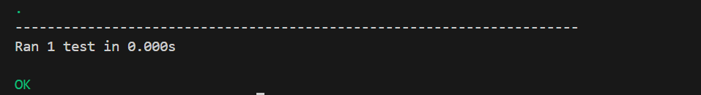

Task 12 :
Write a function AnagramChecker and validate its implementation using 10 unittest test cases.

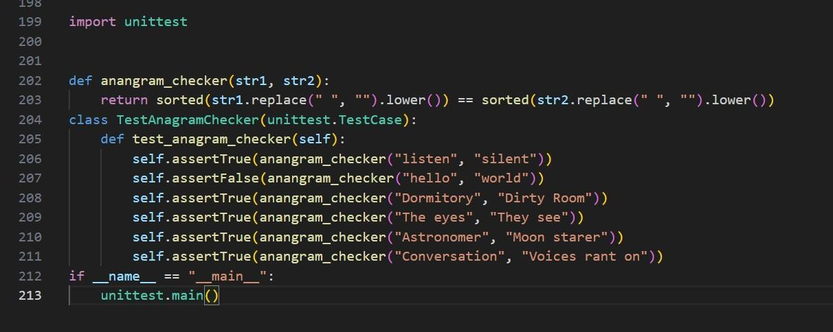

Code:
import unittest

def anangram_checker(str1, str2):
return sorted(str1.replace(" ", "").lower()) == sorted(str2.replace(" ", "").lower())
class TestAnagramChecker(unittest.TestCase): def test_anagram_checker(self):
self.assertTrue(anangram_checker("listen", "silent")) self.assertFalse(anangram_checker("hello", "world")) self.assertTrue(anangram_checker("Dormitory", "Dirty Room")) self.assertTrue(anangram_checker("The eyes", "They see")) self.assertTrue(anangram_checker("Astronomer", "Moon starer")) self.assertTrue(anangram_checker("Conversation", "Voices rant on"))
if name == " main ": unittest.main()

output:
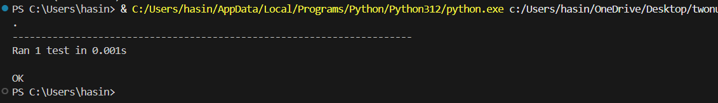

Task 13 :
Write a function ArmstrongChecker and validate its implementation using 8 unittest test cases.

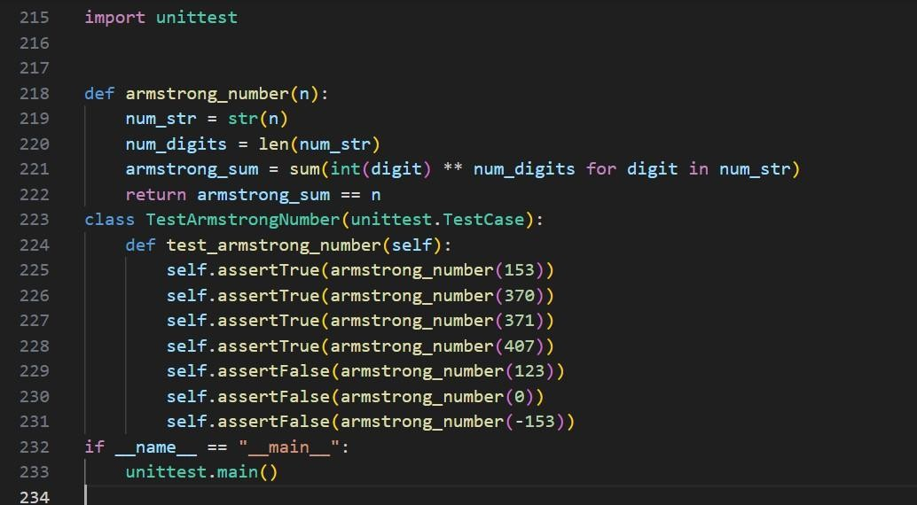

Code:
import unittest

def armstrong_number(n): num_str = str(n) num_digits = len(num_str)
armstrong_sum = sum(int(digit) ** num_digits for digit in num_str) return armstrong_sum == n
class TestArmstrongNumber(unittest.TestCase): def test_armstrong_number(self):
self.assertTrue(armstrong_number(153)) self.assertTrue(armstrong_number(370)) self.assertTrue(armstrong_number(371)) self.assertTrue(armstrong_number(407)) self.assertFalse(armstrong_number(123)) self.assertFalse(armstrong_number(0)) self.assertFalse(armstrong_number(-153))
if name == " main ": unittest.main()

Output:

