
DEPARTMENT OF CSE
PROJECT ABSTRACT SUBMISSION
COURSE: APPLIED MACHINE LEARNING FOR TEXT ANALYSIS PROJECT – 1(24ALT3101) A.Y. 2026 - 2027
TITLE OF THE PROJECT | Retrieval-Augmented Generation (RAG) Chatbot for University Academic Assistance
S. No. | University ID | Name
1 | 2420030657 | K.Akshitha Reddy
2 | 2420030703 | G.Hemalatha
3 | 2420030735 | G.V.S Hasini
4
Name of the Guide |  | Srilakshmi Potluri

Abstract
The Retrieval-Augmented Generation (RAG) Chatbot for University Academic Assistance is an AI-powered system designed to provide students, faculty, and university staff with fast, accurate, and reliable access to academic information. In many universities, students often spend significant time searching through websites, notices, PDFs, or contacting administrative offices to find details about course syllabi, examination schedules, attendance policies, fee structures, library services, placement opportunities, and academic regulations. Traditional chatbots are generally rule-based and limited to predefined responses, making them incapable of handling complex or newly updated queries. This creates delays, increases the workload on university staff, and may result in inconsistent or outdated information being shared.
The proposed system overcomes these limitations by using the Retrieval-Augmented Generation (RAG) framework, which combines intelligent document retrieval with the language generation capabilities of a Large Language Model (LLM). When a user submits a question, the chatbot first searches a repository of official university documents to retrieve the most relevant information. It then uses the retrieved content to generate a clear, natural, and context-aware response. This approach ensures that the answers are based on authentic and up-to-date university resources, significantly reducing the chances of incorrect or fabricated information while improving the overall reliability of the system.
The RAG chatbot supports natural language interactions, allowing users to ask questions in a conversational manner without requiring specific commands or keywords. The system provides instant responses, is available 24/7, and can be easily updated by adding new university documents to its knowledge base. As a result, it enhances the accessibility of academic information, saves time for students, reduces the burden on faculty and administrative staff, and improves the overall efficiency of university support services. Furthermore, the chatbot can be extended with features such as multilingual support, voice-based interaction, and personalized recommendations, making it a scalable and intelligent solution for modern educational institutions.

Approach:
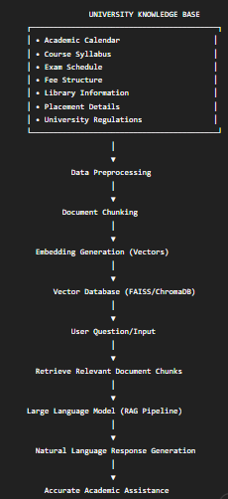

Signature of the Guide HOD

