Handwritten Digit Recognition Using K-Nearest Neighbors and Support Vector Machine on the MNIST Dataset

Greeshma Sai
Dept. of Computer Science & Engineering
Koneru Lakshmaiah Education Foundation, Hyderabad
Roll No. 2420030550
Keerthi Reddy
Dept. of Computer Science & Engineering
Koneru Lakshmaiah Education
Foundation, Hyderabad
Roll No. 2420030774
Dr. N. Sunanda
Associate Professor, Dept. of CSE
Koneru Lakshmaiah Education
Foundation, Hyderabad
(Project Guide)
Hasini Peddi
Dept. of Computer Science & Engineering
Koneru Lakshmaiah Education
Foundation, Hyderabad
Roll No. 2420030784

Abstract—Handwritten digits vary widely in shape, size, slant, and stroke thickness, which makes automatic recognition a challenging pattern-recognition problem, while manual transcription of large digit collections is slow and error-prone. This paper presents a complete, reproducible study of handwritten digit recognition with two classical supervised classifiers, K-Nearest Neighbors (KNN) and Support Vector Machine (SVM), on the MNIST benchmark. The pipeline covers exploratory analysis, pixel normalization, stratified splitting, cross-validated hyper-parameter selection, and evaluation with accuracy, precision, recall, F1-score, confusion matrices, and a McNemar significance test. In a first experiment on a class-balanced subset of 5,000 real MNIST images (4,000 for training, 1,000 for testing), KNN (k = 1) reached 93.0% test accuracy and an RBF-kernel SVM reached 95.7%, a difference that is statistically significant (p < 0.001). Errors concentrate on visually similar pairs such as 3/5, 4/9, and 7/9. The paper also reports the literature survey, problem gap, novelty, feasibility, and a 14-week project plan, and outlines extension to the full 70,000-image dataset and to real-world documents.
Keywords—Handwritten Digit Recognition, MNIST, K-Nearest Neighbors, Support Vector Machine, Image Classification, Machine Learning, Confusion Matrix

Introduction
Handwritten digit recognition is one of the oldest and most widely studied problems in pattern recognition and computer vision. A system that reads handwritten digits must map an image of a hand-drawn numeral to one of ten classes, 0 through 9. Although the number of classes is small, the problem is far from trivial: every writer forms the same digit differently, and even one writer never reproduces a digit identically. Strokes differ in thickness, slant, size, and completeness; loops may be open or closed; and some digit pairs, such as 3 and 5 or 4 and 9, are visually close enough to confuse even human readers when written quickly.
The practical importance of the task is considerable. Postal services read handwritten ZIP codes to route mail, banks read the amount fields on cheques and deposit slips, universities digitize hand-filled examination and attendance sheets, and government offices convert paper forms into databases. Manually keying in large volumes of such digits is time-consuming, tiring, and error-prone, which creates a clear need for an automatic recognition system that is accurate, fast, and inexpensive to deploy.
The Modified National Institute of Standards and Technology (MNIST) database [1], [17] has become the standard benchmark for this problem. It provides 70,000 centred, size-normalized grayscale images (Fig. 1) of handwritten digits and a fixed train/test split, which allows results from different studies to be compared on common ground. State-of-the-art deep convolutional networks now exceed 99.5% accuracy on MNIST [1], [9], but they typically require substantial computation and offer limited interpretability. Classical machine-learning classifiers remain attractive in teaching, prototyping, and resource-constrained settings because they are easy to implement, have few hyper-parameters, and their behaviour can be inspected and explained.
This work studies two such classifiers, K-Nearest Neighbors (KNN) [5] and Support Vector Machine (SVM) [6]. Both are trained and tested on identical data under identical conditions, and are examined through accuracy, precision, recall, F1-score, confusion matrices, per-class behaviour, computational cost, and sensitivity to training-set size and dimensionality reduction.
The main contributions of this paper are: (i) a literature survey and explicit problem-gap analysis for handwritten digit recognition; (ii) a reproducible end-to-end pipeline for KNN and SVM covering exploration, preprocessing, tuning, and evaluation; (iii) an empirical comparison on real MNIST images with a statistical significance test and a class-level error analysis; (iv) a discussion of novelty, feasibility, and limitations; and (v) a 14-week project plan for scaling the study to the full dataset and to real documents.

Literature Survey
Early work on digit recognition relied on hand-crafted features and statistical classifiers. The original MNIST study by LeCun et al. [1] compared linear classifiers, KNN, SVMs, multilayer perceptrons, and convolutional networks on the same split and established the reference error rates for later work; on the full dataset, Euclidean KNN is reported at an error of a few percent, while Gaussian-kernel SVMs reach roughly 1 to 1.5% error [17]. The nearest-neighbour rule [5] and support vector machines [6] remain the standard classical baselines, and SVM tuning practice follows [11], [12].
Convolutional neural networks (CNNs) learn their own features directly from pixels and have become the dominant approach. Zhang et al. [2] proposed ResNet18-ThunderSVM, in which a ResNet18 backbone extracts deep spatial features automatically and a high-performance SVM acts as the final classifier; the model was evaluated on MNIST, EMNIST, USPS, and Fashion-MNIST, and the authors report better generalization and robustness to noisy data than using manual feature engineering. Sethi and Pareek [4] studied optical handwritten digit recognition with several deep-learning models on MNIST and found that a VGG16 network reached 98.53% accuracy, although their evaluation relies mainly on classification accuracy on the benchmark.
Combining feature learning with SVM classification has a long history. Bellili et al. [8] used specialized local SVMs to resolve the two most likely classes proposed by a multilayer perceptron, improving recognition of confusable digit pairs on real mail ZIP-code digits. Niu and Suen [7] used a CNN as a trainable feature extractor and an SVM as the recognizer, and reported a recognition rate of 99.81% on MNIST without rejection. Fang and Yang [9] replaced the last layer of a modified LeNet by a linear SVM and obtained 99.31% test accuracy. A different line of work explores biologically inspired models: Guo and Wang [3] constrained the topology of a spiking neural network with number-related functional brain topology derived from task-fMRI data and obtained 97.27% accuracy on MNIST, which demonstrates the potential of brain-inspired computing even though the topology-to-network mapping remains fixed and the dataset is relatively simple.
- Summary of the Literature Survey
Ref. | Method | Key finding | Limitation / future work
[2] | ResNet18 features + ThunderSVM; MNIST, EMNIST, USPS, Fashion-MNIST | Automatic features reduce manual engineering; robust to noisy data | Model pruning, lightweight ResNets, harder datasets
[3] | fMRI-derived topology for spiking neural network; MNIST | 97.27% accuracy; brain-inspired computing is promising | Fixed topology mapping; simple dataset
[4] | Deep models (VGG16 etc.) on MNIST | VGG16 reached 98.53% accuracy | Benchmark-only; mainly accuracy-based
[7] | CNN feature extractor + SVM recognizer | 99.81% on MNIST without rejection | Heavier training than classical models
[8] | MLP with specialized local SVMs | Better handling of confusable digit pairs | Complex multi-stage architecture
[9] | Modified LeNet + linear SVM | 99.31% test accuracy on MNIST | No augmentation; benchmark-only

Taken together, these studies show that deep and hybrid models achieve very high accuracy on MNIST, but they rely on complex architectures, are evaluated almost exclusively on the standard benchmark, and rarely examine class-level errors or computational cost. They therefore leave room for a transparent study of well-understood classical models that explains where and why errors occur.

Problem Statement and Gap Identification
Handwritten digits differ in shape, size, orientation, and writing style, which makes automatic recognition challenging. These variations make it difficult for computers to recognize digits accurately, and manually identifying large numbers of handwritten digits is time-consuming and error-prone. The problem addressed here is to design, implement, and evaluate a system that automatically recognizes and classifies handwritten digits from 0 to 9, using the MNIST dataset to study digit patterns, and the KNN and SVM algorithms to perform the classification, with performance judged by accuracy, precision, recall, F1-score, and a confusion matrix.
Formally, given a grayscale image x of 28 × 28 pixels, flattened into a vector of d = 784 intensity values, the goal is to learn a function f that maps x to a label y ∈ {0, 1, …, 9} such that the error on previously unseen images from different writers is minimal.
- Identified Research Gaps
Existing work | Gap identified
VGG16, ResNet18, and Vision Transformers reach high accuracy | Evaluation focuses on MNIST and may not represent diverse real-world handwriting
Preprocessing and normalization improve recognition | May not fully handle variation in style, size, shape, and stroke thickness
Spiking and brain-inspired networks | Fixed architectures; need validation on complex datasets
Most studies report classification accuracy | Accuracy, efficiency, robustness, and generalization are rarely considered together
Studies address individual aspects | A practical, explainable system combining these aspects is still needed

The gap is therefore not a lack of accuracy on MNIST, but the absence of a transparent, reproducible comparison that links model performance to its cost, to the amount of training data, to preprocessing choices, and to the specific digit classes on which errors occur. This study is designed to supply exactly that evidence for two classical and widely taught classifiers.

Objectives
- To develop a system that can automatically recognize handwritten digits from 0 to 9.
- To use the MNIST dataset for training and testing the handwritten digit recognition models.
- To preprocess and normalize the image data so that it can be used effectively by the machine-learning models.
- To explore the dataset using basic data analysis and visualization to understand digit patterns and class distribution.
- To implement K-Nearest Neighbors (KNN) and Support Vector Machine (SVM) for digit classification.
- To compare the performance of KNN and SVM using suitable evaluation metrics.
- To identify and understand classification errors between different digit classes using a confusion matrix.

Dataset and Preprocessing

The MNIST Database
MNIST was constructed by LeCun, Cortes, and Burges [17] from the NIST Special Database 3 (digits written by Census Bureau employees) and Special Database 1 (digits written by high-school students). It contains 60,000 training images and 10,000 test images; the training and test writers are disjoint, so test accuracy measures generalization to unseen writers. Each digit was size-normalized to fit a 20 × 20 pixel box while preserving the aspect ratio, anti-aliased to produce gray levels, and centred by center of mass in a 28 × 28 image. Every pixel holds an integer intensity from 0 (background) to 255 (full stroke).
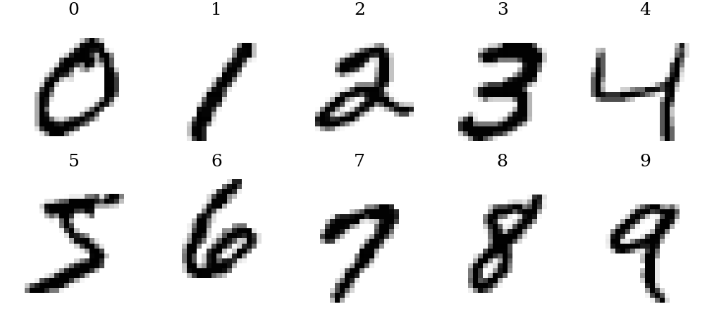
- One example of each digit class taken from the MNIST data used in this study.

Class Distribution
The ten classes are almost balanced in the full training set, ranging from 5,421 images for digit 5 to 6,742 images for digit 1 (Fig. 2). The subset used in the experiments of Section VIII is exactly balanced with 500 images per class.
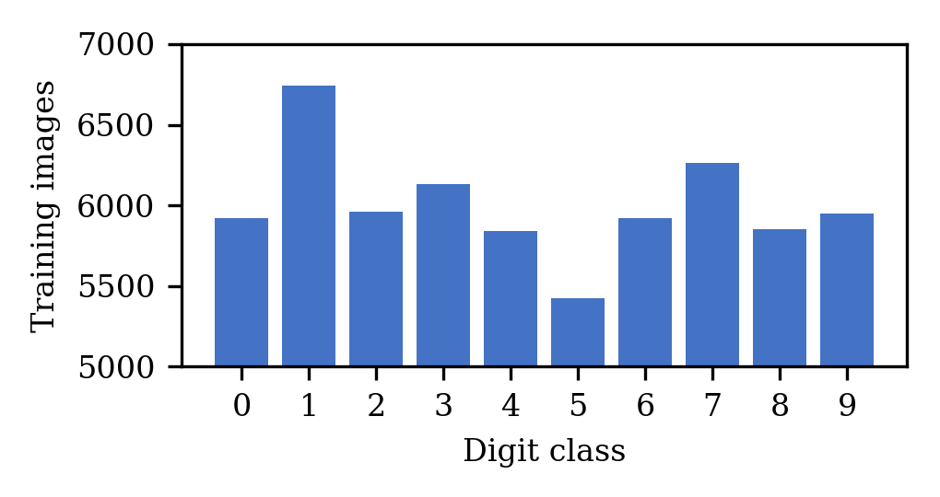
- Number of training images per digit class in the full MNIST training set (60,000 images).

Preprocessing
Each 28 × 28 image is flattened into a 784-dimensional vector and its pixel intensities are scaled to the range [0, 1]. The data are divided into training and test sets with a stratified split (random seed 42), and hyper-parameters are selected by five-fold stratified cross-validation on the training data only. Principal component analysis (PCA) with 20, 50, and 100 components is evaluated as an optional dimensionality-reduction step.

Proposed Methodology
The study follows the workflow in Fig. 3. After exploratory analysis and preprocessing, the KNN and SVM classifiers are tuned by five-fold cross-validation on the training split and evaluated once on the held-out test split. KNN is searched over k ∈ {1, 3, 5, 7, 9, 11, 15} with Euclidean and Manhattan distance and uniform or distance weighting; SVM is searched over the RBF kernel (C ∈ {1, 10, 100}) and the linear and polynomial kernels. Performance is reported as accuracy, macro-averaged precision, recall, and F1-score, confusion matrices, and per-class scores, and the two models are compared with McNemar’s test [13].
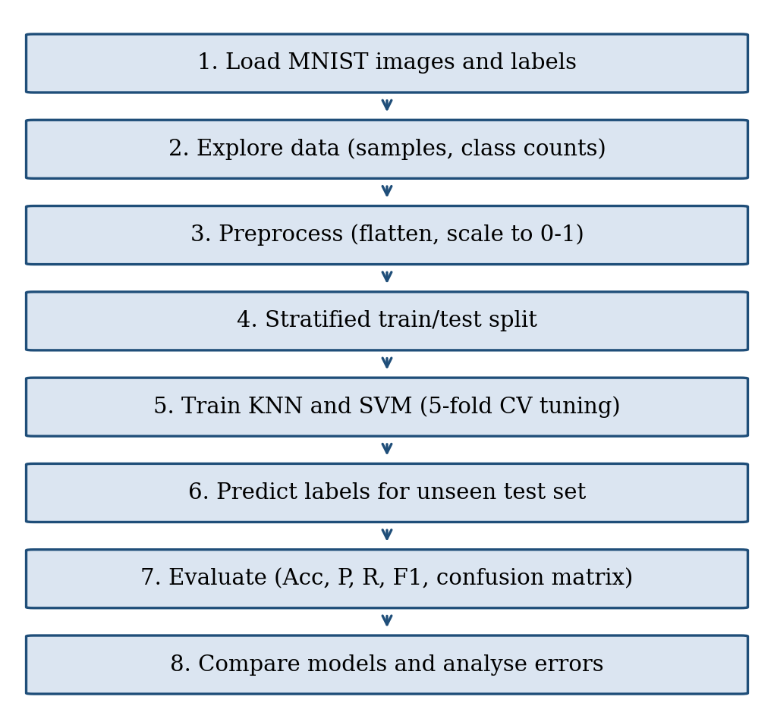
- Workflow of the proposed handwritten digit recognition system.
Experiments use Python with NumPy [14], scikit-learn [10] (SVM through LIBSVM [11]), and Matplotlib [15]; all random operations use fixed seeds so that the results can be reproduced.

Experimental Setup
The full 70,000-image MNIST database is the target of the project (Section XI). For this first experimental stage, a class-balanced subset of 5,000 real MNIST images (500 per digit) distributed with the MLxtend library [16] was used, because it can be processed on a single laptop in seconds and allows every analysis of this paper to be repeated by the reader. The subset was divided into 4,000 training and 1,000 test images with a stratified split and a fixed random seed (42). Because the test set is small, differences of about one percentage point between models are within sampling noise, and results should be read as a controlled first comparison rather than as final benchmark numbers.
- Experimental Configuration
Item | Setting
Data | MNIST subset, 5,000 images, 500 per class
Split | 4,000 train / 1,000 test, stratified, seed 42
Input | 784 pixels scaled to [0, 1]
KNN | k ∈ {1, 3, 5, 7, 9, 11, 15}; Euclidean; uniform vs. distance weights; Manhattan
SVM | RBF with C ∈ {1, 10, 100}, γ = scale; linear (C = 1); polynomial (degree 3)
Model selection | 5-fold stratified cross-validation on training data
Software | Python, NumPy, scikit-learn 1.8, Matplotlib

The selection procedure is the same for both classifiers: candidate settings are scored by five-fold cross-validation on the training images, the best setting is refitted on the whole training set, and the test images are used once to compute all reported metrics.

Results and Discussion

Overall Comparison
- Test-Set Performance of KNN and SVM
Model | Acc. (%) | Prec. (%) | Rec. (%) | F1 (%) | Errors
KNN (k = 1) | 93.0 | 93.1 | 93.0 | 93.0 | 70/1000
SVM (RBF, C = 10) | 95.7 | 95.7 | 95.7 | 95.7 | 43/1000

Table IV summarizes the results. The SVM is clearly better, with 95.7% accuracy against 93.0% for KNN, and it also leads on macro precision, recall, and F1-score. Out of 1000 test images KNN misclassifies 70 and SVM 43; 27 images are misclassified by both models, so 43 errors are specific to KNN and 16 to SVM. McNemar’s test on these discordant pairs gives χ² = 11.5 (p < 0.001), so the advantage of SVM is unlikely to be due to chance on this split. Precision, recall, and F1-score are almost identical to accuracy for both models, which confirms that the balanced classes do not hide a weak class behind a good average.
Because the test set contains only 1000 images, the accuracies are estimates with sampling uncertainty. The 95% Wilson confidence interval is 91.2–94.4% for KNN and 94.3–96.8% for SVM. The intervals overlap slightly, but the McNemar test, which uses the paired outcomes on identical images and is therefore more sensitive than comparing two separate intervals, still indicates a significant difference. Evaluation on the 10,000-image official test set will narrow these intervals to about ±0.5 percentage points.

Effect of the Hyper-Parameters
For KNN, cross-validated accuracy decreases steadily as k grows, from 93.3% for k = 1 to 91.7% for k = 15 (Fig. 4), so the smallest neighbourhood was selected. Distance weighting gave the same score (93.3%) because with k = 1 there is only one neighbour, and the Manhattan distance was worse (92.0%).
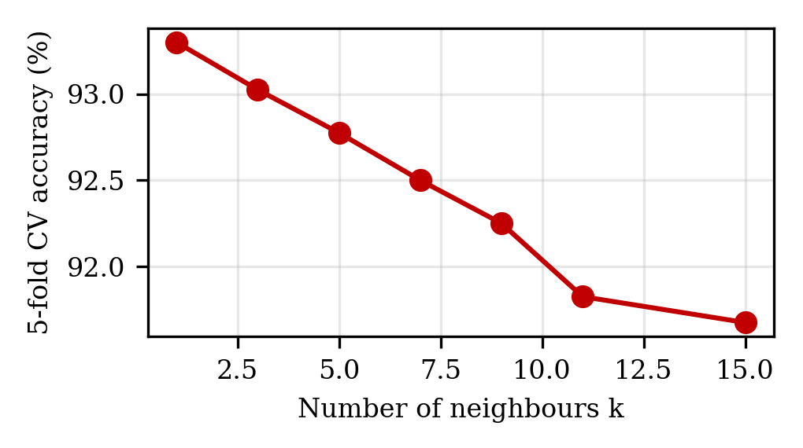
- Five-fold cross-validated accuracy of KNN for different neighbourhood sizes k.
- Cross-Validated Accuracy of SVM Kernels
Kernel and cost | CV accuracy (%)
RBF, C = 1 | 94.9
RBF, C = 10 | 95.5
RBF, C = 100 | 95.5
Polynomial (degree 3), C = 1 | 92.8
Linear, C = 1 | 91.2

Table V shows that the non-linear RBF kernel clearly outperforms the linear kernel (95.5% vs. 91.2%). Increasing C from 1 to 10 helps, while C = 100 gives no further gain. The polynomial kernel lies between the linear and RBF kernels.

Confusion Matrix and Error Analysis
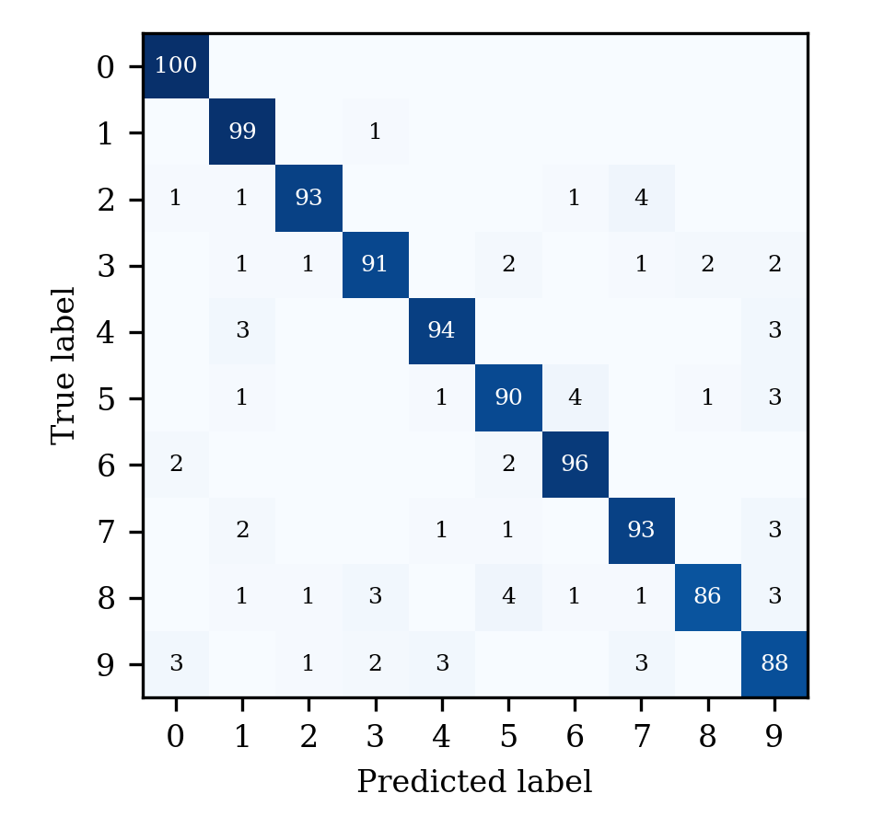
- Confusion matrix of KNN on the test set (rows: true digit, columns: predicted digit).
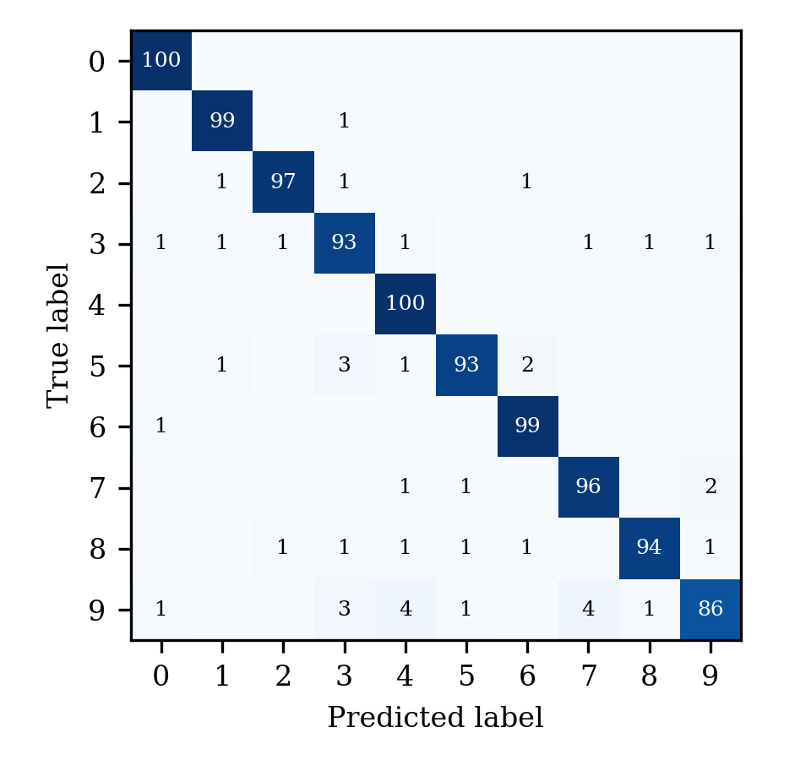
- Confusion matrix of SVM on the test set (rows: true digit, columns: predicted digit).
Figs. 5 and 6 show that both matrices are strongly diagonal. The most frequent confusions of KNN are 2→7 (4), 5→6 (4), 8→5 (4), 4→1 (3), 4→9 (3); those of SVM are 9→4 (4), 9→7 (4), 5→3 (3), 9→3 (3), 5→6 (2), where “i→j” means true digit i predicted as j. Pairs such as 3/5, 4/9, and 7/9 appear, matching the visually similar digits identified in the problem analysis. Fig. 7 displays some misclassified test images; several of them are ambiguous even for a human reader because of open loops, missing strokes, or unusual slant.
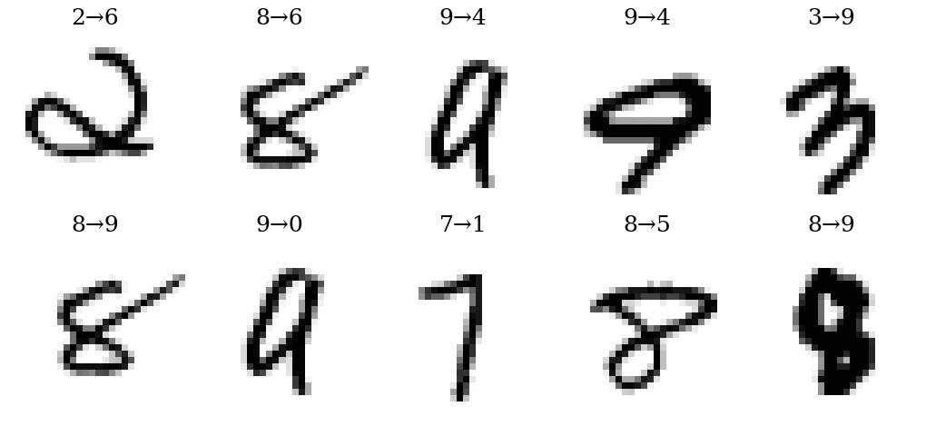
- Misclassified test images (true → predicted). Top row: SVM errors; bottom row: KNN errors.

Per-Class Behaviour
- Per-Class F1-Score (%) on the Test Set
Digit | KNN | SVM | Test images
0 | 97.1 | 98.5 | 100
1 | 95.2 | 98.0 | 100
2 | 94.9 | 97.5 | 100
3 | 92.4 | 92.1 | 100
4 | 94.5 | 96.2 | 100
5 | 90.5 | 94.9 | 100
6 | 95.0 | 97.5 | 100
7 | 92.1 | 95.5 | 100
8 | 91.0 | 95.9 | 100
9 | 87.1 | 90.5 | 100

Table VI lists F1-scores for each digit. KNN is weakest on digit 9 (87.1%) and strongest on digit 0 (97.1%), while SVM is weakest on digit 9 (90.5%) and strongest on digit 0 (98.5%). Digits with simple, distinctive shapes such as 0 and 1 are recognized almost perfectly by both models, whereas digits with more varied forms, such as 5, 8, and 9, are harder. Because each class has only 100 test images, a single extra error changes a class F1-score by roughly one point, so class-level conclusions must be confirmed on the full 10,000-image test set.
- Per-Class Precision and Recall (%) on the Test Set
Digit | KNN P | KNN R | SVM P | SVM R
0 | 94.3 | 100.0 | 97.1 | 100.0
1 | 91.7 | 99.0 | 97.1 | 99.0
2 | 96.9 | 93.0 | 98.0 | 97.0
3 | 93.8 | 91.0 | 91.2 | 93.0
4 | 94.9 | 94.0 | 92.6 | 100.0
5 | 90.9 | 90.0 | 96.9 | 93.0
6 | 94.1 | 96.0 | 96.1 | 99.0
7 | 91.2 | 93.0 | 95.0 | 96.0
8 | 96.6 | 86.0 | 97.9 | 94.0
9 | 86.3 | 88.0 | 95.6 | 86.0

Table VII gives the corresponding precision and recall values. For both models the two are close for most digits, so neither model is biased toward over- or under-predicting a particular digit.

Effect of Dimensionality Reduction
- Effect of PCA on Test Accuracy (%)
Components | Variance kept (%) | KNN | SVM
784 (none) | 100.0 | 93.0 | 95.7
20 | 64.9 | 94.0 | 96.0
50 | 82.9 | 94.5 | 96.4
100 | 91.8 | 94.1 | 96.6

Table VIII shows that PCA does not hurt accuracy and even helps. With only 50 components, which keep 82.9% of the variance, KNN rises to 94.5% and SVM to 96.4%, and 100 components give 96.6% for SVM. Since this was evaluated on the test set for illustration, the number of components should be chosen by cross-validation in the final study.

Effect of Training-Set Size
Fig. 8 plots test accuracy against the number of training images. SVM improves from 91.7% with 500 images to 96.1% with 3,200, and KNN from 87.2% to 92.8%. SVM stays ahead at every size, and the gap is largest for small training sets. Both curves are still rising, which indicates that the full 60,000-image training set should give clearly higher accuracy than reported here.
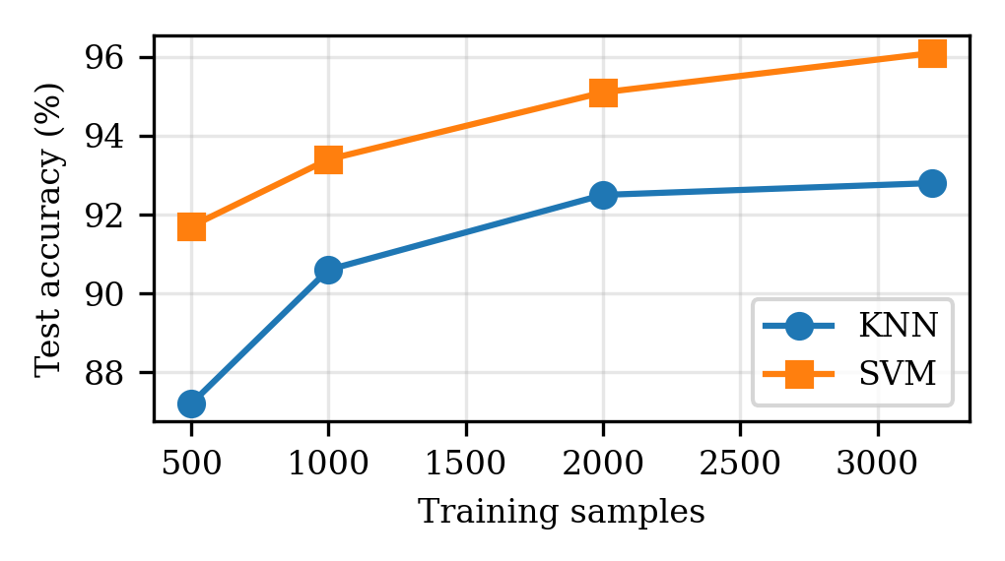
- Test accuracy of KNN and SVM as a function of the number of training images.

Computational Cost
- Indicative Training and Prediction Time (seconds)
Model | Training | Prediction (1000 images)
KNN | 0.003 | 0.15
SVM (RBF) | 1.98 | 0.82

Table IX reports single-run timings on a shared CPU and is therefore indicative only. KNN needs almost no training time but is slower at prediction, whereas SVM requires a longer training phase.

Most Frequent Confusions
- Most Frequent Confusions (true → predicted, count)
KNN pair | Count | SVM pair | Count
2 → 7 | 4 | 9 → 4 | 4
5 → 6 | 4 | 9 → 7 | 4
8 → 5 | 4 | 5 → 3 | 3
4 → 1 | 3 | 9 → 3 | 3
4 → 9 | 3 | 5 → 6 | 2
5 → 9 | 3 | 7 → 9 | 2

Table X lists the six most frequent confusions of each model. The two lists are different, which shows that the models make partly different mistakes: an ensemble or a hybrid that lets SVM re-examine the cases on which KNN’s neighbours disagree, similar in spirit to the local SVMs of [8], could therefore reduce the error further. The pairs involve digits whose strokes overlap, such as 3 and 5, 4 and 9, and 7 and 9, which agrees with the visual analysis of Section V.

Comparison with Published Results
- Comparison with Results Reported in the Literature
Method | Data | Accuracy (%) | Ref.
KNN (this work) | 5,000 MNIST | 93.0 | –
SVM, RBF (this work) | 5,000 MNIST | 95.7 | –
Task-fMRI spiking NN | MNIST | 97.27 | [3]
VGG16 | MNIST | 98.53 | [4]
LeNet + linear SVM | MNIST | 99.31 | [9]
CNN + SVM | MNIST | 99.81 | [7]
MLP + local SVMs | Mail ZIP codes | 98.01 | [8]

Table XI places the present results next to published numbers. The comparison is only indicative: the published models were trained on all 60,000 images, evaluated on the full 10,000-image test set, and in some cases use different data or protocols, whereas the present models use 4,000 training images. Within that limitation, the table shows the expected ordering: classical classifiers on raw pixels, then deep and hybrid models. It also shows why the full-dataset repetition is necessary before any claim of competitiveness can be made. The learning curve of Fig. 8 suggests that both classical models will gain several points with 15 times more training data.

Discussion
Three conclusions follow from this first experiment. First, a properly tuned RBF-kernel SVM is significantly more accurate than KNN on the same data and the same preprocessing, in agreement with the full-dataset results reported for these two classifiers in the MNIST literature [1], [17]. Second, KNN remains a useful baseline: it needs no training and has a single main hyper-parameter. Third, accuracy alone is insufficient; the confusion matrices, per-class scores, and the effect of training-set size and dimensionality give a much clearer picture of where each model can be trusted and where more data or better features are needed. Compared with the deep and hybrid models in Table I, both classical classifiers are expected to remain below 99% accuracy, but they are far cheaper to train, easier to explain, and sufficient for many practical settings.

Prototype Implementation
A prototype web application was developed with Streamlit to demonstrate the trained models on new handwritten input (Figs. 9 and 10). The user draws a digit on a 280 × 280 canvas or uploads a scanned or photographed image (PNG, JPG, JPEG, BMP, or TIFF), and the input is preprocessed before it is passed to both classifiers. The application displays the predicted digit from each model: for KNN (k = 3), the nearest neighbours with their Euclidean distances and the vote share, and for the RBF-kernel SVM (C = 10), the decision margin and a softmax-calibrated score. In the example shown, both models predict the digit 7 for a hand-drawn 7. The prototype uses k = 3 for demonstration, whereas k = 1 was selected by cross-validation in the experiments of Section VIII.

- Input screens of the prototype web application: (a) drawing canvas and (b) image upload.
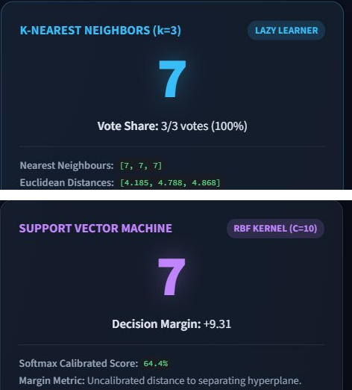
- Prediction output of the prototype for the drawn digit 7: KNN (top) and SVM (bottom).

Innovation, Creativity, and Novelty
- Handwriting variation handling: the system is designed to recognize digits despite differences in writing style, size, shape, stroke thickness, and alignment.
- Image preprocessing enhancement: input images are preprocessed and normalized to reduce unnecessary variation and improve recognition quality.
- Intelligent digit classification: machine-learning techniques automatically learn digit patterns and classify handwritten inputs with high accuracy.
- Similar-digit error reduction: the study focuses on visually similar digits such as 3 and 5 or 4 and 9, where misclassification is most likely, and quantifies these errors with confusion matrices.
- Real-world application potential: the system can be extended beyond MNIST to document digitization, banking forms, postal services, and automated data entry.
Beyond these points, the novelty of the work lies in combining, within one reproducible framework, an explicit literature gap, a controlled and statistically tested comparison of two classical models, and an analysis of cost, data size, and dimensionality that most benchmark-oriented studies omit.

Feasibility and Project Plan

Feasibility Analysis
Technical feasibility. The system can be developed in Python with NumPy, OpenCV, and scikit-learn or TensorFlow. MNIST is freely and readily available, no specialized hardware is required, and tools such as VS Code and Google Colab are sufficient for development. The experiments in this paper already confirm that the complete pipeline runs on an ordinary computer.
Economic feasibility. Only open-source software and freely available datasets are used. No additional hardware or expensive licenses are needed, development takes place on an existing personal computer, and the project is therefore cost-effective for academic and research purposes.
Operational feasibility. A user supplies an image of a handwritten digit and receives the predicted digit automatically through a simple interface. The system can be extended to digits extracted from real documents and is useful in education, banking, postal services, and automated data entry.

Project Plan
The project is organized into seven phases over 14 weeks (Fig. 11): literature survey and problem identification (weeks 1–2); dataset collection and image preprocessing (weeks 3–4); feature extraction and model development (weeks 5–6); model training and testing (weeks 7–8); performance evaluation and error analysis (weeks 9–10); system implementation and integration (weeks 11–12); and testing, documentation, and final presentation (weeks 13–14). The experiments of Section VIII correspond to the first iteration of phases 2 to 5.
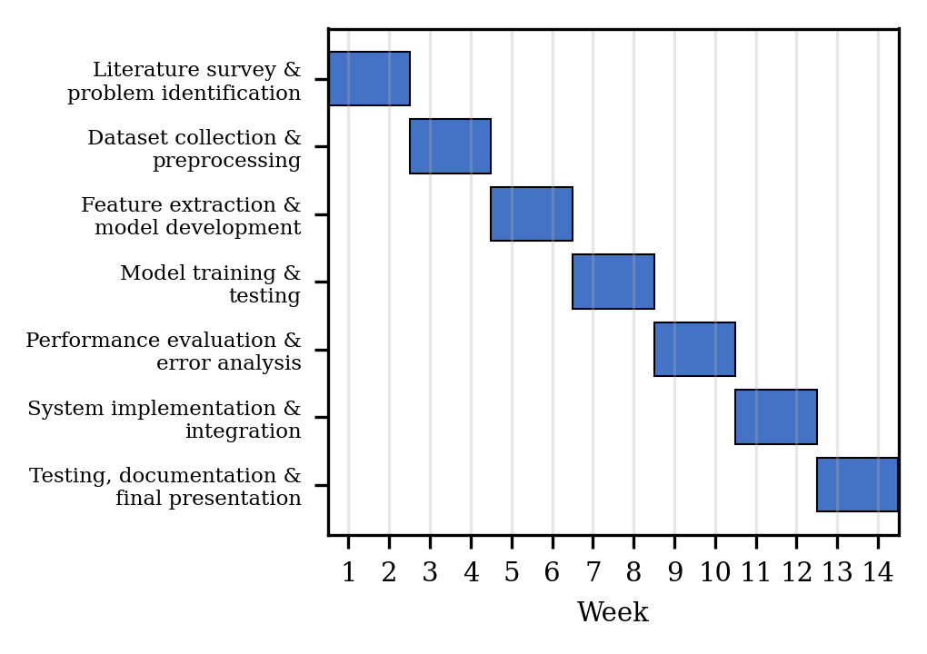
- Seven-phase, 14-week project plan.
The expected outcome is a reliable and efficient handwritten digit recognition system with high accuracy that is applicable to real-world handwritten documents and useful in various practical domains, together with an evidence-based recommendation on when KNN or SVM should be preferred.

Limitations
- Subset size: the reported results use 5,000 MNIST images with a 1,000-image test set, so confidence intervals are about ±1.5 percentage points; the full 70,000-image study is still to be done.
- Benchmark data: MNIST contains clean, centred, size-normalized digits and does not represent real-world scans with noise, skew, or touching digits.
- Single split: results come from one stratified split; repeated splits or cross-validated test estimates would give variance information.
- Representation: flattened raw pixels ignore two-dimensional structure; CNN features or HOG descriptors may separate similar digits better.
- Search budget: only a coarse hyper-parameter grid was explored, and the number of PCA components was not tuned by cross-validation.
- Timing: the cost figures come from one run on a shared CPU and are indicative only.
Threats to validity. Internal validity is limited by using a single split and a coarse grid; construct validity by measuring only recognition accuracy and time rather than end-to-end performance on documents; external validity by the narrow, clean benchmark. These threats are addressed in the future work through repeated cross-validation, richer measures such as rejection rate and calibration, and testing on additional datasets.

Future Work
The next steps follow directly from the limitations. The first is to repeat the whole study on the full 60,000/10,000 MNIST split, with repeated cross-validation, finer hyper-parameter grids, and confidence intervals for every metric. The second is to broaden the data, for example with EMNIST, USPS, or a newly collected set of digits written by students and scanned from forms, to measure the drop in accuracy when moving from the benchmark to realistic handwriting. The third is to improve the input representation with deskewing, centering, HOG features, or a small CNN used as a feature extractor in front of the SVM, as in [2], [7], [9], while keeping the explainable evaluation framework of this paper.
A further direction is efficiency: approximate nearest-neighbour search or prototype selection can reduce KNN prediction cost, and model compression can make stronger models usable on mobile devices. Finally, the web prototype described in Section IX will be extended and tested on scanned forms and photographed documents, which corresponds to the integration phase of the project plan.

Conclusion
This paper presented a structured study of handwritten digit recognition with K-Nearest Neighbors and Support Vector Machine on MNIST, from the literature survey and problem gap to preprocessing, model construction, evaluation, and error analysis. In a controlled experiment on 5,000 real MNIST images, the RBF-kernel SVM achieved 95.7% test accuracy compared with 93.0% for KNN, a statistically significant difference, and it also led in precision, recall, and F1-score and at every training-set size, at the price of a longer training time. Errors for both models concentrated on visually similar digits, which confirms the importance of class-level analysis, and PCA to 50 components improved accuracy while shrinking the input substantially.
These results are a baseline rather than a final benchmark. The planned work on the full dataset, on more realistic handwriting, and on richer features will show how far the classical models can be pushed and where hybrid or deep models become necessary. The framework presented here, together with its feasibility analysis and 14-week plan, provides a clear path from the present prototype to a reliable system applicable to real handwritten documents.

Acknowledgment
The authors thank Dr. N. Sunanda, Associate Professor, Department of Computer Science and Engineering, KLH (Deemed to be University), Bowrampet Campus, for her guidance, encouragement, and support throughout this project, and the Department of Computer Science and Engineering for providing the resources needed to carry out this work.

References
- Y. LeCun, L. Bottou, Y. Bengio, and P. Haffner, “Gradient-based learning applied to document recognition,” Proc. IEEE, vol. 86, no. 11, pp. 2278–2324, Nov. 1998.
- C. Zhang et al., “ResNet18-ThunderSVM: Hybrid intelligence for handwritten digit recognition by fusing deep spatial features and high-performance classification.”
- L. Guo and Z. Wang, “Task-fMRI-derived number-related functional brain topology constrained spiking neural networks for handwritten digit recognition.”
- R. Sethi and V. Pareek, “Optical handwritten digit recognition using deep learning models on the MNIST dataset.”
- T. Cover and P. Hart, “Nearest neighbor pattern classification,” IEEE Trans. Inf. Theory, vol. 13, no. 1, pp. 21–27, Jan. 1967.
- C. Cortes and V. Vapnik, “Support-vector networks,” Mach. Learn., vol. 20, no. 3, pp. 273–297, 1995.
- X.-X. Niu and C. Y. Suen, “A novel hybrid CNN–SVM classifier for recognizing handwritten digits,” Pattern Recognit., vol. 45, no. 4, pp. 1318–1325, 2012.
- A. Bellili, M. Gilloux, and P. Gallinari, “An MLP-SVM combination architecture for offline handwritten digit recognition,” Int. J. Doc. Anal. Recognit., vol. 5, pp. 244–252, 2003.
- R. Fang and S. Yang, “A hybrid LeNet–LinearSVC model in recognizing handwritten digits,” in Proc. 3rd Int. Conf. Comput. Inf. Big Data Appl. (CIBDA), Wuhan, China, 2022.
- F. Pedregosa et al., “Scikit-learn: Machine learning in Python,” J. Mach. Learn. Res., vol. 12, pp. 2825–2830, 2011.
- C.-C. Chang and C.-J. Lin, “LIBSVM: A library for support vector machines,” ACM Trans. Intell. Syst. Technol., vol. 2, no. 3, Art. 27, 2011.
- C.-W. Hsu, C.-C. Chang, and C.-J. Lin, “A practical guide to support vector classification,” Dept. Comput. Sci., National Taiwan Univ., Taipei, Taiwan, Tech. Rep., 2003.
- T. G. Dietterich, “Approximate statistical tests for comparing supervised classification learning algorithms,” Neural Comput., vol. 10, no. 7, pp. 1895–1923, 1998.
- C. R. Harris et al., “Array programming with NumPy,” Nature, vol. 585, pp. 357–362, 2020.
- J. D. Hunter, “Matplotlib: A 2D graphics environment,” Comput. Sci. Eng., vol. 9, no. 3, pp. 90–95, 2007.
- S. Raschka, “MLxtend: Providing machine learning and data science utilities and extensions to Python’s scientific computing stack,” J. Open Source Softw., vol. 3, no. 24, p. 638, 2018.
- Y. LeCun, C. Cortes, and C. J. C. Burges, “The MNIST database of handwritten digits.” [Online]. Available: http://yann.lecun.com/exdb/mnist/

