USER INTERFACE DESIGN – 23CSE113
EXPERIMENT NAME : WEATHER APP - CLONE
AIM:
To develop a Weather Forecasting Web Application using HTML, CSS and JavaScript that provides real-time weather information, hourly forecasts, 5-day forecasts and current location weather detection using OpenWeatherMap API.
PROGRAM CODE:
HTML:
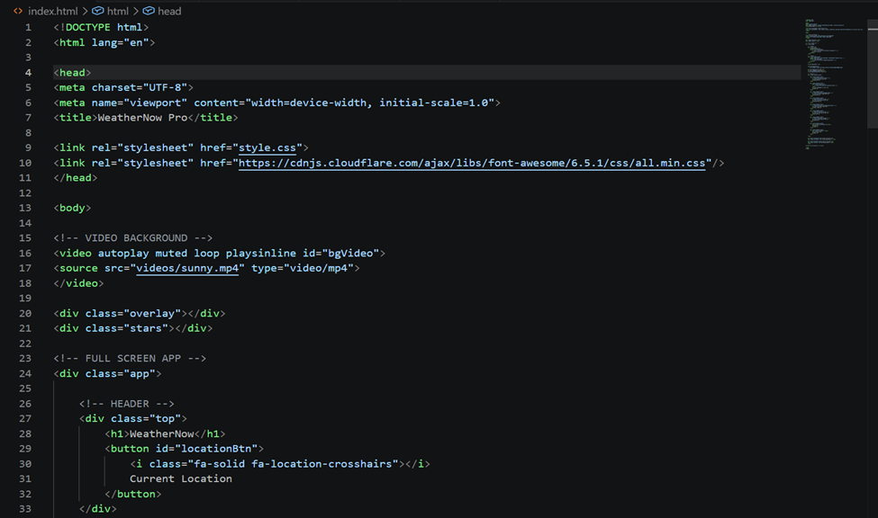

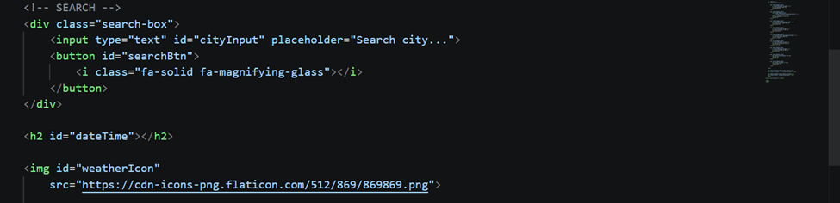

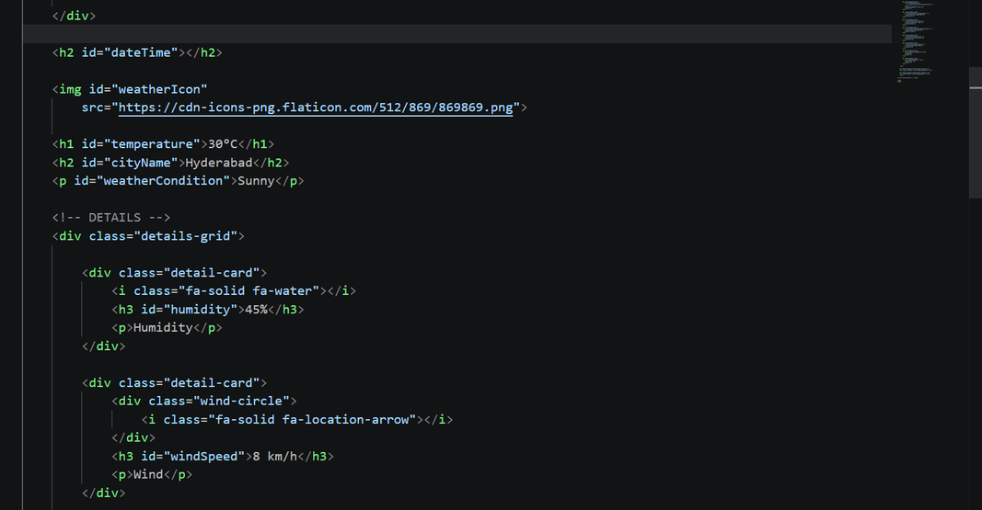

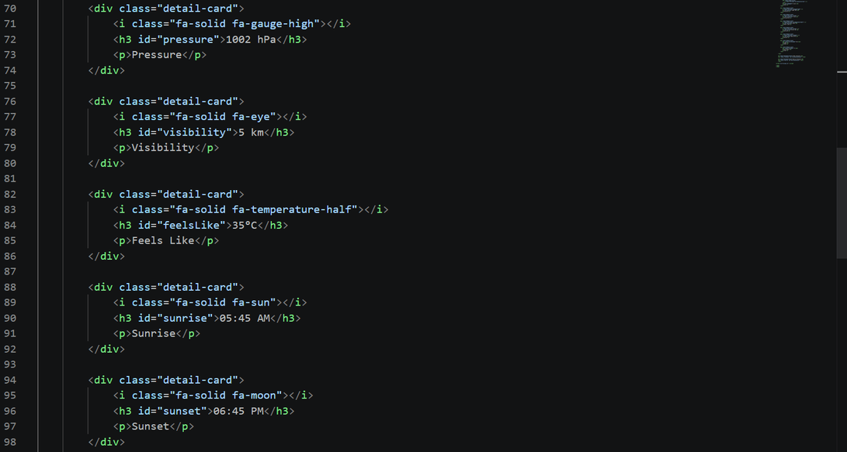
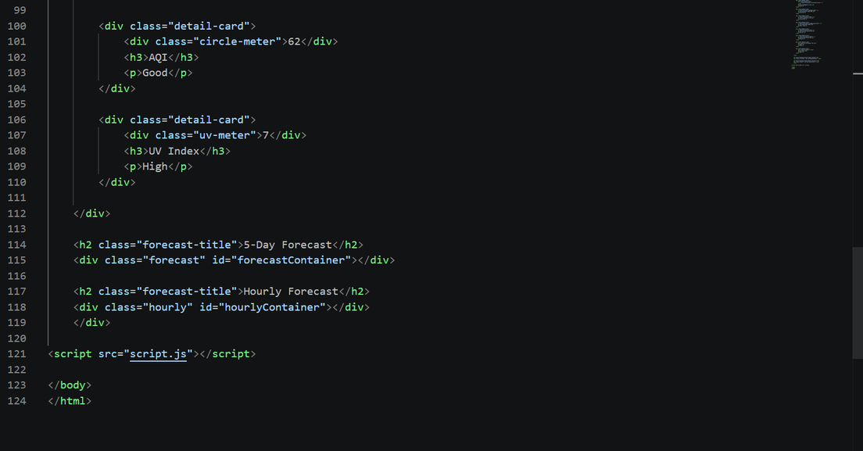

CSS:
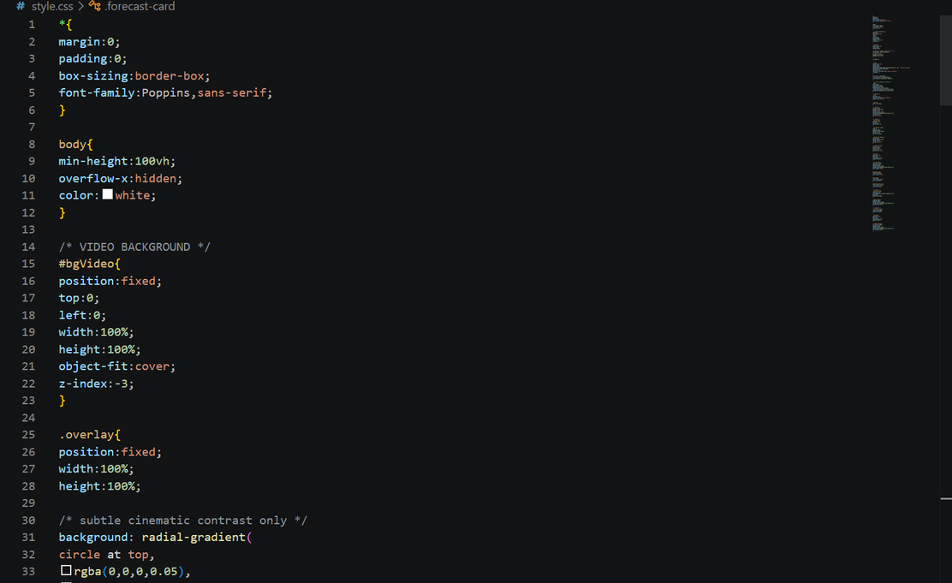
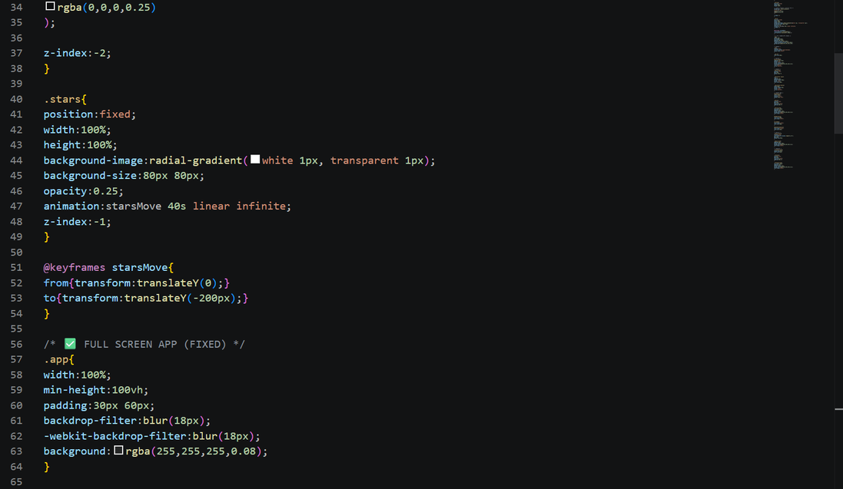

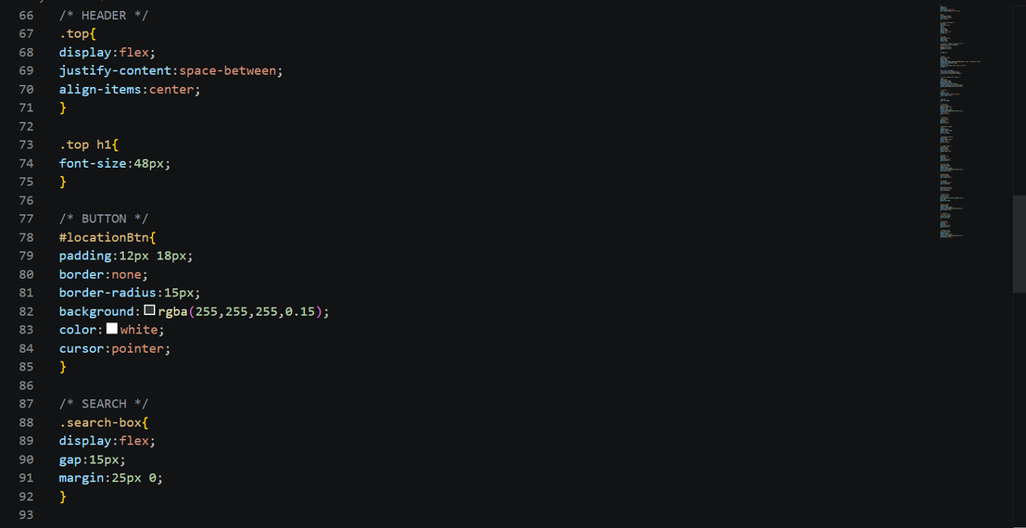
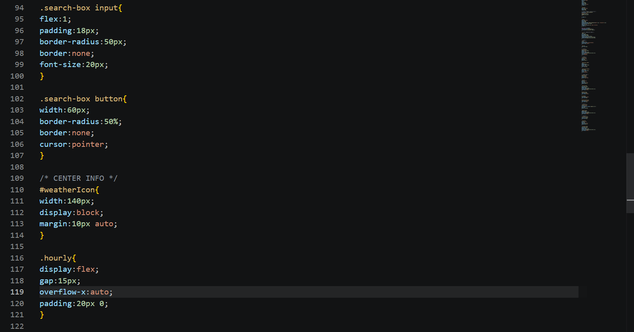

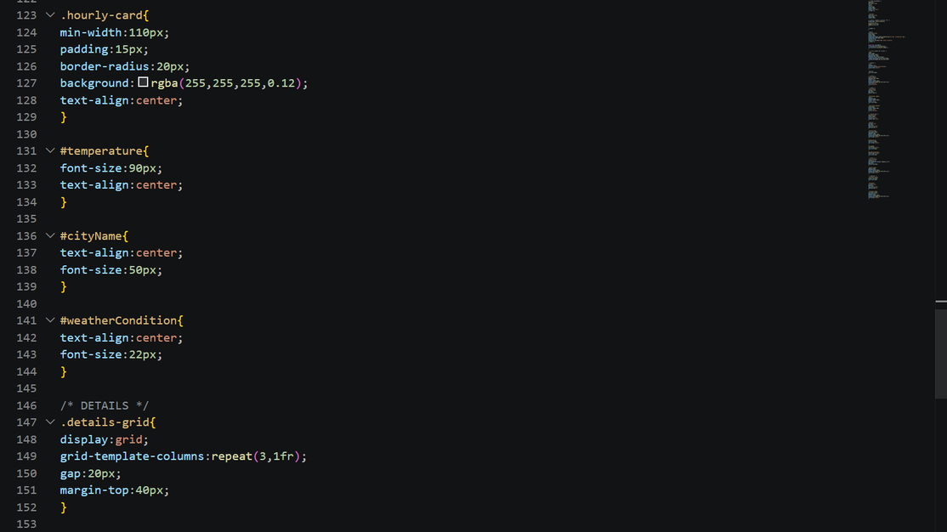
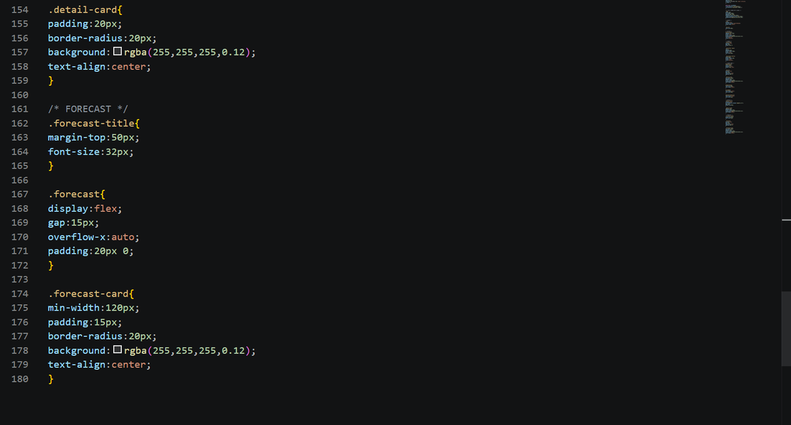

JAVA SCRIPT:

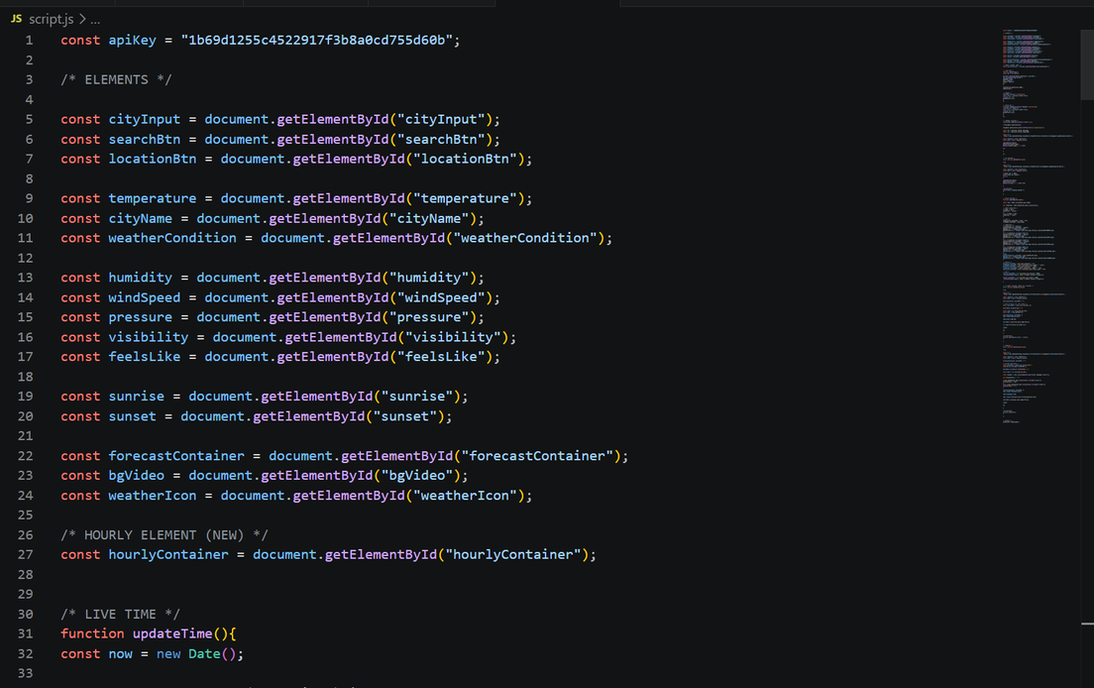
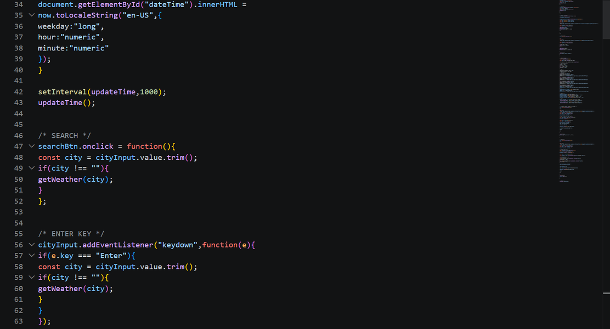

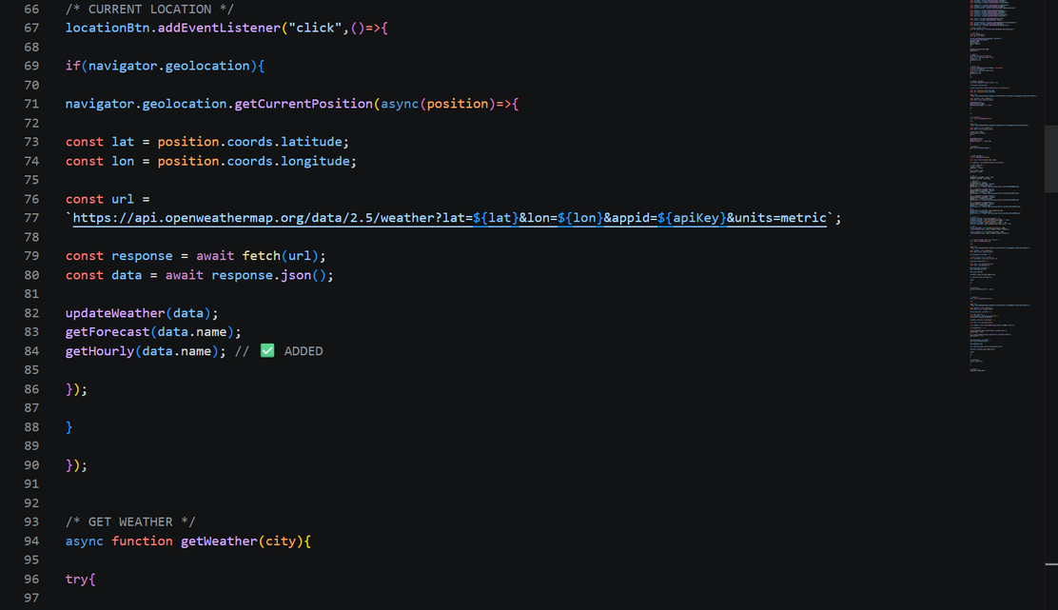

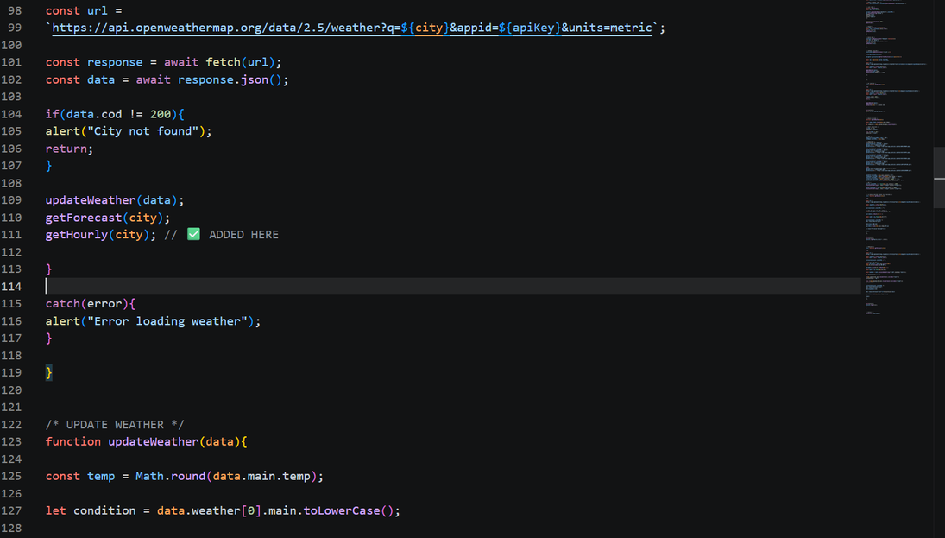

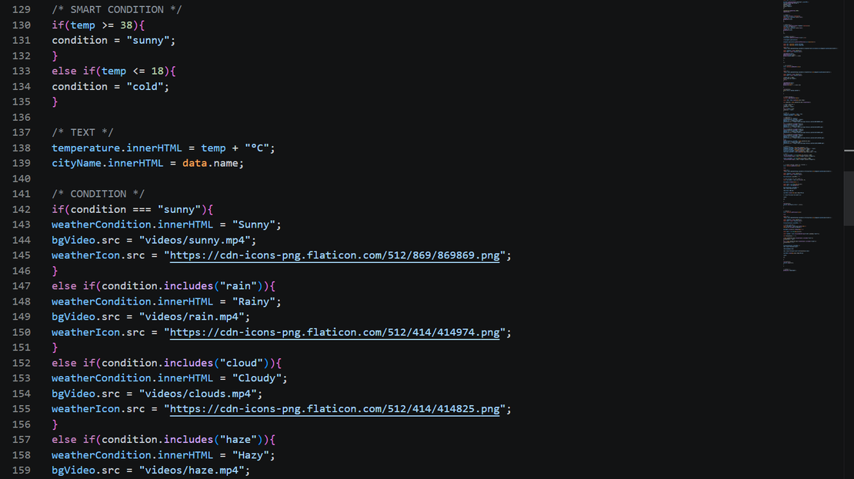

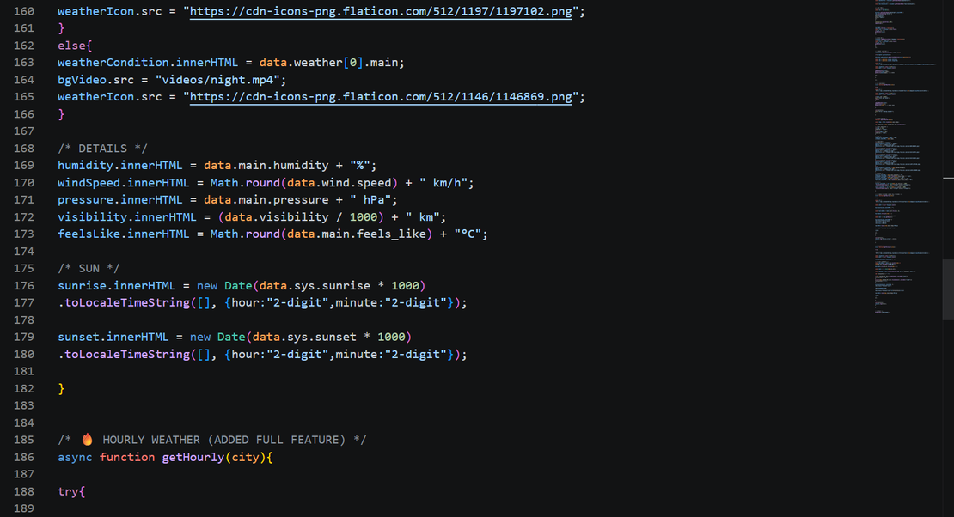

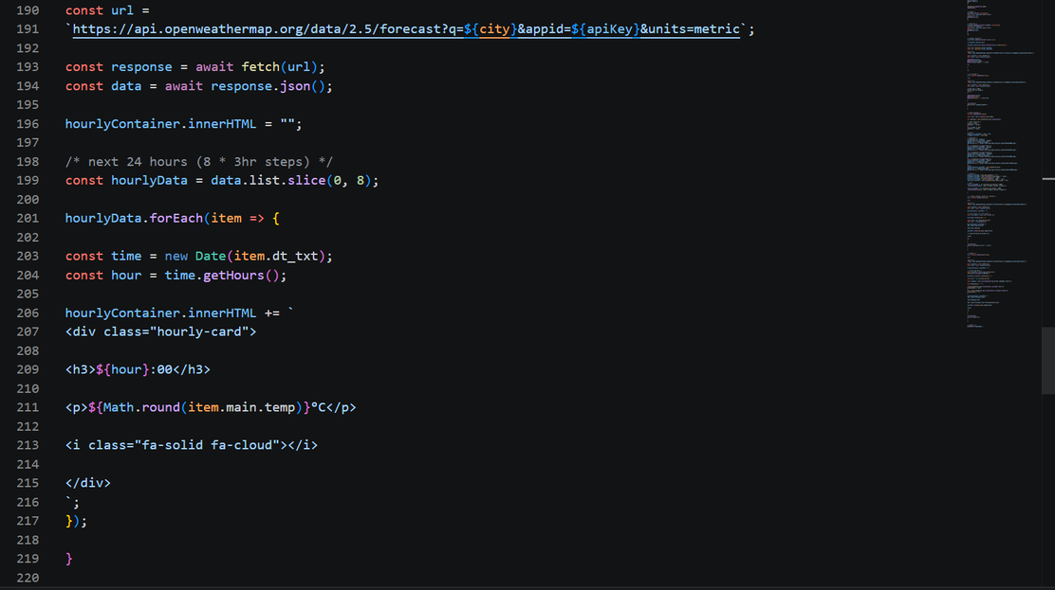

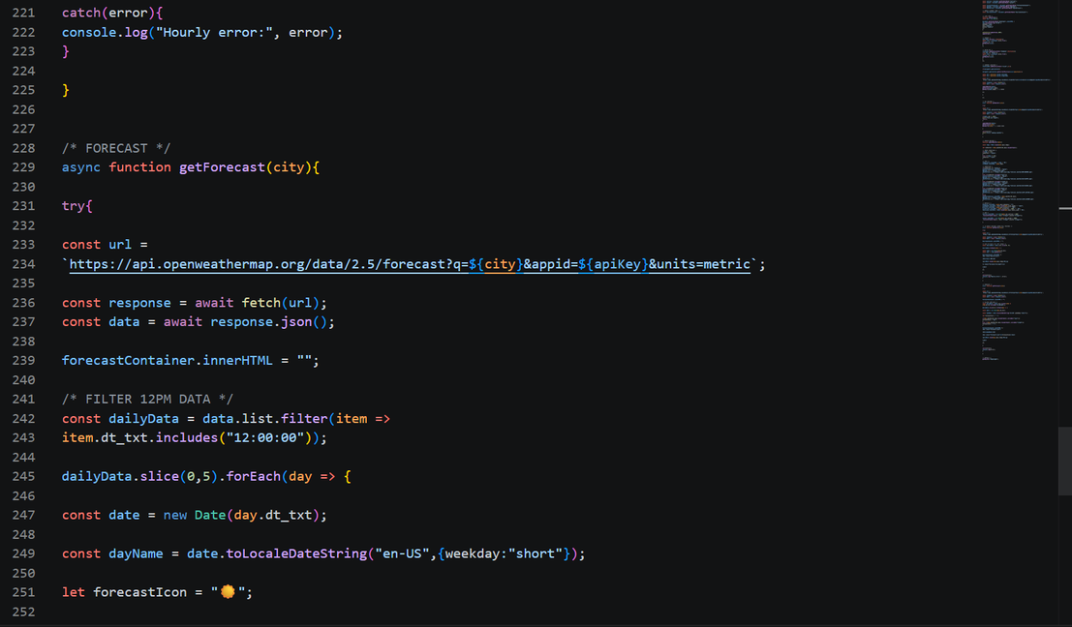

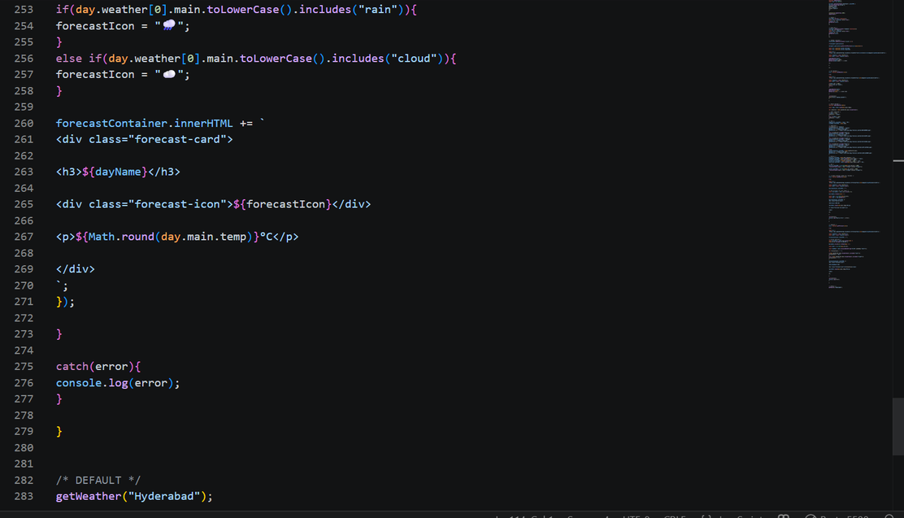

OUTPUT:
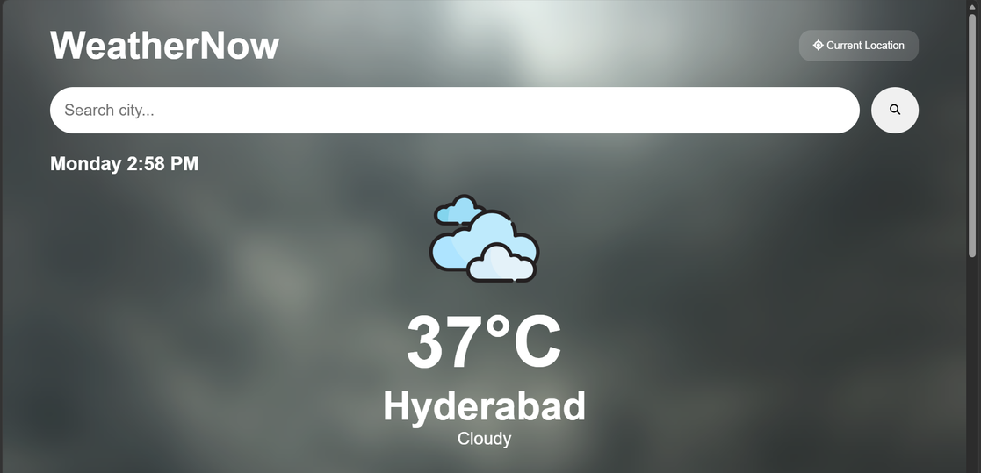

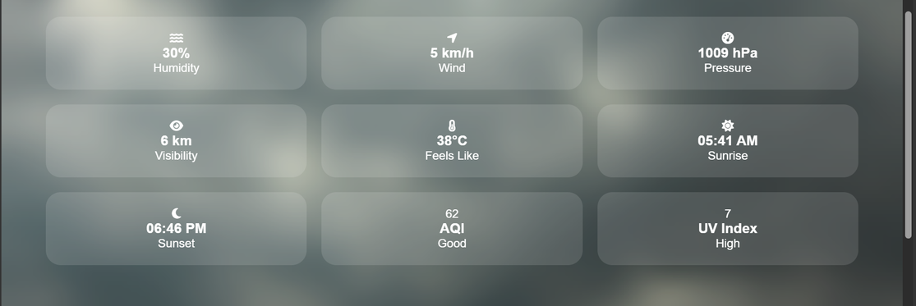

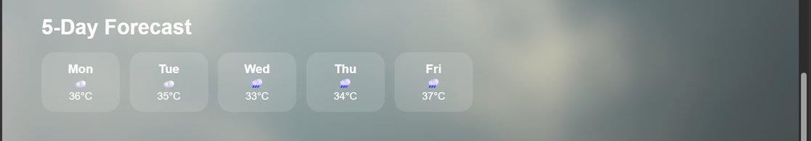

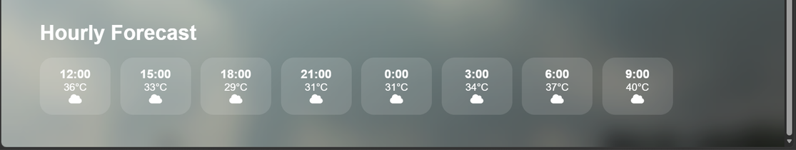

KEY HIGHLIGHTS OF THE OUTPUT:
- it gives the weather report of current location.
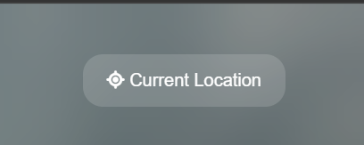
- it gives the weather report of searched location.
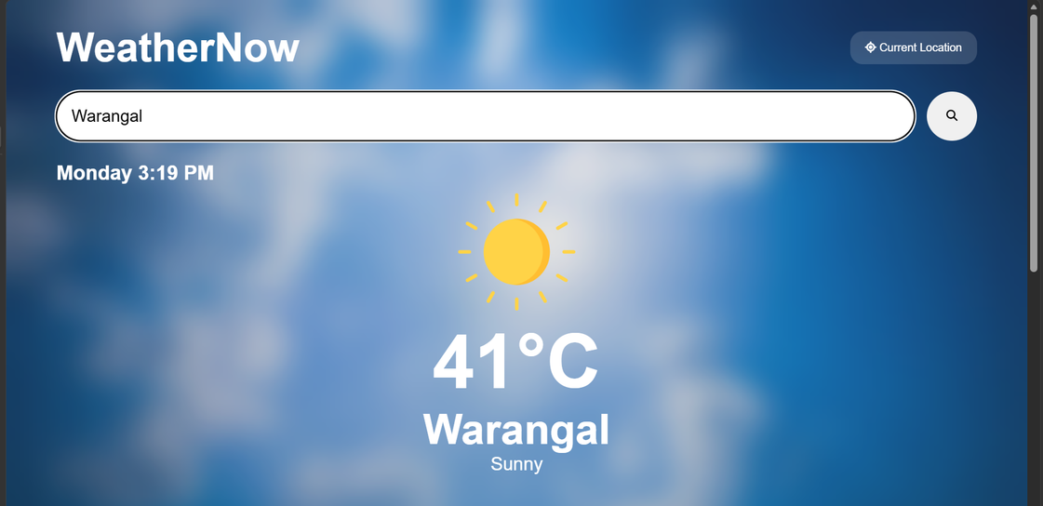

EXPLANATION
HTML Tags
Tag | Explanation
<html> | Root element that contains the entire webpage.
<head> | Stores metadata, stylesheet links, and page settings.
<meta> | Defines character encoding and responsive viewport settings.
<title> | Sets the browser tab title as WeatherNow Pro.
<link> | Connects external stylesheets and Font Awesome icons.
<body> | Contains all visible webpage content.
<video> | Displays dynamic weather background videos.
<source> | Specifies video file source.
<div> | Generic container used for grouping webpage sections.
<h1> | Displays main headings such as temperature and application title.
<h2> | Displays section headings and city information.
<h3> | Displays weather detail values and forecast data.
<p> | Displays weather descriptions and labels.
<button> | Creates clickable buttons for search and location services.
<input> | Accepts city name entered by the user.
<img> | Displays weather condition icons.
<i> | Displays Font Awesome weather-related icons.
<script> | Connects the JavaScript file to the webpage.

CSS Properties
Property | Explanation
margin | Removes or sets outer spacing around elements.
padding | Adds inner spacing inside elements.
box-sizing | Includes padding and border in element size calculations.
font-family | Specifies the font style used throughout the page.
min-height | Sets minimum page height.
overflow-x | Prevents horizontal scrolling.
color | Sets text color.
position | Controls element positioning.
top | Sets distance from the top edge.
left | Sets distance from the left edge.
width | Defines element width.
height | Defines element height.
object-fit | Ensures videos cover the entire screen.
z-index | Controls stacking order of elements.
background | Sets backgrounds and gradients.
background-image | Creates animated star background effect.
background-size | Controls star pattern spacing.
opacity | Controls transparency level.
animation | Applies animation effects.
transform | Moves animated elements.
display | Defines layout type such as flex or grid.
justify-content | Aligns items horizontally.
align-items | Aligns items vertically.
gap | Creates spacing between elements.
border | Removes or defines borders.
border-radius | Creates rounded corners.
cursor | Changes mouse pointer appearance.
flex | Allows flexible element sizing.
text-align | Aligns text horizontally.
grid-template-columns | Defines weather details grid structure.
backdrop-filter | Applies glassmorphism blur effect.
-webkit-backdrop-filter | Browser support for blur effect.
min-width | Defines minimum card width.
font-size | Controls text size.

CSS Animations
Animation | Explanation
starsMove | Creates continuously moving stars background effect.

JavaScript Elements & Patterns
Element / Pattern | What it does in this code
const apiKey | Stores OpenWeatherMap API key.
document.getElementById() | Retrieves HTML elements using their IDs.
addEventListener() | Attaches event listeners to buttons and input fields.
searchBtn.onclick | Handles weather search button click.
navigator.geolocation | Detects user's current location.
getCurrentPosition() | Retrieves latitude and longitude coordinates.
async function | Performs asynchronous API requests.
await fetch() | Requests weather data from OpenWeatherMap API.
response.json() | Converts API response into JavaScript object.
updateTime() | Updates current date and time every second.
setInterval() | Repeats time update continuously.
getWeather(city) | Retrieves weather information for a city.
updateWeather(data) | Updates weather details on the webpage.
getForecast(city) | Retrieves 5-day weather forecast.
getHourly(city) | Retrieves hourly weather forecast.
addEventListener('keydown') | Allows search using Enter key.
Math.round() | Rounds temperature and weather values.
toLocaleString() | Formats date and time display.
toLocaleTimeString() | Formats sunrise and sunset time.
toLocaleDateString() | Formats forecast day names.
innerHTML | Dynamically updates webpage content.
src | Changes weather icons and background videos.
slice() | Extracts first 24-hour forecast entries.
filter() | Filters forecast data for daily predictions.
forEach() | Iterates through forecast records.
template literals (${}) | Inserts dynamic values into HTML strings.
catch(error) | Handles API and network errors.
console.log() | Displays debugging information.

JavaScript APIs Used
API | Purpose
OpenWeatherMap Current Weather API | Retrieves current weather information.
OpenWeatherMap Forecast API | Retrieves hourly and 5-day forecast data.
Geolocation API | Detects user's current location.
Fetch API | Sends requests to weather services.
Date API | Handles date and time formatting.

WeatherNow Pro Components
Component | Purpose
Video Background | Displays weather-based background videos.
Search Box | Allows city-based weather search.
Current Location Button | Fetches weather for user's location.
Weather Icon | Shows weather condition visually.
Temperature Display | Shows current temperature.
Weather Details Grid | Displays humidity, wind, pressure, etc.
Hourly Forecast Section | Shows upcoming hourly weather.
5-Day Forecast Section | Shows future weather predictions.
Live Clock | Displays current day and time.
Glassmorphism Cards | Creates modern weather dashboard appearance.

RESULT
Thus, the WeatherNow Pro application was successfully designed and developed using HTML, CSS and JavaScript. The application provides real-time weather information, current location weather detection, hourly forecasts and 5-day forecasts using the OpenWeatherMap API with a modern user interface.

