PROJECT REPORT
STUDENT RECORD MANAGEMENT
SYSTEM (SRMS)
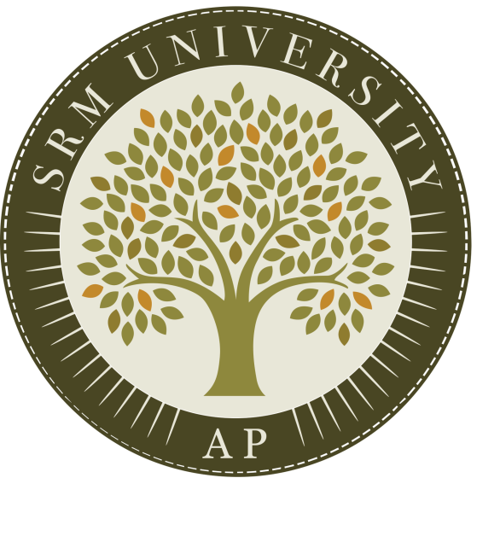
SUBMITTED BY:
Name : B.Sai Hasitha
Registration no : AP24110010908
CSE 2ND YEAR THIRD SEMESTER SECTION - Q

SUBMITTED TO
RAKESH RAMA RAJU
CODING SKILLS – I (CSE 201)

ABSTRACT
The Student Record Management System (SRMS) is a small-scale software application built using the C programming language to maintain and organize student information in a structured manner. The project focuses on implementing a simple data-handling mechanism through text files without relying on external databases. By using concepts such as structures, file I/O, and function-based modular programming, the system enables secure storage and easy retrieval of student details like roll number, name, and marks.
The system provides two levels of access—administrator and normal user. Administrators can add new entries, modify existing data, delete records, and view the complete list of students. Regular users can only access and view stored information. This role-based division improves data integrity and prevents unauthorized edits. SRMS acts as a practical demonstration of how real-world record systems operate internally and serves as a beginner-friendly project for students learning file management and data organization in C. The overall model is simple, lightweight, and effective for academic learning and simulation.
This project emphasizes how structured programming in C can be used to build a basic management system that performs essential operations with minimal complexity. By integrating file handling techniques, the SRMS ensures that all student records remain stored even after the program closes, which closely resembles the behavior of database-driven applications. The project also demonstrates how role-based access improves system reliability by making sure that only authorized users can make changes to the stored data.
The SRMS is particularly useful for beginners because it provides hands-on exposure to practical programming concepts such as persistent storage, data validation, structured data representation, and modular code design. Through this project, learners gain confidence in writing real-world style applications using simple C code, while also understanding how information systems maintain accuracy and consistency.

INTRODUCTION
In educational institutions, student-related data must be maintained in a clear and reliable manner. Manual methods such as writing records in notebooks often lead to mistakes or difficulty in updating information. To address this problem, computerized record systems have become essential. The Student Record Management System (SRMS) is designed to offer a basic digital solution using the C programming language while keeping the process simple and easy to understand for learners.
The project uses structures to represent each student and employs text files to store information permanently. A login system differentiates between an administrator and a general user, ensuring that only authorized persons can make changes to the data. Administrators are provided with options to insert, edit, search, or delete records, while normal users are allowed to only view details. This helps maintain accuracy and prevents accidental modification of student information.
SRMS introduces students to important programming concepts including file operations, user-defined functions, decision-making statements, and loops. It demonstrates how a small program can function as a data-handling system similar to larger management applications. The simplicity of the project makes it suitable for academic submissions, practical learning, and understanding how real-time systems use persistent storage for managing information efficiently.
In modern learning environments, maintaining accurate student data is an essential task, and even small institutions require a system that can organize and process information effectively. The Student Record Management System addresses this need by providing a computerized solution built entirely using fundamental C programming concepts. It offers a structured approach for handling student details and ensures that information is neatly stored and easily retrievable.
The project highlights the importance of dividing a program into smaller modules to improve readability and simplify maintenance. C language features such as structures, file pointers, and conditional logic are used creatively to build a system that works smoothly even without a database. Additionally, the system reinforces secure access by implementing a login mechanism that separates administrative tasks from regular viewing access.
By completing this project, students learn how real applications perform operations like adding, updating, and deleting information. It also teaches them how software can handle data safely and systematically, preparing them for more advanced programming projects in the future.

OBJECTIVES
The main objective of the Student Record Management System (SRMS) is to create a simple computerized platform that can store and manage student information more efficiently than traditional handwritten records. The project aims to reduce errors, improve accuracy, and make the process of accessing student details faster and more organized.
Another objective is to help learners understand how data can be saved permanently using file handling in C. By using structures and modular programming, the system showcases how even a basic program can function like a real-world record management tool. The project also focuses on building a clear separation between different user roles, ensuring that only authorized users—such as administrators—are allowed to modify records, while general users can only view them.
In addition, the system aims to provide a user-friendly text-based interface so that anyone with basic computer knowledge can operate it without difficulty. It encourages good programming practices such as modular design, validation of user input, and safe handling of stored data. Ultimately, the project’s objective is not only to create a functional record management tool but also to strengthen the student’s practical understanding of C programming and its use in building simple management applications.

MODULES
The SRMS project is divided into several functional modules, each responsible for a specific set of tasks to keep the system’s workflow simple and organized. These modules work together to handle student data efficiently while maintaining clarity in the program structure.
1. Login & Authentication Module
This module manages the identity verification process. It checks usernames, passwords, and user roles stored in a text file. Based on the login credentials, the system decides whether the user should get administrator access or standard user access. This ensures that sensitive operations are performed only by authorized individuals.
2. Student Data Entry Module
This section allows administrators to add new student records. It collects details such as roll number, name, and marks, performs basic validations, and stores the data in the student file. This module ensures that every new entry follows the required format.
3. Search & View Module
This module enables users—both admin and normal users—to search for a specific student using the roll number or view the complete list of stored records. It reads data from the file and displays it neatly on the console, helping users gather information quickly.
4. Update/Modify Module
Administrators can make corrections or changes to existing records using this module. It locates the required record, updates the necessary fields, and rewrites the modified data back to the file, ensuring that the latest information is always stored.
5. Delete Module
This module removes unwanted or outdated student records. It creates a temporary file, copies all records except the one to be deleted, and replaces the old file—thus maintaining data accuracy without leaving gaps.
6. File Handling & Data Storage Module
This core module manages all interactions with the text files. It ensures that data is stored permanently, retrieved correctly, and updated safely. It also organizes the flow of reading and writing data throughout the system.
7. Menu Navigation Module
This module provides a structured menu for administrators and users. It guides the flow of operations, ensures a user-friendly interface, and helps in smooth navigation between different features of the system.

DATA FLOW DIAGRAM
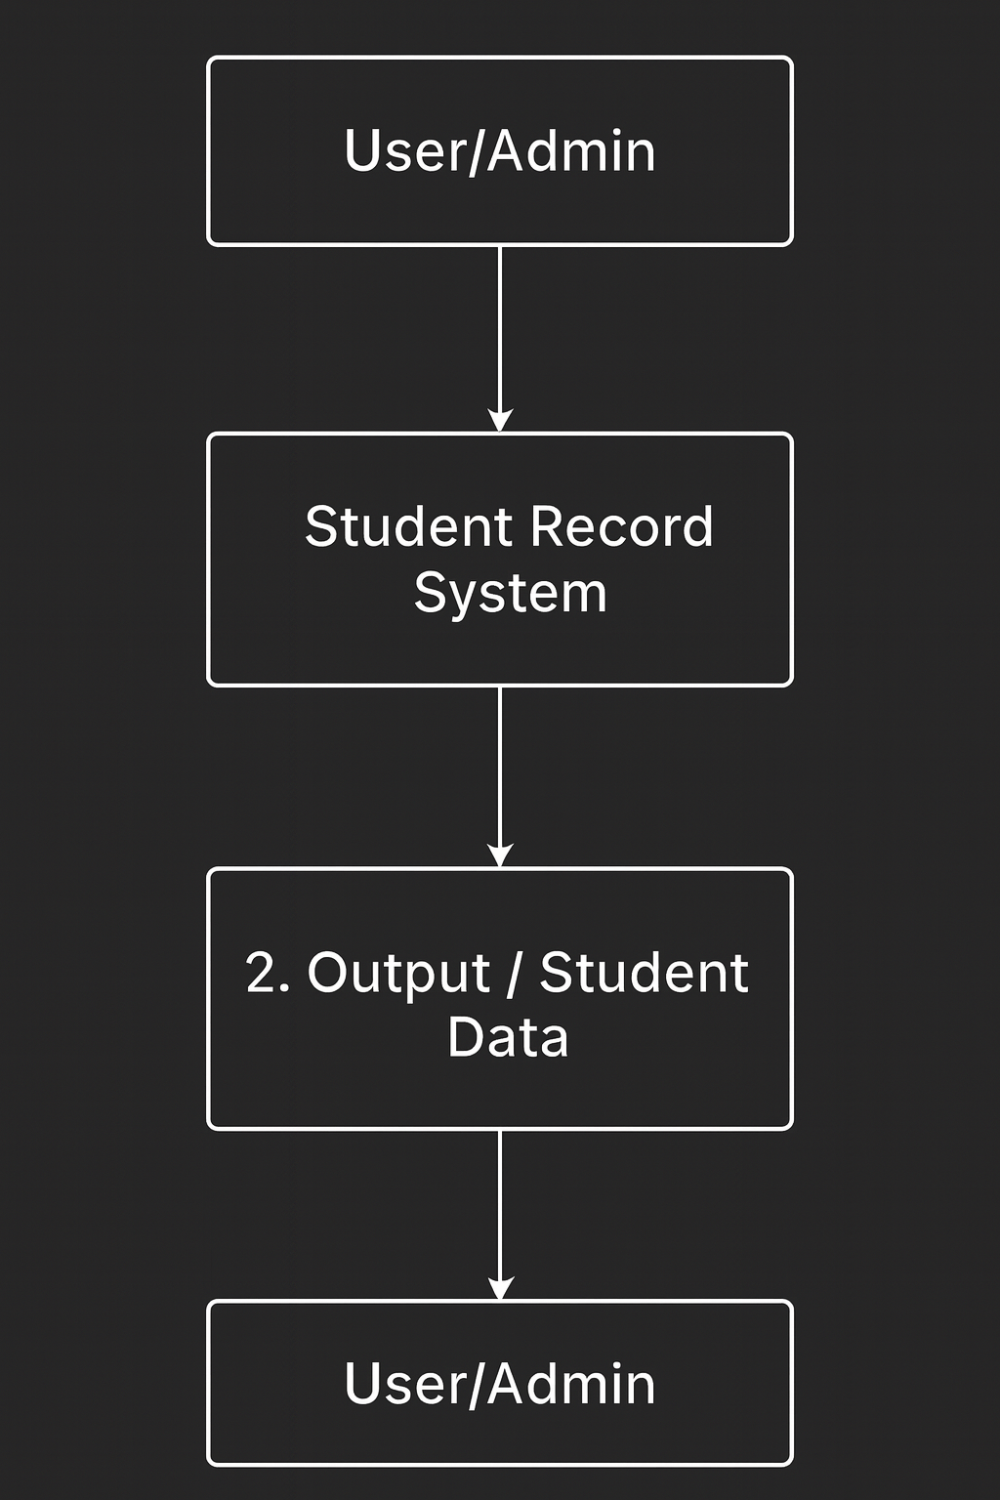

EXPLANATION :
The diagram represents the Student Record Management System as a single overall process. In this level, the user or administrator interacts with the system by providing login details or requesting operations such as viewing student data. The system processes these inputs and returns the required output back to the user. Since it focuses only on the general flow, the internal working is not shown here. It simply explains that the system receives requests, processes them, and provides the appropriate data or response.

CODES AND OUTPUTS
*User Menu:
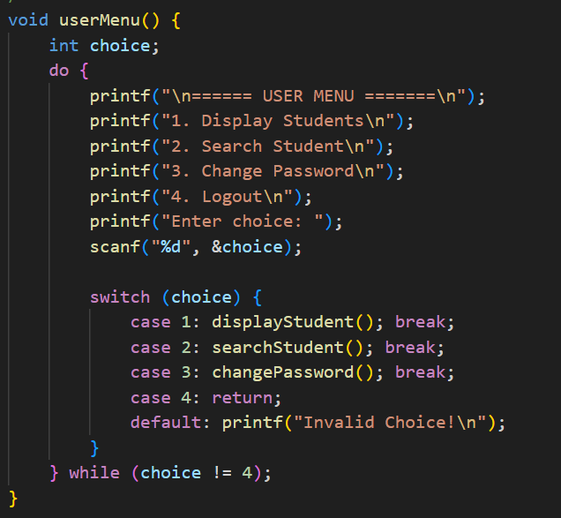
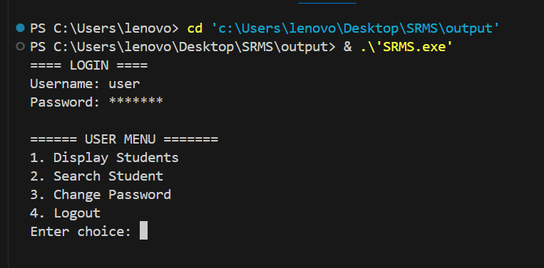

*Password:
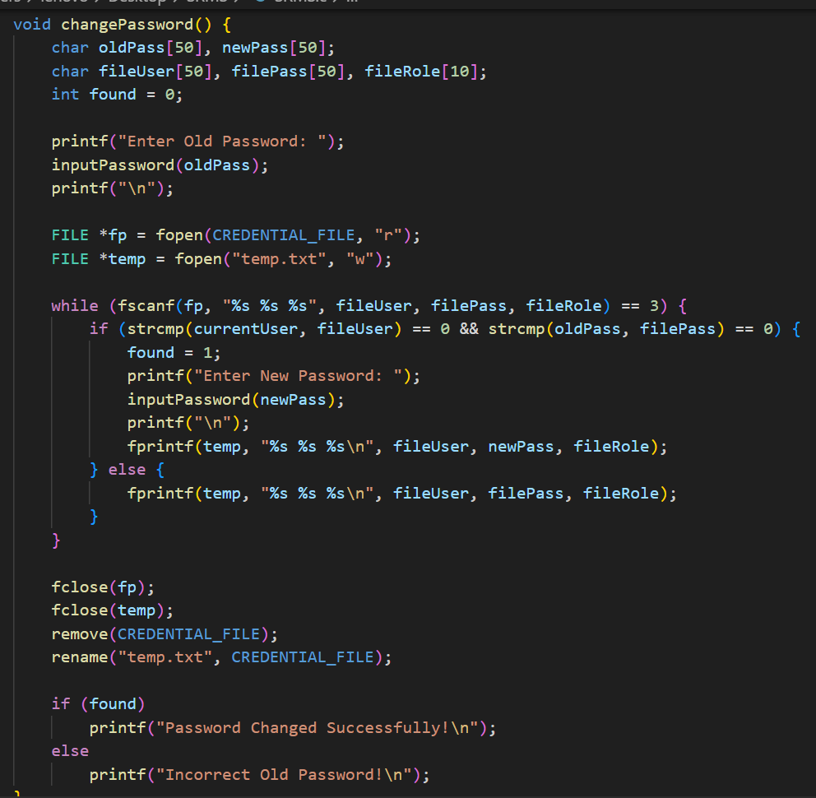
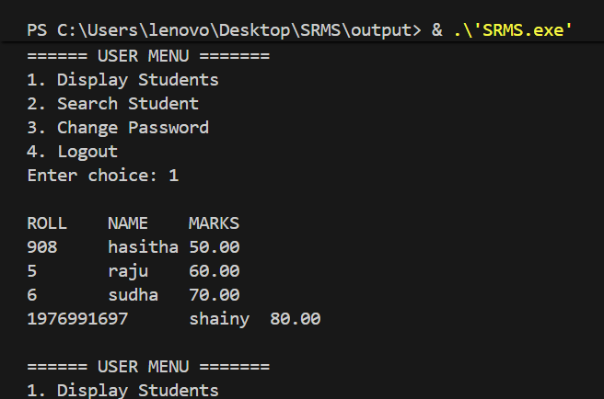
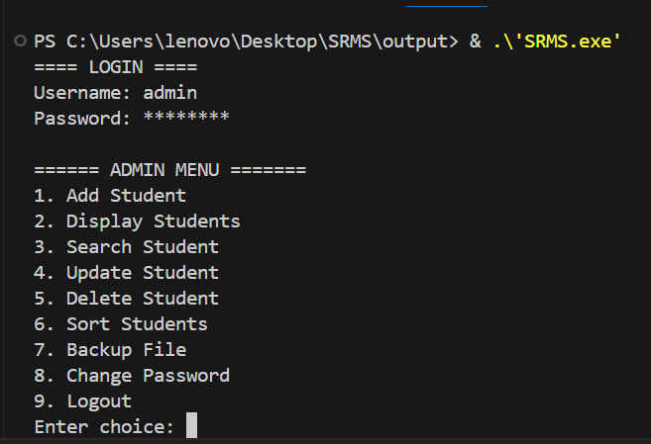

*Admin Menu:
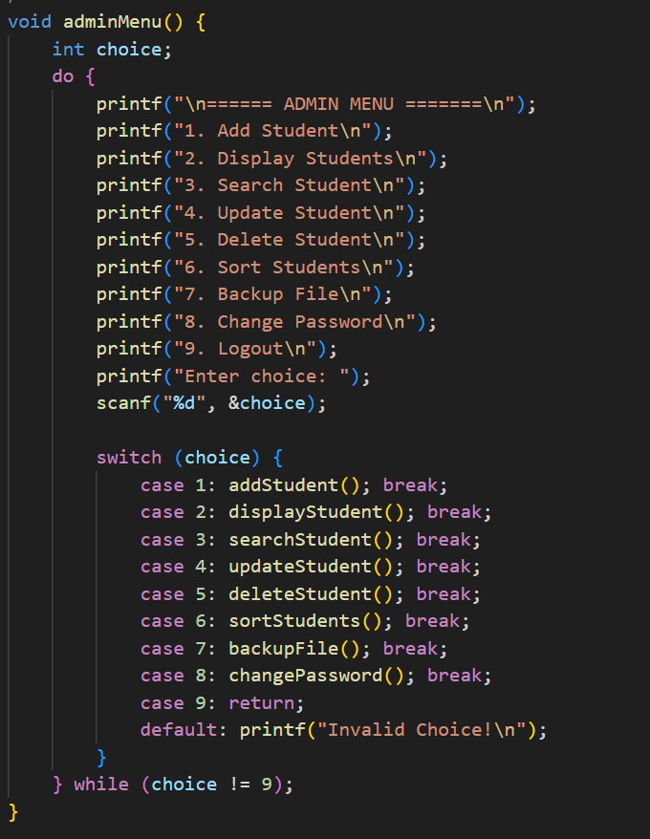
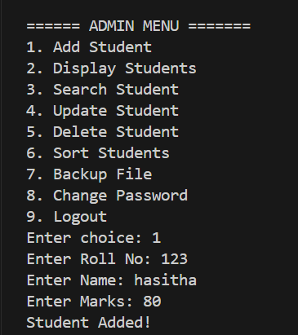

References:
TutorialsPoint. (2023). C Programming – File Handling.
Retrieved from https://www.tutorialspoint.com/cprogramming/c_file_io.htm
GeeksforGeeks. (2023). C Structures and File Handling.
Retrieved from https://www.geeksforgeeks.org
W3Schools. (2023). C Programming Basics.
Retrieved from https://www.w3schools.com/c
— Provided general reference for C syntax and functions.

CONCLUSION
The development of the Student Record Management System highlights the importance of structured programming in solving real-world problems. By creating a simple yet effective platform for managing student information, the project proves that even foundational C language concepts can be used to build meaningful applications. The system’s ability to store data permanently using text files shows how persistent storage can be achieved without advanced database technologies.
Throughout the implementation, the project demonstrates the advantages of breaking the program into smaller functional modules, which improves readability, maintainability, and ease of troubleshooting. The login mechanism and role-based access add an element of security, ensuring that only authorized users can modify sensitive data. These features not only enhance the software but also expose learners to practical considerations that arise in real software development.
Overall, the project successfully meets its goals by delivering a reliable, user-friendly, and educational application. It provides a strong foundation for beginners and opens the door to more advanced concepts such as database integration, graphical interfaces, and larger management systems. The SRMS stands as a valuable learning tool that strengthens programming logic, problem-solving abilities, and system-design skills.

