***Intelligent Software Project Management***

**Project ID : *16_098***

**Project Proposal**

**B.Sc. Special (Honors) Degree in Information Technology**

**Submitted on 09-03-2016**

**Project ID :16_098**

**Authors:**

|  |  |  |
| --- | --- | --- |
| **Student ID** | **Name** | **Signature** |
| IT13030568 | Gimhana Dewapura |  |
| IT13038724 | I.D.U.T Dharmarathna |  |
| IT13032852 | R.M.M.D Gunathilake |  |
| IT13033538 | R.G.H.K Wijewickrama |  |

**Supervisor**

………………………………….

***Mr.Tharindu Dilshan Perera***

**DECLARATION**

We declare that this is our own work and this project proposal does not incorporate without acknowledgement any material previously submitted for a Degree or Diploma in any other University or institute of higher learning and to the best of our knowledge and belief it does not contain any material previously published or written by another person except where the acknowledgement is made in the text.

………………………………….. ……………………………………….

Gimhana Dewapura I.D.U.T Dharmarathna

………………………………….. ……………………………………….

R.M.M.D GunathilakeR.G.H.K Wijewickrama

**Abstract**

First role in the software development process is the project management. The project manager doesn’t engage in a real work. The project management role helps to ensure that the software development process works as it was intended. The project management role is also very similar to development management role. So this will be easy to facilitate, encourage and the prioritize the process.

In different kinds of applications, project management programs frequently have a learning cure that raise depends on the program’s complexity. It use online management applications. Not only that but also it usually costs money to purchase quality software too. The basic tasks of the project managers are learning how to use a program’s major features. Therefore they should ensure that team members learn to use the components that they need to represent their task. As it takes a long period of time to plan a project, explain milestones, enter all the things in to the system and allocate tasks to each and every member in the team. Project management software cause amateur project managers to build up the projects which are more complex.

If you’re a traditional project manager who enjoys spending your time actually adding value to your project, rather than repeating the same routine tasks over and over, agree the success criteria with the customer, monitoring the finance, monitoring the progress, monitoring the risk, do the predictions, estimate the time and cost, generate the reports are doing in manually, you’ll want to consider advocating the concept of automating the project management role. If you are a project manager who’s committed to broadening the talent and time of the members of your team, avoiding the risk of your project falling to deliver on quality and time, you will hope to encourage your team to get the essential time and effort needed to automate the kinds of jobs that will be emphasizes in this research.

As the result of above responsibilities we are willing to automate the project management role via this research .That is the criteria we are mainly focusing through this research. Automating the above each and every responsibilities can provide real value to software development projects. In this research, we will explore the value of automation and provide some guidance for automating aspects of the development process. As the result of this research we will be able to run any kind of software project without having a project manager role.

Table of Contents

1. INTRODUCTION 6

1.1 Background 7

1.2 Literature Review 9

1.3 Research Gap 14

2. OBJECTIVES 16

2.1 Main Objectives 16

2.2 Specific Objectives 17

3. RESEARCH METHODOLOGY 18

3.1 Text mining System 18

3.2 Extract Mentioned Requirements 20

3.3 Build up a knowledge base system 22

3.4 Generate Software project management predictions 25

4. DESCRIPTION OF PERSONAL AND FACILITIES 28

5. REFERENCES 29

## 1. INTRODUCTION

### Background

In previous different types of software projects were managed through the Gantt Charts, and project management techniques and tools by the project manager. As the example, some of the responsibilities of project management roles such as adding the value to the project, gathering user requirements, developing the use cases, monitoring the risk management, do the predictions, estimate the time and cost, generating reports are processing in manual way. There isn’t any automation system for that process. In modern project management tools and techniques were improved to more professional and modern solutions. With the globalization and vast IT industrial revolution, software project management solution are in huge demand throughout the world to complete project within a defined scope, time & cost constraints.

Now a day’s many companies use various types of software project management systems to increase the efficiency of their products. Company run a set of software projects at a time and needs input from teams or group of individuals for a multilevel development plan. Hence a good automated project management system is needed.

Automated project management system represent a fast growing technology in IT field. With the involvement of users ,who utilize the project management applications helps to build, web based project management system enter a major role in a large number of companies .Therefore automated project management systems gives high quality web applications for customers and it will helps ensure the durability too. Developing a web based automated project management system helps users to handle projects in a convenient way without the help of any project manager. The reliability and the robustness of the automated web based project management system offers lots of advantages to the organization or user who is willing to use our product. A web based project management system has also been developed, which highly meets the standard and requirements set by the user. In here customer needs are basically the most important to understand , how to analyze the requirements, produce a design and go about development and testing so that the system you deliver is a high quality and does what the client wants it to do. In here we extract the customer requirement through the documents, especially or user can easily add the requirements what they need. Those requirements can be ambiguous or may be unnecessary requirements. Ontology engine will grab those requirements from the designing diagrams or from the single lines which are in the documents. According to the inbuilt methodology ontology engine decide all the possible and essential requirements through the each and every diagrams without any duplications of the same requirements. As the output it will release the finalize unambiguous unique requirements according to the user priority.

Another important part of this system is automated prediction generator. One of the most important thing of the project management includes is risk management of the project. In lots of projects risks are analyzed and identified in a random way. This is a massive problem because unexpected risk can be arise.so for avoiding that we do the automated risk prediction for each and every activity. As well as this system will predict the time consuming and estimate the project cost. According to this automated software project management system can surprisingly increase performance, productivity and efficiency within an organization without a project manager.

.

### Literature Review

In the modern world the project manager plays a crucial role in an organization, so to enhance the effectiveness of the role many tools and softwares have been introduced. Even though there are several softwares and tools for project management in the world, according to the literature survey done no organization or person has used ontology to output the decisions of a project manager. When considering the roles of project manager, handling of documents play a major role.

According to the “The Text-To-Onto Ontology Learning Environment” by Alexander Maedche and Steffen Stab the main components of a text mining system are “Text and Processing Management”, “Text Processing Server”, “a Lexical Database and Domain Lexicon”,”Learning Module” and the “Ontology Engineering Environment Onto Edit”

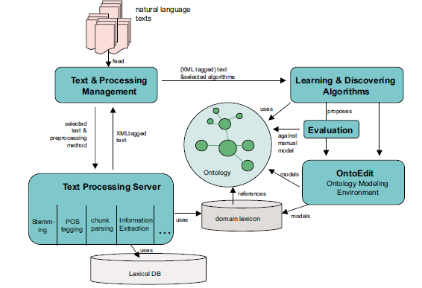

Figure 1.2.A

This system has been evaluated and applied for building domain ontologies in the tourism and the insurance domain[14].

Texts are considered as “bag of words” by search engines. Search engines do not take into account semantics of text documents when performing indexes and searching. The language to express queries is artificial: a set of key words. Its semantics is very far from the semantics of any natural language. The most popular techniques utilized by search engines’ developers include;

* Vector space model
* Boolean model
* Probabilistic model.

Morphological analyzers can be used to convert the texts into functional style. Morphological information helps define word meaning [15].

Communication is a crucial aspect of co-operative work, and several studies provide evidence that engineers spend 40±66% of their time communicating in order to get input to their work and to output results from their work. The most frequently cited barrier for seeking both oral and written information is cost/time. Morten Hertzum and Annelise Mark Pejtersen propose to classify design information according to a model involving two dimensions Ð stakeholder domains and levels of abstraction Ð and hypothesis that design documentation is strongly biased toward technical descriptions of the resulting product (i.e., the lower abstraction levels of the manufacturing domain)[16].

Although the researches have been concluded in information summarizing retrieval and extracting regarding to many areas in the world it is still new to the project management area.

Extract mentioned requirement is one of the important part of this research. We decide to use diagrams for this function, first we need to separately identify inputted diagrams. This identification done using shapes inside those diagrams. when we read research papers, we could be collected some information about this shape identification [6]. We can use image processing area to identify shapes. Makoto Sato [7] already have developed to identify inputted shape comparing with encoded data that store in image database. in this above mentioned method has some problems, when the number of test images is large or each image size is large, search speed lower, but this method is not related to the software project management area. In this research we will hope to develop a method to identify shapes and using those identified shapes we can separately identify inputted diagrams.

After identify the diagrams, we need to extract information from that diagrams such as diagram name, relationships, requirements etc. we can use information extraction method for this task. In here we need to extract information from images. When we use research papers, we can find different ways to extract text from images. But they are not related to Software project management area. Extraction of this information involves detection, localization, tracking, extraction, enhancement, and recognition of the text from a given image. However, variations of text due to different in size, style, orientation, and alignment, as well as low image contrast and complex background make the problem of text extraction [10]. Image content can be divided into two main categories, perceptual content and semantic content. Perceptual content includes attributes such as color, intensity, shape, texture, and their temporal changes, whereas semantic content means objects, events, and their relations [10]. Text are belonging to the semantic content. In here we will hope to use these methods to extract text from images [8] [9]. After extracting we should map that extracted information in correct way as in image.

In modern IT world, knowledge base information extraction is being became one of the most fast growing tool for buildup successful desktop application or web base application. It is totally based on specific domain. In modern world, different type areas such as e-commerce systems, health care systems, and financial systems supposed to use of knowledge base information extraction system. Because it increases an efficiency of the final output. According to our research area we decided to apply a knowledge base systems to our automated software project management system. When we do any software project, project manager control each and every activity. He has got lots of responsibilities of it. To get successful final output, requirements that supply from the client is the main factor that affect to achieve the goal with successful. To achieve above goal we decided to build up a knowledge base system. In current software project management systems, they don’t handle the requirement gathering in automated way. In this case, use of knowledge base system is support for knowledge extraction in automated way [3].

Information extraction systems enable to identify entities within document (e.g. ‘Client’ is a ‘Person’, login is a verb.)However, those information is of little use without acquiring the relation between these entities (e.g. ‘Client is logging to the system’).Extracting those kind of relations automatically is difficult, but crucial to complete the acquisition of knowledge fragments and ontology population [3].

It will show this ontology have a major role in mapping information. This is a major area which is growing in academic activity to build up the principles to present the modeling of domain in the particular area [6]. Basically knowledge base system consists of their own relations, definitions and own properties [6].

Ontology can be divided as highly informal, and semi informal, semi-formal and rigorously format. High informal ontologies are expected in natural language.

On a typical IT project, the overall project manager has to manage many different disciplines and functional areas that eventually have to work together for the success of the project. Compound this multi-disciplined deliverable set is always on the critical path, and it is easy to see why a project manager is extremely important to the success of the project [11]. Hence the tasks which is done by a project manager should be properly managed, well organized and most importantly should meet the deadlines and finally completed on time.

Automation is key to cost-savings, however; because of the automation capabilities, less employee time is spent on project management, requiring either less staff or allowing staff to focus on other, more profitable tasks. Automation also means that information is available all the time. Instead of having to ask someone a question about a task, the user can go into the program and see the status. That way, if someone is on vacation, ill or tied up in meetings, the project still can continue to run.

The most famous research on prediction was done by Philip Tetlock of the University of Pennsylvania, and his seminal 2006 book [Expert Political Judgment](http://www.amazon.com/Expert-Political-Judgment-Good-Know/dp/0691128715) provides crucial background. [12] However several people has done researches on prediction and they came with absolute results. According to our research we are going to make predictions through the system itself. Normal scenario of making predictions in software project management is project manager will go through past completed projects and make decisions depend on them. It is more time consuming and not a realistic method. Even though there are some software project management tools there is no such a proper tool where we can get all kind of valuable predictions that we must know.

PMI’s Pulse of the Profession™ research, which is consistent with other studies, shows that "less than two-thirds of projects meet their goals and business intent (success rates have been falling since 2008), and about 17 percent fail outright. Failed projects waste an organization’s money: for every US$1 billion spent on a failed project, US$135 million is lost forever…unrecoverable." [13].We can clearly see that how making successful predictions are going to help to complete the project successfully and also keep the reputation of the company.

In this making predictions function user can view all the details of the project in a single interface and just by looking at it he can get an idea of the overall project. How each and every task goes with time, success rate of the project, risk analysis, developer efficiency etc. The system will send notifications when things run behind schedule, as well. Should a task not be completed on time, an email will be sent to all designated parties. Surprises are kept to a minimum, and problems can be resolved more quickly.

### Research Gap

Currently project managers of companies face different kind of problems and even though some of them are smaller kind of issues it costs both the company and the project. So somehow these issues have to be solved in order to come up with a better project. As we all know generally a project manager has to involve in the project from the very beginning and manage it through the entire time period until it is completed. So then his time is wasted unnecessarily and that is also a cost to the company too. Likewise still project managers have to undergo several obstacles whether they like them or not. Currently there are several researches have been done related to project management and but most of them have limitations in some aspect. None of them are not implemented to do the project management process fully automatically. So here what we are trying to achieve is bridge the gap to automate the whole process of managing the project. Hence the tasks which are done by the project managers will be maintained in an effective way since they are monitored by the system automatically. Ultimately the system will become the active project manager of the company because it is handling the every phase project management by own.

* 1. **Research Problem**

In this research, we are going to automate some of the software project management methods. The main requirement of this research is to find a solution for problems associated with Requirement Gathering, Analyzing Documents, Generating User Stories and Prediction such as cost, deadline, risk management etc. The above mentioned things are done by manually by project manager. This improvement needs to be more reliable, efficient, secured and consistent. There is a separate person or group for the Requirement Gathering and Generating User Stories. That person or group arrange the meeting with the client and gather the requirements. According to that gathered requirement, Team members should build UML diagrams. Then using these UML diagrams, Requirement Engineers create the SRS document and submit to the client. This is the normal scenario that Software Company has to follow. This is the low efficient, high cost, high risk and time consuming way, and also requirement can be misplaced. That mean, all of the requirement are in the SRS document but those requirements are not finalized. When we consider about Analyzing Documents, Project manager or Requirement Annalistic go through the all the pages of the document to find specific area. This is the time consuming cost wasting way. These are the limitation of the manual project management. We can avoid above mentioned limitations by using this product.

## OBJECTIVES

### Main Objectives

* **Requirement Gathering**

In here requirements are gathered using the documents provided by the client and using text areas reserved for clients on the web application new requirements are gathered.

* **Resource Management**

Resources Management are done using allocating them to the correct places at correct time calculating in what amounts they have to be allocated.

* **Efficiency**

Efficiency is handled using continuously monitoring the work done by employees and monitoring how budget is moving.

* **Cost Reductions**

Cost spent on project managers are reduced to a great extent

* **Time Management**

Time spent in requirement gathering and analyzing is reduced, time spent on user stories creating is reduced.

* **Risk Management**

Risk Management is done using taking better decisions.

* **Report Generation**

Reports are generated using the provided data, and self-analyzed data.

* **Predicting Decisions**

Decisions are predicted using the budget provided, resources provided and the deadline of the project.

* **Generating User Stories**

User stories are generated by sending the requirements gathered via the ontology engine.

* **Generating Budgets**

Budgets are generated according to the requirements provided and the total amount of money allocated to the project.

### Specific Objectives

* Learning about text mining and coming up with methods and algorithms to summarize data provided in the documents, find specific areas when stakeholders provide key words and matching the requirements provided with the output user stories from the ontology engine.
* Learning about ontology mechanism and coming with algorithms to make ease of the work happening inside the ontology engine, in here requirements gather from diagrams such as use case stories, activity diagrams etc. provided by the developers are analyzed and output user stories are sent to the text mining system to match with its requirements.
* Learning about predicting mechanisms, in here data from text mining system and ontology engine is taken as inputs to the predicting system and using them the predictions such as budget allocation, resources allocation, sprint predictions etc. are done.

## RESEARCH METHODOLOGY

### Text mining System

This system basically concentrates on the tasks related to the document side of a project such as “how to store documents precisely”, “how to synchronize documents to the project management system”, “Summarizing documents ,”search documents” and “matching user stories with the client’s requirements according to the provided documents”. The below mentioned description will give a clear idea about the text mining system.

* Storing Documents

In this function the client allows to send the documents related to the project, and the sent documents are stored in a database precisely. The way of storing the documents is the important matter here, for this have to move along with an algorithmic approach. Using several algorithms documents of the project are stored so it can be retrieved quickly when it is needed by somebody.

* Synchronize documents with the project management system

In the first function mentioned, documents are stored precisely, so in the second function what is going to happen is, the stored documents are synchronized with the project management system, so in here synchronizing is attaching of the documents to the system, so whenever a person need a documents, that person can go to the text mining system and can access that documents, this system is sunk in main project management system.

* Options choosing in the system

In here the person who is accessing the text mining system is allowed to choose options, since it does have 2 selecting options such as “selecting summarizing option” and “selecting docs using keywords.

* Selecting summarizing option

In here the person who is accessing is allowed to take summarized reports of the lengthy reports provide.

* Selecting docs using keywords

In here the person who is accessing is allowed to get required reports for the task by providing keywords related to the docs.

* Matching final information with the client requirements

This is the main research area from the above mentioned functions. Final information are generated as a result of the mechanism inside the ontology engine. Clients requirements also have gathered using the analytical techniques used in the text mining system. So in here there are 2 types of final requirements such as, requirements mentioned in the final information and the requirements gathered using the documents related to the project, to give a better output these both requirements have to be matched. This function allows the project management system to check the above mentioned two types of requirements whether they are matching.

### Extract Mentioned Requirements

There are several software project management methods that use in software companies such as waterfall, Agile etc. In here, we are going to automate some of that project management methods. When we consider about this methods, project team members prepare some UML diagrams. As an example, think about use case diagram. Suppose team has five members and they prepare use case diagram for same function but these use cases are different from each use cases and different use case diagrams can have same information. In here, what we are going to do is, scan all the diagrams and extract information from those diagrams, then compare this extracted information to identify the duplicated information (requirement). That mean this is not based on the type of the UML diagram.

First step is to store the unique shapes in the database according to the UML diagrams. This stored shapes are encoded. They must be decoded to detect their features like edge information [7]. Then input the image of the UML diagram and identify the shapes boundaries and generate query data. Identification of the shape is done by using the boundary line of the shape [6]. Shapes can be square, oval, arrow, diamond, circle etc. Then these identified shapes compare with the unique shapes that are stored in the database to determine which type of the UML diagram is, such as activity diagram, use case diagram, class diagram etc. this is done by compares the query data with encoded data of a shape read out from an image database [7].

According to the UML diagram, extract the information (text) that are inside the shapes. Text data present in UML diagram images contain useful information (requirements) to develop the software product. Extraction of this information involves detection, localization, tracking, extraction, enhancement and recognition of the text from given images of UML diagrams [10]. Final outcome will be the type of the UML diagram and extracted information (requirement).

Identify diagram

Input diagrams

Output the diagram name & extracted information

Extract the information from particular shape

(Text)

### Build up a knowledge base system

An ontology have become a major and fast growing tool for developing useful applications.It describe and represent an area of knowledge. Ontologies are based on some domains(a domain is a specific subject area or area of knowledge like health, e-commerce , science etc.).The reason ontology is becoming famous is that particular domain can be communicated between human and the application system. Because ontology aims for a domain knowledge. [1] .According to this research we will develop an ontology to identify all of the unique ambiguous user requirements and build up the final user stories. Ontology is supporting for the knowledge extractions to build up our final product. According to this case there are three key areas can be identified. Knowledge extraction tool used to extract the appropriate data together with paragraph and sentence from the documents. And knowledge extraction tool is the first key area. As the second key area separated details are send to knowledge based system with metadata derived from the vocabulary of the knowledge base system. Managing the information and storing the data is the major task in second key area. Narrative generation is the final key area.

To develop the knowledge base system there are different editors are available. We have decided to use Protégé editor as our ontology creation tool. It is free and open source ontology editor and a knowledge based system[1]. Protégé use OWL ontology language. It is a language which is defining ontologies on the Web [2]. OWL ontology supposes to describes a particular domain in terms of classes ,properties and individuals and rich description of the characteristics of that objects[2].Reasons of using OWL ontology language is , open and extensible , can distribute among many systems and matching with web standards. In creation of ontology we define classes and subclasses in word set and map relations in between those words. According to our context of ontology we are using to grab the similar meanings which are given by different words and as a knowledge based information extraction.

As the example,

let’s assume the word called “author” is used to identify a person. But it can be given the same meaning as “book writer ”. In here we are going to identify those words which gives similar meanings. Now we are going to map those identified key words in to a suitable classes

How to mapping with in OWL concept?

Client login to the system.

(gathered requirements)

**Apple Pie Parser**

System , Client -> noun

login-> verb

**Gate**

Client -> person

**WordNet**

Login -> activity

**Submit a query**

Person – activity -> login

**XML**

**<system>  
 <person>Client</person>  
 <activity>login</activity>  
 </system>**

The Apple pie Parser used for grouping grammatically related phrases as the result of syntactical analysis [3]. Semantic examination then locates the main components of a given sentence (e.g.: subject, verb, object) and identifies named entities (e.g.: Client is a person, login is activity) using GATE and WordNet. Then submits a query to the ontology server to obtain such knowledge.

### Generate Software project management predictions

When managing software projects in certain situations we need to make useful predictions. Even though they are not 100% correct those predictions should be more accurate in order to come up with a successful project. Because based on them we can make proper decisions and get a clear idea about the project before starting the project to manage. If we can make those predictions before the beginning of the project then the success rate of the project is high [11].

Predicting project completion times is one of the major challenges project managers face. Project schedule overruns are quite common due to the high uncertainty in estimating the amount of time activities require, a lack of historical data about project completion, organizational culture, inadequate skills, the complex and elaborative nature of projects, and many other factors. [12] This historical data can be extremely valuable to the estimating of processes.

After creating the final requirements they will be analyzed by the system automatically and compared with the past project’s data. By going through all the projects which has done earlier system generate predictions corresponding to the current project. It will make important predictions such as

* Total estimated budget
* Who are the suitable developers to the project
* Risk analysis
* Total duration to complete the project
* Success rate of the project etc.

At the beginning it will show these predictions and possible outcomes by using several data mining algorithms and after that system will automatically begin to manage the project. It will send notifications to the respective developers by mentioning his/her task and then system will keep a track of ongoing process of all the developers of the project. At the same time a notification will be send to a senior manager which is handling the project mentioning the allocated developer crew and their developer efficiencies which is predicted by using their past work. According to that he/she can manually make the changes of the project. Most important thing of these predictions is predicting the success rate of the project. That is very much needed because we must know that if the project can be completed at the given time and successfully

meet the deadlines when it is managing. In a timeline user can see the ongoing progress of the current handling project. Timelines can be very helpful for more visually-oriented people. The time line is directly correlated to the scope of a project. It will also give you the ability to adjust your timeline and schedule appropriately throughout the project’s duration based on real-time data, making the process extremely transparent to the entire team, including your client [13].

It also generate charts of the current project and it will manage the risk analysis. If a project is a very large one then the probability of failure of the project is high. Hence we need to come up with better predictions such as managing the duration for each task, risk analysis, suitable developers etc. in order to deliver the project on time without defects.

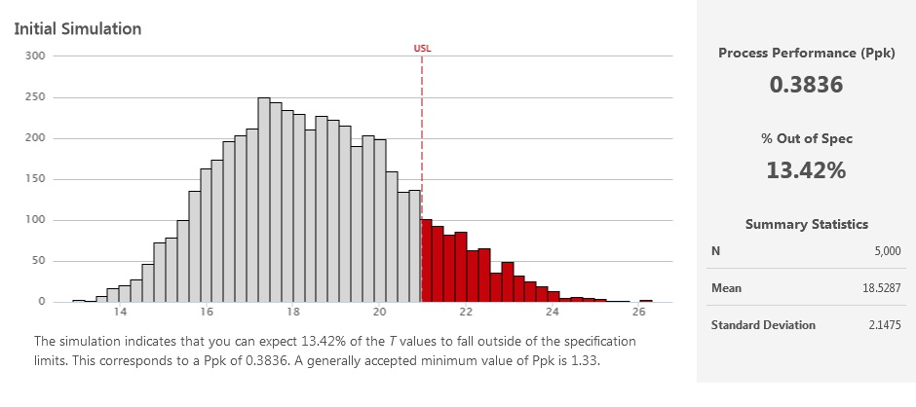

The significant factor of this system is it will make all the predictions automatically and periodically it will check the progress of the overall project automatically. So then there is no user involvement. In a well-organized dashboard it will show all the current updates of the project. By maintaining a graphical view of project management both the user and developer can easily track what is going on with the project. If there are any delays in certain tasks then system will send notifications for the developer and also to the senior manager.

At the end system will generate a detailed report including the cost of the project, duration took to complete each task, developer efficiency, risk analysis etc.

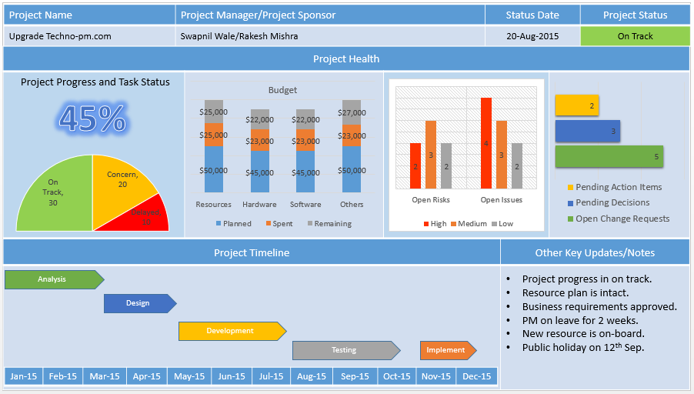

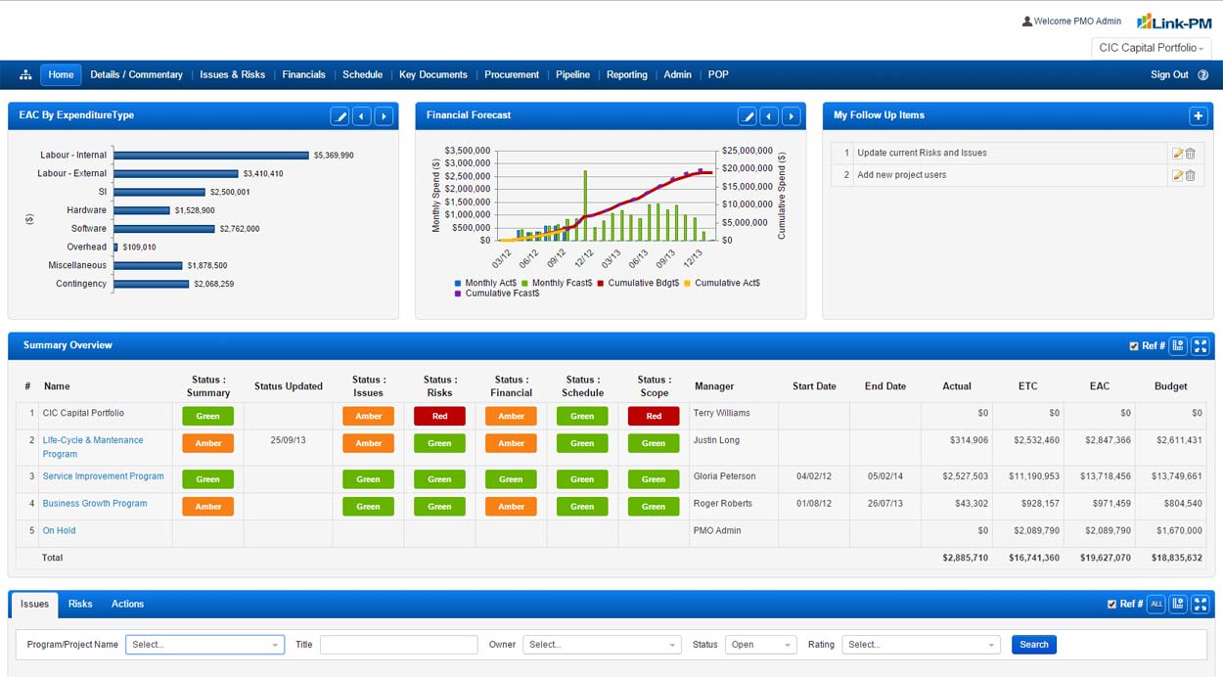

## DESCRIPTION OF PERSONAL AND FACILITIES

|  |  |  |
| --- | --- | --- |
| **Member** | **Component** | **Task** |
| Gimhana Dewapura IT13030568 | Text mining System | 1.summerizing 2.information extraction and retrieve.  3.anlysis the data. |
| I.D.U.T Dharmarathna IT13038724 | Extract mention requirement | 1.indentify the diagrams. 2.extract information. 3.out put map requirements |
| R.M.M.D Gunathilake IT13032852 | Build up knowledge base system | 1.identify requirements. 2.idenfiy the similarities. 3.remove the duplications. 4.finalize the unambiguous requirements. |
| R.G.H.K Wijewickrama IT13033538 | Predictions using present time previous data. | 1.Analyze and finalize the requirements.  2.Go through previous records.  3.Cost prediction ,estimate time and risk analysis. 4.Show notifications. |

**Ghantt chart**

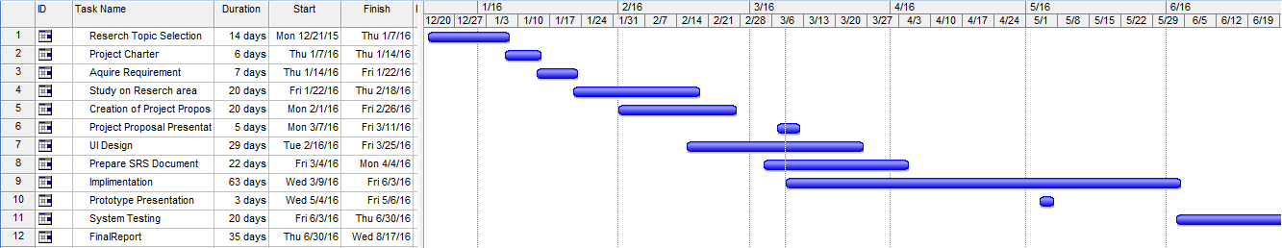

## REFERENCES

1. Kaushal Giri, “Role of Ontology in Semantic Web ” , DESIDOC journal of Library Information Trchnology,Vol.31,No. 2,pp.116-120,March 2011.
2. Rene witte,Ninus Khamis, and Juergen,”Flexible Ontology Population from Text:The OwlExporter”,www.Irec-conf.org,http://www.lrec-conf.org/proceedings/lrec2010/pdf/932_Paper.pdf
3. Alani,Harith; kim,Sanghee; Millard, Dacid E; Weal J; Hall,Wendy; Lewis, Paul H. and Shadbolt Nigel R.(2003).Automatic ontology-based knowledge extraction from web documents. IEEE Intelligent System,18(1), pp. 14-21.
4. Anne-Mai Aadamsoo,Web Based Project Management System.VAASAN AMMATTIKORKEAKOULU ,UNIVERSITY OF APPLIED SCIENCES,2010,1.
5. Joselice Ferreira Lima,Cleia M.Gomes Amaral, and Luis Fernando R. Molinaro, “ Ontology:An Analysis of the Literature ” , link.springer.com , <http://link.springer.com/chapter/10.1007%2F978-3-642-16419-4_44#page-1>

1. Carl Sant'Anselmo, Robert Sant'Anselmo, David C. Hooper “Identification symbol, system and method” U.S. Patent 5 612 524, March 18, 1997.
2. Makoto Sato “Image retrieval by comparing wavelet encoded database images with input shapes” U.S. 6 532 307 B1, March 11, 2003.
3. David Moon, Keith Bradbury, George Vranješević. (1998, May 18). Extract Text from an Image (2nd ed.) [Online]. Available: <http://www.investintech.com>
4. Yu Zhong, K. Karu, A. K. Jain. (2005, Aug 16). Locating text in complex color images (2nd ed.) [Online]. Available: <http://ieeexplore.ieee.org>
5. Keechul Jung, Kwang InKim, Anil K. Jain “Text information extraction in images and video”, Oct 28, 2003.
6. Emily Wheeler , “Three Benefits of Automated Project Management” , 2012 , <http://www.nationalservicecenter.com/?wpdmact=process&did=Mi5ob3RsaW5r>
7. Ondiappan Arivazhagan, "Ari", Honors graduate in Civil / Structural Engineering from University of Madras.He is a certified PMP, PMI-SP, PMI-RMP from PMI, USA. 26 March, 2015 , <http://blog.minitab.com/blog/statistics-in-the-field/making-better-estimates-of-project-duration-using-monte-carlo-analysis>
8. Brian Jackson , August 11th 2014 , <http://www.itbusiness.ca/blog/5-ways-to-more-accurately-forecast-with-project-management-software/50306>
9. Alexander Maedche , and Steffen Staab, “The TEXT-TO-ONTO Ontology Learning Environments”,<http://search.easydialsearch.com/search?q=The%20Text-To-Onto%20Ontology%20Learning%20Environment>, <http://citeseerx.ist.psu.edu/viewdoc/download?doi=10.1.1.2.2806&rep=rep1&type=pdf> .
10. Vitaly Klyuev and Vladimir Oleshchuk, “Semantic retrieval: an approach to representing, searching and summarising text documents”, <https://scholar.google.com/scholar?hl=en&q=Semantic+retrieval%3A+an+approach+to+representing%2C+searching+and+summarising+text+documents+&btnG=&as_sdt=1%2C5&as_sdtp>=,

https://www.researchgate.net/profile/Vladimir_Oleshchuk/publication/264817692_Semantic_retrieval_an_approach_to_representing_searching_and_summarising_text_documents/links/5409967c0cf2822fb739eadb.pdf

1. Morten Hertzum and Annelise Mark Pejtersen, “The information-seeking practices of engineers: searching for documents as well as for people”, <https://scholar.google.com/scholar?q=searching+inside+documents&btnG=&hl=en&as_sdt=0%2C5>,

http://citeseerx.ist.psu.edu/viewdoc/download?doi=10.1.1.618.8660&rep=rep1&type=pdf