网络通信实验报告

作者 : 王彬(10161043 软件03)
联系电话 : 15291686564
提交日期 : 2013-6-13

实验题目：
Socket网络编程
实验内容：
Image communication based on TCP and UDP,comparing the consumed time;
即：使用套接字TCP通信以及UDP通信，记录并比较两者的耗时；
实验要求：
    - 使用课上讲述的Socket，建立TCP以及UDP通信；
    - 记录TCP以及UDP通信的消耗时间，分析原因；
    - 分析TCP以及UDP通信的区别；
运行环境介绍：
语言：C#
集成环境：CSC
操作系统：WIN7
关键算法：
由于之前使用过一些Socket编程，所以尝试使用异步模式和同步模式的结合。
【解释：
异步通信：
在通信中，“异步通信”是一种很常用的通信方式。异步通信在发送字符时，所发送的字符之间的时间间隔可以是任意的。当然，接收端必须时刻做好接收的准备（如果接收端主机的电源都没有加上，那么发送端发送字符就没有意义，因为接收端根本无法接收）。发送端可以在任意时刻开始发送字符，因此必须在每一个字符的开始和结束的地方加上标志，即加上开始位和停止位，以便使接收端能够正确地将每一个字符接收下来。异步通信的好处是通信设备简单、便宜，但传输效率较低（因为开始位和停止位的开销所占比例较大）。
同步通信：
“同步通信”的通信双方必须先建立同步，即双方的时钟要调整到同一个频率。收发双方不停地发送和接收连续的同步比特流。但这时还有两种不同的同步方式。一种是使用全网同步，用一个非常精确的主时钟对全网所有结点上的时钟进行同步。另一种是使用准同步，各结点的时钟之间允许有微小的误差，然后采用其他措施实现同步传输。
】
首先是项目的总体结构：
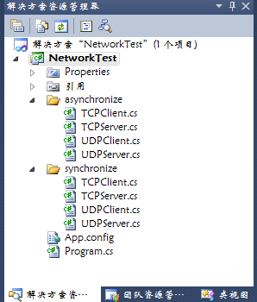
在异步包中包含了TCP异步以及UDP异步，类的结构如下：
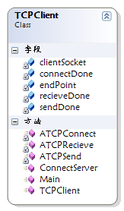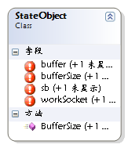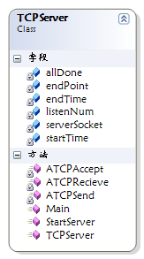
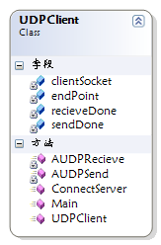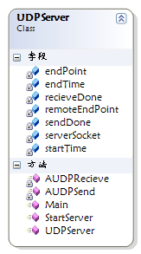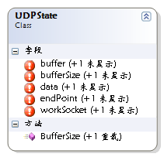
在同步包中包括了同步TCP以及同步UDP，类结构如下：
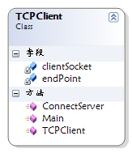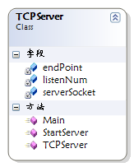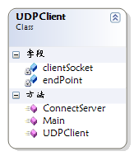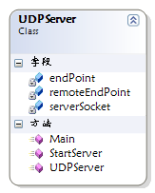
相比之下，同步的通信比较简单，所以我们首先关注同步通信：
TCP同步通信涉及到服务器以及客户端:
服务器部分：(1) 创建套接字；
(2) 绑定套接字到一个IP地址和一个端口上(bind())；
(3)将套接字设置为监听模式等待连接请求(listen())；
(4)请求到来后，接受连接请求，返回一个新的对应于此次连接的套接字(accept())；
(5)用返回的套接字和客户端进行通信(send()/recv())；
(6)返回，等待另一连接请求；
(7)关闭套接字。
客户端部分： (1) 创建套接字；
(2) 向服务器发出连接请求(connect())；
(3) 和服务器端进行通信(send()/recv())；
(4) 关闭套接字。
代码如下：
服务器：
using System;
using System.Collections.Generic;
using System.Linq;
using System.Text;
using System.Net;
using System.Net.Sockets;
namespace NetworkTest.synchronize
{
/// <summary>
/// TCP同步通信的服务类
/// </summary>
class TCPServer
{
private Socket serverSocket;
private IPEndPoint endPoint;
private int listenNum;
public TCPServer()
{
serverSocket = new Socket(AddressFamily.InterNetwork,SocketType.Stream,ProtocolType.Tcp);
string serverIPAddress="127.0.0.1";
string serverIPPort="8090";
endPoint = new IPEndPoint(IPAddress.Parse(serverIPAddress),int.Parse(serverIPPort));
listenNum = 20;
}
/// <summary>
/// 开启服务器
/// </summary>
public void StartServer()
{
serverSocket.Bind(endPoint);
serverSocket.Listen(listenNum);
System.Console.WriteLine("服务器启动，等待客户端的连接...........");
Socket clientSocket = serverSocket.Accept();
DateTime startTime = DateTime.Now;
byte[] buffer = new byte[1024];
int dataLength=clientSocket.Receive(buffer);
string data = Encoding.ASCII.GetString(buffer,0,dataLength);
IPEndPoint remoteEndPoint=(IPEndPoint)clientSocket.RemoteEndPoint;
System.Console.WriteLine(remoteEndPoint.Address+":"+remoteEndPoint.Port+" say :"+data);
string sendData = @"I Have Got It!";
byte[] sendbuffer = new byte[1024];
sendbuffer = Encoding.ASCII.GetBytes(sendData);
clientSocket.Send(sendbuffer);
dataLength = clientSocket.Receive(buffer);
data = Encoding.ASCII.GetString(buffer, 0, dataLength);
System.Console.WriteLine(remoteEndPoint.Address + ":" + remoteEndPoint.Port + " say :" + data);
System.Console.WriteLine("通信结束..........");
DateTime endTime = DateTime.Now;
TimeSpan span = endTime - startTime;
System.Console.WriteLine("使用时间（微秒）:"+span.TotalMilliseconds);
clientSocket.Dispose();
}
public static void Main()
{
TCPServer tcpserver=new TCPServer();
tcpserver.StartServer();
}
}
}
客户端：
using System;
using System.Collections.Generic;
using System.Linq;
using System.Text;
using System.Net;
using System.Net.Sockets;
namespace NetworkTest.synchronize
{
/// <summary>
/// TCP同步通信的客户端类
/// </summary>
class TCPClient
{
private Socket clientSocket;
private IPEndPoint endPoint;
public TCPClient()
{
clientSocket = new Socket(AddressFamily.InterNetwork,SocketType.Stream,ProtocolType.Tcp);
string serverIPAddress = "127.0.0.1";
string serverIPPort = "8090";
endPoint = new IPEndPoint(IPAddress.Parse(serverIPAddress), int.Parse(serverIPPort));
}
/// <summary>
/// 连接到服务器
/// </summary>
public void ConnectServer()
{
try
{
clientSocket.Connect(endPoint);
}
catch (SocketException e)
{
System.Console.WriteLine("找不到服务器，异常退出" + "错误码:" + e.ErrorCode);
return;
}
string sendString=@"Hello Server......";
byte[] sendbuffer = new byte[1024];
sendbuffer = Encoding.ASCII.GetBytes(sendString);
clientSocket.Send(sendbuffer);
byte[] buffer = new byte[1024];
int dataLength = clientSocket.Receive(buffer);
string data = Encoding.ASCII.GetString(buffer, 0, dataLength);
IPEndPoint remoteEndPoint = (IPEndPoint)clientSocket.RemoteEndPoint;
System.Console.WriteLine(remoteEndPoint.Address + ":" + remoteEndPoint.Port + " say :" + data);
sendString = @"END";
sendbuffer = Encoding.ASCII.GetBytes(sendString);
clientSocket.Send(sendbuffer);
clientSocket.Disconnect(false);
clientSocket.Dispose();
}
public static void Main()
{
TCPClient tcpclient=new TCPClient();
tcpclient.ConnectServer();
}
}
}
UDP同步通信的包括服务器以及客户端，需要注意的区别是UDP服务器不需要监听，而且服务器获得客户端的IPEndPoint是通过RecieveFrom函数得到的：
服务器部分：(1)建立Socket对象
(2)与本地IPEndPoint绑定
(3)使用SendTo()以及RecieveFrom()函数通信
客户端部分：(1)获得服务器IPEndPoint
(2) 使用SendTo()以及RecieveFrom()函数通信
服务器：
Code
using System;
using System.Collections.Generic;
using System.Linq;
using System.Text;
using System.Net;
using System.Net.Sockets;
namespace NetworkTest.synchronize
{
/// <summary>
/// UCP同步通信的服务器类
/// </summary>
class UDPServer
{
private Socket serverSocket;
private IPEndPoint endPoint;
private IPEndPoint remoteEndPoint;
public UDPServer()
{
serverSocket = new Socket(AddressFamily.InterNetwork,SocketType.Dgram,ProtocolType.Udp);
string serverIPAddress = "127.0.0.1";
string serverIPPort = "8090";
string clientIPAddress = "0.0.0.0";
string clientIPPort = "0";
remoteEndPoint = new IPEndPoint(IPAddress.Parse(clientIPAddress), int.Parse(clientIPPort));
endPoint = new IPEndPoint(IPAddress.Parse(serverIPAddress),int.Parse(serverIPPort));
}
public void StartServer()
{
serverSocket.Bind(endPoint);
System.Console.WriteLine("服务器开启，等待通信..........");
DateTime startTime = DateTime.Now;
byte[] buffer = new byte[1024];
EndPoint UdpEP=(EndPoint)remoteEndPoint;
int dataLength = serverSocket.ReceiveFrom(buffer,ref UdpEP);
string data = Encoding.ASCII.GetString(buffer,0,dataLength);
System.Console.WriteLine(UdpEP.ToString() + " say :" + data);
string sendData = @"I Have Got It!";
byte[] sendbuffer = new byte[1024];
sendbuffer = Encoding.ASCII.GetBytes(sendData);
serverSocket.SendTo(sendbuffer,UdpEP);
dataLength = serverSocket.ReceiveFrom(buffer, ref UdpEP);
data = Encoding.ASCII.GetString(buffer, 0, dataLength);
System.Console.WriteLine(UdpEP.ToString() + " say :" + data);
System.Console.WriteLine("通信结束........");
DateTime endTime = DateTime.Now;
TimeSpan span = endTime - startTime;
System.Console.WriteLine("使用时间（微秒）:" + span.TotalMilliseconds);
}
public static void Main()
{
UDPServer udpserver=new UDPServer();
udpserver.StartServer();
}
}
}
客户端：
Code
using System;
using System.Collections.Generic;
using System.Linq;
using System.Text;
using System.Net;
using System.Net.Sockets;
namespace NetworkTest.synchronize
{
/// <summary>
/// UDP同步通信的客户端
/// </summary>
class UDPClient
{
private Socket clientSocket;
private IPEndPoint endPoint;
public UDPClient()
{
clientSocket = new Socket(AddressFamily.InterNetwork,SocketType.Dgram,ProtocolType.Udp);
string serverIPAddress = "127.0.0.1";
string serverIPPort ="8090";
endPoint = new IPEndPoint(IPAddress.Parse(serverIPAddress),int.Parse(serverIPPort));
}
public void ConnectServer()
{
string sendData = @"Hello Server......";
byte[] sendbuffer = new byte[1024];
sendbuffer = Encoding.ASCII.GetBytes(sendData);
clientSocket.SendTo(sendbuffer,endPoint);
byte[] buffer = new byte[1024];
EndPoint UdpEP = (EndPoint)endPoint;
int dataLength = clientSocket.ReceiveFrom(buffer, ref UdpEP);
string data = Encoding.ASCII.GetString(buffer, 0, dataLength);
System.Console.WriteLine(UdpEP.ToString() + " say :" + data);
sendData = @"END";
sendbuffer = Encoding.ASCII.GetBytes(sendData);
clientSocket.SendTo(sendbuffer, UdpEP);
clientSocket.Close();
}
public static void Main()
{
UDPClient udpclient=new UDPClient();
udpclient.ConnectServer();
}
}
}
接着我们介绍异步通信，异步通信主要是利用了函数的回调功能，在C#中体现为委托，即在连接时发出BeginConnect()后去做其他的事，而连接成功后使用EndConnect()；
TCP异步通信的服务器以及客户端：
在同步模式中，在服务器上使用Accept方法接入连接请求，而在客户端则使用Connect方法来连接服务器。相对地，在异步模式下，服务器可以使用BeginAccept方法和EndAccept方法来完成连接到客户端的任务，在客户端则通过BeginConnect方法和EndConnect方法来实现与服务器的连接。
使用BeginAccept的基本流程是：
- 创建本地终节点，并新建套接字与本地终节点进行绑定；
- 在端口上侦听是否有新的连接请求；
- 请求开始接入新的连接，传入Socket的实例或者StateOjbect的实例。
在建立了套接字的连接后，就可以服务器端和客户端之间进行数据通信了。异步套接字用BeginSend和EndSend方法来负责数据的发送。注意在调用BeginSend方法前要确保双方都已经建立连接，否则会出异常。
.Net里提供了EventWaitHandle类来表示一个线程的同步事件。EventWaitHandle即事件等待句柄，他允许线程通过操作系统互发信号和等待彼此的信号来达到线程同步的目的。
代码部分：
服务器：
Code
using System;
using System.Collections.Generic;
using System.Linq;
using System.Text;
using System.Net;
using System.Net.Sockets;
using System.Threading;

namespace NetworkTest.asynchronize
{
/// <summary>
/// TCP异步通信的服务器端
/// </summary>
public class TCPServer
{
private Socket serverSocket;
private IPEndPoint endPoint;
private int listenNum;
private ManualResetEvent allDone;
private DateTime startTime;
private DateTime endTime;

public TCPServer()
{
allDone = new ManualResetEvent(false);
serverSocket = new Socket(AddressFamily.InterNetwork,SocketType.Stream,ProtocolType.Tcp);
string serverIPAddress = "127.0.0.1";

string serverIPPort = "8090";

endPoint = new IPEndPoint(IPAddress.Parse(serverIPAddress), int.Parse(serverIPPort));

listenNum = 20;

}

public void StartServer()
{
serverSocket.Bind(endPoint);
serverSocket.Listen(listenNum);

while(true)
{
allDone.Reset();
System.Console.WriteLine("服务器开启，等待连接..........");
serverSocket.BeginAccept(new AsyncCallback(ATCPAccept),serverSocket);
allDone.WaitOne();
}

}

private void ATCPAccept(IAsyncResult iar)
{

Socket mySocket = (Socket)iar.AsyncState;
Socket clientSocket = mySocket.EndAccept(iar);

IPEndPoint endPoint = (IPEndPoint)clientSocket.RemoteEndPoint;
System.Console.WriteLine(endPoint.Address + ":" + endPoint.Port + " 连接到服务器");
startTime = DateTime.Now;

StateObject state = new StateObject();
state.workSocket = clientSocket;
clientSocket.BeginReceive(state.buffer,0,state.BufferSize(),0,new AsyncCallback(ATCPRecieve),state);
}

private void ATCPRecieve(IAsyncResult iar)
{
StateObject state = (StateObject)iar.AsyncState;
Socket clientSocket = state.workSocket;

int dataLength = clientSocket.EndReceive(iar);
state.sb.Clear();
state.sb.Append(Encoding.ASCII.GetString(state.buffer,0,dataLength));

IPEndPoint remoteEndPoint = (IPEndPoint)clientSocket.RemoteEndPoint;
System.Console.WriteLine(remoteEndPoint.Address+":"+remoteEndPoint.Port+" say :"+state.sb);
if (state.sb.ToString().Equals("END"))
{
clientSocket.Disconnect(false);
clientSocket.Shutdown(SocketShutdown.Both);
clientSocket.Close();
endTime = DateTime.Now;
TimeSpan span = endTime - startTime;
System.Console.WriteLine("通信结束.........");
System.Console.WriteLine("使用时间（微秒）:"+span.TotalMilliseconds);
allDone.Set();
}
else
{
string sendData = "I Have Got It!";
byte[] sendBuffer = new byte[1024];
sendBuffer=Encoding.ASCII.GetBytes(sendData);
clientSocket.BeginSend(sendBuffer, 0, sendBuffer.Length, 0, new AsyncCallback(ATCPSend), clientSocket);
}
}
private void ATCPSend(IAsyncResult iar)
{
Socket clientSocket = (Socket)iar.AsyncState;
int dataLength = clientSocket.EndSend(iar);
StateObject state = new StateObject();
state.workSocket = clientSocket;

clientSocket.BeginReceive(state.buffer, 0, state.BufferSize(), 0, new AsyncCallback(ATCPRecieve), state);
}
public static void Main()
{
TCPServer tcpserver=new TCPServer();
tcpserver.StartServer();
}
}
/// <summary>
/// 建立一个构造体，便于数据的传递
/// </summary>
public class StateObject
{
// Client socket.
public Socket workSocket = null;
// Size of receive buffer.
public const int bufferSize = 1024;
// Receive buffer.
public byte[] buffer = new byte[bufferSize];
// Received data string.
public StringBuilder sb = new StringBuilder();
public int BufferSize()
{
return bufferSize;
}
}
}
客户端：
Code
using System;
using System.Collections.Generic;
using System.Linq;
using System.Text;
using System.Net;
using System.Net.Sockets;
using System.Threading;

namespace NetworkTest.asynchronize
{

/// <summary>
/// TCP异步通信的客户端类
/// </summary>
class TCPClient
{
private Socket clientSocket;
private IPEndPoint endPoint;
private ManualResetEvent connectDone;
private ManualResetEvent sendDone;
private ManualResetEvent recieveDone;

public TCPClient()
{
connectDone = new ManualResetEvent(false);
sendDone = new ManualResetEvent(false);
recieveDone = new ManualResetEvent(false);

clientSocket = new Socket(AddressFamily.InterNetwork, SocketType.Stream, ProtocolType.Tcp);

string serverIPAddress = "127.0.0.1";

string serverIPPort ="8090";

endPoint = new IPEndPoint(IPAddress.Parse(serverIPAddress), int.Parse(serverIPPort));
}

/// <summary>
/// 连接到服务器
/// </summary>
public void ConnectServer()
{
clientSocket.BeginConnect(endPoint,new AsyncCallback(ATCPConnect),clientSocket);
connectDone.WaitOne();

string data = "Hello Server......";
byte[] sendBuffer = new byte[1024];
sendBuffer = Encoding.ASCII.GetBytes(data);
clientSocket.BeginSend(sendBuffer,0,sendBuffer.Length,0,new AsyncCallback(ATCPSend),clientSocket);
sendDone.WaitOne();

StateObject state = new StateObject();
state.workSocket = clientSocket;
clientSocket.BeginReceive(state.buffer, 0, state.BufferSize(), 0, new AsyncCallback(ATCPRecieve),state);
recieveDone.WaitOne();

data = "END";
sendBuffer = Encoding.ASCII.GetBytes(data);
clientSocket.BeginSend(sendBuffer, 0, sendBuffer.Length, 0, new AsyncCallback(ATCPSend), clientSocket);
sendDone.WaitOne();

clientSocket.Disconnect(false);
clientSocket.Dispose();
clientSocket.Close();
}

private void ATCPConnect(IAsyncResult iar)
{
Socket mySocket = (Socket)iar.AsyncState;
try
{
mySocket.EndConnect(iar);
}
catch (SocketException e)
{
System.Console.WriteLine("错误码:" + e.ErrorCode);
}

connectDone.Set();
}

private void ATCPSend(IAsyncResult iar)
{
Socket clientSocket = (Socket)iar.AsyncState;
clientSocket.EndSend(iar);
sendDone.Set();
}

private void ATCPRecieve(IAsyncResult iar)
{
StateObject state = (StateObject)iar.AsyncState;
Socket clientSocket = state.workSocket;
int dataLength = clientSocket.EndReceive(iar);
state.sb.Clear();
state.sb.Append(Encoding.ASCII.GetString(state.buffer, 0, dataLength));

System.Console.WriteLine(endPoint.Address + ":" + endPoint.Port + " say :" + state.sb);
recieveDone.Set();
}

public static void Main()
{
TCPClient tcpclient=new TCPClient();
tcpclient.ConnectServer();
}
}

/// <summary>
/// 建立一个构造体，便于数据的传递
/// </summary>
public class StateObject
{
// Client socket.
public Socket workSocket = null;
// Size of receive buffer.
public const int bufferSize = 1024;
// Receive buffer.
public byte[] buffer = new byte[bufferSize];
// Received data string.
public StringBuilder sb = new StringBuilder();

public int BufferSize()
{
return bufferSize;
}
}
}
UDP异步通信类似，均是使用回调函数，即在原来的函数之前添加Begin以及End，另一方面注意委托的使用规则。
代码：
服务器：
Code
using System;
using System.Collections.Generic;
using System.Linq;
using System.Text;
using System.Net.Sockets;
using System.Net;
using System.Threading;

namespace NetworkTest.asynchronize
{
/// <summary>
/// UDP异步通信的服务器端
/// </summary>
class UDPServer
{
private Socket serverSocket;
private IPEndPoint endPoint;
private IPEndPoint remoteEndPoint;

private ManualResetEvent sendDone;
private ManualResetEvent recieveDone;

private DateTime startTime;
private DateTime endTime;

public UDPServer()
{
serverSocket = new Socket(AddressFamily.InterNetwork,SocketType.Dgram,ProtocolType.Udp);
endPoint = new IPEndPoint(IPAddress.Parse("127.0.0.1"),8090);
remoteEndPoint = new IPEndPoint(IPAddress.Parse("0.0.0.0"), 0);

sendDone = new ManualResetEvent(false);
recieveDone = new ManualResetEvent(false);
}

public void StartServer()
{
serverSocket.Bind(endPoint);
System.Console.WriteLine("服务器开启，等待数据.........");

startTime = DateTime.Now;

UDPState state=new UDPState();
state.workSocket = serverSocket;
state.endPoint=(EndPoint)remoteEndPoint;
serverSocket.BeginReceiveFrom(state.buffer,0,state.BufferSize(),0,ref state.endPoint,new AsyncCallback(AUDPRecieve),state);
recieveDone.WaitOne();

string sendData = "I Have Got It!";
byte[] sendBuffer = new byte[1024];
sendBuffer = Encoding.ASCII.GetBytes(sendData);
serverSocket.BeginSendTo(sendBuffer,0,sendBuffer.Length,0,state.endPoint,new AsyncCallback(AUDPSend),serverSocket);
sendDone.WaitOne();

state = new UDPState();
state.workSocket = serverSocket;
state.endPoint = (EndPoint)remoteEndPoint;
serverSocket.BeginReceiveFrom(state.buffer, 0, state.BufferSize(), 0, ref state.endPoint, new AsyncCallback(AUDPRecieve), state);
recieveDone.WaitOne();

endTime = DateTime.Now;

TimeSpan span = endTime - startTime;

System.Console.WriteLine("通信结束..........");

System.Console.WriteLine("使用时间（微秒）:"+span.TotalMilliseconds);
}

private void AUDPRecieve(IAsyncResult iar)
{
UDPState state = (UDPState)iar.AsyncState;
Socket mySocket = state.workSocket;
int dataLength=mySocket.EndReceiveFrom(iar,ref state.endPoint);
state.data = Encoding.ASCII.GetString(state.buffer,0,dataLength);

System.Console.WriteLine(state.endPoint.ToString()+ " say :" + state.data);

recieveDone.Set();
}

private void AUDPSend(IAsyncResult iar)
{
Socket mySocket = (Socket)iar.AsyncState;
mySocket.EndSendTo(iar);
sendDone.Set();
}

public static void Main()
{
UDPServer udpserver=new UDPServer();
udpserver.StartServer();
}
}

class UDPState
{
public Socket workSocket=null;
public EndPoint endPoint=null;
public const int bufferSize = 1024;
public byte[] buffer = new byte[bufferSize];
public string data="";

public int BufferSize()
{
return bufferSize;
}
}
}
客户端：
Code
using System;
using System.Collections.Generic;
using System.Linq;
using System.Text;
using System.Net.Sockets;
using System.Net;
using System.Threading;

namespace NetworkTest.asynchronize
{
/// <summary>
/// UDP异步通信的客户端
/// </summary>
class UDPClient
{
private Socket clientSocket;
private IPEndPoint endPoint;

private ManualResetEvent sendDone;
private ManualResetEvent recieveDone;

public UDPClient()
{
clientSocket = new Socket(AddressFamily.InterNetwork, SocketType.Dgram, ProtocolType.Udp);
endPoint = new IPEndPoint(IPAddress.Parse("127.0.0.1"), 8090);

sendDone = new ManualResetEvent(false);
recieveDone = new ManualResetEvent(false);
}

public void ConnectServer()
{
string sendData = "Hello Server......";
byte[] sendBuffer = new byte[1024];
sendBuffer = Encoding.ASCII.GetBytes(sendData);
clientSocket.BeginSendTo(sendBuffer, 0, sendBuffer.Length, 0,(EndPoint)endPoint, new AsyncCallback(AUDPSend), clientSocket);
sendDone.WaitOne();

UDPState state = new UDPState();
state.workSocket = clientSocket;
state.endPoint = (EndPoint)(new IPEndPoint(IPAddress.Parse("0.0.0.0"),0));
clientSocket.BeginReceiveFrom(state.buffer, 0, state.BufferSize(), 0, ref state.endPoint, new AsyncCallback(AUDPRecieve), state);
recieveDone.WaitOne();

sendDone.Reset();
string sendData2 = "END";
byte[] sendBuffer2 = new byte[1024];
sendBuffer2 = Encoding.ASCII.GetBytes(sendData2);
clientSocket.BeginSendTo(sendBuffer2, 0, sendBuffer2.Length, 0,(EndPoint)endPoint, new AsyncCallback(AUDPSend), clientSocket);
sendDone.WaitOne();
}

private void AUDPSend(IAsyncResult iar)
{
Socket mySocket = (Socket)iar.AsyncState;
mySocket.EndSendTo(iar);
sendDone.Set();
}

private void AUDPRecieve(IAsyncResult iar)
{
UDPState state = (UDPState)iar.AsyncState;
Socket mySocket = state.workSocket;
int dataLength = mySocket.EndReceiveFrom(iar, ref state.endPoint);
state.data = Encoding.ASCII.GetString(state.buffer,0,dataLength);

System.Console.WriteLine(state.endPoint.ToString() + " say :" + state.data);

recieveDone.Set();
}

public static void Main()
{
UDPClient udpclient=new UDPClient();
udpclient.ConnectServer();
}
}

class UDPState
{
public Socket workSocket=null;
public EndPoint endPoint=null;
public const int bufferSize = 1024;
public byte[] buffer = new byte[bufferSize];
public string data="";

public int BufferSize()
{
return bufferSize;
}
}
}

实验结果以及分析：
TCP同步通信:
首先启动服务器：
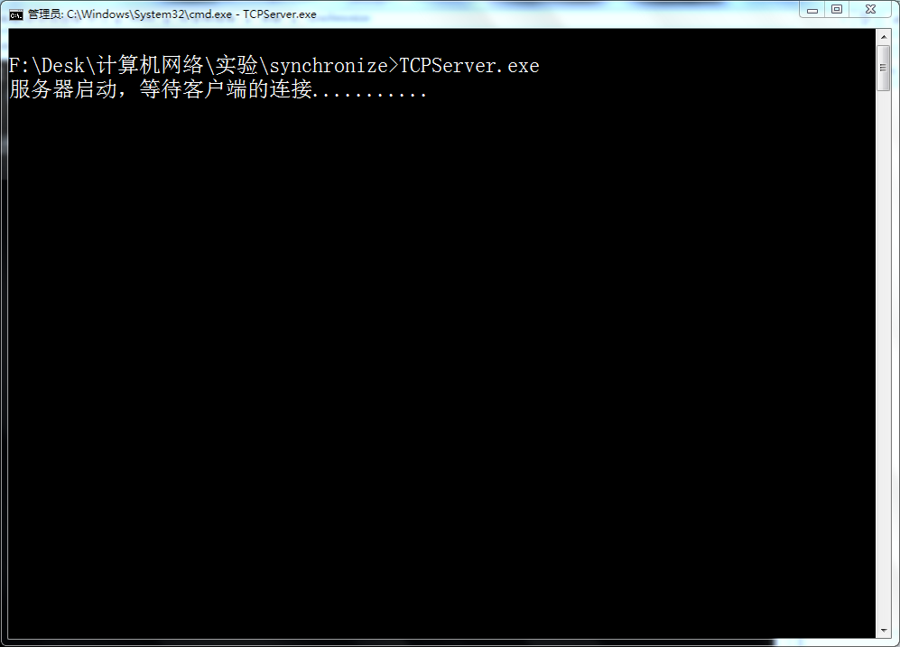
打开客户端：
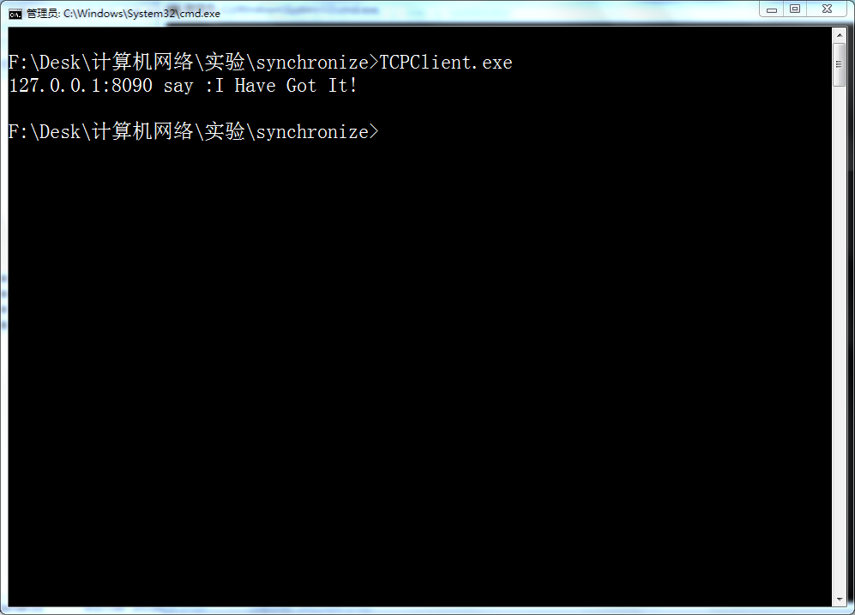
同时服务器的结果如下：
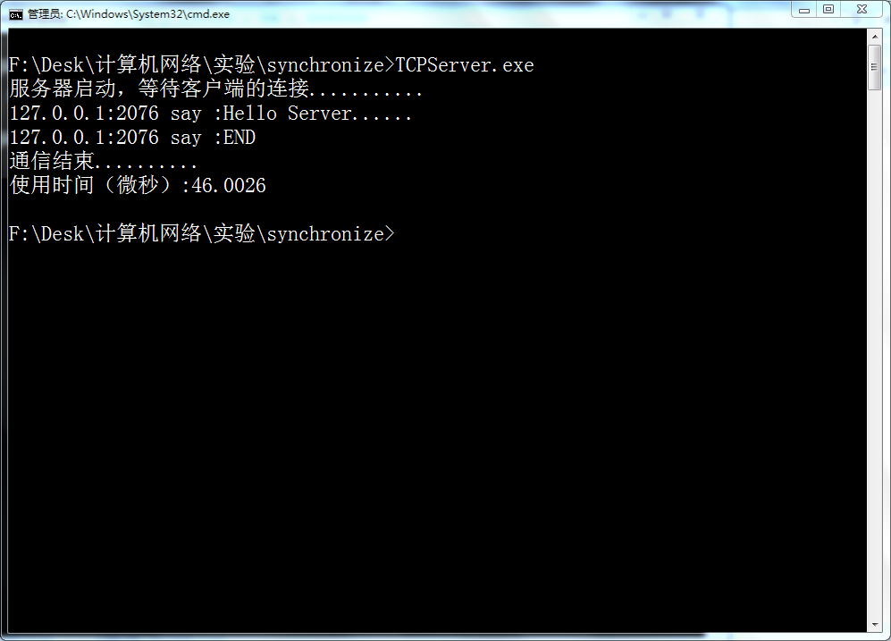
UDP同步通信
启动服务器：
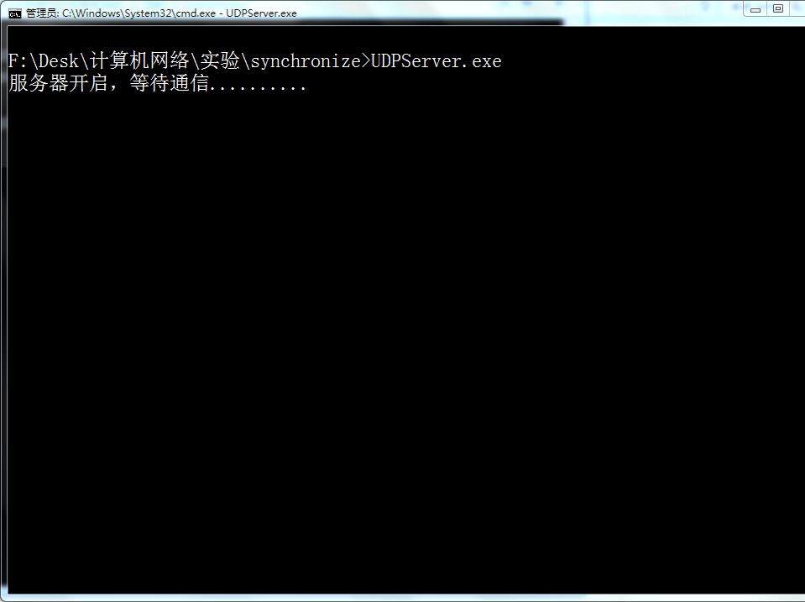
打开客户端：
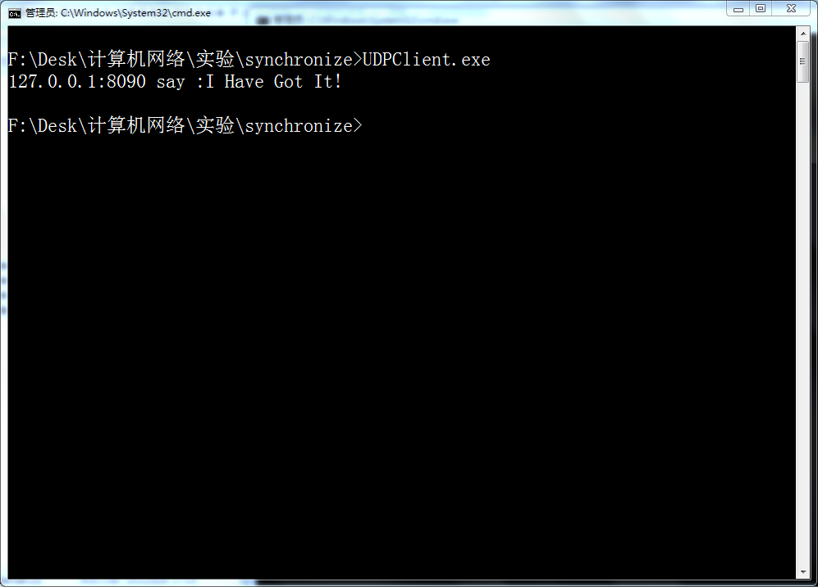
同时服务器的结果如下：
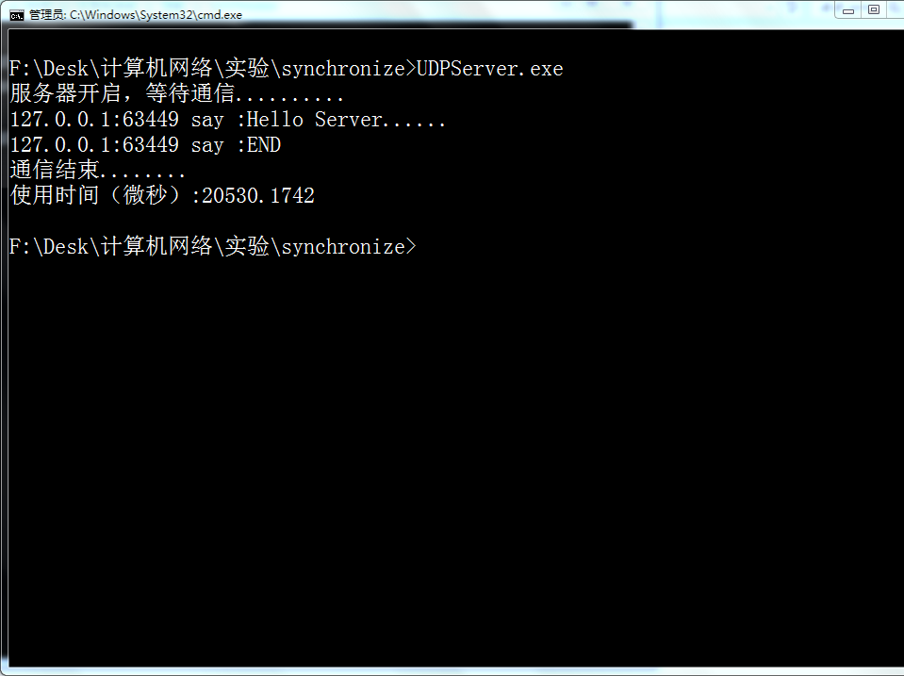
TCP异步通信
开启服务器：
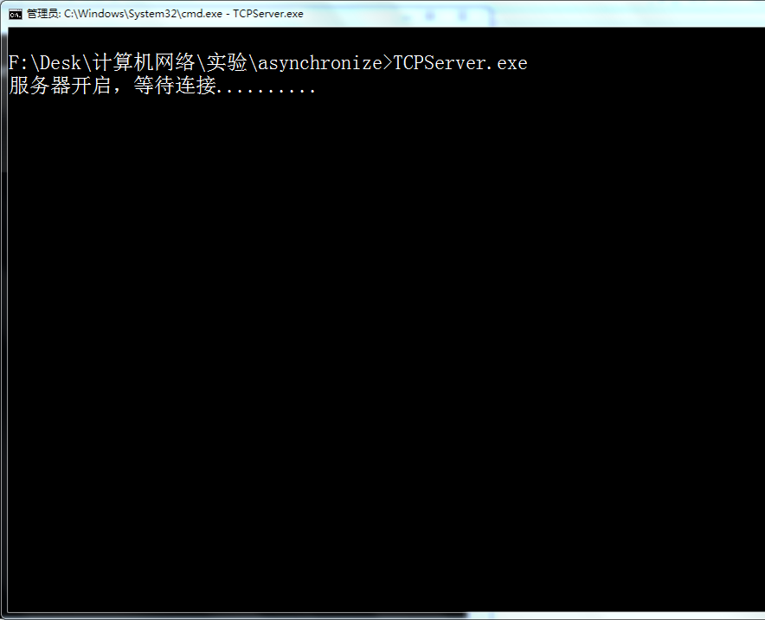
打开客户端，同时打开两个：区别在与端口号
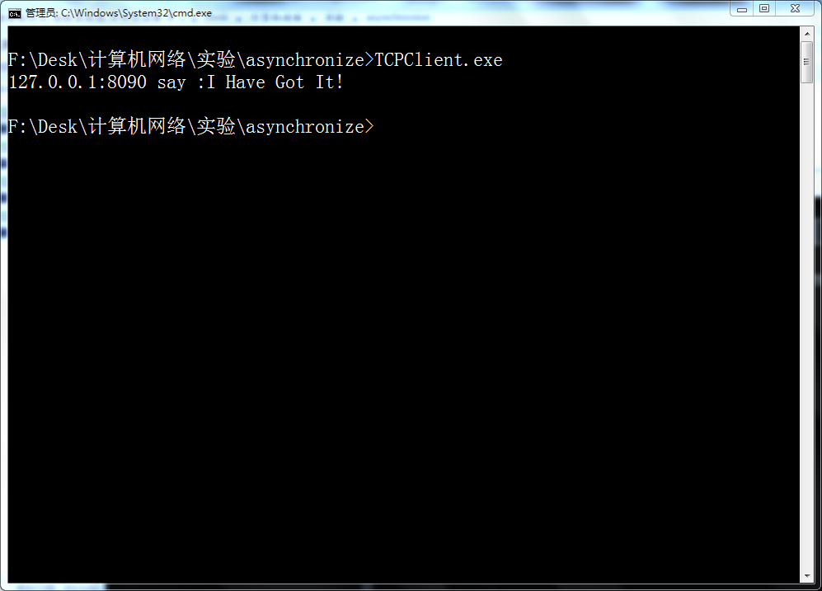
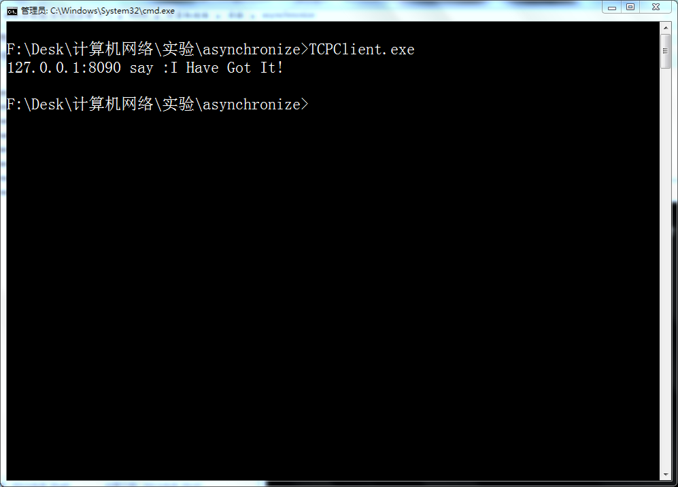
同时服务器的结果如下
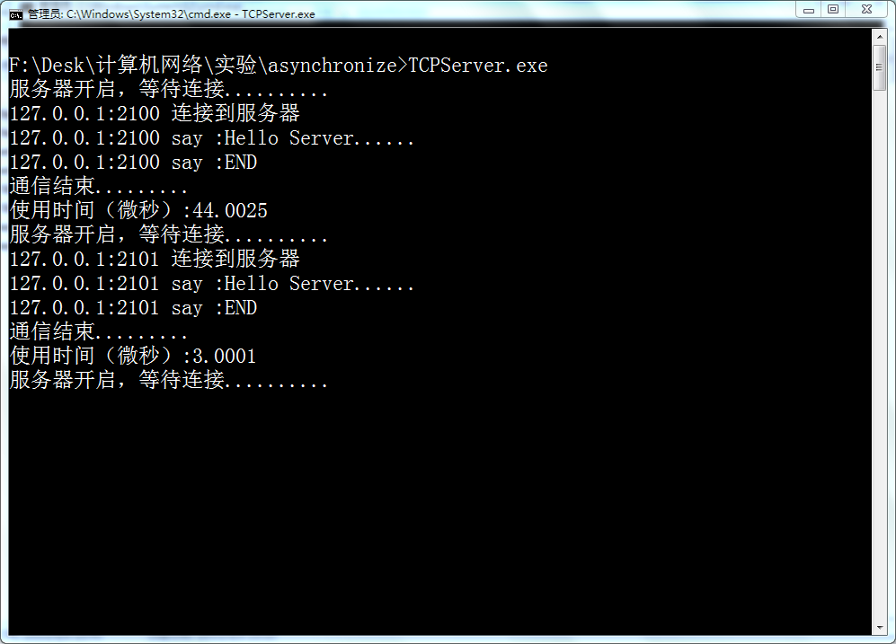
UDP异步通信
开启服务器：
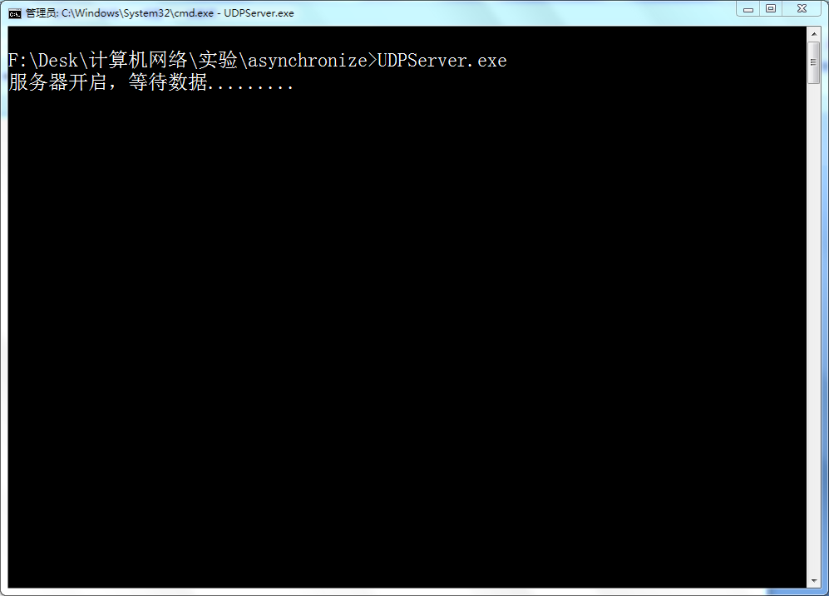
打开客户端：
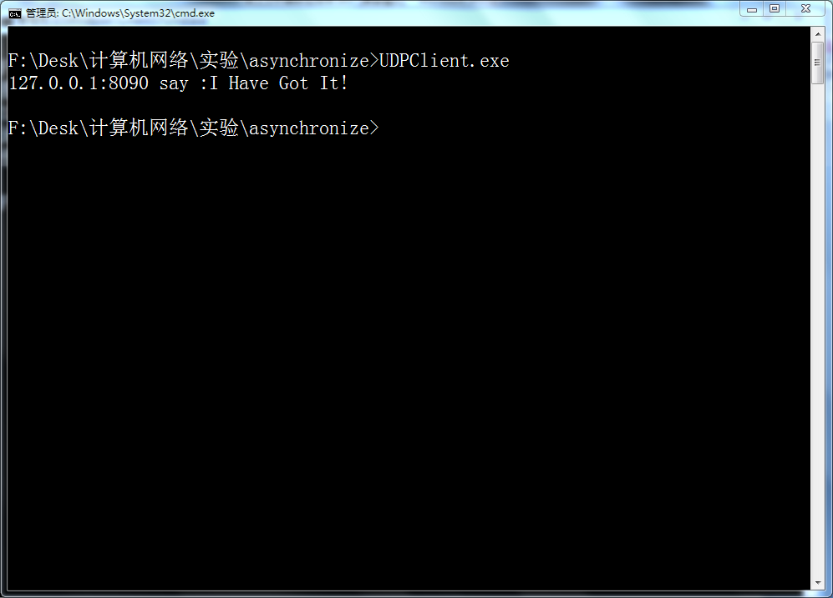
同时服务器结果：
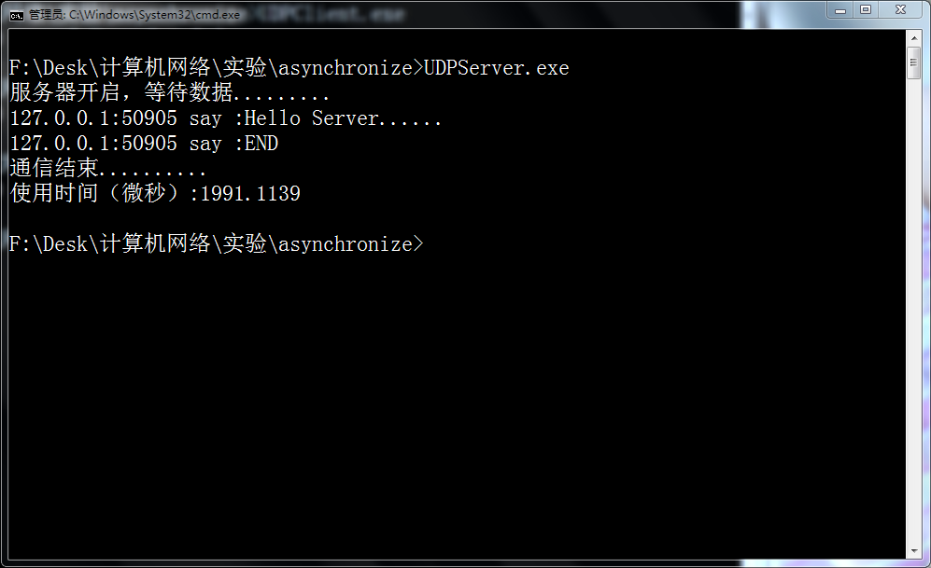
结果分析：
通过上面结果可以看出，基于给定的通信模式，这里我约定客户端发出两条信息，服务器回一条，发现TCP的性能好些，为什么呢？
可以考虑TCP面向连接，因此三次会话使用的一连接，而UDP不面向连接，三次会话每一次都需要建立寻址。

实验总结：
这次试验让我学习到了网络通信的不同模式，以及不用模式中在C#中的使用方式。
在之前一直困惑于C#的异步通信的实现方式，不理解为什么要使用委托以及这些回调函数是如何与套接字紧密结合的。而现在明白了，并实现了出来，虽然在容错性方面还非常薄弱，在异常处理方面也没有考虑，但是这个难题的攻破还是非常令人欣喜的，之后就可以致力于异常以及更高的方面。
另外，也认识到了TCP、UDP通信在编程方面的区别，从而加深了对TCP、UDP协议的理解。
最后非常感谢朱利老师的讲课，从您的课中学习到了许多以前无法理解的原理以及知识。

