STU33010: Mid Term Assignment 2020

Michael Haskins

14/11/2020

# Introduction

The time series dataset (file <pop.csv> ) corresponds to several time series of population size for the UK till year 2018. In this report I will find the best Holt-Winters algorithms to predict the populations of England, Scotland, Northern Ireland and Wales (4 time series) for the years 2019 and 2020.

This report will consist of 5 sections;

1. England
2. Scotland
3. Northern Ireland
4. Wales
5. Warnings about the accuracy of these forecasts

Note: Sections 1-4 will contain the following:

* Basic analysis of this time series
* The appropriate Holt-Winters algorithm for this time series and justification for its selection.
* Forecasts for 2019 and 2020.

## The time series

require("fma")  
require("knitr")   
myts = read.csv("pop.csv")  
  
kable(myts)

|  |  |  |  |  |  |  |  |
| --- | --- | --- | --- | --- | --- | --- | --- |
| Year | Scotland.population | Great.Britain.population | England.population | United.Kingdom.population | England.and.Wales.population | Northern.Ireland.population | Wales.population |
| 1971 | 5235600 | 54387600 | 46411700 | 55928000 | 49152000 | 1540400 | 2740300 |
| 1972 | 5230600 | 54557700 | 46571900 | 56096700 | 49327100 | 1539000 | 2755200 |
| 1973 | 5233900 | 54692900 | 46686200 | 56222900 | 49459000 | 1530000 | 2772800 |
| 1974 | 5240800 | 54708700 | 46682700 | 56235600 | 49467900 | 1526900 | 2785200 |
| 1975 | 5232400 | 54702200 | 46674400 | 56225700 | 49469800 | 1523500 | 2795400 |
| 1976 | 5233400 | 54692600 | 46659900 | 56216100 | 49459200 | 1523500 | 2799300 |
| 1977 | 5226200 | 54666600 | 46639800 | 56189900 | 49440400 | 1523300 | 2800600 |
| 1978 | 5212300 | 54654800 | 46638200 | 56178000 | 49442500 | 1523200 | 2804300 |
| 1979 | 5203600 | 54711800 | 46698100 | 56240100 | 49508200 | 1528300 | 2810100 |
| 1980 | 5193900 | 54796900 | 46787200 | 56329700 | 49603000 | 1532800 | 2815800 |
| 1981 | 5180200 | 54814500 | 46820800 | 56357500 | 49634300 | 1543000 | 2813500 |
| 1982 | 5164500 | 54746200 | 46777300 | 56290700 | 49581600 | 1544500 | 2804300 |
| 1983 | 5148100 | 54765100 | 46813700 | 56315700 | 49617000 | 1550600 | 2803300 |
| 1984 | 5138900 | 54852000 | 46912400 | 56409300 | 49713100 | 1557300 | 2800700 |
| 1985 | 5127900 | 54988600 | 47057400 | 56554000 | 49860700 | 1565400 | 2803400 |
| 1986 | 5111800 | 55110300 | 47187600 | 56683800 | 49998600 | 1573500 | 2810900 |
| 1987 | 5099000 | 55222000 | 47300400 | 56804000 | 50123000 | 1582000 | 2822600 |
| 1988 | 5077400 | 55331000 | 47412300 | 56916400 | 50253600 | 1585400 | 2841200 |
| 1989 | 5078200 | 55486000 | 47552700 | 57076500 | 50407800 | 1590400 | 2855200 |
| 1990 | 5081300 | 55641900 | 47699100 | 57237500 | 50560600 | 1595600 | 2861500 |
| 1991 | 5083300 | 55831400 | 47875000 | 57438700 | 50748000 | 1607300 | 2873000 |
| 1992 | 5085600 | 55961300 | 47998000 | 57584500 | 50875600 | 1623300 | 2877700 |
| 1993 | 5092500 | 56078300 | 48102300 | 57713900 | 50985900 | 1635600 | 2883600 |
| 1994 | 5102200 | 56218400 | 48228800 | 57862100 | 51116200 | 1643700 | 2887400 |
| 1995 | 5103700 | 56375700 | 48383500 | 58024800 | 51272000 | 1649100 | 2888500 |
| 1996 | 5092200 | 56502600 | 48519100 | 58164400 | 51410400 | 1661800 | 2891300 |
| 1997 | 5083300 | 56643000 | 48664800 | 58314200 | 51559600 | 1671300 | 2894900 |
| 1998 | 5077100 | 56797200 | 48820600 | 58474900 | 51720100 | 1677800 | 2899500 |
| 1999 | 5072000 | 57005400 | 49032900 | 58684400 | 51933500 | 1679000 | 2900600 |
| 2000 | 5062900 | 57203100 | 49233300 | 58886100 | 52140200 | 1682900 | 2906900 |
| 2001 | 5064200 | 57424200 | 49449700 | 59113000 | 52360000 | 1688800 | 2910200 |
| 2002 | 5066000 | 57668100 | 49679300 | 59365700 | 52602100 | 1697500 | 2922900 |
| 2003 | 5068500 | 57931700 | 49925500 | 59636700 | 52863200 | 1704900 | 2937700 |
| 2004 | 5084300 | 58236300 | 50194600 | 59950400 | 53152000 | 1714000 | 2957400 |
| 2005 | 5110200 | 58685500 | 50606000 | 60413300 | 53575300 | 1727700 | 2969300 |
| 2006 | 5133100 | 59084000 | 50965200 | 60827100 | 53950900 | 1743100 | 2985700 |
| 2007 | 5170000 | 59557400 | 51381100 | 61319100 | 54387400 | 1761700 | 3006300 |
| 2008 | 5202900 | 60044600 | 51815900 | 61823800 | 54841700 | 1779200 | 3025900 |
| 2009 | 5231900 | 60467200 | 52196400 | 62260500 | 55235300 | 1793300 | 3038900 |
| 2010 | 5262200 | 60954600 | 52642500 | 62759500 | 55692400 | 1804800 | 3050000 |
| 2011 | 5299900 | 61470800 | 53107200 | 63285100 | 56170900 | 1814300 | 3063800 |
| 2012 | 5313600 | 61881400 | 53493700 | 63705000 | 56567800 | 1823600 | 3074100 |
| 2013 | 5327700 | 62275900 | 53865800 | 64105700 | 56948200 | 1829700 | 3082400 |
| 2014 | 5347600 | 62756300 | 54316600 | 64596800 | 57408700 | 1840500 | 3092000 |
| 2015 | 5373000 | 63258400 | 54786300 | 65110000 | 57885400 | 1851600 | 3099100 |
| 2016 | 5404700 | 63785900 | 55268100 | 65648100 | 58381200 | 1862100 | 3113200 |
| 2017 | 5424800 | 64169400 | 55619400 | 66040200 | 58744600 | 1870800 | 3125200 |
| 2018 | 5438100 | 64553900 | 55977200 | 66435600 | 59115800 | 1881600 | 3138600 |

# England

## Visualization of the time series

mytsEngland<-ts(myts$England.population, start=1971,end=2018,frequency=1)  
  
ggtsdisplay(mytsEngland, lag.max = 47, main = "England population time series")

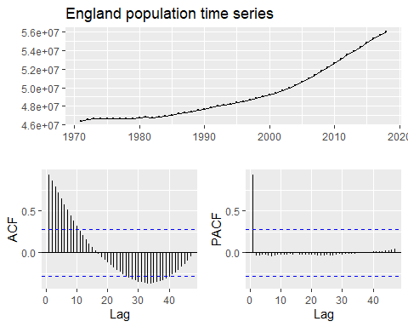

##Diff to remove trend, as makes it easier to spot seasonal patterns  
ggtsdisplay( diff(mytsEngland),lag.max = 47, main = "Differentiated England population time series" )

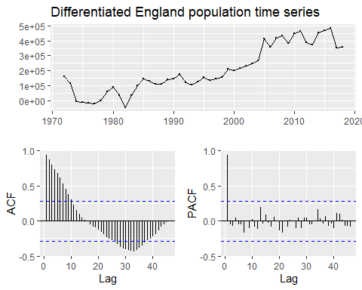

## Analysis of time series

It can be determined that there is a trend due to the upward slope of the time series and that there is no seasonal pattern visible due to the straight line of the time series and also due to the fact there is no pattern visible in the PACF graph.

## Appropriate Holt-Winters algorithm

Since there is a trend and no seasonal pattern the Holt-Winters algorithms that are appropriate to use are the SES(Which can handle a small trend) or DES.

It is important to choose the Holt-Winters algorithm that has the lowest Sum of Square Error (SSE), as this will yield the most accurate forecasts.

##Below Code will yield the SSE of SES Holt-Winters Algorihtm  
SESSSE = HoltWinters(mytsEngland, beta = FALSE, gamma = FALSE)$SSE  
  
##Below Code will yield the SSE of DES Holt-Winters Algorihtm  
DESSSE = HoltWinters(mytsEngland, gamma = FALSE)$SSE  
  
if( SESSSE > DESSSE){  
 print("DES is the best Holt-Winters Algorithm for this time series, as it has lower SSE than SES")  
} else {  
 print("SES is the best Holt-Winters Algorithm for this time series, as it has lower SSE than DES")  
}

[1] "DES is the best Holt-Winters Algorithm for this time series, as it has lower SSE than SES"

## Forecasts for 2019 and 2020

As was determined above DES is the best Holt-Winters Algorithm for this time series, as it has lower SSE than SES, meaning the forecasts generated using DES will be more accurate than those of SES.

##Prediction for 2019 using DES  
predict(HoltWinters(mytsEngland, gamma = FALSE), n.ahead=1)[1]

[1] 56335000

##Prediction for 2020 using DES  
predict(HoltWinters(mytsEngland, gamma = FALSE), n.ahead=2)[2]

[1] 56692800

# Scotland

## Visualization of the time series

mytsScotland<-ts(myts$Scotland.population, start=1971,end=2018,frequency=1)  
  
ggtsdisplay(mytsScotland,lag.max = 47, main = "Scotland population time series")

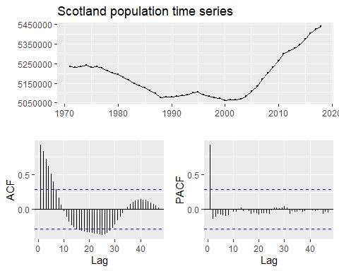

##Diff to remove trend, as makes it easier to spot seasonal patterns  
ggtsdisplay( diff(mytsScotland),lag.max = 47, main = "Differentiated Scotland population time series" )

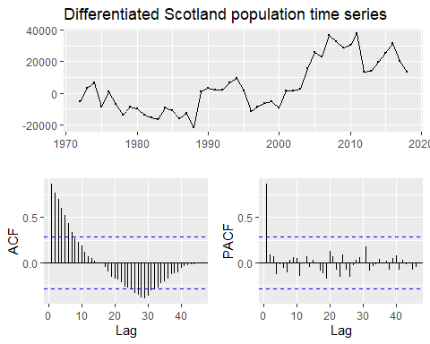

## Analysis of time series

There is a trend in this time series. We can see that the population was trending generally downward until 2003 and ever since its been on a strong upward trend. This is reflected in the ACF plot where we can see it is initially sloping downward and then when the lag is around 16 (Reflecting the trend turnaround in circa 2003) the trend reverses. Since the Holt-Winters algorithms place decreasing emphasis on older results more emphasis will be placed on the data that reflects the upward trend as this data is more recent so is more relevant.

It can also be determined that there is no seasonality in the time series as even when the trend is removed, by differentiating, it is still impossible to see anything resembling a seasonal pattern in the PACF graph.

## Appropriate Holt-Winters Algorithm

Since there is a trend and no seasonal pattern the Holt-Winters algorithms that are appropriate to use are the SES(Which can handle a small trend) or DES.

It is important to choose the Holt-Winters algorithm that has the lowest Sum of Square Error (SSE), as this will yield the most accurate forecasts.

##Below Code will yield the SSE of SES Holt-Winters Algorihtm  
SESSSE = HoltWinters(mytsScotland, beta = FALSE, gamma = FALSE)$SSE  
  
##Below Code will yield the SSE of DES Holt-Winters Algorihtm  
DESSSE = HoltWinters(mytsScotland, gamma = FALSE)$SSE  
  
if( SESSSE > DESSSE){  
 print("DES is the best Holt-Winters Algorithm for this time series, as it has lower SSE than SES")  
} else {  
 print("SES is the best Holt-Winters Algorithm for this time series, as it has lower SSE than DES")  
}

[1] "DES is the best Holt-Winters Algorithm for this time series, as it has lower SSE than SES"

## Forecasts for 2019 and 2020

As was determined above DES is the best Holt-Winters Algorithm for this time series, as it has lower SSE than SES.

##Prediction for 2019 using DES  
predict(HoltWinters(mytsScotland, gamma = FALSE), n.ahead=1)[1]

[1] 5453202

##Prediction for 2020 using DES  
predict(HoltWinters(mytsScotland, gamma = FALSE), n.ahead=2)[2]

[1] 5468304

# Northern Ireland

## Visualization of the time series

mytsNorthernIreland<-ts(myts$Northern.Ireland.population, start=1971,end=2018,frequency=1)  
  
ggtsdisplay(mytsNorthernIreland, main = "Northern Ireland population time series", lag.max = 47)

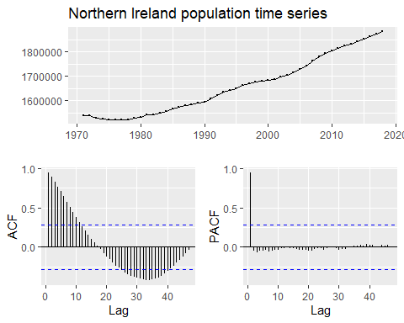

##Diff to remove trend, as makes it easier to spot seasonal patterns  
ggtsdisplay( diff(mytsNorthernIreland), main = "Differentiated Northern Ireland population time series", lag.max = 47 )

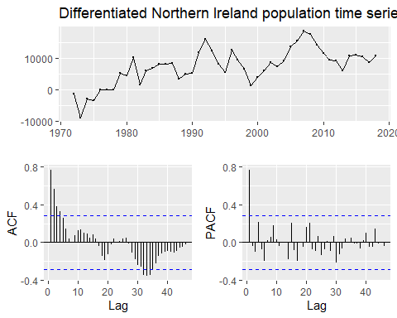

## Analysis of time series

It can be determined that there is a consistent upward trend in the time series due to the slope of the plotted line of the time series being generally positive.

It can also be determined that there is no seasonality in the time series as even when the trend is removed, by differentiating, it is still impossible to see anything resembling a seasonal pattern in the PACF graph.

## Appropriate Holt-Winters Algorithm

Since there is a trend and no seasonal pattern in the time series the Holt-Winters algorithms that are appropriate to use are the SES(Which can handle a small trend) or DES.

It is important to choose the Holt-Winters algorithm that has the lowest Sum of Square Error (SSE), as this will yield the most accurate forecasts.

##Below Code will yield the SSE of SES Holt-Winters Algorihtm  
SESSSE = HoltWinters(mytsNorthernIreland, beta = FALSE, gamma = FALSE)$SSE  
  
##Below Code will yield the SSE of DES Holt-Winters Algorihtm  
DESSSE = HoltWinters(mytsNorthernIreland, gamma = FALSE)$SSE  
  
if( SESSSE > DESSSE){  
 print("DES is the best Holt-Winters Algorithm for this time series, as it has lower SSE than SES.")  
} else {  
 print("SES is the best Holt-Winters Algorithm for this time series, as it has lower SSE than DES.")  
}

[1] "DES is the best Holt-Winters Algorithm for this time series, as it has lower SSE than SES."

## Forecasts for 2019 and 2020

As was determined above DES is the best Holt-Winters Algorithm for this time series, as it has lower SSE than SES.

##Prediction for 2019 using DES  
predict(HoltWinters(mytsNorthernIreland, gamma = FALSE), n.ahead=1)[1]

[1] 1892030

##Prediction for 2020 using DES  
predict(HoltWinters(mytsNorthernIreland, gamma = FALSE), n.ahead=2)[2]

[1] 1902460

# Wales

## Visualization of the time series

mytsWales<-ts(myts$Wales.population, start=1971,end=2018,frequency=1)  
  
ggtsdisplay(mytsWales, lag.max = 47, main = "Wales population time series")

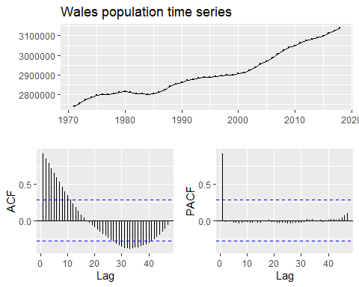

##Diff to remove trend, as makes it easier to spot seasonal patterns  
ggtsdisplay( diff(mytsWales),lag.max = 47, main = "Differentiated Wales population time series" )

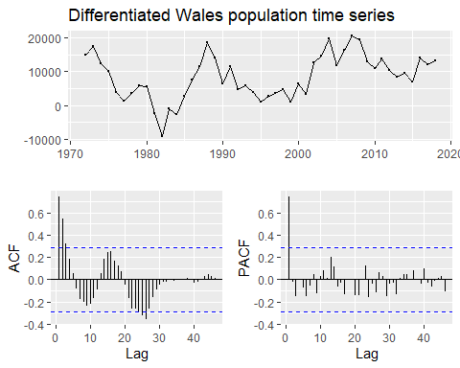

## Analysis of time series

It can be determined that there is a trend in the time series due to the upward slope of the plotted line of the time series and the ACF graph having a generally downward sloping line.

It can also be determined that there is no seasonality in the time series as even when the trend is removed, by differentiating, it is still impossible to see anything resembling a seasonal pattern in the PACF graph.

## Appropriate Holt-Winters Algorithm

Since there is a trend and no seasonal pattern in the time series the Holt-Winters algorithms that are appropriate to use are the SES(Which can handle a small trend) or DES.

It is important to choose the Holt-Winters algorithm that has the lowest Sum of Square Error (SSE), as this will yield the most accurate forecasts.

##Below Code will yield the SSE of SES Holt-Winters Algorihtm  
SESSSE = HoltWinters(mytsWales, beta = FALSE, gamma = FALSE)$SSE  
  
##Below Code will yield the SSE of DES Holt-Winters Algorihtm  
DESSSE = HoltWinters(mytsWales, gamma = FALSE)$SSE  
  
if( SESSSE > DESSSE){  
 print("DES is the best Holt-Winters Algorithm for this time series, as it has lower SSE than SES.")  
} else {  
 print("SES is the best Holt-Winters Algorithm for this time series, as it has lower SSE than DES.")  
}

[1] "DES is the best Holt-Winters Algorithm for this time series, as it has lower SSE than SES."

## Forecasts for 2019 and 2020

As was determined above DES is the best Holt-Winters Algorithm for this time series, as it has lower SSE than SES.

##Prediction for 2019 using DES  
predict(HoltWinters(mytsWales, gamma = FALSE), n.ahead=1)[1]

[1] 3151837

##Prediction for 2020 using DES  
predict(HoltWinters(mytsWales, gamma = FALSE), n.ahead=2)[2]

[1] 3165107

# Warnings about the accuracy of the forecasts in this report

It is important to remember that forecasts are rarely 100% accurate and their accuracy decreases the further into the future they are. The forecasts for 2019 and 2020 should be quite accurate as they are only one year and two years into the future. Below is a plot of the population forecasts for Wales. Note how wide the 95% and 80% confidence intervals are the further into the future the forecast.

## Light grey area is the 95% CI   
## Blue area is the 80% CI   
## The blue line is the plotted line of all the forecasts   
 plot(forecast(HoltWinters(mytsWales, gamma = FALSE), h = 20), main = "Wales DES Holt-Winters Forecasts")

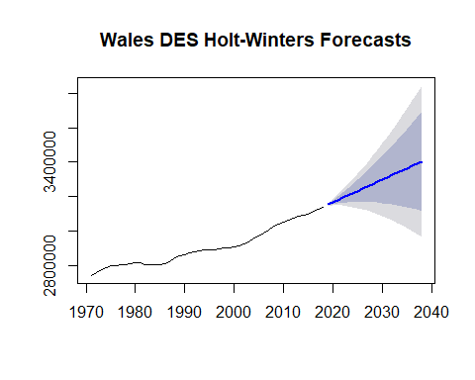

## External factors that can affect the forecasts

Holt-Winters Algorithms only take into account previous years data and do not account for changes in any of the below external factors when calculating forecasts, changes in these external factors can greatly affect the accuracy of the forecasts.

* Government Policies can affect population, such as emigration/immigration polices and child benefit policies.
* Recessions/ Economic hardship typically result in population decreases.
* Unexpected Events
  + War & Famine: Both result in decreases in populations.
  + Diseases & Virus: Covid-19 has resulted in thousands of deaths across the UK, thus reducing the population, and has made forecasts less accurate as this is a new occurrence and the past data that has been used to create these forecasts was not subject to the affects of Covid-19 on the populations across the UK.