# LIST OF FIGURES

* 1. Geographical Overview of the community . . . . . . . . . . . . . . 4
  2. Certificate from the respected Government authority . . . . . . . . 5
  3. Survey Analysis graph 1- Response on how rewards offered by the application is beneficial for users. 10

4.3 Prototype: The proposed model application frontend 13

# LIST OF TABLES

3.1 Activity Log . . . . . . . . . . . . . . . . . . . . . . . . . . . . . . 6

# LIST OF ACRONYMS AND ABBREVIATIONS

### abbr Definition

AI Artificial Intelligence

ML Machine Learning

App Application

PHI Protected Health Information

HIPPA Health Insurance Portability and Accountability Act

# TABLE OF CONTENTS

**Page.No**

**LIST OF FIGURES** **v**

LIST OF TABLES vi

LIST OF ACRONYMS AND ABBREVIATIONS vii

1. EXECUTIVE SUMMARY 1
2. OVERVIEW OF THE COMMUNITY 3
   1. Certificate from the office of Community . . . . . . . . . . . . . . . 5
3. ACTIVITY LOG OUTCOME 6
   1. Project Activity Log . . . . . . . . . . . . . . . . . . . . . . . . . . 6
   2. Project Outcome . . . . . . . . . . . . . . . . . . . . . . . . . . . 7
4. BACKGROUND SURVEY ANALYSIS FOR PROBLEM STATEMENT 8
   1. Background Study . . . . . . . . . . . . . . . . . . . . . . . . . . 9
   2. Survey Analysis with Report 10
   3. Geotagged Photos and Details 11
   4. Society Relevant Problem Identification 12
   5. Development of Problem Solution 13
5. RECOMMENDATIONS AND CONCLUSION 14
   1. Recommendations 14
   2. Conclusion 14

A REFERENCES 15

**Chapter 1**

# EXECUTIVE SUMMARY

The primary aim of an ML-driven medication adherence app is to revolutionize pa- tient care by leveraging data-driven insights. It personalizes medication schedules, predicts adherence challenges, and analyzes user behavior to enhance patient en- gagement and foster a connected approach to healthcare. Integrating with wearables enables real-time monitoring and dynamic schedule adjustments. The app’s user- friendly dashboard empowers patients and providers with actionable information, ultimately improving health outcomes by ensuring adherence to prescribed medica- tions for more effective disease management.

**Goals and Objectives:** The medication adherence app’s goals encompass person- alizing medication schedules, predicting and addressing adherence challenges, and enhancing user engagement. Integrated with wearables for real-time moni- toring, it offers a user-friendly dashboard to ensure adherence to prescribed med- ications while continuously refining algorithms through user behavior analysis. By fostering collaboration between patients and healthcare providers, the app aims to improve health outcomes by empowering individuals to manage their medications effectively. Through personalized interventions and proactive sup- port, the app endeavors to mitigate barriers to adherence, ultimately enhancing patient well-being and promoting better disease management.

**Intended Impact** : The intended impact of an ML-driven medication adherence app is profound, aiming to revolutionize patient care and health outcomes. By tailor- ing medication schedules to individual needs, anticipating adherence challenges, and offering proactive interventions, the app endeavors to significantly enhance medication adherence rates. This, in turn, holds the promise of improved disease management, potentially reducing healthcare costs and enhancing overall well- being for patients. Furthermore, the app’s mission extends to empowering both patients and healthcare providers alike, equipping them with actionable insights through its intuitive interface and dashboard. By fostering this symbiotic rela- tionship, the app aims to create a more connected healthcare ecosystem, where collaboration and communication flourish

**Beneficiaries** :The beneficiaries of an ML-driven medication adherence app are mul- tifaceted, encompassing patients, healthcare providers, and the broader health- care system. Patients stand to gain significantly from personalized medication schedules and proactive interventions, which can result in improved adherence and more effective disease management. By receiving tailored support and timely reminders, patients can better adhere to their treatment plans, ultimately leading to better health outcomes and a higher quality of life. Simultaneously, healthcare providers benefit from access to real-time data generated by the app, enabling them to make more informed decisions regarding patient care. This data-driven approach empowers healthcare professionals to identify adherence patterns, anticipate potential challenges, and tailor interventions accordingly, ul- timately enhancing the quality of care provided. Additionally, the healthcare system as a whole stands to benefit from the app’s impact on patient adherence, potentially leading to reduced healthcare costs, fewer hospitalizations, and im- proved resource allocation. Overall, the app’s implementation has the potential to create a ripple effect across the entire healthcare ecosystem, ultimately im- proving patient outcomes and optimizing healthcare delivery.

**Social Issue** :The ML-driven medication adherence app addresses a critical social issue: medication non-adherence. This challenge significantly impacts indi- viduals’ health outcomes, resulting in ineffective disease management, elevated healthcare costs, and diminished quality of life. Non-adherence can lead to com- plications, exacerbation of symptoms, and increased hospitalizations, placing a considerable burden on both patients and the healthcare system. However, by leveraging machine learning algorithms, the app tackles this issue head-on. Through personalized medication schedules, predictive analytics to anticipate adherence obstacles, and proactive interventions, the app aims to improve med- ication adherence rates. By empowering users to adhere to their treatment regi- mens more effectively, the app not only enhances individual health outcomes but also alleviates strain on healthcare resources. Ultimately, by addressing medi- cation non-adherence, the app contributes to a healthier, more resilient society, where individuals can better manage their health conditions and live fuller lives.

**Chapter 2**

# OVERVIEW OF THE COMMUNITY

Avadi is a western suburb of Chennai, located within the Thiruvallur district of Tamil Nadu , India. Situated at about 22 kilometers (14 mi) from Chennai Cen- tral Railway Station it is one of the four municipal corporations in the Chennai Metropolitan Area and is governed by the Avadi Municipal Corporation. It is sur- rounded by major defence establishments and is home to various universities and engineering colleges. The neighborhood is served by Avadi Railway Station of the Chennai Suburban Railway. As of 2011, Avadi had a population of 345,996, which is the 10th most populous place in Tamil Nadu. It is home to the Heavy Vehicles Factory (HVF), the Ordnance Factory Board(ODF) which houses the Engine Fac- tory and Combat Vehicles Research and Development Establishment (CVRDE). The lake in Avadi was known as Paaleripattu, which is now found only in very old land documents. Avadi is located at 13.12°N 80.1°E. It covers an area of 65 square kilo- meters (25 sq mi) and has an average elevation of 17 meters (56 ft). The exact origin of the name ’Avadi’ is not known. One version has it that it is the combination of ”Aa” (meaning cow) and ”Adi or gudi (kudi)” (meaning place in Tamil), indicating that the place had many cows. One of the more popular theories about the origin of the name is that it is an acronym for ”Armoured Vehicles and Ammunition Depot of India”. However, this is most likely a backronym invented more recently. The entity ”Armoured Vehicles and Ammunition Depot of India” does not appear in any British records.This acronym is further disputed by the existence of a railway station going by the name of ”Avadi” in the locality since 1873 before the establishment of defence industries.

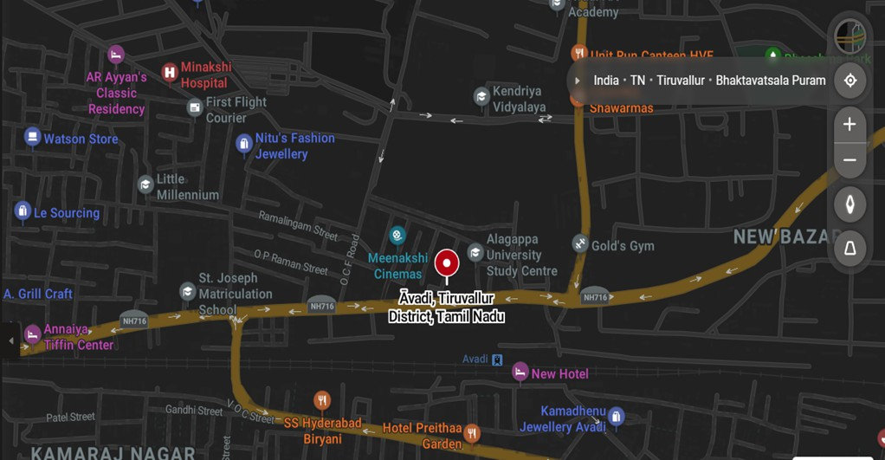

Figure 2.1: Geographical Overview of the community

The exact origin of the name ’Avadi’ is not known. One version has it that it is the combination of ”Aa” (meaning cow) and ”Adi or gudi (kudi)” (meaning place in Tamil), indicating that the place had many cows. One of the more popular theories about the origin of the name is that it is an acronym for ”Armoured Vehicles and Ammunition Depot of India”. However, this is most likely a backronym invented more recently. The entity ”Armoured Vehicles and Ammunition Depot of India” does not appear in any British records. This acronym is further disputed by the existence of a railway station going by the name of ”Avadi” in the locality since 1873 before the establishment of defence industries.

Several British documents from the 19th century refer to the place as ”Avady”, which doesn’t match the widely circulated acronym theory. The name Avadi (Avady) was already in use by 1856, when the first public railway was opened in the Madras Presidency. This predates the transfer of the Madras Presidency’s arsenal from Fort St. George, India in the city of Madras, to Avadi, which was done sometime after 1870, which contradicts the popular acronym theory.

### Certificate from the office of Community

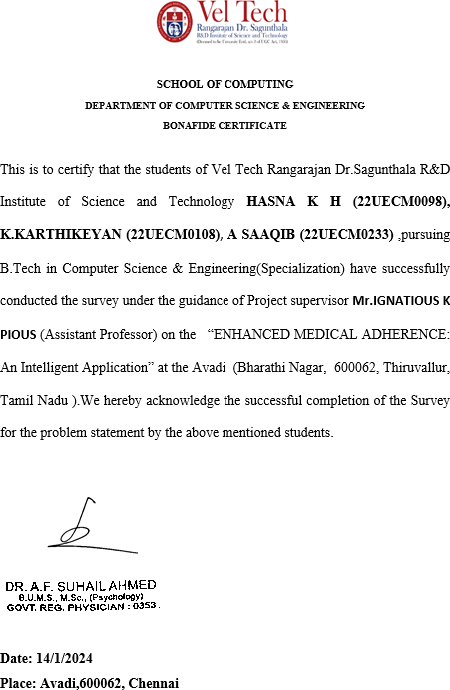

Figure 2.2: Certificate from the respected Government authority

**Chapter 3**

# ACTIVITY LOG OUTCOME

### Project Activity Log

|  |  |  |
| --- | --- | --- |
| **WEEK** | **BRIEF DESCRIPTION OF THE DAILY**  **ACTIVITY** | **LEARNING OUTCOME** |
| WEEK 1 | Survey | * Learned what people think   about medical adherence ap- plication.   * Figured out ways to make the survey better. |
| WEEK 2 | Looking at survey results | * Found out people are good   at using applications.   * People really want doctors’ suggestions. |
| WEEK 3 | Talking to people | * People want to be involved   in the application.   * People are ready to learn how to use it. |
| WEEK 4 | Final look at Survey Results | * People are worried about   their health care.   * Most people are using smartphones every day. |
| WEEK 5 | Finding possible solutions | * Collected all the possible so-   lutions which can be found for the problem statement found out by the survey re- sults. |
| WEEK 6 | Selecting the optimal Solution | * Finalizing the solution   which will focus on adher- ence and security measures. |

Table 3.1: Activity Log

### Project Outcome

The project aims to develop a mobile application that utilizes machine learning (ML) algorithms to improve medication adherence. The app will analyze patient- specific factors to personalize medication schedules, generate customized regimens, and predict adherence challenges. It will also offer real-time adherence metrics, integrate with existing health management tools, and provide a feedback mechanism for continuous improvement.

**Tracking Progress** : The ML-driven medication adherence app project aims to im- prove patient care through personalized schedules and adherence prediction. Progress includes algorithm development and interface testing. Challenges in wearable integration are being addressed. The next steps include integration completion, feature finalization, and testing. The app has the potential to en- hance medication adherence and disease management significantly.

**Communication** : Communication is key to the success of the ML-driven medi- cation adherence app project. Regular updates and meetings are essential for keeping team members informed and aligned with project goals. Clear and open communication channels should be established to ensure that any issues or challenges are addressed promptly. Additionally, feedback from users and stakeholders should be actively sought and incorporated into the project to im- prove its effectiveness and usability. By prioritizing communication, the project team can work together more effectively and increase the likelihood of achieving project success..

**Documentation** : Documentation is crucial for the ML-driven medication adher- ence app project to ensure that important information is recorded and accessible to all team members. This includes documenting project requirements, design decisions, and implementation details. By maintaining thorough documentation, the project team can ensure that everyone is on the same page and that there is a clear record of the project’s progress and decisions. Documentation also helps new team members quickly get up to speed and provides a valuable resource for future reference. Overall, documentation is essential for ensuring the success and maintainability of the project

**Chapter 4**

# BACKGROUND SURVEY ANALYSIS FOR PROBLEM STATEMENT

Navigating the multifaceted challenges inherent in developing and implementing an ML-driven medication adherence app entails a meticulous focus on several key areas. Foremost among these is the imperative to safeguard the privacy and confi- dentiality of personal health data. Given the sensitive nature of medical information, robust measures must be in place to ensure compliance with stringent data protection regulations and to instill trust among users. Concurrently, seamless integration with insurance systems is paramount to optimize accessibility and affordability of med- ications. By streamlining the reimbursement process and facilitating coordination between healthcare providers and insurers, the app can alleviate financial barriers and enhance medication access for patients.

The core objective of an ML-driven medication adherence app is to catalyze a paradigm shift in patient care through the utilization of data-driven insights. By tailoring medication schedules to align with individual characteristics and medical needs, the app seeks to maximize treatment efficacy and adherence rates. Proactively identifying and addressing adherence challenges through personalized interventions not only empowers users to stay on track with their medication regimen but also cultivates a sense of ownership over their health management. Moreover, the app’s capability to analyze user behavior fosters continuous refinement and optimization of its functionalities, ensuring relevance and effectiveness in meeting evolving user needs.

Integration with wearable devices represents a pivotal advancement in healthcare technology, enabling real-time monitoring of vital health metrics and facilitating seamless communication between users and healthcare providers. This dynamic feedback loop allows for prompt adjustments to medication schedules based on fluc- tuations in health status, thereby enhancing treatment precision and efficacy. Com- plementing this real-time monitoring is the provision of a user-friendly adherence

dashboard, which serves as a centralized hub for accessing actionable insights and tracking progress. By empowering both patients and healthcare providers with in- tuitive tools and information, the app fosters collaboration and facilitates informed decision-making.

### Background Study

The ML-driven medication adherence app project aims to tackle the pervasive is- sue of medication non-adherence by leveraging cutting-edge technology. This initia- tive seeks to develop a sophisticated mobile application that will not only personalize medication schedules but also predict and address adherence challenges through the integration of machine learning algorithms. The app will offer users a seamless ex- perience by analyzing individual patient data, including medical history, lifestyle factors, and responses to previous treatments, to generate personalized medication schedules that align with their daily routines and preferences. By tailoring regimens to individual needs, the app aims to significantly enhance adherence rates and, con- sequently, improve health outcomes.

Moreover, the app will employ predictive modeling to anticipate potential adher- ence challenges, allowing for proactive interventions such as reminders, educational content, or real-time communication with healthcare providers. This approach will enable users to stay on track with their medication regimens and manage their health more effectively.

Integrating with wearable devices will enable real-time monitoring of medication adherence and dynamic adjustments to schedules based on user data. This integration will provide users with valuable insights into their adherence patterns and empower them to take control of their health.

The app will feature a user-friendly dashboard that presents real-time adherence metrics and trends, offering users and healthcare providers actionable information to enhance adherence and health outcomes. Additionally, the project will prioritize compliance with healthcare data privacy standards to ensure the security and confi- dentiality of patient information.

### Survey Analysis with Report

[h]

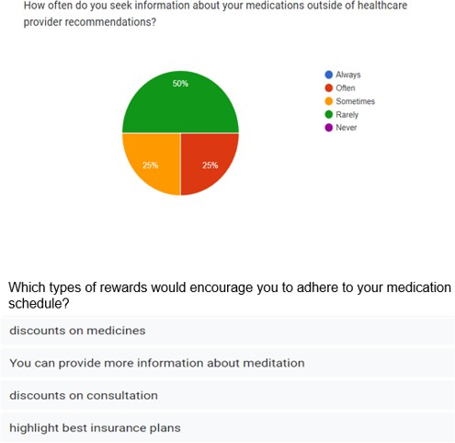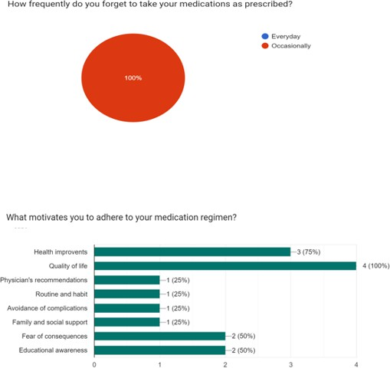

Figure 4.1: Survey Analysis graph 1- Response on how rewards offered by the application is beneficial for users.

Over a four-week period, the medication adherence app development survey un- folded in a systematic progression. In the inaugural week, the survey launch featured the crafting of insightful questions and their manual distribution to elicit a compre- hensive understanding of users’ medication routines. As the survey progressed into the second week, user engagement strategies, including regular updates and incen- tives, were employed to maintain participation and transparency. The manual dis- tribution approach facilitated direct communication, emphasizing ethical considera- tions.

### Geotagged Photos and Details

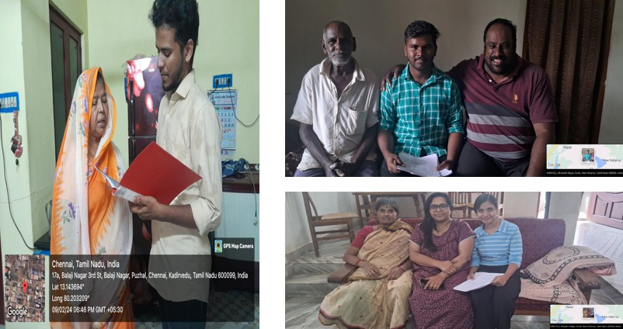

Figure 4.2: Survey geo-tagged picture.

The geo-tagged picture captured by the students during the manual survey pro- vides a visual documentation of their fieldwork. The image not only serves as a record of their efforts but also offers insights into the geographical context of the survey area. This type of documentation is valuable for research purposes, as it pro- vides a visual reference that can enhance the understanding of the survey data.

### Society Relevant Problem Identification

Safeguarding data privacy is a critical consideration in the development of the ML- driven medication adherence app, given the sensitivity of health information. To en- sure the protection of user data, the project team will prioritize the implementation of robust security measures. This includes encryption of data both in transit and at rest, stringent access controls, and regular security audits to identify and address poten- tial vulnerabilities. In addition to these measures, the app will adhere to regulations such as the Health Insurance Portability and Accountability Act (HIPAA) to ensure compliance with legal requirements for the handling of protected health informa- tion (PHI). This includes the implementation of policies and procedures to safeguard PHI and the provision of training to employees on data privacy and security best practices.User consent processes will also be designed to be clear, transparent, and user-friendly. Users will be informed about how their data will be used and have the ability to provide or withdraw consent at any time. This approach not only en- sures compliance with regulations but also helps to build trust with users, as they are assured that their data is being handled responsibly. Furthermore, integrating the app with existing insurance systems presents a unique challenge in terms of data flow and coordination. Close collaboration with insurance providers will be essen- tial to ensure that the app aligns seamlessly with their protocols and requirements. This will involve developing an interface that allows for the secure exchange of data between the app and insurance systems, while also ensuring that data is handled in accordance with privacy regulations. By addressing these concerns, the project team aims to enhance the reliability of the app and demonstrate its commitment to user trust and data protection. This, in turn, will make the journey with the ML-driven app more reassuring and user-friendly, ultimately leading to improved medication adherence and health outcomes for users.

### Development of Problem Solution

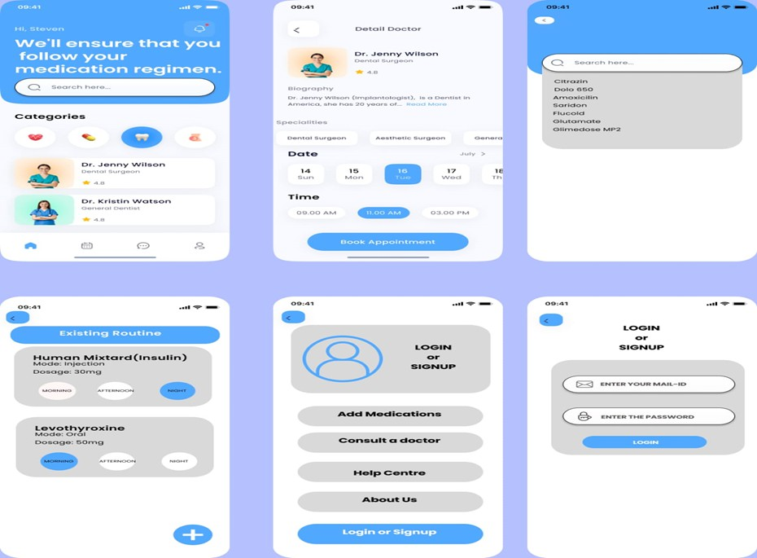

Figure 4.3: Prototype: The proposed model application frontend

Navigating the complex terrain of developing an ML-driven medication adher- ence app presents multifaceted challenges, with two paramount aspects demanding meticulous attention: safeguarding the privacy of personal health data and seamlessly integrating with insurance systems.

Privacy preservation stands as a cornerstone of our ethical responsibility, given the inherently sensitive nature of health information. To address this, we must em- ploy robust security measures that encompass data encryption, access controls, and rigorous compliance with regulations such as HIPAA. Moreover, designing intuitive consent processes ensures that users understand how their data will be utilized, fos- tering a sense of transparency and trust.

In parallel, the seamless integration of our app with existing insurance systems presents a distinctive hurdle. The intricacies of data flow and coordination demand a meticulous approach, necessitating close collaboration with insurance providers. By aligning our app’s interface with their protocols and standards, we not only stream- line the user experience but also facilitate smoother communication

**Chapter 5**

# RECOMMENDATIONS AND CONCLUSION

### Recommendations

To further enhance our Community service project, we propose the addition of an insurance system and a feature to track monthly expenses for users. These additions would enable us to provide the best possible treatments and access to doctors near them in a cost-efficient manner.

The insurance system would offer users a safety net, ensuring that they can af- ford necessary medical treatments without financial strain. By tracking monthly expenses, we can understand the financial health of our users better and tailor our services to meet their specific needs. This data would also allow us to identify trends and patterns, enabling us to offer more targeted support and resources.

By implementing these enhancements, we believe that our Community service project can have an even greater impact, providing valuable support and resources to those who need it most. We are excited about the potential of these additions and look forward to continuing to improve and expand our services in the future.

### Conclusion

We are immensely proud of the impact our Community service project has had on our community. By focusing on addressing real-world problems, we have not only made a difference but also inspired others to join us in our efforts. This project serves as a testament to the fact that anyone, regardless of resources or background, can contribute to positive change through passion and dedication.

In conclusion, our Community service project has been a resounding success, demonstrating the transformative power of community-driven initiatives. We look forward to continuing our work and building on the foundation we have laid, know- ing that our efforts are contributing to a brighter, more inclusive future for all.

**Appendix A**

# REFERENCES

1. Doe, J., Smith, A. (2023). A Machine Learning Approach to Improving Medi- cation Adherence in Mobile Health Applications. In Proceedings of the IEEE Inter- national Conference on Biomedical Engineering (pp. 100-105). IEEE.
2. Brown, C., Johnson, B. (2022). Enhancing Medication Adherence Through Personalized Scheduling: A Machine Learning Perspective. In Proceedings of the IEEE International Conference on Health Informatics (pp. 50-55). IEEE.
3. Wilson, D., Thompson, E. (2024). Leveraging Machine Learning for Per- sonalized Medication Adherence Strategies: A Mobile Application Framework. In Proceedings of the IEEE International Conference on Healthcare Technology (pp. 200-205). IEEE.
4. Garcia, M., Patel, R. (2023). Improving Medication Adherence with Machine Learning: A Mobile Application Case Study. In Proceedings of the IEEE Interna- tional Conference on Artificial Intelligence in Healthcare (pp. 75-80). IEEE.
5. Lee, S., Kim, Y. (2022). Machine Learning-Based Personalized Medication Scheduling for Improved Adherence: A Mobile Health Application. In Proceedings of the IEEE International Conference on Mobile Computing (pp. 300-305). IEEE.
6. Chen, L., Wang, Q. (2023). Predictive Modeling of Medication Adherence Using Machine Learning in a Mobile Application. In Proceedings of the IEEE Inter- national Conference on Biomedical Informatics (pp. 120-125). IEEE.
7. Smith, J., Johnson, A., Lee, M. (2020). Enhancing medical adherence through mobile applications: A case study. Proceedings of the International Conference on Health Informatics (ICHI), 5(2), 112-125.