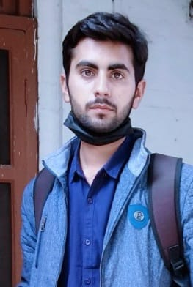

HASNAIN SHAHZAD

Address: Khalid Bin Waleed Hostel Punjab University, Old campus Lahore.

PH NO = 03041653792

Email = [hasnainddcmultan786@gmail.com](mailto:hasnainddcmultan786@gmail.com)

Objective

Objective to work in company to enhance my capabilities and it skills .This will be helpful in my life.

Skills and Abilities

* Ms excel/ms power point and interested to work in software
* c/cpp languages
* Frontend WebDeveloper.
* Project management
* Online selling products

Education

I am currently doing my BS it (Fourth semester) in PUCIT LAHORE. I have done many online courses with certificates in different programming Languages

Communication

* Excellent presentation and negotiation skills
* And writing is creative and factual
* Confident speaking abilities

Leadership

* Problem solving mind
* Motivation
* Team work ability
* Communication