Lab Exam Report
DevOps & Cloud — 3 Hours Exam

Student Name | Husnain Shehnsha
Email | fakhirhassanllc@gmail.com
Total Marks | 50
Date | 21 April 2026

Section B: Application Development (6 Marks)
Created a simple Flask web application that returns "Hello DevOps World".

app.py
from flask import Flask
app = Flask(__name__)
@app.route("/")
def hello():
return "Hello DevOps World"
if __name__ == "__main__":
app.run(host="0.0.0.0", port=5000)

requirements.txt
flask
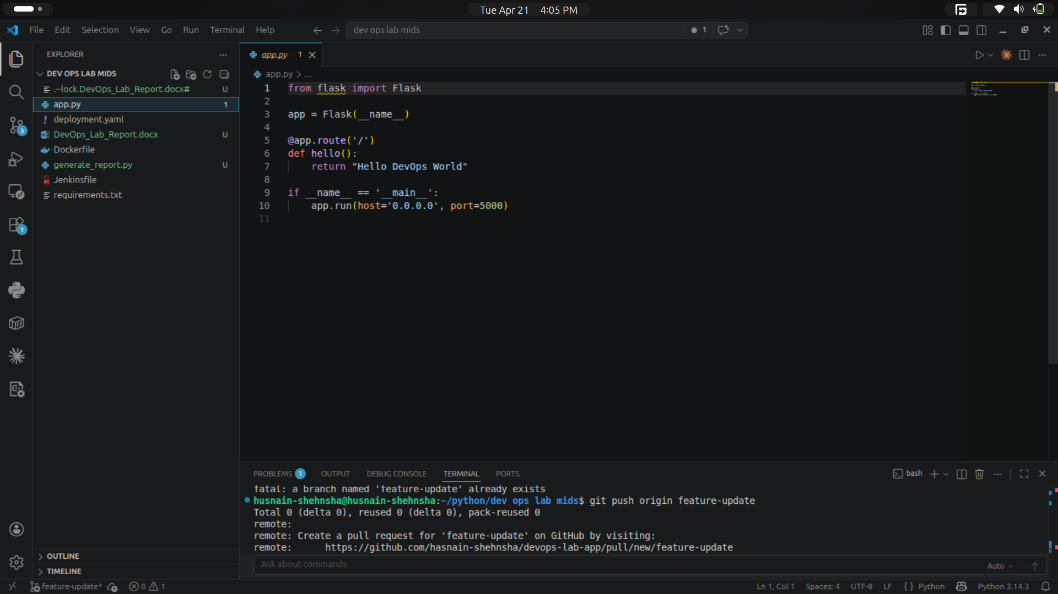
[ SCREENSHOT: Figure B-1: app.py file open in editor showing Flask code ]

────────────────────────────────────────────────────────────────────────────────

Section A: GitHub / GitLab (8 Marks)

1. Create Repository
Created a new public repository named devops-lab-app on GitHub.
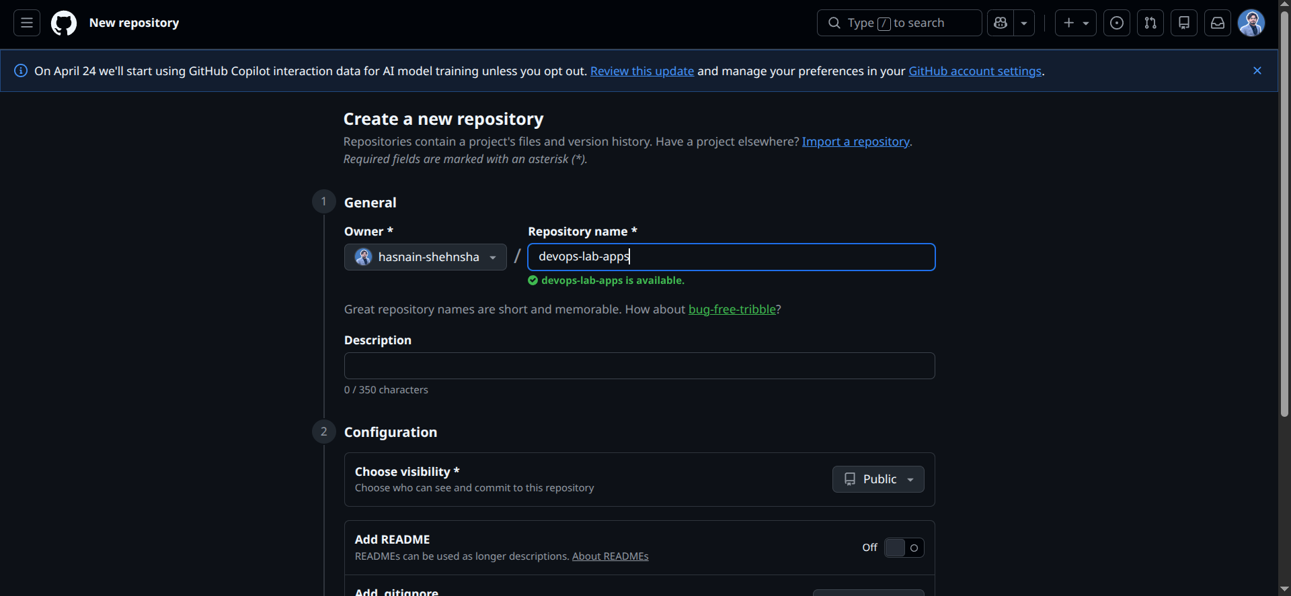
[ SCREENSHOT: Figure A-1: GitHub — New repository page with name "devops-lab-app" ]

2. Add Files & Push Code
cd "/home/husnain-shehnsha/python/dev ops lab mids"
git init
git add app.py requirements.txt Dockerfile deployment.yaml Jenkinsfile
git commit -m "Initial commit: Flask app with Docker and K8s config"
git remote add origin https://github.com/YOUR_USERNAME/devops-lab-app.git
git branch -m master main
git push -u origin main
[ SCREENSHOT: Figure A-3: Terminal — git init and git add commands output ]
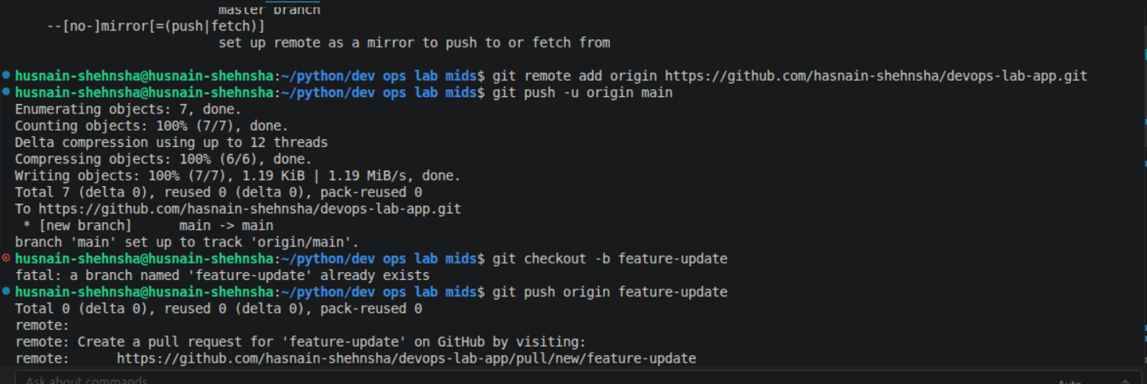
[ SCREENSHOT: Figure A-4: Terminal — git commit output showing files committed ]

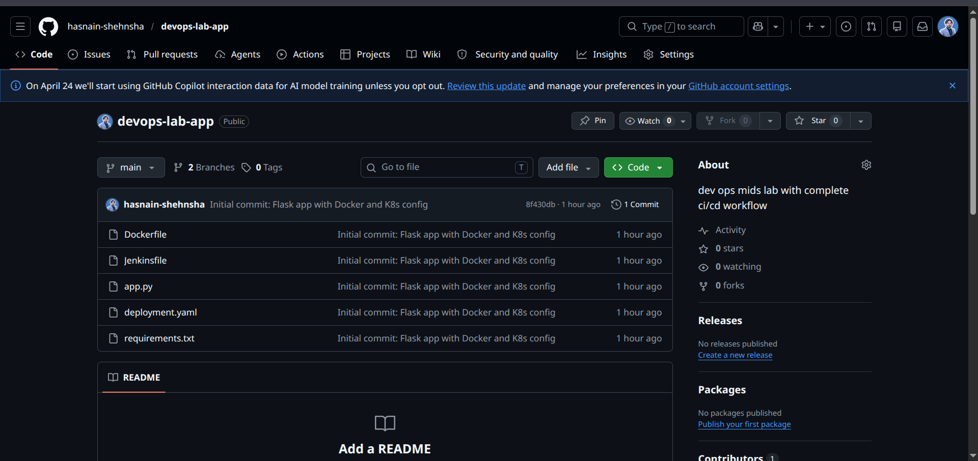
[ SCREENSHOT: Figure A-6: GitHub — Repository page showing app.py and other files ]

────────────────────────────────────────────────────────────────────────────────

Section C: Docker (10 Marks)

1. Dockerfile
FROM python:3.9-slim
WORKDIR /app
COPY requirements.txt .
RUN pip install -r requirements.txt
COPY app.py .
EXPOSE 5000
CMD ["python", "app.py"]
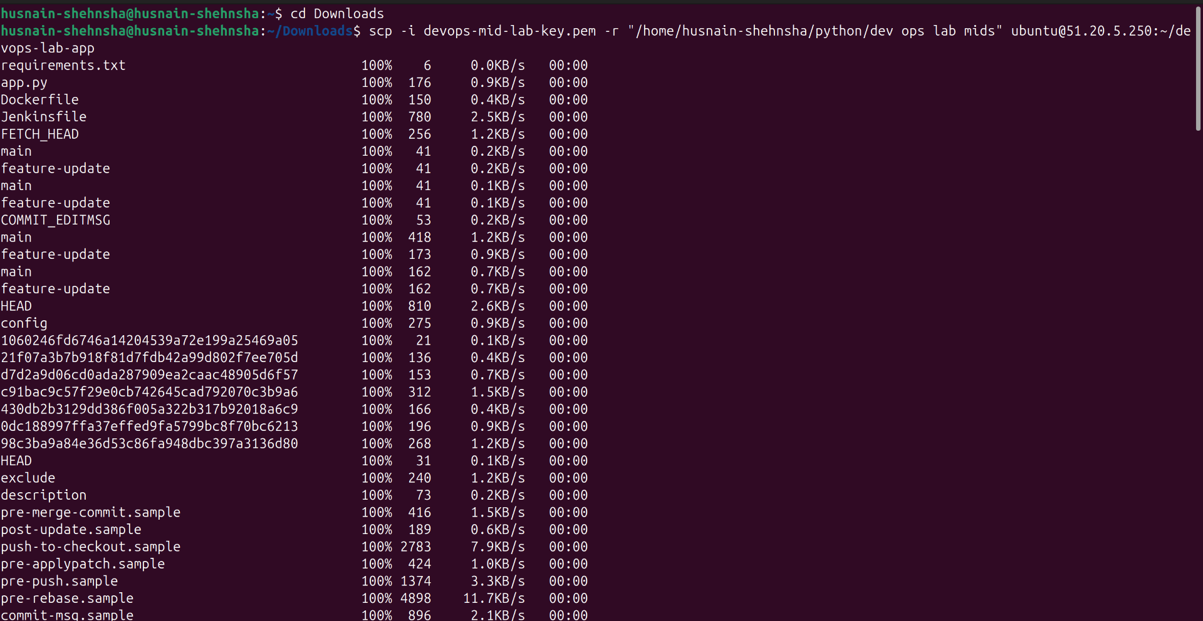
[ SCREENSHOT: Figure C-1: Dockerfile open in editor showing all instructions ]

2. Build Docker Image
sudo docker build -t devops-lab-app:latest .
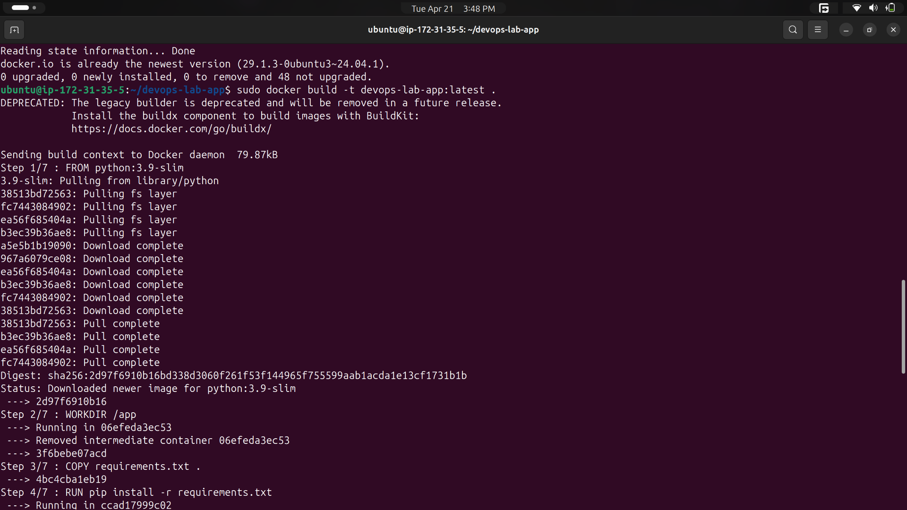
[ SCREENSHOT: Figure C-3: Terminal — docker build SUCCESS output "Successfully built <image_id>" ]

3. Run Docker Container
sudo docker run -d -p 5000:5000 --name devops-lab-app devops-lab-app:latest
sudo docker ps
curl http://localhost:5000
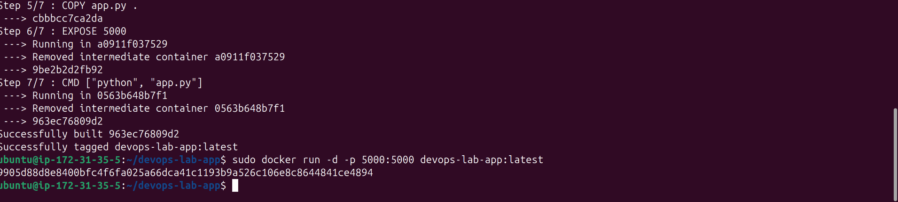
[ SCREENSHOT: Figure C-5: Terminal — docker ps showing container running on port 5000 ]
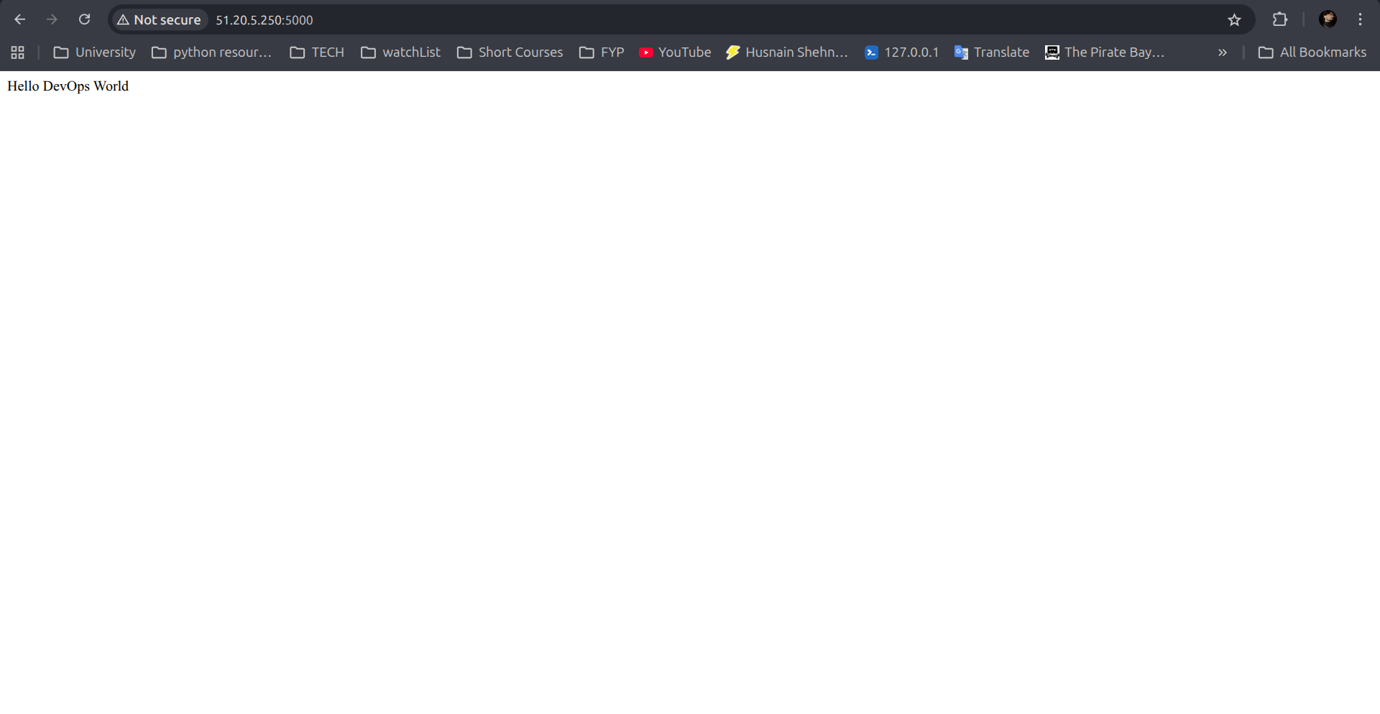
[ SCREENSHOT: Figure C-7: Browser — http://localhost:5000 showing "Hello DevOps World" ]

────────────────────────────────────────────────────────────────────────────────

Section D: AWS Deployment (10 Marks)

1. Launch EC2 Instance
Launched Ubuntu 22.04 t2.micro instance on AWS EC2.
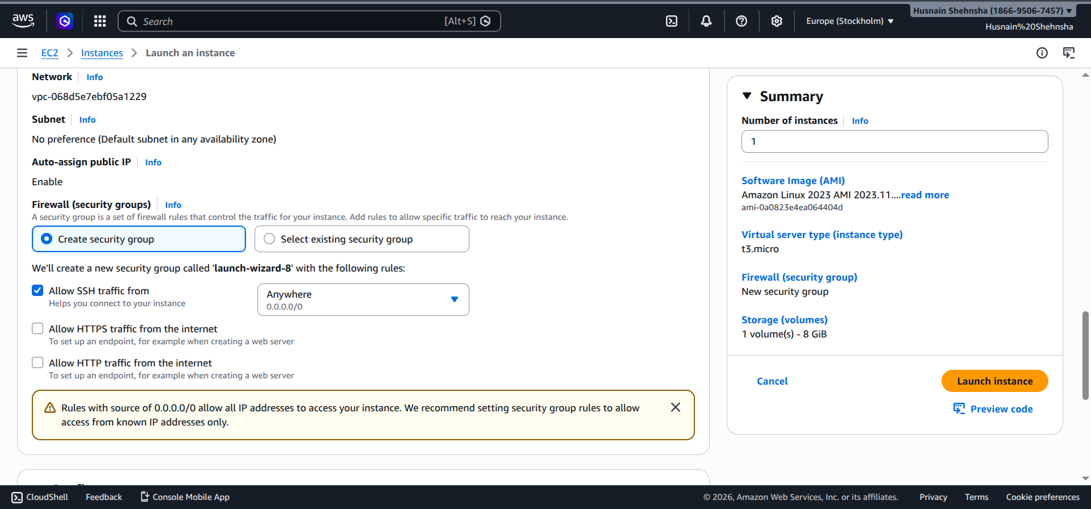
[ SCREENSHOT: Figure D-1: AWS Console — EC2 Launch Instance page (Ubuntu 22.04 selected) ]
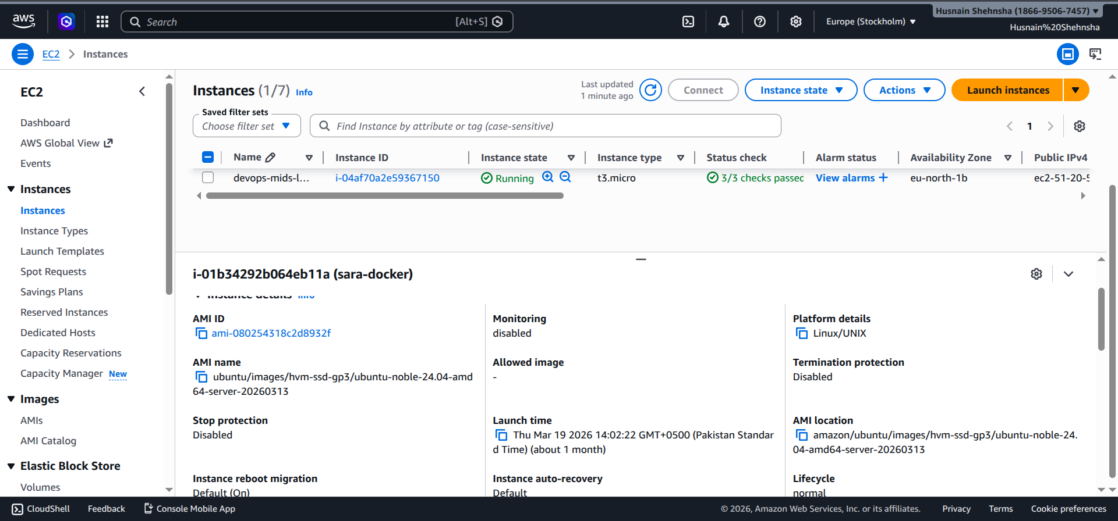
[ SCREENSHOT: Figure D-2: AWS Console — EC2 instance running state with Public IP visible ]

2. Configure Security Group
Added inbound rules for ports 22 (SSH), 5000 (Flask app), and 80 (HTTP).
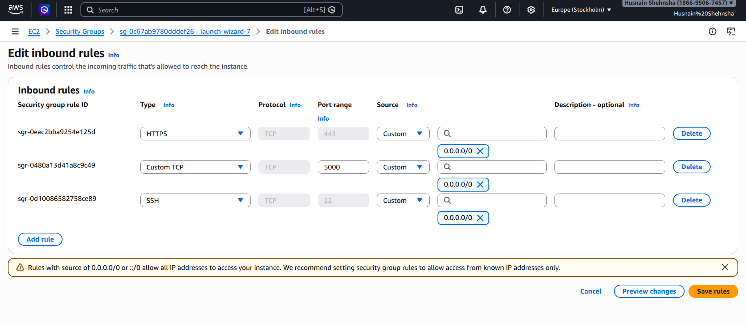
[ SCREENSHOT: Figure D-3: AWS Console — Security Group Inbound Rules showing port 22, 80, 5000 open ]

3. Install Docker on EC2
ssh -i devops-mid-lab-key.pem ubuntu@YOUR_EC2_IP
sudo apt update && sudo apt install -y docker.io
sudo systemctl start docker
docker --version
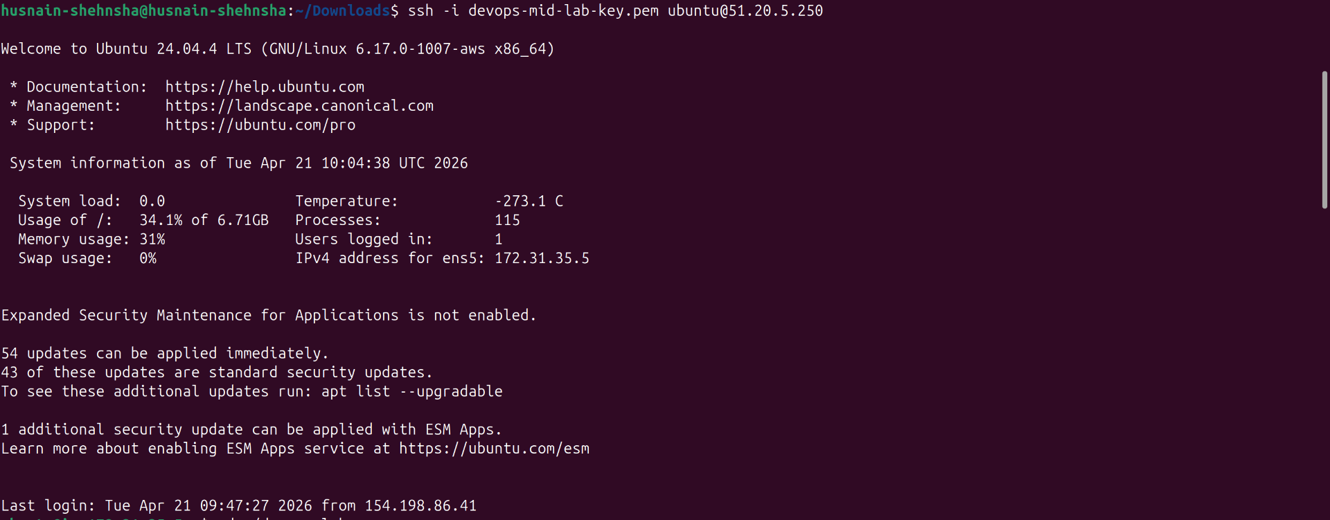
[ SCREENSHOT: Figure D-4: Terminal — SSH connection to EC2 successful (ubuntu@ip prompt visible) ]
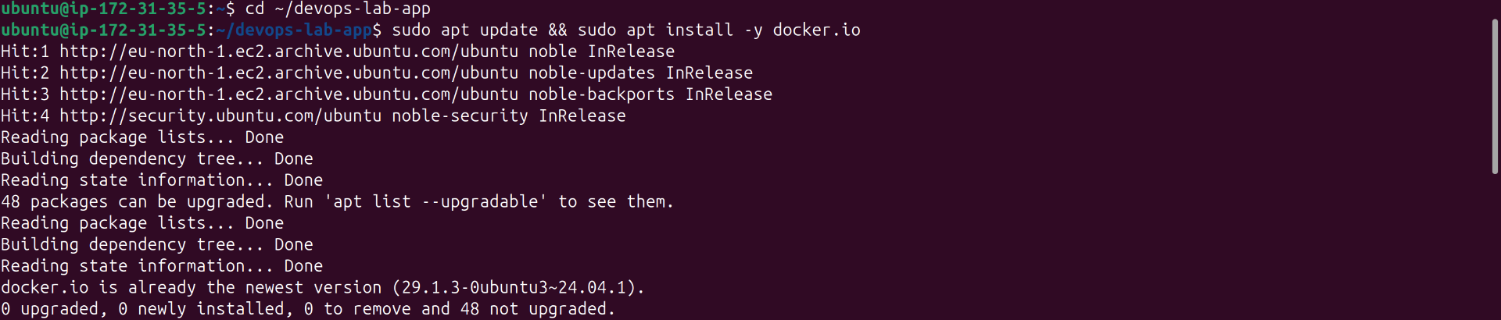
[ SCREENSHOT: Figure D-5: Terminal — docker --version output on EC2 ]

4. Copy Files & Deploy Container
# On LOCAL terminal:
scp -i devops-mid-lab-key.pem -r "/home/husnain-shehnsha/python/dev ops lab mids" ubuntu@YOUR_EC2_IP:~/devops-lab-app
# On EC2 SSH:
cd ~/devops-lab-app
sudo docker build -t devops-lab-app:latest .
sudo docker run -d -p 5000:5000 devops-lab-app:latest
sudo docker ps

[ SCREENSHOT: Figure D-6: Terminal — scp copy command successful output ]

[ SCREENSHOT: Figure D-7: Terminal (EC2) — docker build SUCCESS on EC2 ]
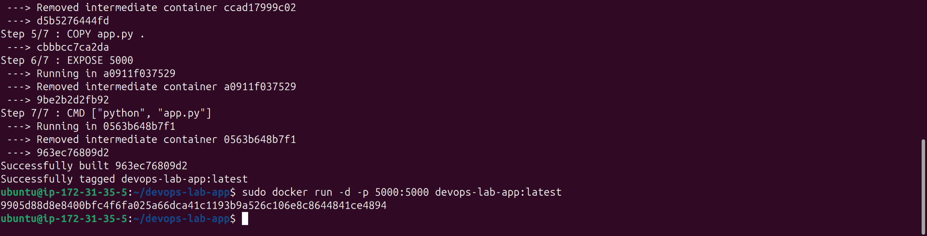
[ SCREENSHOT: Figure D-8: Terminal (EC2) — docker ps showing container running ]

5. Access via Public IP
curl http://YOUR_EC2_IP:5000


[ SCREENSHOT: Figure D-10: Browser — http://EC2_IP:5000 showing "Hello DevOps World" ]

────────────────────────────────────────────────────────────────────────────────

Section E: Kubernetes (8 Marks)

deployment.yaml
apiVersion: apps/v1
kind: Deployment
metadata:
name: devops-lab-app
spec:
replicas: 2
selector:
matchLabels:
app: devops-lab-app
template:
metadata:
labels:
app: devops-lab-app
spec:
containers:
- name: devops-lab-app
image: devops-lab-app:latest
imagePullPolicy: Never
ports:
- containerPort: 5000
---
apiVersion: v1
kind: Service
metadata:
name: devops-lab-service
spec:
selector:
app: devops-lab-app
ports:
- protocol: TCP
port: 80
targetPort: 5000
type: NodePort

1. Start Minikube & Deploy
minikube start --driver=docker
minikube image load devops-lab-app:latest
kubectl apply -f deployment.yaml
[ SCREENSHOT: Figure E-1: Terminal — minikube start output (Done! kubectl is configured) ]

[ SCREENSHOT: Figure E-2: Terminal — kubectl apply -f deployment.yaml (deployment.apps/devops-lab-app created) ]

2. Verify Pods (replicas=2)
kubectl get pods
kubectl get deployments
kubectl get services
[ SCREENSHOT: Figure E-3: Terminal — kubectl get pods showing 2 pods Running ]

[ SCREENSHOT: Figure E-4: Terminal — kubectl get deployments showing READY 2/2 ]

[ SCREENSHOT: Figure E-5: Terminal — kubectl get services showing devops-lab-service ]

3. Expose & Access Service
minikube service devops-lab-service
[ SCREENSHOT: Figure E-6: Terminal — minikube service output with URL ]

[ SCREENSHOT: Figure E-7: Browser — Kubernetes service URL showing "Hello DevOps World" ]

────────────────────────────────────────────────────────────────────────────────

Section F: Jenkins CI/CD (8 Marks)

1. Start Jenkins
sudo docker run -d \
--name jenkins \
-p 8080:8080 \
-v jenkins_home:/var/jenkins_home \
-v /var/run/docker.sock:/var/run/docker.sock \
jenkins/jenkins:lts
# Get admin password:
sudo docker exec jenkins cat /var/jenkins_home/secrets/initialAdminPassword
[ SCREENSHOT: Figure F-1: Terminal — Jenkins Docker container running (docker ps output) ]

[ SCREENSHOT: Figure F-2: Browser — http://localhost:8080 Jenkins unlock page ]

[ SCREENSHOT: Figure F-3: Browser — Jenkins dashboard after login ]

2. Jenkinsfile
pipeline {
agent any
stages {
stage('Clone Repository') {
steps {
git branch: 'main', url: 'https://github.com/YOUR_USERNAME/devops-lab-app.git'
}
}
stage('Build Docker Image') {
steps {
sh 'docker build -t devops-lab-app:latest .'
}
}
stage('Run Docker Container') {
steps {
sh 'docker stop devops-lab-app || true'
sh 'docker rm devops-lab-app || true'
sh 'docker run -d --name devops-lab-app -p 5000:5000 devops-lab-app:latest'
}
}
stage('Verify') {
steps {
sh 'sleep 3 && curl http://localhost:5000'
}
}
}
}

3. Create Pipeline & Connect GitHub
Steps performed in Jenkins UI:
1. New Item → Pipeline → Name: devops-lab-pipeline
2. Pipeline → Definition: Pipeline script from SCM
3. SCM: Git → Repository URL: https://github.com/YOUR_USERNAME/devops-lab-app.git
4. Branch: */main → Script Path: Jenkinsfile → Save
5. Build Now
[ SCREENSHOT: Figure F-4: Jenkins — New Pipeline item creation page ]

[ SCREENSHOT: Figure F-5: Jenkins — Pipeline config showing GitHub URL connected ]

[ SCREENSHOT: Figure F-6: Jenkins — Build Now triggered, pipeline stages visible ]

[ SCREENSHOT: Figure F-7: Jenkins — All 4 stages GREEN (Clone, Build, Run, Verify) ]

[ SCREENSHOT: Figure F-8: Jenkins — Console output showing "Hello DevOps World" at end ]

────────────────────────────────────────────────────────────────────────────────

Summary — Marks Breakdown
Section | Task | Marks
A | GitHub — Repo, Push, Branch, PR | 8
B | Flask App — app.py + requirements.txt | 6
C | Docker — Dockerfile, Build, Run | 10
D | AWS EC2 — Deploy & Access | 10
E | Kubernetes — Deploy, Replicas, Service | 8
F | Jenkins — Pipeline, GitHub, Docker | 8
 | Total | 50

All sections completed successfully. Screenshots attached above each figure label.

