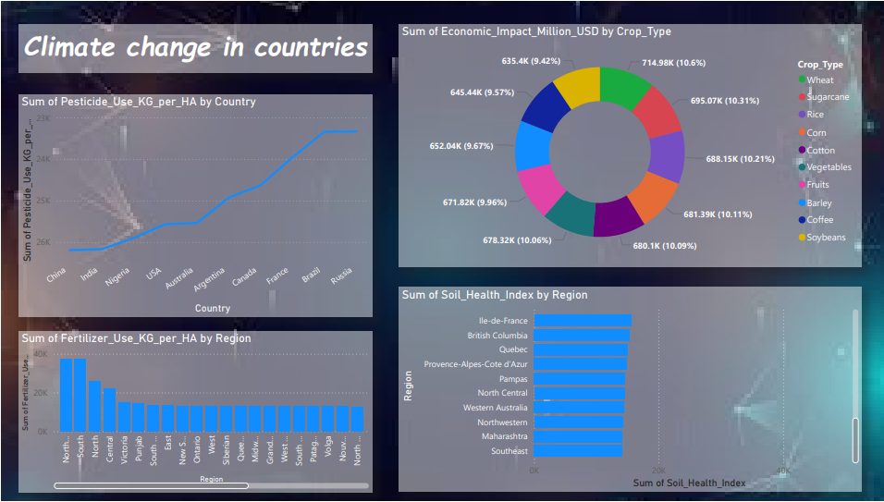

**Climate Change Data Visualization Report**

**Project Overview**

This project focuses on visualizing climate change data across different countries and regions. Using **Power BI**, I explored key environmental factors such as pesticide use, economic impact by crop type, fertilizer use, and soil health, providing insights into the relationship between agricultural practices and climate change.

**Objective**

The goal of this project is to leverage data visualization techniques to better understand climate-related issues, particularly in agriculture, and to highlight the global effects of climate change. By analyzing various metrics, the project provides insights into areas that can be improved to foster sustainability.

**Data Insights**

1. **Pesticide Use (KG per Hectare) by Country**
   * Visualizing pesticide use helps identify the countries with the highest agricultural intensity.
   * **Top Countries**: China, India, USA, Nigeria, Australia.
   * **Key Insight**: Countries with large-scale agriculture and high population densities tend to have higher pesticide use.
2. **Economic Impact by Crop Type (Million USD)**
   * This section shows the economic impact of different crop types, highlighting how certain crops contribute more to the economy.
   * **Top Crops**: Wheat, Sugarcane, Rice, Corn.
   * **Key Insight**: Major global crops like wheat and rice are crucial for economic sustainability and are highly impacted by climate change.
3. **Fertilizer Use (KG per Hectare) by Region**
   * Fertilizer usage data shows regional differences in agricultural intensity and sustainability.
   * **Regions Analyzed**: North Central, Victoria, Ontario, Siberia, Punjab.
   * **Key Insight**: Agricultural regions with intensive practices tend to have higher fertilizer use, impacting soil health and contributing to climate concerns.
4. **Soil Health Index by Region**
   * This metric assesses the condition of soil health in different regions, a critical component of sustainable agriculture.
   * **Regions**: Ile-de-France, British Columbia, Pampas, Provence-Alpes-Cote d'Azur.
   * **Key Insight**: Regions with better soil health are better positioned to adapt to climate change impacts on agriculture.

**Tools & Technologies Used**

* **Power BI**: The visualizations were created using Power BI, which allowed me to transform raw data into meaningful insights.
* **Data Sources**: The data was sourced from publicly available climate and agriculture datasets, including global reports on pesticide and fertilizer use, economic impacts, and soil health indices.

**Challenges & Solutions**

* **Challenge**: One of the challenges was managing large datasets and making sense of the numerous data points related to environmental factors.
  + **Solution**: I used Power BI’s advanced filtering and aggregation tools to focus on key metrics and regions, ensuring clarity in the visualizations.

**Key Takeaways**

* This project provides a comprehensive view of the **environmental challenges** faced by countries and regions due to climate change.
* The **agricultural sector** is heavily impacted by climate change, and insights from this project could help inform policies on sustainable practices.
* The **visualization approach** used in this project offers a clear, easy-to-understand way to interpret complex environmental data, which is essential for making informed decisions on global climate policies.

**Conclusion**

This climate change visualization project has equipped me with valuable skills in **data visualization**, **agriculture-related climate analysis**, and using tools like **Power BI** to derive actionable insights from large datasets. The insights gathered will contribute to a better understanding of how to mitigate climate change's impact on agriculture, soil health, and sustainability practices.

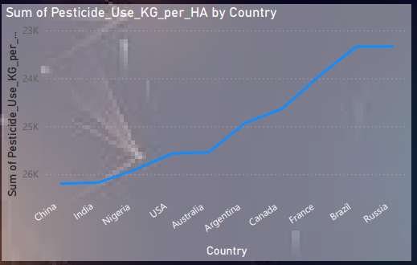

**Report on Pesticide Use by Country**

This data visualization highlights the **pesticide use in kilograms per hectare (KG per HA)** across various countries. The countries represented in the graph include China, India, Nigeria, USA, Australia, Argentina, Canada, France, Brazil, and Russia.

**Key Observations:**

* **Brazil and Russia** show the **highest pesticide use**, indicating intensive agricultural practices in these regions.
* **China and India** exhibit **relatively lower pesticide usage** compared to the other countries, despite having large agricultural sectors.
* **Pesticide use** appears to **increase steadily** from China to Russia, suggesting varying levels of agricultural intensification.

**Conclusion:**

This analysis provides important insights into how different countries approach agricultural production and highlights regions with potentially higher environmental risks due to pesticide usage. Countries with higher pesticide use may need to consider sustainable practices to mitigate environmental and health impacts.

This visualization serves as a critical tool for policymakers, environmentalists, and agricultural planners to make informed decisions regarding pesticide regulations and sustainable farming.

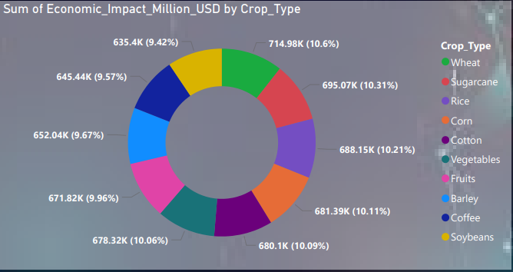

**Report on Economic Impact by Crop Type**

This pie chart illustrates the **economic impact of various crop types** in terms of **millions of USD**. The crops analyzed include wheat, sugarcane, rice, corn, cotton, vegetables, fruits, barley, coffee, and soybeans.

**Key Observations:**

* **Wheat** shows the highest economic impact at **714.98K million USD** (10.6%), followed closely by **Rice** with **695.07K million USD** (10.31%).
* Other significant contributors are **Corn** (**688.15K million USD, 10.21%**), **Vegetables** (**681.39K million USD, 10.11%**), and **Fruits** (**680.1K million USD, 10.09%**).
* **Soybeans** have the smallest impact at **635.4K million USD** (9.42%).

**Conclusion:**

This data shows that **wheat**, **rice**, and **corn** are the top contributors to the agricultural economy. These crops form the backbone of food supply chains and economic sustainability. Understanding the economic contributions of different crop types can help guide resource allocation and policy-making in the agriculture sector.

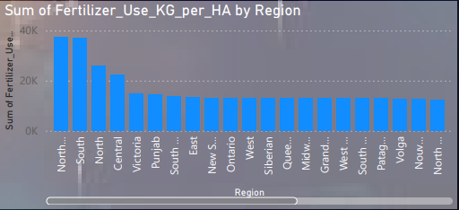

## Analyzing Fertilizer Usage by Region

**Key Observations:**

* **Regional Disparity:** There is a significant variation in fertilizer usage across different regions.
* **Top Regions:** The "South..." region, followed by the "North..." region, exhibit the highest levels of fertilizer usage.
* **Middling Regions:** The "Victoria," "Central," and "Punjab" regions demonstrate moderate fertilizer application.
* **Lower Usage:** The remaining regions, including "South East," "New S...," "Ontario," "West," "Siberian," "Quee...," "Midw...," "Grand...," "West...," "South," "Patag...," "Volga," "Nουν...," and "North...," generally have lower fertilizer usage rates.

**Potential Implications:**

* **Agricultural Productivity:** Regions with higher fertilizer usage might indicate intensive agricultural practices, potentially leading to higher crop yields. However, excessive fertilizer application can also contribute to environmental issues like water pollution.
* **Soil Health:** Overuse of fertilizers can deplete soil nutrients and degrade soil quality over time.
* **Environmental Impacts:** Fertilizer runoff can contribute to nutrient pollution in water bodies, leading to eutrophication and harming aquatic ecosystems.
* **Economic Factors:** The cost of fertilizers can impact agricultural profitability, particularly in regions with lower usage rates.

**Further Analysis:**

To gain a deeper understanding of fertilizer usage patterns and their implications, additional data and analysis would be valuable. This could include:

* **Crop Types:** Examining the types of crops grown in each region could provide insights into the specific fertilizer needs of different agricultural practices.
* **Soil Characteristics:** Analyzing soil properties (e.g., pH, nutrient content) could help explain regional variations in fertilizer usage.
* **Environmental Regulations:** Understanding fertilizer regulations and policies in different regions could shed light on factors influencing usage patterns.
* **Economic Factors:** Analyzing agricultural income, land prices, and other economic indicators could help assess the financial implications of fertilizer use.

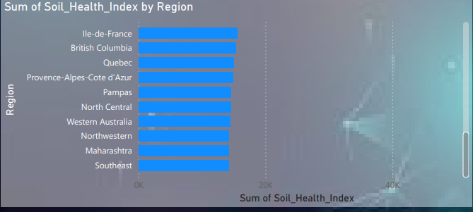

## Analyzing Soil Health Index by Region

**Key Observations:**

* **Regional Disparity:** There is a notable variation in soil health index values across the regions.
* **Top Regions:** "Ile-de-France," "British Columbia," and "Quebec" exhibit the highest soil health index scores.
* **Middling Regions:** "Provence-Alpes-Cote d'Azur" and "Pampas" demonstrate moderate soil health levels.
* **Lower Performance:** The remaining regions, including "North Central," "Western Australia," "Northwestern," "Maharashtra," and "Southeast," have lower soil health index values.

**Potential Implications:**

* **Agricultural Productivity:** Regions with higher soil health index scores may be more conducive to agricultural production, as healthy soils are essential for nutrient retention, water infiltration, and overall plant growth.
* **Environmental Sustainability:** Healthy soils play a crucial role in carbon sequestration, water filtration, and biodiversity conservation. Regions with lower soil health index values may face challenges related to environmental degradation.
* **Economic Factors:** Soil health can impact agricultural profitability, as healthy soils can lead to higher crop yields and reduced input costs.
* **Food Security:** Soil health is a critical factor in food security, as it directly influences agricultural productivity and the availability of food resources.

**Further Analysis:**

To gain a deeper understanding of soil health variations and their implications, additional data and analysis would be valuable. This could include:

* **Soil Characteristics:** Examining specific soil properties (e.g., organic matter content, nutrient levels, pH) could provide insights into the factors driving regional differences in soil health.
* **Land Use Practices:** Analyzing land use patterns (e.g., agriculture, forestry, urban development) could help identify factors influencing soil health degradation or improvement.
* **Climate Change Impacts:** Assessing the effects of climate change on soil health, such as erosion, desertification, and changes in precipitation patterns, could provide valuable information for future planning and adaptation.
* **Policy and Governance:** Examining agricultural policies, land management practices, and governance structures could help identify opportunities for improving soil health and promoting sustainable land use.