**Warehouse Management**

*Mohammad Hasnain Rajan*

**Following are the steps to run the application**

1. git clone <https://github.com/hasnain2808/Warehouse-Management>
2. cd Warehouse-Management
3. python -m venv venv
4. activate the venv depending on the OS
   1. Windows 🡪 venv\Scripts\activate
   2. Ubuntu 🡪 source venv\bin\activate
5. python -m pip install -r requirements.txt
6. set variables depending upon os
   1. Windows
      1. set FLASK_APP= warehouse_management
      2. set FLASK_ENV=development
   2. Ubuntu
      1. export FLASK_APP= warehouse_management
      2. export FLASK_ENV=development
7. #flask init-db Run this command only if you want a fresh sqlite instance
8. flask run

Go to <http://localhost:5000/> to use the App

**Updated UI Screenshots:**

* **Add Product Movement**

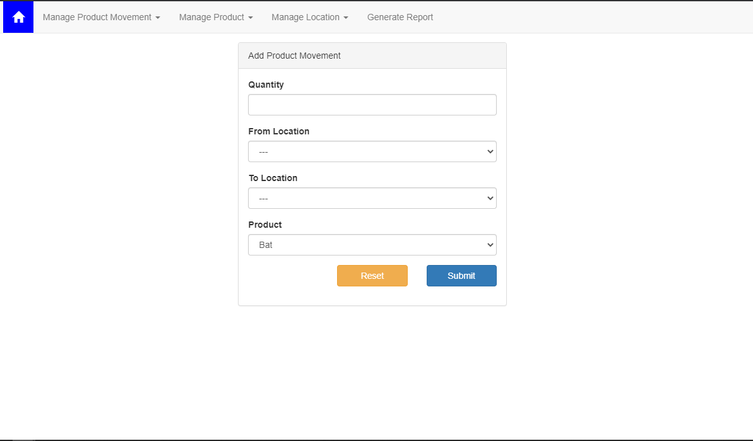

* **Add product movement validations**

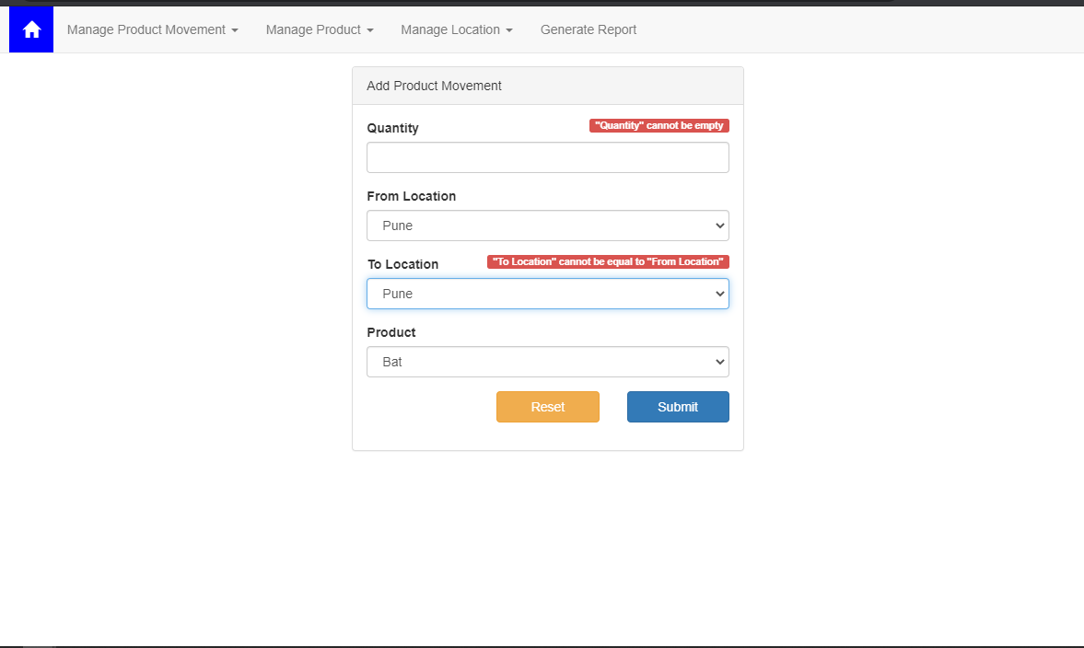

* **Add product movement success**

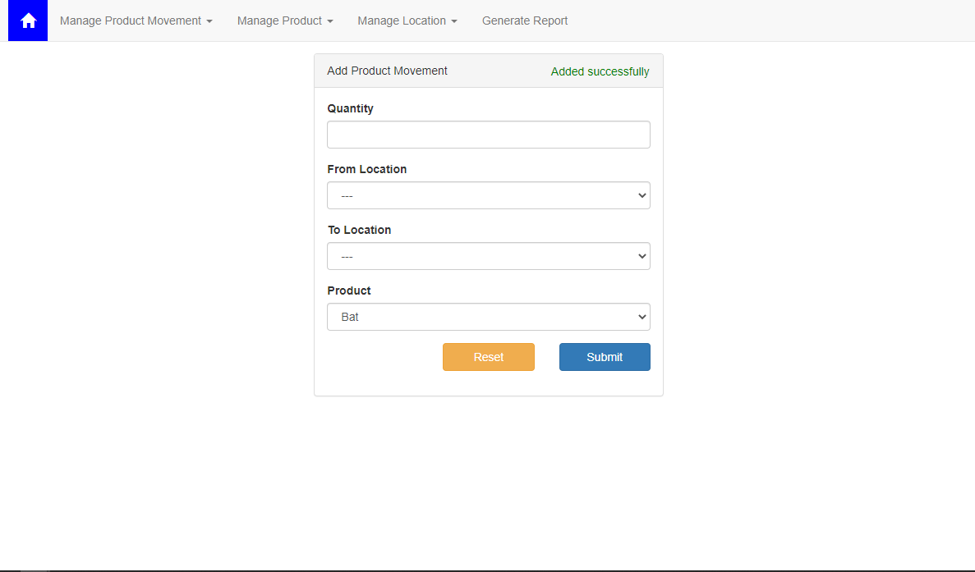

* **View Product Movement**

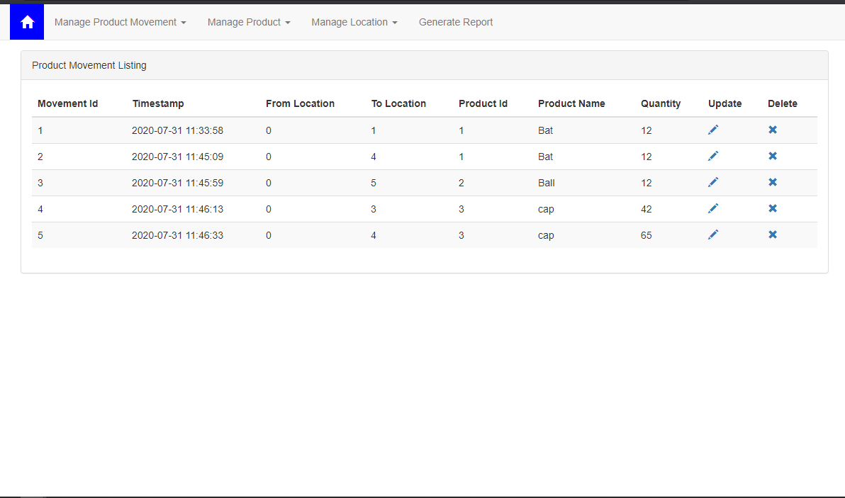

* **Add Product**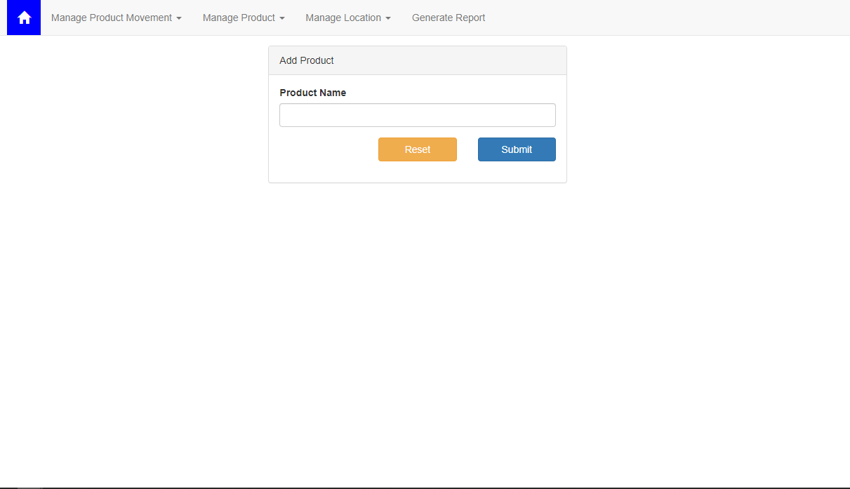
* **View Product**

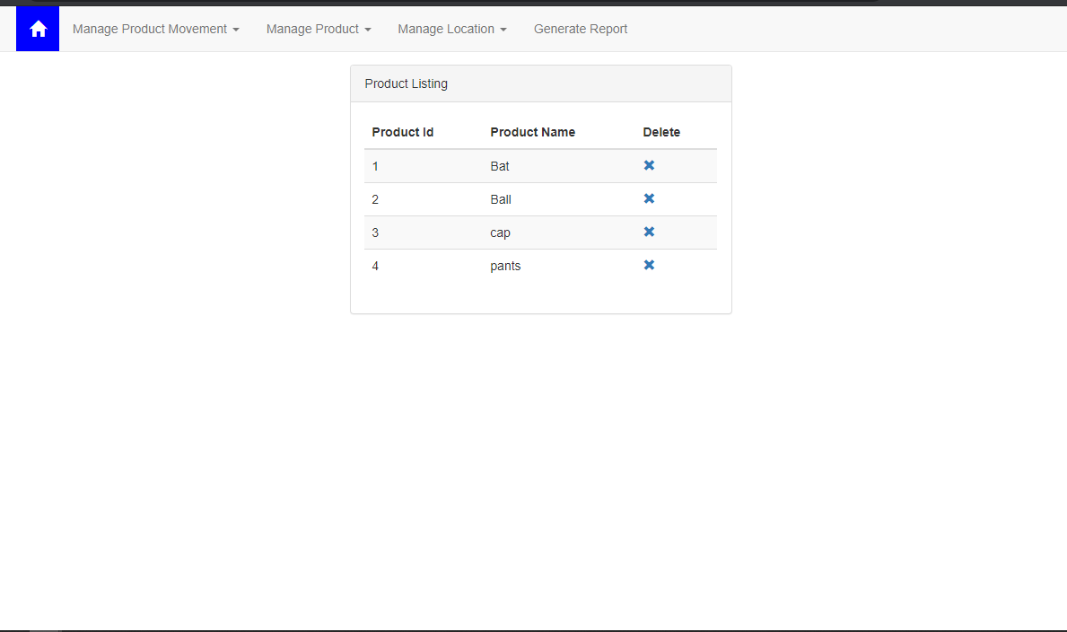

* **Add Location**

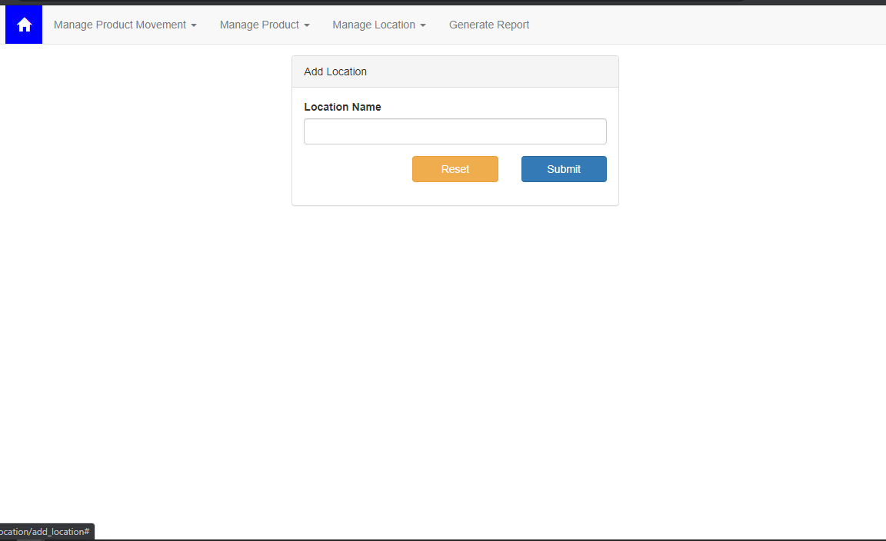

* **View Location**

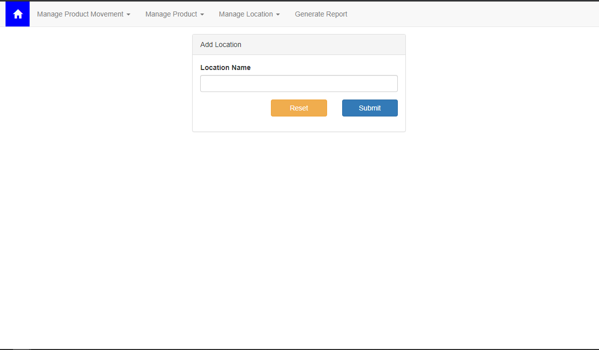

* **Report**

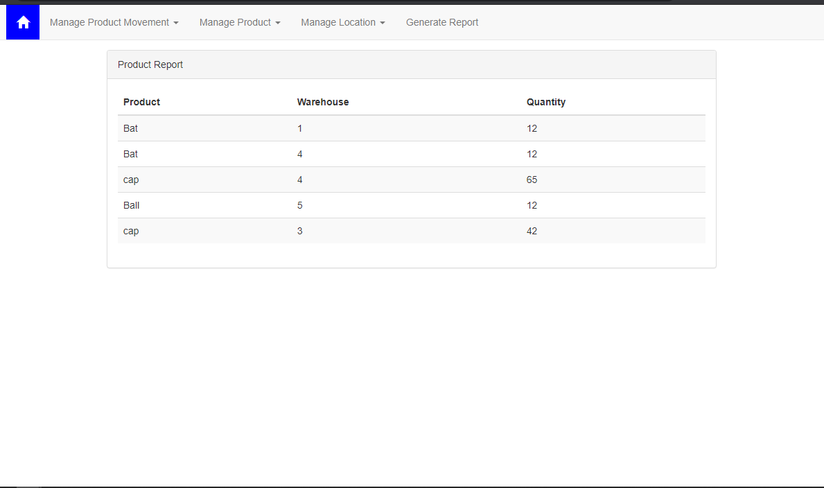

**Responsive**

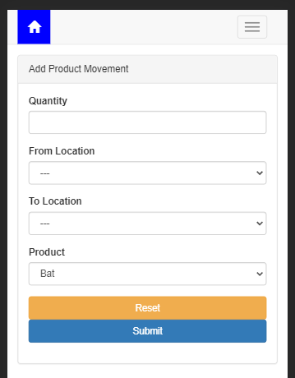

*The tables can be scrolled*

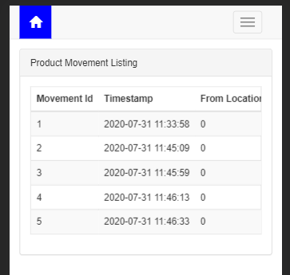 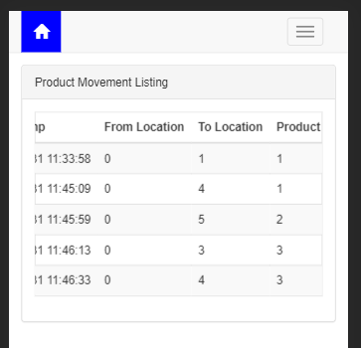

**Navbar**

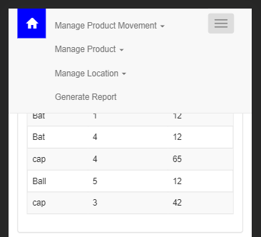

**This report summarizes the key features of the MVP**

**Database**

SQLite was used so that evaluation is easier

The requirements issued directed creation of the following Tables

1. Product (product_id)
2. Location (location_id)
3. ProductMovement (movement_id, timestamp, from_location, to_location, product_id, qty)

Script used

DROP TABLE IF EXISTS Product;

DROP TABLE IF EXISTS Location;

DROP TABLE IF EXISTS ProductMovement;

CREATE TABLE Product (

  product_id INTEGER PRIMARY KEY AUTOINCREMENT

  );

CREATE TABLE Location (

  location_id INTEGER PRIMARY KEY AUTOINCREMENT

  );

CREATE TABLE ProductMovement (

  movement_id INTEGER PRIMARY KEY AUTOINCREMENT,

  timestamp TIMESTAMP DEFAULT CURRENT_TIMESTAMP NOT NULL,

  from_location INTEGER ,

  to_location INTEGER ,

  product_id INTEGER NOT NULL,

  qty INTEGER,

  FOREIGN KEY (movement_id) REFERENCES Product (product_id),

  FOREIGN KEY (from_location) REFERENCES Location (location_id),

  FOREIGN KEY (to_location) REFERENCES Location (location_id)

);

**Views:**

The views were created as directed in the requirements. Edit for Location and Product is not created because as they have only one column and that is the primary key. Editing it is not correct. Although Delete is added for all Entities

|  |  |
| --- | --- |
| **Requirement** | **Endpoint** |
| Add Product | /product/add_product |
| View Product | /product/view_product |
| Delete Product | /product/delete_product/id |
| Add Location | /location/add_location |
| View Location | /location/view_location |
| Delete Location | /location/delete_location/id |
| Add ProductMovement | /product_movement/add_product_movement |
| Edit ProductMovement | /product_movement/update_product_movement/id |
| View ProductMovement | /product_movement/view_product_movement |
| Delete ProductMovement | /product_movement/delete_product_movement/1 |
| Report | /product_movement/get_report |

**Use Cases**

1. Create 3/4 Products

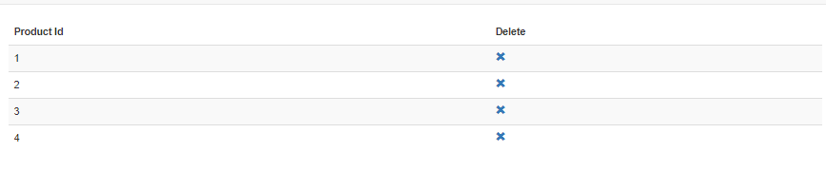

1. Create 3/4 Locations

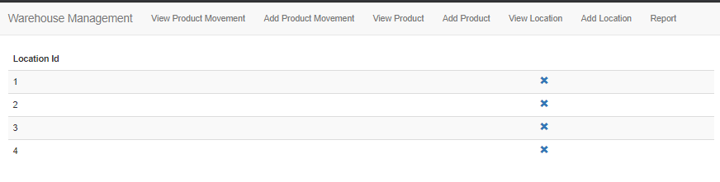

1. Make ProductMovements
   1. After 8 Movements

View

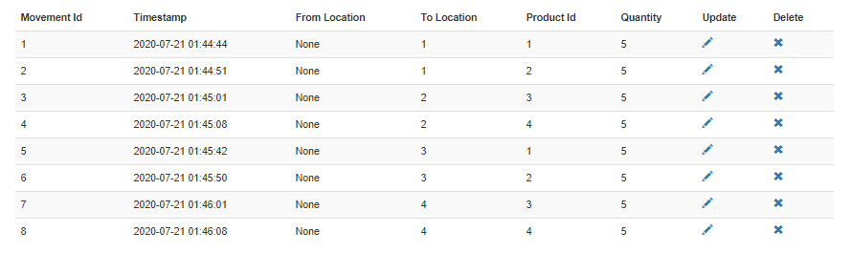

Report

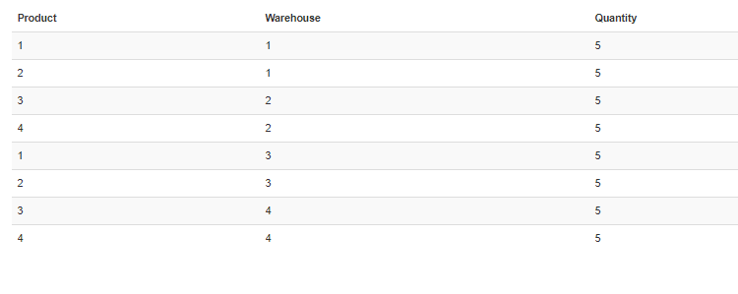

* 1. After 12 movements

View

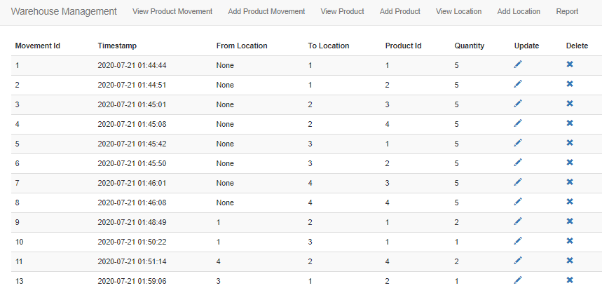

Report

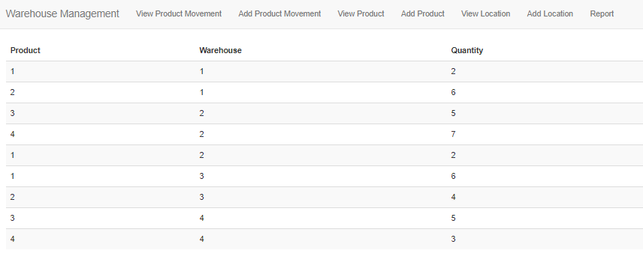

* 1. After 20 movements

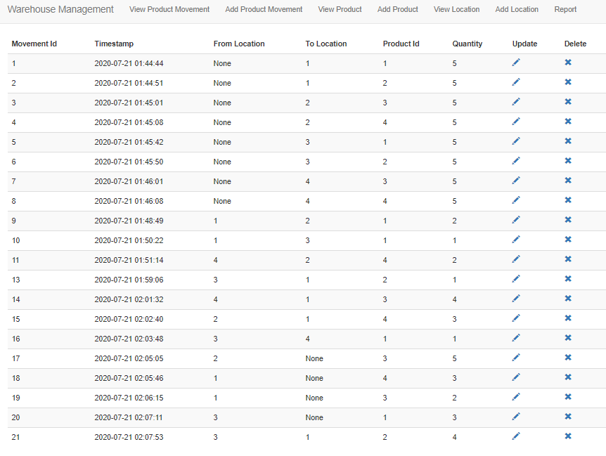

1. Final Report

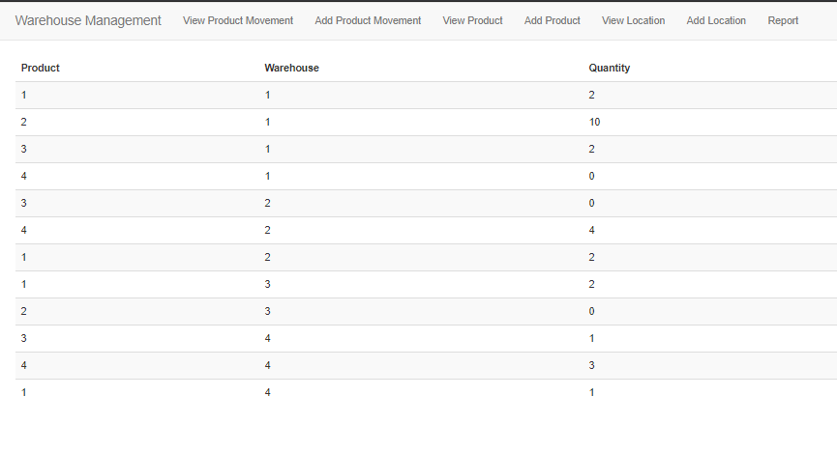

**Key Features**

1. Responsive UI using Bootstrap
2. Add, view, Delete Location
3. Add, view, Delete Product
4. Add, view, Edit, Delete ProductMovements
5. Final Report handles all types of product movements. If the user moves out something that is not available that is easily recognizable in the report by a negative quantity
6. Error handling using try/ catch so that appropriate message is displayed on the console and a error page to the user
7. Form Validations
8. Used SQLite to facilitate Evaluation
9. Code with comments and docstrings
10. Used Reusable templates for navbar