Careem-Style Mobility Decision Brief Generator
Single-file challenge submission package

Submission Items
Requirement | Included Response
Prototype artifact | Public GitHub repository link plus embedded prototype screenshots.
Dataset link | Chicago TNP rideshare data and Ajman Taxi Trips public data links.
100-word summary | Exact 100-word idea and approach summary included below.

1. Public Prototype Link and Screenshots
Public repository: github.com/hasnainakber9/careem_project
The screenshots below show the corrected prototype interface: the overview hero, cleaned navigation, KPI cards, interactive chart controls, route signal map, and generated decision brief.
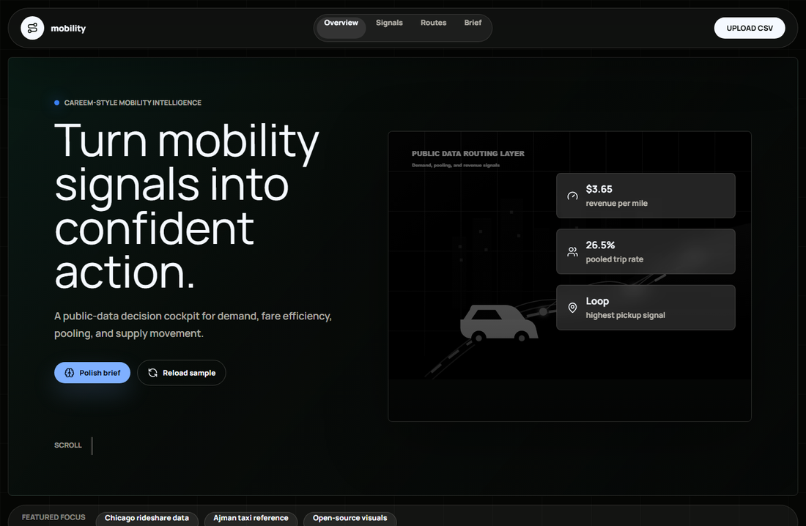
Screenshot 1: Prototype overview and primary navigation.
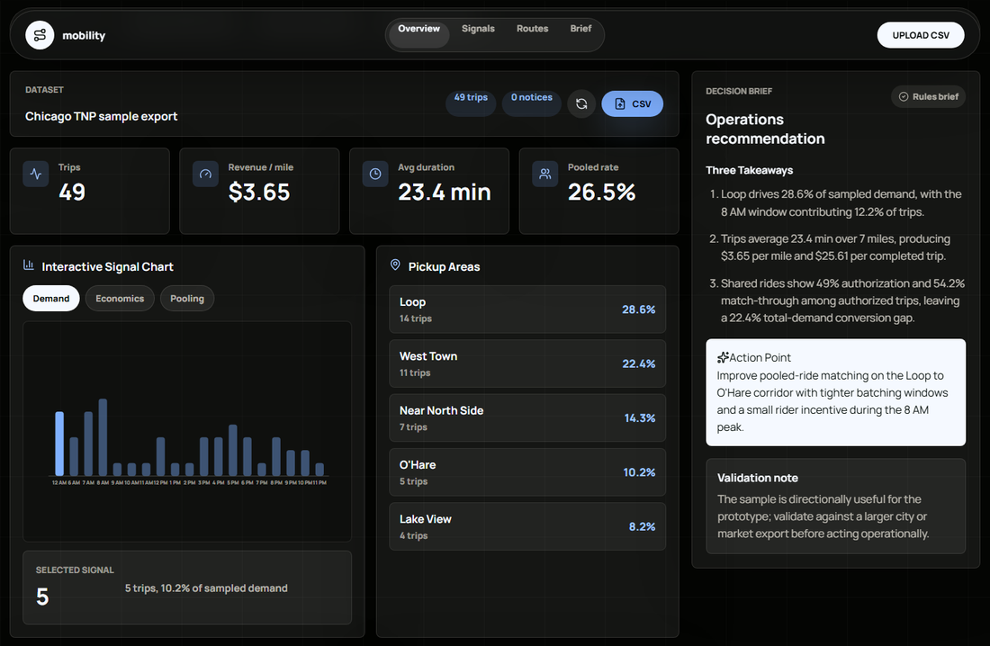
Screenshot 2: Interactive signals, chart controls, route map, and decision brief.

2. Public Dataset Links
Primary dataset: City of Chicago Transportation Network Providers Trips
Used because it closely resembles ride-hailing marketplace operations: trip time, distance, fare, pickup/dropoff areas, shared-trip authorization, shared-trip match, and pooled-trip fields.
Regional reference: Ajman Taxi Trips
Used to add UAE mobility context through regular taxi, special-needs taxi, and women's taxi trip counts.

3. 100-Word Summary
This prototype is a Decision Brief Generator for a Careem-style mobility operations team. It uses public ride-hailing trip data to convert operational metrics into an executive brief. The app analyzes demand by hour and area, trip duration, distance, fare efficiency, top pickup/dropoff corridors, pooled-ride rate, and shared-ride match-through. It then generates three takeaways and one recommended action, such as rebalancing drivers or improving pooled matching. Chicago rideshare data provides rich trip-level behavior, while Ajman taxi records add UAE relevance. The demo runs without secrets using deterministic rules, with optional OpenRouter rewriting when an API key is configured, preserving deployment readiness.
Word count: 100

