**PROJECT # 01**

**Count the number of people in a video**



Session 2020

**Submitted to** Dr. Jawad Khan

**Submitted by**

|  |  |
| --- | --- |
| Hasnain Ali Poonja | 317898 |

**School of Mechanical and Manufacturing Engineering**

**National University of Sciences & Technology NUST**

**Computer Vision Project**

**Count the number of people in a video**

**Problem:**

Count the number of persons in a video. Your algorithm will be given a video and it should be able to tag and count the number of persons in that video. The lightning condition will vary, so your algorithm should be able compensate the variations in light. The algorithm should also be able increase or decrease the count of the persons if a new person enters or leave frame.

**Strategies Used:**

Haar Cascade Classifiers using OpenCV for frontal faces.

Convolutional Neural Networks using Dlib for side faces.

**Video Preprocessing:**

1. Maintaining brightness and applying gamma value correction on a video.
2. Resizing the image to fit on the window.
3. Preparing a dataset for training images for side faces.
4. Use a pretrained model and apply transfer learning for person recognition.

**Result:**

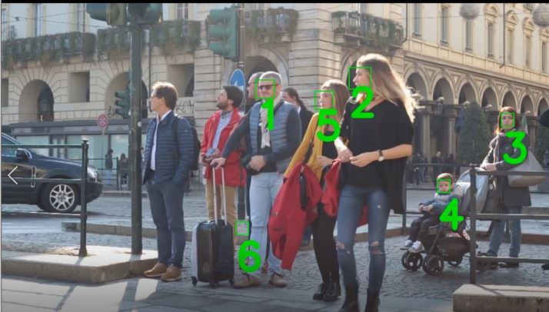

**Code:**

