Department of Computer Sciences



**University Islamabad**

**Web Technology**

**By**

**Hafiz Hasnain Altaf FA18-BCS-023**

**Muhammad Waleed Bin Tariq FA18-BCS-077**

**Submitted to**

**Dr. Muhammad Imran**

Section **BCS-5B**

**___________________________________________________________________________**

CS department, Comsats University Islamabad

Park Road, Islamabad, Pakistan

**Comsats University Islamabad**

**Department of Computer Sciences**

**Project Submission**

**Web Technologies**

**By**

**Hafiz Hasnain Altaf**

**&**

**Muhammad Waleed Bin Tariq**

**Submission Date**

**16-01-2020**

**Title: University Informator**

This project contains the data of different universities of world. This will help the intermediate students to get information of the universities. It will show the name of universities, ranking, research, and program offered.

**Running:**

* Route protection is implemented, there is no access to the website without sign up.
* We also used “Sessions” to store information to be used in multiple pages.
* Searching is done through AJAX calls. The user can search the universities with their Name, Ranking, Research and Scholarships.
* We are using python scripts to scrape data of universities from QS Top Universities.

We used following python libraries for scraping:

“Requests” to GET data

“Requests-HTML” to PARSE data

“UrlLIB3” to SEND data

“UUID” to provide unique ID

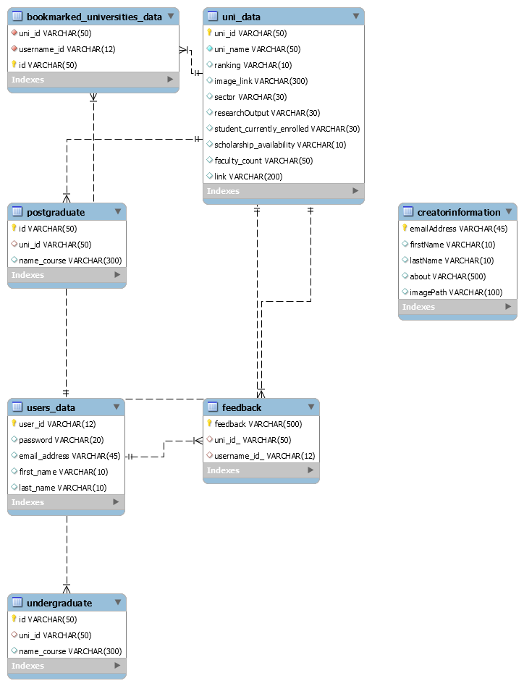**ERD:**