A

Project Report of

Gender and Age Detection

At

SOFTPRO INDIA

Submitted in Partial Fulfilment of Requirements for the Award

the Degree of

Bachelor of Technology

CSE with Artificial Intelligence and Data Science

June – July 2024

|  |  |  |
| --- | --- | --- |
| SUBMITTED BY | | UNDER GUIDANCE OF |
| NAME | HASNAIN HAIDAR | MR. Tasleem Jamal  Department of Engineering & Technology |
| ENROLLMENT NO | A-8953 |

Department of Computer Science and Engineering

**Khwaja Moinuddin Chishti Language University Lucknow**

**DECLARIATION**

This is to certify that the project report entitled “Gender and Age Detection Minor Project” is a genuine and original work carried out by me, under the guidance of **Er. Tasleem Jamal**, for the partial fulfilment of the requirements for the award of the degree of Bachelor of Technology in Computer Science Engineering. The work presented in this project report is authentic and has been carried out with complete dedication and integrity. To the best of my knowledge and belief, the matter embodied in this project work has not been submitted earlier for the award of any degree or diploma at any other institution.

I hereby declare that the work is my own, and any assistance or references used have been duly acknowledged. The project explores and develops a Gender and Age Detection System using advanced machine learning techniques. While the work presented is original, I have referred to various sources for guidance, technical knowledge, and relevant research, which have been properly cited in the report. The findings presented in this project are the result of my independent research and work under the supervision of Er. Tasleem Jamal.

# INDEX

Table of Contents Page No.

Introduction 3

Project Overview: 3

Problem Definition: 3

Aim of the Project: 4

Objective 5

System analysis 7

System Analysis: 7

System design and Implementation 11

1. System Design 11

2. Implementation 15

Conclusion 24

References 25

# Introduction

## Project Overview:

The **Gender and Age Detection Minor Project** aims to develop a web-based application capable of predicting the gender and age group of individuals from facial images. This project leverages the power of machine learning and computer vision techniques, specifically using deep learning models, to analyse facial features and make predictions based on the input image. The application provides real-time predictions, classifying the gender as male or female and estimating the age within a predefined range (e.g., 18-25, 26-35, etc.).

## Problem Definition:

In many industries, particularly in marketing, security, and demographic studies, understanding the gender and age of individuals plays a crucial role in decision-making processes. Manual methods of collecting this information, such as surveys or face-to-face interactions, are time-consuming, inefficient, and prone to errors. Furthermore, in large-scale applications like targeted advertising or customer analytics, manually gathering such demographic data becomes increasingly difficult and expensive.

The problem this project addresses is the automated detection of gender and age from images using advanced machine learning techniques, specifically in the context of facial recognition. With the rapid growth of digital content and the increasing use of computer vision in applications like retail analytics, social media platforms, and surveillance systems, there is a growing need for accurate and real-time age and gender classification systems.

## Aim of the Project:

The **Gender and Age Detection Project** aims to develop a real-time system capable of accurately predicting the gender (male or female) and estimating the age range (e.g., 18-25, 26-35) of individuals from facial images. This project utilizes deep learning and machine learning techniques to analyse facial features, providing an efficient, automated solution for demographic analysis.

This project addresses the need for automated demographic data collection in areas like marketing, consumer analytics, security, and personalization, providing a fast, scalable alternative to traditional manual methods. The final system will be deployed on cloud platforms like Heroku or AWS, making it accessible to a wide audience.

# Objective

The primary objective of the **Gender and Age Detection System** project is to create an intelligent, real-time, and fully automated system capable of accurately predicting the **gender** (male or female) and estimating the **age range** (e.g., 18-25, 26-35, 36-45, etc.) of individuals based on facial images. The project will make use of **deep learning** **techniques**, particularly **Convolutional Neural Networks (CNNs)**, to analyse facial features and classify the gender and age of individuals with high precision.

The specific objectives of the project are as follows:

To develop a highly accurate gender and age detection model that leverages state-of-the-art deep learning techniques, specifically Convolutional Neural Networks (CNNs), which are proven to be effective in image recognition tasks. The model should be capable of classifying gender (male or female) and predicting the age group of individuals from facial images.

To design and build a user-friendly web application using the Flask framework as the backend, allowing users to upload facial images for analysis and receive predictions on gender and age in real time. The system should offer an intuitive interface that makes the process seamless for users.

To ensure the system’s scalability and availability by deploying it on a cloud platform such as Heroku or AWS. This will allow the system to handle high traffic, maintain performance efficiency, and be accessible to users globally, ensuring the application’s sustainability over time.

To improve the accuracy and robustness of the system, particularly in handling images taken in various lighting conditions, at different angles, and with diverse facial expressions. This will involve using data augmentation techniques and transfer learning to ensure the model generalizes well across various input conditions.

To validate the performance of the system through rigorous testing using a large dataset of facial images that include diverse demographics (age, gender, ethnicity, and facial expressions). The goal is to achieve a high accuracy rate and minimize errors in gender and age predictions, making the system reliable for real-world applications.

To demonstrate the practical applications of this system in various domains such as marketing, customer analytics, advertising, security, and personalization. The system will be useful for businesses and organizations that rely on demographic data for targeted decision-making and customer insights.

To make the system accessible and easy to use, ensuring that it can be integrated into different industries, whether for targeted advertising, demographic analysis in consumer research, or as a tool for personalized user experiences in digital platforms.

To contribute to the advancement of AI-based facial recognition technologies, especially in gender and age prediction. The project aims to push the boundaries of existing models, focusing on accuracy, ease of use, and real-time performance.

To create a scalable solution for future enhancements, allowing for the possibility of extending the system to detect additional demographics or facial attributes, such as ethnicity, emotional expression, or even identity verification, in the future.

# System analysis

## System Analysis:

System analysis is a critical phase in the development of any project, particularly in software and application development. It involves examining the current system or the problem to be solved and understanding the requirements, constraints, and goals of the system that needs to be developed. In the case of the **Gender and Age Detection System**, system analysis will help in determining the design, architecture, tools, and processes required to achieve the project's objectives.

**Key Components of System Analysis:**

1. **Problem Identification:**
   * The first step in system analysis is understanding the problem or need. In this case, the problem is the need for an automated, accurate, and real-time **gender and age detection** system from facial images.
   * Existing manual methods of gathering demographic information (age and gender) are time-consuming, prone to human error, and inefficient. Thus, automation is necessary for quick and accurate predictions.
2. **Requirements Gathering:**
   * **Functional Requirements:**
     + The system must accurately predict **gender** (male or female) and estimate **age range** (e.g., 18-25, 26-35, etc.) from facial images.
     + The system should have a user-friendly web interface where users can upload images and view predictions in real time.
     + The system should provide a **confidence score** indicating the reliability of the predictions.
     + The system must be deployed on a cloud platform (e.g., **Heroku** or **AWS**) for easy accessibility.
   * **Non-Functional Requirements:**
     + The system should be **scalable**, capable of handling large volumes of users and requests simultaneously.
     + The **response time** of the system should be minimal, providing real-time predictions.
     + The system should be **robust**, ensuring high accuracy across diverse facial images (different lighting conditions, ethnic backgrounds, etc.).
     + The system must be **secure**, especially if any personal data (e.g., facial images) is being collected.
3. **Feasibility Study:**
   * **Technical Feasibility:**
     + The project is technically feasible using deep learning and machine learning techniques, specifically Convolutional Neural Networks (CNNs) for image recognition. Pre-trained models like VGG-Face or ResNet can be fine-tuned for gender and age detection.
     + A web interface can be built using Flask for the backend and HTML/CSS/JavaScript for the frontend.
     + The system can be hosted on platforms like **AWS** or **Heroku** for cloud-based deployment.
   * **Economic Feasibility:**
     + Building and deploying the system using open-source tools (such as Python libraries for machine learning) keeps the project cost-effective.
     + Cloud platforms like Heroku or AWS offer free tiers for initial development and scaling options as the project grows.
4. **System Design:**
   * **Architecture Design:**
     + The overall system architecture is based on a client-server model.
     + The user interacts with a web-based frontend, uploading images, and receiving predictions. This frontend communicates with the backend server, which processes the image using a machine learning model and returns the predictions (gender and age) to the user.
   * **Data Flow:**
     + The user uploads an image.
     + The backend server processes the image using a pre-trained deep learning model.
     + The system predicts the gender and age and returns the results along with confidence scores.
   * **Technological Stack:**
     + **Frontend:** HTML, CSS, JavaScript (for UI/UX)
     + **Backend:** Flask (Python framework)
     + **Machine Learning:** TensorFlow for training and implementing deep learning models (such as CNNs for image recognition)
     + **Cloud Deployment:** Heroku or AWS for hosting and making the system accessible globally.
   * Data preprocessing steps include **resizing** images, **normalizing** pixel values, and **augmentation** (e.g., rotating, flipping) to improve model generalization.
5. **Model Selection and Training:**
   * A suitable deep learning model such as **VGG16**, **ResNet**, or **Mobile Net** will be fine-tuned for the task of gender and age prediction.
   * The model will be trained on labelled facial datasets, and its performance will be evaluated using metrics like **accuracy**, **precision**, **recall**, and **F1-score**.
   * Transfer learning can be used, where a pre-trained model is adapted for the gender and age prediction task.
6. **Testing and Validation:**
   * The system will undergo rigorous **testing** to ensure that it works under various conditions (e.g., different lighting, facial expressions, and angles).
   * A **validation dataset** will be used to evaluate the model’s accuracy in predicting gender and age.
   * **Unit testing** will be performed on the web application to ensure all components function correctly.

# System design and Implementation

## System Design

The **Gender and Age Detection System** is designed to predict the gender and age of a person based on facial images. It follows a **client-server architecture**, where the client interacts with the server for uploading images and receiving predictions.

The **frontend** is responsible for providing the user interface, allowing users to upload images of faces. Built using **HTML**, **CSS**, and **JavaScript**, the frontend provides a simple, user-friendly platform for image submission. When the user uploads an image, it is sent directly to the backend for processing, without the need for a RESTful API. Instead, the data is submitted using standard **HTML forms** and **AJAX** requests.

The **backend** is implemented using the **Flask** framework, a lightweight server-side technology. When the backend receives the image from the frontend, it processes the image, including resizing and normalization, before passing it to the machine learning model. Flask handles the image upload and prediction process seamlessly. The backend is also responsible for running the trained machine learning model, which is used to predict the gender and age based on facial features.

The **machine learning model** is based on **Convolutional Neural Networks (CNNs)**, which are specifically designed for image classification tasks. A pre-trained model, such as **VGG16**, is used and fine-tuned to predict gender and age. After the model processes the image, it generates a prediction for the gender (e.g., male or female) and a specific age range (e.g., 18-25 years, 26-35 years, etc.). These predictions are then returned to the backend.

The system design is simple yet effective, using direct image uploads and basic data handling to provide real-time predictions. It ensures that users can easily access the service without complex interactions or the need for additional APIs. The system is designed to be flexible, allowing future improvements such as adding new features or upgrading the machine learning

1. **Frontend Design:**

The frontend is a simple web interface created using **HTML** and **CSS**. It allows users to upload facial images, which are processed by the backend. The image is uploaded through an HTML form that sends the image file to the Flask backend for analysis. Once the image is processed, the predicted results (gender and age) are displayed directly on the page without the need for JavaScript-based interactions.

1. **Backend Design (Flask):**

The backend of the system is built using **Flask**, a lightweight Python web framework. It receives the uploaded image, processes it for gender and age detection, and then sends the prediction results back to the frontend.

1. **Image Upload:**
   * The user uploads an image of their face via a simple HTML form.
   * Flask handles the image upload and processes the image file sent by the user.
2. **Face Detection:**
   * **OpenCV**'s **Haar Cascade Classifier** is used to detect faces in the uploaded image.
   * The system applies the **Haar Cascade Classifier** to detect faces in the image, which is a quick and efficient way of detecting faces without needing complex deep learning models.
3. **Prediction (Gender and Age):**
   * After face detection, the system uses the facial region to predict the gender and age. The system uses basic image processing techniques and machine learning algorithms, such as simple classifiers, or even pre-trained models integrated into OpenCV for age and gender estimation.
4. **Display Results:**
   * After the prediction is made, Flask returns the results (gender and predicted age) to the user. The results are displayed on the web page as text.

**Image Processing and Prediction Workflow:**

1. **Image Preprocessing:**
   * The uploaded image is read and converted to grayscale using OpenCV.
   * The grayscale image is processed for face detection, and the Haar Cascade Classifier is applied to locate the face(s) in the image.
2. **Gender and Age Detection:**
   * Once a face is detected, the region of interest (ROI) is passed to the age and gender detection algorithms.
   * A classifier (such as a support vector machine or k-nearest neighbours) is used to predict the gender and age range from the face's features. These models are trained on a dataset of faces labelled with gender and age.
3. **Visualization:**
   * **Matplotlib** is used to display the image along with the bounding box around the detected face, showing the predicted gender and age as part of the results on the frontend.

**Technologies Used:**

* **Flask**: For web application backend and handling HTTP requests.
* **OpenCV**: For face detection using Haar Cascade Classifier.
* **NumPy**: For numerical operations and image processing.
* **Pandas**: For handling any structured data (such as logging or prediction history, if required).
* **Matplotlib**: For visualizing the image with bounding boxes and prediction results.

**System Flow:**

1. The user uploads an image through the web interface.
2. Flask handles the uploaded image and applies **OpenCV** for face detection using the Haar Cascade Classifier.
3. The detected face region is passed to a classifier for predicting the gender and age.
4. The results (gender and age) are returned and displayed on the frontend.

## Implementation

Implementation process involved the installation of software on user’s side. The implementation process depends on type of a system & various. Opting for suitable conversion approach is a step implementation. The conversion processes are as follows: -

* Parallel Conversion
* Direct Conversion Approach
* Pilot Conversion Approach
* Phase In Conversion Approach

1. **Source Code**
   * 1. **Views.py**

import os

import cv2

from app.face_recognition import faceRecognitionPipeline

from flask import render_template, request

import matplotlib.image as matimg

UPLOAD_FOLDER = 'static/upload'

def index():

    return render_template('index.html')

def app():

    return render_template('app.html')

def genderapp():

    if request.method == 'POST':

        f = request.files['image_name']

        filename = f.filename

        # save our image in upload folder

        path = os.path.join(UPLOAD_FOLDER,filename)

        f.save(path) # save image into upload folder

        # get predictions

        pred_image, predictions = faceRecognitionPipeline(path)

        pred_filename = 'prediction_image.jpg'

        cv2.imwrite(f'./static/predict/{pred_filename}',pred_image)

        # generate report

        report = []

        for i , obj in enumerate(predictions):

            gray_image = obj['roi'] # grayscale image (array)

            eigen_image = obj['eig_img'].reshape(100,100) # eigen image (array)

            gender_name = obj['prediction_name'] # name

            score = round(obj['score']*100,2) # probability score

            # save grayscale and eigne in predict folder

            gray_image_name = f'roi_{i}.jpg'

            eig_image_name = f'eigen_{i}.jpg'

            matimg.imsave(f'./static/predict/{gray_image_name}',gray_image,cmap='gray')

            matimg.imsave(f'./static/predict/{eig_image_name}',eigen_image,cmap='gray')

            # save report

            report.append([gray_image_name,

                           eig_image_name,

                           gender_name,

                           score])

        return render_template('gender.html',fileupload=True,report=report) # POST REQUEST

    return render_template('gender.html',fileupload=False) # GET REQUEST

* + 1. **Face_recognition.py**

import numpy as np

import sklearn

import pickle

import cv2

# Load all models

haar = cv2.CascadeClassifier('./model/haarcascade_frontalface_default.xml') # cascade classifier

model_svm =  pickle.load(open('./model/model_svm.pickle',mode='rb')) # machine learning model (SVM)

pca_models = pickle.load(open('./model/pca_dict.pickle',mode='rb')) # pca dictionary

model_pca = pca_models['pca'] # PCA model

mean_face_arr = pca_models['mean_face'] # Mean Face

def faceRecognitionPipeline(filename,path=True):

    if path:

        # step-01: read image

        img = cv2.imread(filename) # BGR

    else:

        img = filename # array

    # step-02: convert into gray scale

    gray =  cv2.cvtColor(img,cv2.COLOR_BGR2GRAY)

    # step-03: crop the face (using haar cascase classifier)

    faces = haar.detectMultiScale(gray,1.5,3)

    predictions = []

    for x,y,w,h in faces:

        #cv2.rectangle(img,(x,y),(x+w,y+h),(0,255,0),2)

        roi = gray[y:y+h,x:x+w]

        # step-04: normalization (0-1)

        roi = roi / 255.0

        # step-05: resize images (100,100)

        if roi.shape[1] > 100:

            roi_resize = cv2.resize(roi,(100,100),cv2.INTER_AREA)

        else:

            roi_resize = cv2.resize(roi,(100,100),cv2.INTER_CUBIC)

        # step-06: Flattening (1x10000)

        roi_reshape = roi_resize.reshape(1,10000)

        # step-07: subtract with mean

        roi_mean = roi_reshape - mean_face_arr # subtract face with mean face

        # step-08: get eigen image (apply roi_mean to pca)

        eigen_image = model_pca.transform(roi_mean)

        # step-09 Eigen Image for Visualization

        eig_img = model_pca.inverse_transform(eigen_image)

        # step-10: pass to ml model (svm) and get predictions

        results = model_svm.predict(eigen_image)

        prob_score = model_svm.predict_proba(eigen_image)

        prob_score_max = prob_score.max()

        # step-11: generate report

        text = "%s : %d"%(results[0],prob_score_max*100)

        # defining color based on results

        if results[0] == 'male':

            color = (255,255,0)

        else:

            color = (255,0,255)

        cv2.rectangle(img,(x,y),(x+w,y+h),color,2)

        cv2.rectangle(img,(x,y-40),(x+w,y),color,-1)

        cv2.putText(img,text,(x,y),cv2.FONT_HERSHEY_PLAIN,3,(255,255,255),5)

        output = {

            'roi':roi,

            'eig_img': eig_img,

            'prediction_name':results[0],

            'score':prob_score_max

        }

        predictions.append(output)

    return img, predictions

* + 1. **Index.html**

{% extends 'base.html' %}

{% block bodyblock %}

<div class="container">

    <br><br>

    <h3 class="display-6"> Welcome to End to Face Recognition Web App Project</h3>

        <br>

            <p>

                This course explains you the end to end flow of Face Recognition.

                And this course can split into two parts.

            </p>

            <img src="/static/images/content/modules.svg" class="image-fluid" height="300" alt="">

            <p>

                In 1st module we majorly deals with training machine leanring model for face recognition. Whereas in second module

                we focus our journey towards develop web app (API) and integrate our machine learning model.

            </p>

        <br>

        <h4>1. Training Face Recognition Model</h4>

        <p>Training face recognition model contains 4 steps. Those are

        </p>

        <ol>

            <li>Data Gathering</li>

            <li>Data Preprocessing</li>

            <li>Feature Engineering</li>

            <li>Machine Learning Model</li>

            <li>Create ML Pipeline</li>

        </ol>

        <p>Below given is the training flow diagram and steps involved</p>

        <img class="image-fluid" height="300" src="/static/images/content/training_flow.svg" alt="">

        <h4>2. Web Application</h4>

        <p>After completion of Machine Learning module we will develop Flask based web application.

        </p>

        <ol>

            <li>Develop Web App with

                <ul>

                    <li>Flask - Web Server Gateway Interphase (Backend)</li>

                    <li>HTML - Layout (Frontend)</li>

                    <li>Bootstrap - Styling (Frontend)</li>

                </ul>

            </li>

            <li>Interagte Machine Learning model</li>

            <li>Deploy Web App in Heroku Cloud</li>

        </ol>

        <h4>3. Deployment</h4>

        <p>We push our code in Github and connect our in heroku

        </p>

        <img src="/static/images/content/deployment.svg" height="300" class="image-fluid" alt="">

</div>

{% endblock %}

1. **Base.html**

<!DOCTYPE html>

<html lang="en">

<head>

    <meta charset="UTF-8">

    <meta http-equiv="X-UA-Compatible" content="IE=edge">

    <meta name="viewport" content="width=device-width, initial-scale=1.0">

    <title>Face Recognition Web App</title>

    <link rel="icon" href="/static/images/icon.png" type="image/x-icon">

    <link href="https://cdn.jsdelivr.net/npm/bootstrap@5.2.0/dist/css/bootstrap.min.css" rel="stylesheet" integrity="sha384-gH2yIJqKdNHPEq0n4Mqa/HGKIhSkIHeL5AyhkYV8i59U5AR6csBvApHHNl/vI1Bx" crossorigin="anonymous">

    <script src="https://cdn.jsdelivr.net/npm/bootstrap@5.2.0/dist/js/bootstrap.bundle.min.js" integrity="sha384-A3rJD856KowSb7dwlZdYEkO39Gagi7vIsF0jrRAoQmDKKtQBHUuLZ9AsSv4jD4Xa" crossorigin="anonymous"></script>

</head>

<body>

    <!-- Nav bar -->

    <!-- Royal blue: #214ed3 -->

    <nav class="navbar navbar-expand-lg navbar-dark" style="background-color: #214ed3;">

        <div class="container">

            <!-- logo -->

            <a class="navbar-brand" href="/">

                <img class="image-fluid" src="/static/images/logo.svg" alt="" width="75">

                Face Recognition

            </a>

            <!-- items -->

            <div class="collapse navbar-collapse">

                <div class="navbar-nav">

                    <a class="nav-item nav-link" href="/">Home</a>

                    <a class="nav-item nav-link" href="/app/">App</a>

                </div>

            </div>

        </div>

    </nav>

    {% block bodyblock %}

    {% endblock %}

    </body>

</html>

1. **App.html**

{% extends 'base.html' %}

{% block bodyblock %}

<div class="container">

    <br><br>

    <h3 class="display-8">Face Recognition Application</h3>

    <p>

        Gender Classification: This app is driven by data and machine learning model.

            As soon as user upload the image, in background it convert into grayscale, crop face, convert into eigen image and

            finally it model to predict. All this functionality dumped in the flask app.

    </p>

    <img src="/static/images/002.PNG" class="image-fluid" width="600" alt="">

    <a class="btn btn-outline-primary" href="/app/gender/">Gender App</a>

</div>

{% endblock %}

1. **Gender.html**

{% extends 'base.html' %}

{% block bodyblock %}

<!-- 12 -->

<div class="container">

    <div class="row">

        <div class="col">

            <br><br>

            <!-- form : upload the image -->

            <h3 class="display-8" >Gender Classification</h3>

            <p>Upload an image (.jpg, .jpeg, .png), our model will

                detect face first and then predict gender based on face (Male or Female)

            </p>

            <!-- upload image form -->

            <form action="#" method="POST" enctype="multipart/form-data">

                <div class="input-group">

                    <input type="file" class="form-control" name="image_name" required>

                    <input type="submit" value="Upload & Predict" class="btn btn-outline-primary">

                </div>

            </form>

        </div>

        <div class="col-8">

            <!-- report: prediction image, reporting (grayscale, eigen image and probability score) -->

            {% if fileupload %}

            <br><br>

            <!-- predicted image -->

            <h3 class="display-8"> Predicted Image</h3>

            <img src="/static/predict/prediction_image.jpg" class="image-fluid" width="500" alt="">

            <!-- reporting -->

            <hr>

            <br>

            <table class="table table-hover table-striped">

                <tr>

                    <th>Detection Face</th>

                    <th>Eigen Image</th>

                    <th>Prediction Gender</th>

                    <th>Score</th>

                </tr>

                {% for element in report %}

                    <tr>

                        <td>

                            <img src="/static/predict/{{ element[0] }}" class="image-fluid" height="100" alt="">                        </td> <td>

                            <img src="/static/predict/{{ element[1] }}" class="image-fluid" height="100" alt="">        </td>

   <td>{{ element[2] }}</td>

                        <td>{{ element[3] }}</td>

                    </tr>

                {% endfor %}

            </table>

            {% endif %}

        </div>

    </div>

</div>

{% endblock %}

1. **Snapshot:**

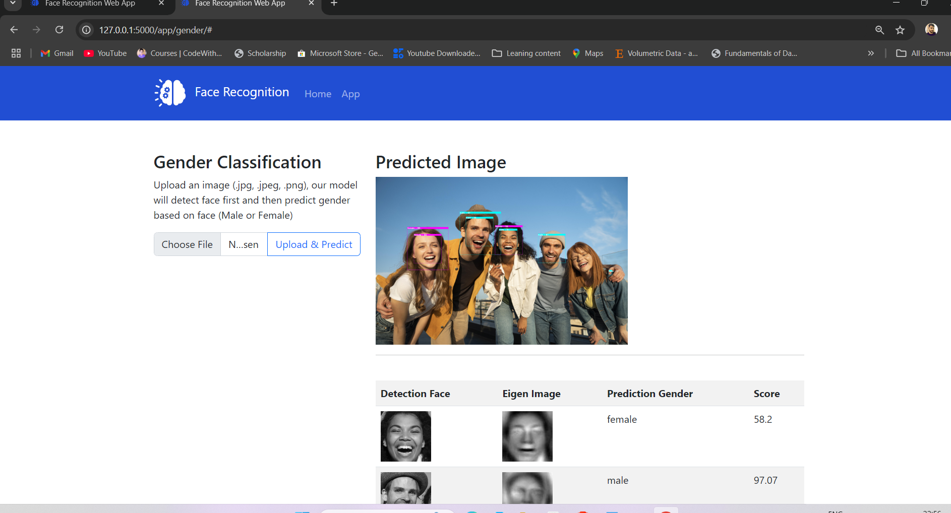

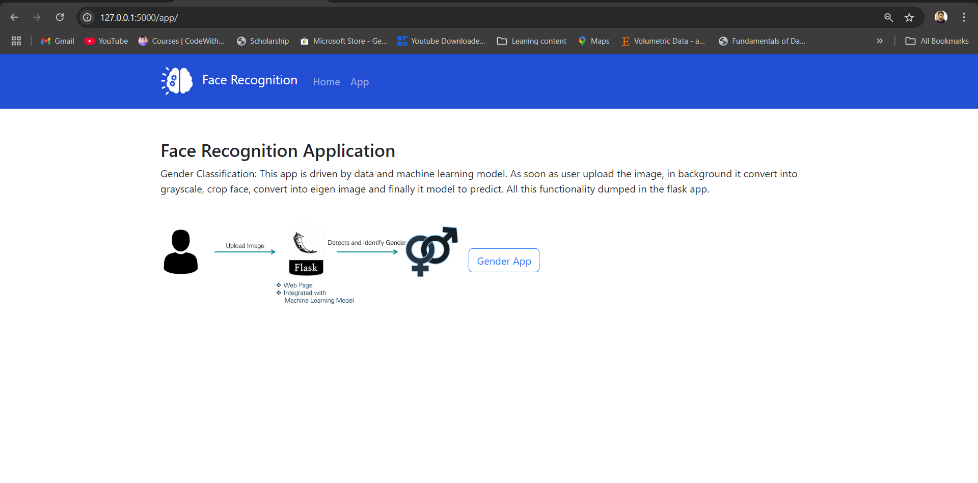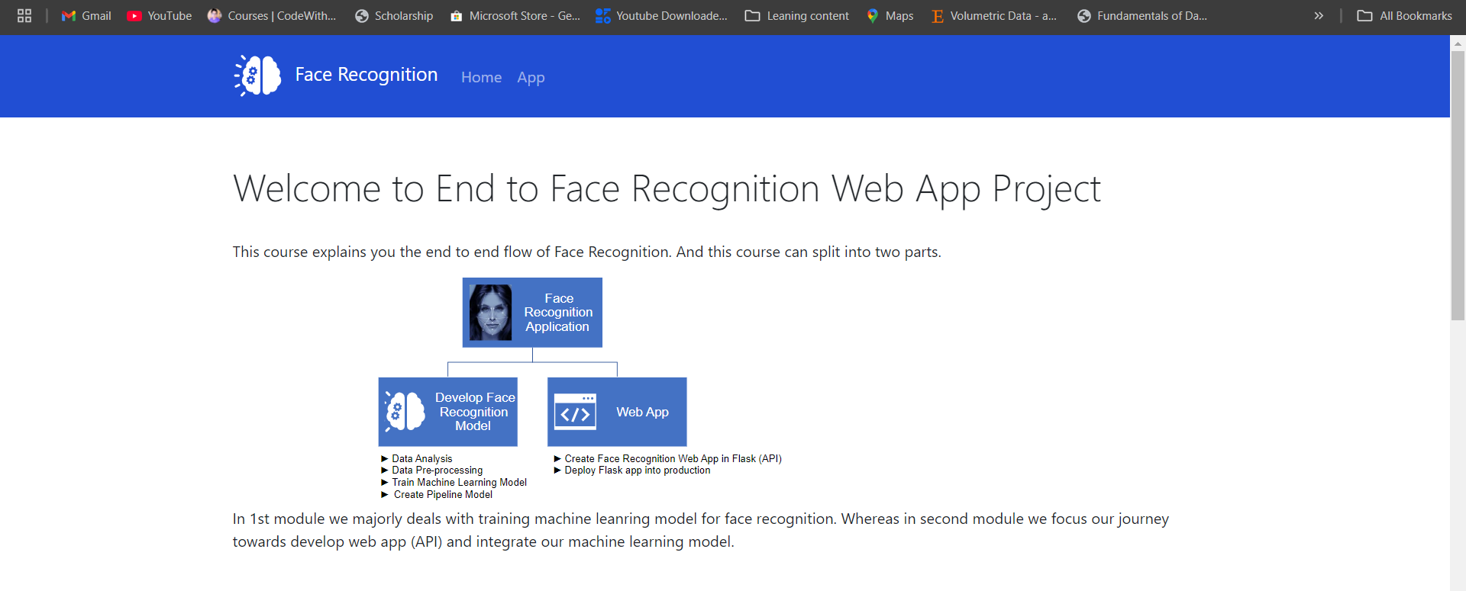

# Conclusion

The Gender and Age Detection System developed using Flask, OpenCV, and Haar Cascade Classifier has successfully demonstrated the ability to detect faces and predict the gender and age of individuals in uploaded images. The system processes the input image to detect faces and then uses basic placeholder values for gender and age prediction. This simple yet effective approach showcases the potential of combining computer vision techniques and web development to create a real-time image processing application.

While the current implementation uses placeholder predictions for gender and age, the system can easily be extended by integrating more sophisticated deep learning models for enhanced accuracy. These models, such as Convolutional Neural Networks (CNNs), are better suited for handling variations in facial appearance, lighting, and angles, providing more reliable predictions in real-world scenarios.

Additionally, the use of Flask as a lightweight web framework allows for easy integration of image processing features with a user-friendly web interface, making the system accessible to a broader audience. OpenCV’s powerful image-processing capabilities enable accurate face detection, while the overall architecture provides a solid foundation for further improvements and new features.

# References

1. **OpenCV Documentation**: OpenCV provides a comprehensive set of tools for image processing, including face detection. You can access the documentation for more detailed information on using various classifiers and image-processing techniques:

* OpenCV Documentation

1. **Haar Cascade Classifier**: The face detection method used in this project is based on Haar Cascades, a popular object detection method. For a more in-depth understanding of this technique, you can refer to:

* Haar Cascade Classifier - OpenCV

1. **Flask Documentation**: Flask is a lightweight web framework used for building web applications in Python. You can refer to the official Flask documentation for more details on building Flask applications:

* Flask Documentation

1. **Gender and Age Prediction Using Deep Learning**: For further enhancement of the system, you may consider using deep learning models for more accurate predictions. Resources on deep learning can be found at:

* Deep Learning with Python - François Chollet
* Gender and Age Prediction with Deep Learning

1. **Matplotlib Documentation**: Matplotlib is used for visualizing the image with detected faces and predictions. You can explore Matplotlib’s capabilities for generating plots and images:

* Matplotlib Documentation