**Preschool Registration WordPress Plugin**

**1. WordPress Environment Requirements:**

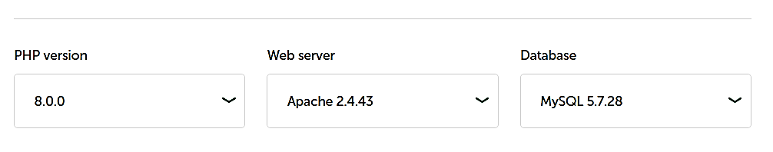

**Preschool Registration WordPress Plugin**

The **Preschool Registration** plugin is a simple tool designed for managing and registering preschool information in a WordPress website. It provides a custom post type named "Registrations" with additional custom fields such as the name of the preschool, address, time of registration, and location. The plugin also enables REST API endpoints for retrieving registration data, including all registrations, a single registration, and registrations with a specific time of registration using query string parameters.

**2. Features:**

1. Custom Post Type: The plugin creates a custom post type called "Registrations" specifically for managing preschool registration information. This post type includes fields for the name of the preschool, address, time of registration, and location.

2. Custom Fields:

- Name of Preschool: A field to enter the name of the preschool.

- Address: A field to enter the address of the preschool.

- Time of Registration: A field to specify the time of registration.

- Location: A field to enter the location of the preschool.

**3. REST API Endpoints:**

- Get All Registrations: Retrieves data for all preschool registrations.

- Get Single Registration: Retrieves data for a specific preschool registration by ID.

- Get Registrations by Time: Retrieves data for preschool registrations with a specific time of registration using query string parameters.

**Installation**

Follow the steps below to install the Preschool Registration plugin:

1. Download the plugin files in a zip format.

2. Log in to your WordPress website's admin panel.

3. Navigate to "Plugins" in the sidebar menu and click on "Add New."

4. Click on the "Upload Plugin" button at the top of the page.

5. Choose the plugin zip file you downloaded and click "Install Now."

6. After the installation, click "Activate Plugin" to enable the Preschool Registration plugin.

**Usage**

**Creating a Preschool Registration**

1. Log in to your WordPress website's admin panel.

2. In the sidebar menu, click on "Registrations" to access the Preschool Registrations section.

3. Click on "Add New" to create a new registration.

4. Fill in the necessary information for the registration:

- Name of Preschool

- Address

- Time of Registration

- Location

5. Click "Publish" to save the registration.

**Retrieving Preschool Registration Data via REST API**

The plugin provides the following REST API endpoints for retrieving preschool registration data:

**Get All Registrations**

- Endpoint: `https://yourwebsite.com/wp-json/wp/v2/preschool-registration`

- Method: GET

- Description: Retrieves data for all preschool registrations.

**Get Single Registration**

- Endpoint: `https://yourwebsite.com/wp-json/wp/v2/preschool-registration/{registration_id}`

- Method: GET

- Description: Retrieves data for a specific preschool registration identified by `{registration_id}`.

**Get Registrations by Time**

- Endpoint: `https://yourwebsite.com/wp-json/wp/v2/preschool-registration?registration_time={time_of_registration}`

- Method: GET

- Description: Retrieves data for preschool registrations with a specific time of registration. Replace `{time_of_registration}` with the desired time (e.g., `year `,-`month`, `day` as `2023-06-05`).

**\*\*Note:** Make sure to replace `https://yourwebsite.com` with your actual website domain.**