Title | Online Job Market Analytics
Problem Statement | A recruitment agency wants to analyze job opportunities posted on a dynamic job portal. Develop a Python application using Selenium to scrape job listings, extract Job Title, Company Name, Location and Salary (if available), store the collected data in a Pandas DataFrame, save the dataset as a CSV file, and visualize job demand by location.
Objectives | • To understand web scraping from a dynamic job portal using Selenium.  • To extract job title, company name, location and salary information from job listings.  • To organize and clean the collected data using a Pandas DataFrame.  • To save the structured job dataset in CSV format.  • To perform location-wise analysis and visualize job distribution using Matplotlib.
Dataset  URL Link /  File | Job Portal: https://www.naukri.com  Search role used: Data Scientist | Cities: Bangalore, Hyderabad, Pune, Chennai, Mumbai and Delhi
Functions  Details | Sl. No. | Function | Package | Description of function
Functions  Details | 1 | Firefox() | selenium | Starts a Firefox browser session controlled by Selenium.
Functions  Details | 2 | driver.get() | selenium | Opens the specified job-portal URL in the automated browser.
Functions  Details | 3 | execute_script() | selenium | Executes JavaScript to scroll the dynamically loaded webpage.
Functions  Details | 4 | find_elements() | selenium | Finds all matching job-card elements on the page.
Functions  Details | 5 | find_element() | selenium | Finds a required field inside an individual job card.
Functions  Details | 6 | time.sleep() | time | Pauses execution briefly to allow dynamic content to load.
Functions  Details | 7 | DataFrame() | pandas | Converts the collected job records into tabular form.
Functions  Details | 8 | drop_duplicates() | pandas | Removes duplicate job records from the DataFrame.
Functions  Details | 9 | reset_index() | pandas | Resets row indexing after data cleaning.
Functions  Details | 10 | to_csv() | pandas | Saves the structured job dataset as a CSV file.
Functions  Details | 11 | value_counts() | pandas | Counts job records for each location for analysis.
Functions  Details | 12 | bar()/savefig() | matplotlib | Creates and saves the location-wise job-demand bar chart.
Steps/  Process/  Procedure/  Algorithm/  Flowchart/  Model | 1. Import Selenium, Pandas, Matplotlib and supporting Python modules.  2. Define the job role, location and maximum number of job listings to collect.  3. Launch the browser using Selenium WebDriver and construct the Naukri search URL.  4. Open the dynamic job-search page and allow sufficient time for the page to load.  5. Scroll the webpage so that dynamically loaded job cards become available.  6. Locate job-card elements using CSS selectors.  7. Extract Job Title, Company Name, Location and Salary from each job card.  8. Store the extracted records in a Python list and convert them into a Pandas DataFrame.  9. Remove duplicate records and save the cleaned dataset as a CSV file.  10. Repeat the search for Bangalore, Hyderabad, Pune, Chennai, Mumbai and Delhi.  11. Use value_counts() to prepare location-wise job analysis and create a bar chart.  12. Save the visualization and multi-city CSV file, display the final summary and close the browser.  START -> Open Job Portal -> Scrape Listings -> DataFrame -> CSV -> Location Analysis -> Bar Chart -> STOP
Program | import time  import pandas as pd  import matplotlib.pyplot as plt  from selenium import webdriver  from selenium.webdriver.common.by import By  from selenium.webdriver.firefox.options import Options  from selenium.common.exceptions import NoSuchElementException  JOB_ROLE = "data scientist"  LOCATION = "bangalore"  MAX_JOBS = 30  options = Options()  driver = webdriver.Firefox(options=options)  driver.set_window_size(1400, 900)  def make_slug(text):  return "-".join(text.lower().strip().split())  def get_text(card, selectors, default="Not Available"):  for selector in selectors:  try:  element = card.find_element(By.CSS_SELECTOR, selector)  text = element.text.strip()  if text:  return text  except NoSuchElementException:  pass  return default  job_slug = make_slug(JOB_ROLE)  location_slug = make_slug(LOCATION)  url = f"https://www.naukri.com/{job_slug}-jobs-in-{location_slug}"  print("Search URL:", url)  driver.get(url)  time.sleep(5)  print("Page Title:", driver.title)  print("Current URL:", driver.current_url)  for i in range(3):  driver.execute_script("window.scrollTo(0, document.body.scrollHeight);")  time.sleep(2)  driver.execute_script("window.scrollTo(0, 0);")  cards = driver.find_elements(By.CSS_SELECTOR, "div.cust-job-tuple")  print("Number of job cards found:", len(cards))  jobs = []  for card in cards[:MAX_JOBS]:  title = get_text(card, ["a.title", "[class*='title']"])  company = get_text(card, ["a.comp-name", ".comp-name"])  location = get_text(card, ["span.locWdth", ".locWdth", "[class*='location']"])  salary = get_text(card, ["span.sal", ".sal", "[class*='salary']"],  default="Not Disclosed")  jobs.append({  "Job Title": title,  "Company Name": company,  "Location": location,  "Salary": salary  })  print("Jobs scraped:", len(jobs))  df = pd.DataFrame(jobs)  df = df.drop_duplicates().reset_index(drop=True)  print("Total unique jobs:", len(df))  print("Dataset Shape:", df.shape)  print(df.head(10))  print("Salary Information:")  print(df["Salary"].value_counts())  df.to_csv("job_market_data.csv", index=False)  print("CSV file saved successfully.")  csv_data = pd.read_csv("job_market_data.csv")  print(csv_data.head())  cities = ["bangalore", "hyderabad", "pune", "chennai", "mumbai", "delhi"]  all_jobs = []  for city in cities:  city_slug = make_slug(city)  url = f"https://www.naukri.com/{job_slug}-jobs-in-{city_slug}"  print("Scraping:", city)  driver.get(url)  time.sleep(4)  city_cards = driver.find_elements(By.CSS_SELECTOR, "div.cust-job-tuple")  print("Jobs found:", len(city_cards))  for card in city_cards[:10]:  title = get_text(card, ["a.title", "[class*='title']"])  company = get_text(card, ["a.comp-name", ".comp-name"])  salary = get_text(card, ["span.sal", ".sal", "[class*='salary']"],  default="Not Disclosed")  all_jobs.append({  "Job Title": title,  "Company Name": company,  "Location": city.title(),  "Salary": salary  })  city_df = pd.DataFrame(all_jobs)  city_df = city_df.drop_duplicates().reset_index(drop=True)  print("Total jobs collected:", len(city_df))  location_analysis = city_df["Location"].value_counts().reset_index()  location_analysis.columns = ["Location", "Number of Jobs"]  print(location_analysis)  plt.figure(figsize=(10, 5))  plt.bar(location_analysis["Location"], location_analysis["Number of Jobs"])  plt.title("Data Scientist Job Demand by Location")  plt.xlabel("Location")  plt.ylabel("Number of Job Listings")  plt.xticks(rotation=45)  plt.tight_layout()  plt.savefig("job_demand_by_location.png", dpi=300, bbox_inches="tight")  plt.show()  city_df.to_csv("job_market_multi_city.csv", index=False)  print("Multi-city dataset saved successfully.")  print("ONLINE JOB MARKET ANALYTICS")  print("Job Role:", JOB_ROLE)  print("Total Jobs Analyzed:", len(city_df))  print("Cities Analyzed:", len(location_analysis))  print(location_analysis.to_string(index=False))  driver.quit()  print("Browser closed successfully.")
Output Snapshots  With  Explanation/  Observations | 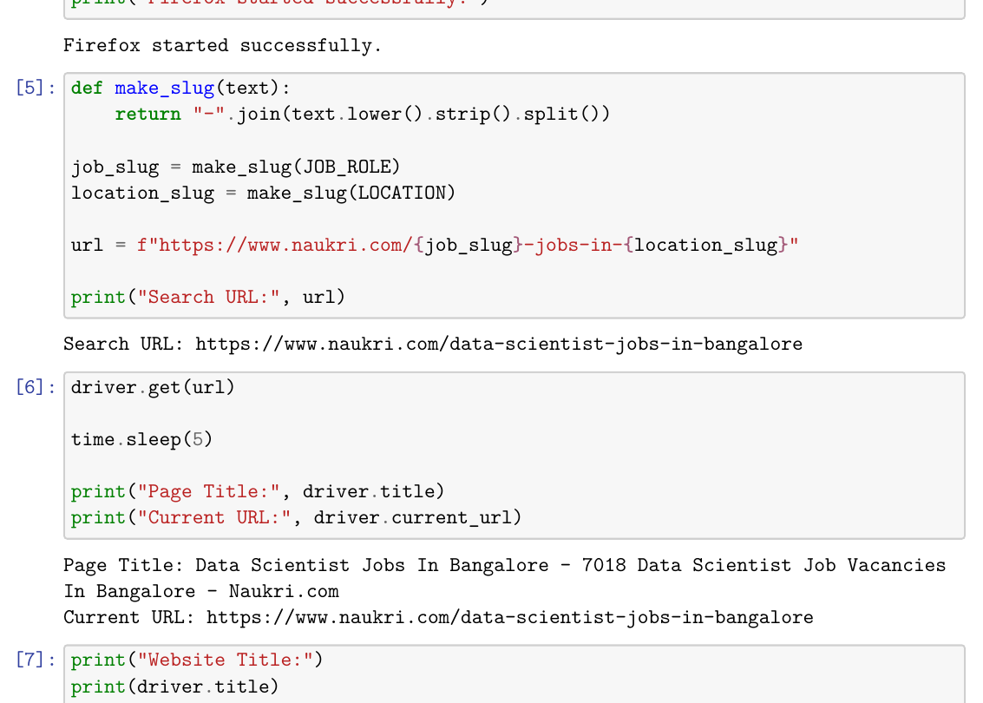  Fig. 1.1: Search URL and Job Portal Validation  The Selenium session generated the Naukri search URL for Data Scientist jobs in Bangalore and successfully retrieved the page title and current URL, confirming that the dynamic job portal was opened correctly.  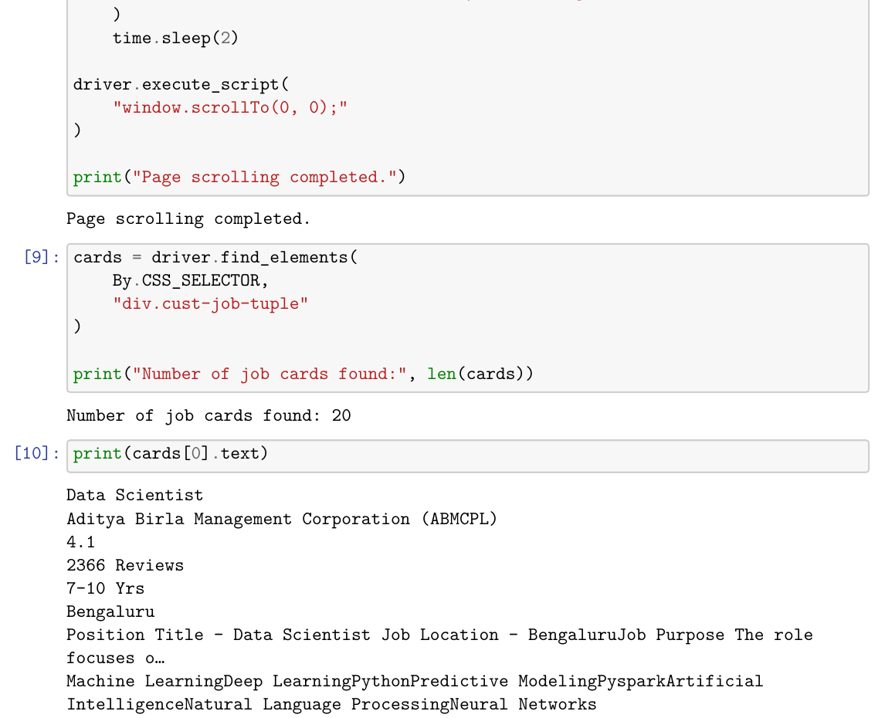  Fig. 1.2: Detection of Dynamic Job Cards  After scrolling the page, Selenium detected 20 job-card elements. The first job card displays details such as job title, company, experience, location and associated skills.  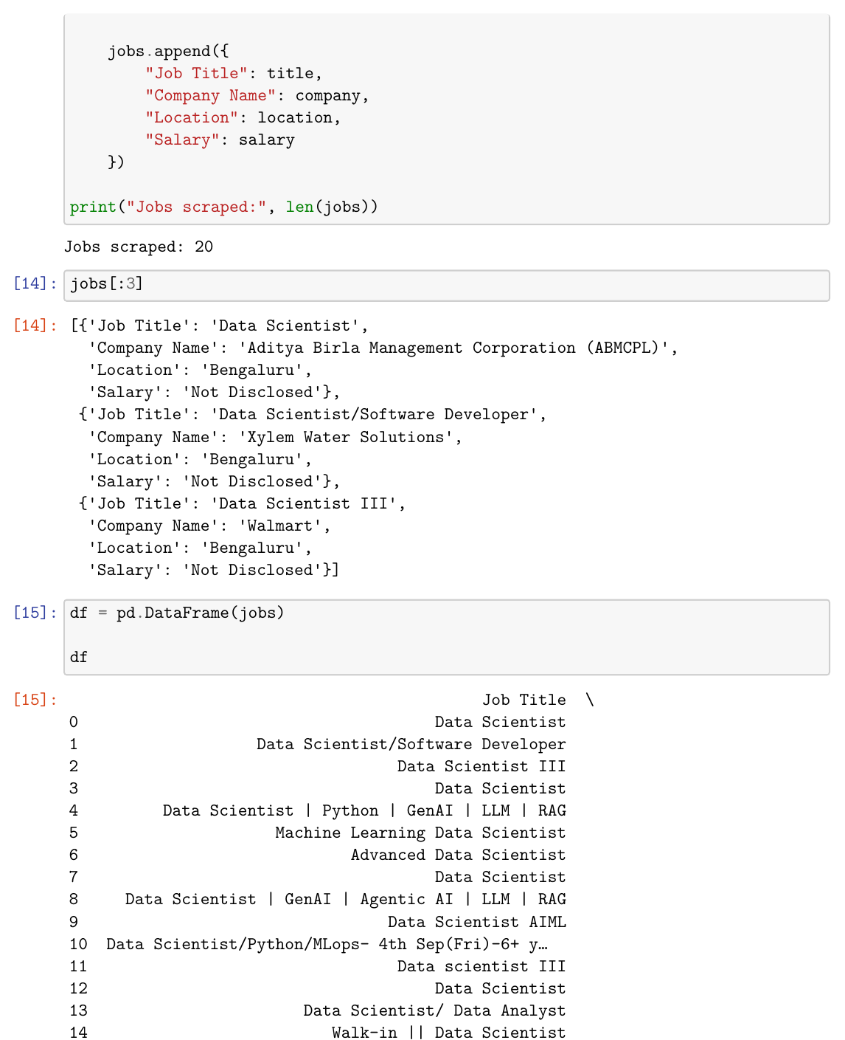  Fig. 1.3: Scraped Job Records and Pandas DataFrame  The scraper collected 20 listings and extracted the required Job Title, Company Name, Location and Salary fields. The records were then converted into a structured Pandas DataFrame.  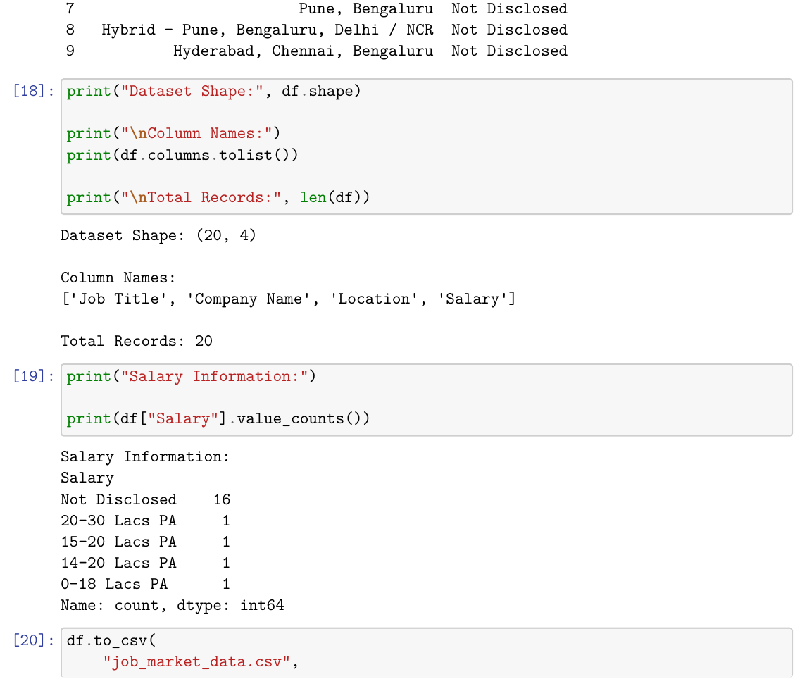  Fig. 1.4: Dataset Structure, Salary Availability and CSV Creation  The initial dataset contains 20 records and 4 required columns. Salary information was unavailable for most listings, while a few postings contained salary ranges. The cleaned DataFrame was saved successfully as job_market_data.csv.  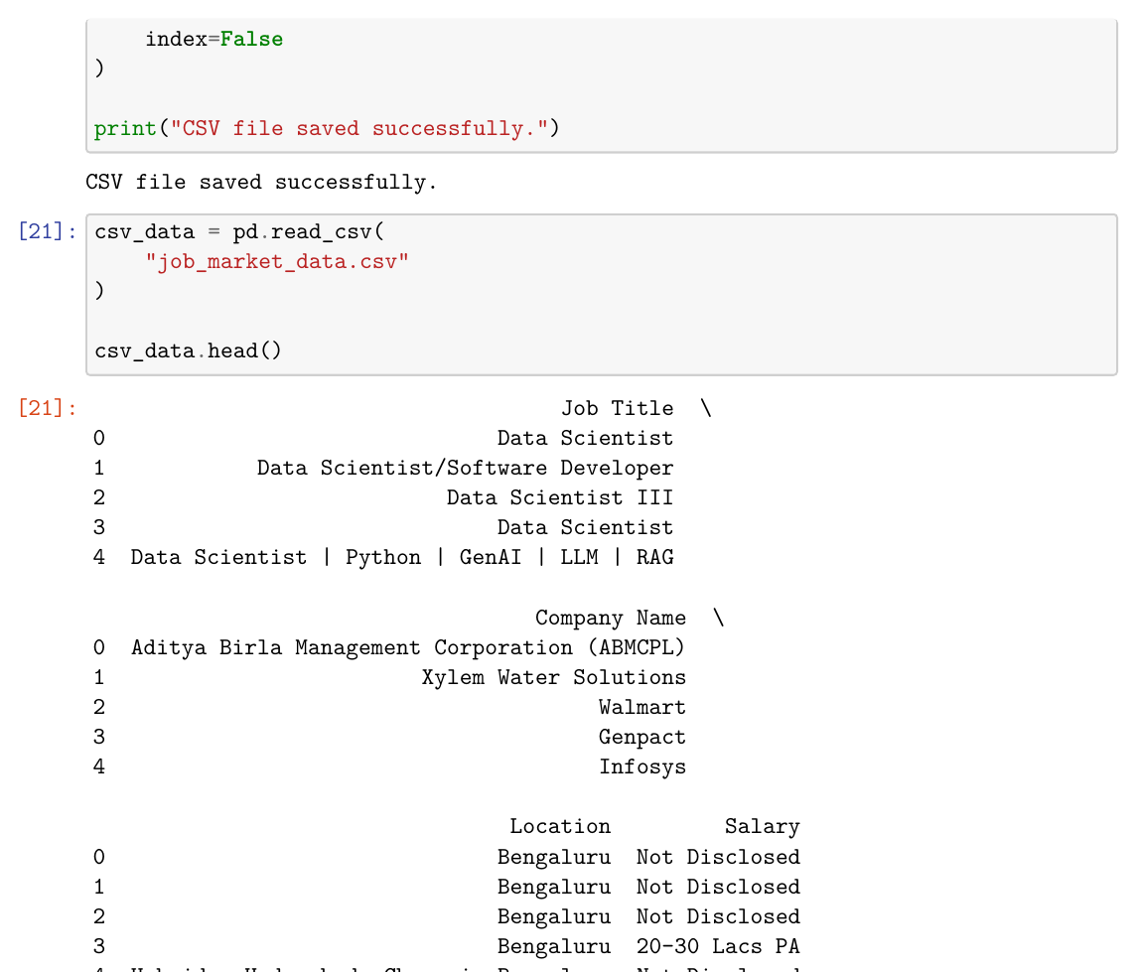  Fig. 1.5: Verification of the Saved CSV Dataset  The generated CSV file was read back using pandas.read_csv(), and the displayed rows confirm that the job-listing data was stored correctly in structured form.  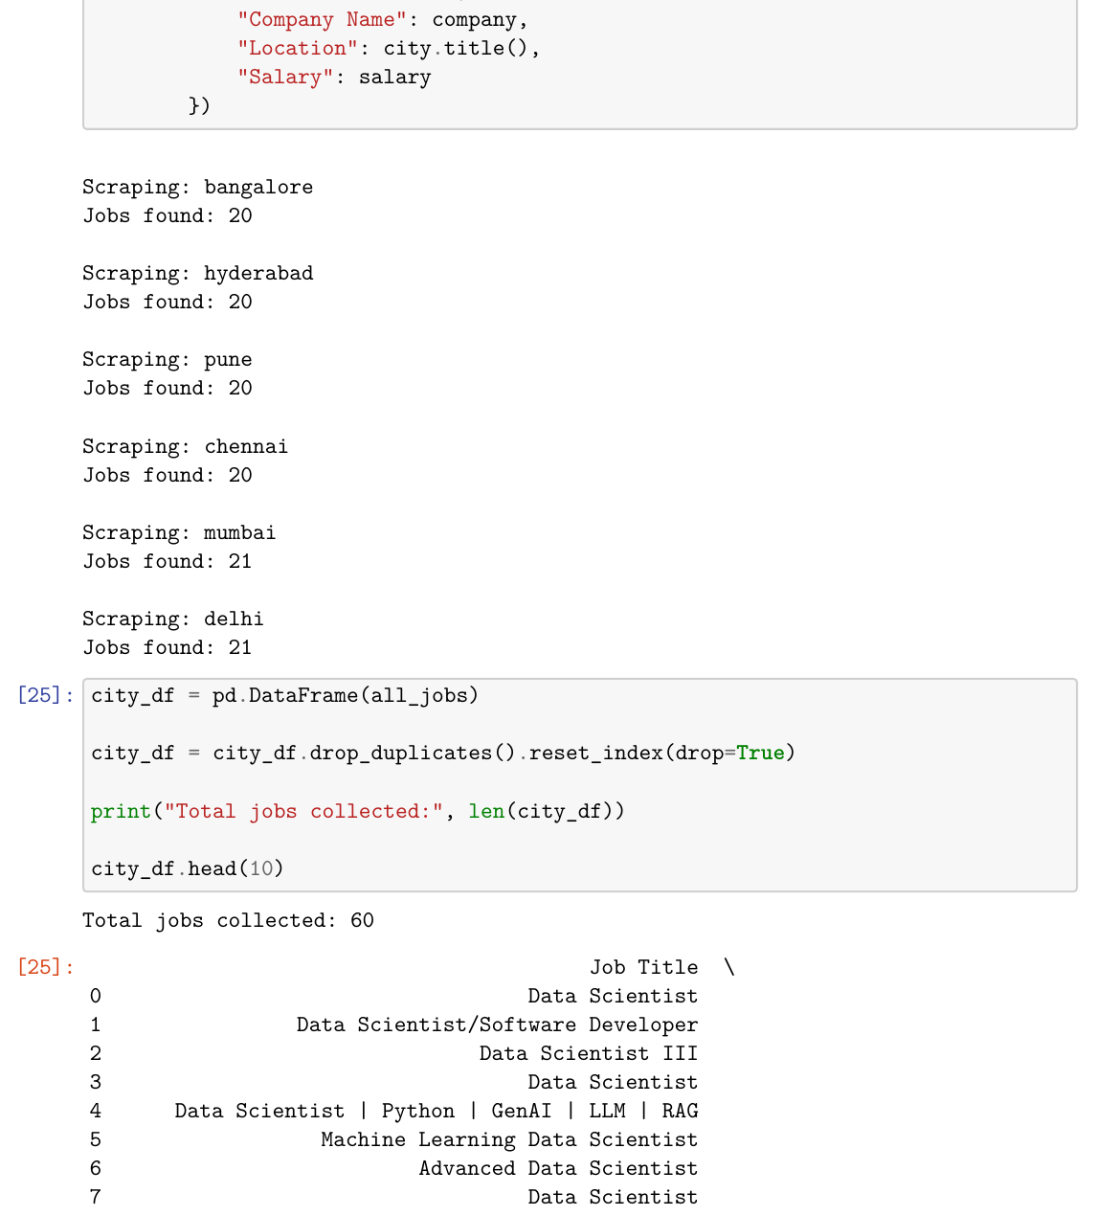  Fig. 1.6: Multi-City Job Data Collection  The same Data Scientist search was executed for Bangalore, Hyderabad, Pune, Chennai, Mumbai and Delhi. A controlled sample of 10 listings per city produced 60 records for location-wise analysis.  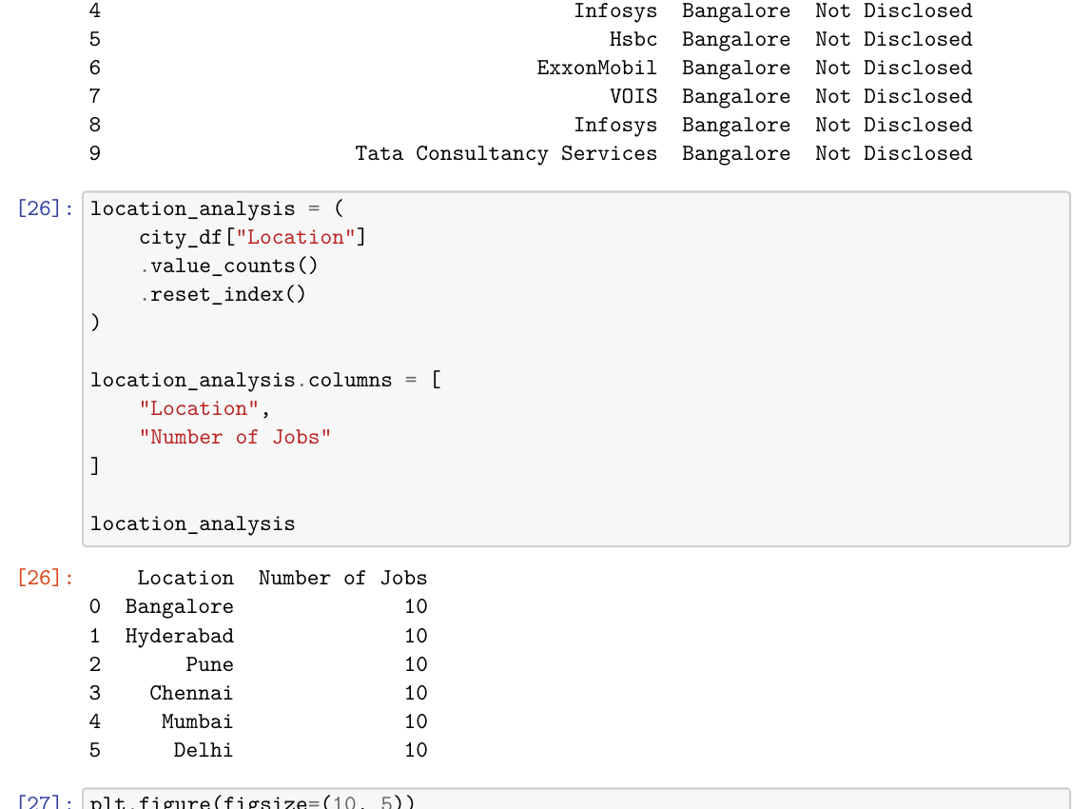  Fig. 1.7: Location-Wise Job Analysis  Pandas value_counts() produced the location-wise summary for the six-city job sample.  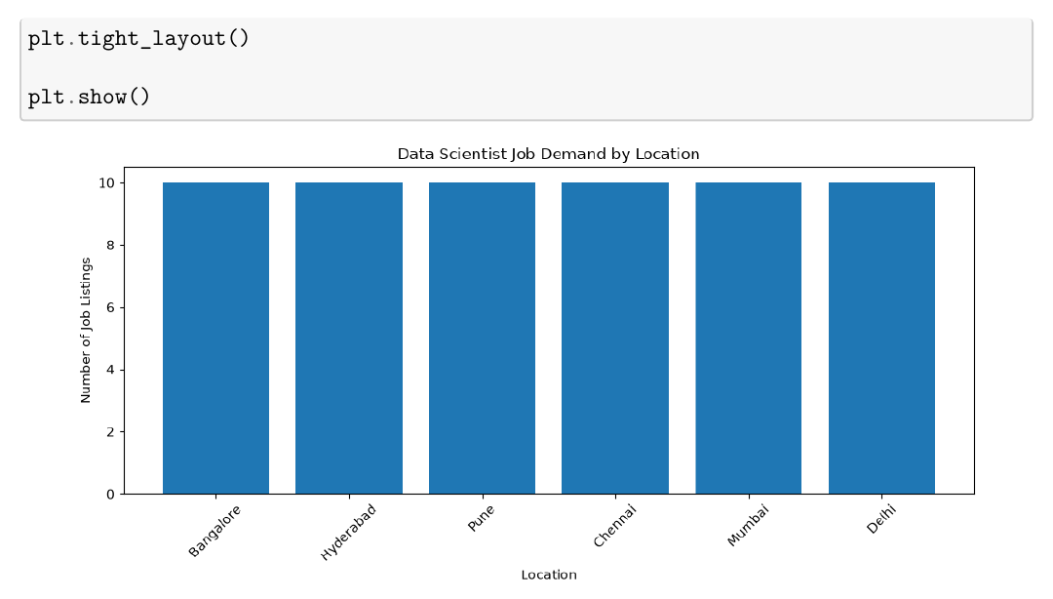  Fig. 1.8: Data Scientist Job Demand Visualization by Location  A Matplotlib bar chart visualizes the number of sampled job listings for each selected city. The graph provides a clear location-wise comparison of the collected job-market sample.  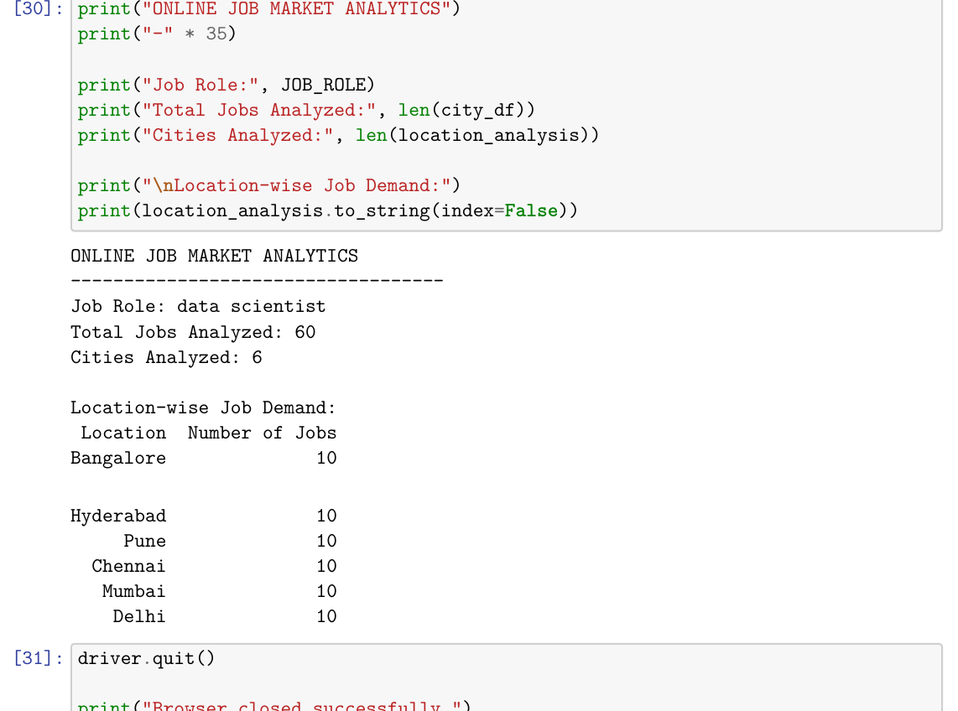  Fig. 1.9: Final Job Market Analytics Summary  The final output confirms that the multi-city dataset and graph were saved successfully. The analysis includes 60 sampled job records across 6 cities and displays the location-wise summary.
Conclusions | The exercise successfully demonstrated Selenium-based web scraping on a dynamic job portal. Job title, company name, location and available salary information were extracted from Naukri, organized in Pandas DataFrames, cleaned and stored as CSV files. Location-wise analysis was performed for six cities and visualized using a Matplotlib bar chart. Thus, the required job listings dataset, CSV output, location analysis and demand visualization were generated successfully.
References | 1. Michael Freeman and Joel Ross, Programming Skills for Data Science: Start Writing Code to Wrangle, Analyze, and Visualize Data with R, Addison-Wesley, 2018.  2. Python Program (GitHub link): https://github.com/hasnainmakada-99/Data-Science-Codes/blob/main/Lab%20Codes/Week5-EP.ipynb  3. Class lecture link: https://drive.google.com/file/d/1HjCacfaFs49XEnuM3idduuKB0Tgjb4xI/view

