Title | Student Marks Data Manipulation and Analysis using Pandas
Problem  Statement | Basic Student Marks Data Manipulation with Pandas: Create a DataFrame with the columns StudentID, Name, and Marks for five students. Display the original dataset, select only the Name and Marks columns, filter students whose Marks are greater than 70, add a Grade column based on the marks obtained, sort the DataFrame by Marks in ascending order, and finally calculate the average marks of all students.
Objectives | • To create a Pandas DataFrame from a Python dictionary containing student records.  • To select specific columns from a DataFrame for focused analysis.  • To filter student records using a conditional expression.  • To create a Grade column using conditional logic and list comprehension.  • To sort student records according to marks.  • To calculate the average marks using a Pandas aggregate function.
Dataset  URL Link /  File | StudentID Name Marks  10 Hasnain 45  11 John 86  12 Alice 90  13 Sahil 67  14 Cook 97
Functions  Details | Sl.  No. | Function | Package | Description of function
 | 1 | DataFrame() | pandas | Creates a DataFrame from dictionary data
 | 2 | [] / Boolean Indexing | pandas | Selects columns and filters rows
 | 3 | sort_values() | pandas | Sorts rows according to Marks
 | 4 | mean() | pandas | Calculates the average Marks value
Steps/  Process/  Procedure/  Algorithm/  Flowchart/  Model | Step 1  Import the pandas library.  Step 2  Create a Python dictionary containing StudentID, Name, and Marks for five students.  Step 3  Convert the dictionary into a Pandas DataFrame and display the original dataset.  Step 4  Select and display only the Name and Marks columns.  Step 5  Filter and display students whose Marks are greater than 70.  Step 6  Add a Grade column by assigning grades A to E according to the marks obtained.  Step 7  Display the updated DataFrame containing the Grade column.  Step 8  Sort the DataFrame by Marks in ascending order and display the result.  Step 9  Calculate and display the average marks using the mean() function.
Program | # Import the Pandas library  import pandas as pd  # Create a dictionary containing student details  dictionary_1 = {  "StudentID": [10, 11, 12, 13, 14],  "Name": ["Hasnain", "John", "Alice", "Sahil", "Cook"],  "Marks": [45, 86, 90, 67, 97]  }  # Convert the dictionary into a Pandas DataFrame  dataFrame = pd.DataFrame(dictionary_1)  # Display the original dataset  print("Diplaying the Original Dataset\n")  print(dataFrame, "\n")  # Select and display only the Name and Marks columns  only_name_colum = pd.DataFrame(  dataFrame, columns=["Name", "Marks"]  )  print("Displaying only name and marks columns\n")  print(only_name_colum, "\n")  # Filter students whose marks are greater than 70  marks_greater_than_70 = pd.DataFrame(  dataFrame[dataFrame["Marks"] > 70]  )  print("Displaying students with marks greater than 70\n")  print(marks_greater_than_70, "\n")  # Assign grades based on the marks obtained  dataFrame["Grade"] = [  "A" if marks >= 90 else  "B" if marks >= 80 else  "C" if marks >= 70 else  "D" if marks >= 60 else "E"  for marks in dataFrame["Marks"]  ]  # Display the updated dataset with the Grade column  print("Displaying the updated dataset\n")  print(dataFrame, "\n")  # Sort the dataset by Marks in ascending order  sort_by_marks = dataFrame.sort_values(  by="Marks", ascending=True  )  print("Displaying the sorted dataset\n")  print(sort_by_marks, "\n")  # Calculate and display the average marks  average = dataFrame["Marks"].mean()  print("Average Marks \n")  print(average)
Output  Snapshots  With  Explanation/  Observations | 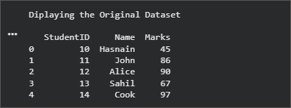 Figure 2.1 Original Student Dataset Figure 2.1 displays the original DataFrame created from the student dictionary. It contains the columns StudentID, Name, and Marks for five students. The pd.DataFrame() function converts the dictionary into a structured tabular format that can be analysed using Pandas.  Figure 2.2 shows only the Name and Marks columns selected from the original DataFrame. This demonstrates column selection and allows the analysis to focus on the st u d student names and their corresponding marks without d i Displaying StudentID. 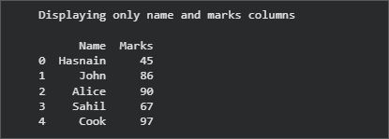 Figure 2.2 Selected Name and Marks Columns  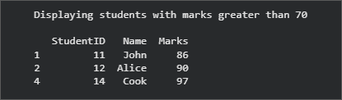 Figu Figure 2.3 Filtering student with marks > 70 Figure 2.3 presents the filtered records for students whose Marks are greater than 70. The Boolean condition dataFrame["Marks"] > 70 retains John, Alice, and Cook because their marks satisfy the specified condition.  Figure 2.4 displays the updated DataFrame after adding the Grade column. Grades are assigned using conditional logic: A for marks of 90 or above, B for 80-89, C for 70-79, D for 60-69, and E for marks below 60. 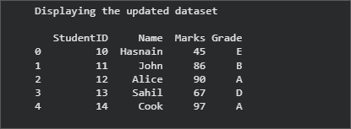 Figure 2.4 Dataset after Adding the Grade Column  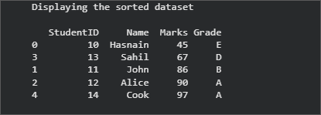 Figure 2.5 Dataset Sorted by Marks in Ascending Order Figure 2.5 shows the records sorted from the lowest marks to the highest marks using sort_values(). Hasnain a appears first with 45 marks, while Cook appears last with 97 marks. The original row indexes are retained by Pandas.  Figure 2.6 displays the average marks calculated using the mean() function. The total marks of all five students divided by five gives an average of 77.0. 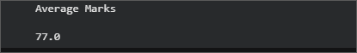 Figure 2.6 Average Marks
Conclusions | This exercise successfully demonstrated basic student-data manipulation and analysis using Pandas. A DataFrame containing StudentID, Name, and Marks was created from a Python dictionary, and multiple operations were performed on the dataset.  The results showed that:  • The Name and Marks columns were selected successfully for focused analysis.  • Students with marks greater than 70 were identified using Boolean filtering.  • A Grade column was generated using conditional logic based on each student's marks.  • The records were arranged in ascending order of marks using sort_values().  • The average marks of the five students were calculated as 77.0 using mean().  Overall, the exercise provided practical experience in DataFrame creation, column selection, row filtering, conditional transformation, sorting, and statistical aggregation. These operations are fundamental for data preprocessing and exploratory data analysis in Data Science and Machine Learning applications.
References | 1. Wes McKinney, Python for Data Analysis: Data Wrangling with pandas, NumPy, and Jupyter, 3rd Edition, O’Reilly Media, 2022.  2. Pandas Documentation: https://pandas.pydata.org/docs/  3. Python Documentation: https://docs.python.org/3/  4. Python Program (Google Colab Link)  https://colab.research.google.com/drive/1qBzvtH6ZEis8Jv20WDiYXKI4PXGSXcWJ?usp=sharing  4. Pandas DataFrame API Reference: https://pandas.pydata.org/docs/reference/api/pandas.DataFrame.html  5. Class lecture link: https://drive.google.com/file/d/15diEukCtrPLimox63oa9ce1U-t4qVMUy/view

