Title | Data Manipulation and Analysis using the Starwars Dataset in R
Problem Statement | Basic Data Manipulation with Pandas: Create a DataFrame with columns  StudentId, Name, and Marks containing data for five students. Perform the following operations: select only the Name and Marks columns, filter rows where Marks is greater than 70, add a new column Grade with a default value, and sort the DataFrame by Marks in descending order. Finally, calculate the average Marks of the Students.
Objectives | - To understand how to create a Pandas DataFrame from a Python  - dictionary.  - To learn column selection techniques using Pandas.  - To apply filtering conditions on DataFrame rows.  - To create and populate new columns in a DataFrame.  - To sort data based on column values.  - To perform basic statistical analysis using Pandas aggregate functions.
Dataset  URL Link /  File | StudentId Name Marks  1 Alice 23  2 Bob 90  3 Charlie 28  4 David 35  5 Emma 82
Functions  Details | Sl. No. | Function | Package | Description of function
 | 1 | DataFrame() | pandas | Creates a DataFrame from structured  data
 | 2 | sort_values() | pandas | Sorts DataFrame rows
 | 3 | mean() | pandas | Calculates the average value
 | 4 | sort_values() | pandas | Sorts DataFrame rows
 | 5
 | 6
 | 7
 | 8
 | 9
 | 10
 | 11
 | 12
Steps/  Process/  Procedure/  Algorithm/  Flowchart/  Model | Step 1  Import the Pandas library and create a dictionary containing StudentId, Name and Marks data.  Step 2  Convert the dictionary into a Pandas DataFrame.  Step 3  Select only the Name and Marks columns from the DataFrame.  Step 4  Filter the DataFrame to display individuals whose Marks is greater than 70.  Step 5  Add a new column named Grade and assign a default value of A  .  Step 6  Sort the DataFrame in descending order based on the Marks column.  Step 7  Calculate the average Marks of all students using the mean() function  .  Step 8  Display all intermediate and final results.
Program | # Load Necessary Packages  import pandas as pd  # Step 1: Create dataset  students = {  "StudentId":[1,2,3,4,5],  "Name":["alice","bob","charlie","david","emma"],  "Marks":[23,90,28,35,82]  }  # Step 2: Create DataFrame  df=pd.DataFrame(students)  print("Original Data frame")  print(df)  # Step 3: Select Name and Marks columns  name_marks = df[["Name","Marks"]]  print("Name and Marks column")  print(name_marks)  # Step 4: Show record where marks>70  filtered_by_marks = df[df["Marks"]>70]  print("Students whose marks are greater than 70")  print(filtered_by_marks)  # Step 5: Add Grade column  df["Grade"]="A"  print("Grade column added: ")  print(df)  # Step 6: Sort by Marks in descending order  sorted_by_marks = df.sort_values(by="Marks",ascending=False)  print("Sorted by marks")  print(sorted_by_marks)  # Step 7: Calculate Average Marks  avg_marks = df["Marks"].mean()  print("Average marks")  print(avg_marks)
Output Snapshots  With  Explanation/  Observations | 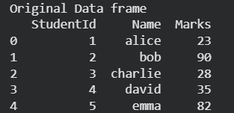  Figure 1.1 displays the original DataFrame created from a Python dictionary containing information about five students. The DataFrame consists of three columns: StudentId, Name, and Marks, where each row represents a different student and their corresponding details. The pd.DataFrame() function converts the dictionary into a structured tabular format, making it easier to store, view, and manipulate data using Pandas. This DataFrame serves as the starting dataset for all subsequent operations such as column selection, filtering, adding new columns, sorting, and calculating statistical measures.  Figure 1.1 Original Data Frame  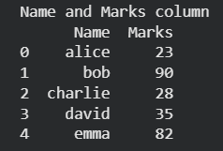  Figure 1.2 Selected Name and Marks Columns  Figure 1.2 shows the DataFrame after selecting only the Name and Marks columns from the original dataset using Pandas column indexing. This operation extracts the required columns and creates a new DataFrame named name_marks, removing the StudentId column from the view. Such column selection helps focus on relevant attributes for analysis and reduces unnecessary data processing.  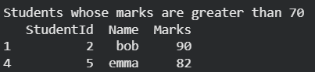  Figure 1.3 presents the filtered DataFrame containing only those students whose Marks are greater than 70. This filtering operation is performed using a conditional expression in Pandas, where the Marks column is checked against the condition Marks > 70. As a result, only the rows satisfying the condition are retained in the new DataFrame filtered_by_marks.Figure 1.3 demonstrates how Pandas can be used to extract specific records based on user-defined criteria, which is a common requirement in data analysis and data preprocessing tasks.  Figure 1.3 Filtered Data (Marks > 70)  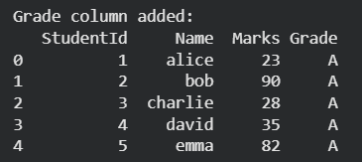  Figure 1.4 displays the DataFrame after adding a new column named Grade with a default value of "A" for all students. This operation is performed using Pandas column assignment, where the same value is assigned to every row in the newly created column. Adding new columns is a common data transformation technique used to enrich datasets with additional information.  Figure 1.4 Data Frame with Grade Column  Figure 1.4 output confirms that the Grade column has been successfully added to the DataFrame, and each student has been assigned the default grade A. The enriched dataset is now ready for further operations such as sorting and statistical analysis.  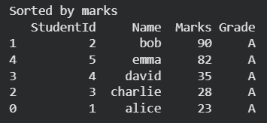  Figure 1.5 illustrates the DataFrame after sorting the records based on the Marks column in descending order using the Pandas sort_values() function. In this operation, students are arranged from the highest marks to the lowest marks. Sorting helps organize data systematically and makes it easier to identify the highest and lowest scoring students.  Figure 1.5 DataFrame Sorted by Marks (Descending)  Figure 1.5 output confirms that the DataFrame has been successfully sorted in descending order of Marks, placing the student with the highest marks at the top and the student with the lowest marks at the bottom. Such sorting operations are commonly used in data analysis to rank, compare, and organize records efficiently.  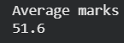  Figure 1.6 presents the average marks of all students in the dataset, calculated using the Pandas mean() function. The average (mean) marks are obtained by summing all the marks and dividing the total by the number of students in the DataFrame. This operation demonstrates the use of aggregate statistical functions in Pandas for summarizing numerical data.  Figure 1.6 Average Marks of Students  Figure 1.6 output confirms that the Pandas mean() function has successfully computed the average marks of the five students as 51.6. Such aggregate functions are widely used in data analysis to summarize and interpret numerical information efficiently.
Conclusions | This experiment successfully demonstrated the use of Pandas for basic data manipulation and analysis. A DataFrame containing the details of five students was created using the columns StudentId, Name, and Marks. Various DataFrame operations were then performed, including selecting specific columns, filtering rows based on a condition, adding a new column with default values, sorting records, and calculating statistical measures. These operations showcased the flexibility and efficiency of Pandas in handling tabular data.  The results showed that:  - The Name and Marks columns could be extracted independently for focused analysis.  - Filtering enabled the identification of students whose Marks were greater than 70.  - A new Grade column was successfully added with a default value of "A" to enrich the dataset.  - Sorting arranged the records in descending order of Marks, making it easy to identify the highest and lowest scoring students.  - The average Marks of the students were calculated as 51.6, demonstrating the use of aggregate functions in data analysis.  Overall, this exercise provided a strong foundation in DataFrame creation, data selection, filtering, transformation, sorting, and statistical analysis using Pandas. These fundamental data manipulation techniques are widely used in Data Science, Machine Learning, Data Analytics, and Business Intelligence applications, making them essential skills for working with real-world datasets.
References | - Michael Freeman and Joel Ross, Programming Skills for Data Science: Start Writing Code to Wrangle, Analyze, and Visualize Data with R, Addison-Wesley, 2018  - Python Program https://colab.research.google.com/drive/1socP9oEo5yp4QBEeUJSBnJ6VIU1JTys1?usp=sharing  - Class lecture link  https://drive.google.com/file/d/15diEukCtrPLimox63oa9ce1U-  t4qVMUy/view?usp=drive_link

