HASNAA MEZRAOUI
Healthcare Analytics Portfolio
Clinical risk scoring, population health, descriptive epidemiology, predictive modeling and data visualization with SAS, SAS Visual Analytics and Tableau
Master’s degree in Healthcare Analytics
hmezraoui@icloud.com
October 2026

Introduction
I am a healthcare analytics professional with a master’s degree in Healthcare Analytics. My work sits where clinical questions meet data: I turn hospital discharge records, cohort studies and public health datasets into clear findings that clinicians, managers and policy teams can act on.
This portfolio brings together six projects from my graduate training. Each one starts from a real healthcare question, such as which county should receive an opioid prevention program first, which newborns are most at risk of brain hemorrhage, or how a patient’s 10-year cardiovascular risk is calculated, and walks through the data, the method, the SAS code or tool workflow, the visualizations, and what the results mean in practice. Every project ends with its limitations and the next steps I would take, because knowing what a result cannot tell you is as important as the result itself.

What I bring
- Data preparation in SAS: DATA step programming, missing-value imputation, derived variables, formats, PROC SQL aggregation.
- Clinical and public health measures: Framingham cardiovascular risk scoring, incidence and hospitalization rates, length of stay, payer mix.
- Statistics and modeling: descriptive statistics, distribution analysis, correlation analysis, decision-tree feature selection, confusion-matrix evaluation.
- Visualization and reporting: SAS ODS Graphics (SGPLOT, SGPIE, UNIVARIATE), SAS Visual Analytics dashboards, Tableau Public.
- Healthcare data domains: inpatient discharge data, payer and demographic data, cohort study data, neonatal clinical data, opioid misuse surveillance.

Projects at a glance
# | Project | Healthcare question | Methods | Tools
1 | Framingham 10-Year Cardiovascular Risk Score | What is each patient’s 10-year risk of cardiovascular disease? | Imputation, derived variables, published risk equation | SAS DATA step, SGPLOT
2 | Opioid Misuse Episodes in New York Counties | Which county should a prevention program target first? | Rate calculation, payer and trend comparison | SAS, PROC SQL, SGPLOT
3 | Appendicitis Hospitalizations in Florida | Who is hospitalized for appendicitis, and how often? | Descriptive epidemiology, hospitalization rate | SAS FREQ, MEANS, UNIVARIATE, SGPIE
4 | Intraventricular Hemorrhage in Very Low Birth Weight Infants | Which factors are linked to brain hemorrhage in VLBW newborns? | Decision tree, confusion matrix, correlation | SAS Visual Analytics
5 | Hospital Length of Stay in New York, 2015 | How does length of stay vary by diagnosis, county, race and payer? | Exploratory visual analysis | Tableau Public
6 | Operational and Clinical Dashboards | What should managers and clinicians see at a glance? | Dashboard design for three audiences | SAS Visual Analytics

Project 1. Framingham 10-Year Cardiovascular Risk Score
Tools: SAS (DATA step, PROC SGPLOT) | Data: Framingham Heart Study teaching dataset | Skills: data cleaning, clinical risk equations

Objective
Calculate each participant’s 10-year risk of developing cardiovascular disease using the Framingham general cardiovascular risk equations (D’Agostino et al., 2008), then describe how that risk is distributed among men.

Data preparation
- Missing values: missing HDL and LDL cholesterol were replaced with the sample means (49.36 and 176.46 mg/dL); missing blood-pressure medication status was set to “not treated”.
- Total cholesterol: estimated with the Friedewald relationship (Total = LDL + HDL + triglycerides/5), assuming triglycerides of 150 mg/dL, which adds 30 mg/dL.
- Risk equation: sex-specific coefficients for age, total cholesterol, HDL, systolic blood pressure (treated or untreated), smoking and diabetes are summed, centered on the cohort mean, and converted to a 10-year probability with the baseline survival: Risk = 1 − S₀^exp(Σβx − mean).

SAS code
/* Framingham 10-year general CVD risk (D'Agostino et al., 2008) */
data WORK.FRAMINGHAM;
set MYDATA.FRAMINGHAMDEMO5;

/* 1. Impute missing values */
if HDLC = . then HDLC = 49.36; /* sample mean */
if LDLC = . then LDLC = 176.46; /* sample mean */
if BPMEDS = . then BPMEDS = 0; /* assume untreated */

/* 2. Estimate total cholesterol: LDL + HDL + TG/5 (TG = 150 mg/dL) */
TotalChol = HDLC + LDLC + 30;

/* 3. Sex-specific risk equation */
if SEX = 1 then do; /* men */
SysBPFactor = ifn(BPMEDS = 1, 1.99881, 1.93303);
Cig = ifn(CURSMOKE = 1, 0.65451, 0);
DM = ifn(DIABETES = 1, 0.57367, 0);
RiskFactors = 3.06117*log(AGE) + 1.12370*log(TotalChol)
- 0.93263*log(HDLC) + SysBPFactor*log(SYSBP)
+ Cig + DM - 23.9802;
BaselineSurv = 0.88936;
end;
else if SEX = 2 then do; /* women */
SysBPFactor = ifn(BPMEDS = 1, 2.82263, 2.76157);
Cig = ifn(CURSMOKE = 1, 0.52873, 0);
DM = ifn(DIABETES = 1, 0.69154, 0);
RiskFactors = 2.32888*log(AGE) + 1.20904*log(TotalChol)
- 0.70833*log(HDLC) + SysBPFactor*log(SYSBP)
+ Cig + DM - 26.1931;
BaselineSurv = 0.95012;
end;

/* 4. 10-year risk, in percent */
RiskScore = 100 * (1 - BaselineSurv**exp(RiskFactors));
run;

/* Distribution of risk among men */
proc sgplot data=WORK.FRAMINGHAM;
where SEX = 1;
histogram RiskScore / scale=percent;
title "Risk score for men";
run;

Results
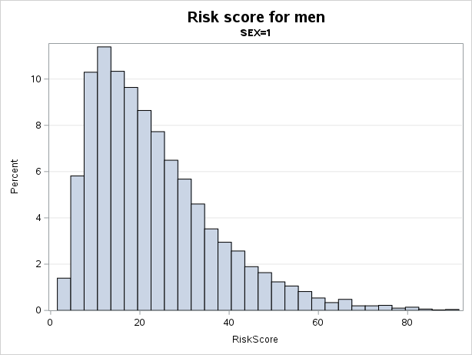
Figure 1. Distribution of 10-year cardiovascular risk among men (percent of men per risk band).
- Shape: risk among men is strongly right-skewed. Most men fall between about 5% and 30%, and only a small tail exceeds 60%.
- Most common band: the tallest bar sits at about 12% risk and holds 11.4% of men.
- Highest risk: very few men reach the top of the scale; the maximum is close to 90%.

Limitations and next steps
- Mean imputation shrinks variability; multiple imputation or a sensitivity analysis on complete cases would show how much the choice matters.
- Total cholesterol is estimated from a fixed triglyceride value; using measured total cholesterol where available would be more accurate.
- Next, compare the distribution for women, group participants into low (<10%), intermediate (10–20%) and high (>20%) risk, and check calibration against observed events.

Project 2. Opioid Misuse Episodes in New York Counties
Tools: SAS (DATA step, PROC SQL, SGPLOT) | Data: New York hospital episodes by county, payer and year, 2010–2015 | Skills: rates, stratification, trend analysis

Objective
A state agency wants to launch an opioid misuse prevention program in one county first. The task was to identify the counties with the highest rates of opioid misuse episodes, compare those rates across payers, and examine how they changed between 2010 and 2015.

Approach
- Combined the yearly files into a single dataset (SAS Studio Combine Tables task).
- Calculated a rate for every county, payer and year record: opioid misuse episodes divided by total episodes.
- Ranked counties, then broke the top three down by payer and by year.

SAS code
/* Opioid misuse rate for each county-payer-year record */
data MYDATA.HOSPITALISATION;
set MYDATA.HOSPITALISATION;
if TotalEpisodes > 0 then Rate = OpioidEpisodes / TotalEpisodes;
run;

/* Pooled county rate: all opioid episodes / all episodes */
proc sql;
create table WORK.COUNTY_RATES as
select County,
sum(OpioidEpisodes) as OpioidEpisodes,
sum(TotalEpisodes) as TotalEpisodes,
calculated OpioidEpisodes / calculated TotalEpisodes
as PooledRate format=percent8.3
from MYDATA.HOSPITALISATION
group by County
order by PooledRate desc;
quit;

/* Q1. Rates by county */
proc sgplot data=MYDATA.HOSPITALISATION;
vbar County / response=Rate stat=sum;
title "The Rates of Opioid Misuse Episodes by County";
run;

/* Q2. Top three counties by payer */
proc sgplot data=MYDATA.HOSPITALISATION;
where County in ("Greene" "Onondaga" "Schenectady");
vbar County / response=Rate stat=sum group=Payer
groupdisplay=cluster datalabel;
title "The Rates of Opioid Misuse Episodes by County";
run;

/* Q3. Same comparison, one chart per year */
proc sort data=MYDATA.HOSPITALISATION out=WORK.BYYEAR;
by Year;
run;
proc sgplot data=WORK.BYYEAR;
by Year;
where County in ("Greene" "Onondaga" "Schenectady");
vbar County / response=Rate stat=sum group=Payer
groupdisplay=cluster datalabel;
title "The Rates of Opioid Misuse Episodes by County and Year";
run;

Results

1. Which counties have the highest rates?
Summing the record-level rates ranks Greene first (0.133), followed by Schenectady (0.047) and Onondaga (0.029).
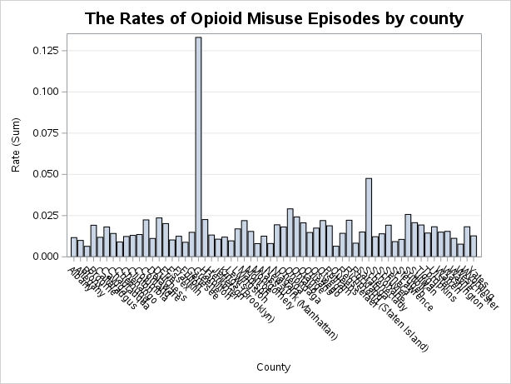
Figure 2. Sum of opioid misuse rates by county, 2010–2015.

2. How do rates differ by payer?
County | Commercial | Medicaid | Medicare | Other | Unknown
Greene | 0.0032 | 0.0120 | 0.0048 | 0.0018 | 0.1110
Onondaga | 0.0053 | 0.0078 | 0.0038 | 0.0053 | 0.0068
Schenectady | 0.0025 | 0.0048 | 0.0026 | 0.0020 | 0.0357

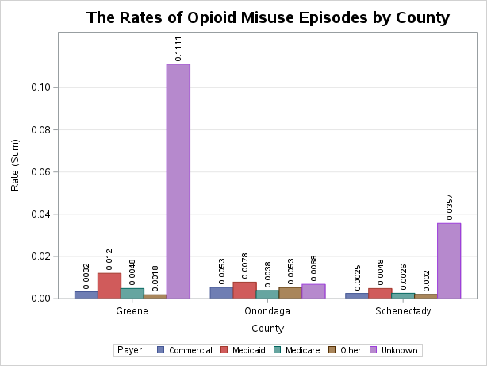
Figure 3. Opioid misuse rates in the top three counties by payer (sum over 2010–2015).
Among identified payers, Medicaid has the highest rate in all three counties, which is consistent with what is known about opioid misuse and Medicaid populations. The “Unknown” payer group, however, dominates the totals for Greene and Schenectady.

3. How did rates change over time?
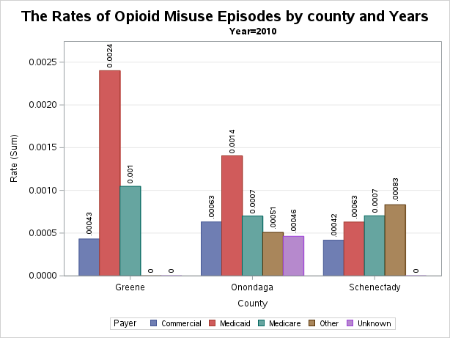 | 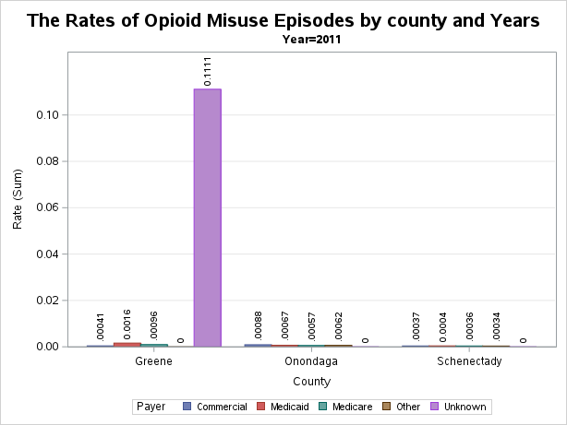
Figure 4. Rates by county and payer in 2010 (left) and 2011 (right).
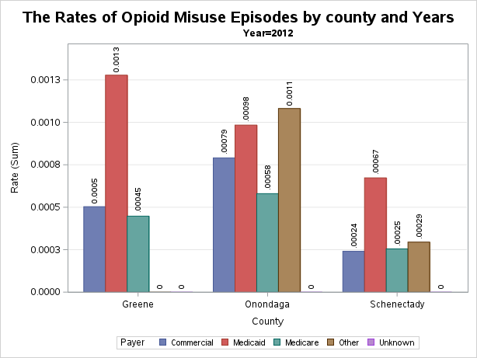 | 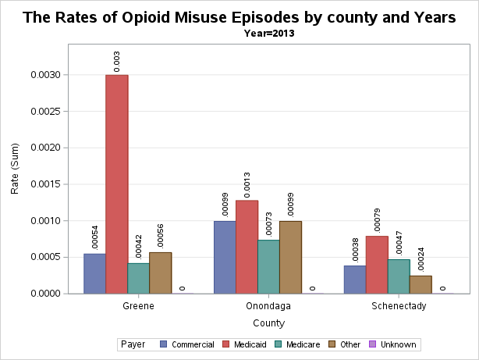
Figure 5. Rates by county and payer in 2012 (left) and 2013 (right).
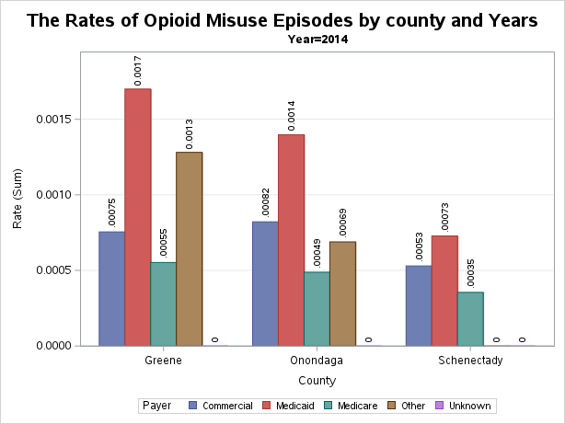 | 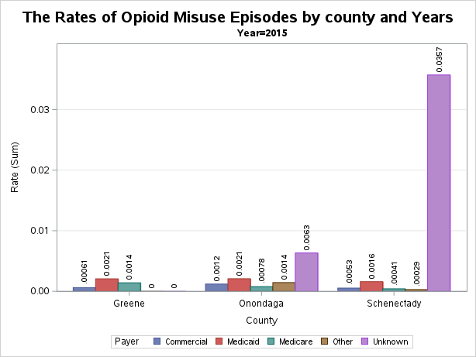
Figure 6. Rates by county and payer in 2014 (left) and 2015 (right).
The year-by-year view explains the ranking. Apart from two spikes, every rate is below 0.003, and Greene’s Medicaid rate (0.0013 to 0.0030) is the highest or tied-highest Medicaid rate of the three counties every year. The two spikes, Greene’s “Unknown” payer in 2011 (0.111) and Schenectady’s in 2015 (0.036), are single records that most likely come from very small denominators.

Recommendation
Greene County is the best candidate for the first program: it ranks first overall and has the highest or tied-highest Medicaid rate every year. Because the overall ranking is driven by two outlier records, I would confirm the decision with the pooled county rate (total opioid episodes divided by total episodes, computed in the PROC SQL step above) before committing resources.

Limitations and next steps
- Adding rates across payers and years gives small groups the same weight as large ones; the pooled rate or a population-based rate per 100,000 residents is a fairer comparison.
- Records with few total episodes should be flagged or suppressed, and the “Unknown” payer category investigated as a data-quality issue.
- Next, plot pooled rates as a line chart over time to show trend direction for each county.

Project 3. Appendicitis Hospitalizations in Florida
Tools: SAS (FREQ, MEANS, UNIVARIATE, SGPIE, SGPLOT) | Data: 47,460 Florida inpatient discharges, three years | Skills: descriptive epidemiology, rates

Objective
Describe the 47,460 hospitalizations for appendicitis in Florida over a three-year period: who the patients are, how they were admitted, who paid, how long they stayed, and how the state’s hospitalization rate compares with the national figure.

SAS code
proc format;
value agegrp 0-20 = 'Ages 0 to 20'
21-44 = 'Ages 21 to 44'
45-64 = 'Ages 45 to 64'
65-84 = 'Ages 65 to 84'
85-99 = 'Ages 85 to 99'
100-high = '100 and up';
run;

/* Counts and percentages for categorical variables */
proc freq data=MYDATA.APPENDICITIS;
tables ETHNICITY RACE SEX PAYER ADM_PRIOR AGE / nocum;
format AGE agegrp.;
run;

/* Age and length of stay */
proc means data=MYDATA.APPENDICITIS n mean median min max maxdec=2;
var AGE LOS;
run;
proc univariate data=MYDATA.APPENDICITIS;
var AGE;
histogram AGE;
qqplot AGE / normal(mu=est sigma=est);
run;

/* Charts */
proc sgpie data=MYDATA.APPENDICITIS;
pie ETHNICITY / datalabeldisplay=all;
title "Appendicitis hospitalisation distributed by ethnicity";
run;
proc sgplot data=MYDATA.APPENDICITIS;
vbar AGE;
format AGE agegrp.;
run;
proc sgplot data=MYDATA.APPENDICITIS;
vbar ADM_PRIOR;
title "Priority of admission";
run;

Results

Demographics
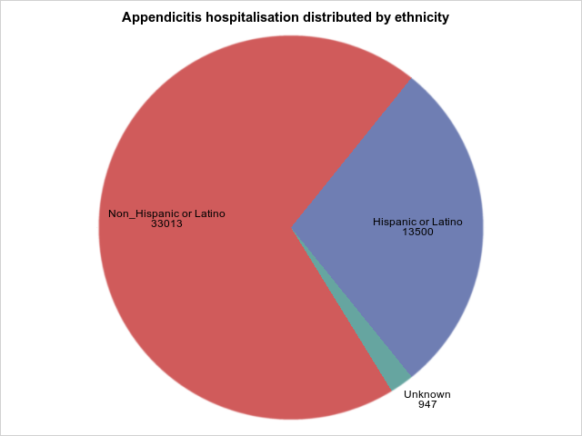 | 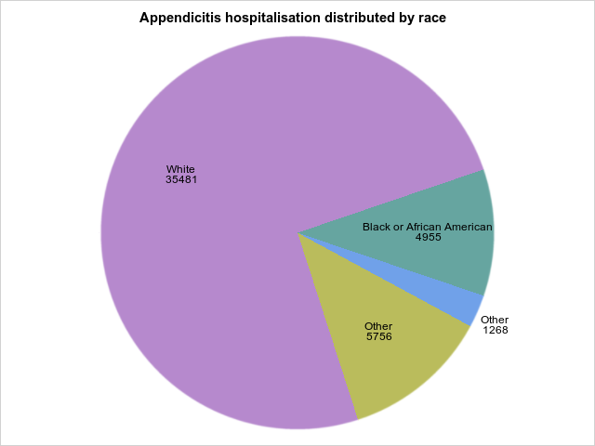
Figure 7. Hospitalizations by ethnicity (left) and race (right).
- Non-Hispanic or Latino patients account for 33,013 cases (69.6%), Hispanic or Latino patients for 13,500 (28.4%), and 947 (2.0%) are unknown.
- White patients account for 35,481 cases (74.8%) and Black or African American patients for 4,955 (10.4%). The two “Other” slices (5,756 and 1,268) are the same category coded two ways and together make up 7,024 cases (14.8%).
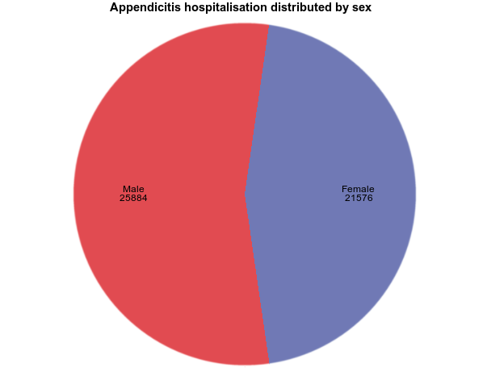
Figure 8. Hospitalizations by sex.
- Males account for 25,884 cases (54.5%) and females for 21,576 (45.5%).
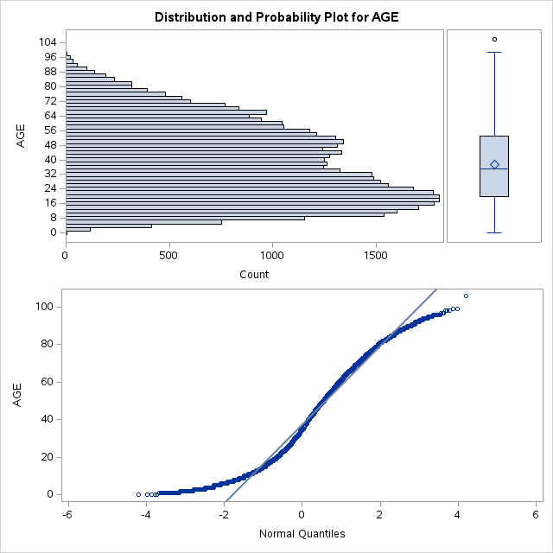 | 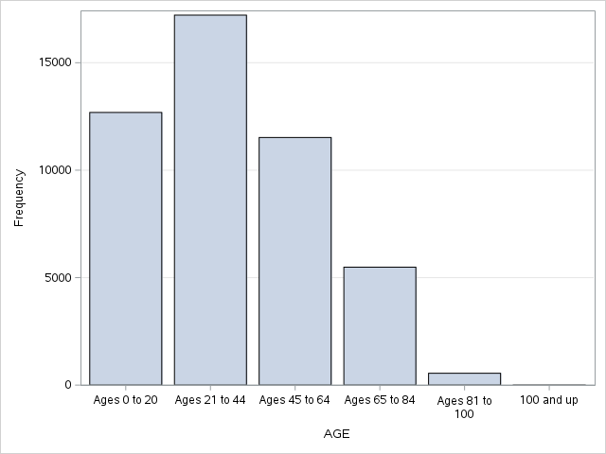
Figure 9. Age distribution with normal probability plot (left) and hospitalizations by age group (right).
- Mean age is 37.4 years and median age 35. The distribution is bimodal, with one peak between 15 and 25 years and a second between 45 and 56 years.
- The largest age group is 21 to 44 years. One record above 100 years is an outlier that should be checked against the source data.

Admission and payer
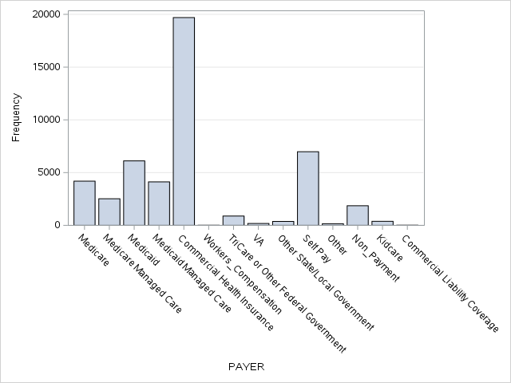 | 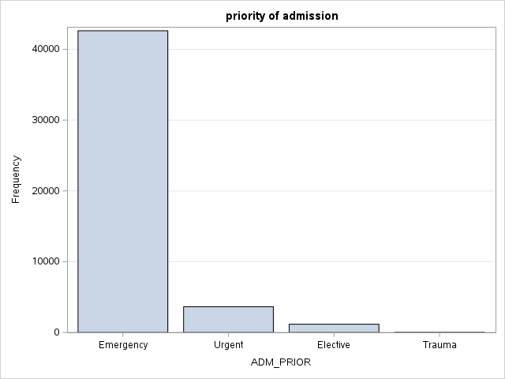
Figure 10. Hospitalizations by payer (left) and admission priority (right).
- Commercial health insurance is the largest payer, with 19,695 cases (41.5%).
- Emergency admissions account for 42,624 cases (89.8%).

Clinical profile
Measure | Value
Length of stay | mean 3.02 days, median 2 days, range 0 to 124 days
Complicated appendicitis | 14,392 cases (30.3%)
Uncomplicated appendicitis | 33,068 cases (69.7%)
Post-operative cases | 3,202 cases (6.7%)

Hospitalization rate
The 47,460 hospitalizations over three years correspond to about 15,820 per year. Against a Florida population of about 21 million, that is roughly 75.5 hospitalizations per 100,000 residents per year, below the national benchmark of 112 per 100,000.

Conclusion
Patients hospitalized for appendicitis in Florida were mostly White (74.8%) and non-Hispanic (69.6%), with a slight male majority (54.5%) and a concentration of young adults. Nine in ten were admitted through the emergency route, commercial insurance paid for the largest share, and about three in ten cases were complicated. The state’s hospitalization rate is lower than the national figure.

Limitations and next steps
- Hospitalization counts are not true incidence: one patient can be admitted more than once, and appendicitis treated without admission is missed.
- Next, compare complicated versus uncomplicated cases by age, payer and race, since delayed care is a known driver of perforation.

Project 4. Intraventricular Hemorrhage in Very Low Birth Weight Infants
Tools: SAS Visual Analytics | Data: 671 VLBW infants, Duke University Medical Center | Skills: decision trees, model evaluation, correlation

Research question
In newborns with very low birth weight (under 1,600 grams), are birth weight, gestational age, pneumothorax, mode of delivery, single versus multiple birth, and being born at Duke versus transferred in associated with the risk of intraventricular hemorrhage (IVH)?

Data
The very low birth weight dataset (Vanderbilt Department of Biostatistics) contains 671 infants treated at Duke University Medical Center. The outcome, IVH, is recorded as absent, possible or definite, and is missing for 144 infants.
Variable | Meaning
ivh | Intraventricular hemorrhage: absent, possible, definite
bwt | Birth weight (grams)
gest | Gestational age (weeks)
pneumo | Pneumothorax (1 = yes)
delivery | Mode of delivery (vaginal or abdominal)
twn | Multiple birth (1 = twin or more)
inout | Born at Duke or transferred in

Method
- Built a decision tree in SAS Visual Analytics with IVH as the target, to rank the candidate predictors by importance.
- Evaluated the tree with a confusion matrix and the Kolmogorov–Smirnov (Youden) statistic.
- Explored the leading predictors with scatter plots, bar charts, box plots and a correlation matrix.

Results
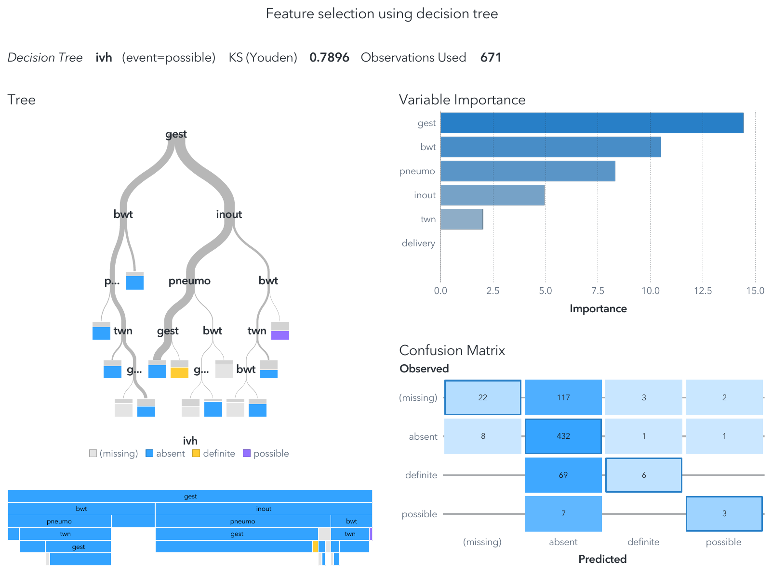
Figure 11. Decision tree, variable importance and confusion matrix for IVH.
- Most important predictors: gestational age, then birth weight, pneumothorax, birth location and multiple birth. Mode of delivery contributed nothing.
- Model performance: the tree classifies 463 of 671 infants correctly (69%), only slightly better than always predicting “absent” (66%). It identifies 6 of 75 infants with definite IVH and 3 of 10 with possible IVH. The KS value of 0.79 refers to the “possible” class only.
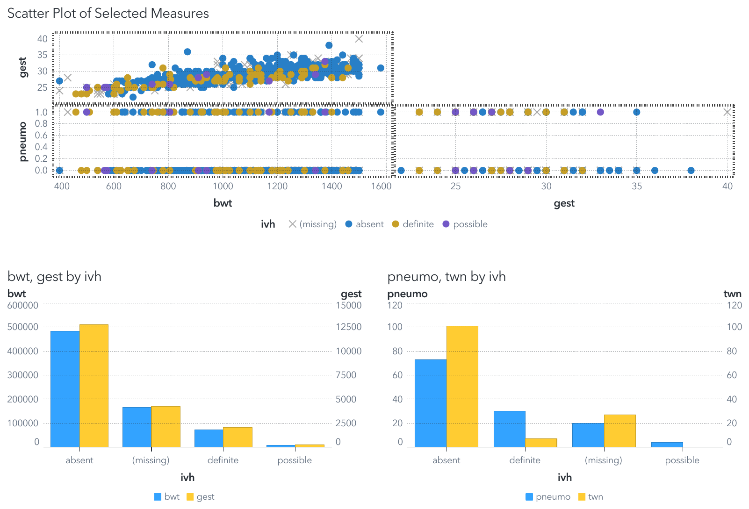
Figure 12. Scatter plots and grouped bar charts of the leading predictors by IVH status.
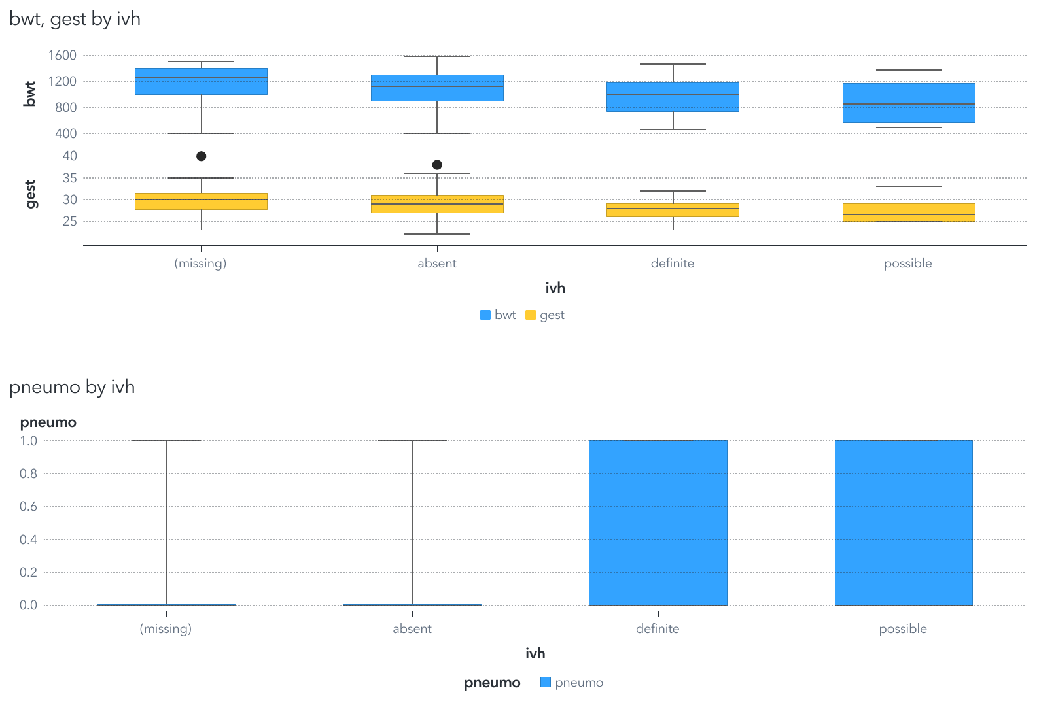
Figure 13. Birth weight and gestational age (box plots) and pneumothorax by IVH status.
- Pattern: infants with definite or possible IVH have lower median birth weight and gestational age, and pneumothorax is more common among them.
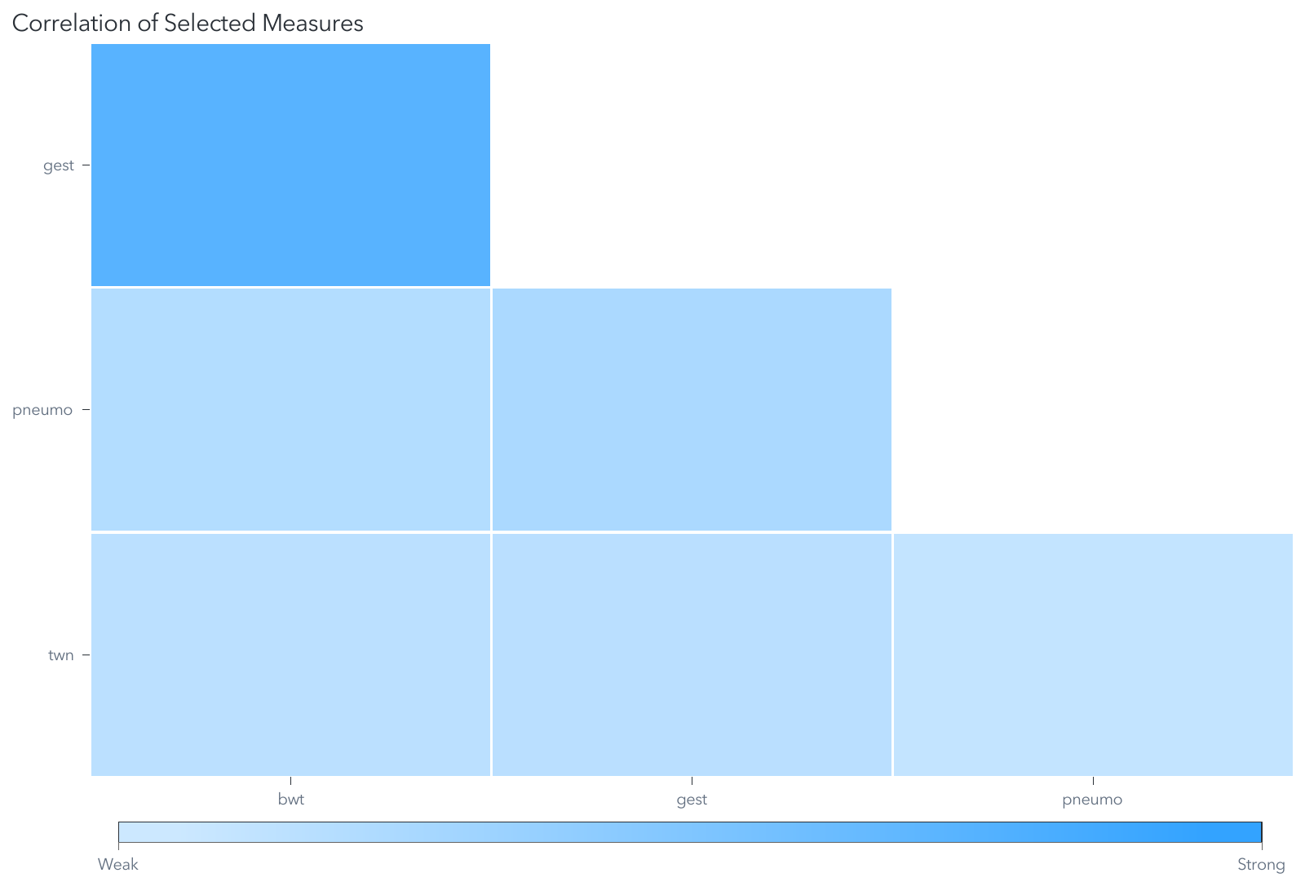
Figure 14. Correlation heat map of the leading predictors.
Variable 1 | Variable 2 | Correlation
bwt | gest | 0.7543
gest | pneumo | −0.2121
bwt | pneumo | −0.1592
gest | twn | 0.1164
bwt | twn | 0.1046
pneumo | twn | 0.0536

Birth weight and gestational age are strongly correlated (r = 0.75), so they carry overlapping information. All other pairs are weakly correlated (|r| < 0.3).

Conclusion
Lower gestational age, lower birth weight and pneumothorax are the strongest signals for IVH in this cohort, while mode of delivery shows no association. The tree is useful for selecting variables but is not accurate enough to predict IVH for individual infants.

Limitations and next steps
- The 144 infants with missing IVH status were kept as a separate class; they should be excluded or handled explicitly.
- With only 10 “possible” cases, combining possible and definite into “any IVH” would give a more stable outcome.
- Next, fit a logistic regression with gestational age (or birth weight, not both, given their correlation), pneumothorax and birth location, and validate it on held-out data.

Project 5. Hospital Length of Stay in New York, 2015
Tools: Tableau Public | Data: hospital_los_ny2015 (CSV, 35 fields, 10,552 rows) | Skills: exploratory visual analysis

Objective
Explore how average hospital length of stay (LOS) in New York State in 2015 varies by diagnosis, hospital county, race and payer, using New York open data.

Results

Length of stay by diagnosis
I placed average length of stay on Columns and CCS diagnosis on Rows, filtered to the ten diagnoses with the longest stays, and then rotated the chart so diagnosis labels and values are easier to match.
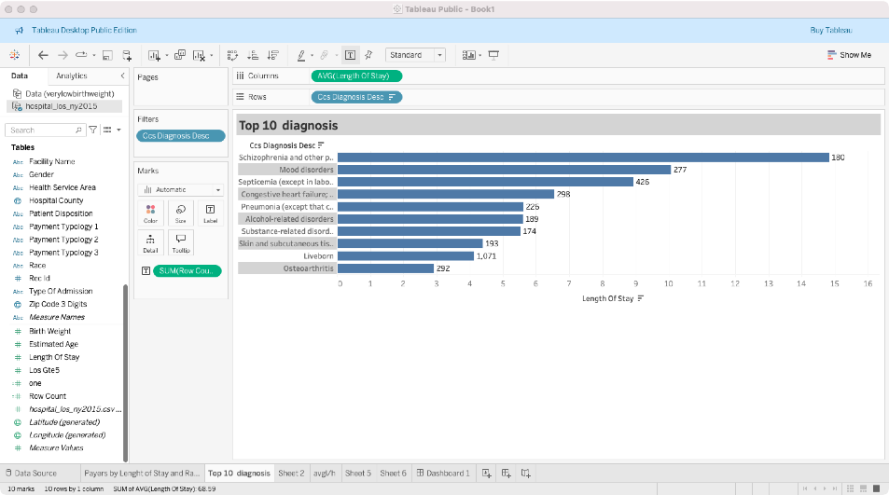
Figure 15. Top 10 diagnoses by average length of stay (horizontal).
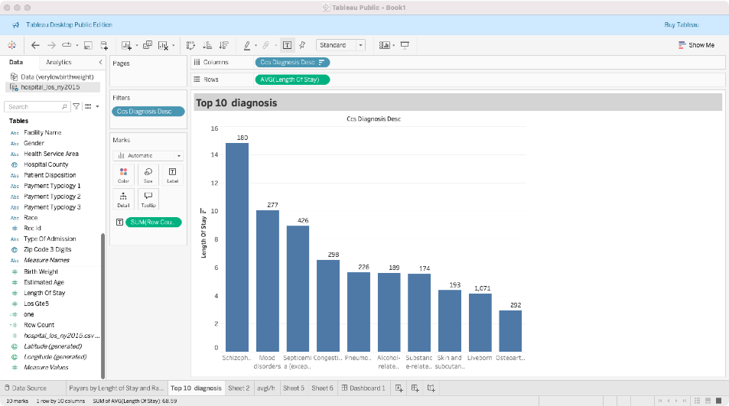
Figure 16. Top 10 diagnoses by average length of stay (vertical).
Schizophrenia and other psychotic disorders have the longest average stay, at about 15 days, followed by mood disorders (about 10 days) and septicemia (about 9 days). Behavioral health conditions dominate the top of the list.

Length of stay by hospital county
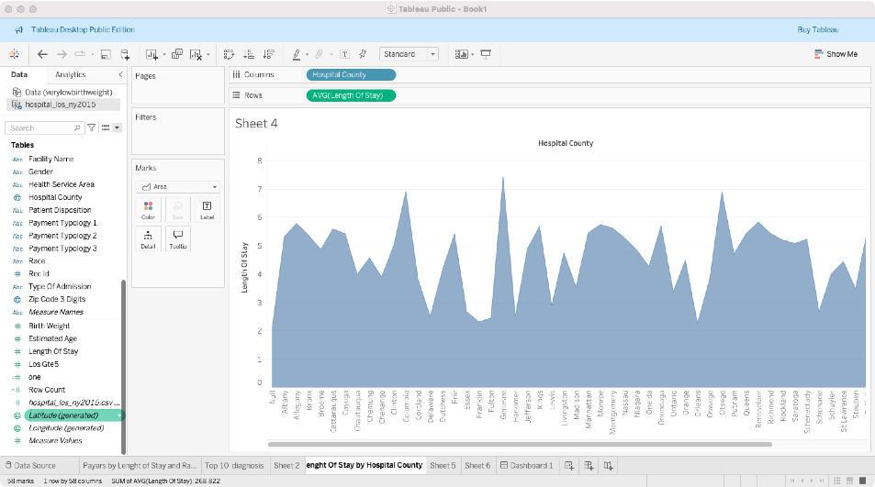
Figure 17. Average length of stay by hospital county.
Average stays range from about 2.25 days in Orleans County to about 8 days in Yates County. A bar chart sorted by value would make this comparison easier than an area chart, since counties are categories, not a continuous scale.

Length of stay by race
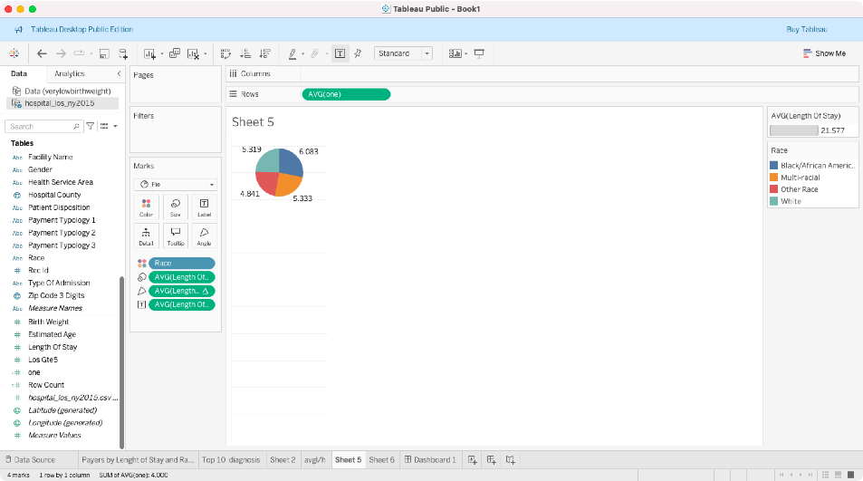
Figure 18. Average length of stay by race.
Black or African American patients have the longest average stay (6.1 days), followed by multiracial (5.3), White (5.3) and other races (4.8). Because averages are not parts of a whole, a bar chart would represent this better than the pie chart shown.

Stays and length of stay by payer
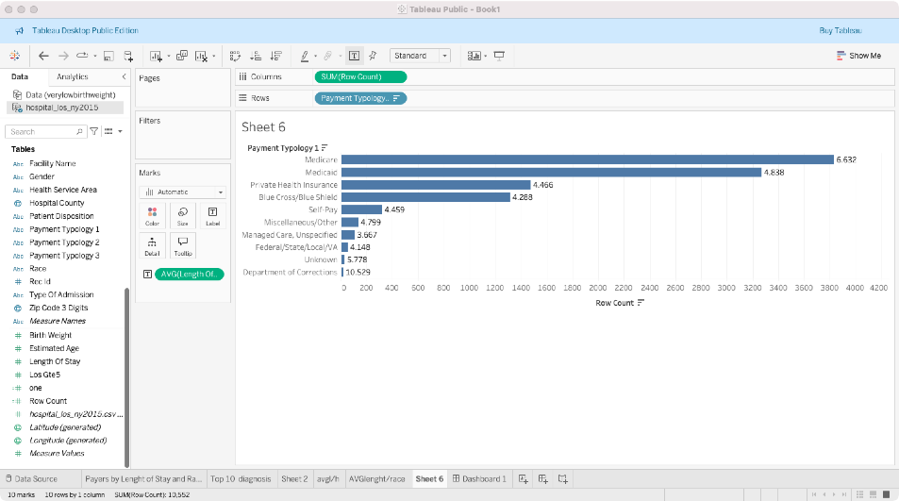
Figure 19. Number of records by primary payer, labeled with average length of stay.
Medicare covers the largest number of stays, followed by Medicaid. Medicare stays also last longer on average (6.6 days) than Medicaid (4.8) or private insurance (4.5). The Department of Corrections has the longest average stay (10.5 days) but very few records.
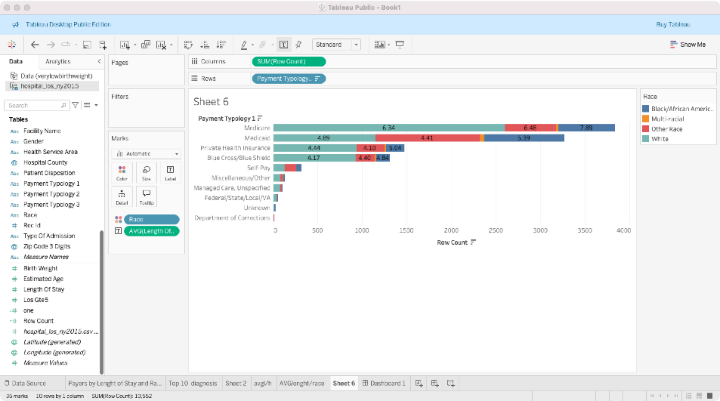
Figure 20. Records by primary payer and race, labeled with average length of stay.
White patients are the largest group for every payer. Within Medicare, Black or African American patients stay longer on average (7.9 days) than White patients (6.3 days), and the same gap appears within Medicaid (5.4 versus 4.9 days).

Limitations and next steps
- Differences in average stay by race may reflect differences in diagnosis and severity; comparing within diagnosis groups would show whether the gap persists.
- Next, combine these views into an interactive Tableau dashboard with filters for diagnosis, county and payer.

Project 6. Operational and Clinical Dashboards
Tools: SAS Visual Analytics | Data: readmissions, post-operative discharge, Framingham heart data | Skills: dashboard design for different audiences

Objective
Design three one-page reports, each from a different healthcare dataset and for a different audience, choosing chart types that answer that audience’s main question.

Readmission history (audience: hospital decision makers)
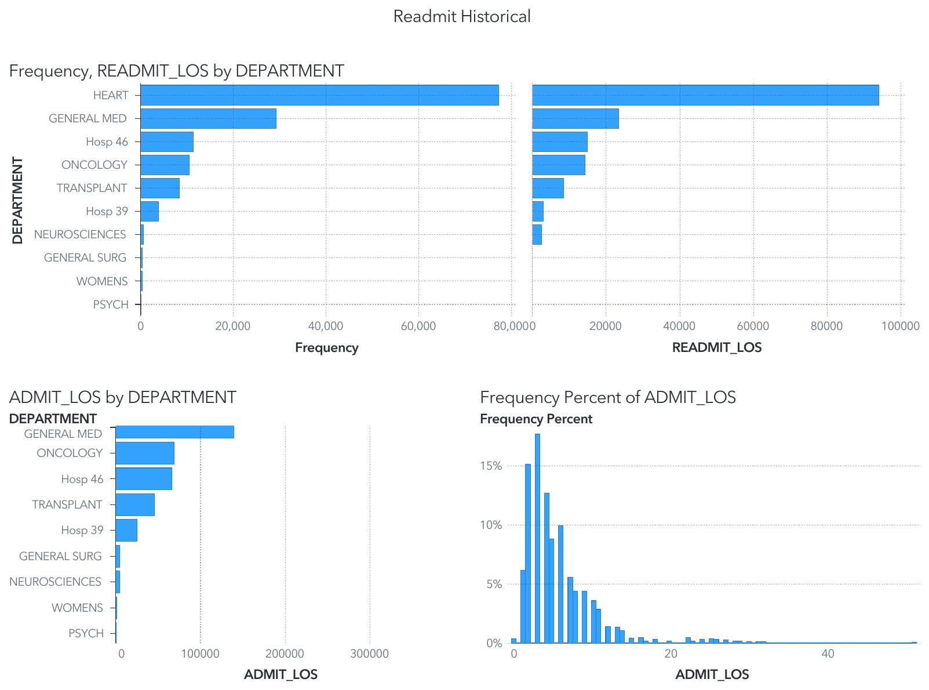
Figure 21. Readmission and admission length of stay by department, with the distribution of admission length of stay.
Heart and General Medicine account for the most readmissions and readmission days, so they are the first departments to examine when studying causes of readmission. Admission length of stay is right-skewed: most stays last 1 to 10 days, with a long tail beyond 20 days.

Post-operative discharge (audience: care teams)
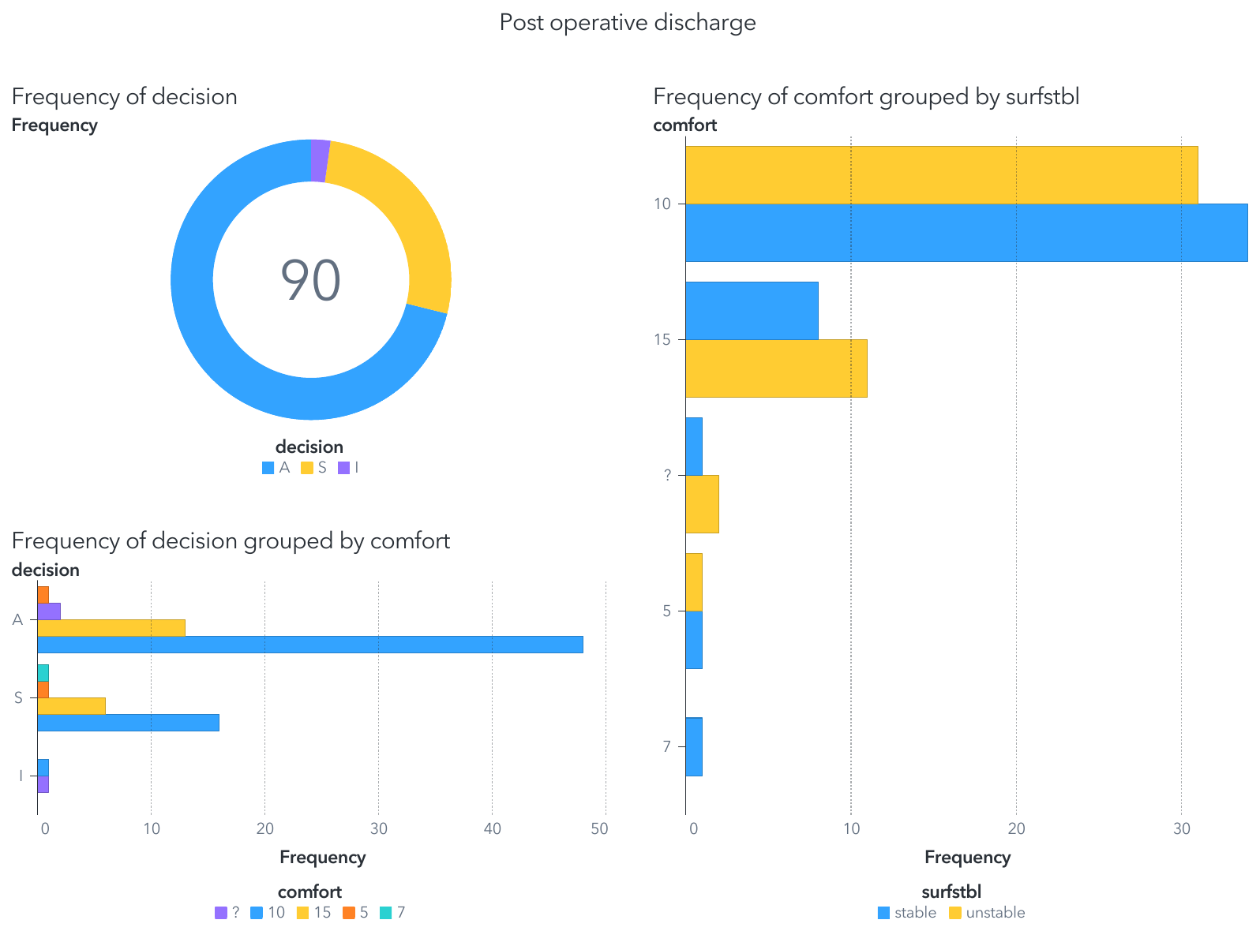
Figure 22. Discharge decisions for 90 post-operative patients by comfort score and temperature stability.
Of 90 post-operative patients, most were sent home (A), about a quarter went to a general hospital floor (S), and very few went to intensive care (I). Most patients reported a comfort score of 10, and the decision mix is similar across comfort levels, which helps clinicians see that comfort alone does not drive the discharge decision.

Heart study outcomes (audience: clinicians)
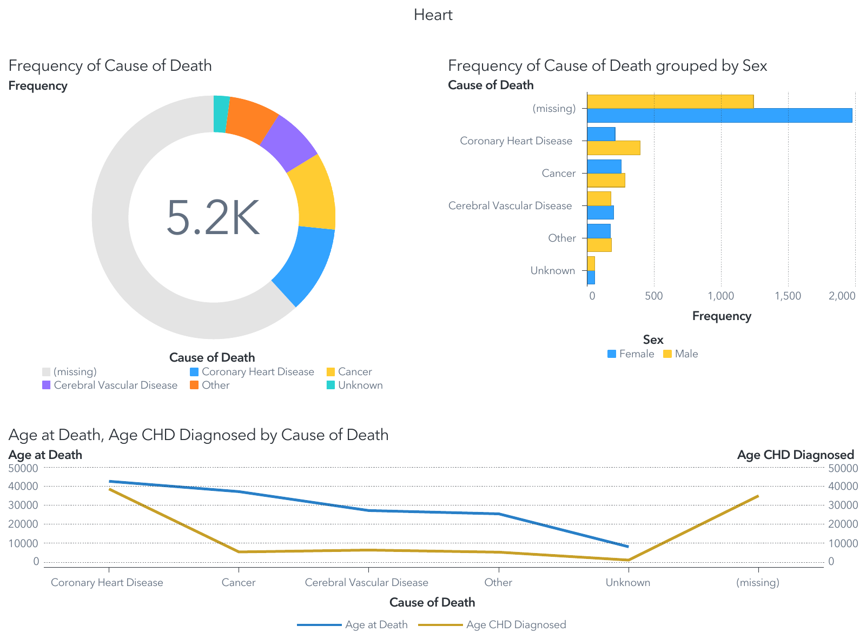
Figure 23. Cause of death overall and by sex, with age at death and age at CHD diagnosis by cause of death.
Of about 5,200 participants, most had no recorded cause of death because they were still alive at the end of follow-up. Among deaths, coronary heart disease is the leading cause, and men die of coronary heart disease about twice as often as women.

Lessons learned and next iteration
- Several charts show sums (total length of stay, total age at death) where averages answer the question better; the next version would use averages and rates.
- Missing values should be relabeled with their meaning (for example “Alive” instead of “(missing)” for cause of death) and “?” comfort scores cleaned before charting.
- Categories on the x-axis are better shown as bars than as a connected line.

Contact
Thank you for reviewing my portfolio. I would welcome the chance to discuss how these skills can support your team’s clinical, operational or population health analytics.
Hasnaa Mezraoui
hmezraoui@icloud.com

