MLOps Assignment #02 — Technical Report
End-to-End ML Pipeline: Apache Airflow + MLflow | Titanic Survival Prediction
Hasnat Noor | i222049 | MLOps BS DS | March 12, 2026
1. Architecture — Airflow + MLflow Interaction
Apache Airflow  - Orchestrates all 11 pipeline tasks as a DAG  - Schedules parallel execution of Tasks 4a & 4b  - Passes data via XCom (paths, run_id, metrics)  - Retries=2, retry_delay=10s on every task  - BranchPythonOperator routes model to register or reject  MLflow Tracking  - Groups all runs under experiment: Titanic_Survival  - Logs params: model_type, n_estimators, max_depth  - Logs metrics: accuracy, precision, recall, F1  - Stores serialized sklearn model as run artifact  - Registers approved models in Model Registry | Interaction Flow  Each Airflow PythonOperator task directly calls the MLflow Python API. The train_model task opens an MLflow run via mlflow.start_run() and pushes the resulting run_id to XCom. Downstream tasks pull this run_id and resume the same MLflow run to append metrics and register the model — creating a one-to-one traceability between every Airflow execution and its MLflow record.  train_model mlflow.start_run() → log params + artifact  evaluate_model mlflow.log_metric() → accuracy, precision, recall, F1  register_model mlflow.register_model() → TitanicSurvivalModel  reject_model mlflow.log_param(rejection_reason)

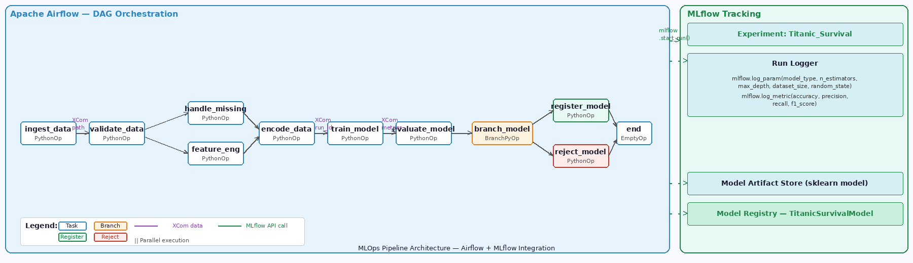
Figure 1 — Pipeline architecture showing all Airflow tasks, parallel execution, branching logic, and MLflow integration points
2. DAG Structure and Task Dependencies
DAG ID: mlops_titanic_pipeline | Schedule: Manual (None) | Catchup: False | Owner: Hasnat_Noor | Retries: 2 | Retry Delay: 10s

# | Task ID | Operator | Depends On | Key Action
T2 | ingest_data | PythonOperator | — | Load CSV → print shape → log missing → XCom push path
T3 | validate_data | PythonOperator | ingest_data | Check Age & Embarked missing % < 30% → retry demo on attempt 1
T4a | handle_missing | PythonOperator | validate_data ║ | Fill Age→median, Embarked→mode, Fare→median [PARALLEL]
T4b | feature_engineering | PythonOperator | validate_data ║ | Compute FamilySize=SibSp+Parch+1, IsAlone flag [PARALLEL]
T5 | encode_data | PythonOperator | T4a + T4b | Merge outputs, LabelEncode Sex & Embarked, drop Name/Ticket/Cabin
T6 | train_model | PythonOperator | encode_data | Train model → mlflow.start_run() → log params + artifact → XCom run_id
T7 | evaluate_model | PythonOperator | train_model | Compute accuracy, precision, recall, F1 → log all to MLflow
T8 | branch_model | BranchPythonOperator | evaluate_model | acc >= 0.80 → register_model | acc < 0.80 → reject_model
T9a | register_model | PythonOperator | branch_model | mlflow.register_model() → TitanicSurvivalModel vN
T9b | reject_model | PythonOperator | branch_model | Log rejection_reason to MLflow run
— | end | EmptyOperator | T9a or T9b | Convergence — trigger_rule: none_failed_min_one_success

Parallel Design: Tasks T4a and T4b both depend on validate_data and execute simultaneously. encode_data uses a join on PassengerId to merge their outputs before training.
No Cyclic Dependencies: All XCom communications are strictly unidirectional. Data flows left-to-right only. Verified via Airflow Graph View — confirmed acyclic.

3. Experiment Comparison Analysis
Hyperparameters per Run
Run | Model Type | n_estimators | max_depth | Train Size | Test Size
Run 01 | RandomForest | 10 | 2 | 712 | 179
Run 02 | RandomForest | 200 | 10 | 712 | 179
Run 03 | LogisticRegression | — | None | 712 | 179

MLflow Metrics Comparison
Run | Accuracy | Precision | Recall | F1-Score | Threshold | Decision
Run 01 | 0.7765 | 0.8269 | 0.5811 | 0.6825 | ≥ 0.80 | REJECTED
Run 02 | 0.8324 | 0.8333 | 0.7432 | 0.7857 | ≥ 0.80 | REGISTERED ✓
Run 03 | 0.7989 | 0.7794 | 0.7162 | 0.7465 | ≥ 0.80 | REJECTED

Analysis
Run 01 — RandomForest (n=10, depth=2): Weakest performer. Max_depth=2 limits each tree to only two decision splits, preventing the model from capturing multi-feature survival patterns. Recall of 0.5811 means 42% of survivors were missed. Rejected.

Run 02 — RandomForest (n=200, depth=10): Best performer at 0.8324 accuracy. 200 trees with depth=10 successfully modelled the non-linear interactions between Pclass, Sex, Age, FamilySize, and Fare. Only run to exceed the 0.80 threshold — automatically registered as TitanicSurvivalModel Version 1.

Run 03 — LogisticRegression: Solid baseline at 0.7989. As a linear model it cannot capture non-linear survival boundaries, but offers the most balanced precision/recall of the three runs. Falls 0.0011 short of the registration threshold.

Best Model: Run 02 (RandomForest, n=200, depth=10) wins on all four metrics. Registered in MLflow Model Registry.

4. Failure and Retry Explanation
Retry Configuration  - retries = 2 (max 3 total attempts)  - retry_delay = timedelta(seconds=10)  - Applied globally via default_args to all tasks  - Failed task → orange in Airflow UI (UP_FOR_RETRY)  - After 2 retries → red (FAILED) → downstream skipped  Retry Evidence (Task: validate_data)  - attempt=1.log → ValueError raised → UP_FOR_RETRY  - 10 second delay → attempt=2.log begins  - attempt=2.log → Validation PASSED ✓  - Pipeline continues to handle_missing + feature_eng  - Airflow Graph View: orange → green transition visible | How the Retry Was Demonstrated  The validate_data function reads kwargs['ti'].try_number to detect the current attempt number. On attempt 1, it deliberately raises a ValueError simulating a transient failure (e.g. unavailable data source or locked file). Airflow catches the exception, marks the task UP_FOR_RETRY, waits 10 seconds, and re-queues.  On attempt 2, the intentional failure is skipped. Real validation logic runs — Age missing: 19.87%, Embarked missing: 0.22% — both well below the 30% threshold. Task completes with Validation PASSED and downstream parallel tasks begin immediately.  Why This Matters in Production  Transient failures are common in production — network timeouts, temporary database locks, or slow API responses. Automatic retries prevent entire pipeline failures due to momentary issues and eliminate the need for manual intervention in most cases.

5. Reflection — Production Deployment
Deployment Strategy | Containerize DAGs with Docker and deploy on Google Cloud Composer or AWS MWAA. Migrate MLflow backend from SQLite to PostgreSQL with artifact storage in AWS S3. Use CI/CD (GitHub Actions) to auto-deploy DAG updates on every push to main branch.
Monitoring | Add data drift detection (Evidently AI) to alert when feature distributions shift. Track live model accuracy in Grafana dashboards. Configure Airflow SLA miss alerts via Slack or email. Trigger automatic retraining when accuracy drops below 0.80.
Model Versioning | Use MLflow Registry stage transitions: Staging → Production → Archived. Implement a champion-challenger framework routing 10% of traffic to new versions before full promotion. Track full lineage from raw data version to registered artifact.
Security | Store all credentials in AWS Secrets Manager or HashiCorp Vault — never hardcode in DAG files. Enforce RBAC in Airflow to restrict DAG triggers and model promotions. Encrypt all inter-service communication with TLS. Secure MLflow behind an auth proxy.

Hasnat Noor | i222049 | MLOps BS DS | March 2026

