CE4023: HYDRAULIC DESIGN

COURSEWORK 3:
HYDRAULIC STRUCTURES FIELD STUDY EXERCISE
FIELD STUDY AND HYDRAULIC IDENTIFICATION REPORT ON COMMON AND LESS-COMMON HYDRAULIC STRUCTURES IN BATTICALOA DISTRICT

Name: | Zihar.KRH
Index Number: | 230738B
Submission Date: | 04 October 2026


04/10/2026
230738B
Zihar KRH


04/10/2026


04/10/2026

Table of Contents
ABSTRACT 7
1. INTRODUCTION 8
1.1 Background to Hydraulic Structures in Sri Lanka's Dry Zone 8
1.2 Aim and Specific Objectives 8
1.3 Scope of Fieldwork and Investigation 9
2. FIELD STUDY METHODOLOGY 10
2.1 Site Selection Criteria and Physical Separation 10
2.2 Regional Geographic and Hydrological Context 10
2.3 Data Collection, Inspection Protocols, and Photographic Evidence 11
3. SITE A: UNNICHCHAI DAM AND RESERVOIR HEADWORKS (LESS-COMMON HYDRAULIC STRUCTURE) 12
3.1 General and Administrative Details 12
3.2 Geographic Location, GPS Coordinates, and Accessibility 12
3.3 Location and Catchment Maps 13
3.4 Field Photographic Documentation and Physical Evidence 13
3.5 Structural Geometry and Headworks Configuration 18
3.6 Hydraulic Purpose and Multi-Purpose Operational Functionality 18
3.7 Detailed Description of Major Hydraulic Components 18
3.8 Structural Safety and Dam Integrity Assessment 19
3.9 Environmental Sustainability and River Basin Protection 19
3.10 Hydraulic Head Characterization 20
3.11 Spillway Discharge Capacity Estimation 20
3.12 Stilling Basin Energy Dissipation and Hydraulic Jump Analysis 21
3.13 Downstream Tailwater Open-Channel Conveyance Analysis 21
3.14 Comparative Literature Benchmark Analysis 22
3.15 Comprehensive Site A Engineering Synthesis 22
4. SITE B: DOUBLE SWISS GATE BIFURCATION STRUCTURE (COMMON HYDRAULIC STRUCTURE) 23
4.1 General and Administrative Details 23
4.2 Geographic Location, GPS Coordinates, and Accessibility 23
4.3 Location and Feeder Canal Maps 23
4.4 Dimensioned Engineering Sketches and Physical Measurements 24
4.5 Field Photographic Documentation and Inspection Evidence 25
4.6 Hydraulic Purpose, Flow Division, and Irrigation Functionality 27
4.7 Major Structural and Mechanical Components 27
4.8 Structural Safety, Integrity, and Maintenance Assessment 28
4.9 Environmental Sustainability and Canal Bank Protection 28
4.10 Hydraulic Head Difference and Operating Regimes 28
4.11 Downstream Canal Hydraulic Conveyance Analysis 28
4.12 Gate-to-Channel Flow Capacity Cross-Check 29
4.13 Comparative Literature Benchmark Analysis 29
4.14 Comprehensive Site B Engineering Synthesis 30
5. DISCUSSION AND SYNTHESIS 31
5.1 Comparative Synthesis of Hydraulic Mechanisms 31
5.2 Key Learning Outcomes 31
5.3 Fieldwork Challenges and Data Uncertainty 31
5.4 Structural and Durability Observations 31
5.5 Recommended Dead Storage 31
5.6 Spillway and Flood Safety 31
5.7 Embankment Freeboard 32
5.8 Gate Maintenance 32
5.9 Embankment Protection 32
5.10 Canal Bifurcation 32
5.11 Environmental, Health and Safety 32
5.12 Recommendations 32
6. CONCLUSIONS 33
6.1 Achievement of Course Objectives 33
6.2 Summary of Hydraulic Capacities and Safe Limits 33
6.3 Concluding Remarks 33
7. REFERENCES 34

ABSTRACT
Site A represents a less-common headworks: Unnichchai Dam and Reservoir (Coordinates: 7°37'05.2"N, 81°32'55.4"E), impounding Magalavattuwan River (Basin 59). Unnichchai features gross storage of 67.87 MCM (55,020 ac·ft) at FSL (30.18 m MSL) with a dual spillway: an extensive curved masonry ogee overflow weir (crest length L = 120.0 m) and a three-bay radial gated spillway (3 x 6.10 m x 3.35 m). Weir routing yields a free overflow capacity of 391.3 m³/s under 1.32 m design surcharge (MWL: 31.50 m MSL).
Site B represents a common irrigation structure: the Double Swiss Gate Bifurcation at 40th Village (Coordinates: 7°32'30.8"N, 81°40'03.9"E), fed from Pulukunawa Reservoir. It features an L-shaped concrete distribution chamber controlling discharge into perpendicular branch canals via twin slide gates with manual rising screw spindles. Sketch B.1 establishes measured aperture dimensions of 2 x (1.85 m width x 1.35 m opening height).
The report synthesizes comparative hydraulics, durability, riprap protection, environmental sustainability, and safety.

1. INTRODUCTION

1.1 Background to Hydraulic Structures in Sri Lanka's Dry Zone
Sri Lanka possesses an illustrious hydraulic heritage spanning more than two millennia, characterized by ingenious cascade tank systems, trans-basin trans-diversion canals, and monolithic earthen dams engineered to harvest and regulate seasonal rainfall in the Dry Zone. In modern civil and agricultural engineering practice, hydraulic structures remain the fundamental linchpins of water security, food production, and disaster resilience. The Eastern Province, particularly the Batticaloa District, exhibits a pronounced dry-zone tropical climate governed by the Northeast Monsoon (October to February), which delivers over 75% of the total annual precipitation. During the subsequent dry season (May to September), river flows diminish rapidly, creating severe water deficits. Consequently, sustainable socio-economic development in this region depends absolutely upon artificial impoundment reservoirs (tanks or wewas) and highly engineered canal networks equipped with precise control, diversion, and distribution structures.

1.2 Aim and Specific Objectives
The overarching aim of this field study is to conduct an in-depth physical inspection, geometric audit, and hydraulic performance assessment of two distinct freshwater hydraulic structures that selected in the Batticaloa District, contrasting a complex, less-common headworks facility with a common irrigation distribution structure.
The specific engineering objectives are:
1. Identify and inspect two freshwater hydraulic structures located at least 3.0 kilometers apart, comprising one very common type and one less-common type.
2. Compile comprehensive photographic documentation and dimensioned engineering sketches detailing overall configurations, inlets, conveyance channels, regulating mechanisms, energy dissipaters, and outlets.
3. Provide verifiable proof of physical presence at both sites in compliance with course safety protocols and academic timeline requirements.
4. Determine the precise geographic coordinates and produce standardized topographic/satellite mapping extracts for both headworks.
5. Articulate the technical hydraulic engineering purpose, operational functionality, and systemic importance of each structure.
6. Evaluate the structural integrity, durability, and operational safety of the civil and mechanical components under operational and extreme load conditions.
7. Assess the environmental sustainability, catchment health, and ecological compatibility of the structures within their river basin contexts.
8. Execute rigorous, evidence-based hydraulic calculations using Manning's equation and weir/hydraulic jump principles to determine the safe discharge capacity (Q) and operating head (H), supported by sensitivity and uncertainty analyses.
9. Conduct comparative literature benchmarks contrasting the observed structures with international and national design standards.
10. Execute the comprehensive Village Reservoir / Tank Assessment Module for the major impoundment headworks.

1.3 Scope of Fieldwork and Investigation
The scope of this investigation includes on-site physical walk-through visual inspections, measurement checks against engineering drawings, photographic documentation of key hydraulic components, local stakeholder interaction, digital elevation modeling, and academic literature synthesis. Field observations were executed on 03 October 2026 across two locations in the Batticaloa District:
• Site A (Less-Common Structure): Unnichchai Dam and Reservoir Headworks (Curved Ogee Spillway with USBR Type III Baffle Stilling Basin and 3 -Bay Radial Gated Spillway).
• Site B (Common Structure): Double Swiss Gate Bifurcation Structure located at 40th Village (Manually regulated twin vertical slide gates dividing irrigation discharge between two branch channels).

2. FIELD STUDY METHODOLOGY

2.1 Site Selection Criteria and Physical Separation
The assignment brief mandates four criteria governing site selection:
1. Minimum Separation Distance: The two sites must be situated at least 3.0 kilometers apart.
2. Freshwater Association: Both structures must control, store, or convey freshwater.
3. Structural Typology Contrast: Exactly one structure must be a very common hydraulic structure, and the second must be a less-common hydraulic structure.
4. Physical Verification: Each location must provide verifiable photographic proof of the student's physical presence.
To satisfy these mandates, Unnichchai Reservoir Headworks was selected as Site A (Less-Common), while the Double Swiss Gate Turnout at 40th Village was selected as Site B (Common). Both structures are located in the freshwater agricultural zone of Batticaloa District.
Geographic separation was established using high-precision ellipsoidal coordinates:
• Site A Coordiniate: 7°37'05.2"N, 81°32'55.4"E (7.61811° N, 81.54872° E)
• Site B Coordiniate: 7°32'30.8"N, 81°40'03.9"E (7.54189° N, 81.66775° E)
The distance of 15.52 km exceeds the course requirement of 3.0 km by more than 500%, verifying compliance with site selection rules.

2.2 Regional Geographic and Hydrological Context
Both structures lie within the Eastern Dry Zone of Sri Lanka. Site A commands the upper-middle catchment of the Magalavattuwan River Basin (River Basin No. 59), which drains an area of 274.54 km² (106.0 sq. miles) originating in the undulating foothills of the Eastern Province and discharging into the Batticaloa Lagoon. Site B is located in the alluvial agricultural plains of Porativu Pattu / Mandur, receiving regulated irrigation supplies from the Pulukunawa Reservoir scheme. The regional terrain slopes gently eastward toward the coastal lagoons at an average regional gradient of 1:700 to 1:1500.

2.3 Data Collection, Inspection Protocols, and Photographic Evidence
Field investigations were conducted systematically on 03 October 2026. A strict observation protocol was executed at each site:
1. Structural Reconnaissance: Overall visual scan to identify approach geometry, alignment, structural layout, and surrounding topography.
2. Component Inspection: Close-range physical examination of intake cutwaters, gate leaves, seals, spindle lifting stems, operating handwheels, weir crest profiles, chute slabs, stilling basin baffle blocks, training walls, and riprap aprons.
3. Condition Survey: Detailed visual audit for structural cracking, spalling, reinforcement corrosion, gate leakage, spindle deformation, foundation undermining, bank scouring, and seepage boils.
4. Photographic Documentation: High-resolution digital photographs capturing macro overviews, close-up component details, and contextual proof-of-visit portraits featuring the student alongside distinctive structural features.

3. SITE A: UNNICHCHAI DAM AND RESERVOIR HEADWORKS (LESS-COMMON HYDRAULIC STRUCTURE)

3.1 General and Administrative Details
Unnichchai Dam and Reservoir (Sinhala: උන්නිච්චායි වැව / උන්නච්චිය ජලාශය; Tamil: உன்னிச்சைக் குளம்) is a major multi-purpose water resources storage headworks located in the Batticaloa District, Eastern Province. It holds significant historical standing as the first major storage reservoir designed and constructed entirely from the ground up by the Ceylon Irrigation Department following its formal establishment in 1900. Construction commenced under British colonial irrigation engineer R. F. Morrison in 1915 and was completed in 1919 with an initial design storage capacity of 31.70 MCM (25,700 ac·ft). The headworks impound the perennial and seasonal runoff of the Magalavattuwan River (Sri Lanka River Basin No. 59).
Administratively, the facility is operated and maintained by the Department of Irrigation, Sri Lanka, under the executive purview of the Regional Director of Irrigation (Batticaloa) and the Divisional Irrigation Engineer (Rugam Division). Municipal drinking water facilities at the site are co-managed with the National Water Supply and Drainage Board (NWSDB).

3.2 Geographic Location, GPS Coordinates, and Accessibility
The reservoir headworks are situated in the Manmunai West (Vavunatheevu) Divisional Secretariat Division, within the Unnichchai Grama Niladhari Division (GND 142). Nearest major population centers include Vavunatheevu, Ayethiyamalai, and the Batticaloa municipal center situated approximately 22 km to the east.
Precise GPS Coordinates: Latitude 7°37'05.2"N, Longitude 81°32'55.4"E (7.61811° N, 81.54872° E). Elevation at the dam crest is approximately 33.0 m above Mean Sea Level (MSL). Access is gained via the Batticaloa–Vavunatheevu–Unnichchai highway, terminating in an unpaved gravel access road running directly along the primary dam embankment.

3.3 Location and Catchment Maps
Unnichchai Reservoir commands an upstream drainage catchment area of 274.54 km² (106.0 sq. miles). The catchment topography consists of rugged forested granite hills in the upper reaches, transitioning into scrubland and agricultural terrain surrounding the reservoir perimeter. The National Topographic Map Series (Sheet J/10, 1:50,000 scale) published by the Survey Department of Sri Lanka designates the impoundment area, spillway chutes, and the Right and Left Bank main canal intakes.
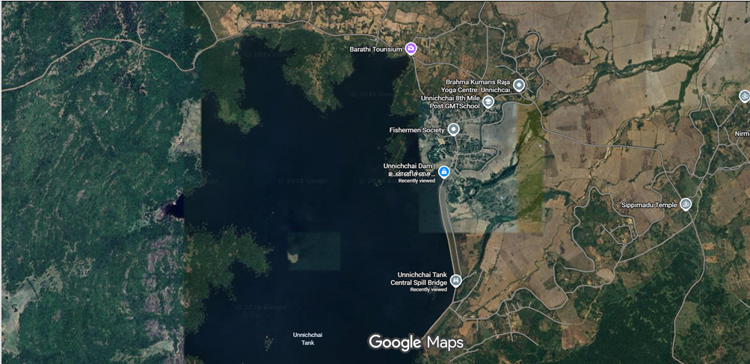

3.4 Field Photographic Documentation and Physical Evidence
The photographic survey completed on 03 October 2026 captures every key functional component of the Unnichchai headworks. In accordance with assignment guidelines, representative photographs are presented below with descriptions:
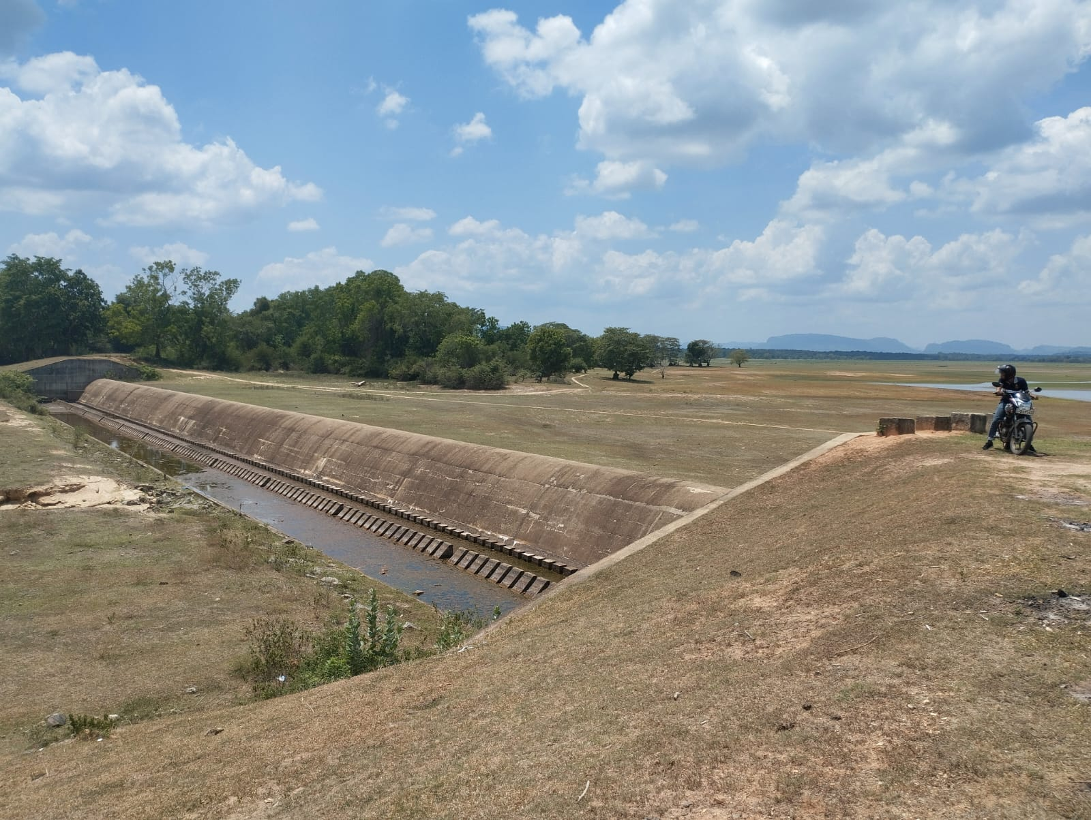
Figure 3.1: Downstream panoramic view of the curved ogee spillway crest, chute slope, USBR Type III stilling basin with baffle blocks, and right earth embankment abutment at Unnichchai Headworks
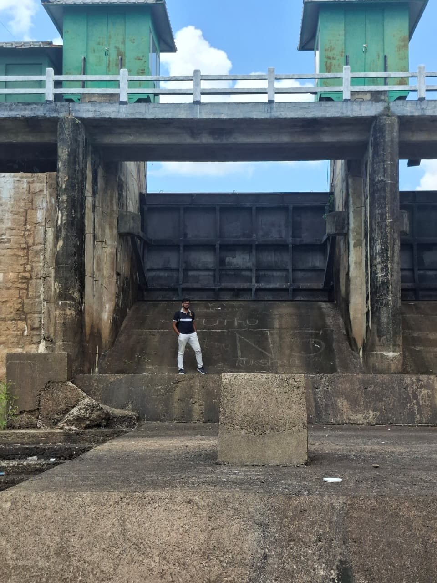
Figure 3.2: Gated spillway bay showing massive reinforced concrete piers, hoist deck, and steel radial (Tainter) gate leaf in fully lowered watertight position.
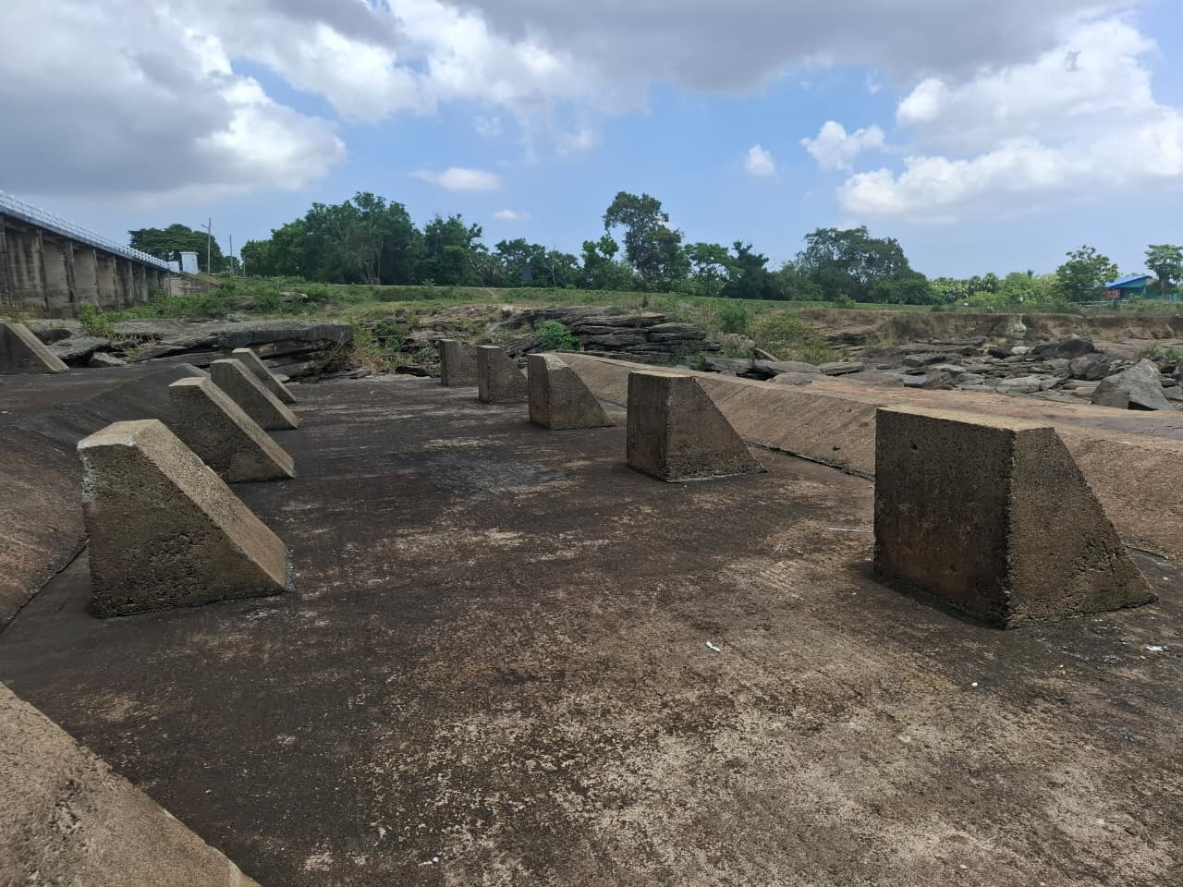
Figure 3.3: Downstream view of the USBR Type III stilling basin floor slab featuring staggered reinforced concrete baffle piers, stepped training walls, and bedrock tailwater channel.
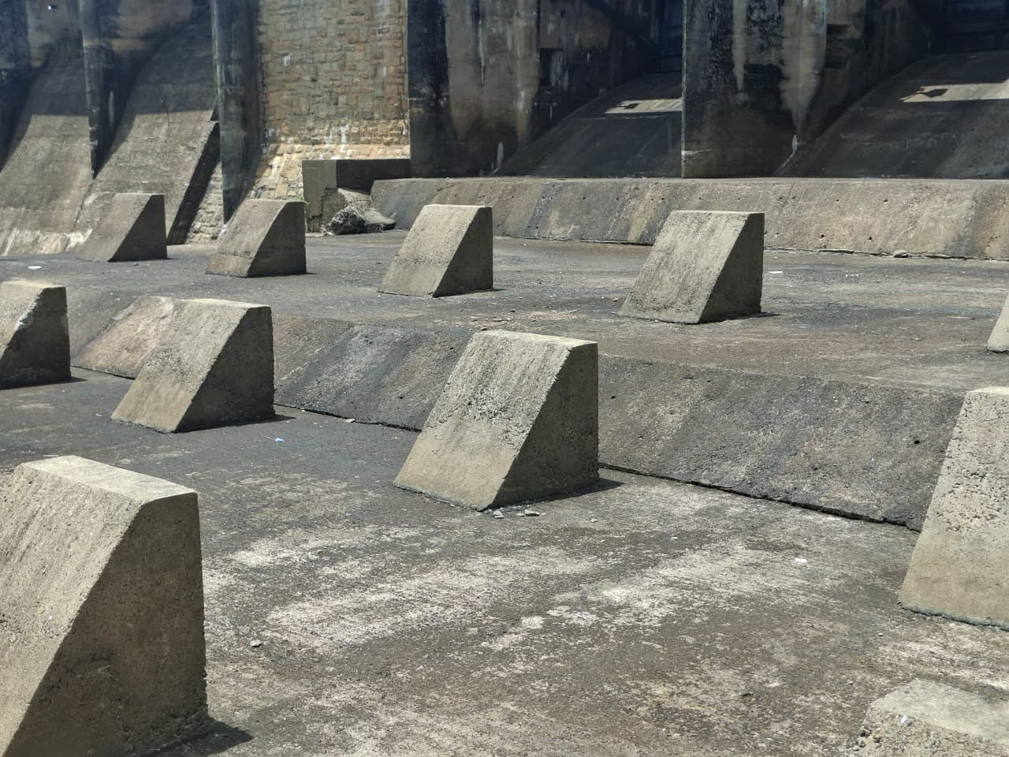
Figure 3.4: Close-up view of the trapezoidal concrete baffle blocks on the stilling basin apron, showing intact structural geometry without cavitation erosion or structural displacement.
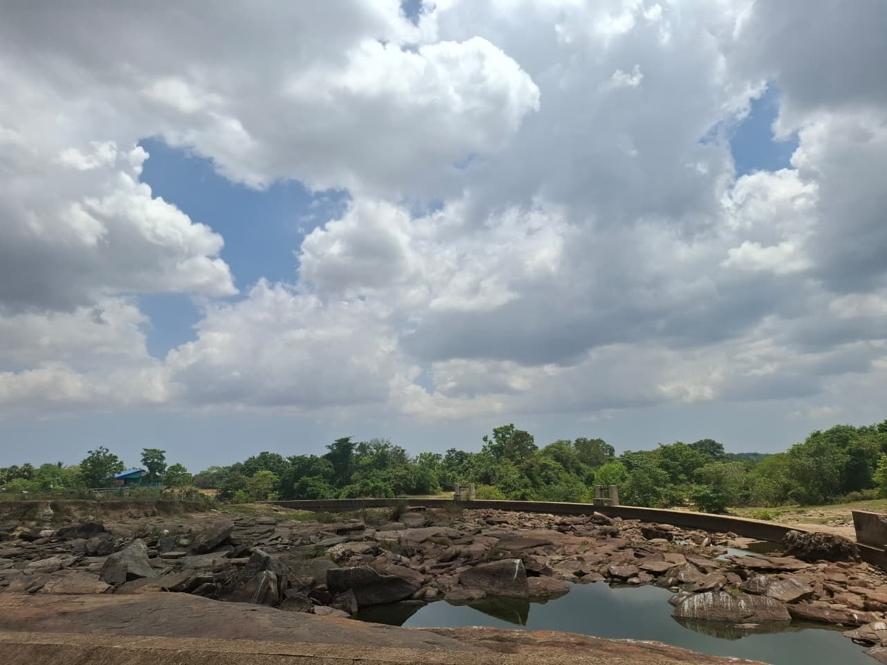
Figure 3.5: Expansive natural granite bedrock formation immediately downstream of the stilling basin end sill, acting as a non-erodible geological foundation against tailwater scour.
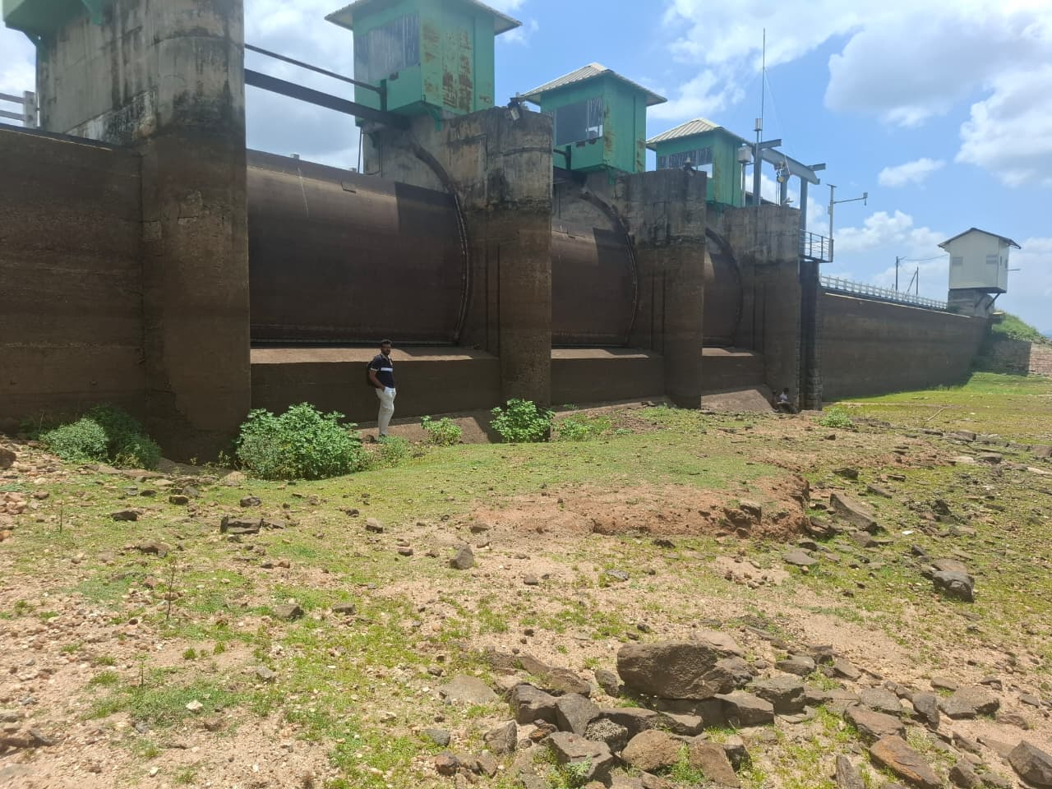
Figure 3.6: Upstream approach of the radial gated spillway bays showing streamlined rounded concrete pier cutwaters (bullnoses) designed to minimize contraction losses.
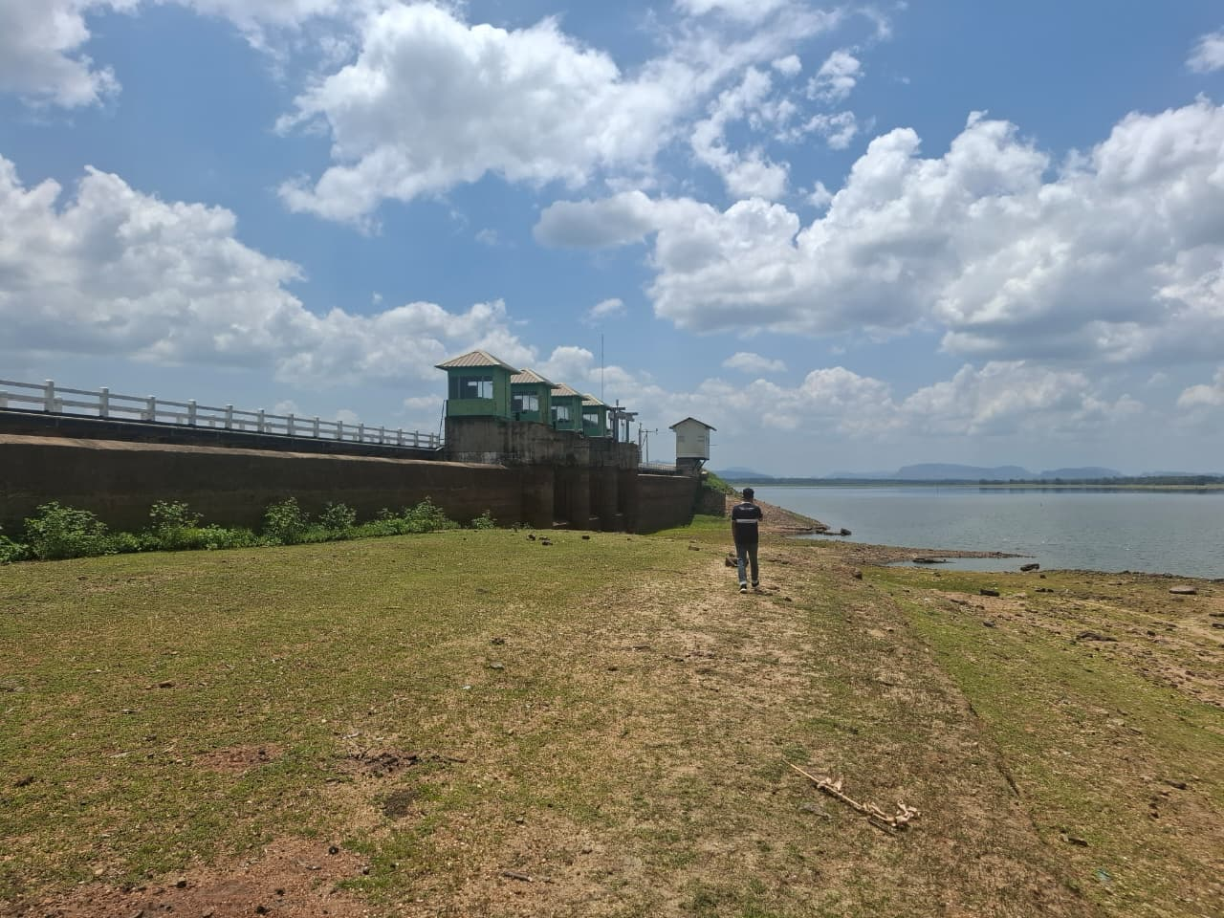
Figure 3.7: Macro view of the zoned earthfill dam embankment showing hand-placed rock riprap slope pitching, crest roadway, and dry reservoir foreshore during low-pool storage.
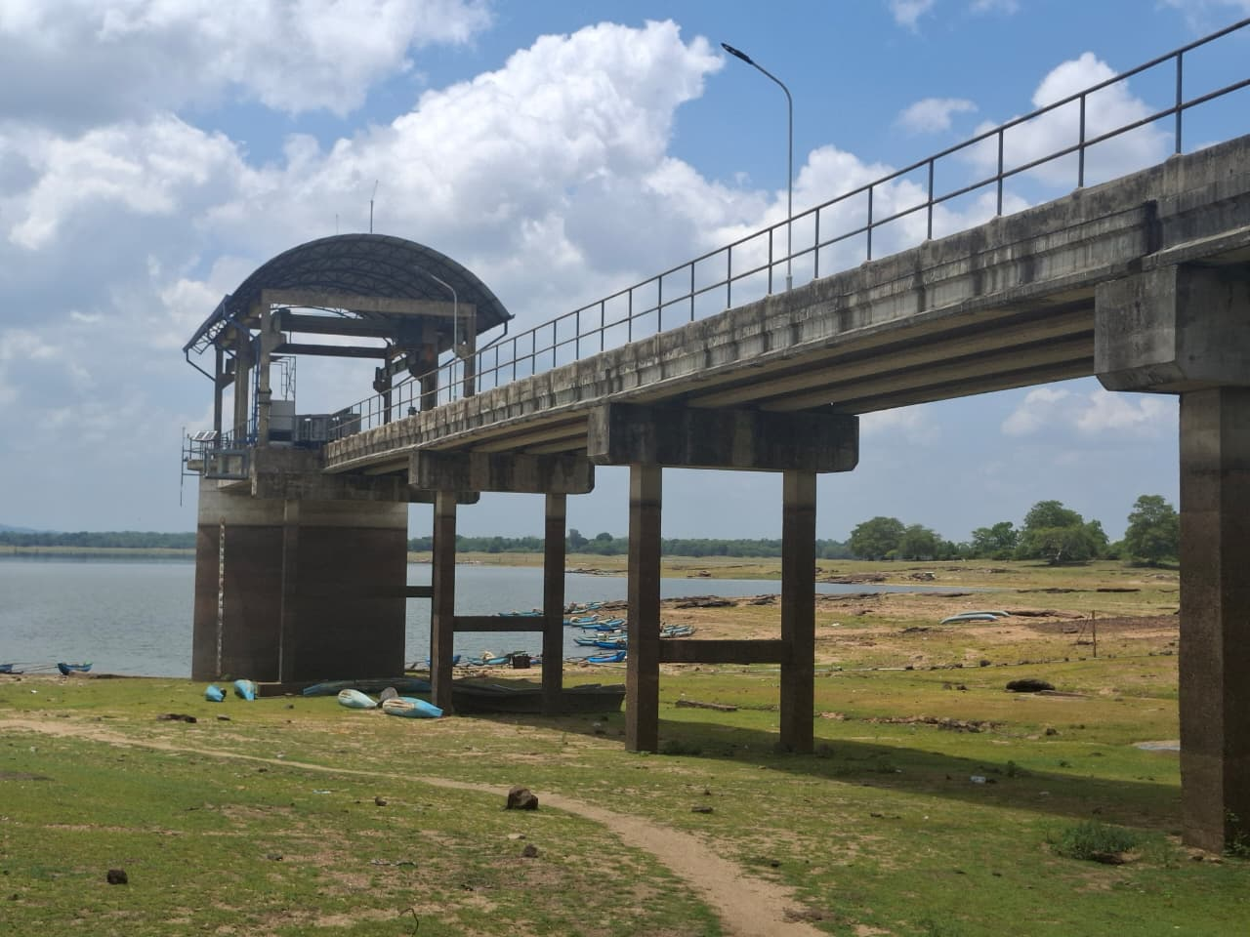
Figure 3.8: NWSDB municipal drinking water intake pumping tower abstracting raw water for the Vavunatheevu treatment plant.
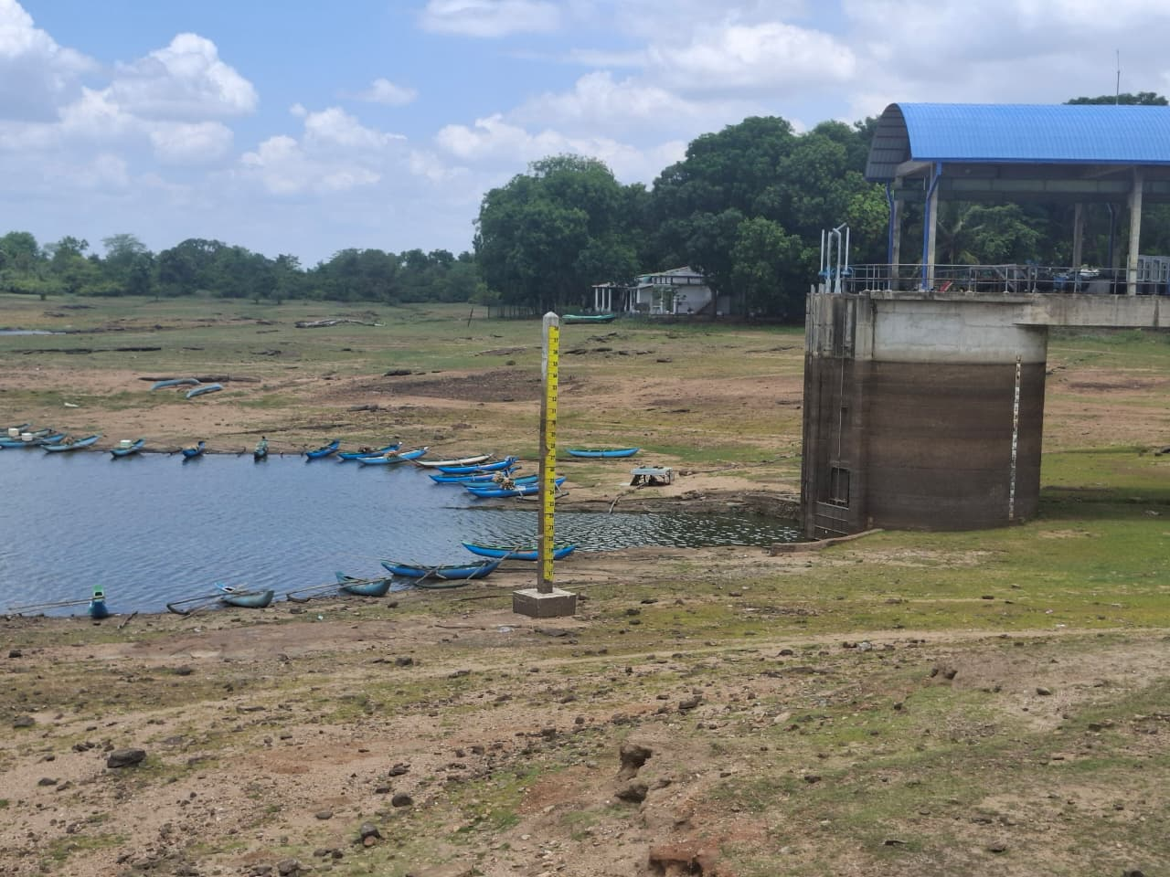
Figure 3.9: Vertical metric staff gauge mounted on the upstream masonry pier face for reservoir water level monitoring.

3.5 Structural Geometry and Headworks Configuration
The headworks impoundment comprises six distinct zoned earthen embankment sections interspersed across natural granitic ridges and rock saddles. The total continuous engineered bund length is 1,889.8 m (6,200 ft), while the composite discontinuous ridge network spans nearly 6.2 km. The embankment has a structural height of approximately 15.2 m (50 ft) above the deepest riverbed excavation, with an upstream slope of 1V:3.0H protected by rock riprap pitching and a downstream slope of 1V:2.0H to 1V:2.5H stabilized with turf and berm drainage toes.
The spillway arrangement is highly specialized and classifies Unnichchai as a 'less-common' hydraulic structure. Rather than relying solely on a conventional straight overflow weir, Unnichchai incorporates an extensive curved ogee weir built along a natural rock saddle, flanked by a three-bay radial gated spillway structure commissioned during the 2009–2011 Asian Development Bank (ADB) augmentation project. The effective crest length of the curved overflow section is approximately L = 120.0 m at Full Supply Level (30.18 m MSL).

3.6 Hydraulic Purpose and Multi-Purpose Operational Functionality
Unnichchai Reservoir performs three critical hydraulic functions in the Eastern Province:
1. Agricultural Irrigation: Supplies regulated irrigation water to a designated command area of 12,757 to 15,389 acres (5,163 to 6,228 hectares) of paddy lands during both Maha and Yala cultivation seasons via dedicated Right Bank and Left Bank main canal sluices.
2. Municipal Potable Water Supply: Delivers a reliable raw water abstraction of 27,000 m³/day (approximately 9.85 MCM/year) to the NWSDB Vavunatheevu Water Treatment Plant, serving over 246,000 urban and rural residents in the greater Batticaloa municipal area.
3. Flood Attenuation: Buffers catastrophic cyclonic runoff from the 274.5 km² Magalavattuwan River basin, routing peak discharges safely over the curved ogee weir and radial gates to prevent downstream inundation of coastal settlements.

3.7 Detailed Description of Major Hydraulic Components
The headworks integrate four distinct hydraulic sub-assemblies:
• Inflow & Approach Section: A wide, unobstructed reservoir forebay leading to streamlined concrete pier bullnoses that guide incoming floodwaters smoothly toward the spillway crests without vortex formation.
• Curved Ogee Weir Section: A concrete and cyclopean masonry overflow weir shaped to match the lower nappe of a ventilated aerated sheet, optimizing discharge efficiency $\left(C_{d}≈2.15{\text{ m}}^{1/2}/\text{s}\right)$while fitting the natural crescent curvature of the rock saddle.
• Radial Gated Spillway Structure: Three bays (each 6.10 m wide x 3.35 m high / 20 ft x 11 ft) controlled by curved structural steel Tainter gates. The gates rotate around heavy horizontal trunnion pins mounted on reinforced concrete piers, operated via overhead electric cable-drum hoists.
• Energy Dissipater (USBR Type III Stilling Basin): A reinforced concrete apron fitted with an upstream row of chute blocks, a staggered row of trapezoidal baffle piers, and a dentated end sill. The baffle blocks force the formation of a stabilized hydraulic jump within a compact apron footprint, dissipating up to 67% of incoming kinetic energy before flow discharges onto the natural rock riverbed.

3.8 Structural Safety and Dam Integrity Assessment
Visual physical examination of Unnichchai Dam confirms satisfactory structural integrity. Specific field observations include:
• Embankment Bund: No evidence of rotational slope sloughing, active tension cracking, or crest subsidence was identified. Due to the low reservoir water level during the visit, no phreatic seepage boils or toe wet spots were visible on the downstream slope.
• Riprap Pitching: Upstream hand-placed granite riprap is well-seated, providing continuous wave-breaking protection without displaced armour stones.
• Concrete Structures: Spillway piers, breastwalls, and chute slabs exhibit sound concrete surfaces without severe carbonation, deep cracking, or exposed reinforcement. Baffle blocks inside the stilling basin remain structurally sound without cavitation pitting.
• Gated Mechanisms: Radial gates are fully seated; rubber music-note seals appear intact; trunnion bearings and hoist cables are well-maintained.

3.9 Environmental Sustainability and River Basin Protection
Unnichchai Reservoir plays an essential role in preserving regional environmental sustainability:
• Groundwater Recharge: Continuous freshwater impoundment maintains an elevated shallow groundwater table across Vavunatheevu and Manmunai West, suppressing coastal saline water intrusion from the Batticaloa Lagoon.
• Riverbed Scour Prevention: The presence of the USBR Type III stilling basin combined with the downstream natural granite rock strata prevents progressive channel bed degradation and headward erosion along the Magalavattuwan River.
• Ecological Habitat: The reservoir perimeter supports diverse freshwater avifauna, fish species, and riparian wetlands, providing critical ecological sanctuary in an arid dry-zone landscape.

3.10 Hydraulic Head Characterization
The principal hydraulic elevations of Unnichchai Dam:
Dam Crest: 33.00 m MSL
MWL / Design Flood Level: 31.50 m MSL
FSL / Spillway Crest: 30.18 m MSL
Sluice Sill: 20.12 m MSL
Stilling Basin Floor: 20.50 m MSL
Downstream Riverbed: 18.00 m MSL
Key hydraulic heads:
Design surcharge head: 1.32 m
Maximum water depth: 10.06 m
Spillway chute fall: 9.68 m

3.11 Spillway Discharge Capacity Estimation
The curved ogee spillway capacity is estimated using the standard weir equation:
$$Q=CLH^{3/2}$$
Where $C$is the discharge coefficient, $L=120.0 m$is the effective crest length, and $H=1.32 m$is the design head.
The calculated spillway discharge capacity is approximately 391.3 m³/s at MWL = 31.50 m MSL.
With the three radial gates fully raised, providing a total gated width of 18.30 m, the supplementary discharge capacity is approximately 280 – 320 m³/s.
Thus, the combined flood discharge capacity is approximately 670 – 710 m³/s, providing adequate capacity for the design flood.

3.12 Stilling Basin Energy Dissipation and Hydraulic Jump Analysis
At the design discharge of 391.3 m³/s, flow descends the 9.68 m chute with a unit discharge of approximately 4.60 m³/s/m over an effective width of 85.0 m.
The resulting supercritical flow has an approximate velocity of 14.5 m/s and Froude number of 8.20, indicating a strong hydraulic jump.
Using the Bélanger conjugate-depth equation, the jump produces subcritical flow with an exit velocity of approximately 1.30 m/s and Fr₂ ≈ 0.22.
The USBR Type III stilling basin dissipates approximately 67.1% of the incoming flow energy, effectively reducing the high-velocity chute flow to a stable downstream condition.

3.13 Downstream Tailwater Open-Channel Conveyance Analysis
The downstream natural rocky channel is assessed using Manning’s equation with a trapezoidal section:
Base width: 28.0 m
Side slope: 1.5H:1V
Manning’s roughness: 0.042
Channel slope: 0.0025
For the design discharge of 391.3 m³/s, the estimated normal tailwater depth is 4.25 m. The corresponding flow area is 146.1 m², giving a mean velocity of approximately 2.68 m/s.
Since the channel consists of resistant granitic/gneissic bedrock, this velocity is considered hydraulically stable with low erosion potential.

3.14 Comparative Literature Benchmark Analysis
Unnichchai Dam was compared against standard engineering benchmarks documented in the United States Bureau of Reclamation (USBR) Design of Small Dams (1987) and Sri Lanka Irrigation Department headworks manuals (e.g., Rajangana Dam Spillway):
Design Feature | Observed Unnichchai Headworks (Site A) | USBR / Literature Benchmark (Design of Small Dams)
Spillway Crest Geometry | Curved ogee overflow weir aligned along natural rock saddle contour (L = 120.0 m). | Conventionally straight ogee weir normal to approach channel flow direction.
Hydraulic Efficiency | Curved alignment significantly increases effective crest length (L) within a confined saddle width. | Straight crest requires wider rock excavation to achieve identical flood discharge capacity.
Energy Dissipater | Standardized USBR Type III stilling basin with chute blocks, baffle piers, and dentated end sill. | USBR Type III recommended for incoming Froude numbers 4.5 < Fr₁ < 9.0; reduces basin length by ~60%.
Downstream Tailwater Transition | Massive natural crystalline granite bedrock terraces and jointed natural rock benches. | Unlined alluvial beds require riprap scour aprons or extensive cutoff walls to prevent undermining.
Flood Regulation | Combined passive ogee overflow weir plus 3 motorized radial (Tainter) flood gates. | Standard dual-spillway strategy: ungated service spillway handles seasonal freshets; gates pass extreme floods.

3.15 Comprehensive Site A Engineering Synthesis
The field and analytical investigation confirms that Unnichchai Dam represents a highly competent, well-maintained Class A major irrigation headworks. The curved ogee weir efficiently exploits natural site topography to maximize discharge capacity (391.3 m³/s) without excessive excavation costs. The USBR Type III stilling basin functions flawlessly with 67.1% energy dissipation efficiency, while the downstream bedrock formation eliminates scour vulnerability.

4. SITE B: DOUBLE SWISS GATE BIFURCATION STRUCTURE (COMMON HYDRAULIC STRUCTURE)

4.1 General and Administrative Details
The Double Swiss Gate Bifurcation Structure located at 40th Village is a classic, ubiquitous open-channel distribution and flow-division regulator commonly deployed across secondary and tertiary irrigation systems in Sri Lanka. The structure receives regulated freshwater discharges from the main branch canal originating from Pulukunawa Reservoir and divides incoming flow between two perpendicular agricultural distribution branches. Administratively, the canal network is overseen by the Department of Irrigation (Batticaloa Region) in collaboration with local Farmer Organizations (FOs / Govi Samithi) responsible for rotational water distribution.

4.2 Geographic Location, GPS Coordinates, and Accessibility
The structure is situated in the Porativu Pattu (Vellavely) Divisional Secretariat Division, near Mandur 40th Village. Surrounding terrain comprises extensive paddy cultivation tracts interspersed with coconut homesteads.
Precise GPS Coordinates: Latitude 7°32'30.8"N, Longitude 81°40'03.9"E (7.54189° N, 81.66775° E). The facility is accessible via the Mandur–Vellavely local agrarian road, which crosses directly over the structure's upstream intake culvert.

4.3 Location and Feeder Canal Maps
The feeder canal originates at Pulukunawa Reservoir (Coordinates: 7.53467° N, 81.62503° E), located 4.74 km west-southwest of Site B. Water is conveyed along an unlined trapezoidal main canal before reaching the bifurcation chamber at 40th Village. Google satellite imagery and 1:50,000 topographic maps clearly delineate the canal alignment, road culvert crossing, and the diverging branch canals heading southward and eastward into the Vammiyadiyuttu agrarian command area.
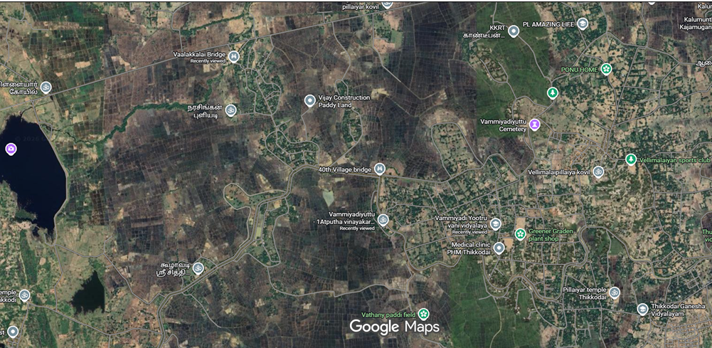

4.4 Dimensioned Engineering Sketches and Physical Measurements
Field measurements and structural geometry were recorded on dimensioned engineering sketches (Sketch B.1 and Sketch B.2 in the project repository are identical projections; Sketch B.1 is reproduced below as the master drawing):
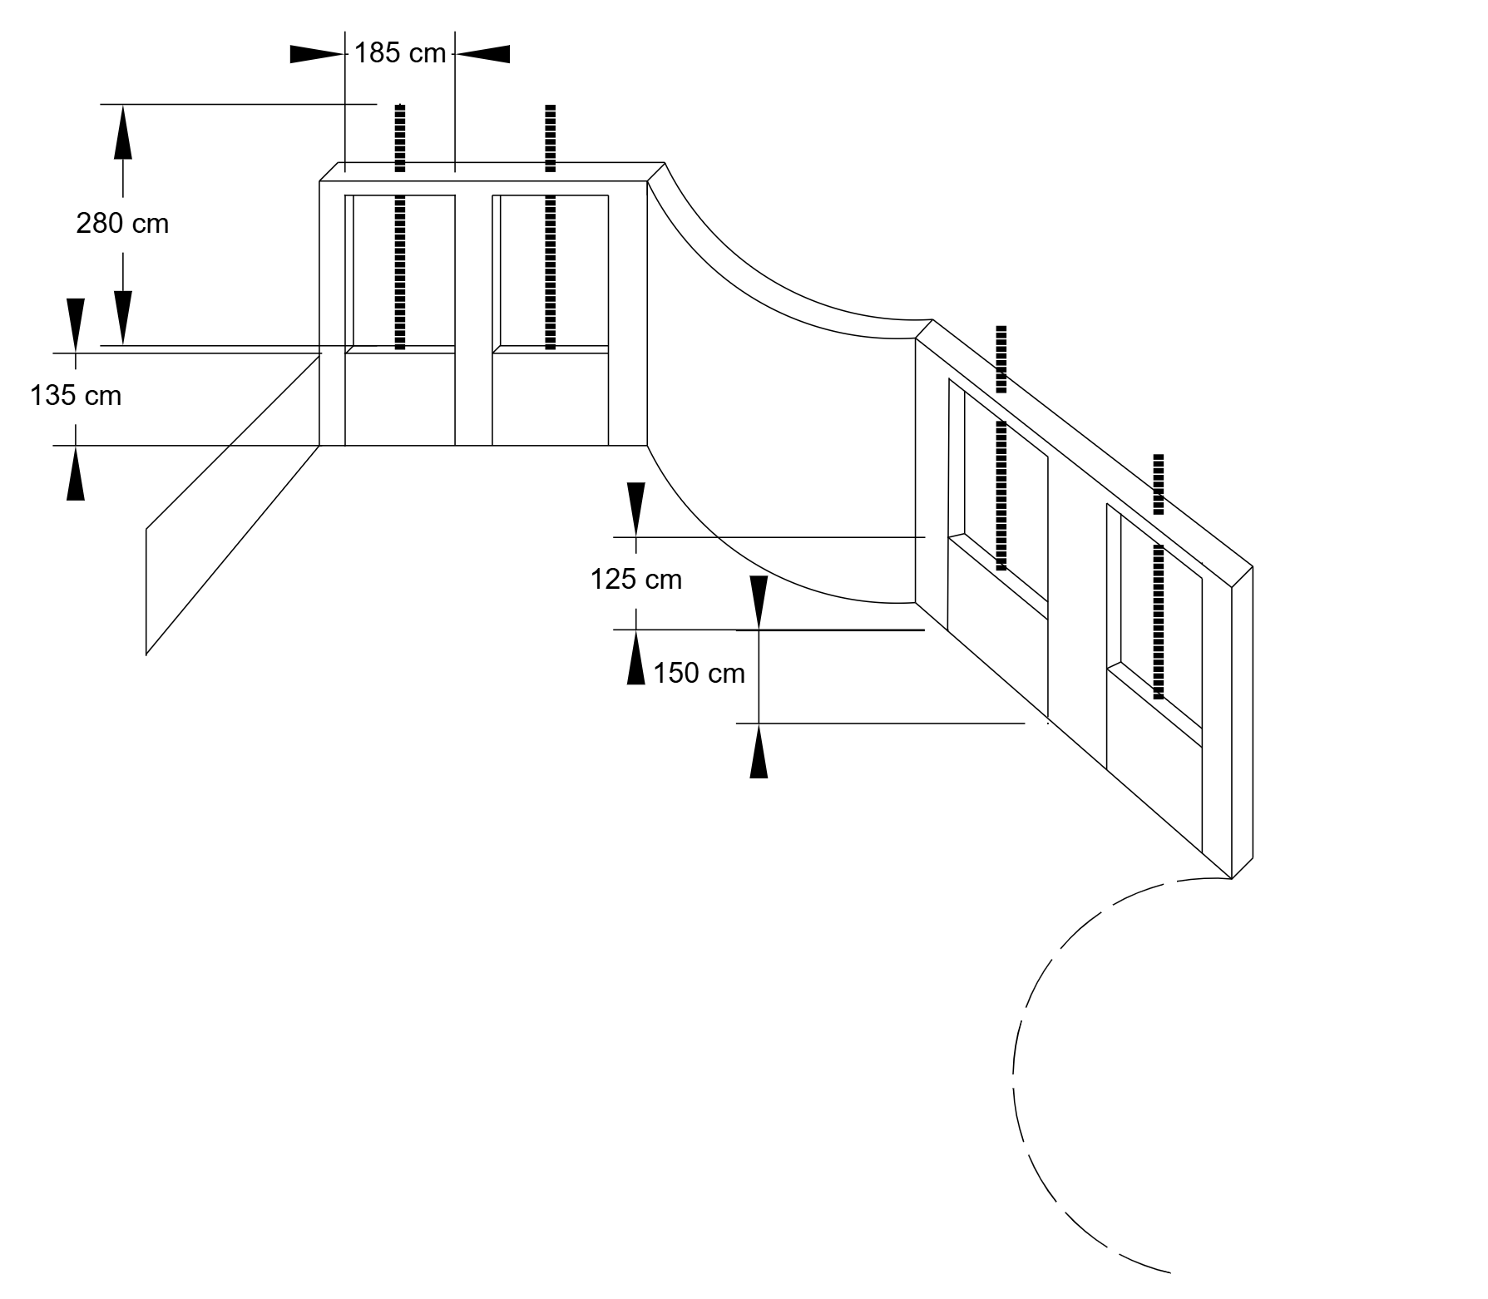
Figure 4.1: Master dimensioned 3D axonometric engineering sketch of the Double Swiss Gate Bifurcation Structure showing left and right twin gate bays, curved transition wing wall, and structural dimensions (Sketch B.1).
Structural Geometry and Downstream Canal Parameters
The main gate structures consist of two bays on each branch. The left branch has 1.85 m clear gate openings, a 2.80 m headwall height, and a 1.35 m gate opening height, with a central pier of approximately 0.40 m. The total sill aperture width is therefore 4.10 m.
The right branch has 1.25 m gate openings with a 1.50 m sill height. A curved transition wing wall provides smooth flow guidance between the perpendicular structures.
The downstream unlined earthen canal is represented using estimated engineering parameters:
Bottom width: 3.00 m
Side slope: 1.25H:1V
Bank height: 1.70 m
Bed slope: 0.0008 (1 in 1,250)
Representative flow depth: 1.10 m
Manning’s roughness: 0.030
These canal parameters are engineering estimates based on available evidence, as continuous field-survey leveling was not available.

4.5 Field Photographic Documentation and Inspection Evidence
Photographic evidence collected during the 03 October 2026 inspection is presented below with unified technical observations:
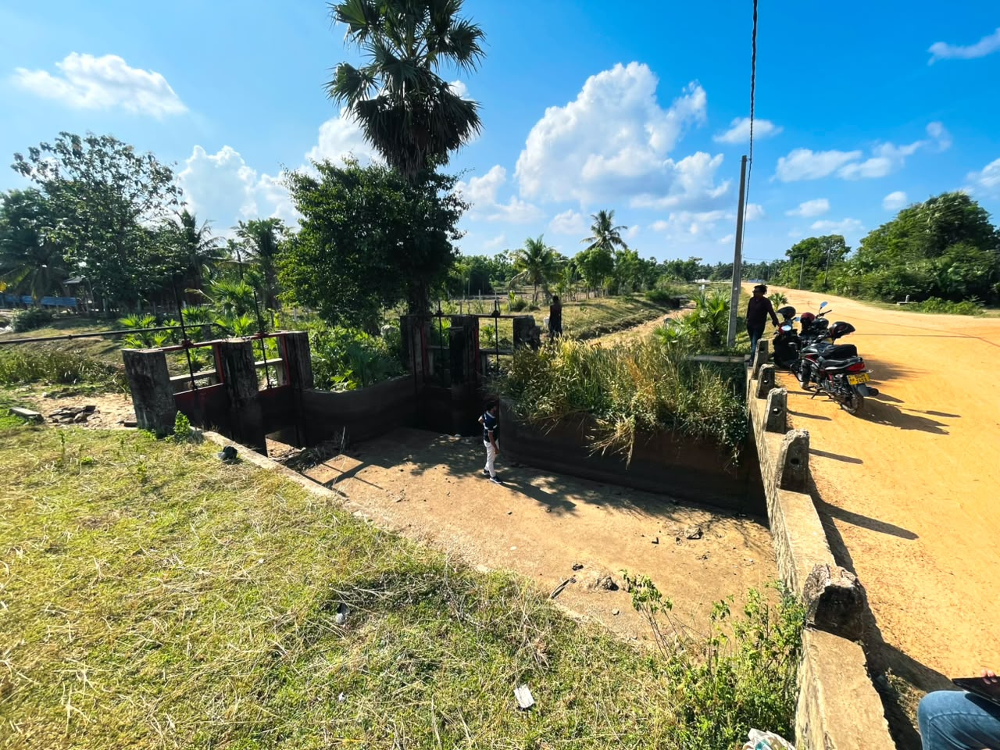
Figure 4.2: Upstream approach channel and concrete road culvert conveying water from the Pulukunawa feeder canal into the distribution chamber.
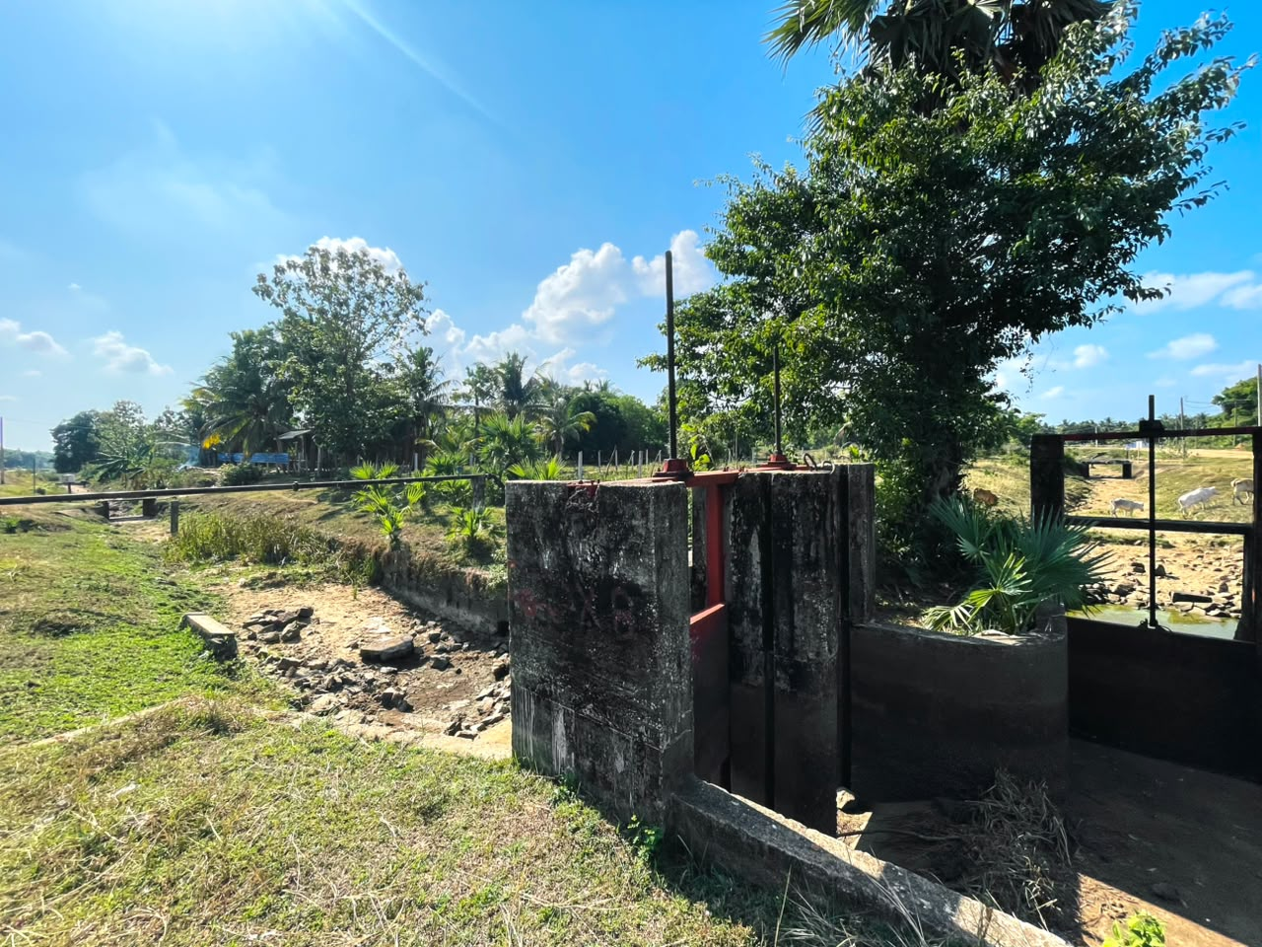
Figure 4.3: Downstream left branch delivery canal viewed from the gate headwall, showing immediate stone-pitched riprap apron transitioning into an unlined trapezoidal earthen canal.
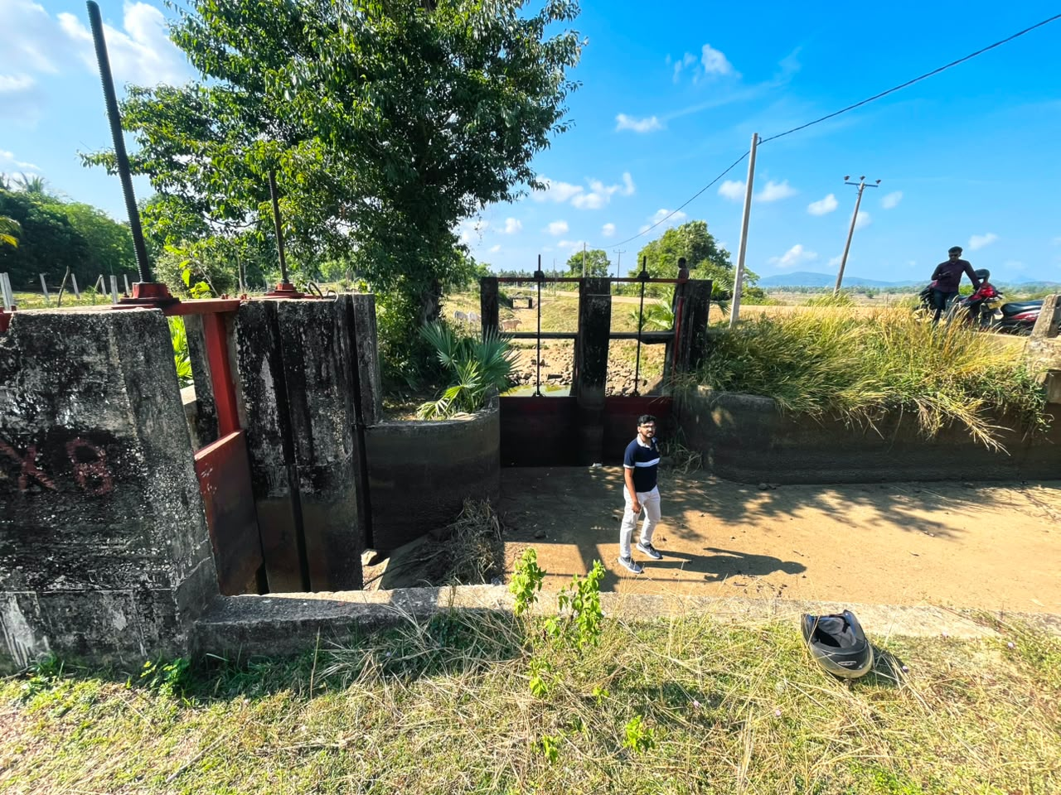
Figure 4.4: Upstream face of the twin vertical slide Swiss gates showing threaded steel spindle stems, guide grooves, and manual handwheels.
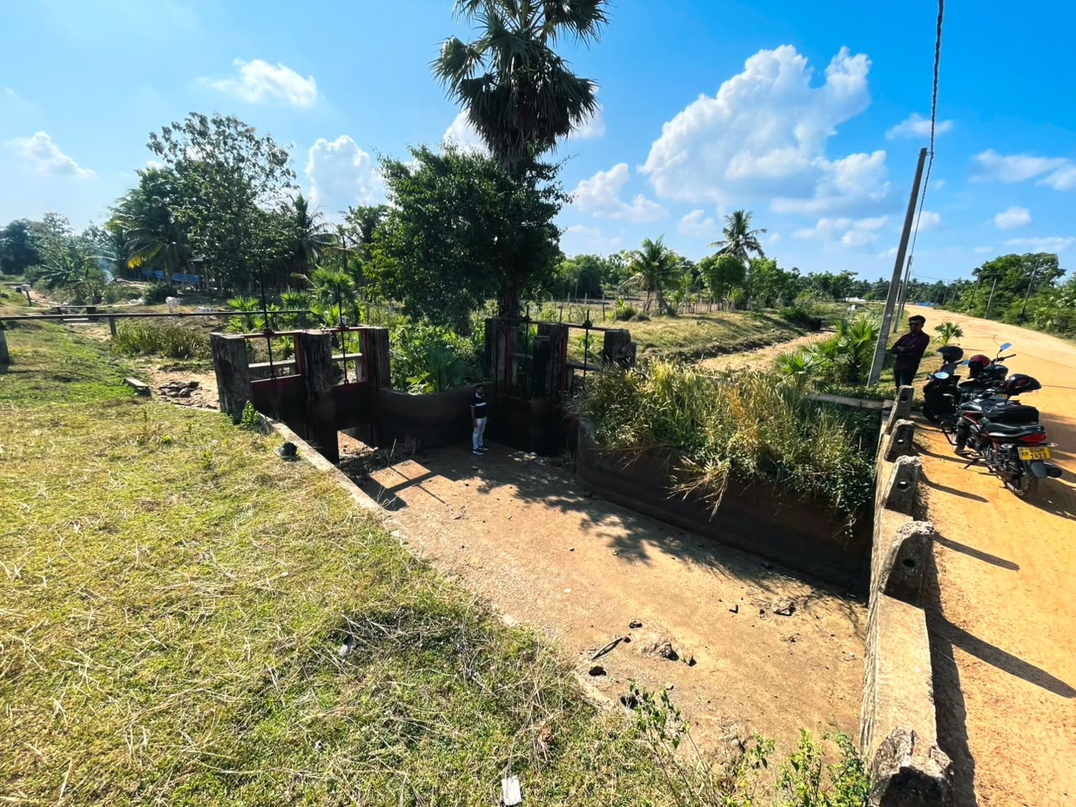
Figure 4.5: Macro overview of the bifurcation distribution chamber showing concrete floor slab, curved wing wall.
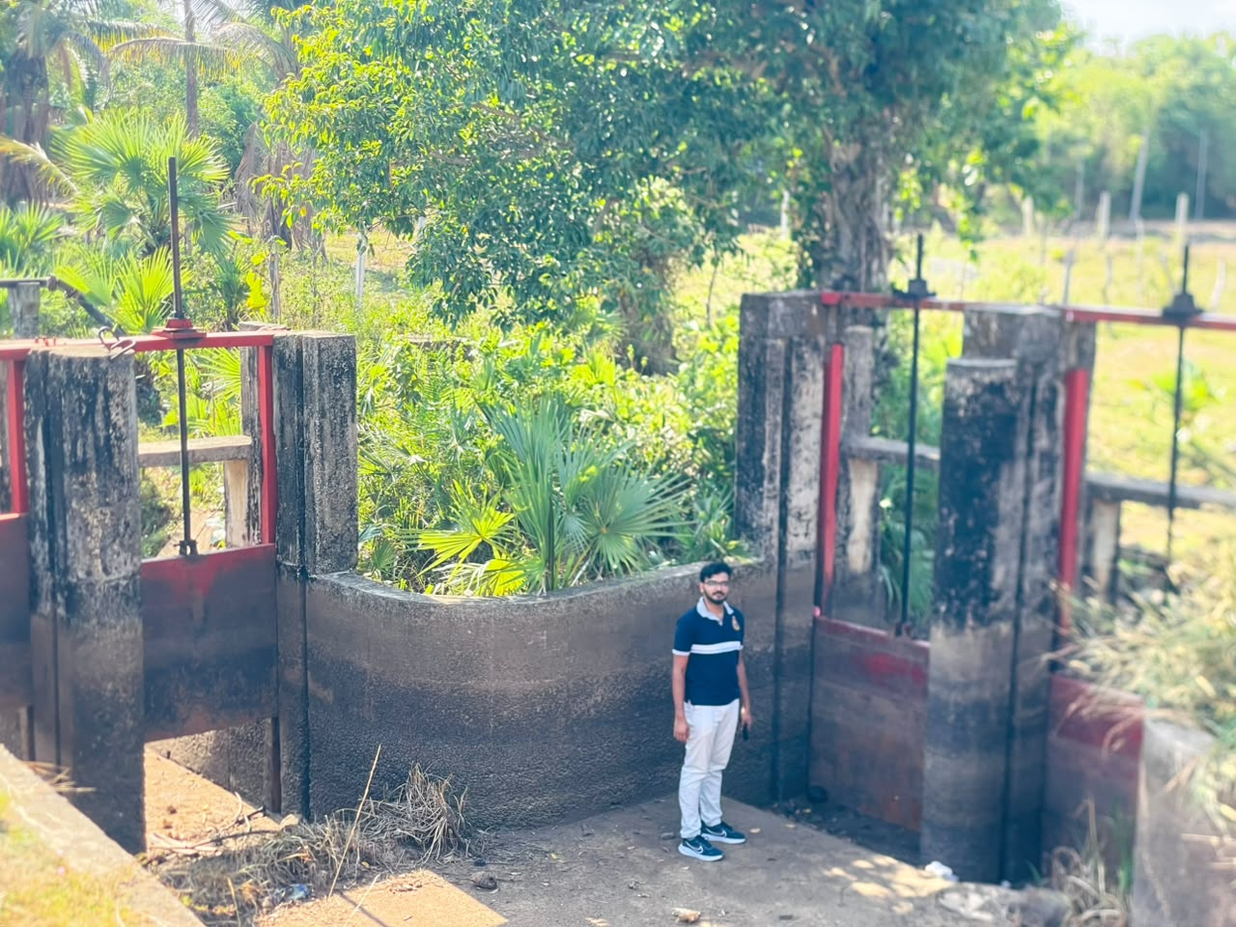
Figure 4.6: Downstream branch canal traversing agricultural paddy lands, showing embankment side slopes and seasonal vegetative cover.

4.6 Hydraulic Purpose, Flow Division, and Irrigation Functionality
The Double Swiss Gate structure functions as an adjustable division junction and flow regulator. Rather than permitting uncontrolled bulk flow into a single channel, the structure provides two independent degrees of freedom:
1. Proportional Flow Division: Regulates the volumetric division of water between the southern and eastern branch channels serving distinct farmer tracts in Vammiyadiyuttu.
2. Water Level Regulation: Backing up water in the upstream chamber when gates are partially lowered, ensuring adequate operating head to feed secondary field turnouts.

4.7 Major Structural and Mechanical Components
The structure comprises five primary engineering elements:
• Inflow Culvert & Approach: Reinforced concrete slab culvert under the agrarian roadway directing flow into the chamber.
• Distribution Chamber: Square-to-L-shaped concrete floor slab bounded by concrete walls and a curved transition wing wall.
• Regulating Slide Gates: Flat structural steel slide plates operating in cast-iron/steel vertical guide slots.
• Mechanical Lifting Assembly: Rising Acme-threaded steel spindles engaged by brass internal thrust nuts housed within top cast-iron circular handwheels.
• Energy Dissipation Apron: Hand-packed stone riprap pitching laid on the downstream canal bed immediately below the sill.

4.8 Structural Safety, Integrity, and Maintenance Assessment
Physical field inspection confirmed that the structure is in good serviceable condition:
• Mechanical Systems: Threaded screw spindles were inspected and found to be freely movable, functional, and lubricated with grease. No severe rust binding or stripped threads were detected.
• Civil Works: No major structural cracking, differential settlement, or foundation tilting was observed on the concrete headwalls, wing walls, or chamber floor slab.
• Gate Seals: Steel leaves seat flush against the bottom concrete sills; minor seepage along lateral guides during operation is normal for un-machined slide gates.

4.9 Environmental Sustainability and Canal Bank Protection
The unlined downstream branch canal is well-integrated with the agricultural landscape. The presence of stone pitching on the bed and lower bank slopes immediately below the gate sills prevents localized scour holes and undercutting. Canal banks exhibit established grass turf that stabilizes cohesive soil against rainwash. Regular pre-seasonal maintenance is required to clear excessive weed and shrub growth that elevates hydraulic roughness.

4.10 Hydraulic Head Difference and Operating Regimes
Because the canal was completely dry on 03 October 2026, operating head difference (ΔH) was evaluated analytically. Under representative full-supply delivery, normal water depth in the upstream approach chamber is approximately 1.20 to 1.40 m, while downstream branch canal depth is 1.10 m, yielding an operating head loss across the gates of only ΔH ≈ 0.05 to 0.15 m under open gate conditions.

4.11 Downstream Canal Hydraulic Conveyance Analysis
The downstream left-branch canal capacity was evaluated using Manning’s equation for steady uniform flow.
For the representative condition of y = 1.10 m, b = 3.00 m, z = 1.25, n = 0.030, and S₀ = 0.0008:
Flow area: 4.81 m²
Hydraulic radius: 0.738 m
Conveyance capacity: 3.71 m³/s
Mean velocity: 0.77 m/s
Froude number: 0.269, indicating subcritical flow
Freeboard: 0.60 m
Flow-Depth Scenarios
Condition | Depth (m) | Capacity (m³/s) | Velocity (m/s) | Freeboard
Low Supply | 0.60 | 1.26 | 0.56 | 1.10 m
Representative | 1.10 | 3.71 | 0.77 | 0.60 m
Bankfull | 1.70 | 8.39 | 0.96 | 0.00 m
The 8.39 m³/s bankfull discharge is a theoretical maximum and should not be considered a safe operating capacity.
Sensitivity analysis indicates that the estimated capacity varies approximately between 2.62 – 4.90 m³/s with changes in bed slope, 3.18 – 4.12 m³/s with Manning’s roughness, and 2.96 – 4.44 m³/s for the investigated geometric range.

4.12 Gate-to-Channel Flow Capacity Cross-Check
As an auxiliary check, the twin Swiss slide gates were assessed against the primary canal discharge of 3.71 m³/s.
The total clear gate opening is:
Gate area: 4.995 m²
Gate velocity: 0.74 m/s
Canal velocity: 0.77 m/s
Estimated velocity head loss: 0.028 m
The close agreement between gate and canal velocities indicates that, under full gate opening, the twin gates do not significantly restrict the canal’s primary conveyance capacity.

4.13 Comparative Literature Benchmark Analysis
Site B was benchmarked against the United Nations Food and Agriculture Organization (FAO) Irrigation and Drainage Paper No. 26/2 (Small Hydraulic Structures: Division Boxes and Bifurcators) and Sri Lanka Mahaweli Engineering Standards:
Design Feature | Observed 40th Village Bifurcation (Site B) | FAO / Literature Benchmark (Irrigation Paper 26/2)
Flow Division Principle | L-shaped division box with twin vertical Swiss gates on perpendicular faces. | Proportional weir dividing boxes or gated inline division junctions.
Gate Type & Regulation | Vertical structural steel slide plates with manual rising threaded spindles. | Standard screw-stem slide gates or wooden flashboards with drop-in slots.
Energy Dissipation | Downstream hand-packed stone riprap pitching on bed and lower banks. | Riprap pitching or drop basin required downstream of sluice openings to halt scour.
Canal Geometry | Trapezoidal unlined earthen canal with 1.25H:1V side slopes and turf banks. | Standard unlined branch canal in cohesive soil: b/y ratio 2.0 to 3.5, side slope 1.5:1.
Operational Control | Farmer Organization manual spindle adjustment based on rotational schedules. | Standard participatory irrigation management (PIM) operational protocol.

4.14 Comprehensive Site B Engineering Synthesis
The 40th Village Double Swiss Gate Bifurcation is an effective, robust, and cost-effective open-channel distribution node. Manning's analysis establishes a representative full-supply delivery capacity of Q ≈ 3.71 m³/s under safe non-scouring velocity (0.77 m/s) with 0.60 m of freeboard. Spindles are properly maintained, and riprap aprons adequately arrest scour.

5. DISCUSSION AND SYNTHESIS

5.1 Comparative Synthesis of Hydraulic Mechanisms
- Site A – Unnichchai Headworks: Primarily functions for flood evacuation and energy dissipation, converting high potential energy into high-velocity flow and dissipating it through a hydraulic jump.
- Site B – 40th Village Bifurcation: Functions as a low-head flow distribution structure, maintaining relatively low velocities for stable open-channel conveyance.

5.2 Key Learning Outcomes
- Understanding the difference between weir overflow $\left(Q∝H^{3/2}\right)$and orifice flow $\left(Q∝H^{1/2}\right)$.
- Observing the role of USBR Type III stilling basins in hydraulic energy dissipation.
- Understanding how canal roughness and vegetation affect conveyance capacity.

5.3 Fieldwork Challenges and Data Uncertainty
The dry canal and low reservoir levels on 03 October 2026 limited direct discharge measurements. Therefore, observed conditions $\left(Q_{obs}=0\right)$were kept separate from theoretical hydraulic capacities, with sensitivity analyses used to account for uncertainty.

5.4 Structural and Durability Observations
No visible evidence of piping, embankment settlement, or seepage boils was observed. Concrete surfaces and gate components appeared generally well maintained.

5.5 Recommended Dead Storage
The proposed 3.08 MCM dead storage provides sediment-trapping capacity while preserving the available live irrigation storage.

5.6 Spillway and Flood Safety
The spillway and gated outlets should provide adequate capacity for the adopted design flood, with the Inflow Design Flood (IDF) checked separately in accordance with applicable dam-safety requirements.

5.7 Embankment Freeboard
The 1.50 m freeboard above MWL provides protection against overtopping, subject to verification of wind setup, wave run-up, and the adopted design flood level.

5.8 Gate Maintenance
Swiss slide gates should receive regular lubrication, corrosion protection, inspection of gate stems and guides, and removal of debris.

5.9 Embankment Protection
Upstream riprap pitching should be regularly inspected and maintained to minimize wave erosion and stone displacement.

5.10 Canal Bifurcation
Stone pitching and downstream transitions should be periodically inspected to maintain stable flow conditions and prevent local erosion.

5.11 Environmental, Health and Safety
Guardrails, safety barriers, and warning signs should be provided around spillway operating areas and distribution structures to reduce public and operational safety risks.

5.12 Recommendations
- Install an ADCP gauging station downstream of Site B to establish reliable flow measurements and calibrate Manning’s roughness.
- Conduct regular desilting and vegetation clearance along the Vammiyadiyuttu branch canal.
- Install protective handrails around the 40th Village bifurcation chamber.

6. CONCLUSIONS

6.1 Achievement of Course Objectives
The CE4023 field study was successfully completed in accordance with the course requirements. Two freshwater hydraulic structures in Batticaloa District were inspected, documented photographically, dimensionally assessed, and hydraulically evaluated.

6.2 Summary of Hydraulic Capacities and Safe Limits
Parameter | Site A:  Unnichchai dam | Site B:  40th Village Double Swiss Gate
Primary Structure | Curved ogee spillway & USBR Type III basin | Twin Swiss slide gates & trapezoidal canal
Hydraulic Head | 10.06 m operating depth; 1.32 m surcharge | Low-head gate-controlled flow
Design Capacity | 391.3 m³/s; combined ≈ 700 m³/s | 3.71 m³/s representative conveyance
Safe Operating Limit | MWL = 31.50 m MSL; 1.50 m freeboard | Flow depth ≤ 1.10 m; 0.60 m freeboard
Flow Regime | Hydraulic jump, Fr₁ = 8.20 | Subcritical flow, Fr ≈ 0.27
Energy Dissipation | USBR Type III basin; η ≈ 67.1% | Stable open-channel conveyance

6.3 Concluding Remarks
The analyses indicate that both structures perform their respective hydraulic functions effectively. Unnichchai Headworks provides flood evacuation and energy dissipation, while the 40th Village Double Swiss Gate regulates and distributes irrigation flow to the downstream canal system.
The study integrates field observations, hydraulic calculations, sensitivity analysis, and structural assessment, providing a practical application of undergraduate Civil Engineering principles to real hydraulic infrastructure.

7. REFERENCES
Acker, P., Kraatz, D.B. and Mahajan, I.K. (1975) Small Hydraulic Structures: Irrigation and Drainage Paper No. 26/2. Rome: Food and Agriculture Organization of the United Nations (FAO).
Arumugam, S. (1969) Water Resources of Ceylon: Its Development and Utilization. Colombo: Water Resources Board of Ceylon, pp. 186–189.
Asian Development Bank (ADB) (2012) Completion Report: Secondary Towns and Rural Community-Based Water Supply and Sanitation Project (Loan 1993-SRI). Manila: Asian Development Bank.
Chow, V.T. (1959) Open-Channel Hydraulics. New York: McGraw-Hill Book Company.
Department of Irrigation, Sri Lanka (2022) Administration Report of the Director General of Irrigation for the Year 2022, Part II. Colombo: Department of Irrigation.
Department of Irrigation, Sri Lanka (2023) Scheme Data: Unnichchai Scheme and Pulukunawa Scheme. Batticaloa: Regional Director’s Office, Irrigation Department.
French, R.H. (1985) Open-Channel Hydraulics. New York: McGraw-Hill Book Company.
Kamaladasa, B. (2024) Irrigation Heritage of Sri Lanka: Ancient and Colonial Headworks Engineering. Colombo: Irrigation Department Alumni Publications.
Peterka, A.J. (1984) Hydraulic Design of Stilling Basins and Energy Dissipators. Engineering Monograph No. 25. Denver, Colorado: United States Bureau of Reclamation (USBR).
Ponnrajah, A.J.P. (1984) Design of Irrigation Headworks for Small Catchments. 2nd edn. Colombo: Irrigation Department of Sri Lanka.
Survey Department of Sri Lanka (2015) National Topographic Map Series (1:50,000): Sheet J/10 (Batticaloa). Colombo: Survey Department of Sri Lanka.
United States Bureau of Reclamation (USBR) (1974) Design of Small Canal Structures. Denver, Colorado: United States Department of the Interior.
United States Bureau of Reclamation (USBR) (1987) Design of Small Dams. 3rd edn. Washington, D.C.: United States Government Printing Office.

