**A COMPARATIVE STUDY ON FACIAL RECOGNITION BETWEEN**

**CONVOLUTIONAL NEURAL NETWORK AND RECURRENT NEURAL NETWORK PERFORMANCE**

**JASPER RICAMORA SUNGA**

PRESENTED TO THE FACULTY OF THE INSTITUTE OF COMPUTER SCIENCE,

UNIVERSITY OF THE PHILIPINES LOS BAÑOS

IN PARTIAL FULFILLMENT

FOR THE DEGREE OF

**BACHELOR OF SCIENCE IN COMPUTER SCIENCE**

**June 2020**

The Faculty of the Institute of Computer Science

of the University of the Philippines Los Baños

accepts the Special Problem entitled

**A COMPARATIVE STUDY ON FACIAL RECOGNITION BETWEEN**

**CONVOLUTIONAL NEURAL NETWORK AND RECURRENT NEURAL NETWORK PERFORMANCE**

**JASPER RICAMORA SUNGA**

In partial fulfillment of the requirements for the

Degree Bachelor of Science in Computer Science

**______________________________________**  
**Prof. VAL RANDOLF M. MADRID**  
Adviser

**______________________________________**  
Date Signed

**______________________________________**  
**Prof.** **JADERICK P. PABICO**  
Director, Institute of Computer Science

**______________________________________**  
Date Signed

**A COMPARATIVE STUDY ON FACIAL RECOGNITION BETWEEN**

**CONVOLUTIONAL NEURAL NETWORK AND RECURRENT NEURAL NETWORK PERFORMANCE**

**ABSTRACT**

**SUNGA, JASPER RICAMORA.** 2020. A Comparative Study on Facial Recognition between Convolutional Neural Network and Recurrent Neural Network Performance. University of the Philippines Los Baños, College of Arts and Sciences, Institute of Computer Science.

This study compares two types of neural networks, specifically, Convolutional Neural Network (CNN) and Recurrent Neural Network (RNN), in its simplest form to record the attendance of students using face recognition given that there are no pre-existing models and dataset that can be used during the first day of classes. The study shows that both CNN and RNN models provided insufficient accuracy rate in the test results. The study also shows that the RNN model is not feasible and is outperformed by the CNN model. The CNN model provided at most 70% accuracy rate which is insufficient for attendance checking.

**BIOGRAPHICAL SKETCH**



Jasper R. Sunga, also known as Hasper, is the youngest of the two children of Renato V. Sunga and Milagros R. Sunga. He took his elementary education at Mariano Marcos State University Laboratory Elementary School, secondary at Philippine Science High School – Ilocos Region Campus. He is currently on his fifth year of a four-year degree Bachelor of Science in Computer Science at the University of the Philippines Los Baños. His hobbies are playing video games with his friends, binge watching anime and TV series, watching tech videos, and watching streamers play video games.

Hasper is a member of the UPLB SIGMA RHO FRATERNITY and the Alliance of Computer Science Students – UPLB. He has participated in a lot of activities in his previous organizations however and has improved his skills on various extra-curricular activities. As a student activist, he continues to pursue a society that is one with the masses and gives a just and lasting peace for the people. This goal he pursues has led him into participating various political activities such as mobilizations, dialogues, and student council participation. Thus, he is the chairperson of the UPLB University Student Council for the academic year 2019-2020.

**ACKNOWLEDGEMENT**

First and foremost, I would like to thank my family, Renato V. Sunga, Milagros R. Sunga, and Jeoffrey R. Sunga, for giving me utmost support especially during my university life despite being against the idea of going far away from our home. I know we have our differences on how I should live my university life but here we are on my last journey as an undergraduate. This is for you.

I would also like to thank my cats Bloo, Ice, Dwight, Pechay, Rengar, Xandy, and Andromeda, for keeping me company and helping me relieve stress. Also, to my girlfriend, Sheryl B. Castillo, thank you for always being there through ups and downs. All of you have been my second family during the last years of my course and I would not want any other second family to support me.

To my *orgmates* and *brods* from the Alliance of Computer Science Students – UPLB and the UPLB SIGMA RHO FRATERNITY, thank you for always supporting me on my endeavors.

To my friends from *Zark Memes*, thank you for playing with me all the time and sometimes being the phantom sixth man, for sharing nonsense memes, and for sharing different stories and still manage to laugh them all out. I hope we all reach our goals and still be friends sharing the same old nonsense memes and will soon find different games that we will play.

To all the instructors and professors, thank you for the continuous service of teaching us *Iskolar ng Bayan* not just in our academics but also in realizing what lies beyond the four corners of a classroom. Moreover, I would also like to thank my adviser, Val Randolf M. Madrid, for teaching me the importance of my academics and for the dedication on guiding me throughout this study.

Finally, I dedicate all my work to the masses who inspire me in pursuing this course. I will continue to serve the people and inspire the younger generations to do the same.

**TABLE OF CONTENTS**

**BIOGRAPHICAL SKETCH iv**

**ACKNOWLEDGEMENT v**

**INTRODUCTION 1**

1. Background of the Study  **1**
2. Statement of the Problem **2**
3. Significance of the Study **2**
4. Objectives **3**
5. Scope and Limitations of the Study **3**

**REVIEW OF RELATED LITERATURE 3**

**MATERIALS AND METHODS 4**

1. Overview **4**
2. Conduct of Study **5**
3. Flowchart **6**
4. Analysis of Results **9**

**RESULTS AND DISCUSSION 9**

1. Selection of Class **9**
2. Data Privacy Agreement **9**
3. Loading Dataset **10**
4. Training Datasets  **10**
5. Testing Neural Network Models  **12**
6. Analysis of Results  **14**
7. Out of Class Pictures **15**
8. Overall Feasibility **17**

**CONCLUSION 18**

1. Data Collection **18**
2. CNN and RNN Training **18**
3. Testing Results **18**
4. Attendance Checking  **19**
5. Overall Performance **19**

**RECOMMENDATION 19**

1. Data Collection **19**
2. Neural Network Model **19**

**REFERENCES 21**

**APPENDIX 22**

1. **INTRODUCTION**
2. **Background of the Study**

Classes within schools or universities have attendances of students monitored. It is important that the attendance is monitored as it together with peer effect has a direct correlation to academic performance [1]. Furthermore, the performance of students in their academics shows that low performing students are affected by absenteeism compared to high performing students [2]. The traditional methods of monitoring the attendance are roll call, and manual checking of designated seats. These methods of checking the attendance consumes a significant amount of time which results to lesser lecture times.

Alternative ways in checking the attendance that aims to solve the issue of the traditional methods include the use of fingerprint-based biometrics systems and radio frequency identification system or RFID. A fingerprint-based biometrics system is a commercially available system. It reads the employee’s fingerprint and records the fingerprint for the identification of the said employee. Improvements on the system, specifically using the optimized 5/3 DWT architecture and CORDIC Based FFT which are used for scanning and comparing images, were found to make the system more accurate [3]. RFID systems use tags or contact pads that has the information of an employee attached. The RFIDbased attendance system made by Al-Naima and Ameen for Al-Nahrain University improved the traditional recording of attendance, roll call, as it takes into consideration the time, reliability, efficiency and ease of control to make the system [4]. Presented to the Faculty of the Institute of Computer Science, University of the Philippines Los Banos in partial fulfillment of the requirements for the ˜ Degree of Bachelor of Science in Computer Science The fingerprint biometrics system and the radio frequency identification (RFID) systems are already established but the cost of the mentioned systems should still be considered. In 2017, the cheapest USB fingerprint scanner costs $50.00 or around PhP 2500.00 [5]. Currently, the minimum cost of a fingerprint biometrics system’s hardware is still at around PhP 1500.00 on online stores. Depending on its capabilities and speed, RFID systems can be expensive from equipment cost to licensing cost. Passive RFID systems will cost you at least $1000.00 or PhP50000.00 for the reader and $.10 or PhP5.00 for the tag while active RFID systems will cost you at most 10 times less for the system compared to the passive system but will cost you at least $5.00 or around PhP250.00 for the tags [6].

With the advancement of image processing in computer science, face recognition can now be achieved in any computers and smartphones. Edge detection and feature extraction methods had become a way to achieve face recognition. The different methods can achieve accurate results with any given environments surrounding the face and angles of the camera [7]. With the advancement of face recognition and the right combinations of filters, edge detection algorithms, and features extraction methods, a system that will monitor the attendance of students in a class can be done.

1. **Statement of the Problem**

The traditional method of checking attendance consumes a significant amount of time given that the average duration of a class is one hour and thirty minutes. With the advancement of technology, face recognition can be used to check the attendance of a class. However, initial data of classes is usually required to be inputted first before face recognition methods can be used. Thus, possible data privacy issues may arise for some students.

1. **Significance of the Study**

The study seeks to solve the problem in finding the most efficient neural network architecture in using face recognition for attendance checking in classes. It also seeks to solve the problem of not having a global database of students’ faces because of privacy concerns at the same time generating a face recognition neural network model with limited amount of data given at a time.

1. **Objectives**

The general objective of this study is to compare the performance of convolutional neural network and recurrent neural network in the application of having limited data set given. The specific objectives are the following:

1. secure a data privacy agreement for a classroom;
2. create face data sets using face detection libraries given a classroom image;
3. design respective neural network models that will learn from the per meeting data set;
4. evaluate the accuracy of the models using a data set from the following meeting;
5. repeat all procedures until the end of the semester; and
6. evaluate the overall performance of the model
7. **Scope and Limitations of the Study**

The study will be conducted in a selected classroom during the second semester of the academic year 2019-2020 in University of the Philippines - Los Baños. The expected number of students to be tested will be at least five. The distance of the students from the camera that will be used will be dependent on the built-in face detection algorithm the camera is using.

1. **REVIEW OF RELATED LITERATURE**

There are many researches on the usage of the integration of neural networks for face recognition, but there is no study yet on the comparison on the speed and accuracy of convolutional neural network and recurrent neural network for the usage of face recognition in attendance checking.

Students from Ankara University have developed a mobile system that records the attendance of students in their smartphones via face recognition [8]. The system uses the smartphones of its users and the face recognition process was also done using the smartphone. Eigenfaces, Fisherfaces, and Local Binary Pattern were used to develop an algorithm that will recognize the faces of the students. Results showed that the mobile system satisfies the needs of teachers, students, and parents in tracking the attendances.

Convolutional neural networks (CNN) consists of convolutional layers that contains different types of filters that will detect features from an object resulting in recognition of patterns and recognition of the object itself. In 2018, a study on face recognition via convolutional neural network on videos resolved the problem of severe image blurring, dramatic poses, and occlusion [9]. The study proposed a framework of convolutional neural network that will be fed still images and artificially blurred image to make the framework learn blurred insensitive images quickly. The framework was later called “Trunk-Branch Ensemble - Convolutional Neural Network” as it solves dramatic poses and occlusion by sharing the mid and lower convolutional layers between the trunk and branch networks. In 2016, a joint convolutional neural network architecture was made to recognize the face and age of detected faces [10]. The architecture is called FDAR-Net or Face Detection and Attribute Recognition Network. The architecture combines three convolutional neural networks of feature-based recognition, specifically face detection, gender detection, and age detection. It detects all candidates of a face in a given image and determining every candidate if it is a face window or not. With 20 stages and a total of 26,000 face and non-face samples, the accuracy of FDAR-Net is 92.5% for the gender recognition and 95.4% for the age recognition with a margin of error of a year old.

Recurrent Neural Network (RNN) connects all nodes to one another and forming one direction. RNN is widely used in speech recognition and natural language processing however, in 2016, a recurrent neural network based architecture named Elman Levenberg Recurrent Neural Network was used together with a 3D Gray-Level Concurrent Matrix (GLCM) was used to achieve face recognition [11]. The 3D GLCM was used to extract characteristic features from images in the dataset used then were trained using Elman Levenberg Recurrent Neural Network. It achieved a 96.25% accuracy in recognizing faces. Moreover, emotion recognition was also achieved using recurrent neural networks by facial features [12]. The study determined five different emotions from a video feedback.

1. **MATERIALS AND METHODS**
2. **Overview**

An application will be created to measure the speed and accuracy of Convolutional Neural Network and Recurrent Neural Network. The application will be created in Python 3.6.9 with the use of OpenCV, face recognition api, Keras Deep Learning Library, and TensorFlow. The images that will be fed into the application will be captured using the Xiaomi Pocophone F1 with 12 megapixels camera. The distance of the camera to the class will be around five meters.

1. **Conduct of Study**
2. **Class Selection**

The class will be selected from a laboratory class in any computer science subject during the second semester of academic year 2019-2020. The students will be requested beforehand that they will be used for the purpose of this study alone.

1. **Data Privacy Agreement**

The students and the user for the class attendance system will have an agreement on how the images taken will be stored. For this study, the class chosen will have an agreement that the images taken will be used until the end of the semester and the images taken will be solely for academic purposes only.

The students will have the following rights for their images:

1. Right to opt out of the study
2. Right to delete images anytime during the semester
3. Right to choose how to store their images
4. Right to hide their names

The students that will participate in this study will be confidential and their names will not be revealed. The students’ names will be replaced with a label with the format: Person {number}.

1. **Flowchart**

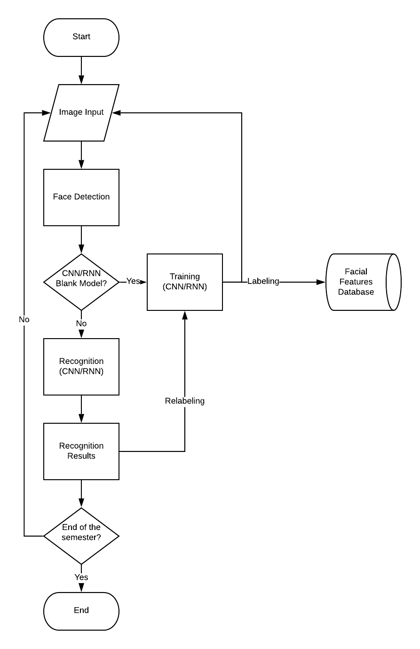

Figure 1: Flowchart in Using Face Recognition via CNN/RNN

The application will follow a concrete procedure in obtaining the input into giving the output needed for the study. It will give the face recognition results which will contain the labels of faces recognized and the accuracy of the recognition.

1. **Image Input**

The images will be captured during the lecture hours of the selected class. Students will be asked to perform 10 different postures for the image analysis. The 10 different postures will be:

1. Facing directly to the camera
2. Facing 30 degrees to the left
3. Facing 30 degrees to the right
4. Facing 30 degrees to the upward
5. Facing 30 degrees to the downward
6. Facing 30 degrees to the upper-right
7. Facing 30 degrees to the lower-right
8. Facing 30 degrees to the upper-left
9. Facing 30 degrees to the lower-left
10. Any angle determined by the subject
11. **Face Detection**

To provide consistency of data, images that will be used in both frameworks for the neural networks will have the same image input and face detection algorithm as shown in Figure 1. The result of the detected faces will then be fed into the two different algorithms.

1. **Data Augmentation**

Datasets will have at most 10 data augmentation procedures for the dataset to fill in the insufficient amount of data input since having at least 100 pictures taken will consume time for the lecture hours.

1. **Training and Recognition**

The training and recognition process of the selected neural networks will be done consecutively with an adequate time interval to prevent decrease in performance due to heating. The training data that will be extracted during the run will be saved into the features database of the algorithm used.

1. **Convolutional Neural Network Model**

The convolutional neural network model that will be used will have the following characteristics:

1. three convolutional layers with
2. 64 input nodes,
3. window size of 3x3,
4. activation function of rectified linear.
5. final activation of softmax

The sizes of these layers are kept at a minimal size with a minimum amount of data received. The final activation function that will be used is softmax to receive outputs of percentage predictions of classes.

1. **Recurrent Neural Network Model**

The recurrent neural network model that will be used will have the following characteristics:

1. two Long-Short Term Memory Layer with
2. dropout layer of 30%
3. final activation of softmax

The size of the layers is to keep a minimum size for a minimum amount of data received and to match the convolutional neural network model. The final activation function that will be used is softmax to receive outputs of percentage predictions of classes.

1. **Recognition Results**

The results will contain the predicted label of the face being recognized and the accuracy of the recognition. The results will be saved in a log where the history of the results will be seen. If the results shows inaccurate assumptions of the faces, relabeling will be done. The differences in accuracy and speed will be determined on the training and recognition capabilities of the selected neural network**.**

1. **Analysis of Results**

The analysis will be performed after the end of the semester. The results will be analyzed and interpreted by measuring the percent accuracy of the neural network in recognizing the faces of the input. It will also determine the minimum number of inputs required to get a reasonable accuracy.

1. **RESULTS AND DISCUSSION**
2. **Selection of Class**

Due to the pandemic, data gathered from the previous class being tested is insufficient. Thus, a group of six people have volunteered to pose as a class. The pictures were taken in a classroom-like setup. Pictures taken from the substitute class is taken every day instead of once per week. However, due to inability constraints, the data sets gathered were only for nine days.

1. **Data Privacy Agreement**

The volunteers taken for this study verbally agreed that their images will be saved to the smartphone and the computer of the user only. Furthermore, they have agreed to use their names during the conduct of the study for conveniences of the user. However, they have expressed to not include their names on the research paper or manuscript of the study. The volunteers also agreed that the images taken should be deleted right after the user has finalized the study.

1. **Loading Dataset**

Input images were taken as a class and individual faces are extracted as shown in Figure 2. The face detection API did not detect all individual pictures due to lighting or extreme angles. The individual faces are then labeled to their corresponding classes. Data augmentation is then used to produce more data to feed the neural network as shown in Figure 3. The number of images after data augmentation is always 100. 10% of the data-set will be used as testing data thus will not be used for training. The attendance of the classes is recorded manually at this time.



Figure 2: Sample Image Inputs

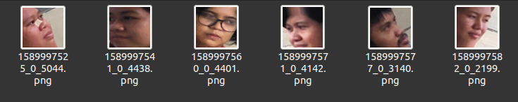

Figure 3: Sample Data Augmented Images

1. **Training Neural Network Models**

After loading the data set, the data images are resized to 150x150 pixels to provide consistency for the neural network models. The neural network training is implemented by training using the data set per day using the model of the neural network used as described. The loss, accuracy, val loss, and val accuracy is recorded per data set inputted in the model. As shown in Figures 4 and 6, the CNN model’s accuracy and val accuracy is higher than that of the RNN model’s by a huge margin. And in Figures 5 and 7, the CNN model’s results are better than that of the RNN model’s.

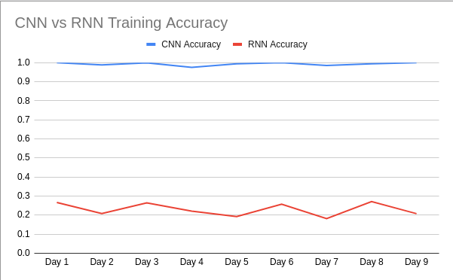

Figure 4: CNN vs RNN Training Accuracy

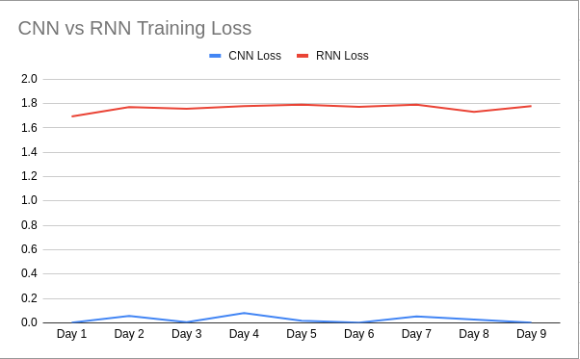

Figure 5: CNN vs RNN Training Loss

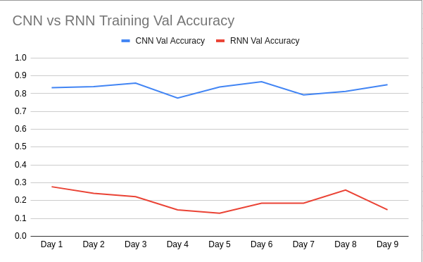

Figure 6: CNN vs RNN Training Val Accuracy

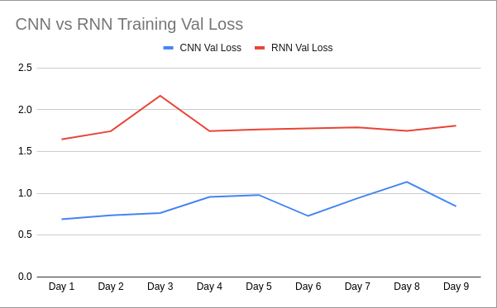

Figure 7: CNN vs RNN Training Val Loss

1. **Testing Neural Network Models**

After every training of the neural network models, a data set from the next meeting will be used to determine the accuracy of the model. Shown in Tables I and II are the testing results from the neural networks used.

Table 1: CNN Test Results

|  |  |  |  |  |  |  |  |
| --- | --- | --- | --- | --- | --- | --- | --- |
|  | Person 1 | Person 2 | Person 3 | Person 4 | Person 5 | Person 6 | Overall |
| Day 1 | 1 | 0.1 | 0.2 | 0.5 | 0 | 0.7 | 0.4166666667 |
| Day 2 | 1 | 0 | 1 | 0.5 | 0.6 | 0.7 | 0.6333333333 |
| Day 3 | 0.8 | 0.8 | 0 | 0.3 | 0.7 | 0.5 | 0.5166666667 |
| Day 4 | 0.7 | 0.5 | 0.6 | 0.2 | 0.7 | 0.8 | 0.5833333333 |
| Day 5 | 0.3 | 0.2 | 0.8 | 0.9 | 0.7 | 1 | 0.65 |
| Day 6 | 0.4 | 0.5 | 0.5 | 0.8 | 0.6 | 1 | 0.6333333333 |
| Day 7 | 0.3 | 0.9 | 0.7 | 0.5 | 1 | 0.8 | 0.7 |
| Day 8 | 0.5 | 0.4 | 0.5 | 0.9 | 0.5 | 1 | 0.6333333333 |

Table 2: RNN Test Results

|  |  |  |  |  |  |  |  |
| --- | --- | --- | --- | --- | --- | --- | --- |
|  | Person 1 | Person 2 | Person 3 | Person 4 | Person 5 | Person 6 | Overall |
| Day 1 | 0..6 | 0 | 0 | 0 | 0 | 0.2 | 0.1333333333 |
| Day 2 | 0 | 0 | 0.3 | 0 | 0 | 0.8 | 0.1833333333 |
| Day 3 | 0.7 | 0 | 0.1 | 0 | 0.1 | 0.5 | 0.2333333333 |
| Day 4 | 0 | 0.6 | 0 | 0 | 0.8 | 0 | 0.2333333333 |
| Day 5 | 0 | 0.1 | 0.6 | 0 | 0 | 0.2 | 0.15 |
| Day 6 | 0 | 0.4 | 0.3 | 0 | 0 | 0.2 | 0.15 |
| Day 7 | 1 | 0 | 0 | 0 | 0.1 | 0 | 0.1833333333 |
| Day 8 | 0.9 | 0.3 | 0 | 0 | 1 | 0 | 0.3666666667 |

An output result of one image consisted of the percentage prediction per class and the highest percentage prediction for the image as shown in Figure 8.

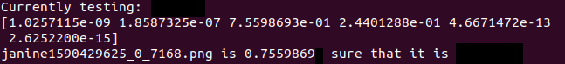

Figure 8: Sample Output for One Image

Figure 9 shows a visual presentation of the sample output. The image above is the sample image being tested. The result can only show person 3 and person 4 results since the percentage of person 1, 2, 5, and 6 are too small.

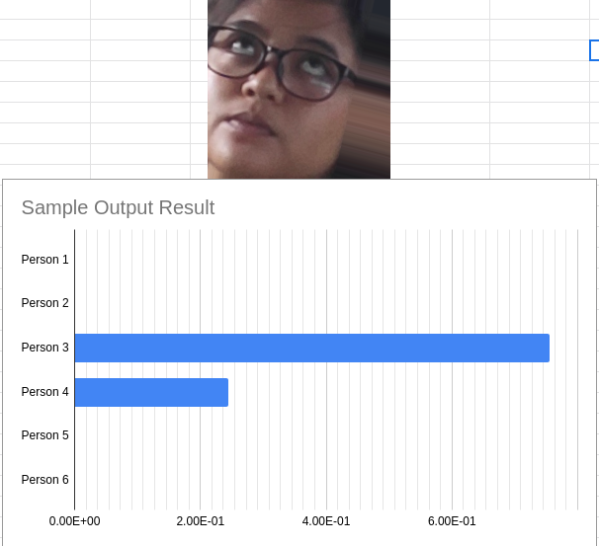

Figure 9: Sample Output Visualization

1. **Analysis of Results**

Both CNN and RNN overall results gave an insufficient accuracy at the end of the run-through of training and testing. This can be the result of insufficient number of data set and minimal number of poses taken per day. However, both models show a consistent increase in accuracy on the overall test result as shown in Figure 10.

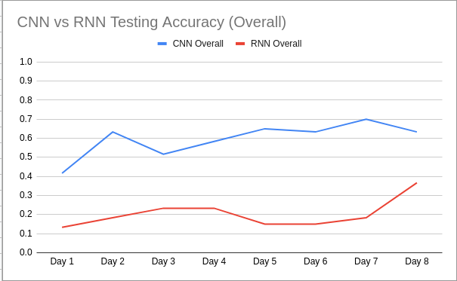

Figure 10: CNN vs RNN Overall Results

CNN overall results have shown that it is more capable for image classification compared to the RNN overall results. Moreover, the RNN model has shown that at the end of the run-through, it resorted to predict only one person from the data set as shown in Figure 12 and Table 2. The RNN model also shows that it had no improvement in predicting person 4 as shown in Figure 11 and it shows a fluctuating result on each person as shown in Figure 12.

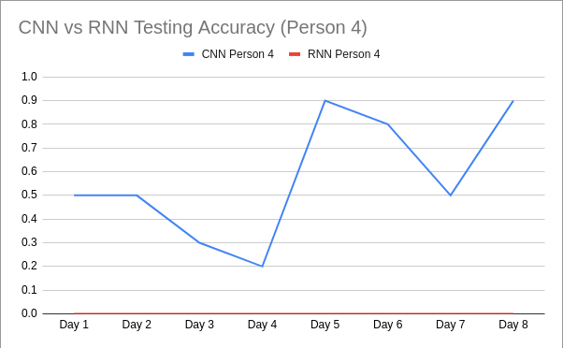

Figure 11: CNN vs RNN Results for Person 4

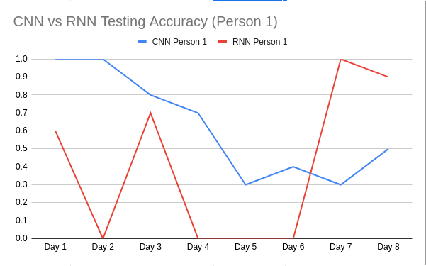

Figure 12: CNN vs RNN Results for Person 1

The CNN model has shown to increase the accuracy on some persons as shown in Figure 11. However, Figure 12 suggests a decreasing trend at days 5 to 7. Thus, the data set at hand was not enough to justify an increase in day 8.

Attendances of the classes are further observed by checking if the percentage accuracy of a person is above 50% as checked in Tables 1 and 2. As shown in the results in Tables 1 and 2,both the CNN model and the RNN model provided insufficient attendance checking accuracy. The RNN model showed that all person is absent all throughout due to low accuracy of each person per day. The CNN model showed at most 6 absences and at least 1 absence per person thus concludes the insufficiency of accuracy on attendance checking.

Further investigation on how the CNN model and the RNN model using the confusion matrices shown in Tables 4 to 19. It is shown that the RNN model is predicting at most two persons per day thus explaining the low accuracy rate of the test results. The CNN model, however, evidently tries to predict accurately with a minimal amount of prediction using only one person.

1. **Out of Class Pictures**

Profile pictures from the social media profiles of the volunteers was gathered to test the result of the neural network models. Each of them has three profile pictures that will be tested. It should be noted that most of these pictures are post processed and out of date. Figure 13 shows the sample out of class pictures taken.



Figure 13: Sample Out of Class Pictures

Table 3: CNN and RNN Test Result for Out of Class Pictures

|  |  |  |
| --- | --- | --- |
|  | CNN | RNN |
| Person 1 | 0.3333333333 | 1 |
| Person 2 | 0.3333333333 | 0 |
| Person 3 | 0 | 0 |
| Person 4 | 0 | 0 |
| Person 5 | 0.6666666667 | 0 |
| Person 6 | 0 | 0 |
| Overall | 0.2222222222 | 0.1666666667 |

As shown in Table 3, both models performed poorly in identifying the classes of the pictures. However, the results shown may be the effect of the post processing and out of date pictures used therefore the performance of the model may not be entirely be because of the model itself.

1. **Overall Feasibility**

Both CNN and RNN is not sufficient in this scenario due to the following reasons:

1. Inefficiency of data set i.e. 10 repeated postures everyday, reduced data set due to inefficient face detection, and limited data set.
2. Both models were in its simplest forms.

The RNN model furthers the insufficiency and it is not feasible for image classification or attendance checking. Even if the CNN model is insufficient, further data set inputs or structural changes may reach at least 90% accuracy.

1. **CONCLUSION**

Both CNN and RNN models provided an insufficient accuracy for the use of attendance checking given the constraints. Multiple factors may have caused the insufficiency of both models. Further testing with an ample amount of data may change the results.

1. **Data Collection**

The number of pictures taken in a class may affect the performance of the neural network models. 10 different postures that resulted into 100 through data augmentation is still considered a limited data set. Moreover, repeatedly using the same postures affected the results especially when the out of class pictures were used.

1. **CNN and RNN Training**

The CNN model outperforms the RNN model in image classification by a huge margin as seen on the training results shown in Figures 4, 5, 6, and 7. The RNN model has never reached near 100% accuracy on training which will reflect on the testing results. The CNN model has trained efficiently and have reached a minimal loss value and a high accuracy rate on training.

1. **Testing Results**

The testing result of both the CNN and the RNN model performed poorly. The RNN model resulted in answering only one to two prediction to all classes. On the other hand, the CNN model outperformed the RNN model with a maximum of 70% accuracy rate on the testing results which is still insufficient to justify the use of CNN. Further changes for the CNN model may improve image classification

1. **Attendance Checking**

The RNN model provided a low accuracy of checking the attendance accurately giving less than 50% accuracy per day. The CNN model, however, maintains a constant accuracy between 50% to 70% on average per day. Thus, both models are insufficient to provide a reliable attendance checking system due to the high margin of error when checking the attendance.

1. **Overall Performance**

The use of both models using the same structure used in this study is insufficient. Moreover, if one of the models was sufficiently accurate beyond day 8, it still would not be worth it for the model to still be training after 8 classes.

1. **RECOMMENDATION**

Although the CNN and RNN models used in this study was insufficient, their structure may be improved as such to improve accuracy. The amount of data collected can also be changed and increased to further improve the efficiency of training.

1. **Data Collection**

The amount of image postures can be changed to further maximize the degree of freedom that the neural network models use during training. Furthermore, the removal of repeatedly used postures may improve the training. However, if data collection will be increased, the amount of time used to take pictures in a lecture may result to unnecessary use of this method of attendance checking. A video input may also be efficient to get more than enough amount of data set.

1. **Neural Network Model**

The proof that CNN outperforms RNN in image classification makes the RNN model useless to further study. On the other hand, further improvement of the CNN model may be implemented. Changes such as input nodes, window size, number of layers, etc. can lead to different results thus the possibility of improved neural network models.

1. **REFERENCES**

[1] V. Kassarnig, A. Bjerre-Nielsen, E. Mones, S. Lehmann, and D. D. Lassen, “Class attendance, peer similarity, and academic performance in a large field study,” PLoS ONE, vol. 12, no. 11, nov 2017.

[2] P. K. Pani and P. Kishore, “Absenteeism and performance in a quantitative module A quantile regression analysis,” Journal of Applied Research in Higher Education, vol. 8, no. 3, pp. 376–389, jul 2016.

[3] S. S. Bhairannawar, S. Sarkar, K. B. Raja, and K. R. Venugopal, “Implementation of Fingerprint Based Biometric System Using Optimized 5/3 DWT Architecture and Modified CORDIC Based FFT,” Circuits, Systems, and Signal Processing, vol. 37, no. 1, pp. 342–366, jan 2018.

[4] F. M. Al-Naima and H. A. Ameen, “Design of an RFID based students/employee attendance system, Tech. Rep. 1, 2016.

[5] D. Thakkar, “Biometric Devices: Cost, Types and Comparative Analysis,” 2018. [Online]. Available: https://www.bayometric.com/ biometric-devices-cost/

[6] B. Ray, “A Breakdown Of 7 RFID Costs, From Hardware To Implementation,” 2018. [Online]. Available: https://www.airfinder.com/ blog/rfid-cost

[7] A. Alazzawi, O. N. Ucan, and O. Bayat, “Performance of Face Recognition System Using Gradient Laplacian Operators and New Features Extraction Method Based on Linear Regression Slope,” Mathematical Problems in Engineering, vol. 2018, 2018.

[8] R. Samet and M. Tanriverdi, “Face recognition-based mobile automatic classroom attendance management system,” in Proceedings - 2017 International Conference on Cyberworlds, CW 2017 - in cooperation with: Eurographics Association International Federation for Information Processing ACM SIGGRAPH, vol. 2017-Janua. Institute of Electrical and Electronics Engineers Inc., nov 2017, pp. 253–256.

[9] C. Ding and D. Tao, “Trunk-Branch Ensemble Convolutional Neural Networks for Video-Based Face Recognition,” IEEE Transactions on Pattern Analysis and Machine Intelligence, vol. 40, no. 4, pp. 1002– 1014, apr 2018.

[10] H. Liu, X. Shen, and H. Ren, “FDAR-Net: Joint convolutional neural networks for face detection and attribute recognition,” Proceedings - 2016 9th International Symposium on Computational Intelligence and Design, ISCID 2016, vol. 2, pp. 184–187, 2016.

[11] R. Y. Dillak, S. Dana, and M. Beily, “Face Recognition using 3D GLCM and Elman Levenberg Recurrent Neural Network,” Tech. Rep., 2018.

[12] A. Mostafa, M. I. Khalil, and H. Abbas, Emotion Recognition by Facial Features using Recurrent Neural Networks, 2018.

1. **APPENDIX**

Table 4: CNN Confusion Matrix Day 1

|  |  |  |  |  |  |  |
| --- | --- | --- | --- | --- | --- | --- |
|  | Person 1 | Person 2 | Person 3 | Person 4 | Person 5 | Person 6 |
| Person 1 | 10 | 0 | 0 | 0 | 0 | 0 |
| Person 2 | 6 | 1 | 0 | 1 | 0 | 2 |
| Person 3 | 0 | 2 | 2 | 2 | 0 | 4 |
| Person 4 | 0 | 1 | 0 | 5 | 0 | 4 |
| Person 5 | 6 | 0 | 1 | 0 | 0 | 3 |
| Person 6 | 3 | 0 | 0 | 0 | 0 | 7 |

Table 5: RNN Confusion Matrix Day 1

|  |  |  |  |  |  |  |
| --- | --- | --- | --- | --- | --- | --- |
|  | Person 1 | Person 2 | Person 3 | Person 4 | Person 5 | Person 6 |
| Person 1 | 0 | 0 | 0 | 5 | 0 | 5 |
| Person 2 | 0 | 1 | 1 | 2 | 0 | 6 |
| Person 3 | 0 | 4 | 0 | 6 | 0 | 0 |
| Person 4 | 0 | 1 | 0 | 9 | 0 | 0 |
| Person 5 | 0 | 0 | 0 | 5 | 0 | 5 |
| Person 6 | 0 | 0 | 0 | 6 | 0 | 4 |

Table 6: CNN Confusion Matrix Day 2

|  |  |  |  |  |  |  |
| --- | --- | --- | --- | --- | --- | --- |
|  | Person 1 | Person 2 | Person 3 | Person 4 | Person 5 | Person 6 |
| Person 1 | 10 | 0 | 0 | 0 | 0 | 0 |
| Person 2 | 0 | 0 | 10 | 0 | 0 | 0 |
| Person 3 | 0 | 0 | 10 | 0 | 0 | 0 |
| Person 4 | 0 | 0 | 2 | 5 | 1 | 2 |
| Person 5 | 0 | 0 | 3 | 1 | 6 | 0 |
| Person 6 | 0 | 2 | 0 | 0 | 1 | 7 |

Table 7: RNN Confusion Matrix Day 2

|  |  |  |  |  |  |  |
| --- | --- | --- | --- | --- | --- | --- |
|  | Person 1 | Person 2 | Person 3 | Person 4 | Person 5 | Person 6 |
| Person 1 | 0 | 2 | 5 | 0 | 0 | 3 |
| Person 2 | 0 | 1 | 8 | 0 | 0 | 1 |
| Person 3 | 0 | 1 | 8 | 0 | 0 | 1 |
| Person 4 | 0 | 0 | 5 | 2 | 0 | 3 |
| Person 5 | 0 | 2 | 4 | 0 | 0 | 2 |
| Person 6 | 0 | 3 | 6 | 0 | 0 | 1 |

Table 8: CNN Confusion Matrix Day 3

|  |  |  |  |  |  |  |
| --- | --- | --- | --- | --- | --- | --- |
|  | Person 1 | Person 2 | Person 3 | Person 4 | Person 5 | Person 6 |
| Person 1 | 8 | 0 | 0 | 2 | 0 | 0 |
| Person 2 | 1 | 8 | 0 | 0 | 1 | 0 |
| Person 3 | 0 | 3 | 0 | 2 | 1 | 4 |
| Person 4 | 1 | 6 | 0 | 3 | 0 | 0 |
| Person 5 | 1 | 1 | 0 | 0 | 7 | 1 |
| Person 6 | 0 | 4 | 0 | 1 | 0 | 5 |

Table 9: RNN Confusion Matrix Day 3

|  |  |  |  |  |  |  |
| --- | --- | --- | --- | --- | --- | --- |
|  | Person 1 | Person 2 | Person 3 | Person 4 | Person 5 | Person 6 |
| Person 1 | 6 | 0 | 0 | 0 | 0 | 4 |
| Person 2 | 4 | 0 | 3 | 0 | 0 | 3 |
| Person 3 | 5 | 0 | 3 | 0 | 0 | 2 |
| Person 4 | 4 | 0 | 1 | 0 | 0 | 5 |
| Person 5 | 1 | 0 | 0 | 0 | 0 | 9 |
| Person 6 | 2 | 0 | 1 | 0 | 0 | 7 |

Table 10: CNN Confusion Matrix Day 4

|  |  |  |  |  |  |  |
| --- | --- | --- | --- | --- | --- | --- |
|  | Person 1 | Person 2 | Person 3 | Person 4 | Person 5 | Person 6 |
| Person 1 | 7 | 2 | 1 | 0 | 0 | 0 |
| Person 2 | 1 | 5 | 1 | 1 | 1 | 1 |
| Person 3 | 1 | 0 | 6 | 2 | 0 | 1 |
| Person 4 | 0 | 2 | 1 | 2 | 0 | 5 |
| Person 5 | 0 | 1 | 0 | 1 | 7 | 1 |
| Person 6 | 0 | 1 | 0 | 0 | 1 | 8 |

Table 11: RNN Confusion Matrix Day 4

|  |  |  |  |  |  |  |
| --- | --- | --- | --- | --- | --- | --- |
|  | Person 1 | Person 2 | Person 3 | Person 4 | Person 5 | Person 6 |
| Person 1 | 0 | 9 | 1 | 0 | 0 | 0 |
| Person 2 | 0 | 5 | 2 | 0 | 1 | 0 |
| Person 3 | 0 | 7 | 0 | 0 | 3 | 0 |
| Person 4 | 0 | 6 | 0 | 0 | 4 | 0 |
| Person 5 | 0 | 6 | 1 | 0 | 3 | 0 |
| Person 6 | 0 | 9 | 1 | 0 | 0 | 0 |

Table 12: CNN Confusion Matrix Day 5

|  |  |  |  |  |  |  |
| --- | --- | --- | --- | --- | --- | --- |
|  | Person 1 | Person 2 | Person 3 | Person 4 | Person 5 | Person 6 |
| Person 1 | 3 | 2 | 4 | 0 | 0 | 1 |
| Person 2 | 0 | 2 | 1 | 3 | 2 | 2 |
| Person 3 | 0 | 1 | 8 | 0 | 0 | 1 |
| Person 4 | 0 | 0 | 1 | 9 | 0 | 0 |
| Person 5 | 0 | 0 | 2 | 1 | 7 | 0 |
| Person 6 | 0 | 0 | 0 | 0 | 0 | 10 |

Table 13: RNN Confusion Matrix Day 5

|  |  |  |  |  |  |  |
| --- | --- | --- | --- | --- | --- | --- |
|  | Person 1 | Person 2 | Person 3 | Person 4 | Person 5 | Person 6 |
| Person 1 | 0 | 0 | 8 | 2 | 0 | 0 |
| Person 2 | 1 | 0 | 1 | 0 | 1 | 7 |
| Person 3 | 2 | 0 | 5 | 0 | 0 | 3 |
| Person 4 | 0 | 2 | 5 | 1 | 0 | 2 |
| Person 5 | 4 | 0 | 4 | 0 | 0 | 2 |
| Person 6 | 0 | 0 | 5 | 0 | 0 | 5 |

Table 14: CNN Confusion Matrix Day 6

|  |  |  |  |  |  |  |
| --- | --- | --- | --- | --- | --- | --- |
|  | Person 1 | Person 2 | Person 3 | Person 4 | Person 5 | Person 6 |
| Person 1 | 4 | 1 | 1 | 0 | 1 | 3 |
| Person 2 | 3 | 5 | 0 | 0 | 0 | 2 |
| Person 3 | 0 | 3 | 5 | 1 | 0 | 1 |
| Person 4 | 0 | 0 | 1 | 8 | 1 | 0 |
| Person 5 | 0 | 3 | 1 | 0 | 6 | 0 |
| Person 6 | 0 | 0 | 0 | 0 | 0 | 10 |

Table 15: RNN Confusion Matrix Day 6

|  |  |  |  |  |  |  |
| --- | --- | --- | --- | --- | --- | --- |
|  | Person 1 | Person 2 | Person 3 | Person 4 | Person 5 | Person 6 |
| Person 1 | 0 | 2 | 7 | 0 | 0 | 1 |
| Person 2 | 0 | 2 | 5 | 0 | 0 | 3 |
| Person 3 | 0 | 4 | 4 | 0 | 0 | 2 |
| Person 4 | 0 | 4 | 2 | 0 | 0 | 4 |
| Person 5 | 0 | 2 | 0 | 0 | 0 | 8 |
| Person 6 | 0 | 3 | 4 | 0 | 0 | 3 |

Table 16: CNN Confusion Matrix Day 7

|  |  |  |  |  |  |  |
| --- | --- | --- | --- | --- | --- | --- |
|  | Person 1 | Person 2 | Person 3 | Person 4 | Person 5 | Person 6 |
| Person 1 | 3 | 2 | 4 | 0 | 1 | 0 |
| Person 2 | 0 | 9 | 0 | 0 | 0 | 1 |
| Person 3 | 0 | 0 | 7 | 1 | 2 | 0 |
| Person 4 | 0 | 1 | 3 | 5 | 1 | 0 |
| Person 5 | 0 | 0 | 0 | 0 | 10 | 0 |
| Person 6 | 0 | 0 | 0 | 1 | 1 | 8 |

Table 17: RNN Confusion Matrix Day 7

|  |  |  |  |  |  |  |
| --- | --- | --- | --- | --- | --- | --- |
|  | Person 1 | Person 2 | Person 3 | Person 4 | Person 5 | Person 6 |
| Person 1 | 10 | 0 | 0 | 0 | 0 | 0 |
| Person 2 | 8 | 0 | 2 | 0 | 0 | 0 |
| Person 3 | 10 | 0 | 0 | 0 | 0 | 0 |
| Person 4 | 10 | 0 | 0 | 0 | 0 | 0 |
| Person 5 | 5 | 0 | 5 | 0 | 0 | 0 |
| Person 6 | 10 | 0 | 0 | 0 | 0 | 0 |

Table 18: CNN Confusion Matrix Day 8

|  |  |  |  |  |  |  |
| --- | --- | --- | --- | --- | --- | --- |
|  | Person 1 | Person 2 | Person 3 | Person 4 | Person 5 | Person 6 |
| Person 1 | 5 | 0 | 3 | 0 | 2 | 0 |
| Person 2 | 0 | 7 | 1 | 1 | 0 | 1 |
| Person 3 | 1 | 2 | 3 | 4 | 0 | 0 |
| Person 4 | 0 | 0 | 0 | 10 | 0 | 0 |
| Person 5 | 0 | 0 | 3 | 4 | 3 | 0 |
| Person 6 | 0 | 0 | 0 | 0 | 0 | 10 |

Table 19: RNN Confusion Matrix Day 8

|  |  |  |  |  |  |  |
| --- | --- | --- | --- | --- | --- | --- |
|  | Person 1 | Person 2 | Person 3 | Person 4 | Person 5 | Person 6 |
| Person 1 | 8 | 2 | 0 | 0 | 0 | 0 |
| Person 2 | 5 | 2 | 0 | 0 | 3 | 0 |
| Person 3 | 2 | 5 | 0 | 0 | 3 | 0 |
| Person 4 | 7 | 2 | 0 | 0 | 1 | 0 |
| Person 5 | 3 | 4 | 0 | 0 | 3 | 0 |
| Person 6 | 2 | 3 | 0 | 0 | 5 | 0 |