- Search S3 and click buckets: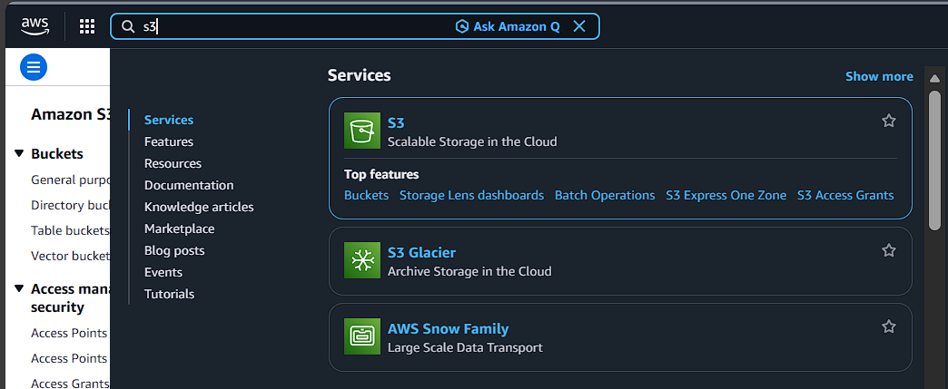

- Click on Create bucket :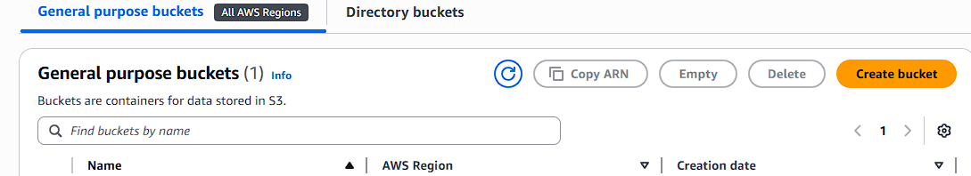

- Select General purpose , Give a bucket Name:
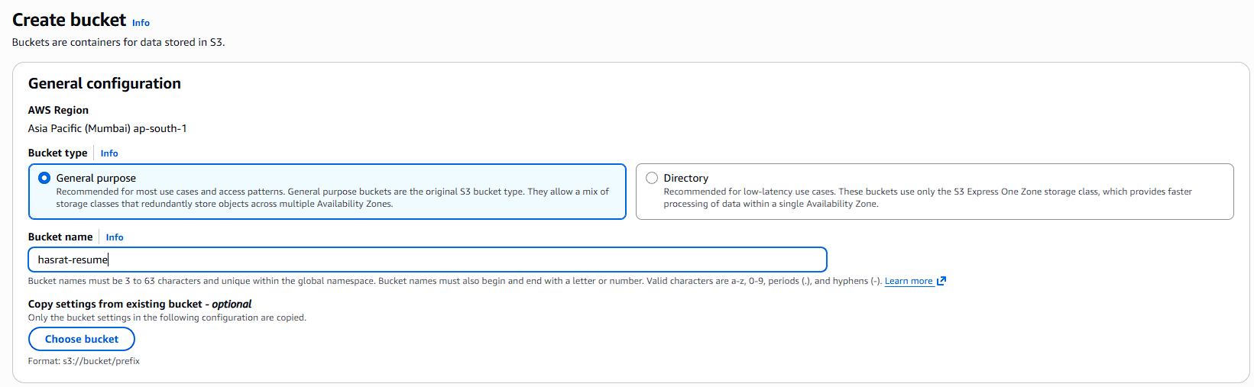

- Untick Block all public access and Click create bucket:
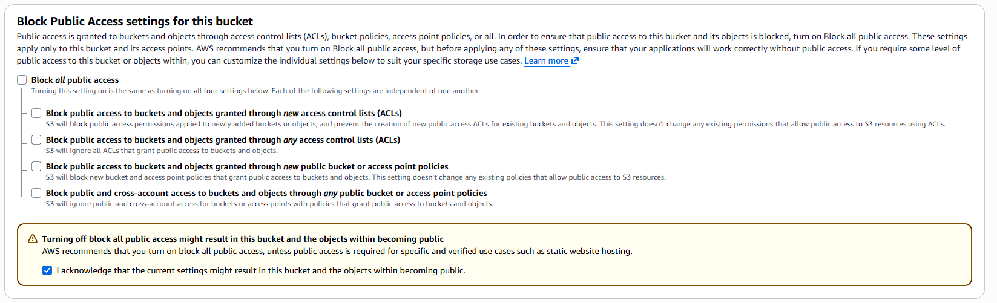

- Click on the Bucket Name (hasrat-resume) :
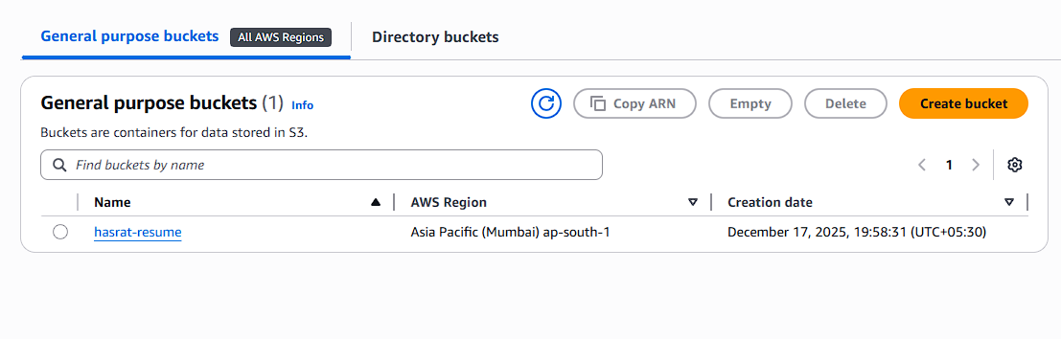

- Click upload and upload the static website files (index.html , style.css) :
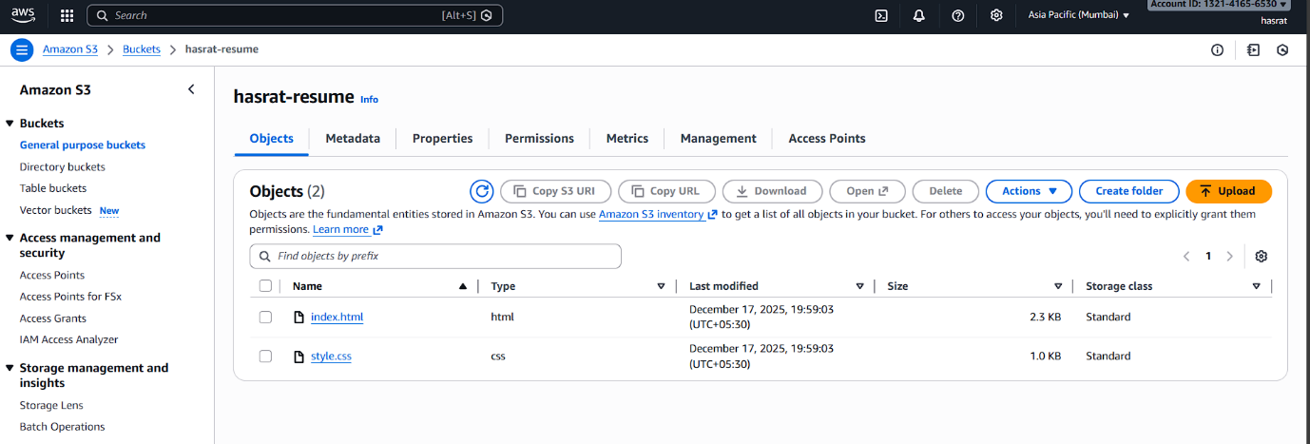

- Inside the Bucket click on Properties Tab:
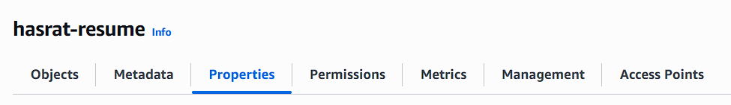

- Scroll down and Click on edit Static web hosting and Select Enable and Save :
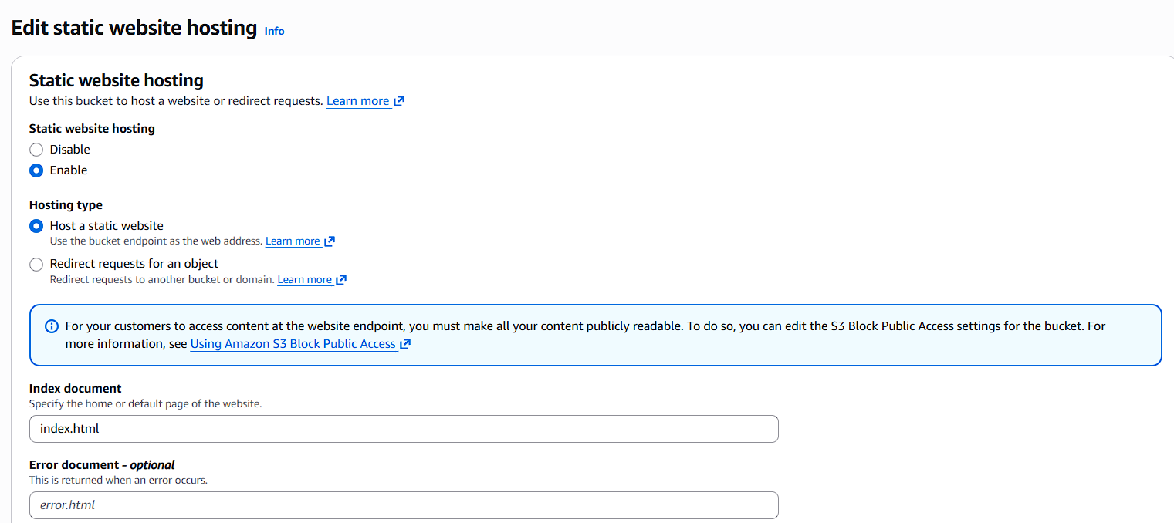

- Now click on Permissions Tab:
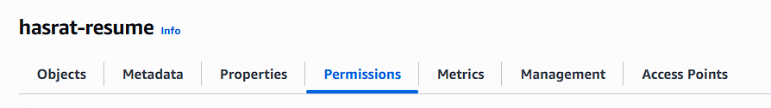

- Select Bucket policy and Update the Policy.

(Public access is enabled, and Static website hosting is ON
Without a bucket policy, users will get “403 Access Denied”
So this policy allows public read access.) :

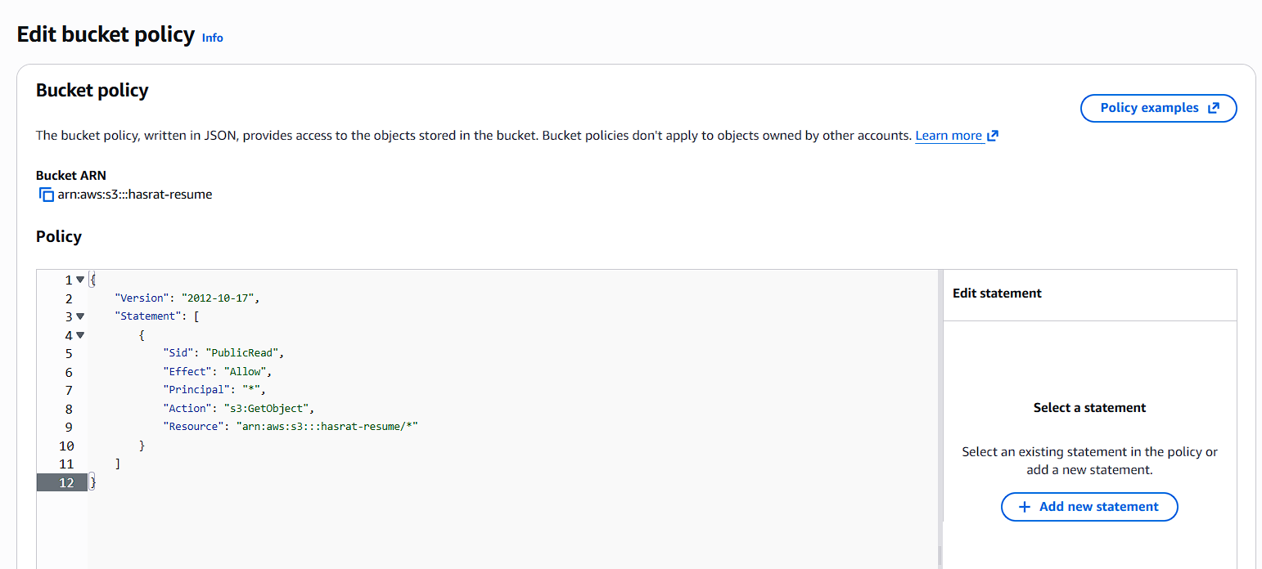

- Now copy the Bucket website Endpoint From the Properties Tab :
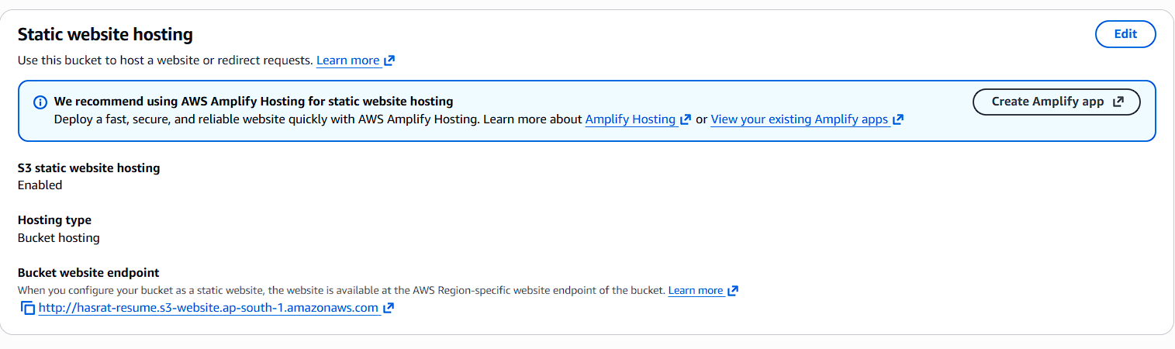

- Paste the Endpoint in the Browser URL tab:
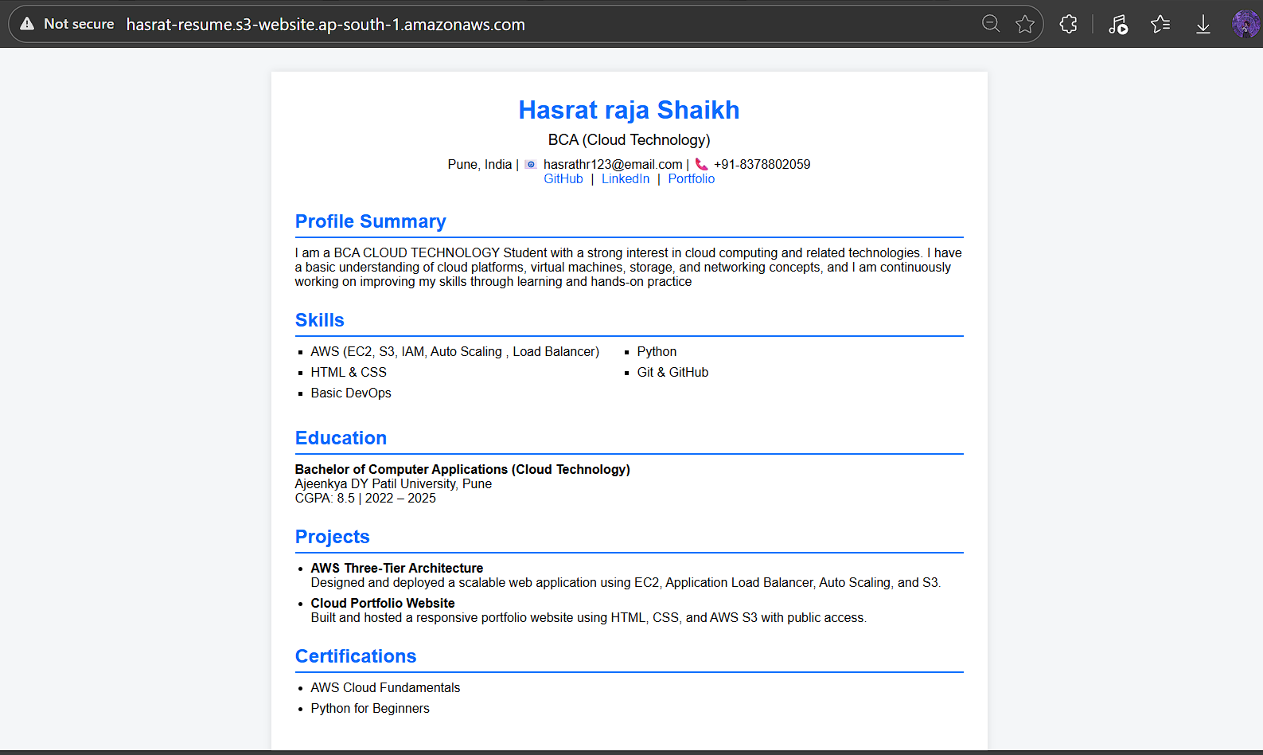

We can see the Static website on S3 is running.

