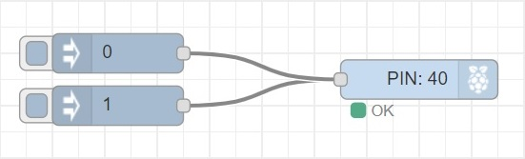

|  |
| --- |
| [{"id":"1bea62c2.25c7bd","type":"inject","z":"284e6f60.4eb09","name":"","topic":"","payload":"1","payloadType":"num","repeat":"","crontab":"","once":false,"onceDelay":0.1,"x":250,"y":320,"wires":[["ad99dae8.685b58"]]},{"id":"ad99dae8.685b58","type":"rpi-gpio out","z":"284e6f60.4eb09","name":"","pin":"40","set":"","level":"0","freq":"","out":"out","x":480,"y":300,"wires":[]},{"id":"3a1eb519.a08d8a","type":"inject","z":"284e6f60.4eb09","name":"","topic":"","payload":"0","payloadType":"num","repeat":"","crontab":"","once":false,"onceDelay":0.1,"x":250,"y":280,"wires":[["ad99dae8.685b58"]]}] |

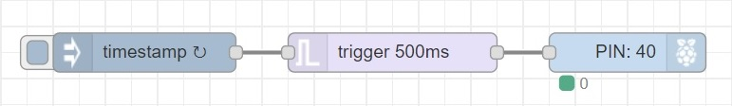

|  |
| --- |
| [{"id":"4d6065ae.864f8c","type":"inject","z":"4d0c9bad.ef8014","name":"","topic":"","payload":"","payloadType":"date","repeat":"1","crontab":"","once":false,"onceDelay":0.1,"x":230,"y":220,"wires":[["4e588d52.2991f4"]]},{"id":"ab836ee6.b8134","type":"rpi-gpio out","z":"4d0c9bad.ef8014","name":"","pin":"40","set":"","level":"0","freq":"","out":"out","x":600,"y":220,"wires":[]},{"id":"4e588d52.2991f4","type":"trigger","z":"4d0c9bad.ef8014","op1":"1","op2":"0","op1type":"str","op2type":"str","duration":"500","extend":false,"units":"ms","reset":"","bytopic":"all","name":"","x":420,"y":220,"wires":[["ab836ee6.b8134"]]}] |