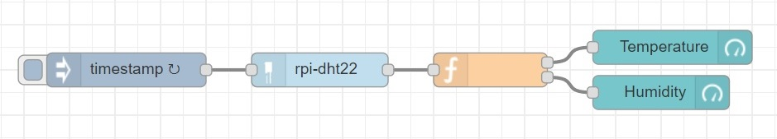

|  |
| --- |
| [{"id":"a07ba111.d28fd","type":"inject","z":"c342db9f.d90f88","name":"","topic":"","payload":"","payloadType":"date","repeat":"1","crontab":"","once":false,"onceDelay":0.1,"x":210,"y":160,"wires":[["d32ae966.faa408"]]},{"id":"d32ae966.faa408","type":"rpi-dht22","z":"c342db9f.d90f88","name":"","topic":"rpi-dht22","dht":22,"pintype":"0","pin":"23","x":380,"y":160,"wires":[["69e86eb6.63e77"]]},{"id":"69e86eb6.63e77","type":"function","z":"c342db9f.d90f88","name":"","func":"var temp,humi;\ntemp={\n \"payload\":msg.payload\n}\nhumi={\n \"payload\":msg.humidity\n}\nreturn [temp,humi];","outputs":2,"noerr":0,"x":530,"y":160,"wires":[["c214d316.270fd"],["702119ae.1b6828"]]},{"id":"c214d316.270fd","type":"ui_gauge","z":"c342db9f.d90f88","name":"","group":"b6070c1e.8f5ed","order":0,"width":0,"height":0,"gtype":"gage","title":"Temperature","label":"°C","format":"{{value}}","min":0,"max":"100","colors":["#00b500","#e6e600","#ca3838"],"seg1":"","seg2":"","x":690,"y":140,"wires":[]},{"id":"702119ae.1b6828","type":"ui_gauge","z":"c342db9f.d90f88","name":"","group":"b6070c1e.8f5ed","order":0,"width":0,"height":0,"gtype":"gage","title":"Humidity","label":"%","format":"{{value}}","min":0,"max":"100","colors":["#00b500","#e6e600","#ca3838"],"seg1":"","seg2":"","x":680,"y":180,"wires":[]},{"id":"b6070c1e.8f5ed","type":"ui_group","z":"","name":"Monitor","tab":"a36069f.fd42098","disp":true,"width":"6","collapse":false},{"id":"a36069f.fd42098","type":"ui_tab","z":"","name":"Home","icon":"dashboard","disabled":false,"hidden":false}] |