

AK Distributors Catalog

Our Partner Brands
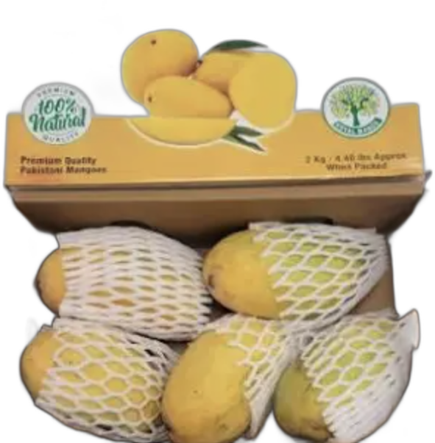

Bake Parlor
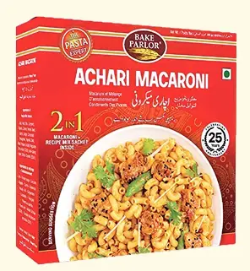  ACHAARI MACARONI (24*250g) | 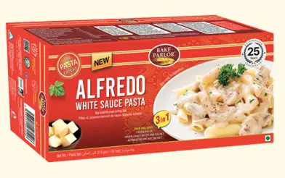  ALFREDO PASTA (24*250g)
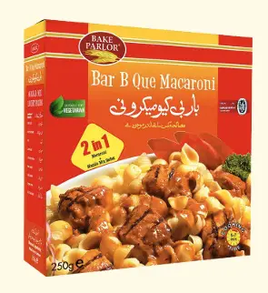  B.B.Q MACARONI (24*250g) | 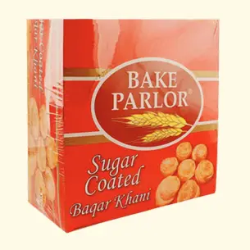  BAQAR KHANI (12*300g)
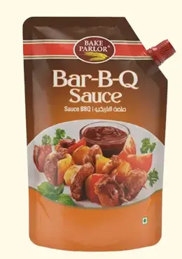  BAR B Q SAUCE POUCH(12*400g) | 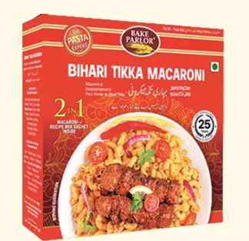  BIHARI TIKKA MACARONI (24*250g)
  BREAD CRUMBS POUCH(48*200g) |   BURGER RUSK JAR (12*300g)
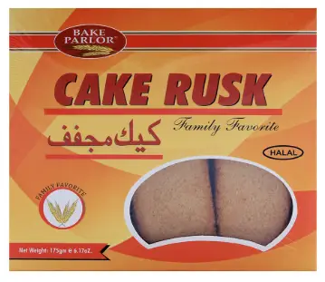  CAKE RUSK (24*400g) |   CANDY RUSK JAR (12*300g)
CHAAT MASALA (144*45g | 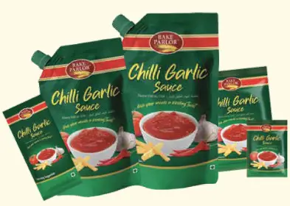  CHILLI GARLIC POUCH (6*800g)
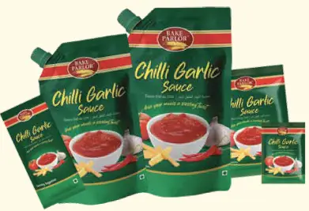  CHILLI GARLIC POUCH(12*400g) | 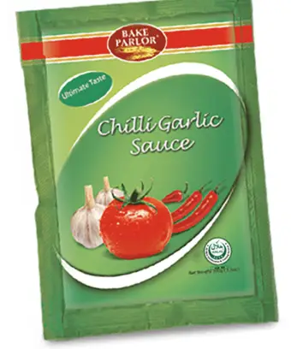  CHILLI GARLIC SACHET((100*10g)*10)
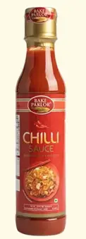  CHILLI SAUCE (12*750 ML) |   CHILLI SAUCE (24*300 ML)
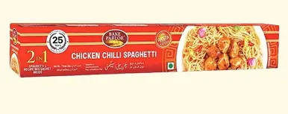  CHILLI SPAGHETTI (24*250g) |   CHOWMEIM HAKKA NOODLES (24*250g)
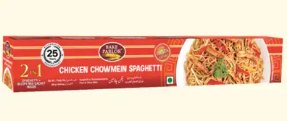  CHOWMEIN SPAGHETTI (24*250g) | 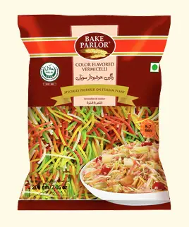  COLOR FLAVOR VERMICELLI (24*400g)
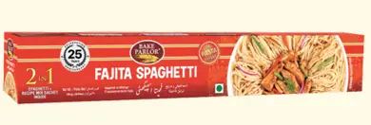  FAJITA SPAGHETTI (24*250g) | 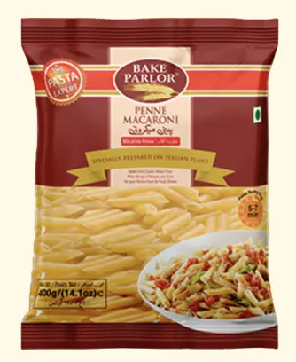  FANCY MACARONI LARGE PENNE DHARI(36*400)
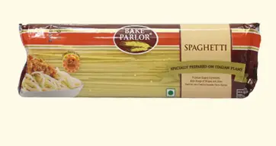  fancy spaghetti (20*500g) | FANCYMACARONI SCREW (36*400g)
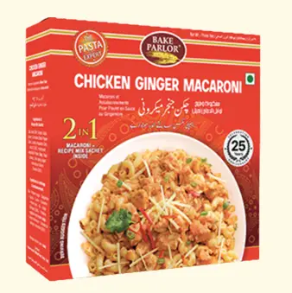  GINGER MACARONI (24*250g) | 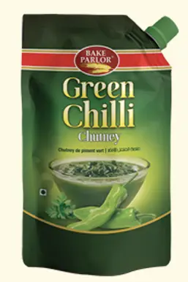  GREEN CHILLI CHUTNI POUCH (12*400g)
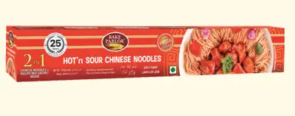  HOT n SOUR CHINESE NOODLES (24*250g) |   ICE CREAM SYRUP (12*800ML)
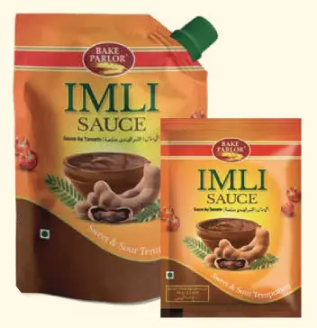  IMLI SAUCE POUCH (12*400g) | 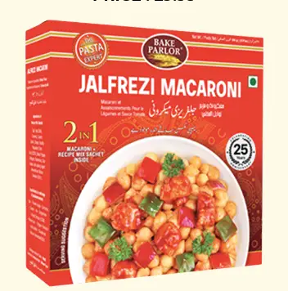  JAIFREZI MACARONI (24*250g)
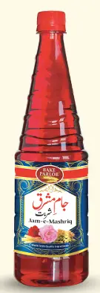  JAM E MASHRIQ (12*800g) | 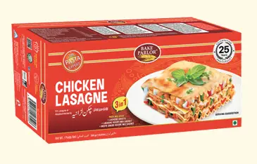  LASAGNA (18*400g)
LASAGNE RECIPE MIX (24*250g) | 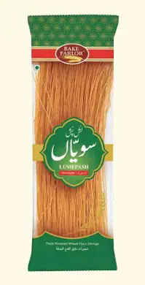  LUSH PASH THICK VERMICELLI (36*350g)
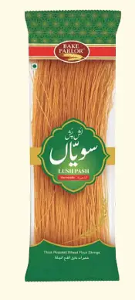  LUSH PASH THICKV VERMICELLI (72*150g) | 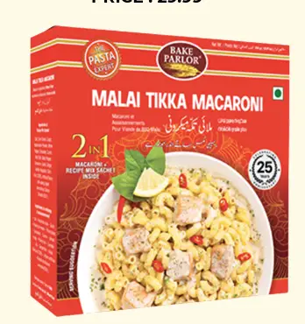  MALAI TIKKA MACARONI (24*250g)
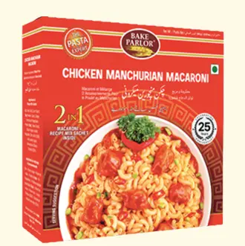  MANCHURIAN MACARONI (24*250g) | 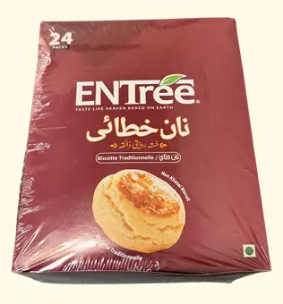  NAN KHATAI (8*192g)
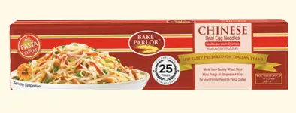  REAL EGG NOODLES (48*227g) | 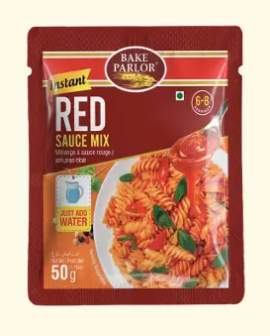  RED SAUCE SEASONING MIX (12*50g*12)
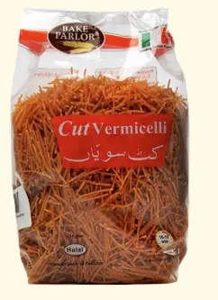  ROASTED CUT PASTA VERMICELLI (24*350g) | ROUND RUSK PLAIN JAR (12*300g)
  ROUND RUSK ZERA JAR (12*300g) | SEVEN SPICE MACARONI (24*250g)
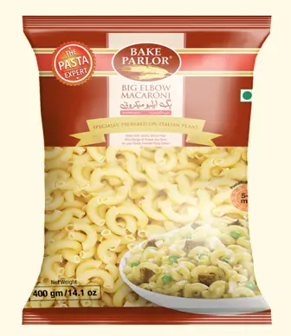  SMALL ELBOW MACARONI BOX (36*400g) | 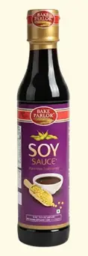  SOYA SAUCE (12*750ml)
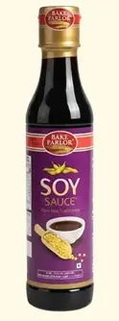  SOYA SAUCE (24*300 ML) | 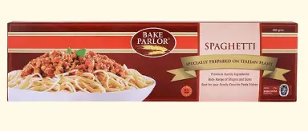  SPAGHETTI BOX (30*450g)
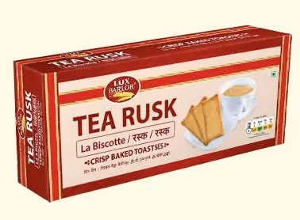  TEA RUSK (PLAIN) (24*240g) | 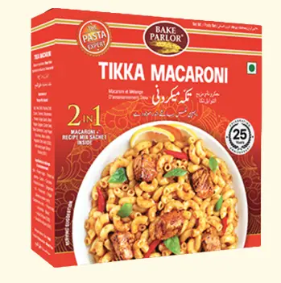  TIKKA MACARONI (24*250G)
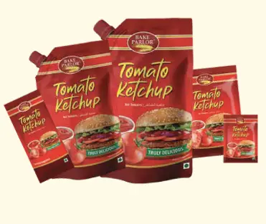  TOMATO KETCHUP POUCH (12*400g) | 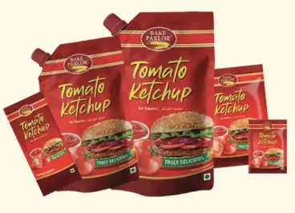  TOMATO KETCHUP POUCH (6*800g)
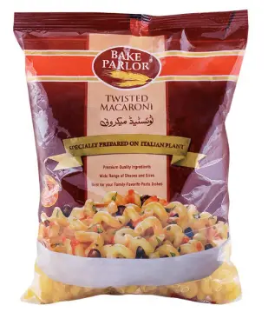  TWISTED MACARONI (36*400g) |   U-SHAPE VERMICELLI (48*150g)
  VINEGAR WHITE (12*750 ML) |   VINEGAR WHITE (4*4Ltr)
VINEGAR WHIYE (24*300 ML) | 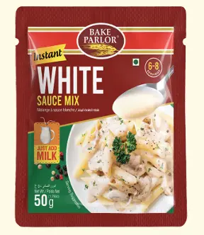  WHITE SAUCE SEASONING MIX (12*50g*12)
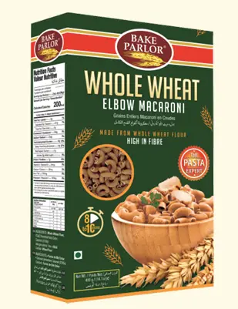
whole wheat elbow macaroni box (24*400g)

ZAIN FOODS
AFGHAN ALMOND NO SHELL (KER NAL) 200g, | AFGHAN ALMOND NO SHELL(KERNAL) 400g
AFGHAN ALMOND WITH SHELL 200g,(07-OZ) | AFGHAN ALMOND WITH SHELL 400g,(14-OZ)
BLACK CARDAMOM 100g, (3.5-OZ) | BLACK CARDAMOM 200g, (07-OZ)
BLACK CARDAMOM 450g, | BLACK MULBERRY 300g,
BLACK PEPPER (MESH) 450g | 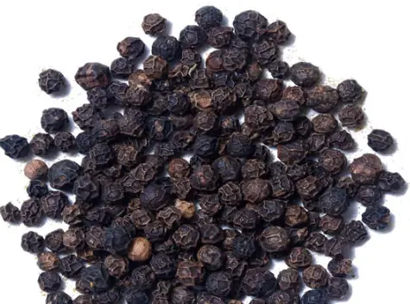  BLACK PEPPER 100g, (3.5-OZ)
BLACK PEPPER 200g, (07-OZ) | BLACK PEPPER WHOLE 450 g,
BLACK RAISIN 200g | BLACK RAISIN 400g,
CASHEW ROSTED 400g | CHICK PEAS 350g
CINNAMON STICKS 100g, (3.5-OZ) | CINNAMON STICKS 200g, (07-OZ)
CORIANDER SEEDS WHOLE 100g, (3.5-OZ) | CORIANDER SEEDS WHOLE 200g,(07-oz)
CORIANDER SEEDS WHOLE 400g, (14-OZ) | CUMIN SEEDS 100 g, (3.5-OZ)
CUMIN SEEDS 200 g, (07-OZ) | CUMIN SEEDS 400 g,(14-OZ)
DAL CHANA , 1-LBS | DRIED APRICOT 400g,(14-OZ)
DRIED PLUM WITH SEED 400g, (14-OZ) | FENNEL SEEDS 100g,(3.5-OZ)
FENNEL SEEDS 200g, (07-OZ) | FENNEL SEEDS 400g, (14-OZ)
FIGS 200g | FIGS 400g
GREEN CARDAMOM 100g,(3.5-OZ) | GREEN CARDAMOM 400g, (14-oz)
GREEN RAISIN (SUNDER KHANI),200g,(07-OZ) | GREEN RAISIN 400g, (14-OZ)
GRFFN RAISIN (SUNDER KHANI) 400g,(14-OZ) | JUMBO GREEN RAISIN 200g, (07-OZ)
JUMBO GREEN RAISIN 400g, (14-OZ) | NATURAL ALMOND(USA) 200g,
NATURAL ALMOND(USA) 400g,(14-OZ) | STAR ANISE 100g, (3.5-OZ)
STAR ANISE 200g,(07-OZ) | WALLNUTS SHELLED 200g,(07-OZ)
WALNUTS SHELLED 400g, (14-OZ) | WHITE MULBERRY 300g
WHOLE CASHEW 400g, (14-OZ)

TOOBA
  BLACK SALT(500g*12 PET JAR) | 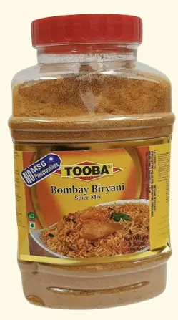  BOMBAY BIRYANI SPICE MIX(1.59Kg*4PET JAR)
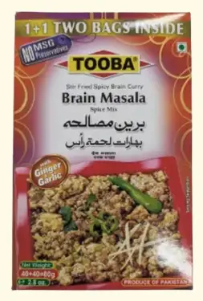  BRAIN MASALA(40+40=80g*48PKTS) | 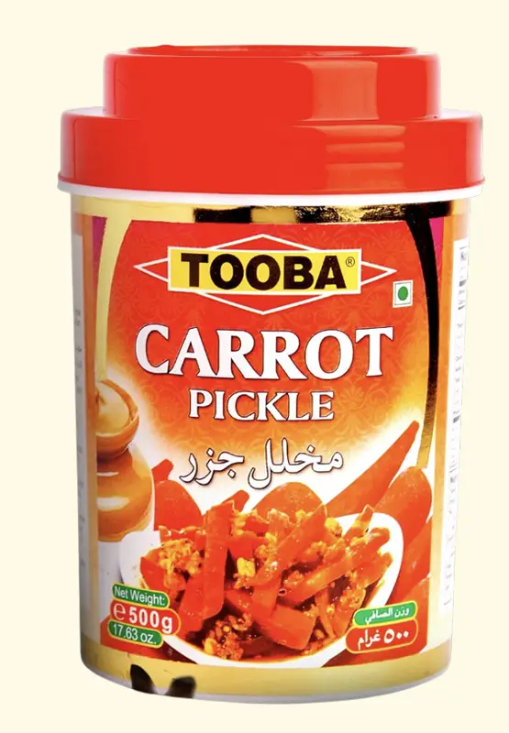  CARROT PICKLE(1Kg*6 PET JAR)
CARROT PICKLE(500g*12 PET JAR) | 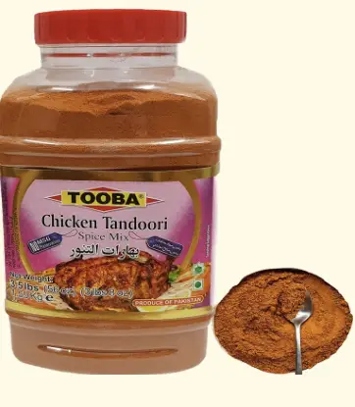  CHICKEN TANDOORI SPICE MIX(1.59Kg*4PET JAR)
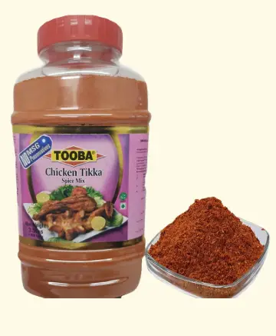  CHICKEN TIKKA SPICE MIX(1.59Kg*4PET JAR) | 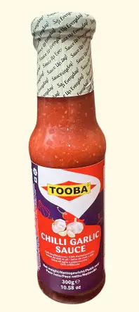  CHILLI GARLIC SAUCE(300g*12 GLASS BOTTLE)
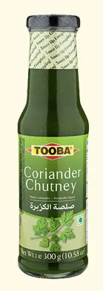  CORIANDER CHUTNEY(270g*12 GLASS BOTTLE) | 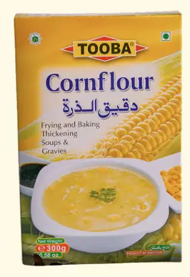  CORN FLOUR(300g*36 Pkts)
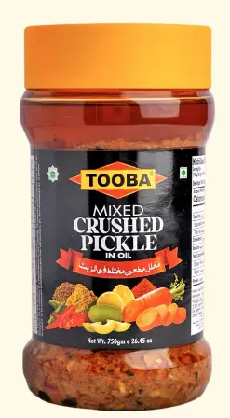  CRUSHED PICKLE | 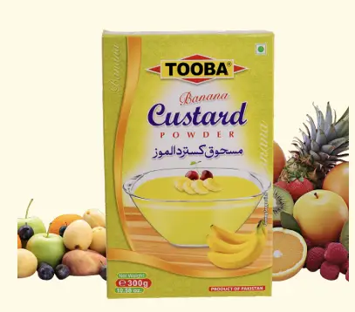  CUSTARD BANANA(300g*36Pkts)
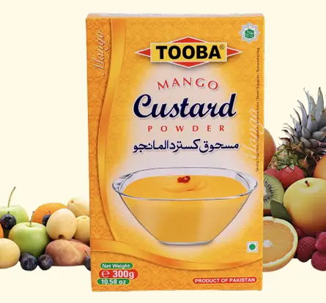  CUSTARD MANGO(300g*36 Pkts) | 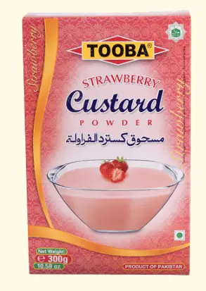  CUSTARD STRAWWBERRY(300g*36Pkts)
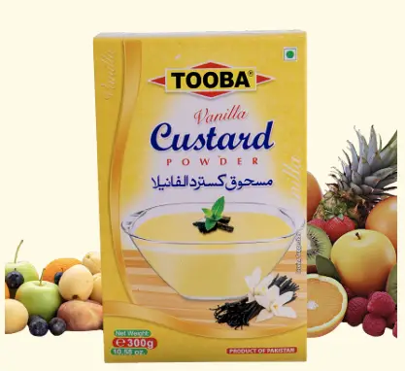  CUSTARD VANILLA(300g*36Pkts) | 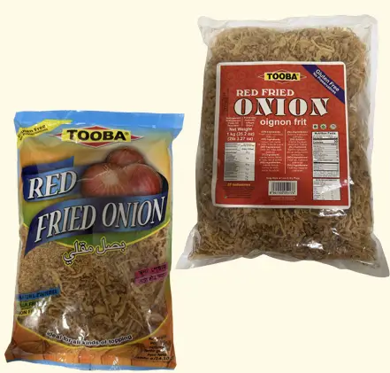  FRIED ONION(1Kg*10 Bags)
FRIED ONION(400g*24 BAGS) | 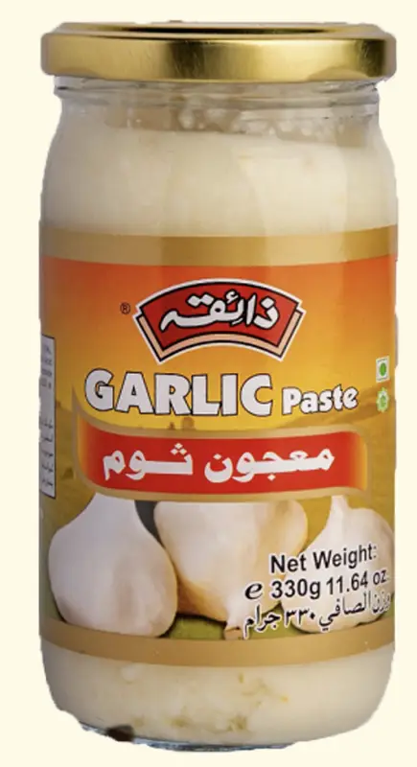  GARLIC PASTE (330g*12 GLASS JAR)
GARLIC PASTE (750g*12 PET JAR) | 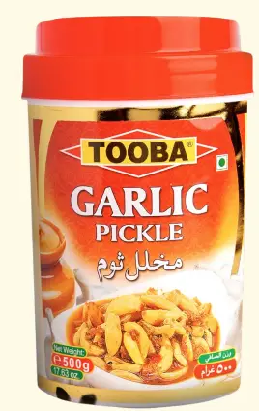  GARLIC PICKLE(1Kg*6 PET JAR)
GARLIC PICKLE(500g*12 PET JAR) | 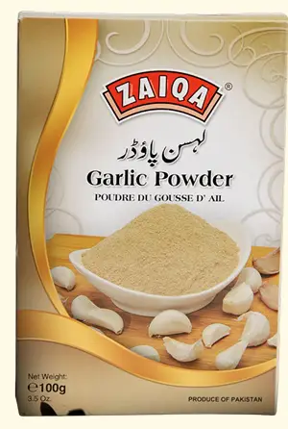  GARLIC POWDER(100g*48PKTS)
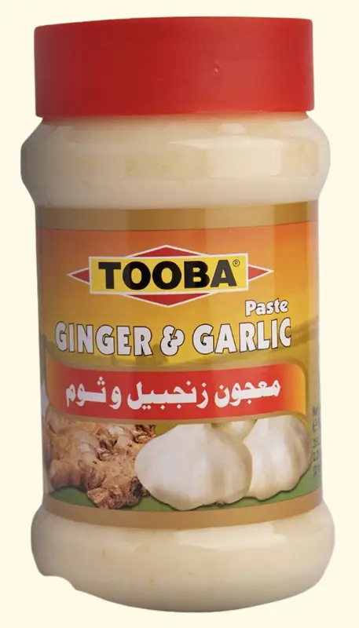  GINGER GARLIC PASTE(750g*12 PET JAR | 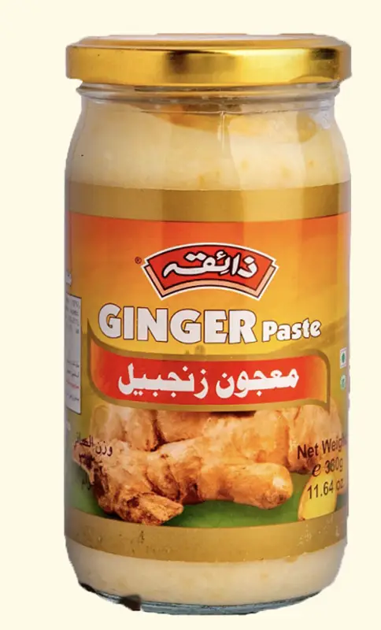  GINGER PASTE (330g *12 GLASS JAR)
GINGER PASTE(750g*12 PET JAR) | 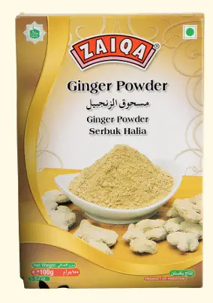  GINGER POWDER(100g*48PKTS)
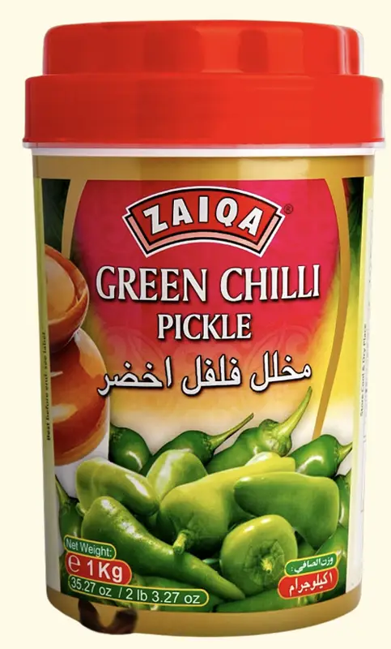  GREEN CHILLI PICKLE(1Kg*6 PET JAR) | GREEN CHILLI PICKLE(500g*12 PET JAR)
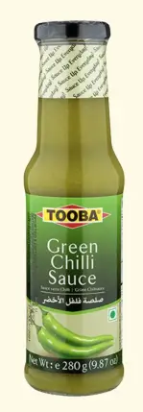  GREEN CHILLI SAUCE(280g*12GLASS BOTTLE) | 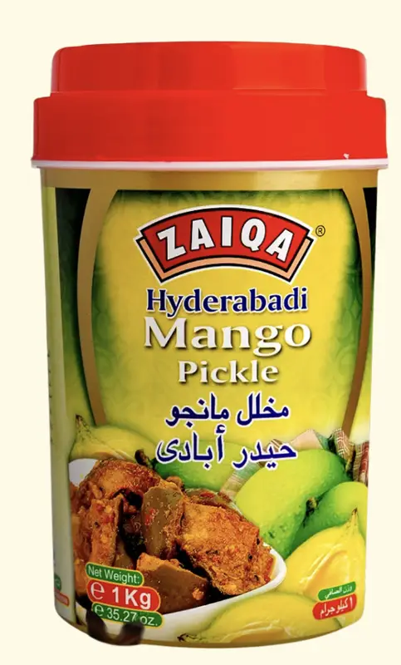  HYDERABADI MANGO PICKLE(1Kg*6PET JAR)
HYDERABADI MANGO PICKLE(500g*12PET JAR) | 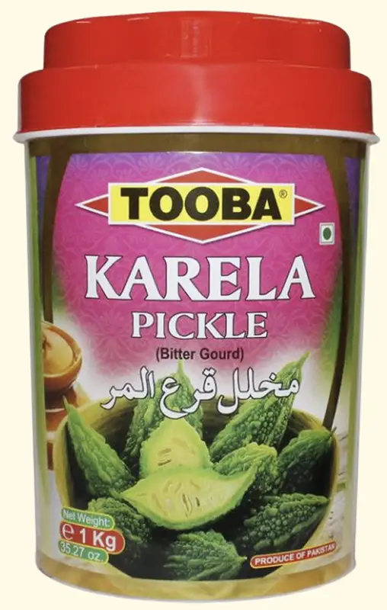  KARELA PICKLE(1Kg*6 PET JAR)
KARELA PICKLE(500g*12 PET JAR) | KEWRA WATER 12*260ML
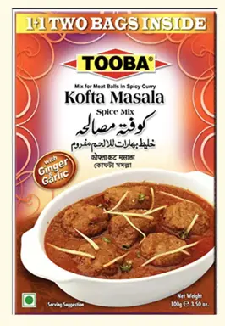  KOFTA MASALA(50+50=100g*48PKTS) | 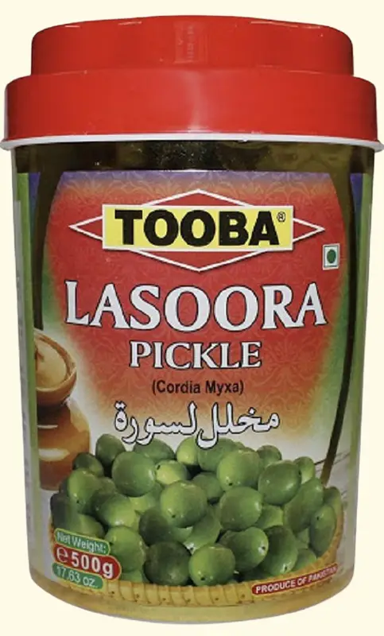  LASOORA PICKLE(1Kg*6 PET JAR)
LASOORA PICKLE(500g*12 PET JAR) | 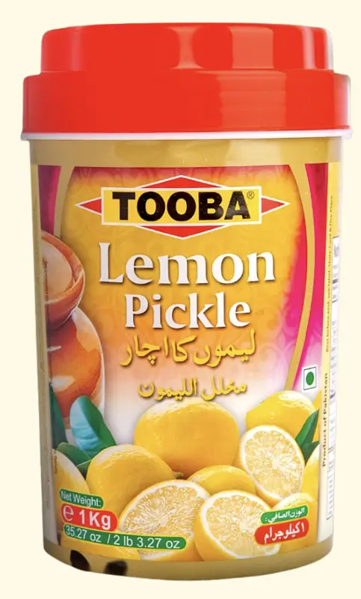  LEMON PICKLE(1Kg*6 PET JAR)
LEMON PICKLE(500g*12PET JAR) |   MANGO CHUTNEY HOT&SPICY(380g*12GLASS BOTTLE)
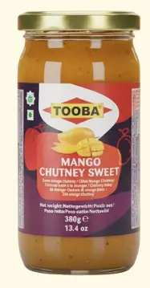  MANGO CHUTNEY SWEET(380g*12 glass bottle) | 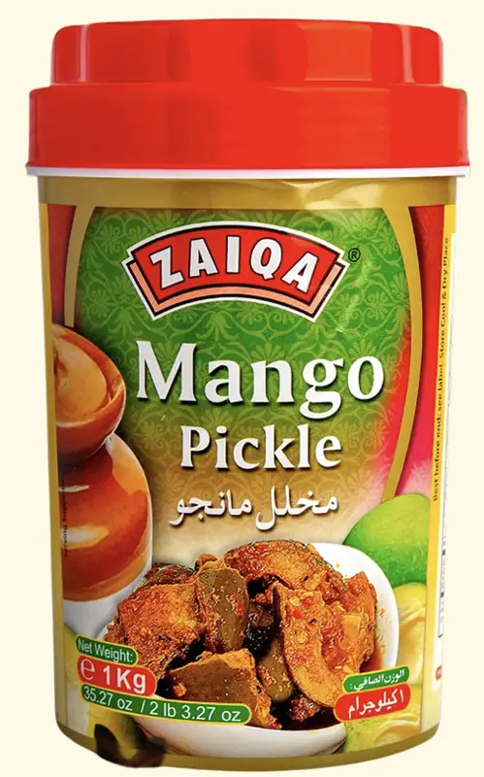  MANGO PICKLE(1Kg*6 PET JAR)
MANGO PICKLE(500g*12 PET JAR) | 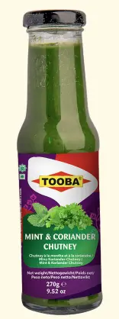  MINT & CORIANDER CHUTNEY(270g*12 GLASS BOTTLE)
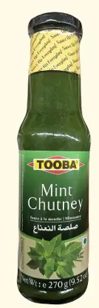  MINT CHUTNEY(270g*12 GLASS BOTTLE) | 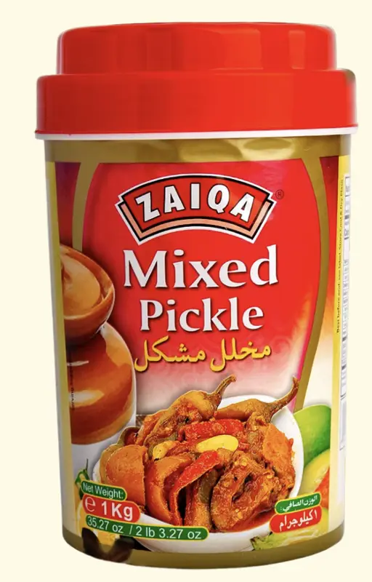  MIXED PICKLE (1Kg*6PET JAR)
MIXED PICKLE(500g*12 PET JAR) | 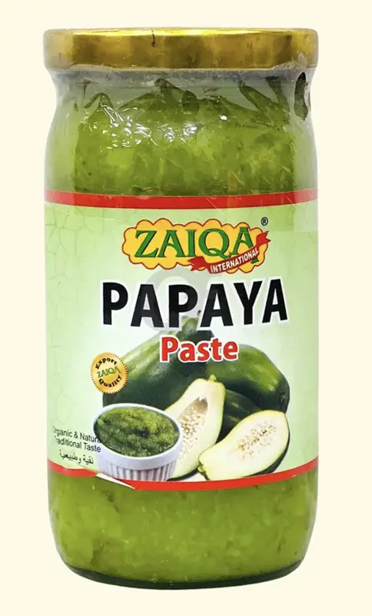  PAPAYA PASTE (750G*12PET JAR)
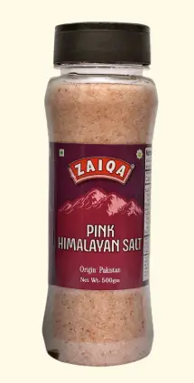  PINK SALT(500g*12PET JAR) | 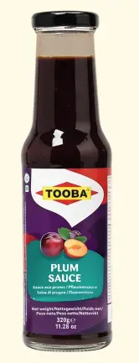  PLUM SAUCE
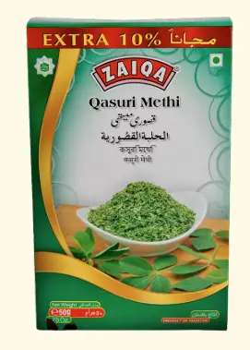  qasuri methi(1Kg*6pkts) | qasuri methi(200g*18pkts)
QASURI METHI(50g*48Pkts) | RED CHILLI CRUSHED(100g*24Pkts)
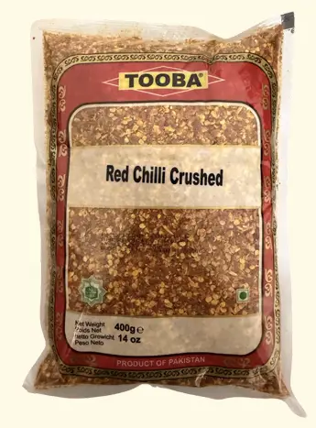  RED CHILLI CRUSHED(400g*12Pkts) | RED CHILLI POWDER(200g*24Pkts)
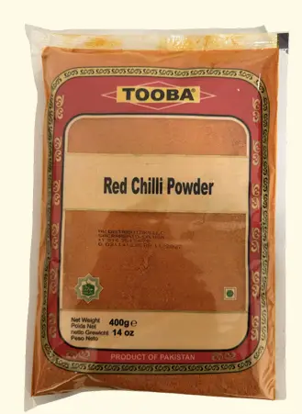  red chilli powder(400g*12pkts) | ROSE EATER (12*260ML)
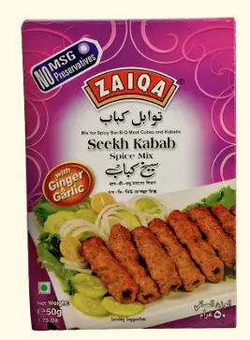  SEEKH KABAB(1.59Kg*4 PET JAR) | 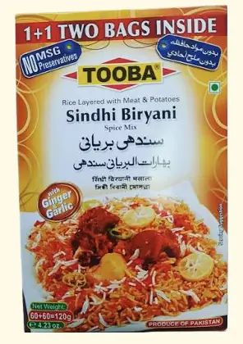  SINDHI BIRYANI SPICE MIX(60+60=120g*48PKTS)
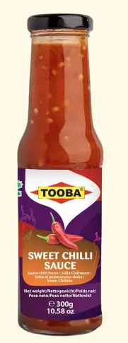
SWEET CHILLI SAUCE(300g*12GLASS BOTTLE)

Youngs Food
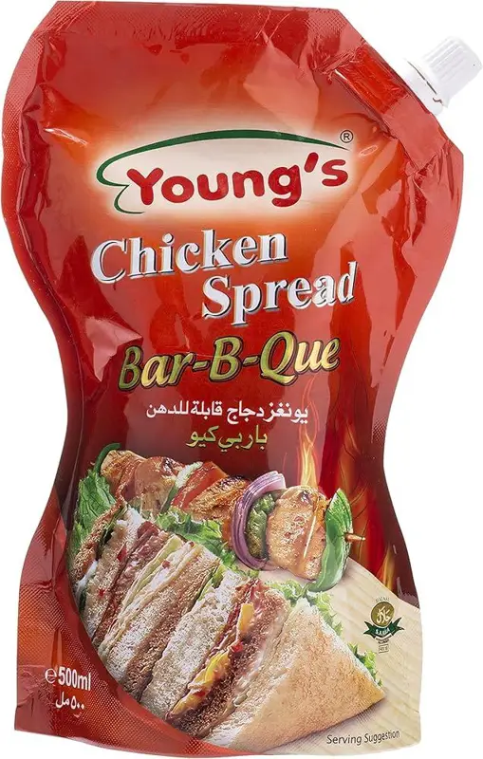  Chicken Flavor Spread BBQ | 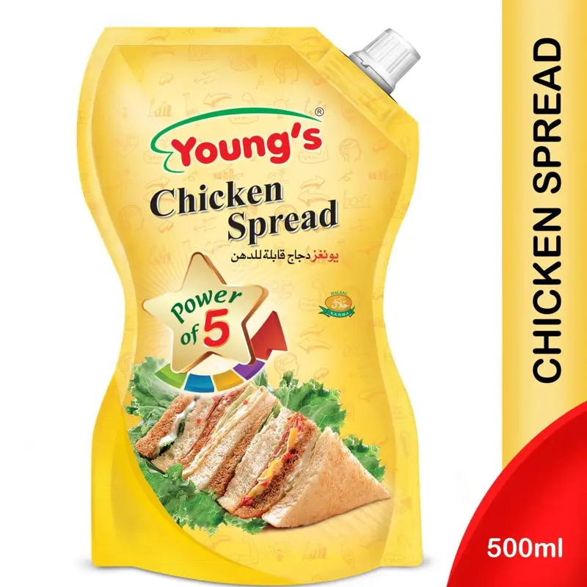  Chicken Flavor Spread Classic
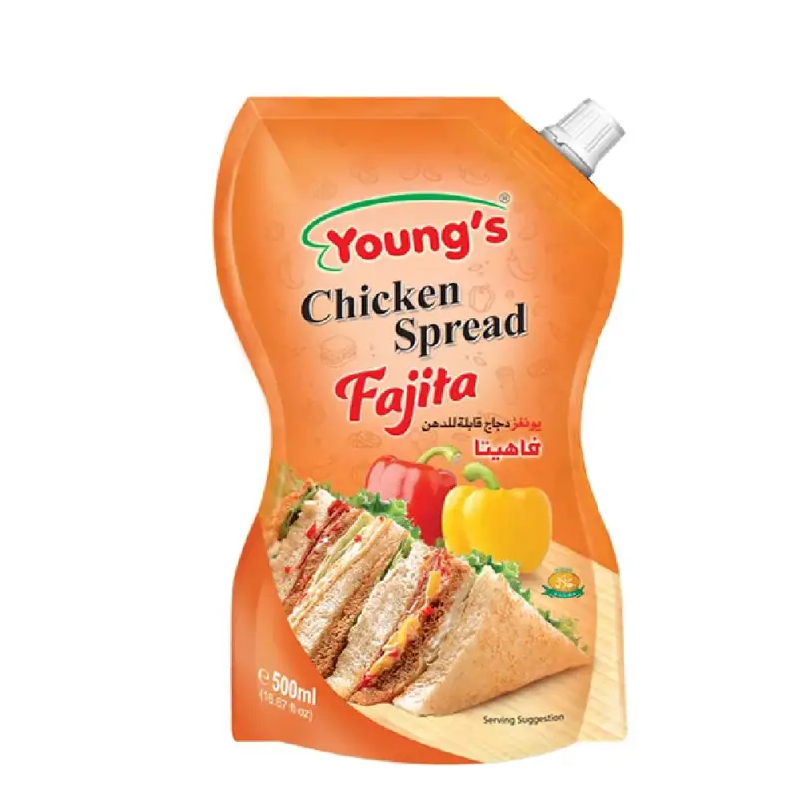  Chicken Flavor Spread Fajita | 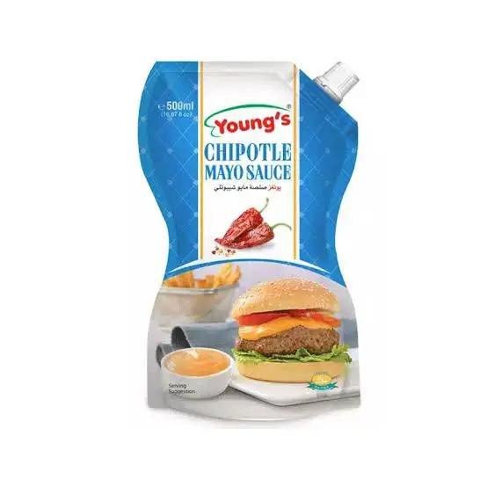  CHIPOTLE MAYO SAUCE
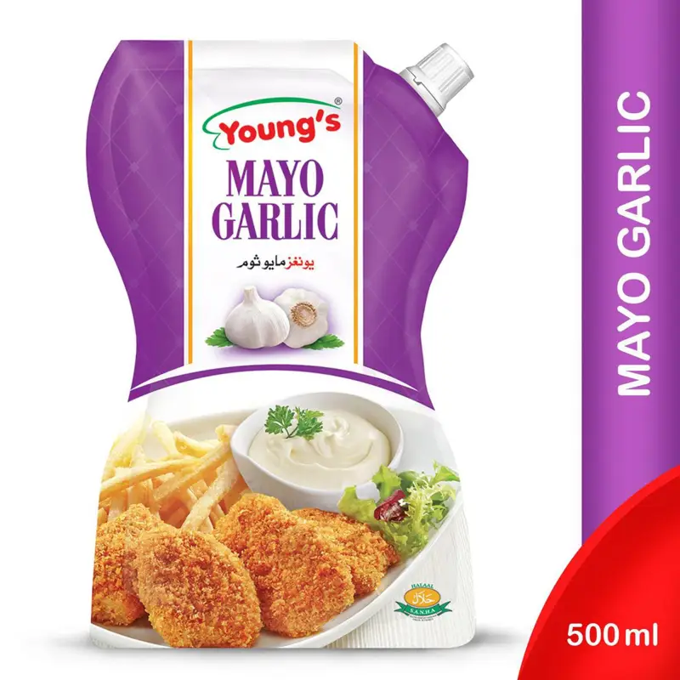  GARLIC MAYO SAUCE | 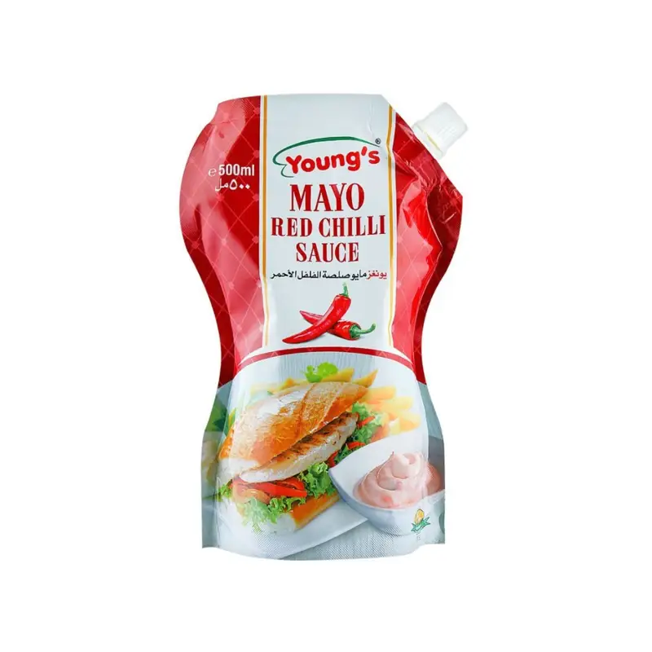  RED CHILLI MAYO SAUCE
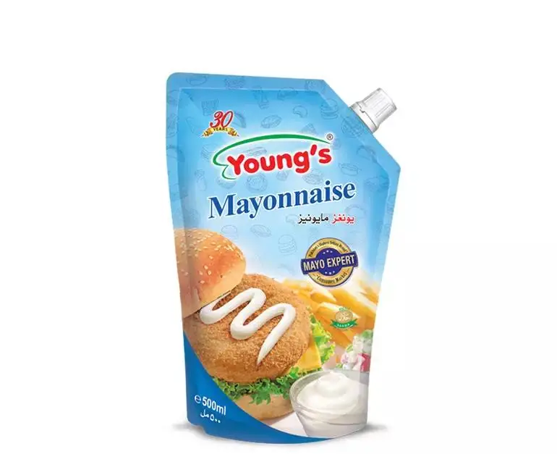  Regular Mayonnaise | 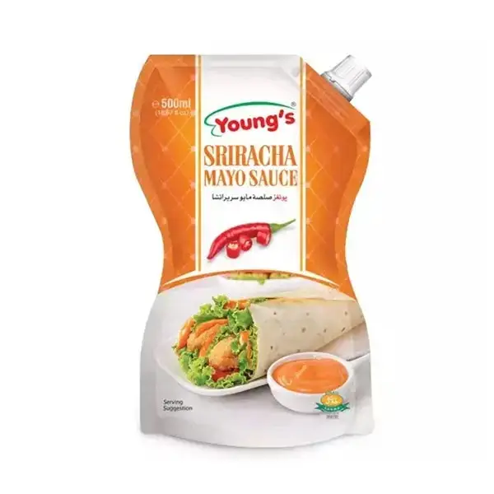  SRIRACHA MAYO SAUCE

FM-MIILEE
  DAL MONG STAND UP POUCH (90G*18) | 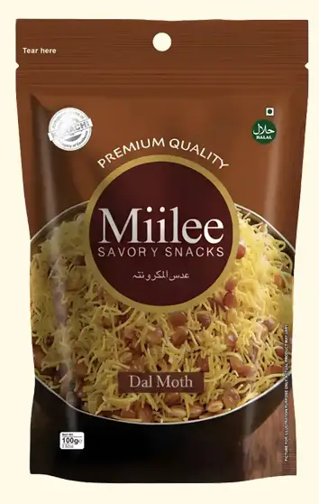  DAL MOTH STAND UP POUCH (100G*18)
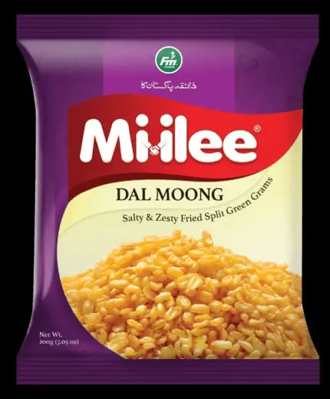  DESI DAL MONG PREMIUM 160 G | 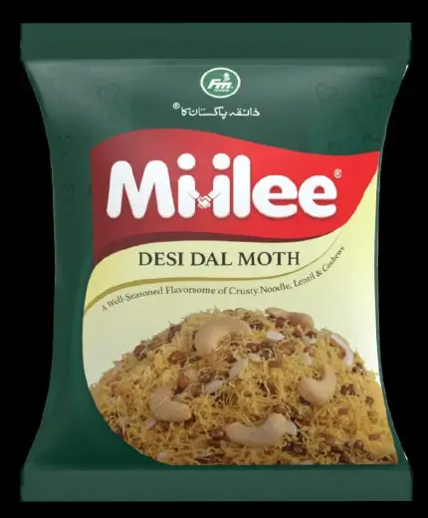  DESI DAL MOTH PREMIUM 160 G
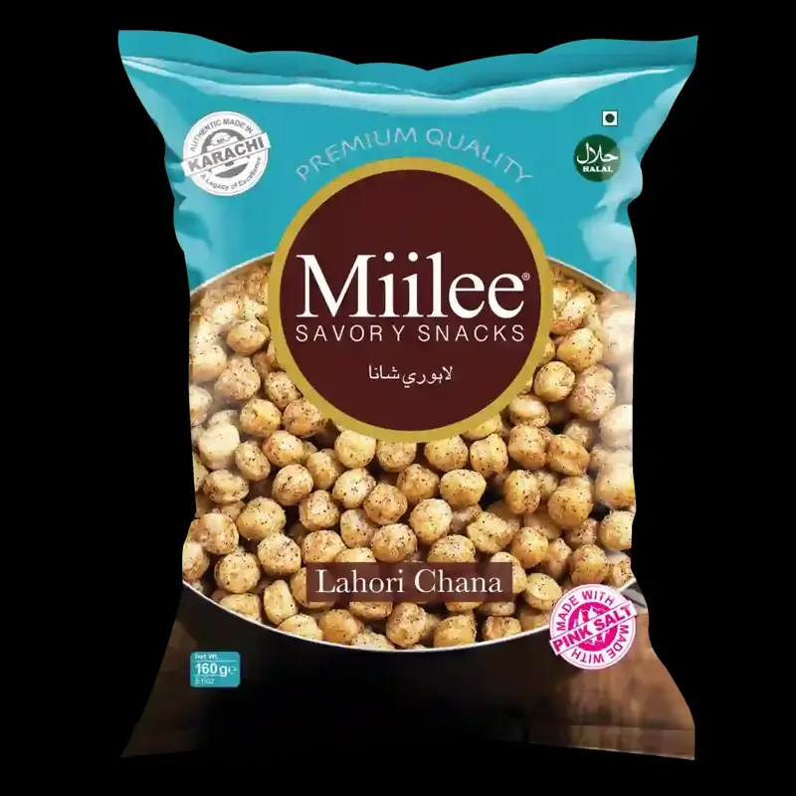  LAHORI CHANAY PREMIUM | 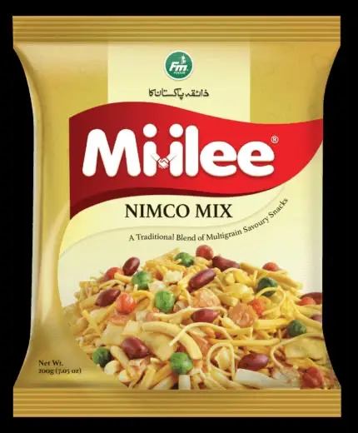  MIX NIMKO PREMIUM 200 G
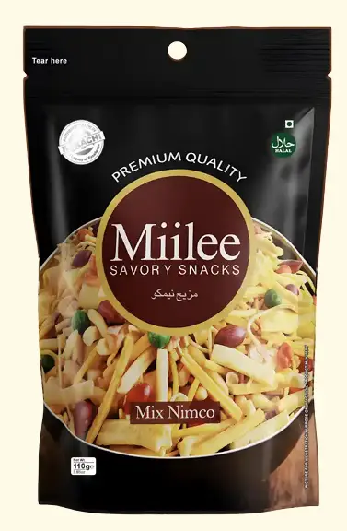  MIX NIMKO STAND UP POUCH 110G*18 | 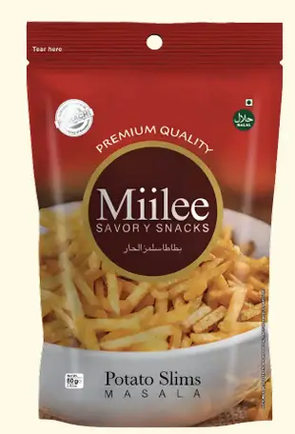  POTATO SLIMS STAND UP POUCH (80G*18)
  SMARTY SLANTY JALEPENO |   SMARTY SLANTY SALTED

SMARTY SLANTY VEGETABLE

KING
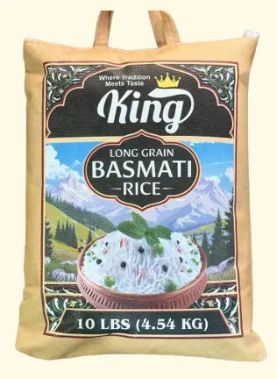  KING LONG GRAIN BASMATI RICE 10-LBS | KING LONG GRAIN BASMATI RICE 20-LBS
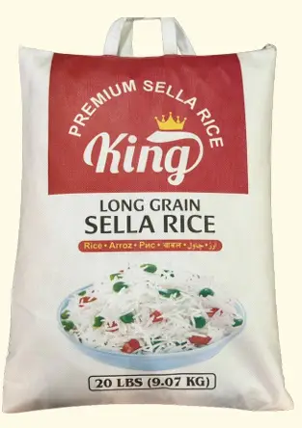  KING LONG GRAIN SELLA RICE 10-LBS | KING LONG GRAIN SELLA RICE 20-LBS

ROYAL MANGO
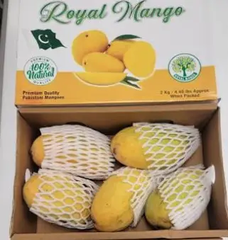
PAKISTANI MANGO BOX

Other
ZAIN FOOD-BLACK PEPPER (200G-7 OZ)

