**Atom camp - Murder Mystery Challenge**

You are working as a crime analyst in a police department. The officer gave you the crime scene report, but you somehow lost it. Somewhat you remember, that case was about a Murder that probably happened on **9th March 2023** in **Atom-city**.

Start by retrieving the corresponding crime scene report from the police department’s database. Follow the given schema diagram to find clues to reach the Murderer. The given schema can help you identify the primary and foreign keys. Find the clues, relate them with related tables using keys and solve the puzzle mystery.

Always remember that behind every case, there is a person involved, and your goal is to solve the entire case.

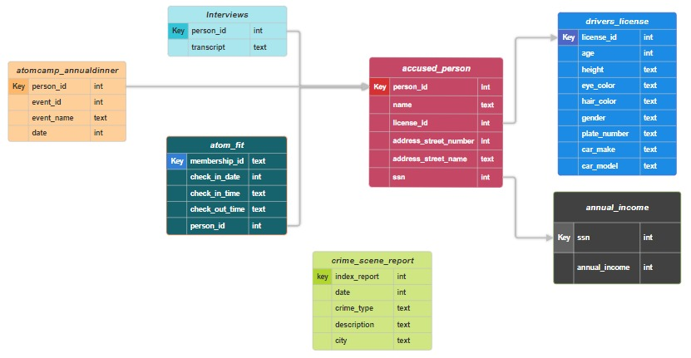

Note: Date is in the text format. 3092023 refers to month = 3, day = 09, year = 2023, 9th March,2023.