Decisio

Application Flow & Architecture Report

Operational Decision Support System
February 2026

1. System Overview
Decisio is an operational decision-support system built for industrial environments. It guides operators through structured incident diagnosis using an AI-driven 10-step diagnostic framework, then generates actionable Decision Briefs with risk-rated options.

The system captures why decisions are made, not how to execute repairs.

2. Technology Stack
Layer | Technology
Frontend | React 19 + Vite, React Router
Backend | FastAPI (Python 3.11), async + sync
AI Pipeline | LangGraph (StateGraph), LangChain
LLM | Azure OpenAI (GPT-4o)
Database | PostgreSQL (async via SQLAlchemy)
Vector Store | Qdrant (Decision Memory)
Auth | JWT + bcrypt

3. High-Level Architecture
The system consists of four main layers:
- React Frontend — Login, Incident Console, Admin Portal
- FastAPI Backend — REST API with auth, incident lifecycle, admin CRUD
- LangGraph Pipeline — 12 AI agents wired into a stateful workflow
- Persistent Storage — PostgreSQL (structured data) + Qdrant (vector search)

Data flows from the operator through the React frontend, to FastAPI, which invokes the LangGraph pipeline. Agents query PostgreSQL for equipment/safety/escalation rules and Qdrant for similar past incidents.

4. Database Schema (9 Tables)

4.1 Core Tables
Table | Purpose | Key Fields
users | System users with role-based access | username, email, user_type, hashed_password
incidents | Core incident records + state snapshot | id, report, state_snapshot (JSONB), status, mttd_seconds
qa_history | Question-answer exchanges per incident | incident_id (FK), question, answer, diagnostic_step
outcome_records | Outcome attempts (success/failure) | incident_id (FK), outcome, resolution_summary

4.2 Operational Data Tables
Table | Purpose | Key Fields
equipment | Asset registry with upstream/downstream links | id, name, equipment_type, criticality, upstream_id, downstream_id
safety_rules | Per-type and general safety rules | equipment_type, rule_text, severity_class (block/constraint), is_general
escalation_levels | Escalation hierarchy definitions | level (1-4+), name, description
escalation_rules | Condition-based escalation routing | condition, confidence_min/max, safety_impact, escalation_level
incident_reports | Historical reports for Decision Memory | title, asset_id, root_cause, resolution, diagnosis times

5. Application Routes
Route | Component | Access
/login | Login Page | Public
/* | Incident Console | Authenticated
/admin/* | Admin Portal | Admin role only

6. Complete Incident Lifecycle
This is the core user journey — from incident report to closure.

Phase 1: Incident Creation
User describes incident → POST /api/incidents
Pipeline triggered: Intake → Screening → Retrieval → Question Generation

Agent | Purpose | Output
Intake Agent | Parse report → structured Incident Card | asset_id, severity, symptoms, safety_level, normalized_summary
Screening Agent | Quick safety/risk assessment | risk_score (1-10), immediate escalation if safety = danger
Retrieval Agent | Search Qdrant for similar past incidents | retrieved_patterns, retrieval_confidence, recurrence detection
Question Agent | Generate diagnostic questions (10-step framework) | 1-3 questions per step, deduplicated against history

Phase 2: Diagnosis Loop (Steps 1-10)
User answers question → POST /api/incidents/{id}/answer
Each answer triggers: Answer Interpreter → Hypothesis Update → Safety Constraint → Advance Step → (next questions or brief)

Agent | Purpose
Answer Interpreter | Extract facts, contradictions, and confidence signals from answer
Hypothesis Update | Bayesian-style hypothesis ranking (probability 0.0 to 1.0)
Safety Constraint | Check DB safety rules → blocks, constraints, warnings + audit trail
Advance Step | Move to next diagnostic step (1 → 10)

The 10 Diagnostic Steps
Step | Category | Focus
1 | Trigger | What triggered the event?
2 | Internal Equipment | Equipment condition checks
3 | Upstream | Upstream process factors
4 | Downstream | Downstream restrictions
5 | Control System | Control/automation status
6 | Instrumentation | Sensor/transmitter accuracy
7 | Utilities | Supply availability
8 | Process Conditions | Operating parameter deviations
9 | Procedure/Human | Human factors
10 | Verification | Final confirmation checks

Loop Exit Conditions
- Confidence ≥ 80% (CONFIDENCE_THRESHOLD)
- Questions asked ≥ 30 (MAX_TOTAL_QUESTIONS)
- All 10 steps completed
- Escalation triggered

Phase 3: Decision Brief
Generated automatically when diagnosis exits: POST /api/incidents/{id}/brief
Output Field | Description
options[] | 2-4 decision options with risk_level (low/medium/medium-high/high)
overall_confidence | System confidence in the diagnosis
decision_authority | Who should approve this decision
escalation_path | Next person to escalate to if it fails
risk_summary | Plain-language risk assessment
safety_constraints | Active safety rules affecting the decision

Phase 4: Outcome Capture
User reports whether the chosen action succeeded: POST /api/incidents/{id}/outcome
- Success → Verification Gate
- Failure (< 2 attempts) → Retry Diagnosis
- Failure (≥ 2 attempts) → Escalation + Expert Capture

Phase 5: Verification & Closure
POST /api/incidents/{id}/verify
- Operator confirms trigger condition has normalized
- Records verification_notes and verification_timestamp
- If verified → Memory Write Agent stores pattern to Qdrant → CLOSED
- If not verified → Escalation triggered

Phase 6: Memory Write (Pattern Storage)
Stores the complete decision pattern to Qdrant vector DB:
Stored Field | Source
signals[] | Facts extracted during diagnosis
root_cause | Confirmed root cause
turning_point_signal | What signal changed the diagnosis direction
why_symptoms_misleading | Expert knowledge (§11)
escalation_rule | When to escalate for similar future incidents
delay_risk | What happens if action is delayed
resolution_timestamp | When it was resolved
asset_id, severity | Incident metadata

7. Escalation Flow
Escalation levels and rules are fully DB-driven (admin-configurable). The escalation agent evaluates conditions in priority order:

Priority | Condition | Level
1 | Safety interlock / danger | Max level (Shutdown)
2 | DB escalation rules match | DB-determined level
3 | Repeated failure pattern detected | Level 4 (OEM)
4 | Risk score ≥ 8.0 | Level 4 (OEM)
5 | ≥ 3 contradictions in diagnosis | Level 3 (Internal Expert)
6 | Confidence < 30% + previous failure | Level 3
7 | ≥ 2 failed attempts or high severity | Level 2 (Shift Engineer)
8 | Default (resolved at technician level) | Level 1 (Technician)

8. Admin Portal

8.1 Dashboard
- Total/open/closed incidents count
- Users, equipment, safety rules counts
- KPI Stats (§27): Average/Min/Max MTTD, escalation rate, process failure rate

8.2 Management Sections
Section | Features
Users | Create, edit, deactivate, change password, role assignment (admin/operator/engineer/viewer)
Equipment | Full CRUD with upstream/downstream linking, criticality levels, process line assignment
Safety Rules | Block/constraint/warning rules per equipment type, with general rules support
Escalation Matrix | Level definitions + condition-based routing rules with confidence ranges
Incidents | View all incidents with status, severity, confidence, and risk score
Reports | Historical incident reports with Traditional vs Structured diagnosis time comparison

Equipment Registry
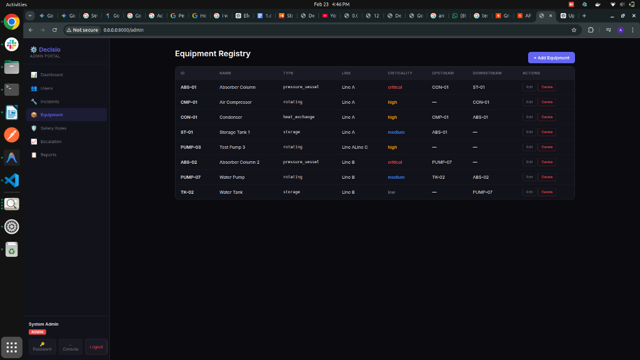

Safety Rules Management
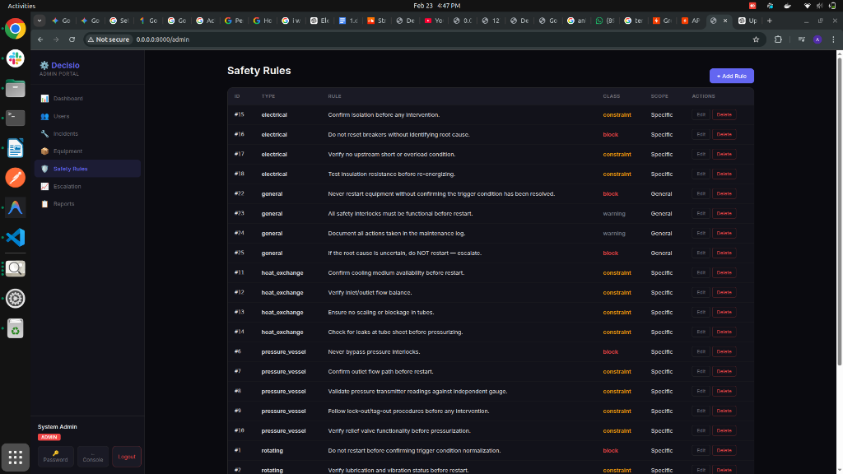

Incidents Overview
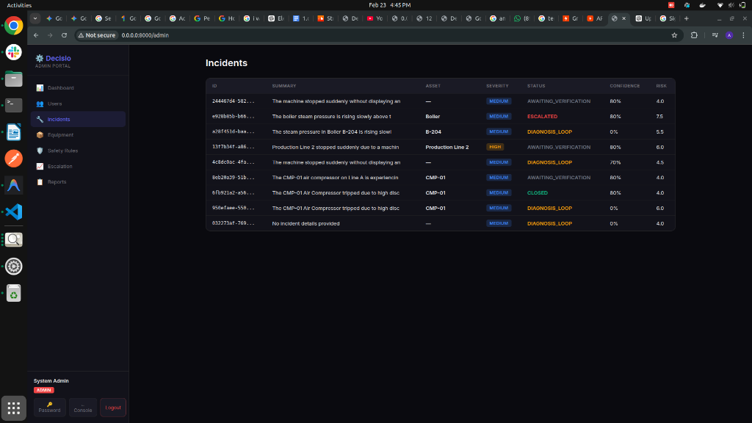

Escalation Matrix Configuration
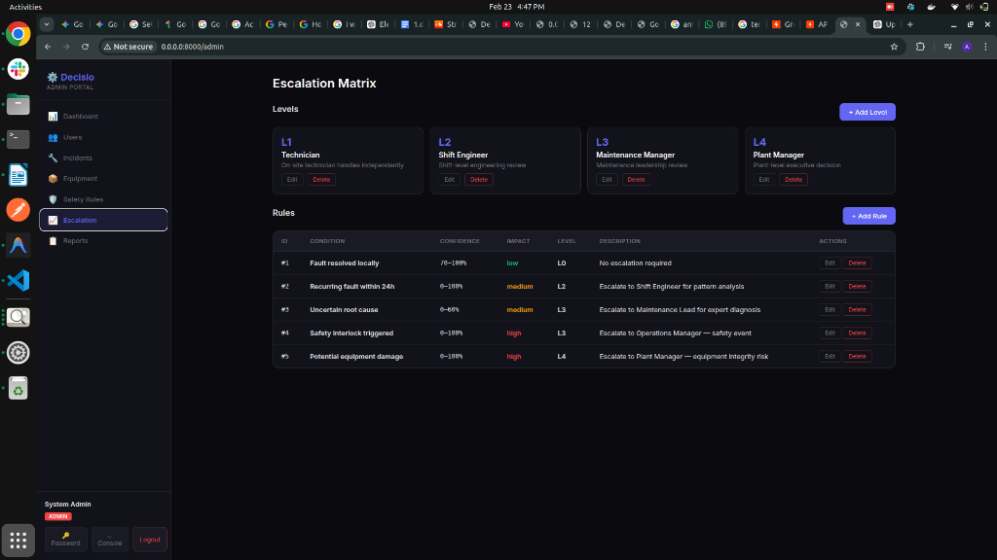

Historical Incident Reports
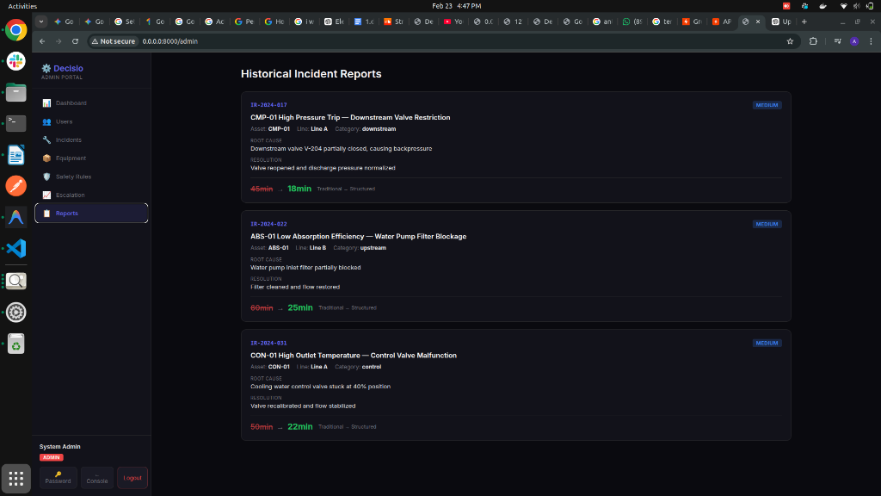

9. API Endpoint Summary

9.1 Incident Lifecycle
Method | Endpoint | Purpose
POST | /api/incidents | Create incident, run intake pipeline
GET | /api/incidents/{id} | Get incident state
POST | /api/incidents/{id}/answer | Submit diagnostic answer
POST | /api/incidents/{id}/brief | Force-generate decision brief
POST | /api/incidents/{id}/outcome | Submit outcome (success/failure)
POST | /api/incidents/{id}/verify | Verify resolution + close
GET | /api/incidents | List all incidents

9.2 Authentication
Method | Endpoint | Purpose
POST | /api/auth/login | JWT authentication
POST | /api/auth/register | Bootstrap first admin
GET | /api/auth/me | Current user info
PUT | /api/auth/change-password | Self-service password change

9.3 Admin CRUD
Resource | Endpoints
Users | GET / POST / PUT / DELETE /api/admin/users
Equipment | GET / POST / PUT / DELETE /api/admin/equipment
Safety Rules | GET / POST / PUT / DELETE /api/admin/safety-rules
Escalation Levels | GET / POST / PUT / DELETE /api/admin/escalation/levels
Escalation Rules | GET / POST / PUT / DELETE /api/admin/escalation/rules
Dashboard | GET /api/admin/dashboard
KPIs | GET /api/admin/stats/kpis

9.4 Operational Data (Read-Only)
Method | Endpoint | Purpose
GET | /api/equipment | Equipment registry
GET | /api/safety-rules | Safety rules (filterable by type)
GET | /api/escalation-matrix | Escalation levels + rules
GET | /api/incident-reports | Historical reports

10. Data Flow Summary
Complete round-trip data flow:

1. Operator reports incident via React frontend
2. Frontend calls POST /api/incidents
3. FastAPI runs the LangGraph intake graph (Intake → Screening → Retrieval → Questions)
4. Agents query PostgreSQL for equipment info and safety rules
5. Retrieval Agent searches Qdrant for similar past patterns
6. State is saved to PostgreSQL, response returned to frontend
7. Diagnosis loop: each answer triggers Answer → Hypothesis → Safety → Advance → Questions
8. When confident enough, Decision Brief is generated with risk-rated options
9. Operator executes chosen option and reports outcome
10. On success: verification gate → memory write to Qdrant → incident CLOSED
11. On failure: escalation agent determines level → expert capture if needed

11. Key Design Principles
Database as Source of Truth: Equipment, safety rules, and escalation config are admin-managed in PostgreSQL
Decision Logic, Not Repair Steps: System records why decisions were made, not how to fix things
10-Step Diagnostic Framework: Systematic elimination of root causes across all failure categories
Verification Gate: Incidents cannot close without confirming the trigger condition has normalized
Decision Memory: Resolved incidents become searchable patterns for future similar incidents
Fuzzy Deduplication: Questions are deduplicated against Q&A history to prevent repetition
Audit Trail: Every safety rule activation is tracked with rules_applied

12. Project File Structure
Path | Purpose
api.py | FastAPI backend (1200+ lines, 30+ endpoints)
frontend/src/App.jsx | React router (3 routes)
frontend/src/LoginPage.jsx | JWT login page
frontend/src/IncidentConsole.jsx | Main operator UI (chat-based diagnosis)
frontend/src/AdminPortal.jsx | Admin dashboard + CRUD (7 sections)
frontend/src/api.js | Frontend API client functions
src/graph.py | LangGraph workflow (3 sub-graphs)
src/state/state.py | DecisioState TypedDict + Pydantic models
src/agents/ (12 files) | 12 LangGraph agents
src/data/assets.py | Equipment lookups (DB-only)
src/data/safety_rules.py | Safety rule lookups (DB-only)
src/data/escalation_matrix.py | Escalation lookups (DB-only)
src/db/models.py | SQLAlchemy ORM (9 tables)
src/db/session.py | Async + sync session factories
src/db/sync_queries.py | Sync DB queries for agents
src/db/crud.py | Async CRUD operations
src/db/seed.py | Database seeder
src/llm.py | LLM client setup (Azure OpenAI)
src/auth.py | JWT + bcrypt authentication

