

University of Engineering and Technology, Lahore
Department of Computer Science

Project Report
Team Members
Name | Roll Number | Email
Muhammad Umar | 2025-CS-90 | umarbutt9514@gmail.com
Muhammad Hassam Jameel | 2025-CS-72 | hassamjamil9@gmail.com
Session: Fall'25 Morning/Evening Section: B Semester: 1st
Course: CSC101 - Discrete Mathematics Teacher: Mr. Waqas Ali
January 3, 2026
- Project Title
Comparative Analysis of String-Matching Algorithms with Basic Plagiarism Detection
Project Links
Github:
https://github.com/hassamjamildesign/string-matching-algorithms.git
Linked in:
https://www.linkedin.com/posts/muhammad-hassam-jamil-308a23389_i-worked-on-a-string-analyzer-project-activity-7414380348232417280-hdky?utm_source=share&utm_medium=member_desktop&rcm=ACoAAF-5v_gBHmPYdlMd8Qx0d-76_Q0aSnhyujQ

- Chosen Track
☑ Track 3: Algorithm Design & Analysis (Rosen Ch. 3)

3. Overview
This project implements three string-matching algorithms (Brute Force, KMP, Boyer-Moore) and a basic plagiarism detector, comparing their performance through empirical testing and complexity analysis.

4. Summary
String matching is fundamental in computer science with applications in text editors, plagiarism detection, and DNA sequencing. This project implements three algorithms with different efficiency characteristics and adds a simple document comparison feature.
We implemented Brute Force (naive), KMP (linear with preprocessing), and Boyer-Moore (sublinear in practice). Additionally, we created a basic plagiarism detector that compares documents characterby-character—a simplified approach suitable for first-semester students rather than advanced similarity metrics.
Our methodology involved C++ implementation, comprehensive testing with multiple scenarios, and performance measurement tracking comparisons and execution time. The project successfully demonstrates how theoretical complexity analysis translates to real-world performance, bridging discrete mathematics theory with practical software development.

5. Technology Stack & Libraries Utilized
Programming Languages:
C++ (C++11 or higher) - Selected for performance and standard library support Libraries:
<iostream> - Input/output operations
<fstream> - File operations
<string> - String manipulation
<chrono> - High-resolution timing
<vector> - Dynamic arrays for LPS table
<windows.h> - Console coloring (Windows-specific)
Development Environment:
Compiler: MinGW-w64 (GCC)
IDE: Visual Studio Code / Code::Blocks
OS: Windows 10/11

6. List of Features
Core Features:
Brute Force Algorithm: Naive pattern matching [Core]
KMP Algorithm: Linear-time with LPS preprocessing [Core]
Boyer-Moore Algorithm: Right-to-left with bad character heuristic [Core]
Performance Tracking: Comparisons, matches, execution time [Core]
Multiple Input Methods: Predefined tests, custom input, file input [Core]
Plagiarism Detection: Character-by-character document comparison [Core]
Enhanced Features:
Predefined Test Suite: 4 test cases covering various scenarios
Colorized Output: Color-coded results for clarity
Match Position Reporting: Shows exact match locations

7. Mathematical Foundations
7.1 Algorithm Complexity (Rosen Ch. 3.2, 3.3)
Big-O Notation: f(n) is O(g(n)) if constants c, n₀ such that f(n) ≤ c·g(n) for all n ≥ n₀.
7.2 Brute Force Analysis Worst Case: O(n·m)
Best Case: O(n)
Space: O(1)
7.3 KMP Analysis
Preprocessing: O(m) Searching: O(n)
Total: O(n + m) Space: O(m)
7.4 Boyer-Moore Analysis
Best Case: O(n/m)
Worst Case: O(n·m)
Average: O(n)
Space: O(256)
7.5 Plagiarism Detection
Similarity Formula: Similarity = (matches / min(n₁, n₂)) × 100%
Time: O(min(n₁, n₂))
Space: O(1)

8. Examination of Key Functions/Methods
8.1 Brute Force
for (int i = 0; i <= n - m; i++) { int j = 0; while (j < m) { comparisons++; if (text[i + j] == pattern[j]) j++; else break; } if (j == m) matches++; }
8.2 KMP (LPS Construction)
vector<int> lps(m, 0); int j = 0; for (int i = 1; i < m; i++) { while (j > 0 && pattern[i] != pattern[j]) j = lps[j - 1]; if (pattern[i] == pattern[j]) j++; lps[i] = j; }
8.3 Boyer-Moore (Bad Character)
int badChar[256]; for (int i = 0; i < 256; i++) badChar[i] = -1; for (int i = 0; i < m; i++) badChar[(int)pattern[i]] = i;
while (shift <= n - m) { int j = m - 1; while (j >= 0 && pattern[j] == text[shift + j]) j--; if (j < 0) { matches++; shift += (shift + m < n) ? m - badChar[text[shift + m]] : 1; } else { shift += max(1, j - badChar[text[shift + j]]); }
}
8.4 Plagiarism Detection
int limit = (len1 < len2) ? len1 : len2; int matches = 0;
for (int i = 0; i < limit; i++) { if (doc1[i] == doc2[i]) matches++; }
double similarity = (matches * 100.0) / limit;
if (similarity > 70) cout << "HIGH similarity"; else if (similarity > 40) cout << "MEDIUM similarity"; else cout << "LOW similarity";

9. Limitations
9.1 Scope Limitations
Case-sensitive matching only
Basic plagiarism detection (position-dependent)
Single pattern matching
Cannot detect paraphrased or rearranged content
9.2 Performance Constraints
Large files may exceed RAM
Match display disabled for texts > 1000 chars
Windows-dependent (not cross-platform)
9.3 Algorithmic Limitations
Boyer-Moore uses only bad character rule
ASCII-only (no Unicode)
Simple plagiarism detection unsuitable for real use

10. User Interface
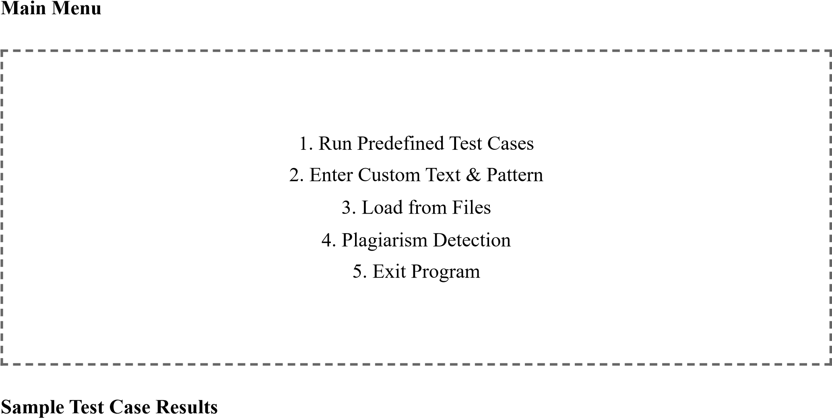
Test 1: Pattern at end - Boyer-Moore: 22K comparisons (0.89ms), Brute Force: 1.8M comparisons (2.45ms)
Test 3: Worst case - KMP best with 400K comparisons vs Brute Force 3.2M

11. Future Improvements
Cross-platform support (ANSI colors)
Case-insensitive matching
Jaccard similarity for plagiarism
GUI interface
Full Boyer-Moore with good suffix rule
Multi-pattern search (Aho-Corasick)

12. Conclusion
This project successfully implemented three string-matching algorithms and basic plagiarism detection. We learned how theoretical complexity translates to practice, with Boyer-Moore often outperforming others despite similar asymptotic complexity. The pragmatic choice to implement simple plagiarism detection appropriate for our skill level taught us valuable lessons about realistic project scoping. This project bridges discrete mathematics theory with practical implementation, demonstrating algorithm analysis is crucial for efficient software.

13. References & Learning Sources
Rosen, K. H. Discrete Mathematics and Its Applications (8th ed.), Chapters 2-3
GeeksforGeeks - KMP and Boyer-Moore tutorials
YouTube: Abdul Bari - String Matching Algorithms
C++ Reference Documentation: cppreference.com
ChatGPT - Concept clarification and report formatting
End of Report

