1. inactivate button doesnt work sometimes:

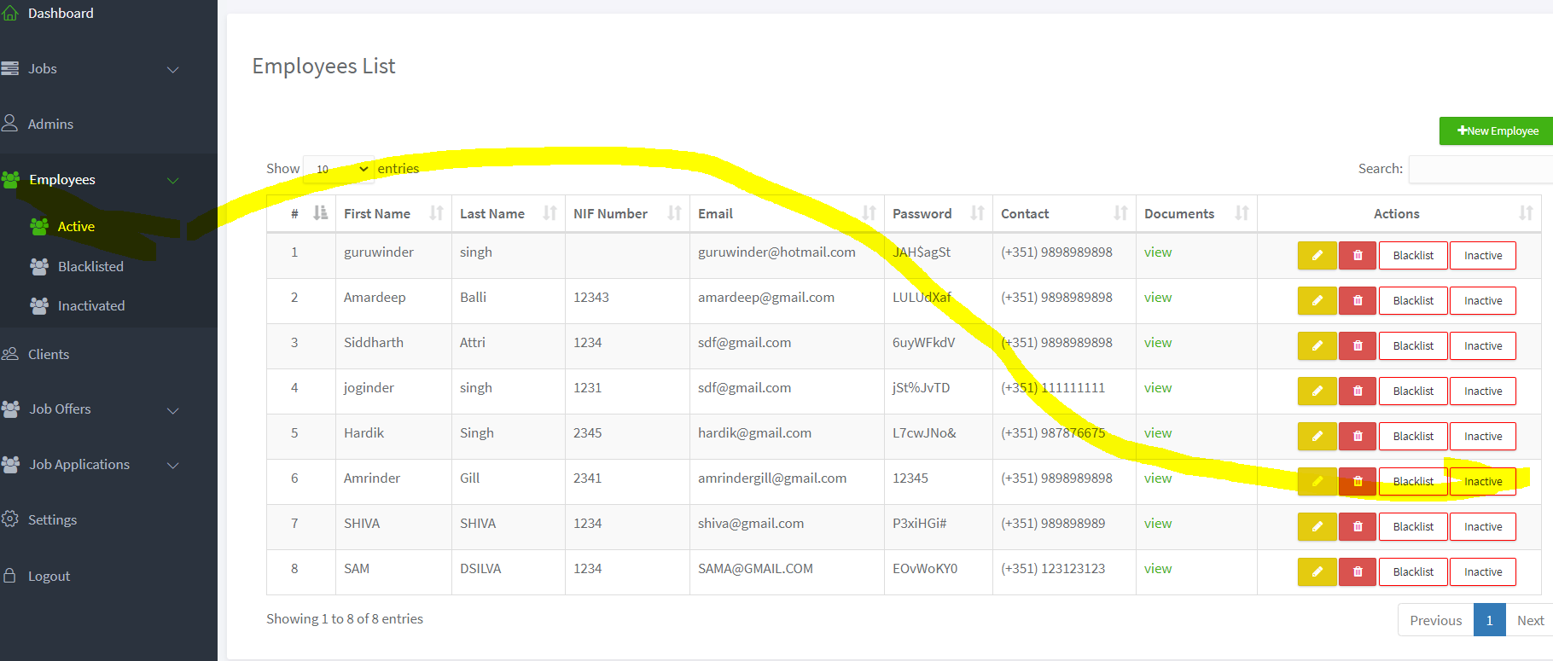

When i click on above highlighted employee inactivate button:

So i get:

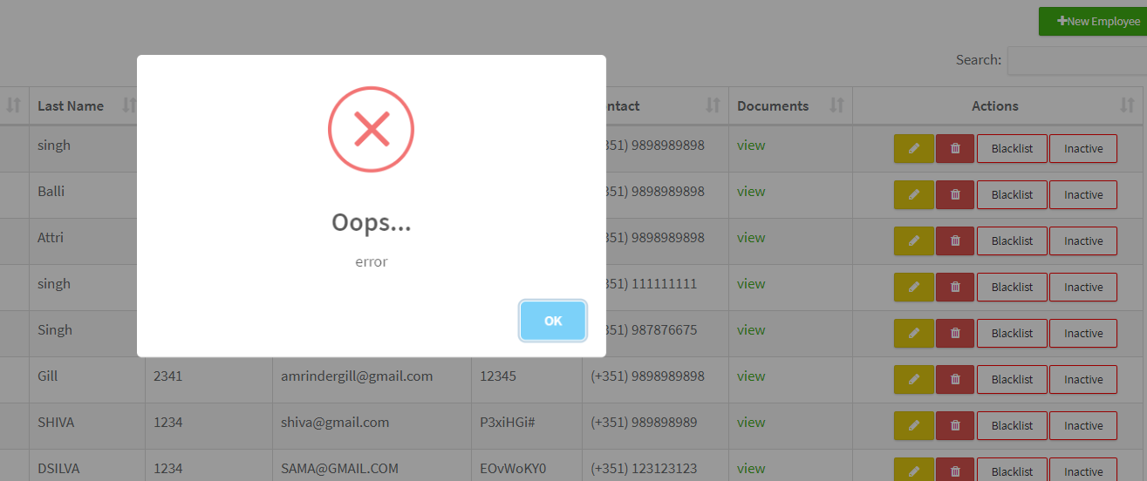

2. Download docs is not working

Go to employee screen:

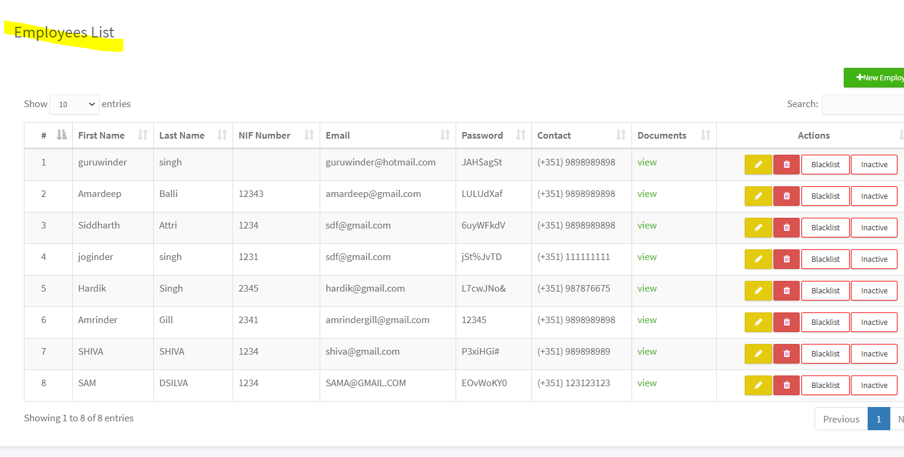

Click on view hyperlink:

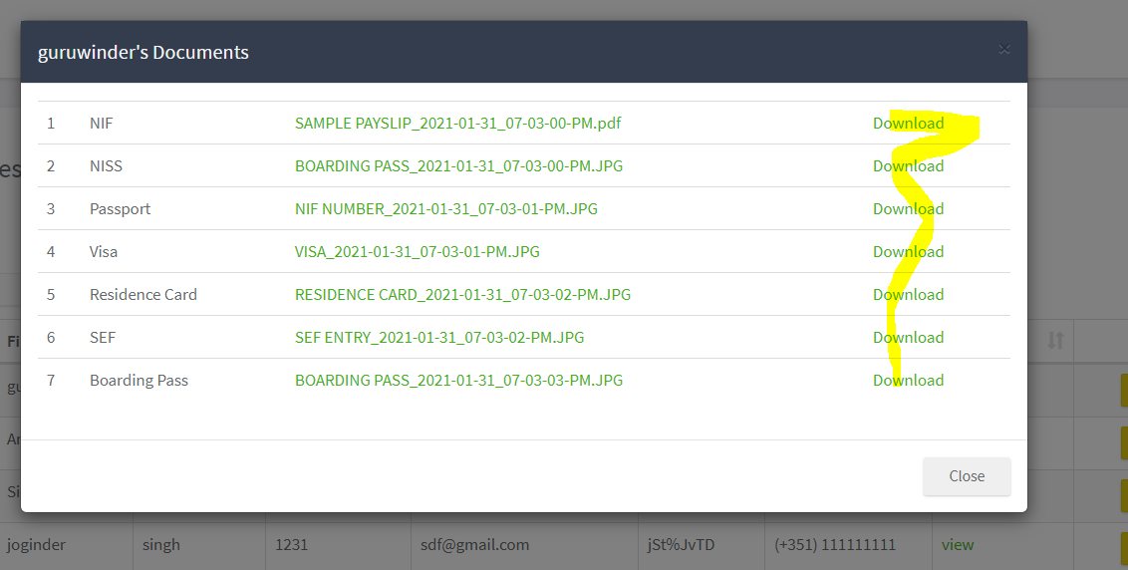

Click on any of download:

So we are getting:

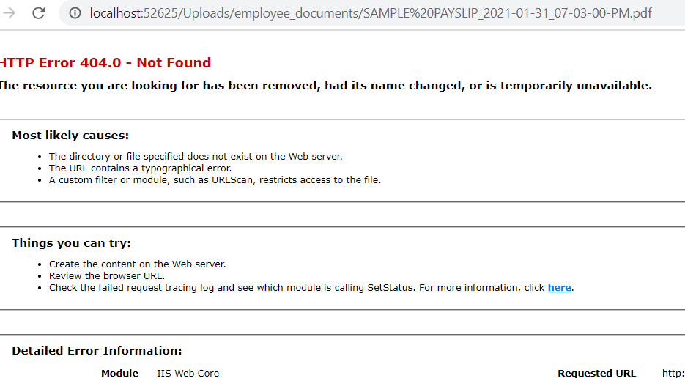

3.when i click on CONTACT its not navigating :

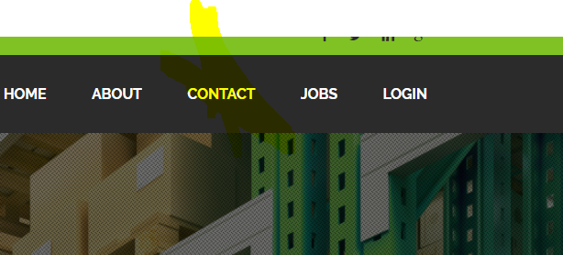

4. There is a privacy policy in hosted website:



We need to add it in our website as well

5. The message should be a description box kind of and also, configure it to email as [geral@workpermit.pt](mailto:geral@workpermit.pt). Whoever writes the query, it goes into this email ID.

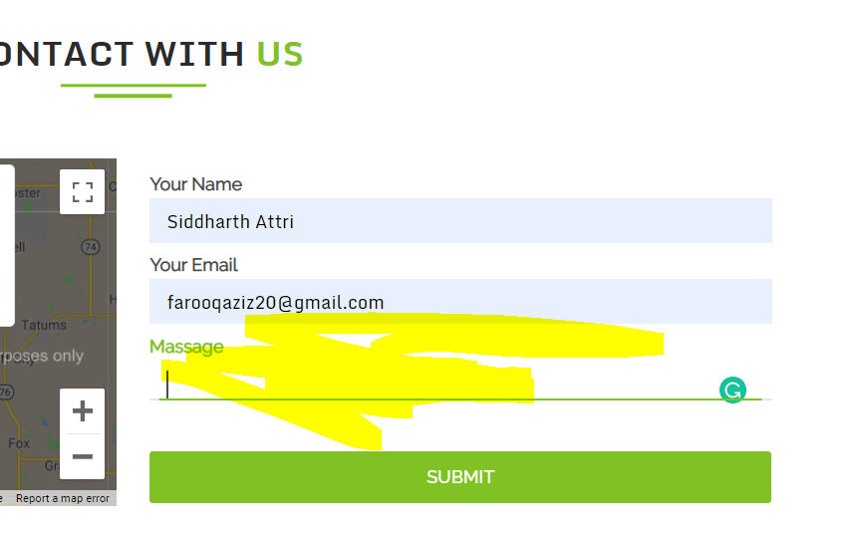

6.In add a new client section inside admin login, phone number length validation is done only for one contact and not for second contact.

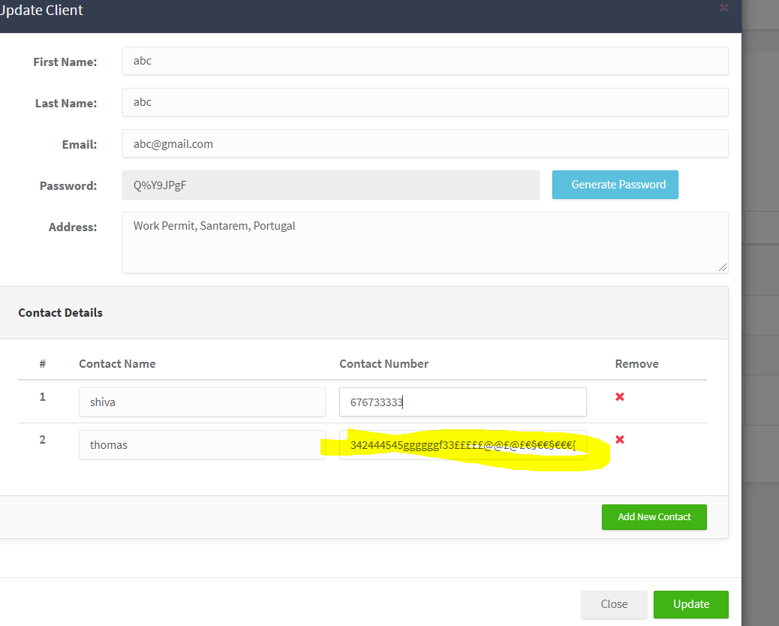

9.If I assign an employee to one job, he is still showing up in another job assign emp pop up.

10. WHEN I MOVE A JOB TO "START JOB" FROM "UPCOMING JOBS" THEN IT IS GENERATING AN ALERT FOR THE NUMBER OF DAYS LEFT. BUT THIS IS SHOWING WRONG NUMBER OF DAYS LEFT. FOR EXAMPLE IF I POST A JOB FROM MONDAY TO FRIDAY i.e FOR 5 DAYS AND WHEN I MOVE IT THEN ALERT WON'T TELL 5 DAYS LEFT BUT SOME 2 OR 3 DAYS.

9. We missed on data saving in excel part : When admin receives a job application from an applicant, admin should be able to save it in excel by right clicking on the table.

10. Please mention phone numbers and email id in below home page header as:

+351 917 773 737

geral@workpermit.pt

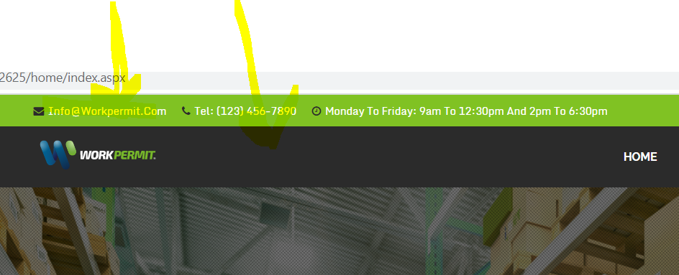

11. Driving license dropdown with Yes/ NO option has to be added in apply job screen:

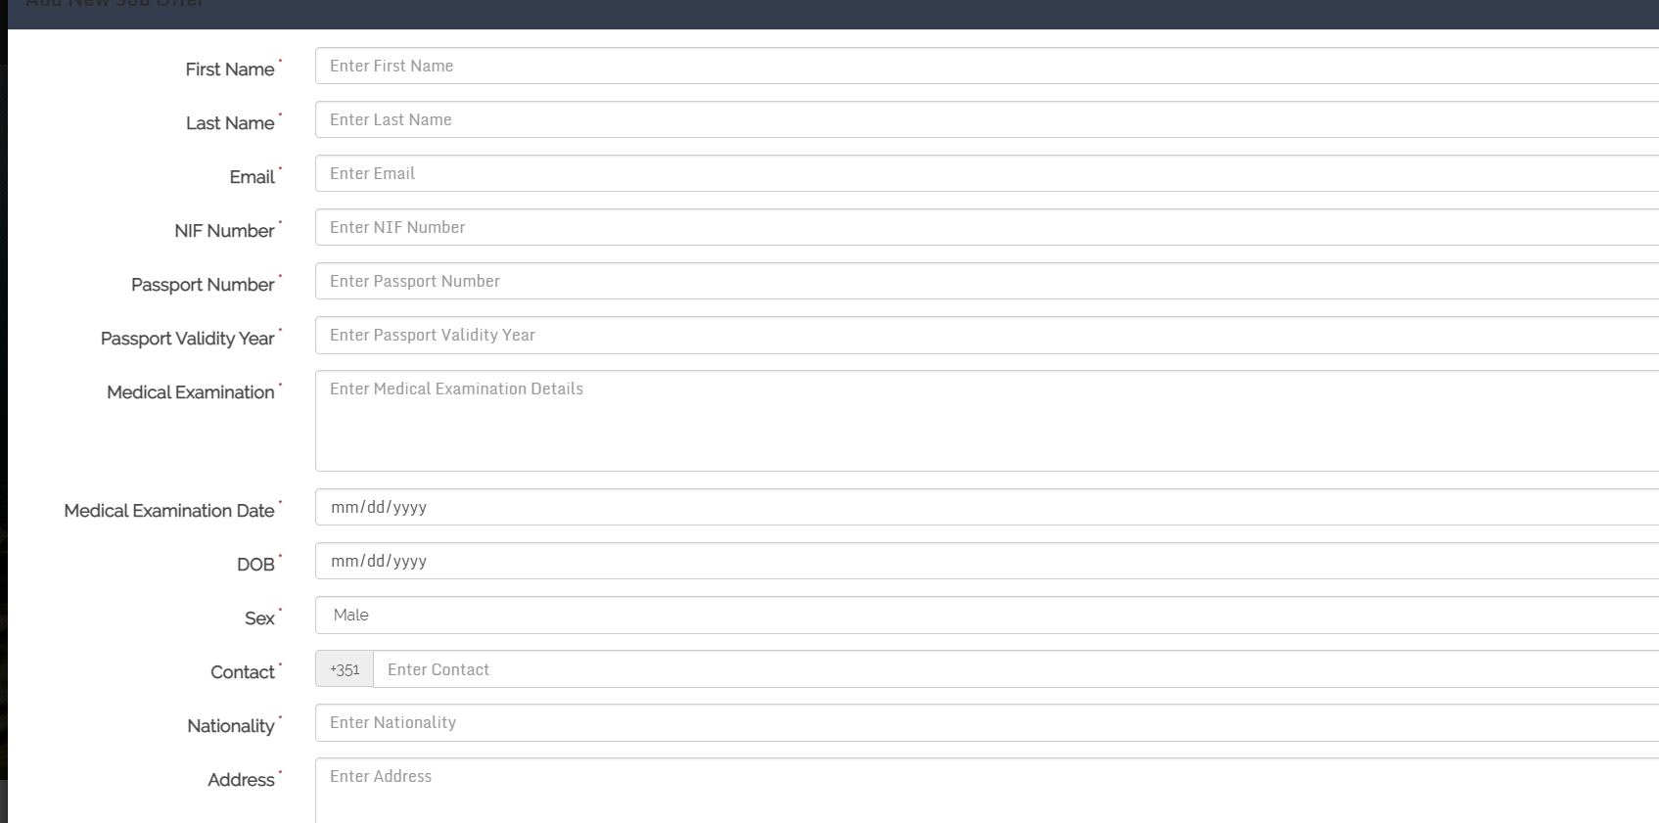

3. When an employee apply for new jobs in sectors , he needs to upload all the documents like we do it inside admin

At the moment, he can upload only 2 documents:

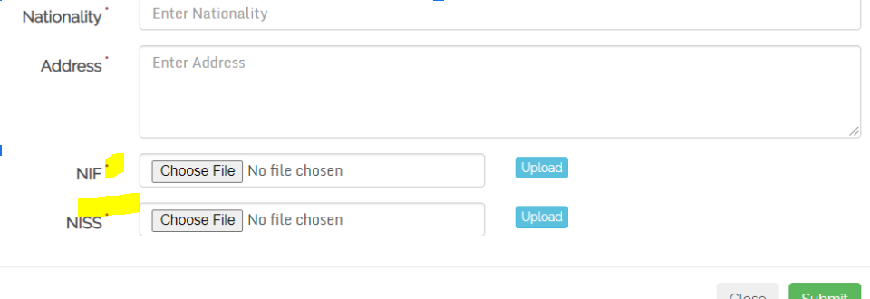

Driving license (YES/ NO)

In apply new job passport validity should be a date field:

