**#4a4a4a**

**NEW REQUIREMENT**

**1**. When an employee is assigned to a client, a separate job contract is made between client and employer(work permit) which is also called (CUTT) document

This document work permit admin and client should be able to see. So just a upload doc field has to be added with the label name as CUTT.

**2**. Client should not be able to see all docs of the employees which admin upload at the time of hiring, client should only and only see below fields:

**OPERATOR ID**

**NISS**

**NIF**

**Residence card no**

**Health care number**

**CUTT**(Job contract)

**Medical document** (sometimes when employee is off sick, work permit needs a medical from doctor, which employee provides to work permit and admin uploads it to system which should be visible to the client as well)

3. Operator ID client provides to the employee assigned to him

------------------------------------------------------------------------------------------------------------------------------

**ISSUES**

1. When i click on CONTACT its not navigating:



2. There is a privacy policy in already hosted website:

We need to add it in our website as well



3. The message should be a description box kind of and also, configure it to email as [geral@workpermit.pt](mailto:geral@workpermit.pt). Whoever writes the query in description box, it goes into “[geral@workpermit.pt](mailto:geral@workpermit.pt)”email ID.

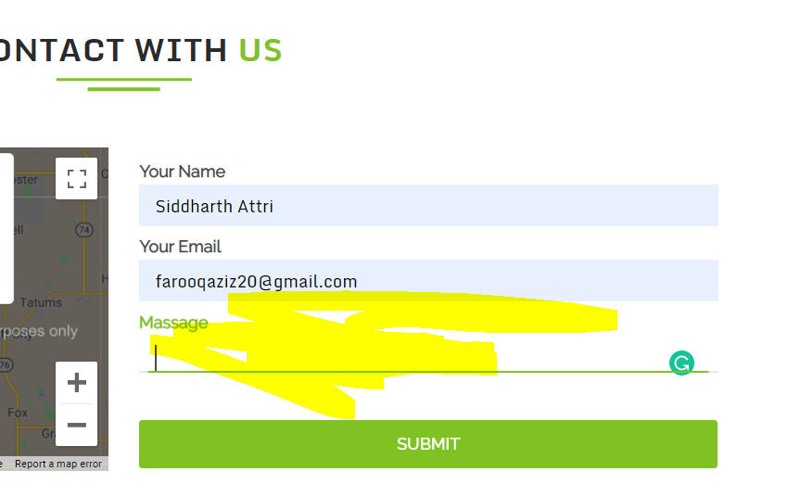

4. We missed on export excel : When an admin receives a job application from an applicant, the admin should be able to save it in excel by right clicking on the table.

5. Please mention phone numbers and email id in below home page header as:

+351 917 773 737

geral@workpermit.pt

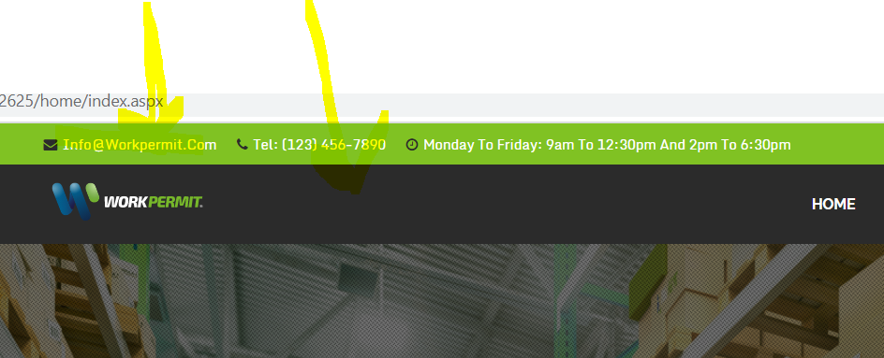

6. In apply job screen 3 more fields have to be added:

1. Driving license dropdown with Yes/ NO option
2. Residence card number field has to be added
3. **Medical examination** label change to **Medical examination number**

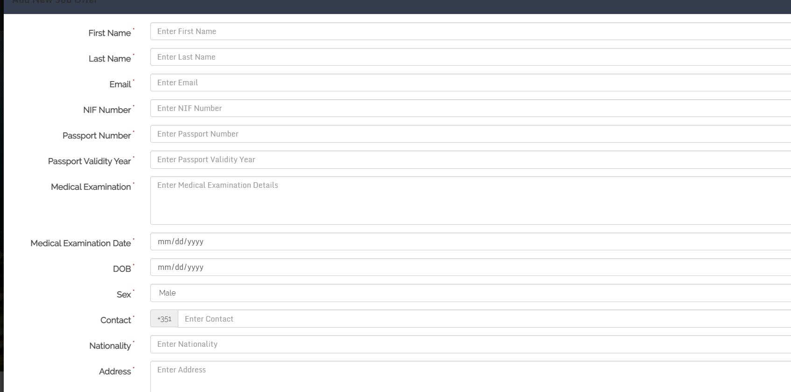

Medical exam is non mandatory

Residence card no is non mandatory

7. When a candidate applies for a new job in sectors, he needs to upload all the documents like an admin uploads.

At the moment, new candidate can upload only 2 documents: NIS and NIFF

Also, Driving license dropdown field with option (YES/ NO) has to be added

In apply new job passport validity should be a date field:

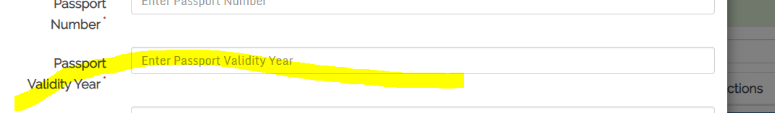

8. Can the jobs flash screen be adjusted so that it comes little bit down

9. In employee add screen, 3 fields have to be added:

Medical examination number

Residence card number

Driving license dropdown (YES/NO) option

10. inactivate button doesnt work sometimes:

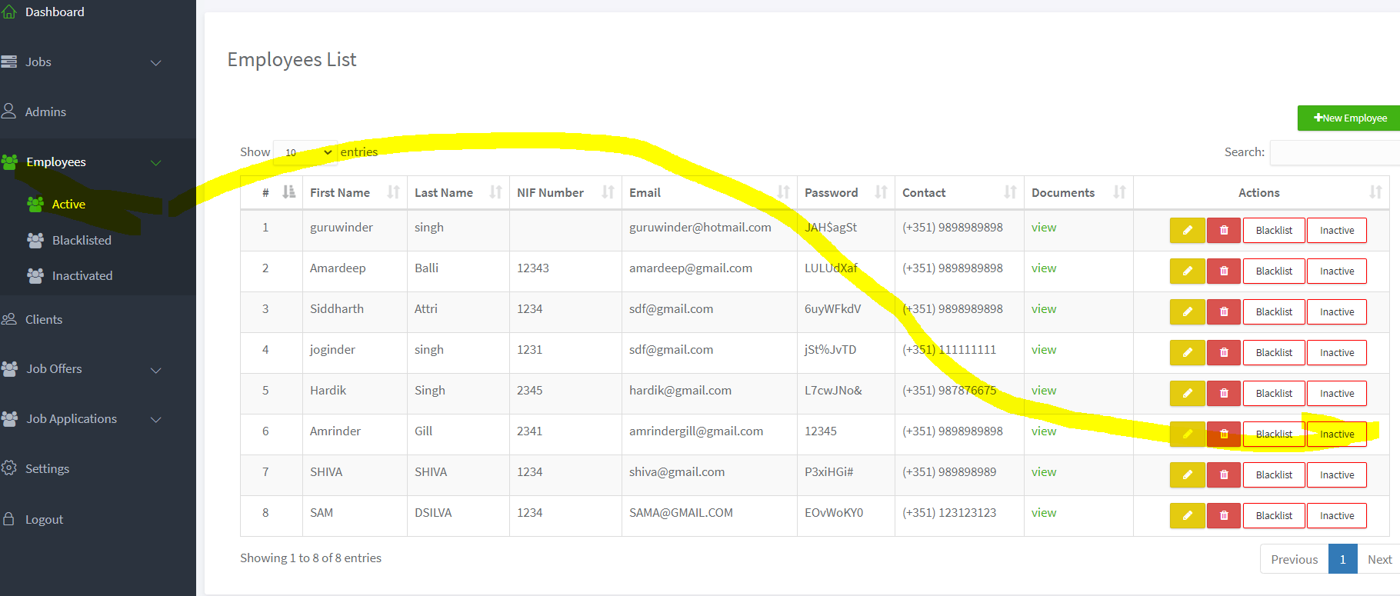

When i click on above highlighted employee inactivate button:

So i get:

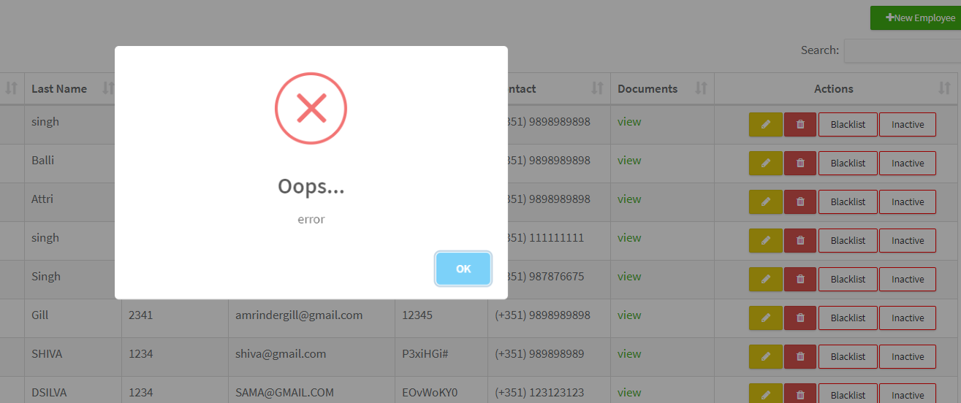

12.In add a new client section inside admin login, phone number length validation is done only for one contact and not for second contact.

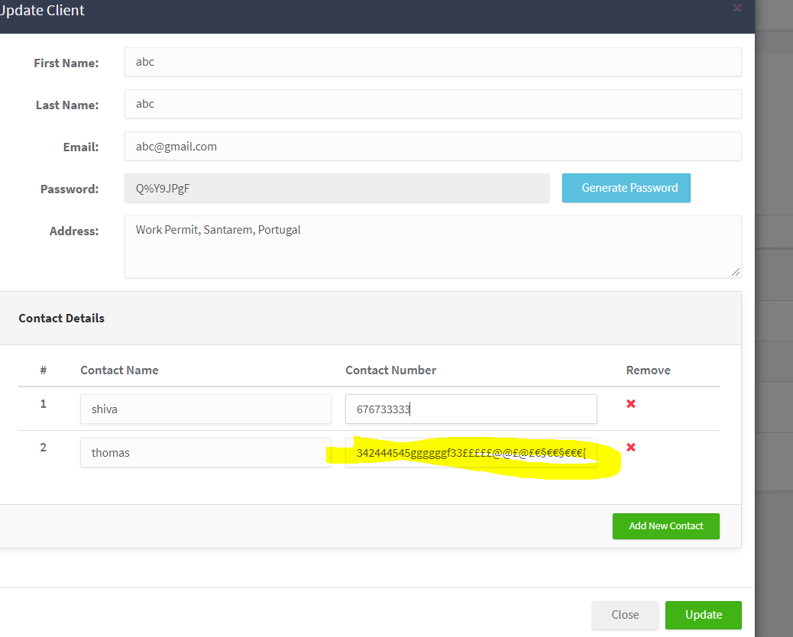

13. In new candidates apply job ,fields validation is missing.

14.If I assign an employee to one job, he is still showing up in another job assign emp pop up.

15. WHEN I MOVE A JOB TO "START JOB" FROM "UPCOMING JOBS" THEN IT IS GENERATING AN ALERT FOR THE NUMBER OF DAYS LEFT. BUT THIS IS SHOWING WRONG NUMBER OF DAYS LEFT. FOR EXAMPLE IF I POST A JOB FROM MONDAY TO FRIDAY i.e FOR 5 DAYS AND WHEN I MOVE IT THEN ALERT WON'T TELL 5 DAYS LEFT BUT SOME 2 OR 3 DAYS.