**Options & Futures (42250)**

**Hassan Fayyaz**

**What is Speculation?**

Speculation is the buying and selling of risky assets, financial instruments, currencies, and commodities for a short period with the aim to earn a large sum of profit caused by fluctuations in the market value. In other words, speculation is a term used in finance to refer to **risky financial transactions** performed in a short period based on a calculated guess to earn a large amount of money. These risky transactions can lead to an enormous loss of money and hold the potential to gain a large sum of money. Speculators are investors responsible for speculation by gathering information, researching the market, analyzing data, and making difficult yet calculated investment decisions.

For example, George, a foreign exchange investor living in Australia who one day invests all of his savings ($100,0000) to buy the American dollar because his research calculated that the American dollar would earn him an enormous amount of money. Although there are indeed chances that George will gain a large amount of profit, there are also high financial risks attached to this investment because uncertainties do exist in the market. A sudden unexpected market crash can change everything, and we see that George does not hesitate to take such a massive financial risk which can make or break his lifestyle. These types of investment risks are known as Speculations.

**Speculation Strategy:**

I want to speculate in ETF markets because ETF markets are generally safer and less risky because they provide investors with diversification to invest in different investments, including stocks, bonds, commodities, and other securities. These ETF shares are traded on the stock exchange and may incur fees and commissions.

The ETF I would like to invest in is **Invesco QQQ ETF** because this ETF invests in some of the most high-performing billionaire dollar companies, including Amazon, Apple, Facebook, Tesla, Google, Ford, Microsoft, Dow Jones, and many more. The Invesco QQQ ETF invests money in companies that are already successful and have the potential to grow and succeed. That is the reason it is listed as the top five exchange-traded products on the U.S. market with nearly $100 billion in assets under management.

The main factor that made me choose Invesco was the fact that it invests **62.31%** of its money in **technology companies**, and stats show it has a history of always performing well and earning the investor a large sum of profit. Technology companies are innovative and come up with life-changing solutions, which is why this ETF has the chance to suddenly rise in price. With pandemic, the demand for technology companies has increased more than ever as we are becoming more and more dependent on technology every day. The **top 5 holdings** of Invesco ETF are Apple (11.31%), Microsoft (9.46%), Amazon (8.57%), (Tesla 4.74%), and Google (3.58%), with a total investment of 37.66%.

Currently, the ETF of Invesco in the last five days has been dropping in price due to a price drop of Microsoft, Amazon, Tesla, and google. This price drop, however, would not last forever, and the prices will be rising soon. This price rise will happen because these five companies are technology companies holding more than 1/3 of the ETF.

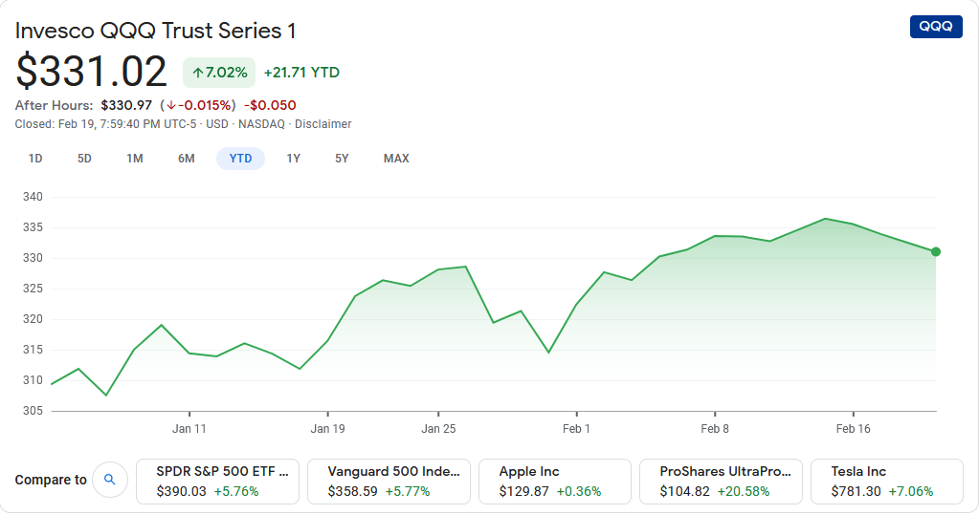

There is an overall price drop in the market, and it is not because these companies are not performing well.  The ETP prices of **Invesco QQQ**will rise soon because of the following reasons:

* **Tesla:** There will always be demand for electric cars with lifesaving technology features.
* **Amazon:** Home delivery has become a need nowadays because the pandemic now requires everyone to social distance and wear masks.
* **Google:** We all desire to learn and gain more knowledge every single day. Without knowledge: we would have no cars, phones, vaccines, computers, and possibly every human-made thing.
* **Microsoft & Apple:**A world without computers and phone is hard to imagine these days because everyone now uses their phones to socialize, and remote office work would have never been possible without computers.