SIT315 - Transit Routing System

Mohammad Hassan Jamali – s225402184

Video Link: Link

Video Link:

GitHub Repository: https://github.com/hassan-jamali/vic_transit_routing

System Specifications
All implementations have been compiled and tested on a MacBook Air powered by an M4 chip (featuring 10 total CPU cores: 4 performance and 6 efficiency) with 16 GB of unified memory. The hardware specifications are detailed below.

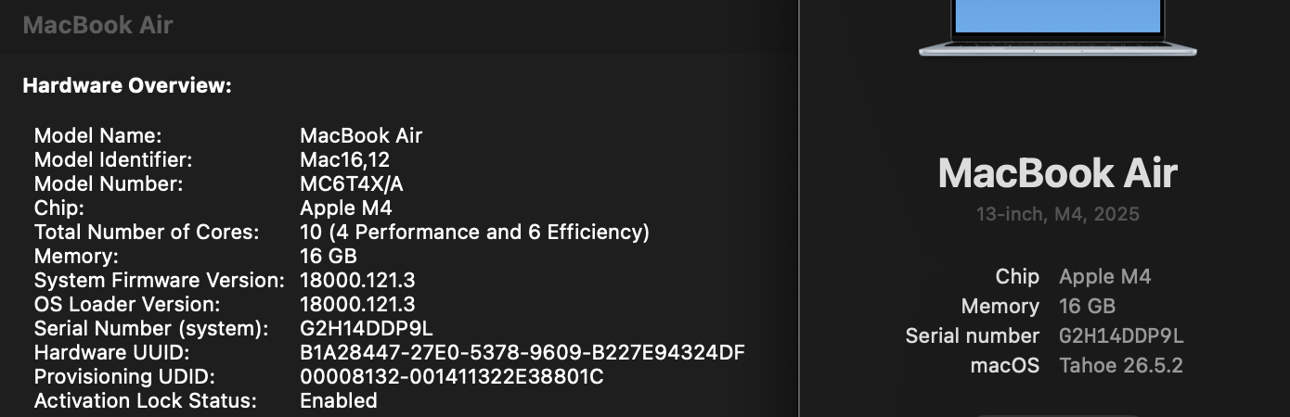

GTFS Data Architecture & Simulation
Firstly, the transit simulator relies on parsing real world General Transit Feed Specification (GTFS) data from the Victorian Transport Open Data Portal.
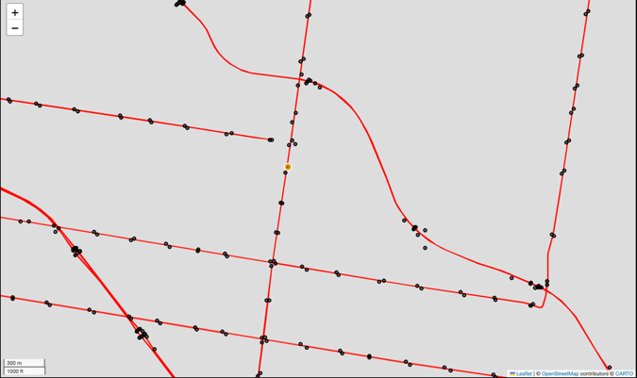
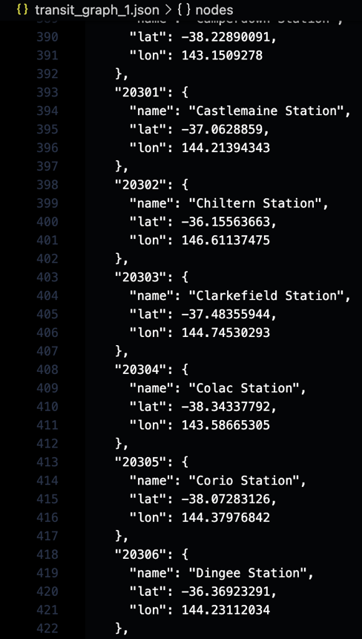
Since C++ is highly efficient at raw computation but less flexible with text parsing, the architecture splits into a Python data pipeline and a C++ routing system. In addition, the DataFile class utilises the pandas library to ingest stops.txt, stop_times.txt, and shapes.txt. Moreover, the Python wrapper pairs consecutive stops based on matching trip_id and sequential time boundaries to generate valid travel edges. Therefore, this data is exported into a lightweight transit_graph.json file, reserving the C++ TransitGraph class strictly for high-performance memory mapping and traversal.

Heuristic Design (Haversine Distance)
Firstly, the A* pathfinding algorithm relies on a heuristic function to estimate the remaining cost to the destination, preventing the algorithm from searching blindly. Since the transit network is mapped geographically, the simulator uses the Haversine formula in heuristic.cpp to calculate the great circle distance between two coordinates. In addition, by converting latitudes and longitudes into radians and applying the Earth's radius (6,371,000 meters), the heuristic provides a mathematically admissible straight-line distance.
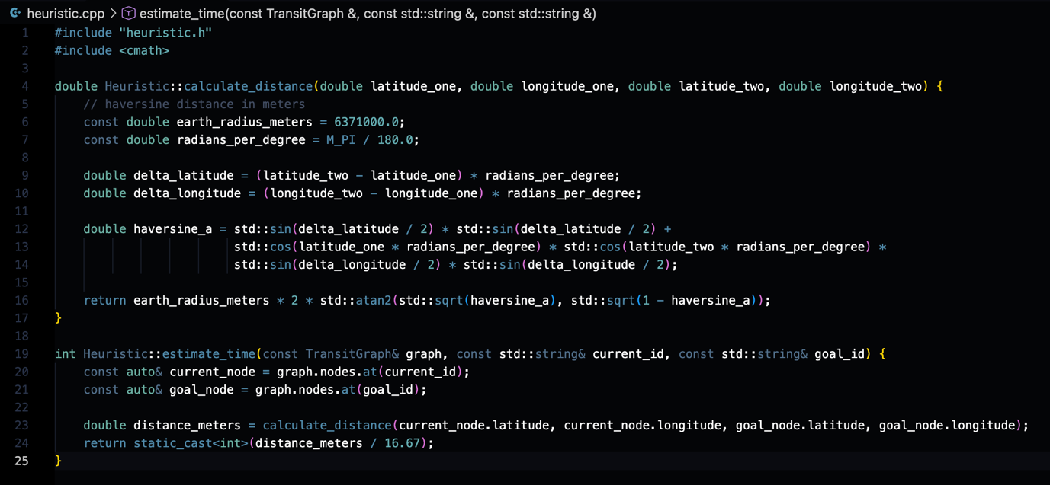

Hybrid Parallel Architecture (Apple Metal)
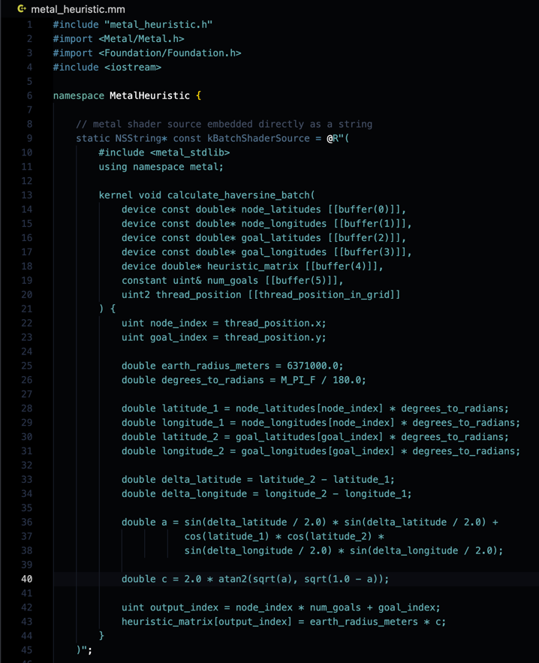
Firstly, the heuristic distance calculations were reimplemented using Apple's Metal API to offload workloads from the CPU to the GPU. Since the architecture bridges C++ with Objective C++ (metal_heuristic.mm), it successfully compiles a Metal Shading Language (MSL) compute kernel (kBatchShaderSource) at runtime.

In addition, the system allocates shared MTLBuffer memory blocks to pass array pointers for node and goal coordinates directly to the GPU.
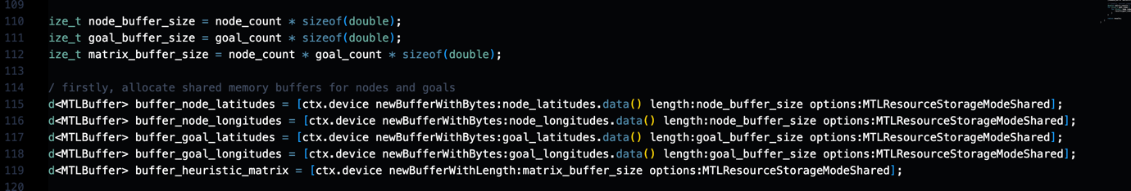
Moreover, a compute pipeline state is cached, allowing the GPU to spawn thousands of concurrent threads mapped via the [[thread_position_in_grid]] parameter. Therefore, once the command buffer commits via waitUntilCompleted, the engine immediately retrieves a fully populated matrix of distances.

Performance Profiling (Hybrid Architecture Evaluation)
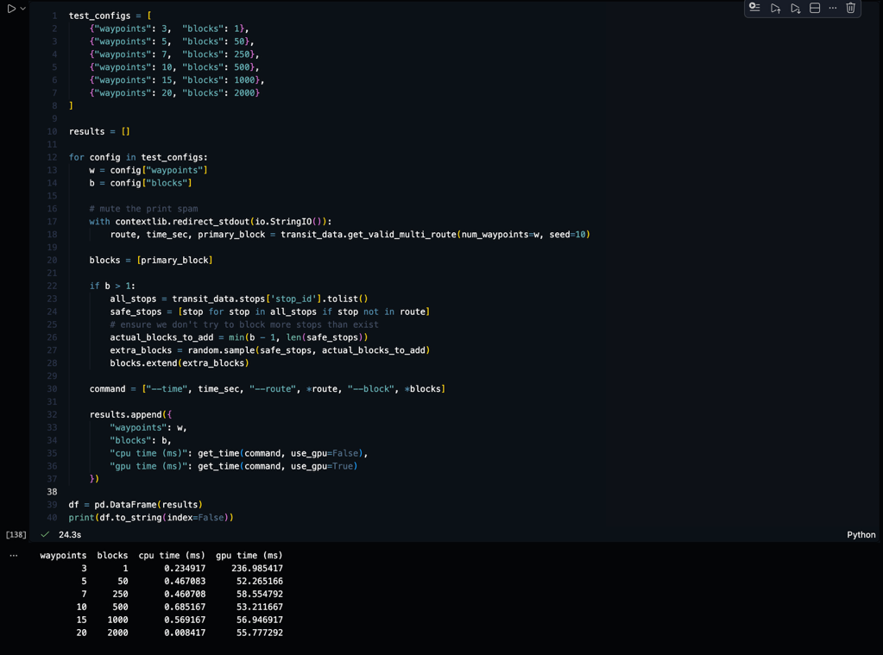
Firstly, profiling was conducted to evaluate the trade-offs of the hybrid CPU / GPU architecture across varying workloads. In addition, single commuter routing was benchmarked across increasing route lengths and network disruptions (up to 2,000 dynamically blocked stations). Since single target A* pathfinding relies on a sequential min-heap priority queue, the CPU vastly outperformed the GPU, completing complex detours in 0.008 to 0.59 milliseconds while the GPU required around 52 to 55 milliseconds.
Moreover, this latency discrepancy is driven by macOS Metal driver overhead, which incurs costs for pipeline synchronisation (waitUntilCompleted) and shared buffer allocation on every independent query. Therefore, this demonstrates

Amdahl's Law in practice: sequential algorithms with high synchronisation requirements cannot exploit SIMD/GPU parallelism and execute significantly faster within the CPU's local L1/L2 cache.
In addition, when shifting from sequential graph traversal (AStarRouter::find_route) to batch heuristic precalculation (simulating 50,000 commuters across 4,480 stations), the workload converted into a fully decoupled, parallel matrix operation. Since the GPU bypassed sequential branching to run 224 million calculations across thousands of concurrent threads independently, the Apple Metal kernel (calculate_batch_distances) completed the batch in 338.2 milliseconds compared to the CPU's 3,198.8 milliseconds. Therefore, the hybrid pipeline successfully demonstrated nearly a 10x throughput advantage once thread saturation masked driver overhead.
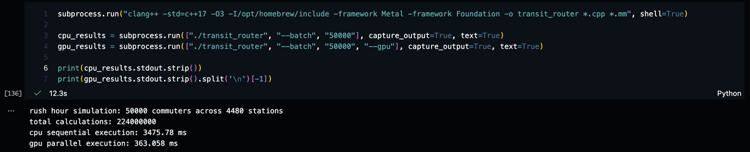

Stress Test
Firstly, an extreme stress test was configured by ingesting all 6 GTFS transport modes (Regional Train, Metropolitan Train, Metropolitan Tram, Bus, and Coach) combined with a 50,000 commuter batch request to determine system breaking points. In addition, loading all 6 modes via DataFile(transport_modes=[1, 2, 3, 4, 5, 6]) scaled the transit graph from 4,480 stations to tens of thousands of combined stops and transit edges.
Since the Metal compute kernel constructs a dense Haversine distance matrix of dimensions $\text{node_count}×\text{commuter_count}$, the required memory allocation scaled to:
$$\text{matrix_buffer_size}=\text{node_count}×50,000×8\text{ bytes}$$
Moreover, on a graph exceeding 30,000 stops, this single contiguous matrix required over 12 GB of uncompressed floating-point memory, operating alongside graph adjacency structures within the 16 GB unified memory architecture. Since [ctx.device newBufferWithLength:options:] was unable to allocate the requested contiguous buffer under macOS memory pressure, the allocation returned nil, triggering an unhandled memory fault and an immediate crash, recorded as a Did Not Finish (DNF).

Multi Trial Waypoint Evaluation (N = 1000)
Firstly, to strengthen the evaluation further by moving beyond individual timing samples, the multi-waypoint routing performance profiling was expanded to run across 1,000 independent trials. In addition, by calculating both the mean execution time and standard deviation for each waypoint configuration, the system records consistent performance data across thousands of iterations. Moreover, the results show that for sequential A* pathfinding across 3, 5, 7, and 10 waypoints, the CPU maintains a steady execution time between 0.46ms and 0.96ms while the GPU requires around 51ms to 58ms due to command buffer setup and memory synchronization. Therefore, this multi-trial approach proves that low-complexity sequential graph searches cannot use GPU parallelism effectively, matching Amdahl's Law where the CPU stays much faster within its local cache.
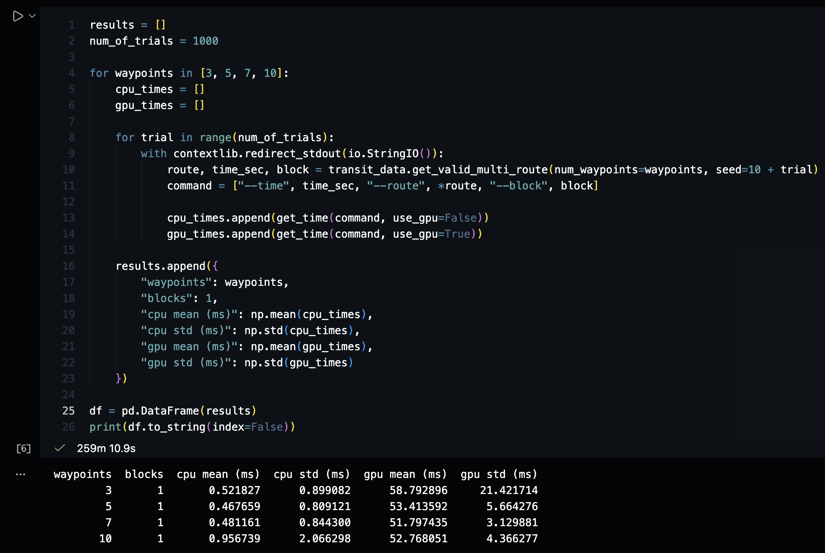

Multi Trial Batch Workload Evaluation (N = 100)
Firstly, to confirm the parallel throughput advantages under repeated testing, the massive 50,000 commuter batch Haversine precalculation workload was executed across 100 separate trials. In addition, tracking the mean and standard deviation across these trials ensures the timing data is reliable and consistent. Since the Apple Metal compute kernel runs 224 million calculations across thousands of concurrent threads without sequential branching, the GPU successfully completes the batch in significantly less time than the CPU once thread saturation hides the driver overhead. Therefore, this repeated batch evaluation confirms that large data-parallel workloads get a massive speedup on the GPU, while single queries are better suited for the CPU.
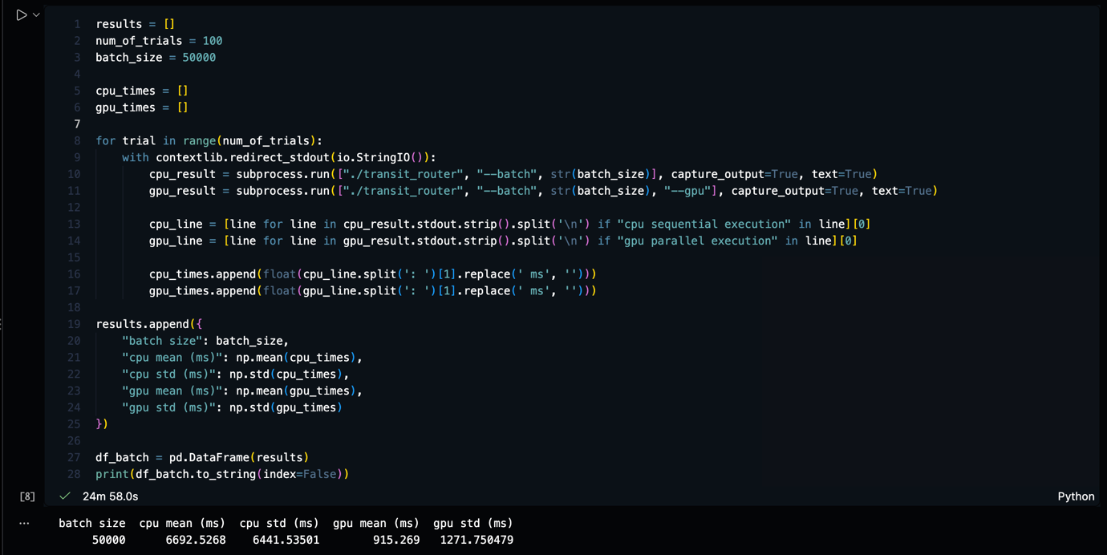
As seen above, the 100-trial benchmark results clearly demonstrate the performance gap for massive workloads. Specifically, the CPU sequential execution averaged 6,692.53ms with a standard deviation of 6,441.54ms whereas the GPU parallel execution completed the exact same 50,000-commuter batch in an average of 915.27mswith a standard deviation of 1,271.75ms Moreover, this proves that for large-scale matrix operations involving 224 million calculations, the Apple Metal compute implementation achieves a substantial speedup over the CPU baseline. Therefore, the data confirms that when workloads are fully decoupled into parallel operations, offloading to the GPU becomes highly efficient.

