**Tables**

**Table name: question-answer**

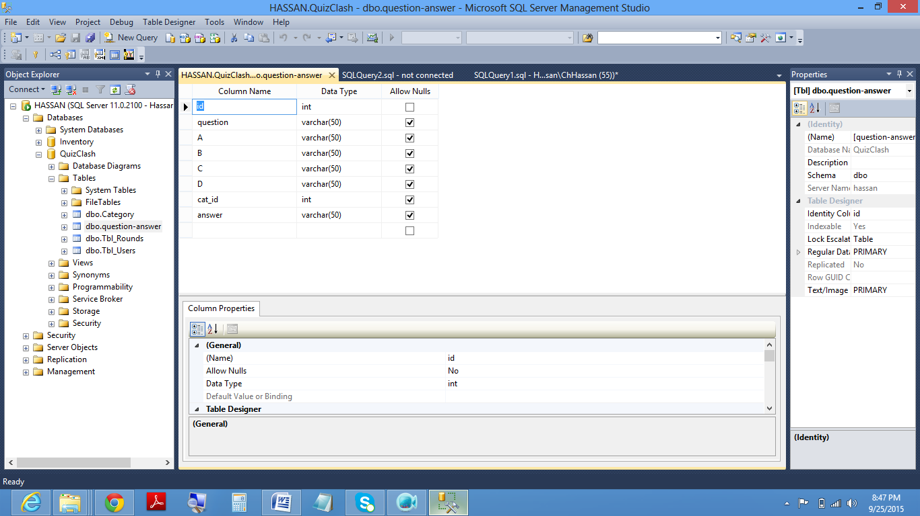

**Table name:Tbl_Users**

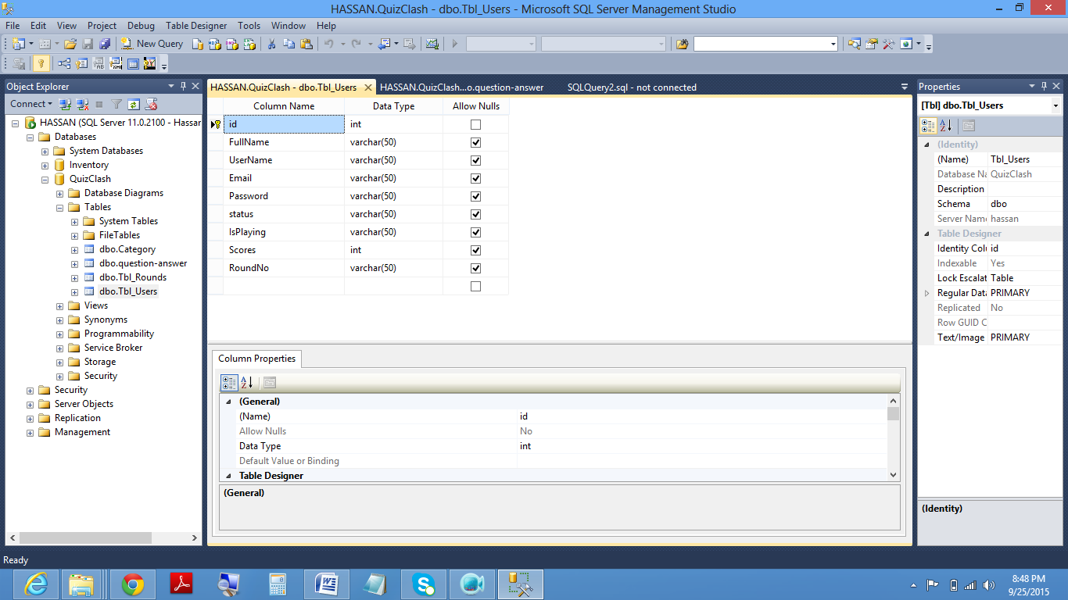

**Table name:Tbl_Rounds**

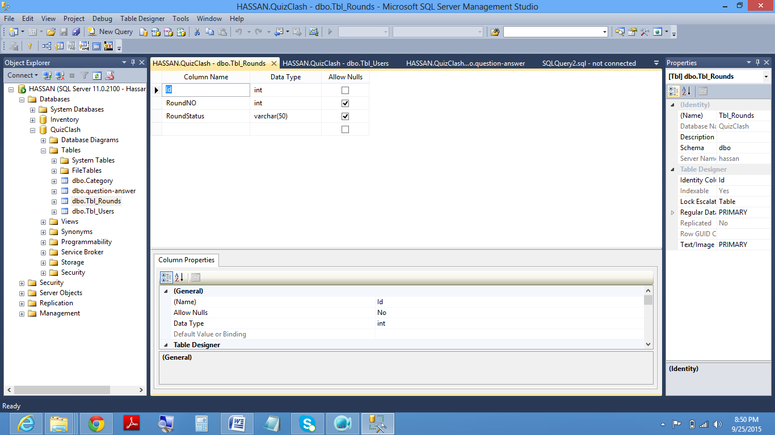

**Table name:Categories**

