

**Faculty of engineering - Shoubra**

**Benha University**

**Research Article / Research Project / Literature Review**

in fulfillment of the requirements of

|  |  |
| --- | --- |
| **Department** | **Engineering Mathematics and Physics** |
| **Division** | **-----------------** |
| **Academic Year** | **2019-2020 Preparatory** |
| **Course name** | **Mechanics** |
| **Course code** | **EMP012** |

**Title: -**

Artificial Intelligence

By:

|  |  |  |  |
| --- | --- | --- | --- |
|  | Name | Edu mail | B.N |
| 1 | حسن محمد رشاد علي | Hasan190011@feng.bu.edu.eg | 299 |

**Approved by:**

|  |  |
| --- | --- |
| Examiners committee | Signature |
| Dr.Ahmed Bayoumi |  |
| Dr.Shady Elmashad |  |
| Dr. Abdelhamid Attaby |  |

**Introduction**

Early signs of artificial intelligence, 1950

British mathematician Alan Turing created a device called the Turing Machine in 1936. Although this device is primitive, it can implement any complex computer algorithm, regardless of its slow or cost. During World War II, an extension of this device was used to decode German messages and communications on behalf of British forces and their allies.

During the same period, some brain and neuroscientists have suggested that the brain contains neural networks that can send and receive some kind of electrical signal through which things are processed. Accordingly, many physicists and mathematicians, including Alan Turing, considered that a device with the ability to think in a similar way to the human brain can be developed since both devices work by sending and receiving electrical signals.

In 1950, the same scientist created a test called Turing Test. This test consists of a set of questions and three players: two players, one is an ordinary person and the other is a device, and the third player (an ordinary person) is a referee. The two players have the mission to answer specific questions that appear on the screen through a keyboard. As for the verdict, its task is to read the answers (without knowing who wrote them) and try to differentiate between the responses of the average person and the device. The scientist suggested that if the referee (who is an ordinary person) cannot distinguish between the answers given by the players (one is an ordinary person and the other is a device), then this device can be considered a smart device.

Artificial intelligence has become a comprehensive term for applications that perform complex tasks that in the past required human inputs such as communicating with customers over the Internet or playing chess. The term is often used interchangeably with its sub-fields, which include machine learning and deep learning. However, there are differences. For example, machine learning focuses on creating systems that learn or improve their performance based on the data they consume. It is important to note that although all avenues of machine learning are only artificial intelligence, not all artificial intelligence is machine learning.

To get the full value of artificial intelligence, many companies are making major investments in data science teams. Data science, which is a multidisciplinary field that uses scientific methods and other methods to extract value from data, combines skills derived from fields such as statistics and computer science with the scientific knowledge to analyze data collected from multiple sources.

The main principle of artificial intelligence is to simulate and transcend the way humans absorb and interact with the world around us. This quickly became the cornerstone of innovation. After AI becomes equipped with several forms of machine learning that recognize patterns of data to enable predictions, AI can add value to your business by:

To provide a more comprehensive understanding of the flood of available data

Rely on forecasts to automate highly complex tasks as well as usual tasks

**Literature Review**

What is artificial intelligence?

In the simplest terms, the term artificial intelligence (AI) refers to systems or devices that mimic human intelligence to perform tasks that can improve themselves based on the information they collect. Artificial intelligence manifests itself in a number of forms. Some of these examples are:

Conversation robots use artificial intelligence to understand customer problems faster and provide more efficient answers

AI-based operators use it to analyze critical information from a wide range of text data to improve scheduling

Recommendation engines can make automated recommendations for TV shows based on users ’viewing habits

Artificial intelligence is more about the ability to think super and analyze data than to be attached to a particular shape or function. Although Artificial intelligence provides images of the high-performance human-like robots that dominate the world, but it is not intended to replace humans. It aims to greatly enhance human capabilities and contributions. Which makes it a valuable asset from the business.

Artificial intelligence technology improves enterprise performance and productivity by automating processes or tasks that previously required manpower. Also, artificial intelligence can understand data on a large scale that no human being can achieve. This ability can bring significant business benefits. For example, Netflix uses machine

learning to provide a level of customization which has helped the company grow its customer base by more than 25 percent in 2017. Most companies have made data science a priority for them and are still investing heavily in them. According to a survey by Gartner of more than 3,000 CEOs, in which participants rated professional analytics and information as the best technology featured for their organization. The chief executives surveyed believe that these technologies are the most strategic for their companies, and therefore, they attract the most new investments.

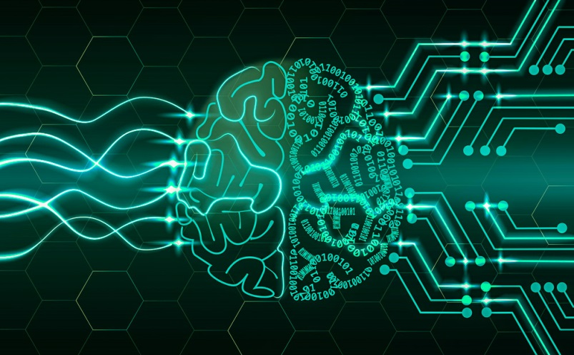

Fig:1

Artificial intelligence provides value for most jobs, businesses, and fields. It includes general applications and applications for specific fields, such as:

- Using transaction data and demographic data to predict the extent of spending of specific customers on the extent of their relationship with the company (or the customer's permanent value)

- Improve prices based on customer behavior and preferences

-Use the image recognition feature to analyze X-ray images of cancer signs

Artificial intelligence capabilities

- Artificial intelligence acquires information through practical practices, and it is able to accurately distinguish between multiple issues.

One of the most important capabilities of artificial intelligence is its response to changes, and it is characterized by flexibility and speed of reaction in all situations.

Artificial intelligence has its ability to perceive, and thus make decisions properly, depending on studying all the possibilities and mastering its results, and then choosing the best decisions that lead to the desired results.

- Be able to quickly detect and correct errors, and make better improvements in the future.

-It can be said that artificial intelligence started with the development of some different computer programs, chief among them chess games, when the scientist Claude Shannon drew up an algorithm that qualified the computer to play chess and expected all the possibilities of the other player to move.

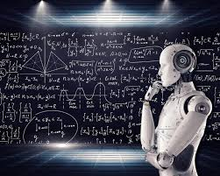 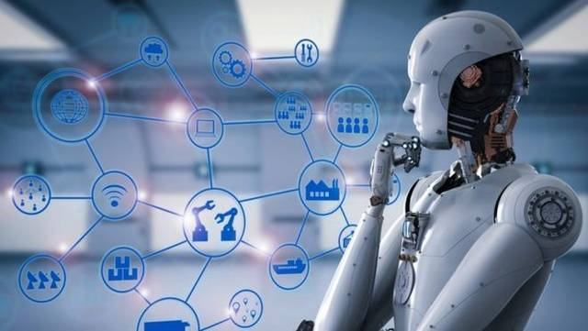

Fig:2 fig:3

Artificial intelligence areas:

-One of the most prominent areas in which simulation programs and applications are distinguished.

Industry through robots capable of performing the tasks of the human race.

- Development of computer programs and applications in various fields, including medicine, engineering, trade and investment, among others.

-Artificial Intelligence introduces all the technical areas that need logical thinking, knowledge, planning, and virtual perception based on applying theories and choosing the right solutions.

- Developing cognitive simulation through testing theories, face recognition, memory activation, and other functions.

- Developing engines with smart capabilities, such as driverless cars and drones.

- Every new day artificial intelligence touches a new door, especially the technology and computer industry.

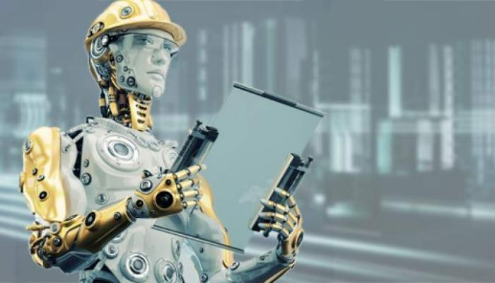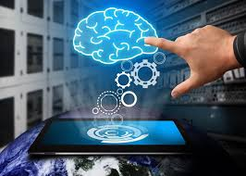   
 fig:4 fig:5

Fig:6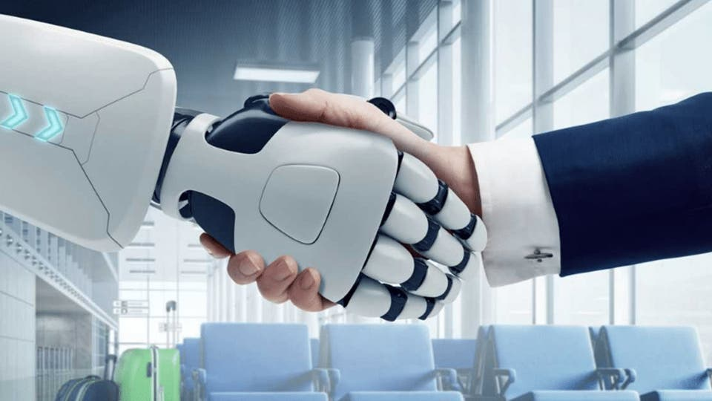

**Artificial intelligence applications:**

There are many practical applications of artificial intelligence, and the most prominent of these applications are the following: Games: Artificial intelligence systems are used in many electronic games; That requires a dimension and strategic thinking, such as poker and chess, for example. Interacting with the visual system: Some applications of artificial intelligence can interpret and analyze the images entered into them. Such as facial recognition software, image analysis for positioning, and other similar applications.

Interacting with handwriting: This is through applications for recognizing handwriting, whether it is writing on paper or on the screen of the device itself. Intelligent robots: Robots do a lot of different actions, as they can do the work that humans do, because of their ability to feel the surrounding factors such as light, heat, sound, or movement, through special sensors, and these robots are able to learn from

**References**

https://al-ain.com

https://sotor.com

https://mawdoo3.com