Milestone 03 - Baseline Models, Evaluation and Initial Findings
Predicting out-of-school status among children aged 5-16 in Pakistan (ASER 2025) - manuscript Section IV draft: Methods (modelling), Results (baseline) and preliminary Discussion.

1. Modelling objective and data
The target is out_of_school (1 = never enrolled or dropped out, 0 = currently enrolled). The analysis file built in Milestone 2 holds 161,803 children from 138 districts, of whom 21,288 (13.2%) are out of school (9.3% when ASER sampling weights are applied). The 13 predictors are age, sex, area, the sex x area interaction, B-form registration, any functional disability, a household asset count (0-8), a digital-use count (0-5), housing structure (1-3) and four province dummies with Punjab as reference. Columns were used exactly as prepared in Milestone 2 (feature_manifest.json); the id, district and weight columns are never used as predictors. The data contain no missing values, so no imputation step was needed.

2. Baseline architectures and justification
- Naive benchmark - majority-class classifier (predicts 'enrolled' for every child). It fixes the performance floor and shows why accuracy is misleading at 13.2% prevalence: it scores 87.5% accuracy with zero recall.
- Logistic regression (standardised inputs, L2 penalty). Hypotheses H1-H4 concern the direction and size of individual effects, which logistic coefficients answer directly as odds ratios with confidence intervals. All predictors are binary or short ordinal scales, so a model linear in the log-odds is an appropriate first fit. Tuned: regularisation strength C and class weighting.
- Decision tree (CART, Gini). Captures non-linear thresholds in the asset and digital counts and interactions such as the gender x area effect (H4) without hand specification, remains interpretable through its splits and Gini importances, and is cheap on 161k rows. Tuned: maximum depth, minimum leaf size and class weighting.

3. Experimental setup and cross-validation
Children are clustered in districts and enrolment rates differ sharply between districts, so a random split would let the model see children from the same district on both sides and over-state performance. We therefore partition with StratifiedGroupKFold grouped by district and stratified on the target. One fold of a 5-fold grouped split is held out as the test set (32,516 children, 29 districts, 20.1% of rows, prevalence 12.5%); the remaining 129,287 children in 109 districts are used for tuning with a second 5-fold grouped stratified split (inner CV). No district appears on both sides of any split (asserted in code). Hyperparameters were selected with GridSearchCV on the inner folds, refitting on ROC-AUC; recall, precision, F1, PR-AUC and accuracy were recorded per fold to show variance. Standardisation for the logistic model is fitted inside each fold.
Table 1. Grouped stratified hold-out split
partition | rows | share_of_rows | positives | prevalence | districts
train | 129,287 | 0.799 | 17,220 | 0.133 | 109
test | 32,516 | 0.201 | 4,068 | 0.125 | 29

Table 2. Inner cross-validation results of the tuned configurations (mean over 5 district-grouped folds; recall, F1 and accuracy are at the default 0.5 threshold, ROC-AUC and PR-AUC are threshold-free)
Model | Best parameters | CV ROC-AUC | SD | CV PR-AUC | CV recall | CV F1 | CV accuracy
Logistic regression | {"C": 0.001, "class_weight": "balanced"} | 0.736 | 0.047 | 0.266 | 0.702 | 0.366 | 0.675
Decision tree | {"class_weight": null, "max_depth": 10, "min_samples_leaf": 200} | 0.744 | 0.051 | 0.292 | 0.068 | 0.112 | 0.859
Logistic regression (age, female, urban) | {"C": 0.001, "class_weight": "balanced"} | 0.586 | 0.042 | 0.175 | 0.618 | 0.253 | 0.514

Hyperparameter exploration. The logistic grid covered C in {0.001, 0.01, 0.1, 1, 10} x class_weight in {none, balanced}; the best point was C = 0.001 with balanced weights (CV ROC-AUC 0.736 +/- 0.047). AUC was flat across C, while balancing matters for recall at the default threshold. The tree grid covered max_depth in {3, 5, 7, 10, 15, none} x min_samples_leaf in {1, 50, 200, 1000} x class_weight; the best point was depth 10, minimum leaf 200, no class weights (CV ROC-AUC 0.744 +/- 0.051; fitted tree depth 10, 221 leaves). Unconstrained trees over-fit district idiosyncrasies and lose AUC on unseen districts. Because refitting is on ROC-AUC, a threshold-free criterion, the selected tree carries no class weighting and at the default 0.5 cut-off flags almost nobody (recall 4.3% on the hold-out, Table 3): almost no leaf reaches a 50% out-of-school share. That is not a defect of the tree; it is why the operating threshold is set separately, and without looking at the hold-out, in section 5. Full grids: outputs/tables/t02-t04.

3.1 Hypothesis H5 - value of the household features
On identical inner folds, a logistic model using only age, sex and area reached ROC-AUC 0.586 (+/- 0.042) against 0.736 (+/- 0.047) for the 13-feature model: a gain of +0.150 AUC in every fold (paired t = 4.56, p = 0.010). On the hold-out districts the AUCs were 0.547 and 0.674. Five folds are a thin basis for a t-test, so the hold-out gain was also bootstrapped by resampling the 29 held-out districts with replacement (1,000 draws): gain +0.127 AUC, 95% interval [+0.078, +0.173], positive in 100% of draws. H0 for H5 is rejected: who is out of school is explained far better by household circumstances than by demographics alone.
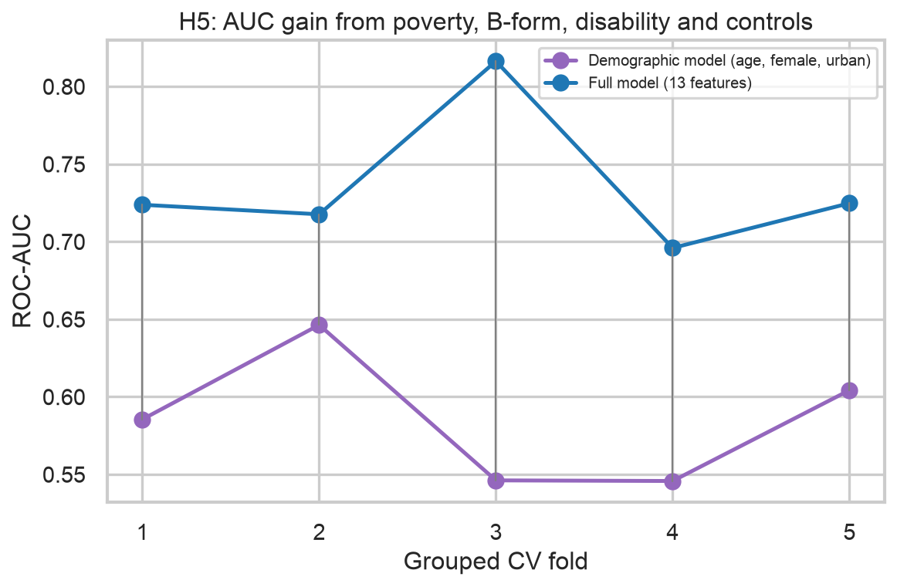
Figure 1. Per-fold ROC-AUC of the demographic and full logistic models (district-grouped CV).

4. Evaluation on the held-out districts
Table 3. Hold-out metrics at the default 0.5 threshold (unweighted and ASER-weighted)
Model | Weighted | Accuracy | Precision | Recall | Specificity | F1 | ROC-AUC | PR-AUC | Flagged
Majority-class baseline | False | 0.875 | - | 0.000 | 1.000 | 0.000 | 0.500 | 0.125 | 0.000
Majority-class baseline | True | 0.851 | - | 0.000 | 1.000 | 0.000 | 0.500 | 0.149 | 0.000
Logistic regression (age, female, urban) | False | 0.466 | 0.133 | 0.590 | 0.449 | 0.217 | 0.547 | 0.148 | 0.556
Logistic regression (age, female, urban) | True | 0.420 | 0.146 | 0.598 | 0.388 | 0.234 | 0.512 | 0.157 | 0.609
Logistic regression | False | 0.620 | 0.192 | 0.634 | 0.618 | 0.295 | 0.674 | 0.214 | 0.414
Logistic regression | True | 0.707 | 0.263 | 0.536 | 0.737 | 0.353 | 0.713 | 0.256 | 0.303
Decision tree | False | 0.867 | 0.282 | 0.043 | 0.984 | 0.074 | 0.711 | 0.236 | 0.019
Decision tree | True | 0.847 | 0.329 | 0.026 | 0.991 | 0.047 | 0.749 | 0.308 | 0.012

The majority-class benchmark reaches 87.5% accuracy and finds no out-of-school child. The balanced logistic regression trades accuracy (62.0%) for recall (63.4%) at the default cut-off (ROC-AUC 0.674, PR-AUC 0.214). The decision tree ranks children better (ROC-AUC 0.711, PR-AUC 0.236) but, tuned without class weights, almost no leaf exceeds a 50% out-of-school share, so its default-threshold recall is only 4.3%. The threshold, not the learner, decides who is flagged. Applying the ASER sampling weights changes the picture in different directions for different models: ROC-AUC rises from 0.674 to 0.713 for the full logistic model and from 0.711 to 0.749 for the tree, but falls from 0.547 to 0.512 for the demographic-only model. The weights up-weight households that the sample under-represents - predominantly poorer, rural ones - where the household features carry most of their signal and where age, sex and area alone separate least; population-level claims should therefore quote the weighted figures. Hold-out AUCs sit 0.03-0.06 below the CV means: the held-out districts are a harder group, within the fold-to-fold spread observed in CV.
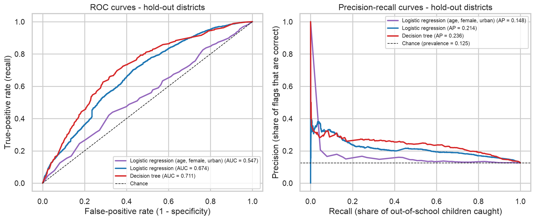
Figure 2. ROC and precision-recall curves on the held-out districts.
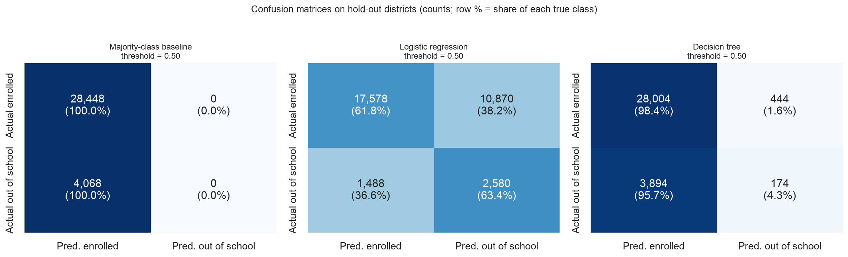
Figure 3. Confusion matrices at the default 0.5 threshold (counts; row % of each true class).

5. Asymmetric error-cost analysis
A false negative (model says 'in school', child is out of school) means a child who needs an enrolment or outreach intervention is never visited - the costly error for an education-access programme. A false positive (model says 'out of school', child is enrolled) spends an outreach visit or a stipend slot on a child who did not need it - wasteful but recoverable. We quantify this by pricing a false negative at r false positives (r = 1, 3, 5, 10), sweeping the threshold from 0.05 to 0.95 and computing the expected cost per 1,000 children screened. The operating threshold is a model setting, so it is chosen without touching the hold-out: each tuned pipeline is re-fitted on the five district-grouped training folds, out-of-fold probabilities are collected for every training child, the cost curve is swept on those, and the cost-minimising threshold is then applied once to the hold-out districts. Table 4 reports both the training out-of-fold metrics that drove the choice and the hold-out metrics at that threshold; its last two columns show what the hold-out's own optimum would have been, to make visible how much selecting the threshold on the test set would have flattered the result.
Table 4. Cost-minimising threshold per cost ratio: chosen on training out-of-fold predictions, then evaluated once on the hold-out
Model | FN:FP | Threshold (chosen on train OOF) | OOF recall | OOF precision | OOF cost/1,000 | Hold-out recall | Hold-out precision | Hold-out flagged | Hold-out cost/1,000 | Hold-out oracle thr. | Oracle cost/1,000
Logistic regression | 1 | 0.930 | 0.000 | - | 133.192 | 0.000 | - | 0.000 | 125.108 | 0.930 | 125.108
Logistic regression | 3 | 0.600 | 0.531 | 0.286 | 363.896 | 0.409 | 0.200 | 0.256 | 426.313 | 0.780 | 363.913
Logistic regression | 5 | 0.540 | 0.642 | 0.263 | 477.875 | 0.568 | 0.201 | 0.353 | 552.282 | 0.570 | 545.455
Logistic regression | 10 | 0.430 | 0.792 | 0.223 | 644.334 | 0.748 | 0.181 | 0.517 | 738.990 | 0.410 | 731.486
Decision tree | 1 | 0.940 | 0.000 | 0.091 | 133.262 | 0.000 | - | 0.000 | 125.108 | 0.890 | 125.108
Decision tree | 3 | 0.280 | 0.327 | 0.341 | 352.936 | 0.289 | 0.266 | 0.136 | 366.558 | 0.300 | 365.113
Decision tree | 5 | 0.160 | 0.628 | 0.276 | 466.984 | 0.621 | 0.237 | 0.328 | 487.329 | 0.160 | 487.329
Decision tree | 10 | 0.070 | 0.834 | 0.213 | 631.881 | 0.828 | 0.184 | 0.562 | 673.545 | 0.090 | 669.855

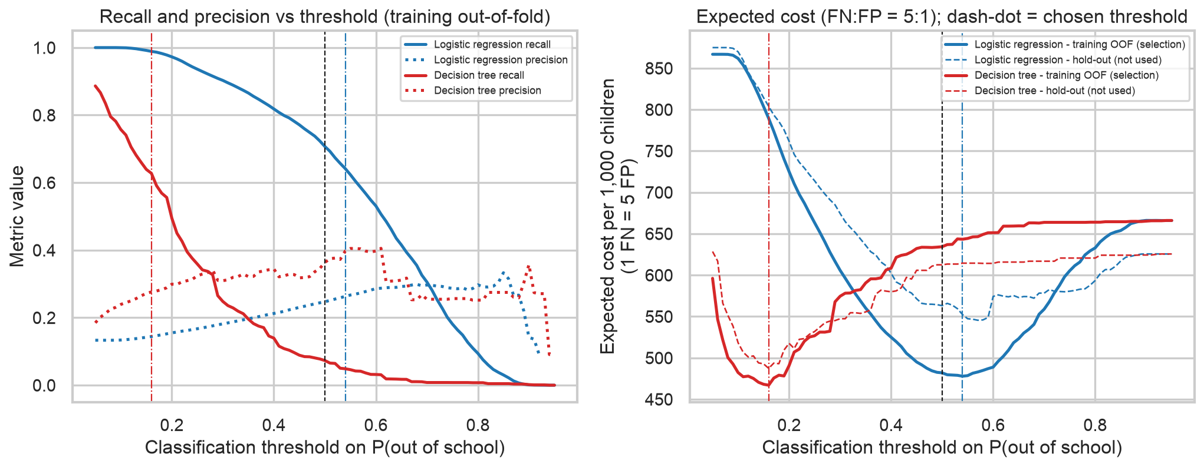
Figure 4. Recall/precision and expected cost versus threshold (cost ratio 5:1). Solid curves are training out-of-fold predictions (used for selection); dashed curves are the hold-out (reported only); dash-dot lines mark the chosen thresholds.
Table 5. Default versus recommended operating point
Model | Threshold | t | TP | FN | FP | TN | Recall | Precision | Specificity | Flagged/1,000 | Caught/1,000 | Missed/1,000 | Cost/1,000 (r=5)
Majority-class baseline | 0.50 (default) | 0.500 | 0.000 | 4,068 | 0.000 | 28,448 | 0.000 | - | 1.000 | 0.000 | 0.000 | 125.108 | 625.538
Logistic regression | 0.50 (default) | 0.500 | 2,580 | 1,488 | 10,870 | 17,578 | 0.634 | 0.192 | 0.618 | 413.643 | 79.346 | 45.762 | 563.107
Logistic regression | recommended | 0.540 | 2,310 | 1,758 | 9,168 | 19,280 | 0.568 | 0.201 | 0.678 | 352.995 | 71.042 | 54.066 | 552.282
Decision tree | 0.50 (default) | 0.500 | 174.000 | 3,894 | 444.000 | 28,004 | 0.043 | 0.282 | 0.984 | 19.006 | 5.351 | 119.756 | 612.437
Decision tree | recommended | 0.160 | 2,525 | 1,543 | 8,131 | 20,317 | 0.621 | 0.237 | 0.714 | 327.716 | 77.654 | 47.454 | 487.329

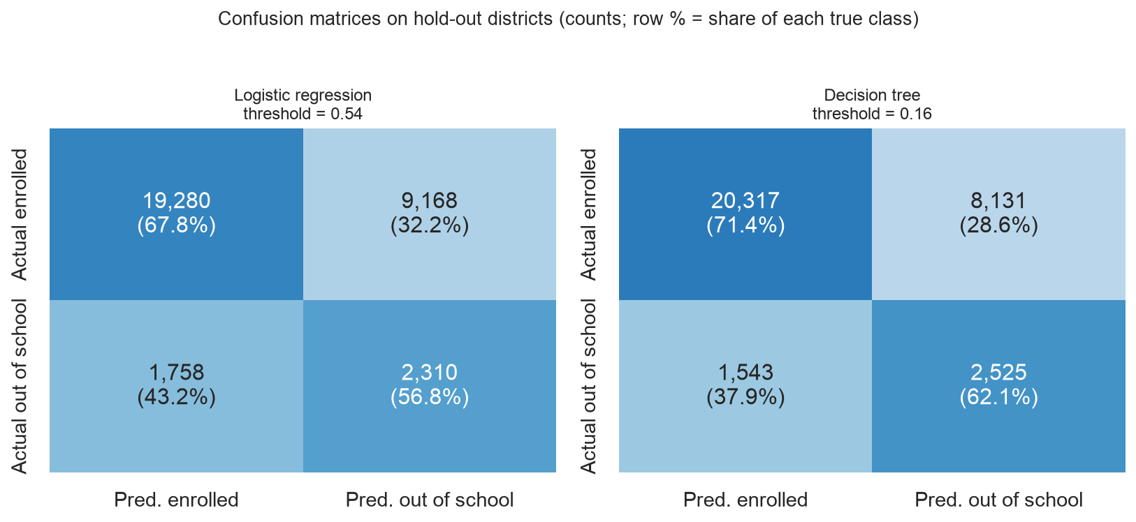
Figure 5. Confusion matrices at the recommended thresholds (cost ratio 5:1).
- With r = 1 the cheapest policy is to flag nobody: neither model is sharp enough to beat the base rate when a false alarm costs as much as a missed child. The cost framing makes this explicit rather than hiding it behind accuracy.
- At r = 5 the optimum moves to a low threshold. Recommended deployment: the decision tree at threshold 0.16 - per 1,000 children screened it flags 328, catches 78 of the 125 out-of-school children and misses 47 (recall 0.62, precision 0.24), the lowest hold-out expected cost of all policies. The default 0.5 threshold on the same tree would catch only 5 per 1,000.
- Logistic regression at threshold 0.54 is a close second (recall 0.57, precision 0.20, 353 flagged per 1,000) and is preferable where officials must explain why a child was flagged.
- At r = 10 both models flag over half of all children to catch 75%-83%; whether that is acceptable is a budget decision for the programme, which the cost ratio makes explicit.
- Honesty check. Had the threshold been picked on the hold-out itself, the logistic optimum would have been 0.57 with cost 545 per 1,000 against 552 at the training-selected 0.54; for the tree the two coincide at 0.16. The flattery from selecting on the test set is small here (about 1.3% of cost for the logistic model) but it is not zero, which is why all numbers at the recommended threshold - Tables 5-7, Figures 5-6 - use the training-selected value.

5.1 Misclassified edge cases
Table 6. Mean feature values by outcome, logistic regression at threshold 0.54
Feature (mean) | True positives | False negatives | False positives | True negatives | FN - TP
age | 8.710 | 9.747 | 8.748 | 9.749 | 1.038
female | 0.448 | 0.379 | 0.384 | 0.340 | -0.069
urban | 0.154 | 0.444 | 0.164 | 0.390 | 0.290
female_x_urban | 0.078 | 0.185 | 0.067 | 0.140 | 0.108
bform | 0.313 | 0.549 | 0.419 | 0.660 | 0.237
any_disability | 0.126 | 0.065 | 0.144 | 0.099 | -0.062
assets_n | 1.788 | 3.046 | 2.149 | 3.721 | 1.258
digital_n | 1.123 | 2.330 | 1.259 | 3.207 | 1.208
house | 1.260 | 2.195 | 1.272 | 2.409 | 0.934
p_hat | 0.684 | 0.383 | 0.668 | 0.320 | -0.301

Table 7. Logistic-regression performance by subgroup on the held-out districts
Variable | Level | n (test) | Positives | Prevalence | Recall | FNR | Precision | ROC-AUC
female | 0 | 20,744 | 2,365 | 0.114 | 0.539 | 0.461 | 0.184 | 0.668
female | 1 | 11,772 | 1,703 | 0.145 | 0.608 | 0.392 | 0.227 | 0.678
urban | 0 | 22,350 | 2,932 | 0.131 | 0.666 | 0.334 | 0.203 | 0.681
urban | 1 | 10,166 | 1,136 | 0.112 | 0.313 | 0.687 | 0.191 | 0.661
any_disability | 0 | 28,884 | 3,662 | 0.127 | 0.551 | 0.449 | 0.205 | 0.674
any_disability | 1 | 3,632 | 406 | 0.112 | 0.719 | 0.281 | 0.181 | 0.706
bform | 1 | 18,249 | 1,689 | 0.093 | 0.428 | 0.572 | 0.158 | 0.675
bform | 0 | 14,267 | 2,379 | 0.167 | 0.667 | 0.333 | 0.230 | 0.636
province | Sindh | 5,017 | 798 | 0.159 | 0.291 | 0.709 | 0.461 | 0.845
province | Khyber Pakhtuknkhwa | 7,889 | 1,086 | 0.138 | 0.576 | 0.424 | 0.252 | 0.705
province | Balochistan | 6,223 | 1,074 | 0.173 | 0.923 | 0.077 | 0.201 | 0.664
province | Punjab | 13,387 | 1,110 | 0.083 | 0.416 | 0.584 | 0.130 | 0.614

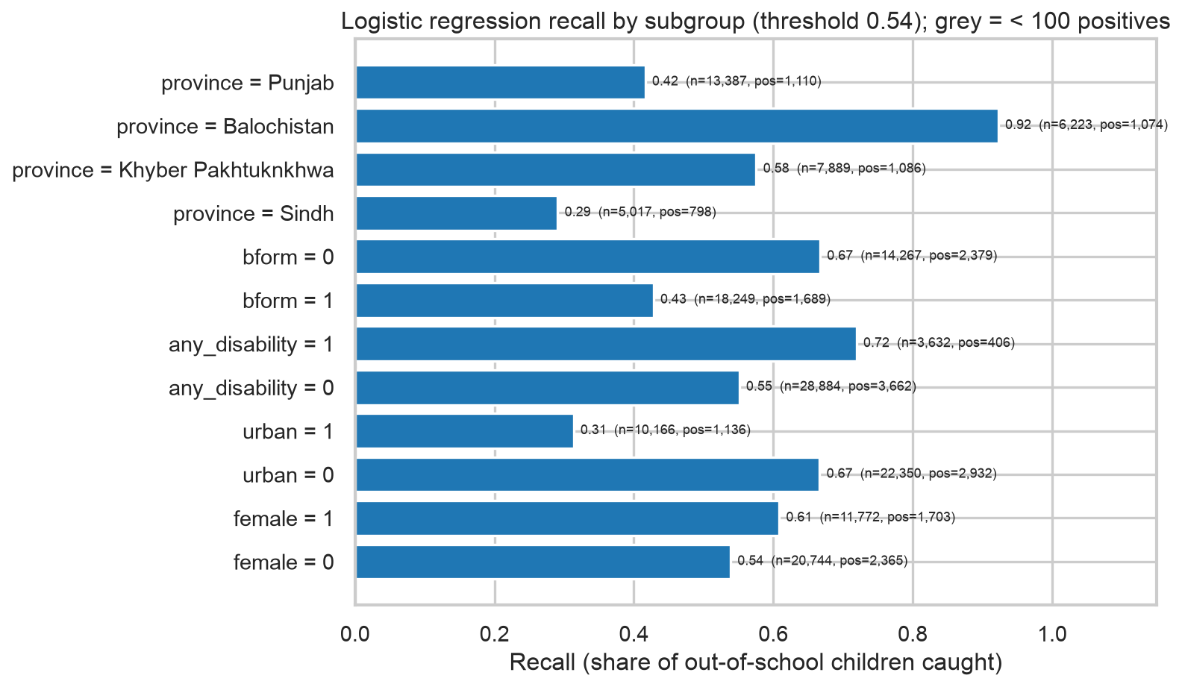
Figure 6. Recall by subgroup (logistic regression, recommended threshold).
The children the model misses look like enrolled children on paper: they are older, far more often urban (44% of false negatives versus 15% of true positives), more often B-form registered, and live in households with more assets, more digital use and better housing. The model has learned 'poor rural household implies out of school' and under-detects out-of-school children in better-off or urban households - plausibly dropouts rather than never-enrolled children, a distinction the current features cannot see. Recall is 0.92 in Balochistan but 0.29 in Sindh and 0.42 in Punjab; 0.31 for urban versus 0.67 for rural children. Islamabad Capital Territory is a single district that fell entirely on the training side of the grouped split, so it has no hold-out estimate; with 52 positives in the whole dataset it is too small for reliable subgroup conclusions.

6. Feature importance and the Milestone 2 hypotheses
Table 8. Logistic regression odds ratios (raw units, training districts; McFadden pseudo-R2 = 0.118)
Feature | Odds ratio | CI low | CI high | p-value | Std. coef
Housing (1 kachha - 3 pacca) | 0.565 | 0.549 | 0.580 | 0.000 | -0.466
Digital use (0-5) | 0.817 | 0.806 | 0.829 | 0.000 | -0.323
Province: Balochistan | 1.791 | 1.712 | 1.873 | 0.000 | 0.234
Any disability | 1.877 | 1.795 | 1.962 | 0.000 | 0.213
Female | 1.476 | 1.416 | 1.538 | 0.000 | 0.190
B-form registered | 0.753 | 0.727 | 0.780 | 0.000 | -0.140
Female x Urban | 0.769 | 0.714 | 0.829 | 0.000 | -0.095
Household assets (0-8) | 0.964 | 0.951 | 0.976 | 0.000 | -0.057
Urban | 0.890 | 0.848 | 0.934 | 0.000 | -0.057
Province: Sindh | 0.889 | 0.843 | 0.938 | 0.000 | -0.054
Age (years) | 0.986 | 0.980 | 0.991 | 0.000 | -0.047
Province: KP | 0.899 | 0.851 | 0.949 | 0.000 | -0.044
Province: ICT | 0.815 | 0.608 | 1.091 | 0.169 | -0.016

Table 9. Tree Gini importance and hold-out permutation importance
Feature | Tree Gini importance | Permutation AUC drop (LR) | Permutation AUC drop (tree)
Housing (1 kachha - 3 pacca) | 0.305 | 0.038 | 0.051
Province: Balochistan | 0.154 | 0.001 | 0.013
Digital use (0-5) | 0.152 | 0.044 | 0.053
Household assets (0-8) | 0.101 | 0.009 | 0.024
Age (years) | 0.068 | 0.000 | 0.030
Any disability | 0.053 | -0.000 | 0.003
Female | 0.046 | 0.009 | 0.018
B-form registered | 0.043 | 0.012 | 0.013
Province: Sindh | 0.031 | -0.007 | 0.007
Province: KP | 0.026 | -0.001 | 0.010
Urban | 0.017 | -0.001 | -0.002
Female x Urban | 0.004 | -0.002 | 0.002
Province: ICT | 0.000 | 0.000 | 0.000

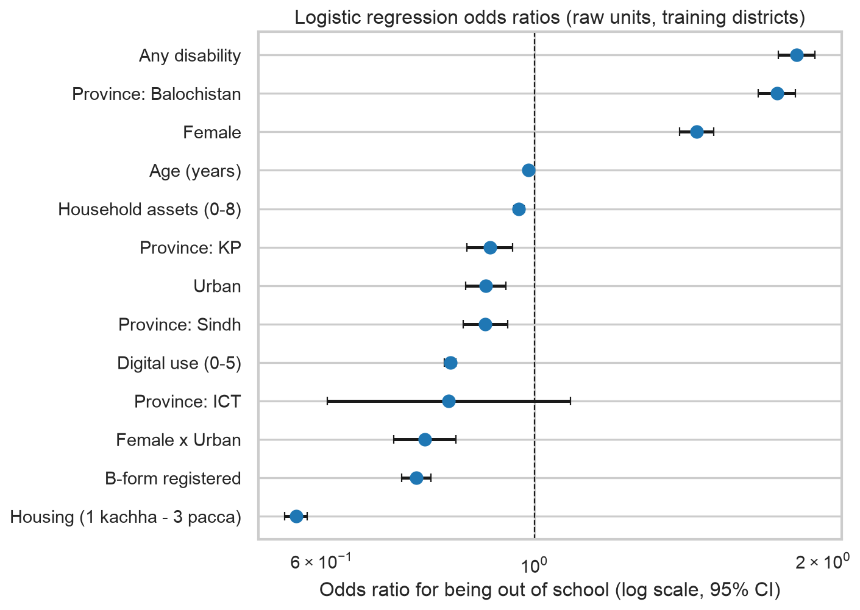
Figure 7. Odds ratios with 95% confidence intervals.
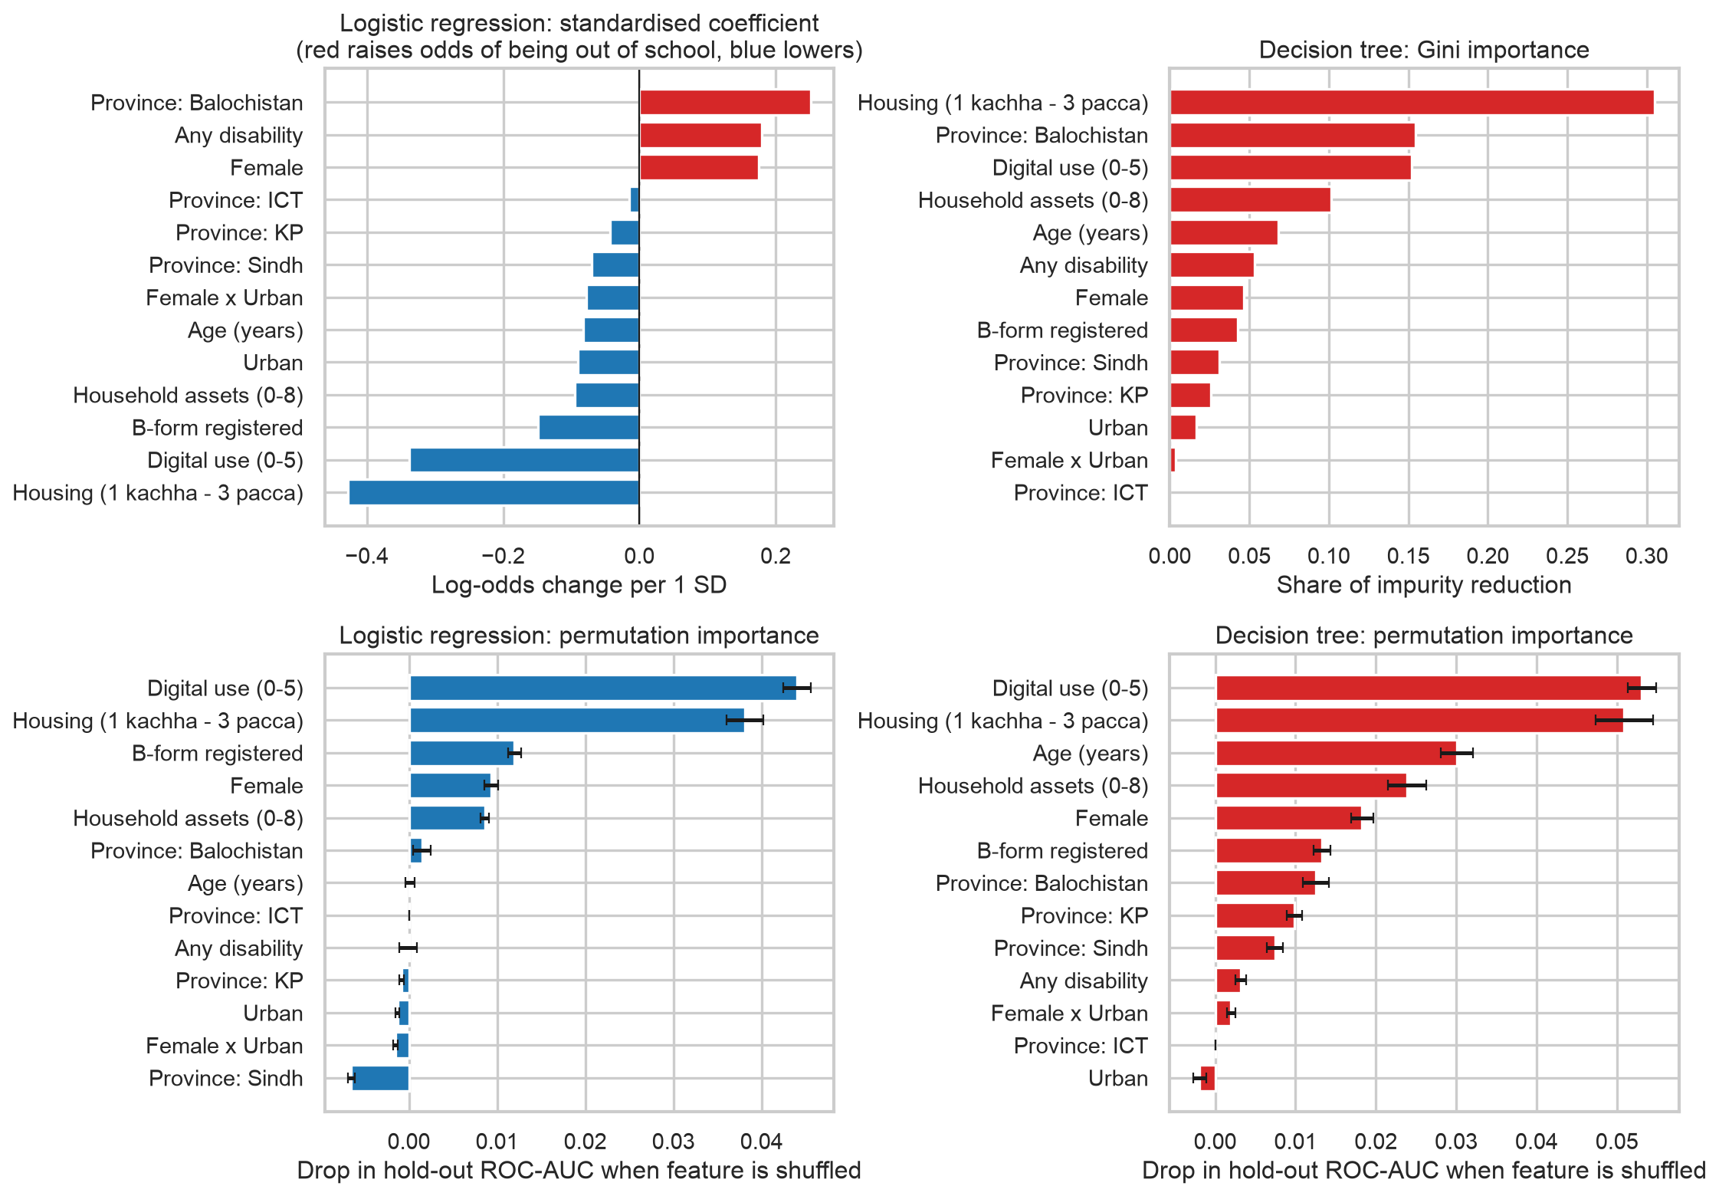
Figure 8. Standardised coefficients, Gini importance and permutation importance.
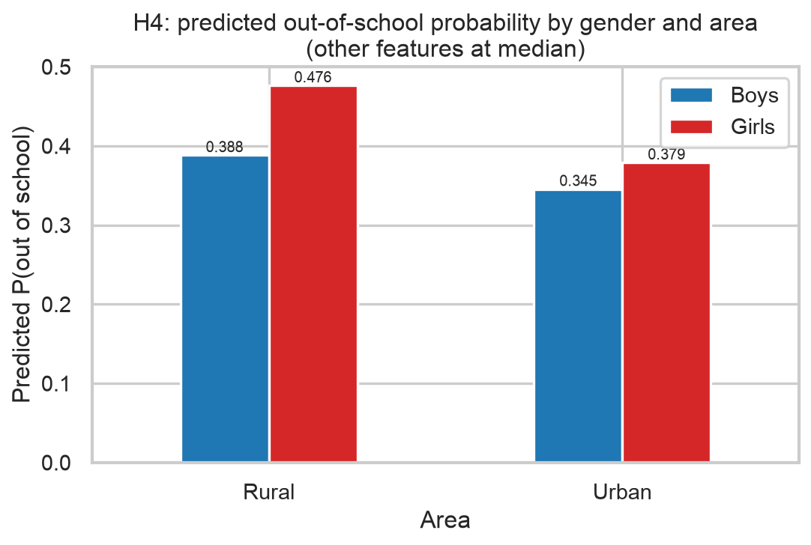
Figure 9. Predicted out-of-school probability by gender and area (H4).
Table 10. Evidence for the five hypotheses
Hypothesis | Variable | H1 expects | Odds ratio | CI low | CI high | p-value | Gini rank | H0 rejected
H1 Poverty | assets_n | OR < 1 | 0.964 | 0.951 | 0.976 | 0.000 | 4 | True
H2 Legal identity | bform | OR < 1 | 0.753 | 0.727 | 0.780 | 0.000 | 8 | True
H3 Disability | any_disability | OR > 1 | 1.877 | 1.795 | 1.962 | 0.000 | 6 | True
H4 Gender x area | female_x_urban | OR != 1 | 0.769 | 0.714 | 0.829 | 0.000 | 12 | True
H5 Feature value | 13 vs 3 features | AUC gain > 0 | - | - | - | 0.010 | - | True

- H1 Poverty (assets_n): OR 0.964 per additional asset, CI excluding 1; Gini rank 4. The direction is as hypothesised, but the per-asset effect is small - housing structure (OR 0.56 per step kachha to pacca) and digital access (OR 0.82 per service) are the dominant poverty signals in both learners. H0 rejected; the asset count is a weaker poverty proxy than housing.
- H2 Legal identity (bform): OR 0.753 for registered children, i.e. 1.33x higher odds without a B-form, significant and consistent across coefficient, Gini and permutation views. H0 rejected.
- H3 Disability (any_disability): OR 1.88, the largest single risk factor after Balochistan residence. H0 rejected.
- H4 Gender x area (female_x_urban): interaction OR 0.769, CI excluding 1. Girls face higher odds everywhere, but the predicted girl-boy gap is 8.8 percentage points in rural areas against 3.3 in urban areas: the gender penalty is a rural phenomenon. The tree barely uses the interaction term because it recreates it through sequential splits. H0 rejected.
- H5 Feature value: +0.150 AUC in cross-validation (every fold, p = 0.010) and +0.127 on hold-out. H0 rejected.
- Controls: Balochistan residence raises the odds 1.79x even after the household variables; age has a small negative coefficient within the 5-16 window; the ICT dummy is not significant (807 children). Note that Balochistan has the largest positive standardised coefficient in the logistic model yet close to zero permutation importance on the hold-out (Table 9), and Sindh's permutation importance is slightly negative. The province dummies overlap heavily with housing quality and digital access (kachha, disconnected households are concentrated in Balochistan), so shuffling a province flag costs little once the household variables remain; the coefficient measures the province's conditional association, the permutation drop its unique contribution to ranking children in new districts. The two views disagree because the information is shared, not because one is wrong.

7. Initial policy takeaways
A caveat before the recommendations. ASER is a single cross-sectional household survey, and every driver above is an association conditional on the other twelve features, not an estimated causal effect. The B-form result is the clearest example: children without a registration are more likely to be out of school, but households that are more engaged with public services may obtain both the document and a school place for reasons unrelated to the document itself, in which case issuing B-forms alone would not move enrolment. The same reasoning applies to housing, digital access and disability. The takeaways below therefore identify where and for whom out-of-school risk concentrates - which is what a targeting model can legitimately inform - and name candidate levers whose causal effect would need to be established (for instance through a piloted or staggered roll-out) before being relied on as policy.
- Target by housing and connectivity, not just an asset count. Housing quality and digital access are the strongest household predictors of out-of-school status; outreach lists built from a simple asset score will miss children in kachha, disconnected homes.
- Birth registration is a candidate lever and a targeting marker. Unregistered children have about 1.3x the odds of being out of school; at minimum, NADRA B-form records identify a population the model flags as high-risk, and a joint registration-plus-enrolment drive is a testable intervention.
- Disability inclusion is a first-order gap (SDG 4.5). Children with a functional difficulty have about 1.9x the odds; screening and inclusive-school capacity belong in any enrolment drive.
- The gender gap is rural. Girl-focused interventions should be prioritised in rural areas, where the predicted penalty is almost three times the urban one.
- Balochistan needs a province-level response: residence there nearly doubles the odds after household factors are accounted for.
- Set the operating threshold explicitly and choose it on training data. At a 5:1 cost ratio the recommended policy flags about 33% of children and catches 62% of out-of-school children on unseen districts; the default 0.5 threshold is not a defensible choice for outreach.

8. Limitations and roadmap for Milestone 04
Current limitations.
- Modest discrimination / underfitting: hold-out ROC-AUC 0.67-0.71 and pseudo-R2 0.12. Thirteen household features cannot separate the harder cases (urban or better-off dropouts); the missing signal is likely school-side (distance, supply, cost) and child history.
- Class imbalance is handled with class weights and threshold tuning, not resampling; precision stays near 0.2 at useful recall levels.
- District heterogeneity: CV standard deviation of about 0.05 AUC between district groups; the hold-out fold is harder than the CV average.
- Potential demographic bias: recall differs sharply by area, province and B-form status. Girls and disabled children are currently caught more often than their counterparts because they carry higher predicted risk, which is itself a fairness question.
- Associational evidence only: the drivers are conditional associations in one cross-sectional survey; none of the policy levers has an estimated causal effect (section 7).
- The H5 paired t-test rests on five folds; the district-cluster bootstrap of the hold-out gain (section 3.1) is the sturdier statement, and both agree.
Plan for Milestone 04.
- Fairness audit using the subgroup frame in subgroup_counts.csv: recall, precision and false-negative rate for girls vs boys, rural vs urban, with vs without disability, and by province, with bootstrap confidence intervals; test whether per-group thresholds or reweighting close the urban and Punjab/Sindh recall gaps. Islamabad Capital Territory (n = 807, 52 positives) is too small for reliable group conclusions and will be reported but not acted on.
- Advanced modelling: gradient boosting and random forest under the same district-grouped CV; probability calibration; interaction terms suggested by the tree; a cost-sensitive objective aligned with the FN:FP ratio.
- Ethical evaluation: harms of mis-targeting (stigma from false flags, exclusion from missed children), use of survey weights for population-level claims, and a deployment note on who sets the cost ratio.

9. Reproducibility
Code: milestone3/src (config, data, cv, models, evaluate, importance, plots, run_all, make_report) and the executed notebook Milestone03_BaselineModels.ipynb. `python src/run_all.py` regenerates every table (outputs/tables) and figure (outputs/figures) from aser2025_training.csv with random state 42; `python src/make_report.py` rebuilds this document.

