# 

CS205

OPerating Systems

|  |  |
| --- | --- |
| M. Hassan AhmedRoll No: K17-3654Section: E | Assignment # 1 |

## Teacher: Ms. Tania Erum

## Batch: 2017

## Semester: Spring 2018

# Scheduling:

## Q1

## 

## Ans a: Average Turnaround time for FCPS: 10.2s

## Ans b: Average Turnaround time for SJF: 8.6s

## Ans c: FCFS Waiting times

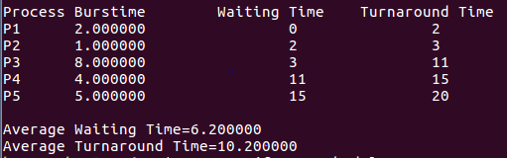

## SJF Waiting times

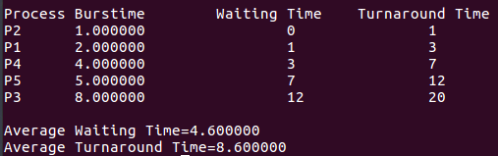

## Ans d: SJF results on minimum average waiting time (over all processes).

# Processes:

## Q1:



## Q2:



# Shell Scripting:

## Q2:

a)b)c)

d) NO, bash doesn’t have pointers but it does have references that allow variables to be referenced indirectly. In Bash (and other shells), you can get the values of array elements with the ${array[index]} notation, assign them with array[index]=... and get the number of elements in the array with ${#array[@]}. The expression inside the brackets is an arithmetic expression.

e)f)g)

# All code files:

