**Graphic 1:**

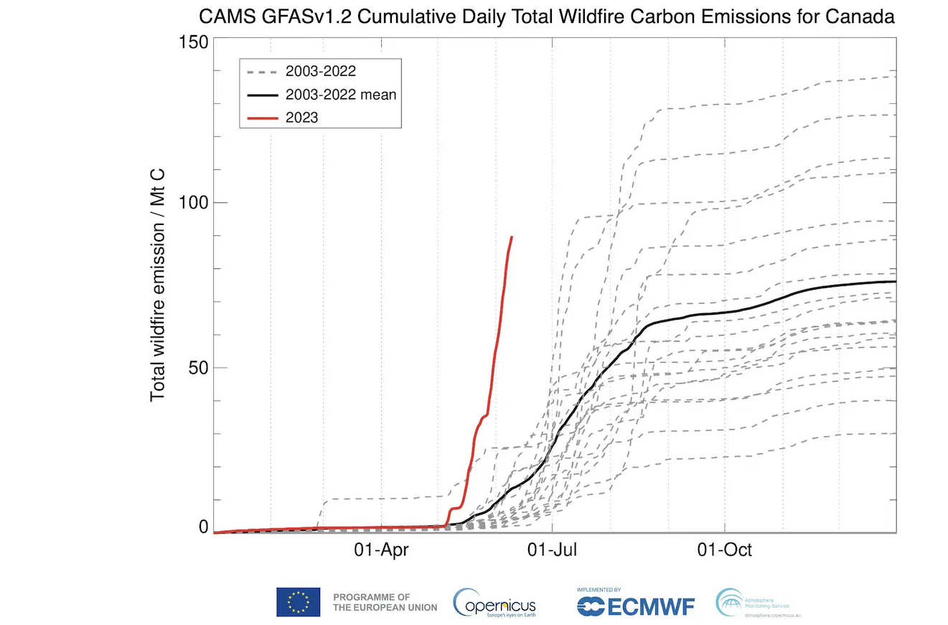

<https://www.washingtonpost.com/weather/2023/06/12/canada-record-wildfire-season-statistics/>

The statistical graphic is a line chart which describes the amount of carbon emissions from wildfires in Canada as of now, in 2023 according to (Livingston, 2023). The graphic has been chosen because it consists of past historical data of the average emission of Carbon in each individual year and the average of all the years, compared to the current year. By reviewing the line chart, we can certainly say that the line in red is the current figure, or the amount of carbon emission in Canada in 2023, has reached to approximately 100 Mt C, which is already higher than average of last 20 years. We can also view that there have been instances (about 4 times) in last 20 years, where the carbon emission levels have reached above 100 Mt C, which less than 25% of the total number of wildfires. Another noticeable issue is that the current spike in Carbon Emission is earlier than the previous years, because the April to June month timeline is comparatively cooler than July to August, where it will get warmer. This illustrates a dangerous aspect of the current wildfire, which means they are going to increase unreasonably in 2023 and could reach the highest amount of carbon emission in a single year, if it maintains the current upward trend.

Upon reviewing the infographic, data labelling is a major issue that may be improved in this statistical graphic. It is confusing to understand the timeline of the months, where do they start and where they end. The lines are also confusing for the reader, as they are not labelled according to their year, so we can observe if there is any increase in carbon emission over the last few years. Another issue is the lack of labelling of the X-Axis, a reader might get confused according to which month and year are the data plotted. In addition, the graphic does not include the standard carbon emission level and the hazardous carbon emission level which might be unhealthy for the people, this would have created awareness for the reader.

1. Livingston I. Analysis | why Canada’s wildfires are extreme and getting worse, in 4 charts [Internet]. WP Company; 2023 [cited 2023 Aug 19]. Available from: https://www.washingtonpost.com/weather/2023/06/12/canada-record-wildfire-season-statistics/

**Graphic 2**

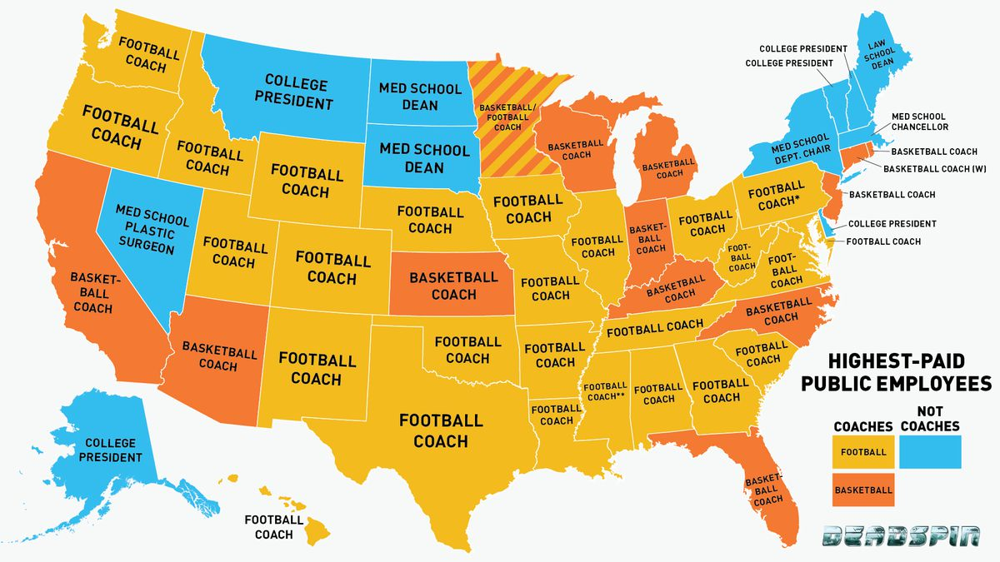

<https://deadspin.com/infographic-is-your-states-highest-paid-employee-a-co-489635228>

This thematic map has been taken from the popular website Deadspin (Fischer-Baum, 2013). The map shows a vivid reflection of highest salaried public employees across all the states of United States of America. This map has been chosen because it shows a thematic view of the entire United States of America, where each state is represented with either of the 3 colours, orange yellow and blue according to the highest paid salaries. The information in the map helps us to understand the most paid government employed are the coaches of football teams or basketball teams during the year of 2013. However, there are also some states which have highest paid public employees who are not coaches. It can be deduced that the majority of the highest paid government employees during 2013 were football coaches, with over 50% ratio, which was followed by basketball coaches. Around 20% of the states have public employees who are not coaches (either football/basketball).

Upon reviewing the thematic map with the article, it can be derived that there are some differences derived in the article and the graph. The article concludes that the map is based upon base pay instead of total salary including bonuses, which is not included in the map. There are inconsistencies in the map, as one of the states has a football or a basketball coach as highest paid, however a single option was not picked. Another issue with the graph is that Alaska is included in the map at the bottom left of the map, however it truly does not reflect the actual map of the United States. In addition, the states are not labelled, so it is difficult for the reader to remember the name of all the states. The labelling in some of the states are not clear and is difficult to understand who the highest paid public employee is, other than their type. The labelling also does not include the name of the person, or the team who represents the highest paid employee, which would make the map more meaningful.

1. Fischer-Baum R. Infographic: Is your State’s highest-paid employee a coach? (probably) [Internet]. Deadspin; 2013 [cited 2023 Aug 18]. Available from: https://deadspin.com/infographic-is-your-states-highest-paid-employee-a-co-489635228

**Graphic 3**

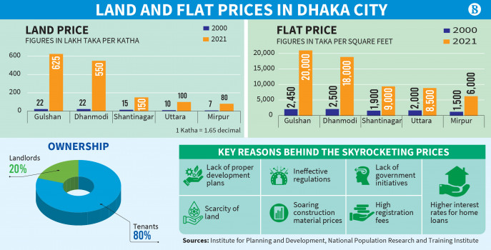

[**https://www.tbsnews.net/economy/2700-land-price-hike-two-decades-makes-owning-home-dhaka-elusive-507510**](https://www.tbsnews.net/economy/2700-land-price-hike-two-decades-makes-owning-home-dhaka-elusive-507510)

The statistical graphic has been chosen because it consists of different pie chart, bar diagrams and infographics. It includes a bar chart on the top left, which describes the price change of lands in different suburbs of Dhaka, the capital of Bangladesh between two 2000 and 2021. Another bar chart on the top right describes the change in apartments across difference suburbs of Dhaka across the same period (2000 to 2021). The infographic also includes a pie chart, which illustrates the person residing in the purchased properties, which shows that majority of the property are rented out to tenants, while the landlords only live in about 20% of the properties they purchase. The infographic also includes some of the reasons behind the increase in the land and apartment purchase price, mainly due to higher interest rates of home loan (Noyon & Jahidul, 2022).

Upon reviewing the infographic, the pie chart is irrelevant to the other information provided in the infographic. The pie chart discusses about the ownership percentage, while the remaining infographic reflects upon the increase in housing prices and the reason for the increase. The bar charts are not adequately labelled in either of the bar charts, the prices are mixed up, above and within the bar charts. There is also lack of labelling in the X Axis and Y Axis of the both the bar charts. The size of the bar charts of close approximate figures like 2450 and 2500, look similar and may confuse readers. The colour element used in the infographic is also not eye soothing, especially the information part, where the reasons for increase in house price is described, the green colour with the background the difficult to view for the reader. Overall, some of the important information of the article is omitted from the infographic, like the overall increase in price. Therefore, it will be difficult to understand the conclusion of the article by only viewing the infographic.

1. Noyon AU, Islam MJ. Up to 2700% land price hike in two decades makes owning home in Dhaka elusive [Internet]. 2022 [cited 2023 Aug 18]. Available from: <https://www.tbsnews.net/economy/2700-land-price-hike-two-decades-makes-owning-home-dhaka-elusive-507510>

**Graphic 4**

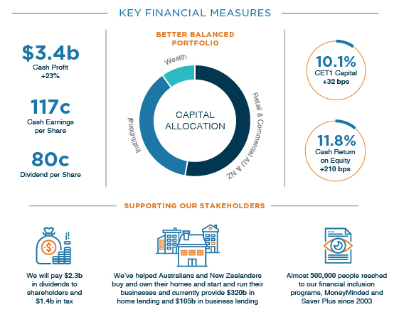

<https://bluenotes.anz.com/posts/2017/05/infographic-anz-s-profit-in-pictures>

This infographic is an illustration of the key performance indicators as part of the annual performance review of ANZ Bank in 2017. The infographic is chosen because of its representation of the business performance of a company in a particular year. The infographic consists of a pie chart which represents the portfolio allocation of the bank at the end of the financial year. There are also various performance indicators included in the infographic, such as the increase in GET1 Capital, Cash Return on Equity, Cash Profit and the updated information on Cash Earnings per Share and Dividends per Share. The infographic ends with how the bank is supporting its stakeholders along with its business operation.

Upon reviewing the various elements of the infographic, the first think that may improve is the inclusion of percentage in the pie chart, without the inclusion of a percentage figures, it will be confusing for the readers to understand the portfolio allocation of the bank. Definition breakdown of the banking terms are required for the general viewers of the financial information. It is also evident that some of the critical information of an organizations financial information is missing from the infographic, like the Earnings after Tax, ROI, Equity to Debt Ratio, etc, which are also important key financial measures for a bank. There is also no evidence of the trend in performance indicators of the bank compared to the previous years. For example, a bar chart including the figures of ROI, EPS or Net Profit for last 3 to 5 years compared to the current year, will show the right indication of the bank to the readers.

1. Raise S. Infographic: ANZ’s profit in pictures [Internet]. 2018 [cited 2023 Aug 19]. Available from: https://bluenotes.anz.com/posts/2017/05/infographic-anz-s-profit-in-pictures

**Graphic: 5**

<https://www.anzdata.org.au/anzdata/for-patients/infographic-statistics/>

The infographic is a yearly review of the kidney treatment summary in Australia published by (ANZ, n.d.) in 2022. It showcases the summary of the kidney related treatments during 2021. The graphic has been chosen because it consists of pie chart, bar chart and other informative elements which make it an ideal infographic. The infographic depicts the yearly summary of people who started kidney dialysis, received kidney transplantation (before and after dialysis) and number of people currently living with a kidney transplant. The infographic also includes a bar chart representing the age of kidney patients, a pie chart representing the types of kidney diseases, and a horizontal bar chart representing the causes of causes of kidney disease.

In my opinion, the infographic is direct in showcasing the information it wants its readers to understand. However, some of the images used within the infographic, especially with the charts are irrelevant or unnecessary for the readers. The bar chart showcasing the demography of kidney diseases consist of some images representing their age, which is unnecessary. The chart labelling is also missing in the chart, like the X-Axis and the Y-Axis, the plotting is also very narrow for the readers to understand the actual number of people in that age group (year distribution, number of people, etc.). The pie chart also consists of some images within the chart, which are not relevant to the information discussed in the chart. The colour scheme used in the infographic is reader friendly, however, some of the images used in the background of texts makes it difficult for the reader to understand the text.

1. Infographic statistics [Internet]. 2022 [cited 2023 Aug 18]. Available from: https://www.anzdata.org.au/anzdata/for-patients/infographic-statistics/