Campaign Brochure – designer tool

Create modular, auto-generated recruitment campaign brochure that combines the job advert with a compelling employer brand story. Below is a structured plan + index that you can give to your developer and designer. It details the brochure flow, required content, and the assets/data clients must provide in order for this to work seamlessly.

📘 Campaign Brochure Plan
🎯 Objective
To create a branded, candidate-facing campaign brochure that highlights:
- The job opportunity (auto-populated from job advert generator).
- The employer brand (culture, values, leadership).
- The employee experience (testimonials, case studies).
- The benefits & career progression.
- A strong call-to-action (easy to apply).

📑 Brochure Index
- Front Cover
  - Company logo & branding
  - Hero image (team, workplace, or product)
  - Campaign tagline (e.g., “Join Us. Shape the Future of [Industry].”)
  - Job title highlighted (“Now Hiring: Senior Software Engineer”)
- Welcome Message / Introduction
  - Short note from CEO/Founder/HR Director.
  - Key message: why join us, our mission, and how people make the difference.
  - Photo of CEO or leadership team.
- The Career Opportunity (Job Advert Page)
  - Auto-pull the job advert content (title, location, salary, role summary, requirements, responsibilities).
  - “Why this role matters” section (employer can provide a short statement).
  - “Apply Now” button or QR code link to application portal.
- About the Company
  - Company overview (history, mission, values).
  - Key stats (number of employees, offices, global reach, awards).
  - Logos of certifications, memberships, or industry recognition.
  - Optional: product/service highlights (one or two visuals).
- Our Culture & Values
  - Short section outlining workplace culture (innovation, teamwork, diversity, sustainability).
  - Supporting imagery (photos of employees at work, team events, office space).
  - Core values in an easy-to-digest format (e.g., icons + short text).
- Employee Testimonials
  - Pull quotes from 2–3 employees (with headshots, names, job titles).
  - Focus on “what it’s like to work here”.
  - Option to include short video testimonial links (QR codes).
- Case Study: A Career Journey (optional)
  - One employee’s growth story: “From Graduate to Team Leader in 3 Years.”
  - Timeline or short narrative with photo.
- Company Benefits
  - List of benefits (flexible working, hybrid policy, pension scheme, healthcare, learning & development).
  - Visual icons for each benefit.
  - Option to include salary benchmarking or career progression chart.
- Diversity, Equity & Inclusion (DEI) (optional but powerful)
  - Short statement about inclusivity and belonging.
  - Diversity stats or initiatives (e.g., employee resource groups, partnerships).
  - Photo of a diverse team in action.
- How to Apply / Call to Action
  - Simple steps to apply (e.g., “Scan QR code / Click link”).
  - Contact details (HR/recruitment email, phone if relevant).
  - CTA tagline: “Your future starts here.”
- Back Cover
  - Company logo, tagline.
  - Website and social media handles.
  - QR code for careers site.
  - Legal disclaimer (if needed).

📦 Assets & Information Required from Clients
To make this auto-generatable, clients should provide:
- Logos & Brand Assets
  - High-res logo (PNG/SVG).
  - Brand colour codes & fonts.
  - Company tagline.
- Images
  - Hero banner image.
  - 3–5 workplace/team images.
  - Employee headshots for testimonials.
  - Optional: product/service images.
- Text Content
  - Company overview (200–300 words).
  - Mission & values (short, bullet-pointed).
  - CEO/leader introduction message (100–150 words).
  - Employee testimonials (2–3 quotes, 50–80 words each).
  - Case study (optional, 200–300 words).
  - Benefits list (titles + 1–2 sentences each).
  - DEI statement (optional, 100 words).
- Links & Interactivity
  - Job application URL.
  - Careers website.
  - Social media links.
  - Optional video links for QR codes.
- Compliance
  - Equal opportunity statement (if required).
  - GDPR/data privacy note if personal data is collected.

⚙️ Developer/Designer Build Considerations
- Modular Templates:
Each section should be optional & swappable depending on what assets the client provides.
- Brand Customisation:
Brochure should adopt client’s colour scheme, font, and imagery.
- Dynamic Content Pull:
Job advert generator auto-fills job page.
Client portal to upload assets (logos, testimonials, benefits list).
- Export Options:
PDF (for email), interactive web version (flipbook/microsite), print-ready option.

👉 This plan ensures the brochure isn’t just a job description, but a storytelling tool that positions the company as an employer of choice.

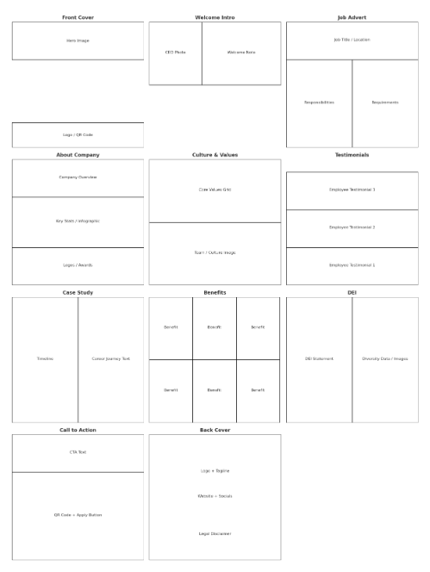

📘 Campaign Brochure Wireframe / Mockup Layout
Below is a page-by-page wireframe outline (in text format) that can be passed to a designer for visualisation. Each page is structured to show layout blocks, text/image placement, and flow.

1. Front Cover
- [Top]: Company Logo (top-left) + Tagline (top-right).
- [Centre]: Large Hero Image (team/product/office).
- [Overlay Text]: Job Title (e.g., Now Hiring: Senior Software Engineer).
- [Footer]: Website + QR code (link to careers site).

2. Welcome / Introduction Page
- [Left Column]: CEO/Leader Photo (circular or portrait).
- [Right Column]: Short welcome note (100–150 words).
- [Footer Strip]: Quote-style pullout (e.g., “Our people are our greatest strength.”).

3. The Career Opportunity (Job Advert)
- [Top Header]: Job Title + Location + Salary.
- [Two-Column Layout]:
  - Left: Responsibilities & Role Description (from job advert generator).
  - Right: Key Requirements (bulleted list).
- [Callout Box]: “Why this role matters” (short text).
- [Footer]: Apply Now button + QR code.

4. About the Company
- [Top Banner]: Company overview (200–300 words).
- [Middle]: Infographic-style Key Stats (e.g., Founded, Employees, Locations, Awards).
- [Bottom]: Logos of certifications/awards/industry bodies.

5. Our Culture & Values
- [Header]: Bold section title with iconography.
- [Grid Layout]: 3–5 Core Values (each with icon + 1 sentence).
- [Full-width Image]: Team photo/workplace culture shot.

6. Employee Testimonials
- [2–3 Testimonial Blocks]:
  - Employee photo (headshot), Name, Job Title.
  - Pull quote (50–80 words).
- [Optional QR Code]: “Watch Emma’s story” (link to video).

7. Case Study: Career Journey (Optional)
- [Left Side]: Timeline/graphic of career progression (e.g., Graduate → Manager).
- [Right Side]: Narrative text (200–300 words) with employee photo.

8. Company Benefits
- [Header Strip]: “Why You’ll Love Working Here.”
- [Grid Layout]: 6–8 benefits (icon + short text, e.g., Flexible Hours, Pension, L&D, Wellness).
- [Visual Cue]: Lifestyle image (team working remotely or office perks).

9. Diversity, Equity & Inclusion (Optional)
- [Left Column]: Statement about inclusivity (100 words).
- [Right Column]: Diversity metrics or initiative highlights.
- [Background Image]: Group/team shot representing inclusivity.

10. How to Apply / Call to Action
- [Top]: Short 1–2 sentence CTA (“Your future starts here – join us today.”).
- [Middle]: Step-by-step application instructions (1–2 steps only).
- [Footer]: Large QR code + Apply button, plus HR/recruitment contact details.

11. Back Cover
- [Full Background]: Solid brand colour.
- [Centre]: Company logo + tagline.
- [Bottom]: Website, social handles, QR code to careers site.
- [Small Footer]: Legal disclaimer/equal opportunities statement.

🎨 Notes for Designer
- Style: Clean, modern, plenty of white space, consistent with employer brand colours.
- Typography: Headings bold & engaging; body copy clear and readable.
- Visual Balance: Mix of text + imagery, avoid text-heavy pages.
- Export: Print-ready PDF + digital interactive version (clickable links/QR codes).

👉 This wireframe serves as the blueprint. Each section is modular, so the system can dynamically include/exclude based on client-provided assets.

