Retaind Sales Assets and process

Sales Process Framework (What the recruiter follows live)
This should be presented inside retaind as a step-by-step sales journey, with prompts, assets, and talking points at each stage.

Stage-by-Stage Sales Assets & Tools
Stage 1: “Why Are We Here Today?” (Context & Intent Framing)
Objective:
Create psychological safety and reposition the conversation away from “agency pitch” toward problem diagnosis.
Assets recruiters should access:
- Discovery call opener script (short, neutral, consultative)
- “Hiring Outcomes vs Hiring Activity” visual
- Client-friendly agenda slide (sets expectations)
Key message:
“This conversation is about reducing hiring risk, not filling vacancies.” – Hiring for Retention

Stage 2: Qualification – Pains, Risks & Objectives
Objective:
Surface commercial and emotional pain (mis-hires, wasted time, attrition, internal pressure, internal mis-alignment, weak talent pool, poor hiring Quality)
Agree on objectives and outcomes (improved assessment and selection process, earlier productivity and better hiring ROI, fairer, compliant non bias hiring, target top 1% talent).
Assets:
- Qualification question bank (Guide the client towards past pains and to agree on objectives)
- Use Cost-of-mis-hire calculator to agree on failure costs
- Agree on Attrition and time-to-productivity benchmarks
Outputs:
- Agree on pains and risks that they wish to avoid
- Agreed definition of “success” beyond just a hire

Stage 3: The Problem with the Contingency Model
Objective:
Create constructive dissatisfaction with the status quo without attacking recruiters or prior suppliers.
Assets:
- Contingency vs retained comparison visual
- Evidence-based outcomes slide (fill rates, retention, ROI)
- Duplication-of-effort visual (multiple recruiters ≠ multiplied effort)
- AI tools devaluing CV transactional services
Key reframing:
“Contingency optimises for speed. Retained optimises for outcomes.”

Stage 4: Introducing the Solution (Reframe Before Product)
Objective:
Shift the frame from recruitment as CV supply to recruitment as risk management.
Assets:
- “Evidence-led hiring” framework slide
- Retained-as-insurance analogy
- Client journey map (from brief → evidence-backed shortlist)

The retaind Methodology (The Core Differentiator)
This is where retaind becomes the proof, not the pitch.

Stage 5: The retaind Process & Methodology
Objective:
Demonstrate that retained isn’t a pricing model—it’s a delivery system.
Assets:
- End-to-end retained workflow visual
- Timeline with milestones & outputs
- Client responsibilities vs recruiter responsibilities matrix

Retained Delivery Steps (What Makes This Impossible to Copy)
Each step below should have three things available in-platform:
- Client-facing explanation
- Visual artefact
- Recruiter script / positioning notes

1. Information Gathering & Requirement Capture
- Structured framework for gathering essential and desirable information
- Stakeholder alignment checklist
- Job Specification

2. Job Spec → Job Advert → Campaign Brochure
- AI-assisted job advert generation (treble applications)
- Client-branded campaign brochure (Attract the top 1%)
- Employer value proposition positioning (Better Psychology)

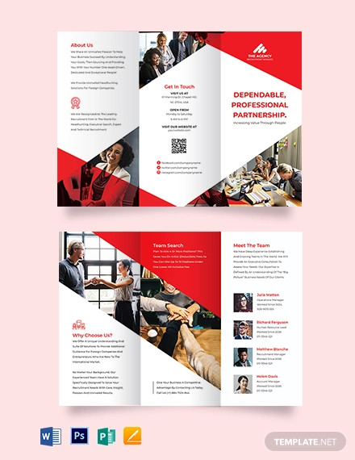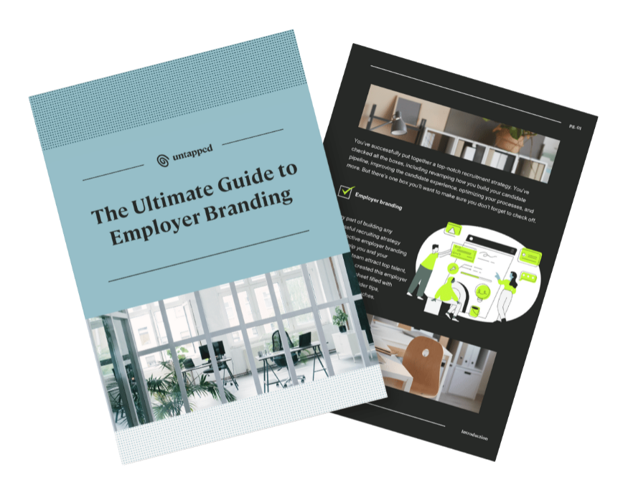

3. Behavioural & Cultural Benchmarking
- Client benchmarking questionnaires
- Explanatory guide (why each trait matters)
- Conflict identification & resolution output
Key value:
Prevents internal misalignment before candidates are ever assessed.

4. Candidate Questionnaire & Benchmark Comparison
- Candidate self-assessment
- Fit vs conflict logic tables
- Positive correlation and risk flags

5. Behavioural Assessment & Insights
- Positive correlations
- Potential conflict areas
- Adaptability indicators

6. Visual Representation (Spider Diagrams)
- Client benchmark vs candidate overlay
- At-a-glance decision visuals



7. Interview Question Generation (generates the questions that you should be asking)
- Behavioural questions (STAR)
- Conflict-probing questions
- Competency validation aligned to benchmark & Questionnaire outputs

8. Video Interviewing
- Structured video interview framework (Targeted questions generated by AI)
- Consistent candidate experience (2 validation and 6 conflict questions)
- Replayable evidence for stakeholders

9. AI Assessment of Interview Responses
- Alignment validation
- Risk confidence scoring
- Narrative summary for clients

10. Shortlist Presentation
- Fit vs conflict report (client-ready)
- Visual summaries
- Interview focus guidance

5. Commercial Close: Pricing & Negotiation (Last, Not First)
Objective:
Anchor price after value is undeniable.
Assets:
- Retained pricing rationale slide
- Fee vs risk reduction visual
- Payment structure options
  - Retainer of £2k. £2k upon presentation of shortlist. Remainder payable at start date. 12 month free replacement policy
  - Retainer of £2k. £2k upon presentation of shortlist. Remainder payable in 6 monthly payments from start date. 6 month free replacement policy
- Comparison to cost of failure
Key positioning:
“You’re not paying for candidates—you’re investing in certainty.”

6. What Recruiters Should Have Access To (System-Wide)
Sales Enablement
- Slide decks per stage (to be provided as images)
- Talk tracks & objection handling (Guidelines and document to be provided)
- ROI calculator. (Designed to calculate true cost per hire, and to demonstrate likely savings. (See design prompt below – at the end of this doc)
Client-Facing Collateral
- Campaign brochures (requires a feature that generates a brochure from information extracted from the clients own website, following their brand, positioning and palette. Should include the following components. About us, What we do, Our Vacancy details (Job advert), A day in the life of (the job being advertised), Our Culture and people, People profiles (covering 3 of 4 people in different roles. (additional pages could also be created to cover any additional information that the client wishes to include.
- Visual reports. (Examples of how results are displayed)
- Benchmark explanations (both internal objectives and why these benchmarks help improve hiring success).
Workflows
- Turning a resou
- Demonstrating how Retaind help maintain a high quality standardised approach.
- Quality control checkpoints and EU AI Automation compliance
Risk-reduction framing - Psychological Advantage
- Evidence-based positioning
- Hiring for retention
- Status elevation from “supplier” to “advisor”

7. Why This Structure Works
- Reduces buyer fear (risk, reputation, failure)
- Builds logical inevitability toward retained
- Makes pricing feel secondary
- Elevates recruiter authority
- Differentiates Retaind beyond other Rectec platforms

ROI Calculator for Recruitment Costs
Guide to build an ROI Calculator that measures the true cost of recruiting, including the cost of bad hires.
The calculator should:
Step 1 – Gather the following inputs:
- Total number of hires in the last 12 months
- Total number of leavers in the last 12 months
- Number of those leavers who left within the first 12 months of their employment
- Average salary (default £50,000)
- Average agency recruitment fee percentage (default 20%)
Step 2 – Perform the following calculations:
- Attrition rate (%):
\text{Attrition %} = \frac{\text{Total Leavers} \times 100}{\text{Total Hires}}
- Perceived recruitment costs:
\text{Perceived Recruitment Costs} = \text{Average Salary} \times \text{Agency Fee %} \times \text{Total Hires}
- Additional cost of 1st year leavers:
Bad Hire Cost (Additional)=Number of 1st Year Leavers×Average Salary×2\text{Bad Hire Cost (Additional)} = \text{Number of 1st Year Leavers} \times \text{Average Salary} \times 2Bad Hire Cost (Additional)=Number of 1st Year Leavers×Average Salary×2
- Actual recruiting costs:
Actual Recruiting Costs=Perceived Recruitment Costs+Bad Hire Cost (Additional)\text{Actual Recruiting Costs} = \text{Perceived Recruitment Costs} + \text{Bad Hire Cost (Additional)}Actual Recruiting Costs=Perceived Recruitment Costs+Bad Hire Cost (Additional)
- Total cost of bad hires (extended):
Cost of Bad Leavers=Number of 1st Year Leavers×Average Salary×3\text{Cost of Bad Leavers} = \text{Number of 1st Year Leavers} \times \text{Average Salary} \times 3Cost of Bad Leavers=Number of 1st Year Leavers×Average Salary×3
Step 3 – Output the results clearly:
- Attrition %
- Perceived Recruitment Costs
- Actual Recruiting Costs
- Cost of Bad Leavers
- Potential savings by reducing first-year leavers to just 5%

BMD ROI Calculator prompt

I am creating an ROI calculator in Replit.com to use on my website - It will be a single page design, with a top section that explains to the user the benefits of entering their details, to establish the likely or predictable ROI that they would enjoy each month and over 12 months by using The Book My Demos Service, based upon the the package they select. Giving them instant results in the dashboard, once they have signed in or provided their personal details (Full name, Company Name and Email Address). Assumptions: For average order values of £5,000 or less 1 meeting is booked each month for every £100 spent. For average order values of £5,000 -£10,000 1 meeting is booked each month for every £150 spent. For average order values of £10,000-£25,000 1 meeting is booked each month for every £200 spent. For average order values of £25,000 or greater 1 meeting is booked each month for every £300 spent. Step 1 - Gather the following inputs. - 1/ Choose a package a/ Email Only @ £595 (offer $750 as a US option) b/ Email & LinkedIn combined & £795 (offer $995 as a US option). 2/ Their Sales Closing ratio % 3/ The average order value from a sale 4/ The average annual revenue value of a customer 5/ The average number of years that they keep a customer. The Outputs required are as follows 1/ The ROI multiple based on what they spent, the average order value and their sales closing ratio %. Present this as a %, as a monetary value in £ or $, and as a fraction (i.e. 1/6). Also provide these as an annual ROI and as a lifetime value ROI. Present these numbers on screen, but also offer to send them as part of a Book my Demos brochure and proposal document. When someone requests the brochure, this should send all their personal and ROI details into info@bookmydemos.com - Now take all this information and convert it into a detailed prompt, that I can copy and paste into the replit AI tool.

