Group music

E-PROJECT - 2025

SEMESTER-1 CPISM

CURRICULUM -7062

|  |  |  |
| --- | --- | --- |
| **F**aculty | Miss Urooj Rehman | |
| Batch | 2406C2 | |
| Serial No. | **Enrollment Number** | **Student Name** |
| 1. | Student 1581509 | Syed hassan Ali |
| 2. | Student 1580794 | Ayaan kashif |
| 3.  4 | Student 1567683  student | Muhammad raza sardar  Muhammad ali |

**SCREENSHOTS (Output)**

**HOME PAGE:**

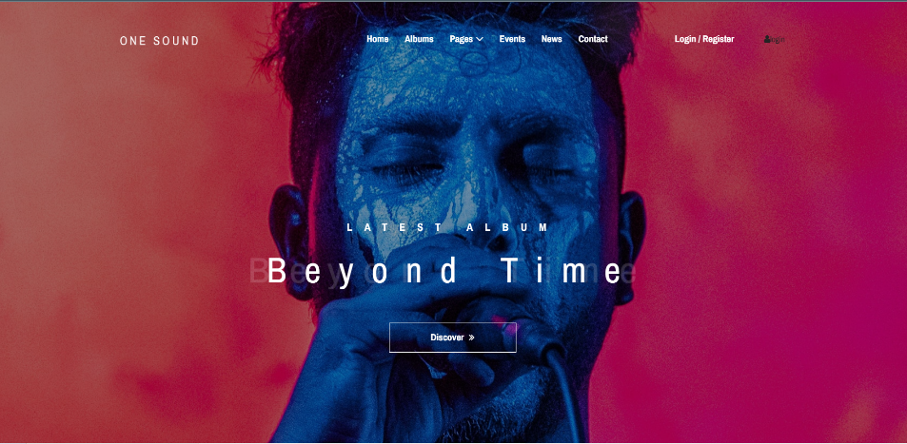

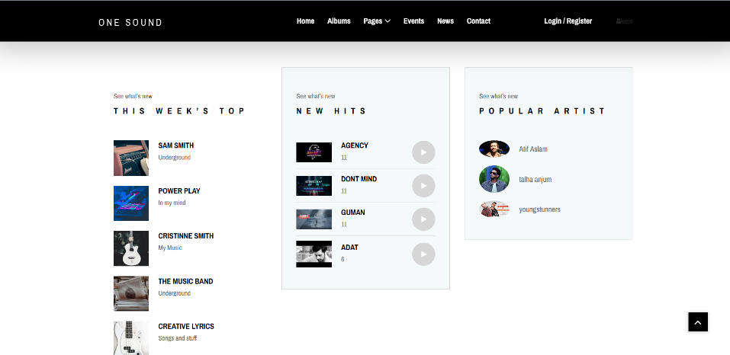

**register**

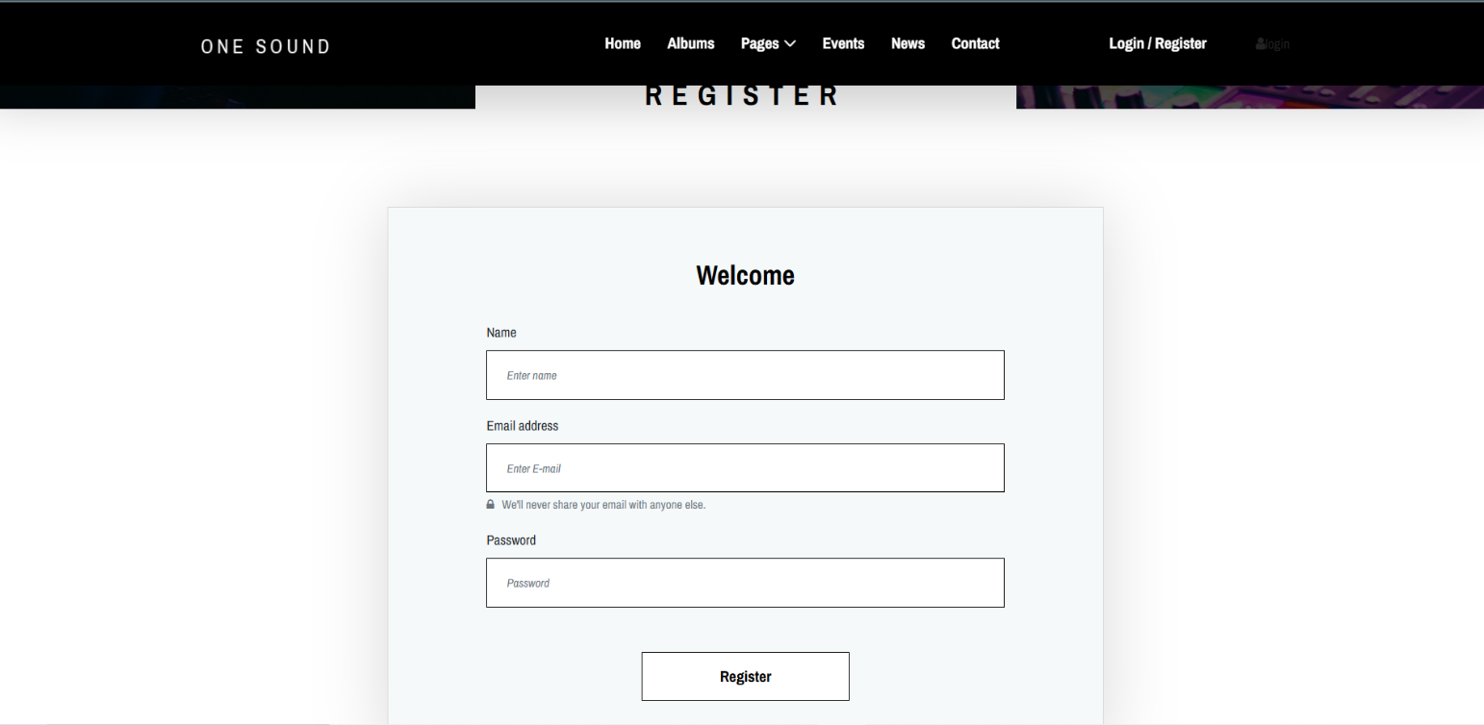**login**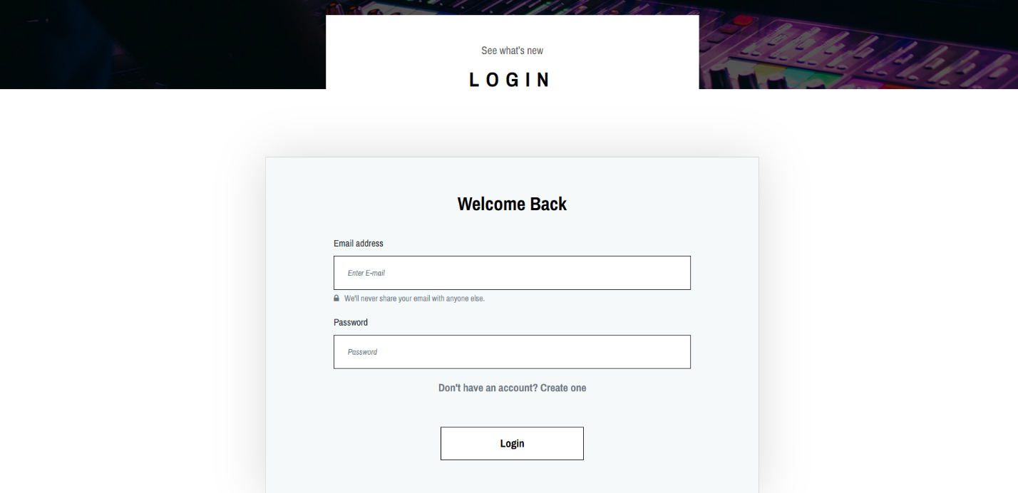

**Albums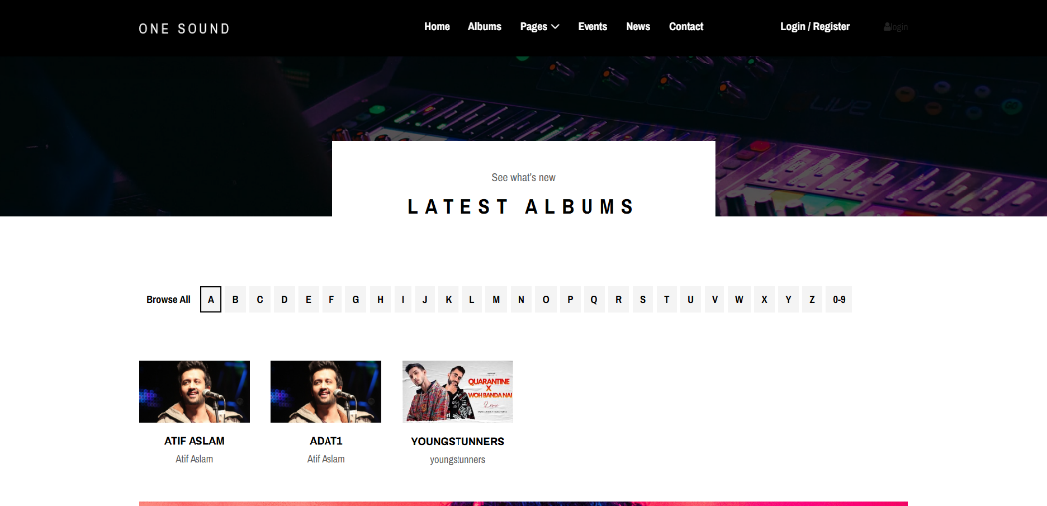:**

**User admin panel:**

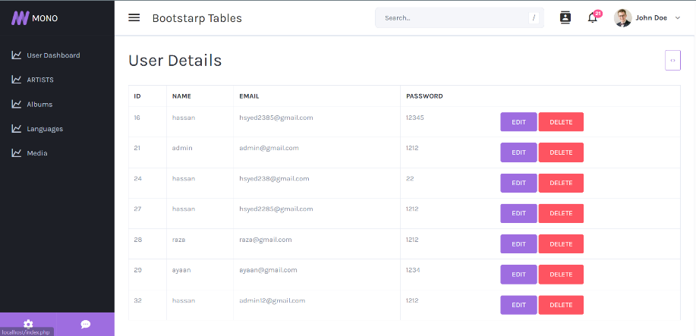 **media admin panel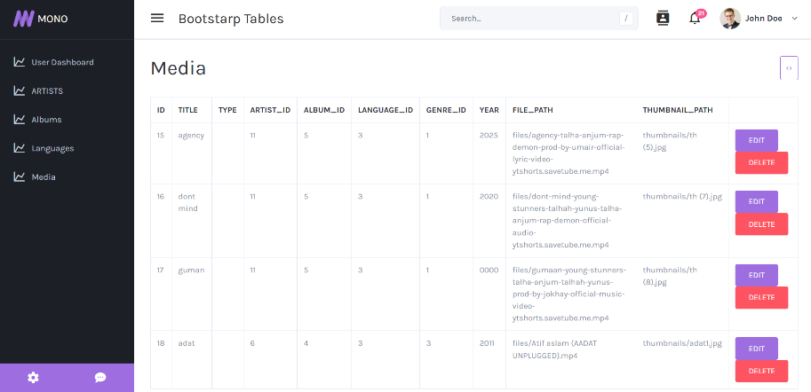 artist admin panel 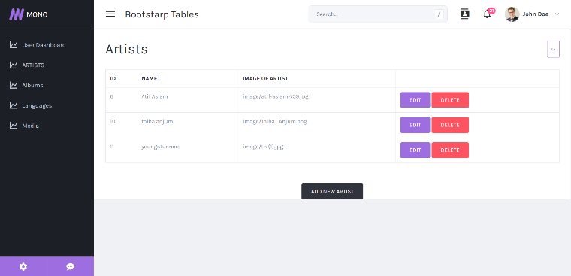 media admin panel** 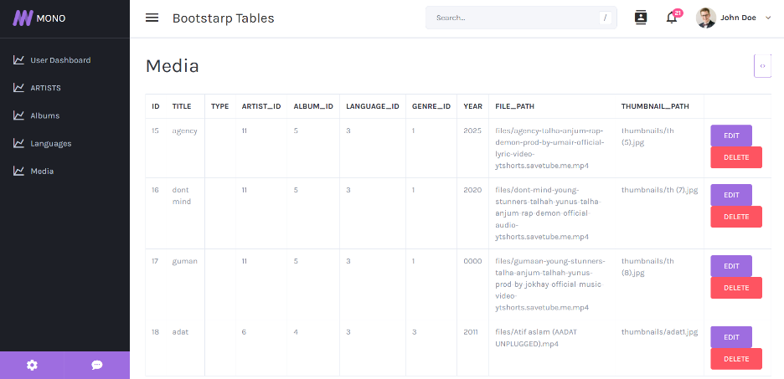

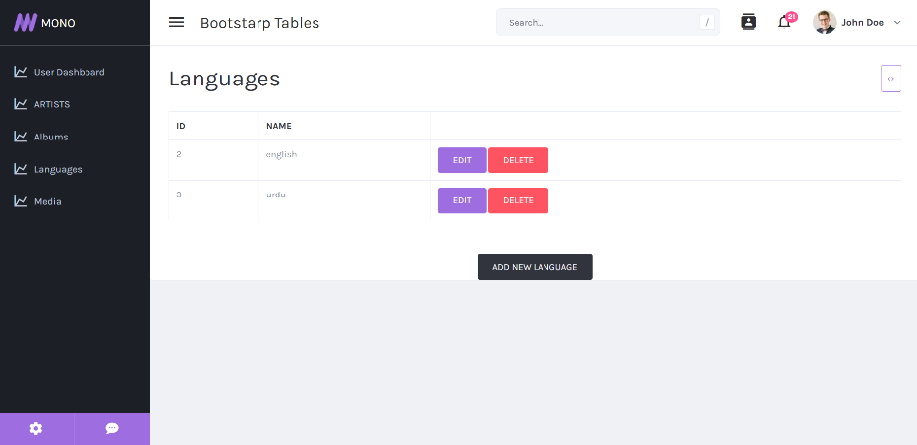

**langauges admin panel**

