19_Internal_Control_Audit
RAM – Internal Control & Audit Framework
Document Code: L_0_19_Internal_Control_Audit

1️⃣ Policy Statement
RAM establishes a structured Internal Control and Audit Framework to:
- Safeguard assets
- Ensure reliability of financial and operational reporting
- Ensure compliance with laws, regulations, and contracts
- Improve governance and risk management effectiveness
- Detect and prevent fraud, misconduct, and inefficiencies
This framework aligns with:
- Committee of Sponsoring Organizations of the Treadway Commission (COSO Internal Control Framework)
- Institute of Internal Auditors (IIA Standards)
- International Organization for Standardization (ISO 31000 Risk Management principles)

2️⃣ Internal Control Architecture (Three Lines Model)

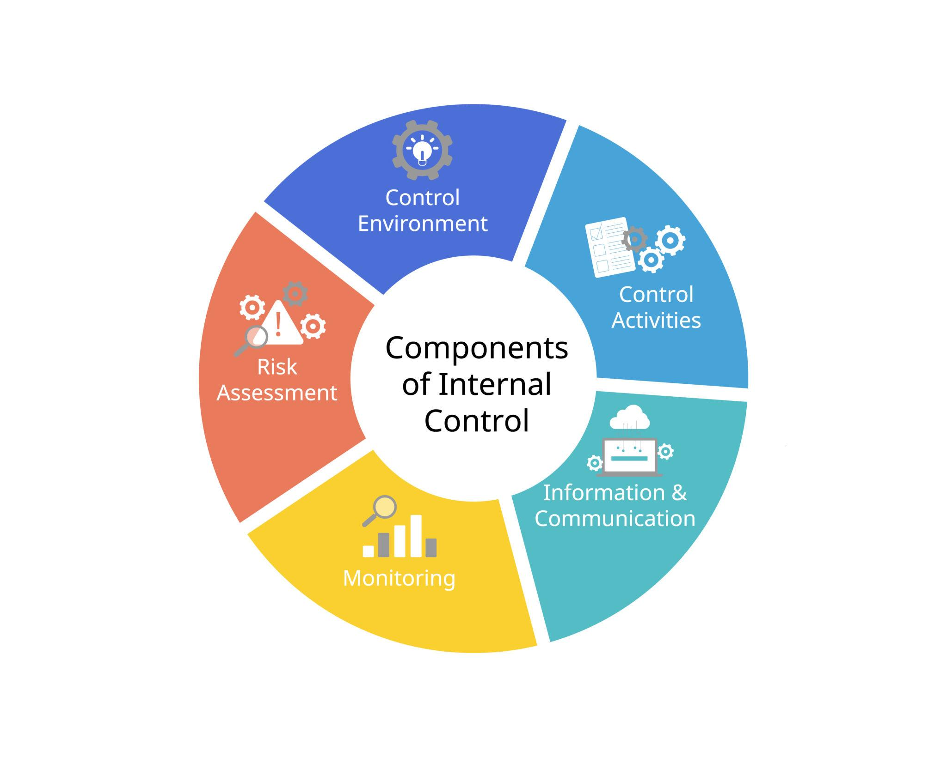
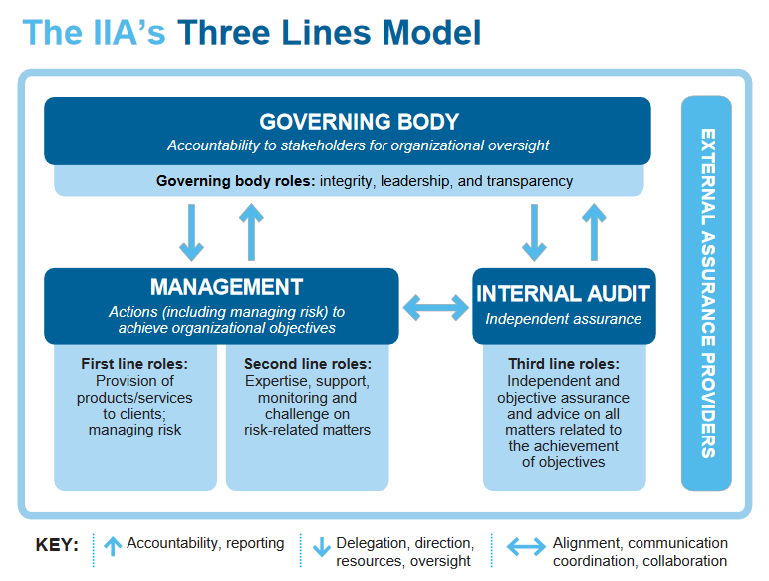
4

Line 1 – Management Controls
- Process owners
- Department heads
- Operational controls
- Financial approvals

Line 2 – Risk & Compliance Oversight
- Risk management function
- Compliance officer
- Data governance
- Quality assurance

Line 3 – Independent Internal Audit
- Internal Audit Function
- Reports directly to Board / Audit Committee
- Provides independent assurance

3️⃣ Work Breakdown Structure (WBS)

19.1 Internal Control Framework
- 19.1.1 Control Environment
- 19.1.2 Risk Assessment
- 19.1.3 Control Activities
- 19.1.4 Information & Communication
- 19.1.5 Monitoring Activities

19.2 Internal Audit Management
- 19.2.1 Audit Charter
- 19.2.2 Annual Audit Plan
- 19.2.3 Risk-Based Audit Planning
- 19.2.4 Fieldwork & Testing
- 19.2.5 Reporting & Follow-up

19.3 Fraud Risk Management
- 19.3.1 Fraud Risk Assessment
- 19.3.2 Whistleblowing Mechanism
- 19.3.3 Investigation Protocol
- 19.3.4 Disciplinary Measures

19.4 Compliance Monitoring
- 19.4.1 Regulatory Tracking
- 19.4.2 Contract Compliance Review
- 19.4.3 Policy Adherence Monitoring

4️⃣ SIPOC – Internal Audit Process
Supplier | Input | Process | Output | Customer
Board / Audit Committee | Audit Charter | Develop Risk-Based Plan | Approved Audit Plan | Management
Management | Financial & Operational Data | Conduct Audit Fieldwork | Audit Report | Board
Departments | Process Documentation | Control Testing | Findings & Recommendations | CEO
HR / Legal | Policies & Compliance Data | Compliance Review | Compliance Status Report | Regulators

5️⃣ BPMN – Internal Audit Flow
Start
↓
Annual Risk Assessment
↓
Audit Plan Preparation
↓
Audit Committee Approval
↓
Engagement Planning
↓
Fieldwork & Testing
↓
Draft Report
↓
Management Response
↓
Final Report Issued
↓
Follow-Up Review
↓
Close Audit
End

6️⃣ RACI Matrix – Internal Audit
Activity | Board | Audit Committee | CEO | Dept Head | Internal Audit
Approve Charter | A | R | C | I | C
Approve Audit Plan | I | A | C | I | R
Conduct Audit | I | I | I | C | R
Respond to Findings | I | I | A | R | C
Follow-Up | I | A | C | R | R
R = Responsible
A = Accountable
C = Consulted
I = Informed

7️⃣ Key Internal Controls by Area

A. Financial Controls
- Segregation of duties
- Dual authorization for payments
- Budget variance analysis
- Bank reconciliation review
- Fixed asset register validation

B. Procurement Controls
- Approved vendor list
- Three-quotation policy
- Contract review checklist
- PO approval hierarchy

C. HR Controls
- Payroll reconciliation
- Employment contract verification
- Leave tracking audit
- Access control review

D. IT Controls
- Access rights management
- Backup & disaster recovery testing
- Change management logs
- Data integrity validation

8️⃣ Fraud Risk Management Framework
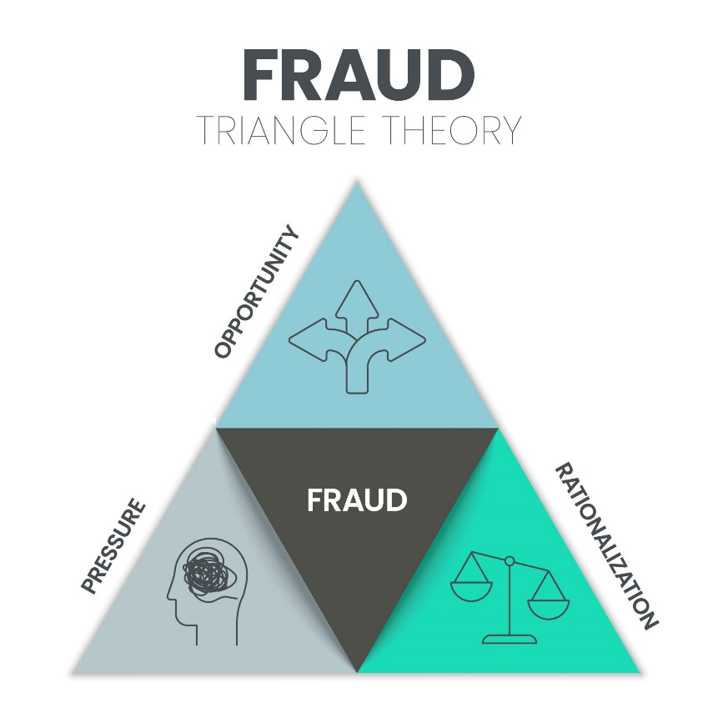

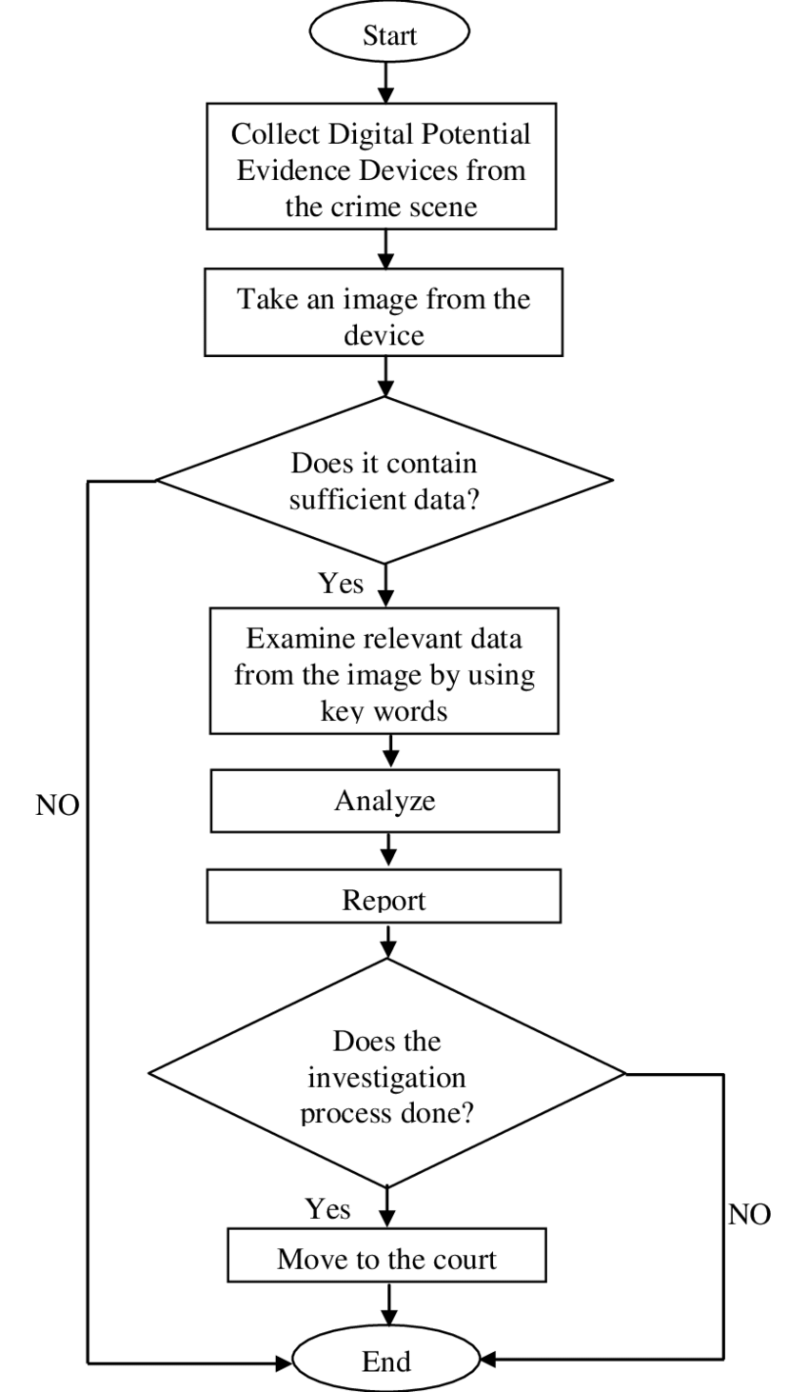
4

Fraud Triangle Elements:
- Pressure
- Opportunity
- Rationalization

Controls:
- Anonymous reporting channel
- Segregation of duties
- Conflict of interest declaration
- Vendor due diligence
- Surprise audits

9️⃣ KPI Dashboard – Internal Control & Audit
KPI | Target
% Audit Plan Completed | ≥ 90%
High-Risk Findings Closed | ≥ 85% within 60 days
Repeat Findings Rate | < 10%
Fraud Incidents Detected | ↓ Year-on-Year
Policy Compliance Rate | ≥ 95%
Control Testing Coverage | ≥ 80% of Critical Processes

🔟 SAP / ERP Control Points (If SAP Used)
If RAM uses SAP SE ERP, control points include:
- User role authorization matrix
- Workflow approval configuration
- Automated 3-way match (PO–GR–Invoice)
- Audit trail activation
- Exception reporting dashboard

11️⃣ Forms & Templates (Standardized Codes)
Code | Form Name
F_19_01 | Internal Audit Charter
F_19_02 | Annual Audit Plan Template
F_19_03 | Risk Assessment Matrix
F_19_04 | Audit Program Checklist
F_19_05 | Working Papers Template
F_19_06 | Audit Report Template
F_19_07 | Management Action Plan Tracker
F_19_08 | Fraud Incident Report Form
F_19_09 | Whistleblower Submission Form
F_19_10 | Compliance Monitoring Checklist

12️⃣ Governance Reporting Structure
Internal Audit → Audit Committee → Board of Directors
↓
CEO (administrative coordination only)
Internal Audit must remain functionally independent.

13️⃣ Maturity Levels (Control Effectiveness Scale)
Level | Description
1 – Ad Hoc | No documented controls
2 – Basic | Controls exist but informal
3 – Defined | Documented and implemented
4 – Managed | Monitored and measured
5 – Optimized | Continuous improvement & automation

14️⃣ Audit Committee Oversight Responsibilities
- Approve audit charter
- Review financial statements
- Oversee external audit
- Monitor internal audit independence
- Review risk management framework
- Oversee whistleblowing cases

15️⃣ Integration with Other RAM Sections
Internal Control & Audit interacts with:
- 11_Finance_Accounting
- 07_Risk_Compliance
- 08_Master_Data
- 15_IT_Data_Governance
- 13_Procurement_Commercial
- 14_Human_Resources_Interface

Executive Summary
The RAM Internal Control & Audit Framework ensures:
- Governance integrity
- Financial transparency
- Operational efficiency
- Regulatory compliance
- Fraud mitigation
- Continuous improvement

Next to do
- Convert this into a Board-grade visual layered governance diagram
- Create a Risk & Control Matrix (RCM) in tabular detailed format
- Prepare a Printable Audit Manual (structured PDF-ready version)
- Or integrate this with your full RAM Process Architecture Master Map**

