14_Human_Resources_Interface
(RAM Policies & Procedures Manual – HR Interface Framework)

14.1 Human Resources Governance Policy
Purpose:
Establish structured coordination between Human Resources (HR) and all RAM functional divisions (Investment, Leasing, Facility, CapEx, Finance, Risk, AI, Procurement, Administration, etc.).
Scope:
All permanent, temporary, contract, and outsourced personnel across RAM.
Objectives:
- Ensure manpower alignment with strategy
- Integrate workforce planning with business plans
- Establish clear HR–Business interface governance
- Align with ISO 30414 (Human Capital Reporting), ISO 37301, COSO

14.2 HR Operating Model (Business Interface Architecture)
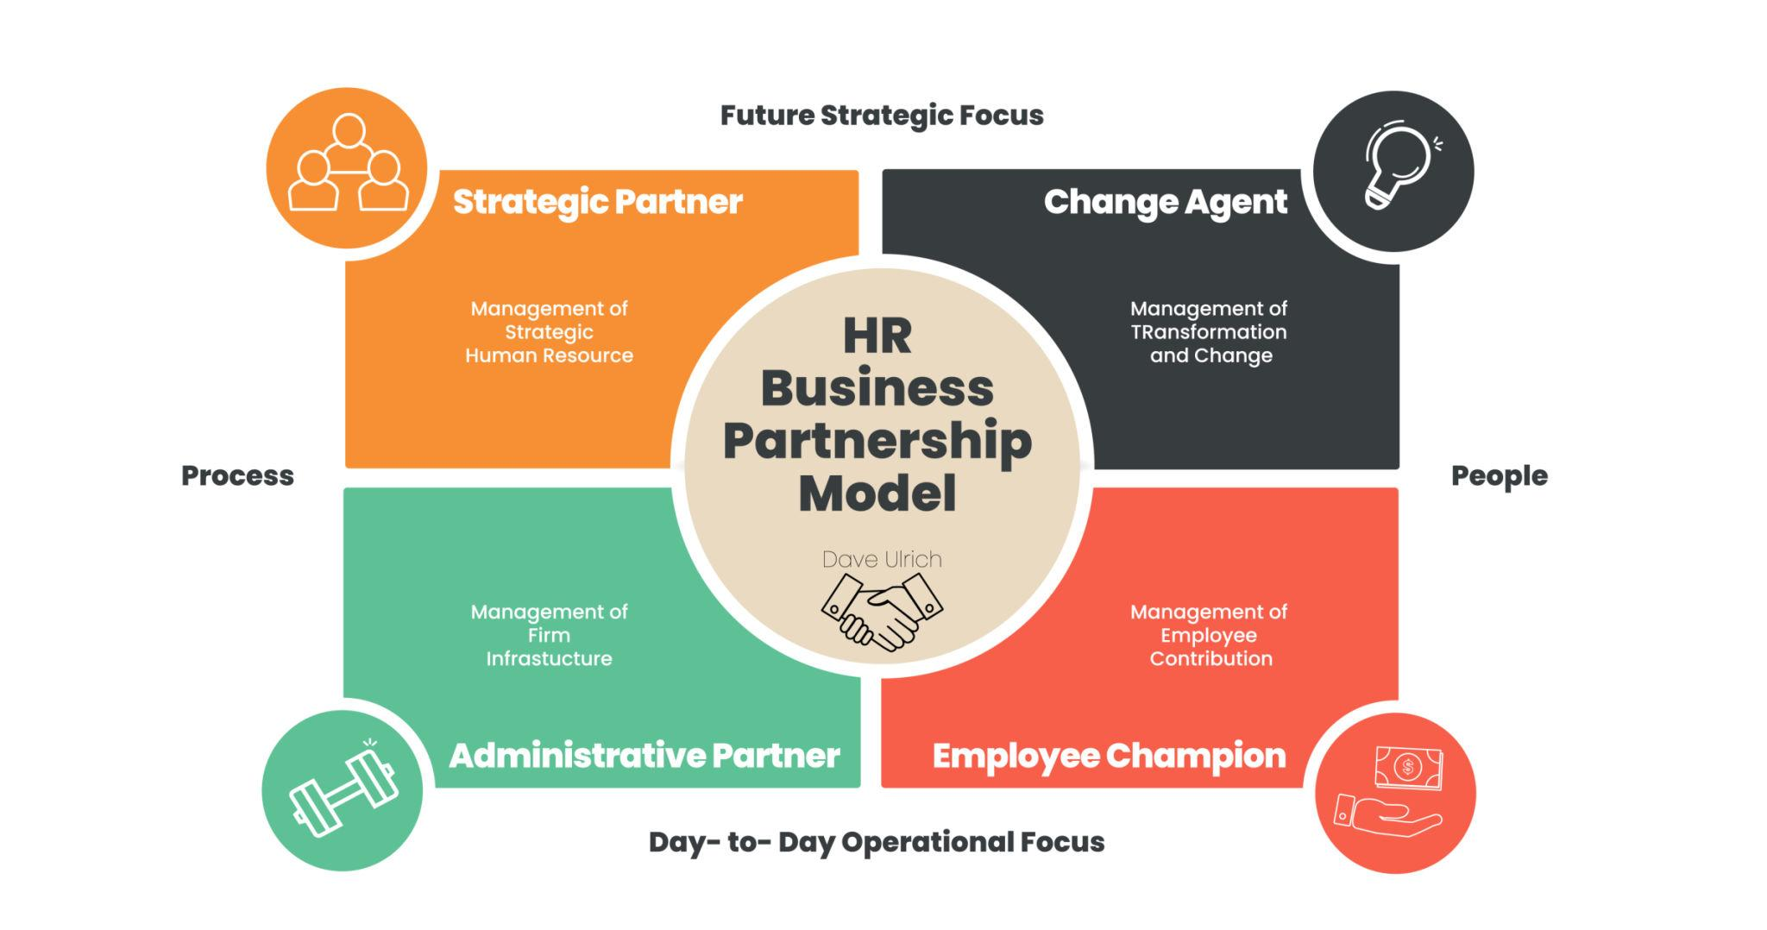
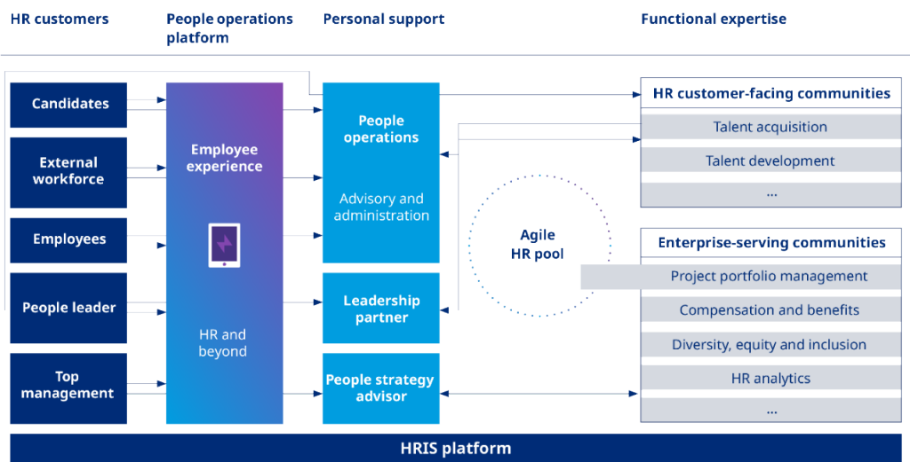
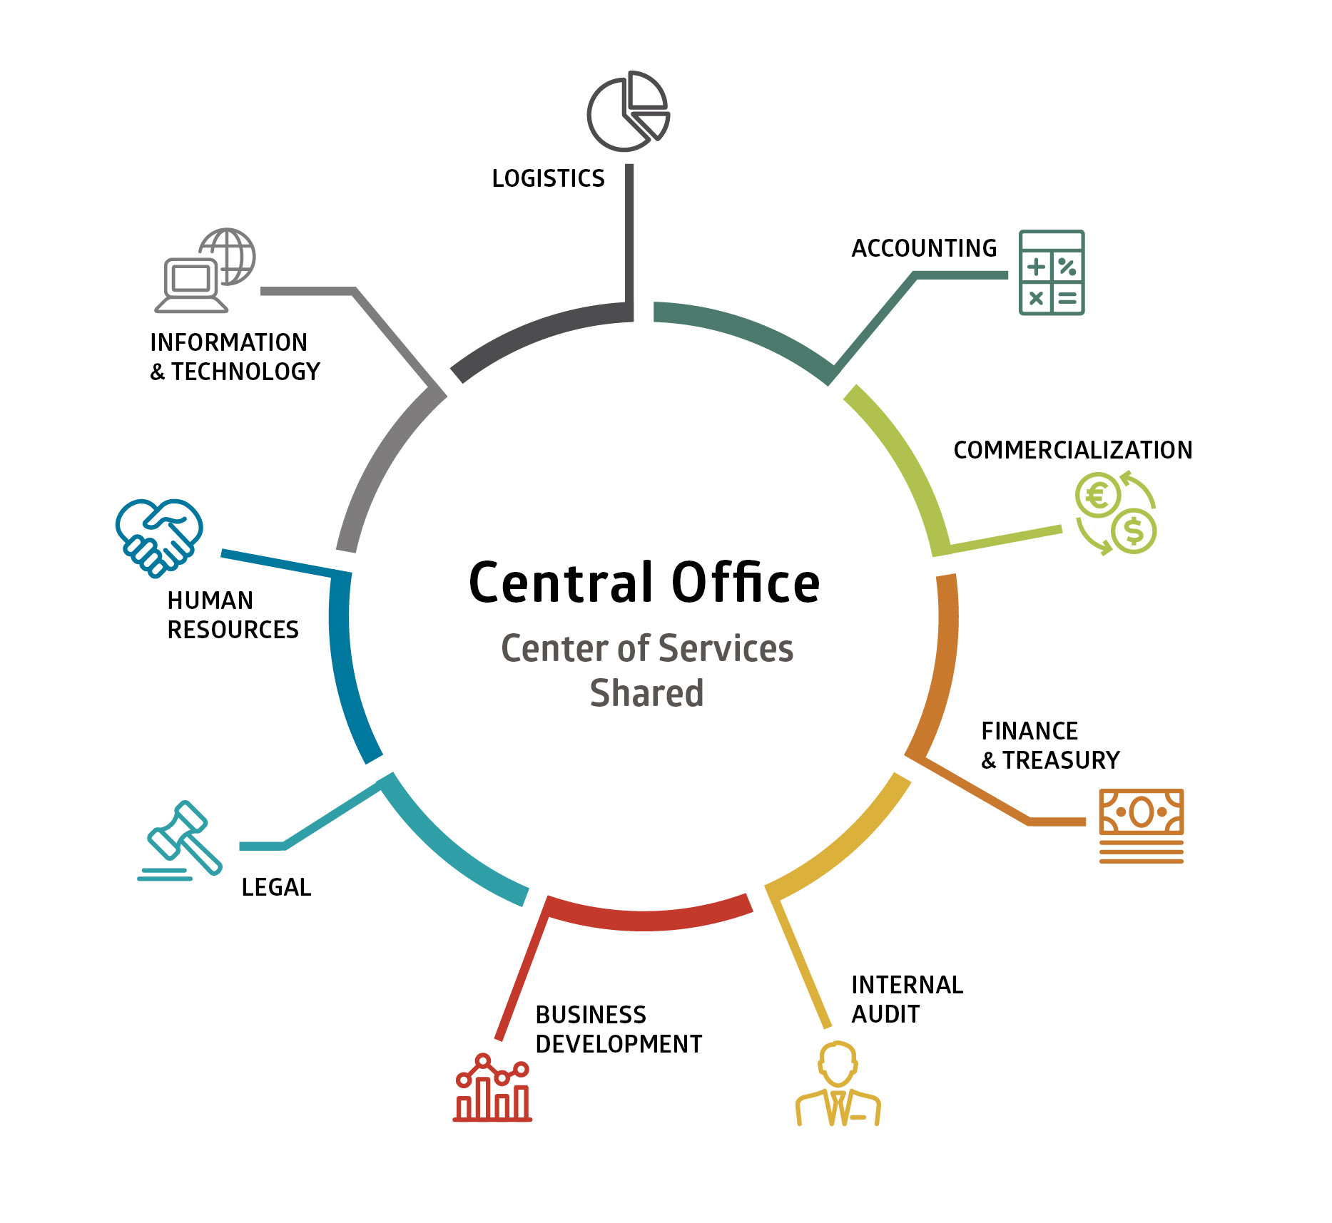
4

14.2.1 HR Structure Model for RAM
Layer | Function | Role
Strategic | HR Director | Workforce Strategy, Policy Governance
Tactical | HR Business Partner (HRBP) | Interface with each Division
Operational | HR Operations | Payroll, Admin, Records
Specialist | COEs (Talent, L&D, Compensation, OD) | Technical Expertise

14.3 Core HR Interface Processes (WBS Structure)

14.3.1 Workforce Planning Interface

14.3.1.1 Annual Manpower Planning Procedure
- Business Units submit manpower forecast
- HR validates against budget (Finance)
- Approval via Management Committee

14.3.1.2 Workforce Gap Analysis
- Skills mapping
- Capacity planning
- Succession risk assessment
Outputs:
- Approved Manpower Plan (F-14-01)
- Workforce Risk Register

14.3.2 Recruitment & Onboarding Interface

14.3.2.1 Recruitment Requisition Workflow
- Department raises request
- Budget validation (Finance)
- HR screening
- Interview Panel (RACI defined)
- CEO approval (if required)

14.3.2.2 Onboarding Governance
- Employment Contract
- NDA & Confidentiality
- System Access Request (IT)
- Policy Acknowledgement
- Probation KPI definition
Forms:
- F-14-02 Recruitment Request
- F-14-03 Interview Evaluation Sheet
- F-14-04 Onboarding Checklist
- F-14-05 Access Control Form

14.3.3 Performance Management Interface

14.3.3.1 KPI Alignment Procedure
- Cascade from Corporate KPIs (Section 06_Performance)
- Departmental KPIs
- Individual Scorecards

14.3.3.2 Appraisal Cycle
- Mid-year review
- Annual review
- Performance Calibration Committee

14.3.3.3 Performance Risk Escalation
- Low performer PIP
- Misconduct referral to Compliance
KPIs:
- % KPI completion rate
- Employee productivity ratio
- Attrition rate
- Engagement score

14.3.4 Compensation & Payroll Interface

14.3.4.1 Payroll Control Procedure
- Attendance validation
- Overtime approval
- Bonus alignment with KPI results
- Finance reconciliation

14.3.4.2 Compensation Review Governance
- Annual salary benchmarking
- Market adjustment review
- Board approval for executive pay
Controls:
- Segregation of Duties
- Payroll audit trail
- Bank file verification

14.3.5 Learning & Development Interface

14.3.5.1 Training Needs Analysis (TNA)
- Department request
- Skills gap review
- Budget alignment

14.3.5.2 Mandatory Training Governance
- Compliance
- Risk & HSE
- AI & Data Ethics (Aligned to 09_AI_Knowledge_HUB)

14.3.5.3 Leadership Development Track
- High-potential identification
- Succession matrix

14.3.6 Employee Relations & Compliance Interface

14.3.6.1 Grievance Handling Procedure
- Complaint registration
- Investigation committee
- Resolution timeline

14.3.6.2 Disciplinary Process
- Warning levels
- HR–Legal coordination
- Termination governance

14.3.6.3 Ethics & Whistleblowing
(Linked to 07_Risk_Compliance)

14.4 SIPOC – HR Interface
Supplier | Input | Process | Output | Customer
Departments | Manpower needs | Recruitment | New hires | Business Units
Finance | Budget | Payroll validation | Salary payment | Employees
Risk | Compliance rules | Training governance | Certified workforce | Management
IT | Access request | Onboarding | System access | Employee

14.5 BPMN – Recruitment Interface (Textual Representation)
Start → Dept Raise Request → Finance Budget Check → HR Review →
Interview Panel → CEO Approval → Offer Letter → Onboarding → End

14.6 RACI Matrix – Key HR Interface Processes
Process | HR | Dept Head | Finance | CEO | IT
Manpower Planning | R | A | C | I | I
Recruitment | R | C | C | A | I
Onboarding | R | C | I | I | R
Payroll | R | I | A | I | I
Performance Review | R | A | I | I | I
(R = Responsible, A = Accountable, C = Consulted, I = Informed)

14.7 SAP / ERP Integration Points
HR Module | Linked Module
Personnel Administration | Finance
Payroll | Treasury
Organizational Management | Strategy
Time Management | Operations
Training & Events | Performance

14.8 HR KPI Dashboard
Category | KPI | Target
Talent | Time-to-hire | < 30 days
Retention | Attrition Rate | < 8%
Performance | % KPI Achievement | > 85%
Payroll | Payroll Accuracy | 100%
Engagement | Survey Score | > 80%

14.9 HR Risk & Control Matrix (Aligned with ISO 37301 & COSO)
Risk | Control | Owner | Frequency
Unauthorized hiring | Budget approval workflow | HRBP | Per case
Payroll fraud | Dual approval & audit | HR + Finance | Monthly
KPI manipulation | Calibration committee | HR Director | Annual
Legal non-compliance | Legal review | HR + Legal | Ongoing

14.10 Key Templates Index
- T-14-01 Manpower Planning Template
- T-14-02 Recruitment Request
- T-14-03 Interview Scorecard
- T-14-04 Employment Contract Template
- T-14-05 Performance Appraisal Form
- T-14-06 Payroll Summary Sheet
- T-14-07 Training Evaluation Form
- T-14-08 Disciplinary Notice Template

14.11 Maturity Levels (HR Interface Model)
Level | Description
Level 1 | Administrative HR only
Level 2 | Process-driven HR
Level 3 | Business Partner Model
Level 4 | Data-driven HR
Level 5 | Strategic Human Capital Governance

If you want next step enhancement, I can now:
- Convert this into WBS-coded policy tree (14.1.1.1 structure)
- Build full Governance Risk & Control Matrix in extended format
- Generate BPMN diagrams visually
- Design board-grade HR Operating Model Architecture Diagram
- Create full forms package in structured table format
- Convert into ISO-aligned policy manual ready for PDF publication
Tell me how deep you want to go in this section.

